Workers who are required to wear personal respiratory protection to control exposure to silica dust, or who are likely to be exposed to crystalline silica in the course of their duties, are required to participate in a health monitoring program.

Screening is conducted to:
- Identify workers who carry out ongoing work using, handling, generating, or storing products containing crystalline silica
- Monitor the effectiveness of the controls for crystalline silica exposure

Managers are required to consult with and provide information to workers who may be exposed to silica dust

Silica and the Lung
Crystalline silica is a common mineral found in most rocks, sands and clays. It is present in things like concrete, bricks, mortar, pavers, tiles, cement sheeting, natural stone products and engineered stone slabs. There are three
forms of crystalline silica: quartz, cristobalite and tridymite.

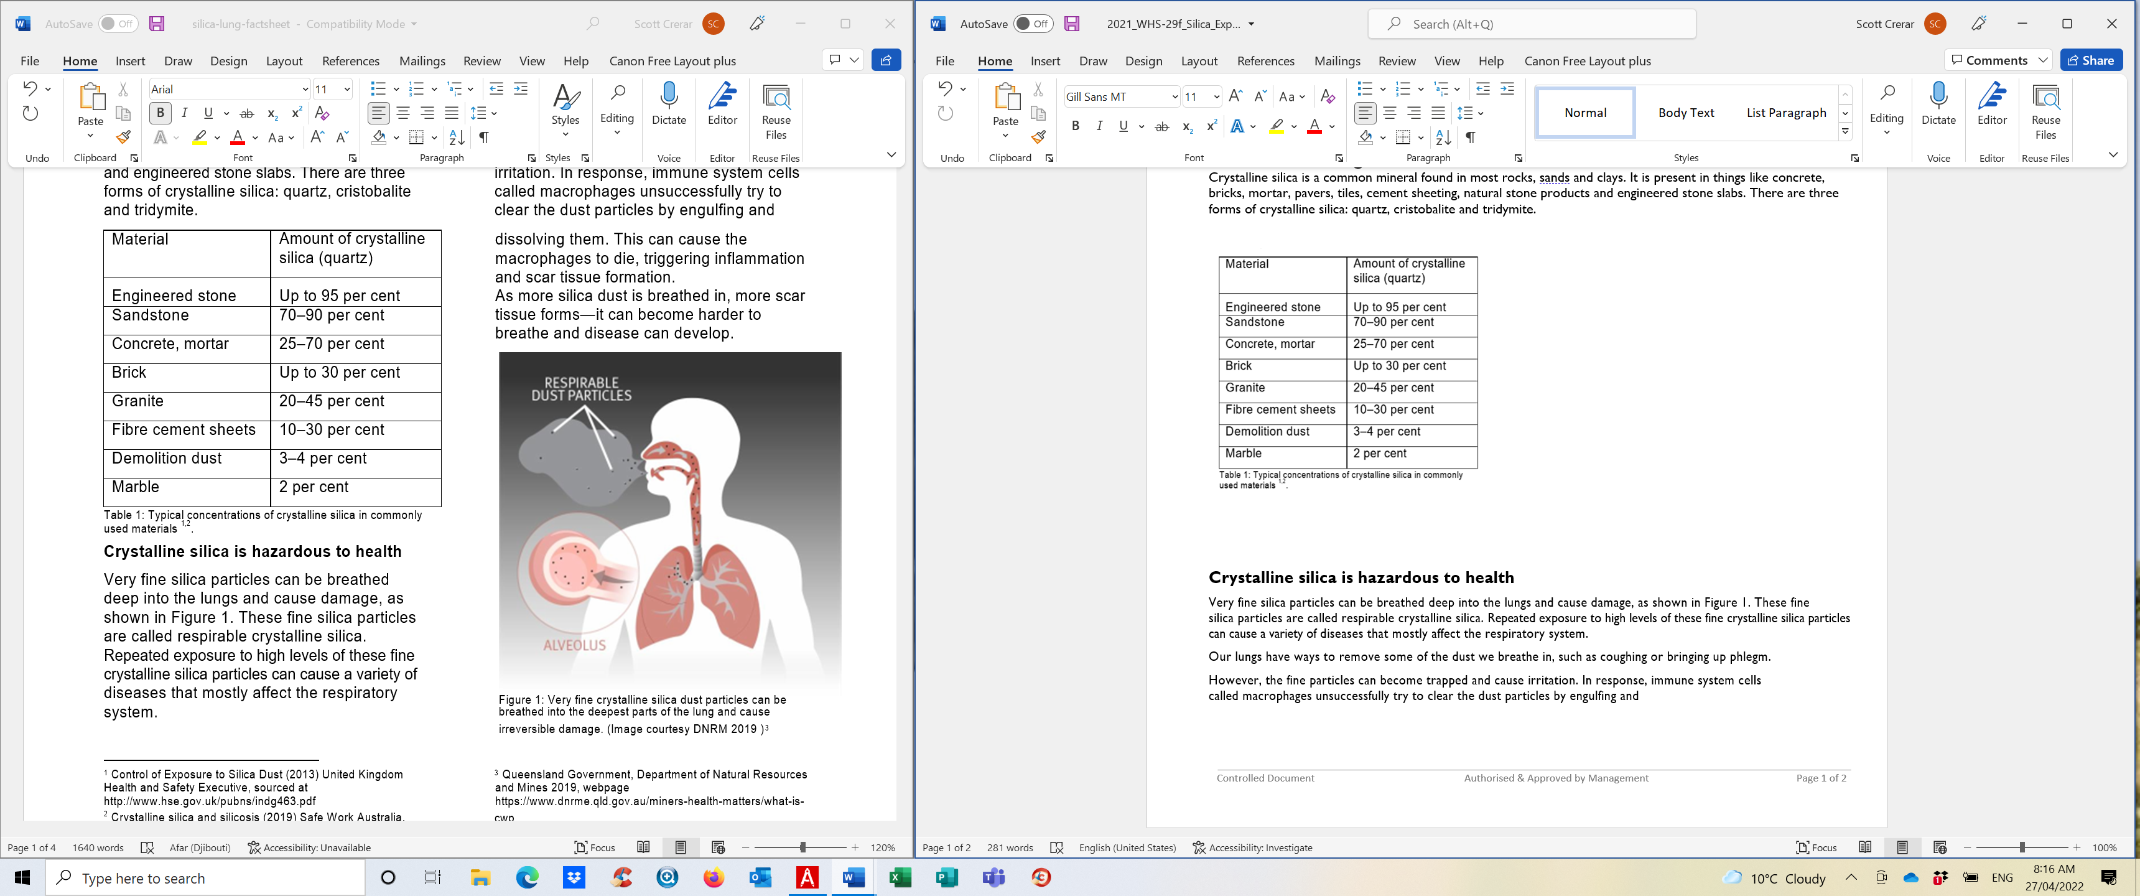
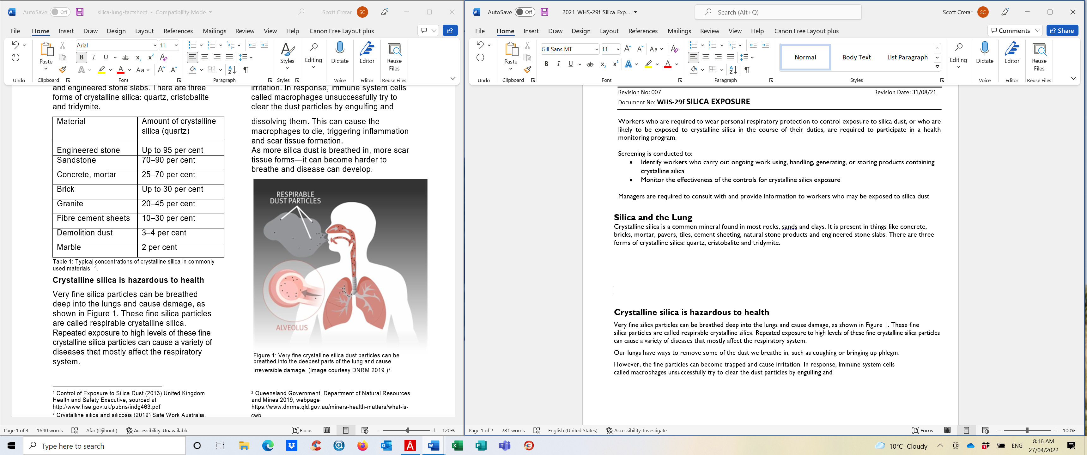

Crystalline silica is hazardous to health
Very fine silica particles can be breathed deep into the lungs and cause damage, as shown in Figure 1. These fine
silica particles are called respirable crystalline silica. Repeated exposure to high levels of these fine crystalline silica particles
can cause a variety of diseases that mostly affect the respiratory system.
Our lungs have ways to remove some of the dust we breathe in, such as coughing or bringing up phlegm.
However, the fine particles can become trapped and cause irritation. In response, immune system cells
called macrophages unsuccessfully try to clear the dust particles by engulfing and dissolving them. This can cause the macrophages to die, triggering inflammation and scar tissue formation. As more silica dust is breathed in, more scar
tissue forms – it can be harder to breathe, and disease can develop.

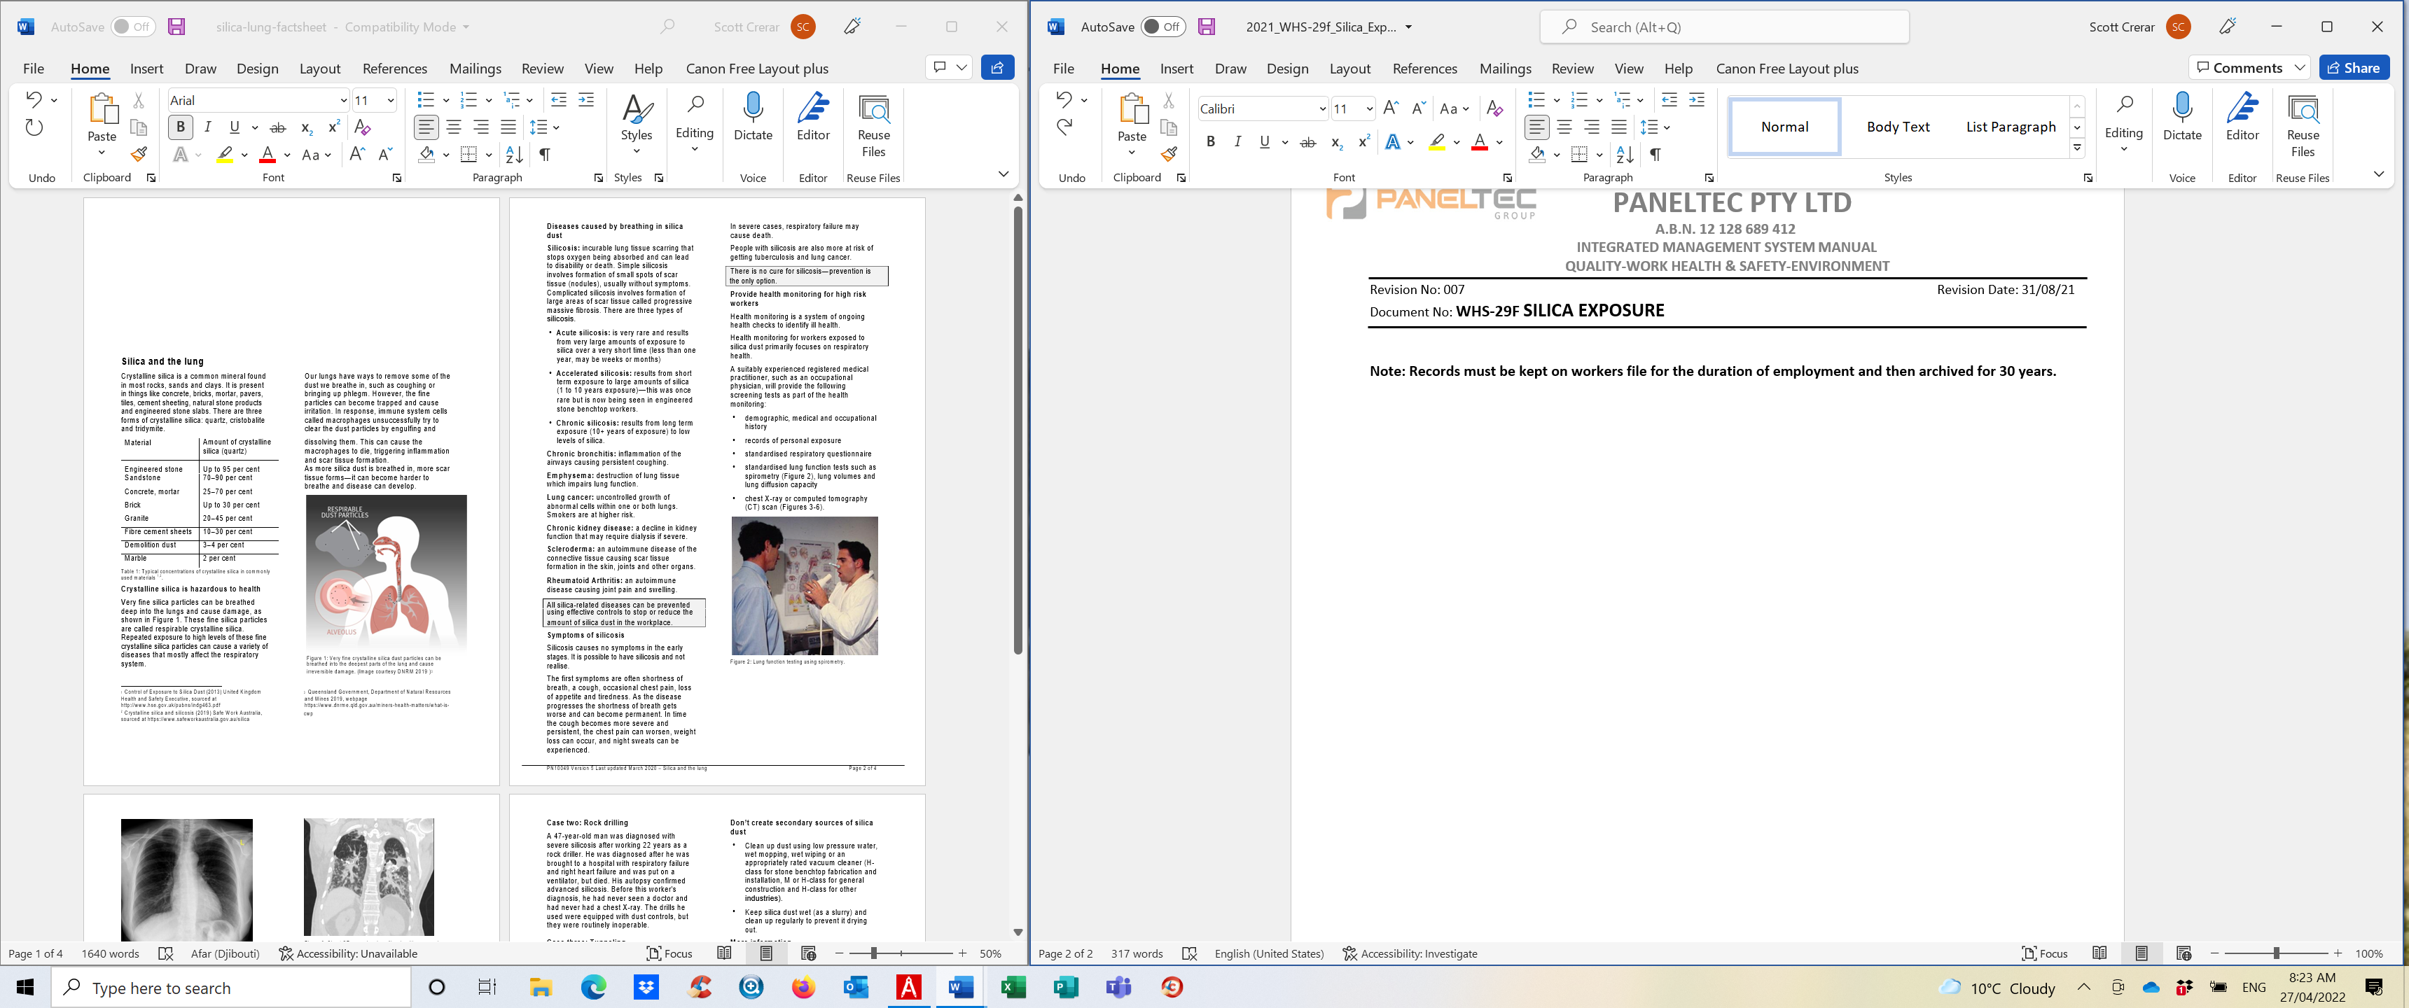

Note: Records must be kept on workers file for the duration of employment and then archived for 30 years.

