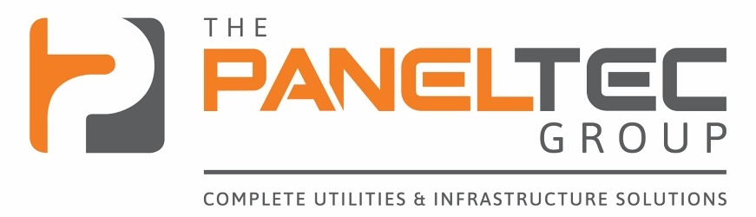
2025
Craig Large Safety and Compliance Manager
Paneltec
September 2025

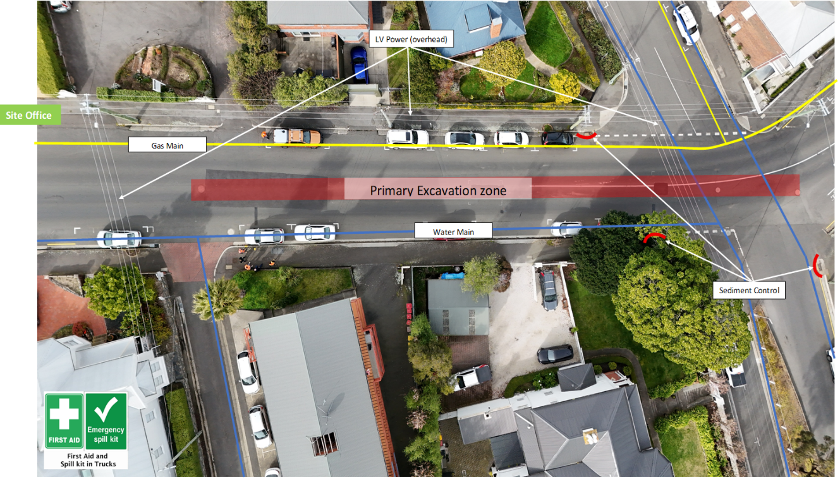

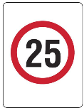
Site Plan (example)
Emergency Response Plan

EMERGENCY CONTACTS
RING 000 OR 112 (only works on Mobile Phone)
- State Your Name
- State Current Location
- State nature of Emergency
- State Assistance Required
SITE EMERGENCY ASSEMBLY AREA | PANELTEC SITE OFFICE
NEAREST EMERGENCY HOSPITAL | NEAREST MEDICAL CENTRE
Launceston General Hospital | Launceston General Hospital
274-280 Charles St, Launceston TAS 7250 | 274-280 Charles St, Launceston TAS 7250
(03) 6777 6777 | (03) 6777 6777
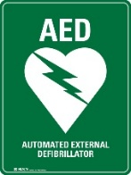
NEAREST AUTOMATIC DEFIBILLERATOR LOCATION (Example)
18A High Street | Launceston | 7250
Launceston Aquatic Centre.

At Front desk.
(Available 07:00 - 21:00 Monday to Friday and 09:00 - 19:00 on Saturdays and 09:00 - 19:00 on Sundays)

FIRST AIDERS – Paneltec Civil | FIRST AIDERS – VIATEC
EMERGENCY RESPONSE COORDINATORS (ERC) CHIEF WARDEN

EMERGENCY CONTACT INFORMATION
Reference | Details
Police, Emergency Services | 000 / 112
Poisons Information Centre | 131 126
EPA Pollution Hotline | 1800 005 171
Telstra | 132 203
Optus | 133 937
Dial Before You Dig | 1100
Local Council
Electrical Emergency  (Tas Networks) | 13 2004
Water Emergency (TasWater) | 13 6992
Gas Emergency (TasGas) | 1802 111
WorkSafe Tasmania | 1300 366 322
PDG Health & Safety Team Lead
TasWater Project Manager
TasWater Supervisor
TasWater Senior Environmental Advisor
TasWater Capital Delivery Engagement Specialist

Arthur St, Launceston
FIRST NAME | LAST NAME | ON-SITE @  Pre-Start (Y/N) | PRESENT  @ Muster (Y/N)

1. INTRODUCTION
The Paneltec Pty Ltd (Paneltec) emergency response procedures have been developed to ensure that all staff and employees (workers) Contractors and sub-Contractors (where appointed) are provided with clearly documented instructions, which shall be implemented, and strictly adhered to in the unlikely event of an emergency being experienced at a Paneltec worksite. These emergency response procedures have been categorised to ensure that specific potential emergencies are managed efficiently, effectively and in a coordinated manner to ensure that the safety and wellbeing of staff and employees (workers) Contractors, sub-Contractors, clients and visitors is the prime consideration at all times.
2. ROLE OF THE CHIEF WARDEN (SUPERVISOR WHERE APPOINTED)
The role of the Chief Warden at a Paneltec controlled worksite is to assume overall Control of the emergency, regardless of the normal site/organization management structure. The Chief Warden shall ensure that the emergency procedures are implemented in a responsive and timely manner. The Chief Warden shall direct Wardens and other staff and employees (workers) to assist in the management of the emergency and to ensure that the appropriate emergency service has been notified. Control remains with the Chief Warden until the appropriate emergency service arrives on site to take over Control of the situation.
The Chief Warden shall be familiar with the worksite / workplace layout, communication systems, location of emergency Control equipment, electrical isolation points, first aid kits and the emergency evacuation point.
The Chief Warden shall be responsible for, and able to provide the responding emergency service with a Comprehensive briefing of the situation, including scope, location of the emergency, the site evacuation status, the sites most appropriate access point/s; and to act on the senior emergency services officers instructions.
The Chief Warden for all Paneltec Worksites will be the Paneltec Supervisor On-site, and the appointed person in charge when the supervisor is absent from the site.
2.1 EMERGENCY RESPONSE - GENERAL GUIDE
When contacting emergency services in relation to a site emergency, the following guidelines and information is to be provided to the relevant emergency responder where it is safe to do.
- What happened?
- Fire (type – fuel, electrical, structural).
- Product spilled (Type fuel, oil etc.)
- Vehicles / people involved (injuries / type , damage etc.).
- Product contamination.
- Where and when did the incident happen.
- What phone number can you be contacted on?
- Nearest Tas Networks Pole Number or “What Three Words” Location i.e. “snub.march.flashbacks”

2.2 WORK SITE EVACUATION PROCEDURE
Procedure
Should the need arise to evacuate the workplace in the unlikely event of an emergency, it is the responsibility of the Paneltec Chief Warden or designated authority to initiate the emergency response procedures and to communicate clearly with other workplace / worksite personnel (workers) client’s customers contractors, sub-contractors and visitors, and to ensure the area is secure by:
- evacuating the area immediately as instructed by the Chief Warden or designated authority.
- proceeding directly to (Site Office) the evacuation assembly point when directed by the Warden or designated authority to do so;
- not re-entering the worksite unless instructed by the appropriate authority, and only after confirming that it is safe to do so.
In an emergency situation, it is important to “stay calm” and consider the following additional instructions:
- Turn off all equipment if possible and safe to do so.
- Do not collect any personal possessions.
- Muster at the days designated emergency assembly point.
- Seek first aid for all injuries.
- Do not leave the site unless given permission to do so by the appropriate authority.
3. FIRE RESPONSE (Including Explosions)
A workplace or worksite fire may include but not be limited to the following:
- Result of an explosion on site.
- Electrical fire; combustible materials, fuels, oils fire, etc.
- Fire originating from a neighbouring vehicle, property, business or scrubland.
- Gas fire.
Procedure
Should the workplace or worksite be threatened by a fire, or should a fire be detected at the workplace immediately alert at least one other person but avoid panic. For workplace or worksite and fires, immediately isolate electricity supply and all fuel dispensing pumps where safe to do so. Attempt to extinguish the fire only if trained and it is safe to do so using available firefighting equipment. If the fire cannot be easily contained and controlled immediately (within 1 minute) raise the alarm by taking the following action:
- Notify / alert at least one other person on site (if possible) and direct them to alert the Chief Warden or Designated authority who shall:
- Telephone Emergency Services (Tas Fire Service) 000 or 112 (only works on Mobile Phones);
- Advise the Fire Service of the organisations name, exact location and the most appropriate safe point of entry.
- Advise the type of fire if known e.g. unleaded, diesel fuel, oil, or electrical.
- Ensure the Fire Brigade hangs up the phone first.
- Disconnect all outside calls. (if using the phone, hang up).
- Prepare for evacuation if required, and if not already initiated.
General Instructions (all personnel) for Fire Emergencies
- Keep your back towards an exit if you are fighting a fire upon leaving.
- If you have to escape through a smoke filled area, do so on hands and knees, or crawl.
- Feel a closed door before opening to see if it hot, if the door is hot do not open the door.
- If the door is cool, shield yourself before opening it slightly in case there is a fire on the other side.
- Evacuate the area immediately as instructed by the relevant Warden; and
- proceed directly to (pre-determined or safe) the evacuation assembly point when directed to do so.
Person’s Clothing on Fire:
- If safe to do so get the person to lie down immediately and use a dry chemical extinguisher (avoid directing the powder into the person’s face) or cover the flames tightly with a blanket or coat, starting at a point nearest the head.
- Once the flames are out, drench the burn area with cool, clean water.
- Call an Ambulance on 000 or 112 (only works on Mobile Phones)
Fuel Spillage Fire:
- Assist anybody in immediate danger, only if safe to do so.
- Evacuate all customers from the site.
- If the fire is small, endeavor to put it out using a dry chemical fire extinguisher.
- If the fire is large, leave the site and prevent others entering the site.
After the Fire:
- Arrange for recharging of fire extinguishers that were used.
- Inform WorkSafe Tasmania to enable an investigation to be conducted.
4. MEDICAL EMERGENCY
Purpose
Medical emergencies may include but not be limited to the following:
- Heart attack.
- Burns.
- Cuts/lacerations/amputations.
- Asthma attack.
- Allergic reactions /poisoning/fitting.
- Falls from height.
- Crush injuries.

Procedure
If a medical emergency occurs at Paneltec the following response shall be followed in line with the DRSABCD Action Plan.
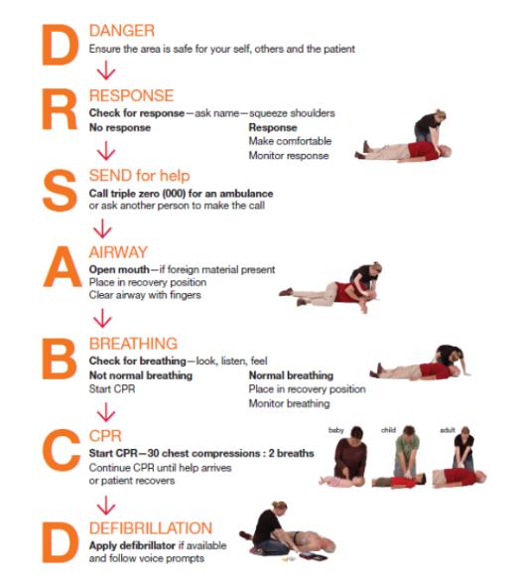
- Danger – Check that there is no danger if you go to assist.
- Response – Check for response from the patient e.g. ask if they are ok and move them only if you know that they have sustained no spinal injuries.
- Send for Help – Call triple 000 or 112 (only works on Mobile Phones)
- Airways - Check the airways are clear.
- Breathing – Look for the chest rising and falling, listen for breathing, feel using your cheek or the back of your hand.
- CPR – 30 Chest Compressions and 2 Breaths.
- Defibrillation – If a unit is available.

If the Patient is Conscious
Stay with them, keep the patient warm and dry; and reassure the patient that help is on the way. Send or call for assistance at the first available opportunity. Carry out first aid if needed ensuring that protective clothing (Gloves etc. from the first aid kit) are worn when administering first aid.
If Further Treatment is Required
The workplace or worksite appointed First Aider shall evaluate the extent and nature of the illness / injuries before deciding on the means of transporting the patient to a hospital (an Ambulance may be required). If in any doubt at all, immediately call an ambulance by phoning Emergency Services (Ambulance) 000 or 112 (only works on Mobile Phones)
Advise the Ambulance Operator of the following:
- Organisation name and exact location.
- The most appropriate point of entry.
- The nature of the illness / injury if known e.g. suspected heart attack, fall, vehicle accident, crushing Injury etc.
- If requested the qualifications and number of qualified first aiders in attendance.
- Ensure the Ambulance operator hangs up the phone first.
- Send a responsible person to the point of entry to guide the Ambulance.

5. EMERGENCY FIRST AID RESPONSE SUMMARY
- Check for any threatening situation and control if safe to do so.
- Do not move a casualty unless exposed to life threatening danger.
CONTROL OF BLEEDING  1. Put on disposable gloves.  2. Apply direct pressure to the wound – use your hands if a dressing is not available.  3. Elevate (raise) the limb.  4. Apply a pad and firm bandage.  Remember:  1. Always check circulation below the bandage.  2. If there is tingling, numbness or blueness, loosen the bandage. | MANAGEMENT OF BURNS  1. Cool the burnt area with cool water for 10 to 15 minutes.  2. If necessary, cover the burn with a clean dressing or plastic wrap and get person to medical attention.  Remember:  1. Avoid breaking blisters.  2. Never remove clothing that is stuck to a burn.  3. Never apply creams to burns area. | EXPIRED AIR RESUSCITATION  Check for Breathing:  1. Turn person on side if necessary clear out person’s mouth with your fingers.  2. Tilt head back and raise chin forward.  3. LOOK for movement of person’s chest.  4. LISTEN for breathing.  5. FEEL for breath on your cheek and for rise and fall of person’s chest.  6. If the person is breathing but unconscious, turn them onto their side and kept their head tilted back to make sure their airway is not blocked.  If Person is Not Breathing:  1. Keep person’s head tilted back.  2. Pinch person’s nose to close it off.  3. Seal person’s mouth with your mouth (use a resuscitate mask to protect against infection).  4. Blow into person’s mouth and watch for chest to rise as air enters lungs.  5. If chest doesn’t rise, adjust head tilt and try again.  6. Give 5 full quick breaths followed by 1 breath every 5 seconds until the person starts to breathe again, or until medical help arrives.
MANAGEMENT OF EYE INJURIES  Foreign bodies in the eye(s):  1. Wash the eye(s) with eyewash or clean water.  2. Never attempt to remove a foreign body which is stuck to the eye surface.  3. Place a covering over the eye and get medical attention.  Chemicals in the eye(s)  1. Wash the eye(s) with clean water for at least 15 minutes.  2. Wash from the nose outwards to prevent injury to the other eye.  3. Make sure you wash under the upper eyelid.  4. Place a covering over the eye(s) and get medical attention | MANAGEMENT OF COLD BURNS (LPG)  1. Warm the burnt area with warm water for 10 to 15 minutes.  2. If necessary, cover the burn with a clean dressing or plastic wrap and get person to medical attention.  Remember:  1. Do not apply direct heat e.g. heater, hot water.  2. Avoid breaking blisters.  3. Never remove clothing that is stuck to a burn.  4. Never apply creams to a burn area.
MANAGEMENT OF MINOR WOUNDS
Abrasions and small cuts:
- Clean the wound with mild antiseptic or soap and water.
- Cover lightly with a clean dressing.
General:
- Wherever there is a risk of infection, use disposable gloves before giving first aid.
- Avoid giving an injured person anything to eat or drink.
- No smoking by injured person.
- Use covers to maintain normal body temperature of the injured person and minimise the effects of shock.

FATAL OR SERIOUS INJURY
Any situation where medical assistance is required, must be regarded as being more important that the continued operation of the site.
Sometimes people become seriously ill or are involved in serious or fatal accident on site.
NOTE: Remember to put on disposable protective gloves from the first aid kit before giving first aid to an injured person.
- Try to determine the seriousness of the injury / illness.
- Call an ambulance on 000 or 112 (only works on Mobile Phones).
- Ensure the casualty is safe from further danger and apply first aid as appropriate until ambulance arrives.
- Secure the site and do not disturb anything until an inspector arrives, or directs otherwise, unless it is essential to make the site safe.

WorkSafe Tasmania must be notified to enable a full investigation to be conducted if overnight hospitalization or a fatality has occurred.
PH: 1300 366 322
6. SPILLS – WET PRODUCT/ DRY PRODUCT
Procedure
If a spillage of all wet products, including fuels, lubricants and chemicals. occurs at the workplace or worksite the following response procedure shall be followed:
Wet Products
- For wet product spills, if possible, form small dam around the spillage utilising suitable materials from the appropriate Environmental Protection Spill Kit (kitty litter, spill “Containment Sausages” etc.).
- Use the suitable absorbent material from the Spill Kit to “mop up” the spill as required.
- Move leaking drums or containers into a suitable drum or containment area (spare storage vessels are located on site for this purpose).
- If there is a significant risk of fire, immediately Contact the Fire Brigade 000 or 112 (only works on Mobile Phones).
- Do not Commence this procedure until the Fire Brigade is on site, the situation has been assessed and all identified risks controlled.
- As soon as it is practicable to do so, barricade the area to ensure there is a clear separation distance from the spill, and the potential for Contact with other site personnel (workers).
- Paneltec “Top” Management shall report the spill to the appropriate agency where required to do so.
- Ensure the area of the spill is de-contaminated in line with environmental guidelines and instructions Contained in the Safety Data Sheet / Material Safety Data Sheet.
Dry Product Spills and Soil Contamination
- for small spills shovel or broom the spilled material, including any broken packages or bags into a suitable drum or receptacle (Suitable storage should be on site at all times for this purpose).
On Completion of Clean Up Operations
- Immediately change clothing and shower, use soap liberally to thoroughly clean skin. Pay particular attention to areas of flesh that may have been exposed during the cleanup operation.
- Contaminated protective clothing must be laundered thoroughly and separately from other clothing.
- Complete Incident Report. The Chief Warden or nominated representative shall arrange for the safe removal and disposal, within approved environmental guidelines of spilled materials from site (external waste disposal organisations shall be utilised for this purpose as required).

CHEMICAL SDS LINKS
  AMC Liquipol |   BK Standard Bactericidal  Pipe Jointing Lubricant |   Soudal PVC Pipe  Cement Type N - Blue
  Diesel |   Dingo Fast Set High  Strength Concrete |   T-O-T® No-Drip Pipe Joint Compound
  Loctite Nickel  Anti-Seize 771 |   MUDEX XDET 202 |   Unleaded Petrol
  Quik-Gel Gold |   Soudal Priming Fluid Red |   Vinidex Welding Wipes 90%

Sodium Hypochlorite

7. BOMB OR SUBSTANCE THREAT (Extremely unlikely)
Procedure
Should a bomb threat be received at Paneltec, all threats are to be treated as serious. They may be in one of three forms:

- Telephone threat.
- Written threat.
- Suspect object.

Telephone threat.

- Do not terminate the conversation.
- Accurately record information given as quickly as possible. Do not rely on memory.

Try to obtain as much information as possible including where, what time, what does it look like, why? Also try to assess the caller (e.g. male, female, speech, background noise, manner e.g. calm, intoxicated and rational, irrational).

Ensure that the exact time of the call/ threat is recorded; do not hang up the phone, and initiate the following:

- Contact the Paneltec Managing Director or Delegated Authority.
- Advise your exact location and contact number.
- Do not discuss the call with other staff.
- Provide assistance as required and follow directions.

If no suspicious object has been located, and the threat is non-specific, the Paneltec proprietor will conduct a search without evacuation.

Where there is a decision to conduct a search - Who conducts the search?
In accordance with Australian Standard AS 3745, Emergency Control Organization and Procedures for Buildings, Structures and Workplaces; Paneltec understands that it should not be assumed that the Police will conduct bomb searches.
Paneltec recognizes that the most appropriate personnel to carry out a search, in any given area, are the occupants of the building, structure or workplace because they have the knowledge of “what belongs” or “what doesn’t belong” in a location at any given time.
The Paneltec Proprietor shall co-ordinate any search using available resources as above. Assistance from workplace, worksite personnel (workers) may be required in line with their specific workspace knowledge.
TasWater Project Specific Requirements

1. Vehicle and Mobile Plant

1.1. Intent.

To eliminate or minimise the risk of fatalities, injuries and incidents arising from the use of vehicles/mobile.

1.2. Requirements.

Plant and Equipment.

1.1 All vehicles/plant and equipment will be assessed fit for purpose prior to purchase, e.g. 5 star Australasian new car assessment program (ANCAP) rating, air bags, appropriate signage, reversing cameras.

1.2 Working load limits (WLL) must be signposted on all lifting equipment.

1.3 Gross Vehicle Mass (GVM) must be available for reference on appropriate vehicles.

1.4 Working Load Limits must be signposted on vehicles, including roof racks and/or other aftermarket addition.

1.5 All vehicles must be maintained in accordance with manufacturers and organisation service requirements.

1.6 Minimum requirements for emergency, first aid and breakdown equipment must be defined and appropriate for use.

Procedures

1.7 Interaction between vehicles, mobile equipment and pedestrians must be controlled through detailed traffic management plans at all depots/sites.

1.8 Seat belts must be used by all occupants of vehicles.

1.9 Systems must be in place to ensure the risks associated with vehicles are managed. The systems must include, but not be limited to:

1.10.1 Assessment and communication of changed environmental and road conditions at the time of travel.

1.10.2 Outline of actions required in the event of an emergency e.g. collision or break down.

1.10.3 Process for monitoring drivers for “at risk behaviours.”

1.10.4 Provision to manage driver fatigue.

1.10.5 Ensure workers are not driving under the effects of drugs and alcohol.

1.10 A documented inspection and preventative maintenance system must be in place to ensure that vehicles are maintained in a safe condition.

1.11 All operating vehicles/plant and equipment must have wheel chocks available and used where a risk assessment deems it appropriate.

1.12 Detailed protocols for material weights in vehicles, e.g. Fine Crushed Rock (FCR), sand, blue metal, etc.

1.13 Load control/restraint requirements must be referenced against load restraining guide.

1.14 A process for managing abnormal loads must be defined.

1.15 Risks from loading, unloading, towing and recovering mobile equipment and vehicles must be mitigated.

1.16 A process for restricting operations due to adverse environmental conditions must be defined.

1.17 Risk of fire in mobile equipment and vehicles must be mitigated.

1.18 Using mobile phones whilst driving is prohibited, unless hands-free applications are fitted to the vehicle.

1.19 All vehicles/plant and equipment must have emergency contact lists.

1.20 Vehicles must be driven to the conditions.

People

1.21 All workers and visitors must be inducted and aware of and vehicle related hazards

1.22 All workers and visitors must abide by the state traffic act and regulations and site-specific speed limits

1.23 All personnel operating vehicles and mobile plant must hold appropriate licences and be competent to operate the type of vehicle(s)/mobile plant in its intended environment.

1.24 Adequate training must be provided to ensure that the vehicle/mobile plant and equipment intended is operated or driven safely.

2. Water Jetting & Vacuum Excavation

2.1 Excavation permit (Contractor supplied, to be equal or greater than TW standard) for non-destructive excavation.

2.2 Max operating pressure of vac truck 2000psi when potholing infrastructure.

2.3 In date DBYD's on site to supplement ability to locate underground services. Hard copies must be present on site. Paneltec Supervisor to contact TasNetworks regarding setting of suppression of the power supply.

3. Incident reporting & Near Misses

All incidents on-site are to be reported immediately to the Compliance Manager and the TasWater Project Supervisor.

TasNetworks Requirements

Working near overhead powerlines
Working near powerlines and underground cables can be very dangerous and it is important that safe distances are maintained. If you are undertaking any work, you need to know the relevant guidelines to ensure your safety and the safety of those around you.

Safe approach distances
Safe approach distances can apply to:
- Parts of a crane or mobile plant including vehicles
- Loads being moved including slings, chains and other lifting gear
- People working at heights e.g. from an elevated work platform, scaffold or other structure, and
- Hand tools, hand control lines, equipment or other material held by a person

Overhead power lines exclusion zones
Zone C (No Go Zone): No one may work within;
- 8 metres of Transmission or extra high voltages power lines
- 3 metres of distribution high voltage and low voltage power lines or telecommunications cables
No one shall work in the No Go Zone without written authority from TasNetworks. Written authority may constitute a TasNetworks Permit to work, or other formal documentation such approval of a Safe Work Method Statement (SWMS) or higher-level methodology.

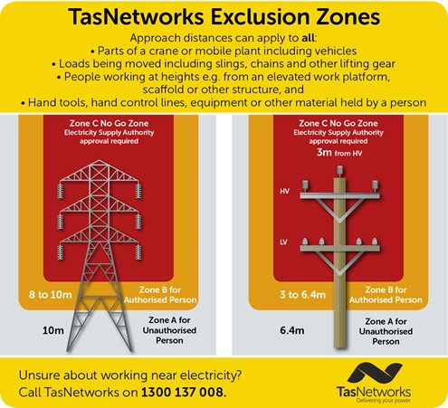
Figure 1
INSTRUCTED PERSONS ONLY CAN OPERATE IN ZONE B

Must HAVE S.A.D Training with TasNetworks

Zone B: Authorised Persons may work in Zone B. Authorised Persons are defined as:
- Those who have completed UETTDREL16 Working Safely Near Live Electrical Apparatus or UETDREL006 Working Safely Near Live Electrical Apparatus as a Non-Electrical Worker within the last 5 years, or
- Workers who, while working in the vicinity of overhead electric lines, are supervised by a person meeting the above training requirement
It is the responsibility of the employer to determine if a worker has the appropriate workplace competence, experience and qualifications to act as an Authorised Person in any zone. This includes holding UETDREL006 /UETTDREL16 at a minimum.

Figure 2
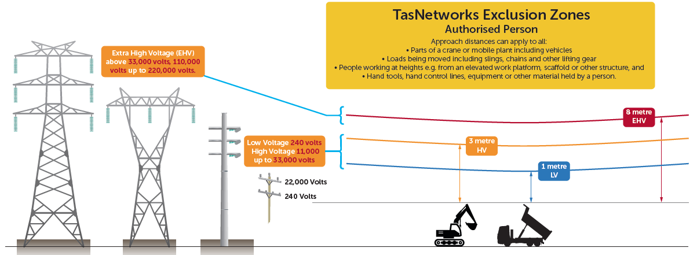
The clearances in Figure 2 is for Authorised persons only. Authorised persons are allowed to within 1 metre of positively identified low voltage conductors and telecommunications cables.

Digging around power poles
Some industries require you to work near our assets. There are rules that state how close you can work around our assets in order to maintain a safe distance, as well as training you may need to have.

What training do I need to work around power poles?
To work around power poles, you either need to have UETTDREL16 Working safely near live electrical apparatus or UETTDREL14 Working safely near live electrical apparatus as a non-electrical worker. or, when you’re working near power poles, be supervised by someone who's completed the relevant training

Working near power poles
- Follow our flow chart for information about working near power poles
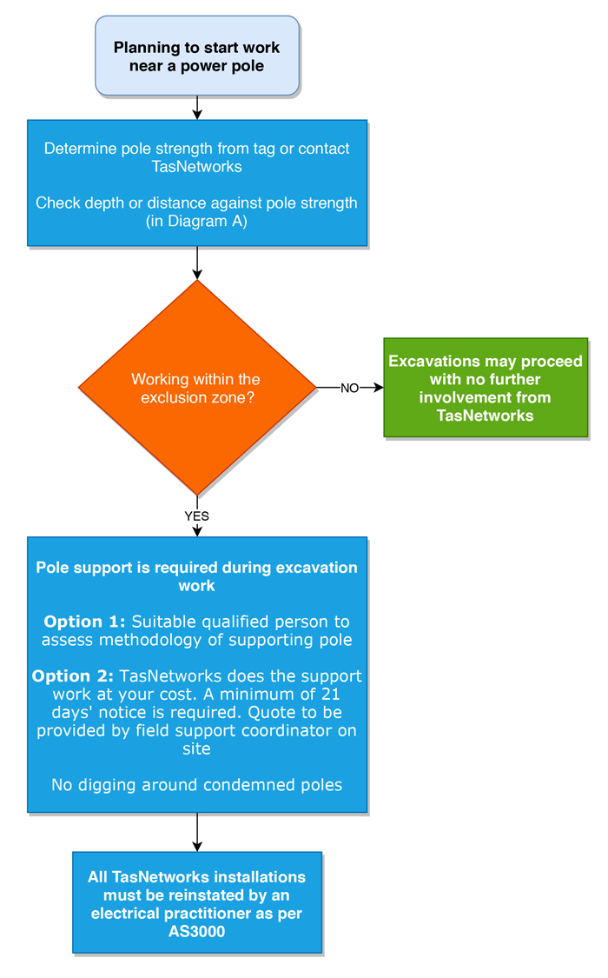

Diagram A Temporary excavation limits when working near power poles
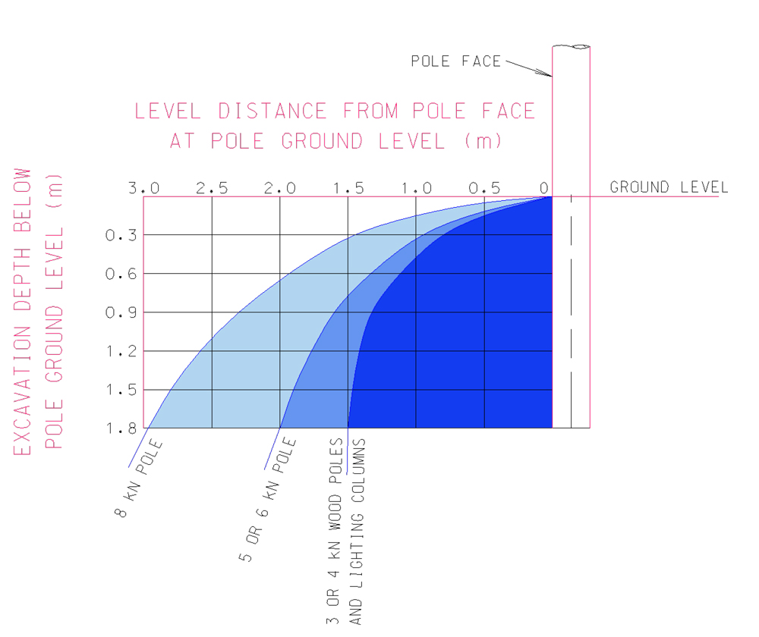

What to do if you contact overhead power lines

- If electrical arcing or flashover occurs, or if objects, plant, machinery, or equipment make contact with overhead power lines, you must call the electricity supplier immediately on

13 2004
- Until help is received, a competent person should remain in control of the situation to caution others of the danger of electrocution.
- You should assume that all power lines are live and are capable of delivering a fatal shock.
- Do not allow anyone to touch or approach any part of the plant or any fallen wires. Simply being too close can kill.
- The diagram below shows the typical affected area surrounding mobile plant when in contact with live overhead power lines.
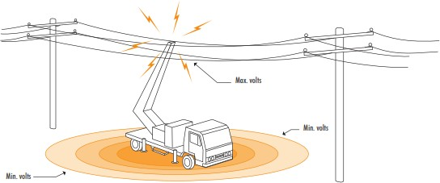
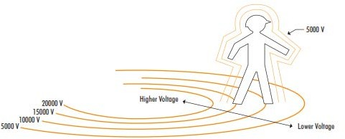

As shown in the diagram you should avoid simultaneous contact across areas of high potential difference.

Powerline Contact Emergency Procedure

Powerlines down – immediate actions
- Keep well clear (minimum 10 metres).
- Immediately notify the supply authority and emergency services.
- Use ‘lookouts’ to warn others at, or near the work site.
- Make sure the line is guarded until it is made safe.
- Quarantine rubber tyred vehicles for 24 hours.

NOTE: Operators should not attempt to jump clear of the machine because:

- Simultaneous contact with the machine and the ground will result in an energy transfer,
- An energy transfer to earth may even occur without a direct contact being made with the ground.
- Where immediate evacuation of the plant cabin is essential, as in the case of a fire, then and only then, operators should jump well clear of the machine. They must ensure that they do not make simultaneous contact with the machine and the ground, and then jump away from the machine keeping their legs together at all times. (Operators should be familiar with this technique and practice it regularly).

If rubber-tyred vehicles come into contact with high voltage lines there is a risk that tyres may explode many hours after the incident. This is caused by pyrolysis, which is a type of combustion that occurs inside the tyre. Contractors should seek advice from workplace safety experts if they think there may be a risk of this occurring.

