Procedure
Under Work Health and Safety Legislation, Paneltec Pty Ltd are required to identify the potential hazards of the proposed work, assess the risks involved, develop controls to eliminate or minimize the risk and monitor and review controls.

Definitions:
Hazard means a situation or thing that has the potential to harm a person. Hazards at work may include: noisy machinery, a moving forklift, chemicals, electricity, working at heights, a repetitive job, bullying and violence at the workplace.
Risk is the possibility that harm (death, injury or illness) might occur when exposed to a hazard.
Risk control means taking action to eliminate health and safety risks so far as is reasonably practicable, and if that is not possible, minimising the risks so far as is reasonably practicable.
Eliminating a hazard will also eliminate any risks associated with that hazard.

Four Step Process to Risk management
- Identify hazards – find out what could cause harm.
- Assess risks if necessary – understand the nature of the harm that could be caused by the hazard, how serious the harm could be and the likelihood of it happening
- Control risks – implement the most effective control measure that is reasonably practicable in the circumstances
- Review control measures to ensure they are working as planned.

The Risk Management Process
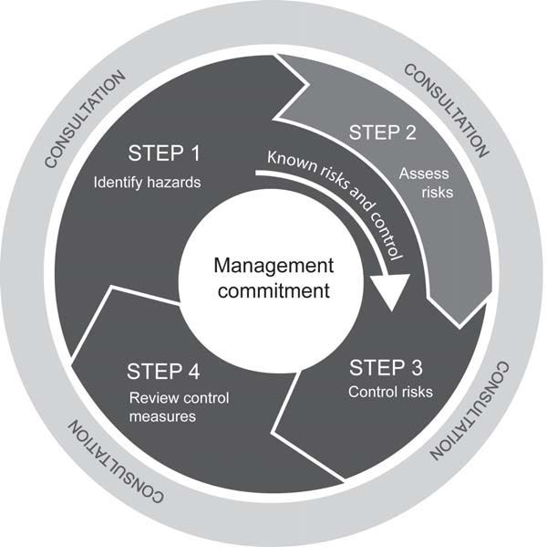

STEP 1 – HOW TO IDENTIFY HAZARDS
Identifying hazards in the workplace involves finding things and situations that could potentially cause harm to people. Hazards generally arise from the following aspects of work and their interaction:
- physical work environment;
- equipment, materials and substances used;
- work tasks and how they are performed work design and management.
The Table below lists some common types of workplace hazards. Some hazards are part of the work process, such as mechanical hazards, noise or toxic properties of substances. Other hazards result from equipment or machine failures and misuse, chemical spills and structural failures.
A piece of plant, substance or a work process may have many different hazards. Each of these hazards needs to be identified. For example, a production line may have dangerous moving parts, noise, hazards associated with manual tasks and psychological hazards due to the pace of work.

Examples of Common Hazards
Hazard | Potential harm
Manual tasks | Overexertion or repetitive movement can cause muscular strain.
Gravity | Falling objects, falls, slips and trips of people can cause fractures, bruises, lacerations, dislocations, concussion, permanent injuries or death
Electricity | Potential ignition source.  Exposure to live electrical wires can cause shock, burns or death from electrocution.
Machinery and equipment | Being hit by moving vehicles, or being caught by moving parts of machinery can cause fractures, bruises, lacerations, dislocations, permanent injuries or  death.
Hazardous chemicals | Chemicals (such as acids, hydrocarbons, heavy metals) and dusts (such as asbestos and silica) can cause respiratory illnesses, cancers or dermatitis.
Extreme temperatures | Heat can cause burns, heat stroke or fatigue.  Cold can cause hypothermia or frost bite.
Noise | Exposure to loud noise can cause permanent hearing damage.
Radiation | Ultra violet, welding arc flashes, micro waves and lasers can cause burns, cancer or blindness.
Biological | Micro-organisms can cause hepatitis, legionnaires’ disease, Q fever, HIV/AIDS or allergies.
Psychosocial hazards | Effects of work-related stress, bullying, violence and work-related fatigue.

  - How to find hazards
Regularly walking around the workplace and observing how things are done can help you predict what could or might go wrong. Look at how people actually work, how plant and equipment is used, what chemicals are around and what they are used for, what safe or unsafe work practices exist as well as the general state of housekeeping. Things to look out for include the following:
    - Does the work environment enable workers to carry out work without risks to health and safety (for example, space for unobstructed movement, adequate ventilation, lighting)?
    - How suitable are the tools and equipment for the task and how well are they maintained?
    - Have any changes occurred in the workplace which may affect health and safety?

As the majority of or activities are classed as High Risk Construction work as per the WH&S Regulation definition Chapter 6 Part 6.1-292 Management have determined that all activities of High Risk will require a Safe Work Method Statement and our SWMS list is our Hazard register.

Consult your workers
Ask your workers about any health and safety problems they have encountered in doing their work and any near misses or incidents that have not been reported.

Review available information
Information and advice about hazards and risks relevant to particular industries and types of work is available from regulators, industry associations, unions, technical specialists and safety consultants.
Analyse your records of health monitoring, workplace incidents, near misses, worker complaints, sick leave and the results of any inspections and investigations to identify hazards. If someone has been hurt doing a particular task, then a hazard exists that could hurt someone else. These incidents need to be investigated to find the hazard that caused the injury or illness.

STEP 2 – HOW TO ASSESS RISKS
A risk assessment involves considering what could happen if someone is exposed to a hazard and the likelihood of it happening. A risk assessment can help you determine:
    - how severe a risk is; whether any existing control measures are effective; what action you should take to control the risk and how urgently the action needs to be taken.
A risk assessment can be undertaken with varying degrees of detail depending on the type of hazards and the information, data and resources that you have available. It can be as simple as a discussion with your workers or involve specific risk analysis tools and techniques recommended by safety professionals.

All hazards have the potential to cause different types and severities of harm, ranging from minor discomfort to a serious injury or death.
Each of the outcomes involves a different type of harm with a range of severities, and each has a different likelihood of occurrence.

A Risk Class will be determined by referring to the categories below.
Level | Description of Consequence or Impact | Consequence | Likelihood / Probability
 |  |  | L  Likely | M  Moderate | U  Unlikely
H (1)  (High level of harm) | Potential death, permanent disability or major structural failure/damage. Off-site environmental discharge/release not contained and significant long-  term environmental harm. | H (1)  (High) | 1 | 1 | 2
M (2)  (Medium level of harm) | Potential temporary disability or minor structural failure/damage.  On-site environmental discharge/release contained, minor remediation required, short-term environmental  harm. | M (2)  (Medium) | 1 | 2 | 3
L (3)  (Low level of harm) | Incident that has the potential to cause persons to require first aid.  On-site environmental discharge/release immediately contained, minor level clean up with no short-term  environmental harm. | L (3)  (Low) | 2 | 3 | 3
Level | Likelihood / Probability
Likely | Could happen frequently
Moderate | Could happen occasionally
Unlikely | May occur only in exceptional circumstances

The Risk Class will be used to determine the level of Controls required to, eliminate or minimise a potential hazard. The higher the Risk Class the more extensive the controls to be provided.

STEP 3 – HOW TO CONTROL RISKS
The most important step in managing risks involves eliminating them so far as is reasonably practicable, or if that is not possible, minimising the risks so far as is reasonably practicable.
In deciding how to control risks you must consult your workers and their representatives who will be directly affected by this decision. Their experience will help you choose appropriate control measures and their involvement will increase the level of acceptance of any changes that may be needed to the way they do their job.

There are many ways to control risks. Some control measures are more effective than others. You must consider various control options and choose the control that most effectively eliminates the hazard or minimises the risk in the circumstances. This may involve a single control measure or a combination of different controls that together provide the highest level of protection that is reasonably practicable.

The hierarchy of risk control
The ways of controlling risks are ranked from the highest level of protection and reliability to the lowest as shown in below. This ranking is known as the hierarchy of risk control. The WHS Regulations require duty holders to work through this hierarchy when managing risk under the WHS Regulations.

For each risk identified the control measure will be decided by using the “Hierarchy of Risk Control”.
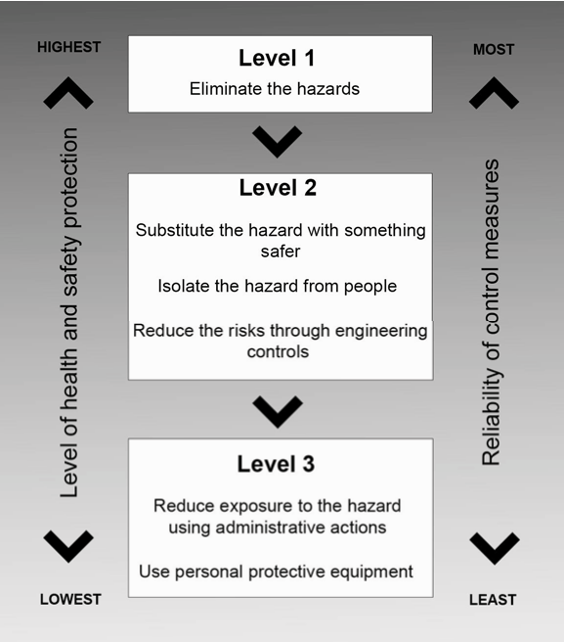

How to ensure that controls remain effective
The following actions may help you monitor the control measures you have implemented and ensure that they remain effective:
Accountability for health and safety – Accountability should be clearly allocated to ensure procedures are followed and maintained. Managers and supervisors should be provided with the authority and resources to implement and maintain control measures effectively.
Maintenance of plant and equipment – This will involve regular inspection and testing, repair or replacement of damaged or worn plant and equipment. It includes checking that any control measures are suitable for the nature and duration of work, are set up and used correctly.
Up-to-date training and competency – Control measures, particularly lower level controls, depend on all workers and supervisors having the appropriate competencies to do the job safely. Training should be provided to maintain competencies and to ensure new workers are capable of working safely.
Up-to-date hazard information – Information about hazards, such as plant and substances, may be updated by manufacturers and suppliers and should be checked to make sure controls are still relevant. New technology may provide more effective solutions than were previously available. Changes to operating conditions or the way activities are carried out may also mean that control measures need to be updated.
Regular review and consultation – Control measures are more effective where there is regular review of work procedures and consultation with your workers and their representatives.

STEP 4 – HOW TO REVIEW CONTROLS
The control measures that you put in place should be reviewed regularly to make sure they work as planned. Don’t wait until something goes wrong.
There are certain situations where you must review your control measures under the WHS Regulations and, if necessary, revise them. A review is required:
    - when the control measure is not effective in controlling the risk;
    - before a change at the workplace that is likely to give rise to a new or different health and safety risk that the control measure may not effectively control; if a new hazard or risk is identified;
    - if the results of consultation indicate that a review is necessary or if a health and safety representative requests a review.
You may use the same methods as in the initial hazard identification step to check controls. Consult your workers and their health and safety representatives and consider the following questions:
    - Are the control measures working effectively in both their design and operation?
    - Have the control measures introduced new problems?
    - Have all hazards been identified?
    - Have new work methods, new equipment or chemicals made the job safer?
    - Are safety procedures being followed?
    - Has instruction and training provided to workers on how to work safely been successful?
    - Are workers actively involved in identifying hazards and possible control measures? Are they openly raising health and safety concerns and reporting problems promptly?
    - Is the frequency and severity of health and safety incidents reducing over time?
    - If new legislation or new information becomes available, does it indicate current controls may no longer be the most effective?
If problems are found, go back through the risk management steps, review your information and make further decisions about risk control. Priority for review should be based on the seriousness of the risk. Control measures for serious risks should be reviewed more frequently.

PANELTEC PTY LTD’S HAZARD ASSESSMENT PROCESS IN BRIEF
- Identify Hazards
  - To help find all potential hazards, the jobs will be broken down into activities and associated job steps.
  - Potential hazards will be identified for each of the activities and job steps and documented on the Safe Work Method Statement (SWMS) forms.
Safe Work Method Statements are used as Risk Assessment tool and SWMS will be developed for use for all High Risk Work processes in consultation with workers.

As the majority of or activities are classed as High Risk Construction work as per the WH&S Regulation definition Chapter 6 Part 6.1-292 Management have determined that all activities of High Risk will require a Safe Work Method Statement and our SWMS list is our Hazard register.
Safe Work Procedures will be written to describe how to use specific equipment/tools. To assist this process, resources such as the following will be used:
  - AS/NZS 4360: Risk Management standard.
  - Worksafe Tasmania.
  - How To Manage Work Health And Safety Risks - Code of Practice 2012 and other publications;
  - Industry best practice;
  - Workplace experience; and
  - Consultation with workers experienced in the task to be undertaken.

Assess the Risks
  - For each potential workplace hazard the risks will be identified, a Risk Class will be determined by referring to the categories above.

Control the Risks
  - For each risk identified the control measure will be decided by using the “Hierarchy of Risk Control” and the above-mentioned resources.

Identify who is Responsible
  - The Safe Work Method Statement will document who is responsible for implementing the control measures.

Monitor and Review
  - Supervisor/Foreman will monitor works throughout the day and should a SWMS be found not adequate report this on an Action Report to the WHS&E Manager.
  - Completed Safe Work Method Statement forms should be reviewed and adjusted where required on an annual basis or when a work process changes.

Work Site Assessment and Implementation of Safe Work Method Statement
  - Before any works are carried out, any hazards associated with the job must be identified, assessed for risk and controlled as far as is practicable using the generic Safe Work Method Statements and the Site Specific Induction & Toolbox Meeting Record (refer to WHS-22).
  - Any additional hazards not identified on the generic SWMS shall be added to Site Specific Induction & Toolbox Meeting Record by the Supervisor/Foreman or contractor along with appropriate control measures.

  - Control measures shall be implemented prior to starting work and each team member shall be briefed on the SWMS before commencing work. Ensure team members know that work is to immediately stop if the SWMS is not being followed.
  - Prior to conducting any new high risk work process where a generic Safe Work Method Statement is not available the Supervisor/Foreman or contractor shall action a SWMS and implement controls in consultation with workers.

Record Keeping
  - Copies of Safe Work Method Statements and Safe Work Procedures and any associated paperwork shall be kept at the office and available to all workers for reference purposes.

Project Works
For specific projects the SF-48 Site Specific Risk Assessment and the SF-49 Site Specific Risk Register forms will be used to identify risks and document control measures to be implemented.

Health and Safety Co-Ordination Plan (HSCP)
A HSCP is required of the principle contractor by legislation for construction projects worth $250,000 or more. The purpose of the HSCP is to set out the arrangements for coordinating health and safety on a construction worksite where there may be many contractors and where the circumstances can change quickly from day to day.
  - HSCP can form part of a Project Management Plan.

PROCEDURE RECORDS
Number | Detail
SWMS/Hazard  Register | Refer to list of Safe Work Method Statements at the front of SWMS folder
SWP | Refer to list of Safe Work Procedures in the SWMS folder
Excel spread sheet | Skills Matrix
- | WHS Management plan developed as required or forms part of Project Management plan
SF-48 | Site Specific Risk Assessment
SF-49 | Site Specific Risk Register

➲ Reference: Code of Practice 2018 -How To Manage Work Health and Safety Risks

