The Guidelines When Working near TasNetworks Electrical Assets (NW30394588) referenced below set out the requirements for working near Overhead Power Lines. Also referenced is material from A Guide to Working Near Overhead Powerlines from WorkSafe Tasmania.

Precautions for working near overhead powerlines Be vigilant at all times
Check for the presence of overhead power lines. Always assume that overhead power lines are live. Always keep a safe distance from overhead power lines.
Make sure that every time your workplace is moved, you thoroughly check the distances between your workplace and the overhead power lines.

Conduct a risk assessment
A risk assessment needs to be carried out for all work where there is a risk of workers being exposed to electrical hazards — such as working near overhead power lines.
Work through the four SAFE steps — spot the hazard, assess the risk, fix the problem, and evaluate the results before you start any work. This will ensure all hazards are identified, and control measures are in place
to remove or reduce risks to an acceptable level.

The risk assessment can be noted on the Site-Specific Toolbox Meeting form.

Know your equipment
Know the exact height of your equipment, more specifically, the exact height when it is fully raised or extended.

Make sure you consider all possible situations, such as:
- any deflections of the structure of the plant or working conditions under movement
- the deflection of the boom of a crane under load
- the movement of any load being lifted
- the movement of the plant or the overhead power lines in windy and other extreme weather conditions
- the effect of unloading plant on uneven ground.

About TasNetworks
Tasmanian Networks Pty Ltd (ACN 167 357 299) (‘TasNetworks’) is the owner and operator of the regulated electricity network in Tasmania, with the exception of the Bass Strait Islands.

Who these guidelines apply to
These guidelines are TasNetworks’ minimum requirements for when work is to be performed near TasNetworks’ electricity network by third parties (persons not working for TasNetworks), such as:
- Councils;
- Contractors to third parties;
- Other Infrastructure Owners;
- Land owners where TasNetworks’ electrical assets cross their property; and
- Any other persons who work in the vicinity of TasNetworks’ electrical assets as or on behalf of a third party.
For simplicity, councils, contractors to third parties, other infrastructure owners and other third parties working near TasNetworks’ electrical assets are referred to as ‘Contractors’ in this document.

Working near overhead structures
TasNetworks’ electricity network uses many overhead structures, including poles, lighting columns and towers.
TasNetworks’ timber poles should have a pole identification tag attached to them. An example of a pole identification tag is shown in Figure 1. The last two numbers on the tag represent the length and strength rating of the pole.
If the tag is missing, then contact TasNetworks for advice before proceeding with any work.
When contacting TasNetworks it is important to provide the pole identification number which is a 6 digit number. An example of a pole identification number is shown in Figure 1A.

Pole length (here, 9 m)
Pole rating (here, 6
kN)

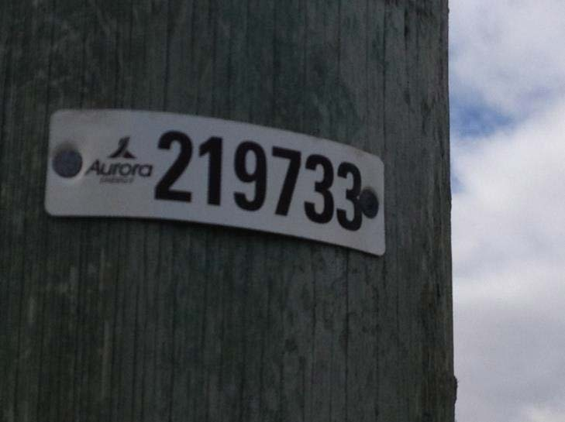
Figure 1: TasNetworks timber pole identification tag
Figure 1A: Pole identification number
Figure 2 shows acceptable excavation limits when working near TasNetworks’ poles and lighting columns.

Working near overhead power lines on poles
Contractors cannot work within 3 m each side of or above overhead power lines (known as the ‘No Go Zone’) unless they have notified TasNetworks by contacting 1300 137 008 at least 7 days in prior to the commencement of the works and received written authorisation for the work.
The notification must provide details of the proposed work and the location.
TasNetworks will provide a response as to whether the work can be undertaken and any requirements that must be adhered to when undertaking the work.
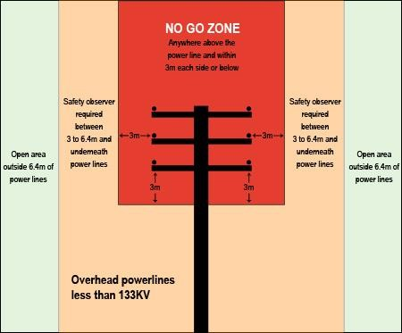
Without prior written authorisation from TasNetworks the Contractor is not authorised to undertake the proposed work. Failure to comply with this requirement can lead to prosecution under the Electrical Supply Industry Act.
Figure 3: Working near overhead power lines
If work is planned between 3.0 m and 6.4 m of overhead power lines or directly below overhead power lines Contractors must conduct a risk assessment and appoint a Safety Observer if required as an outcome of the risk assessment.
The Safety Observer must:
- Be a competent person and should have successfully completed a relevant training course carried out by a registered training organisation;
- Position themselves where they can have an unobstructed view of the work being performed and the potential hazards;
- Not do any other duties while performing their safety observer duties;
- Ensure they are able to communicate with the worker(s) during the process;
- Be aware of any hazards unique to the site, and make sure they are not at risk from them;
- Warn against unsafe approach to energised apparatus; and
- If required, stop work processes to prevent unsafe situations arising.

What to do if you contact overhead power lines
- If electrical arcing or flashover occurs, or if objects, plant, machinery or equipment make contact with overhead power lines, you must call the electricity supplier immediately on

13 2004
- Until help is received, a competent person should remain in control of the situation to caution others of the danger of electrocution.
- You should assume that all power lines are live and are capable of delivering a fatal shock.
- Do not allow anyone to touch or approach any part of the plant or any fallen wires. Simply being too close can kill.
- The diagram below shows the typical affected area surrounding mobile plant when in contact with live overhead power lines.
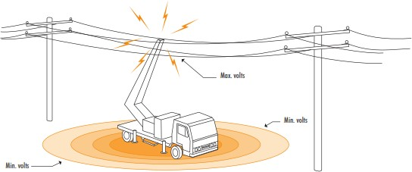

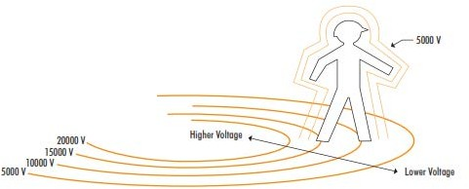
- As shown in the diagram below, you should avoid simultaneous contact across areas of high potential difference.

Emergency Procedure
Powerlines down – immediate actions
- Keep well clear (minimum 10 metres).
- Immediately notify the supply authority and emergency services.
- Use ‘lookouts’ to warn others at, or near the work site.
- Make sure the line is guarded until it is made safe.
- Quarantine rubber tyred vehicles for 24 hours.

NOTE: Operators should not attempt to jump clear of the machine because:
- Simultaneous contact with the machine and the ground will result in an energy transfer.
- An energy transfer to earth may even occur without a direct contact being made with the ground.
- Where immediate evacuation of the plant cabin is essential, as in the case of a fire, then and only then, operators should jump well clear of the machine. They must ensure that they do not make simultaneous contact with the machine and the ground, and then jump away from the machine keeping their legs together at all times. (Operators should be familiar with this technique and practice it regularly). Refer to Emergency A5 laminated card – Emergency Procedure Overhead Wires below.

If rubber-tyred vehicles come into contact with high voltage lines, there is a risk that tyres may explode many hours
after the incident. This is caused by pyrolysis, which is a type of combustion that occurs inside the tyre. Contractors
should seek advice from workplace safety experts if they think there may be a risk of this occurring.

