SAFE WORK METHOD STATEMENT
Persons responsible for supervising, inspecting work, work methods, plant &  equipment and tools | Team Leader (Supervisor)___________________________ | Date:
High Risk Construction Work: | Combination Vacuum Truck & CCTV Survey  TasWater Inspection Program | Asset  Numbers:
SWMS prepared Patrick Monaghan - Paneltec Group - Operations Manager and in consultation with management and workers – 2025.  SWMS Review Date: Aug 2026 unless required earlier Signature: |  | Project &  Location:
Approval to use this SWMS: “I certify that the attached SWMS has been reviewed by me, is endorsed for compliance with WorkSafe guidelines and is approved for use”
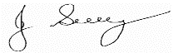
John Guy Director - Paneltec Pty Ltd 0408 449 023 31/08/2025 – V12.0
Name Position  Signature Date

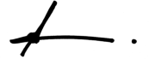
RISK MATRIX
Level | Description of Consequence or Impact | Consequence | Likelihood / Probability
 |  |  | L  Likely | M  Moderate | U  Unlikely
H (1)  (High level of  harm) | Potential death, permanent disability or major structural failure/damage. Off-site environmental discharge/release not contained and significant long-term environmental harm. | H (1)  (High) | 1 | 1 | 2
M (2)  (Medium level of  harm) | Potential temporary disability or minor structural failure/damage.  On-site environmental discharge/release contained, minor remediation required, short-term environmental harm. | M (2)  (Medium) | 1 | 2 | 3
L (3)  (Low level of harm) | Incident that has the potential to cause persons to require first aid.  On-site environmental discharge/release immediately contained, minor level clean up with no short-term environmental harm. | L (3)  (Low) | 2 | 3 | 3
Level | Likelihood / Probability
Likely | Could happen frequently
Moderate | Could happen occasionally
Unlikely | May occur only in exceptional circumstances

HIERARCHY OF RISK CONTROL
The hierarchy of controls must be applied in the order below for all identified hazards.

Level 1
Eliminate the hazard
Level 2
Substitute the hazard with something safer.
Level 3
Isolate the hazard from people. Reduce the risks through engineering
controls.
Level 4
Reduce exposure to the hazard using
administrative actions.
Level 5
Use personal protective equipment
The control measures that you put
in place should be reviewed regularly to make sure they work as planned

ACTIVITY ANALYSIS
Steps in Activity | Potential Hazards | Risk Class | Risk Control Measure | Responsible  Person/s | Residual  Risk Class
1.0 General Safety Requirements  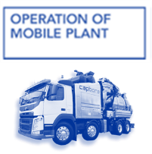  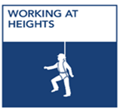 | Personal injury to operator and other workers.  TasWater  Permit Required | 1 | - All workers are to wear required PPE in accordance with TasWater Policy:  - Highly Visible Workwear – Long Pants & Shirt (Sleeves Down)  - Safety Boots  - Hard Hat – No caps underneath  - Safety Glasses - AS/NZS1337  - Prescription Safety Glasses (Where Applicable)  - Hearing Protection (Where Required)  - Face Shield in addition to Safety Glasses when cutting, grinding, using compressed air or high-pressure water jetting  - Construction Gloves Cut Factor >4 & Glove Clip  - If there is a need to climb on top of truck, PROJECT HOLD POINT  REFER: TasWater Supervisor for Working at Heights Permit & Rescue Plan.  - Once a permit is authorised and obtained work can proceed complying with the requirements outlined in the TasWater - Working at Heights Permit & Rescue Plan. | All  Supervisor  TasWater | 2
Steps in Activity | Potential Hazards | Risk Class | Risk Control Measure | Responsible  Person/s | Residual Risk Class
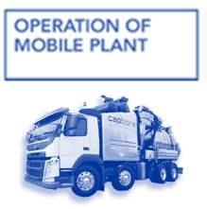  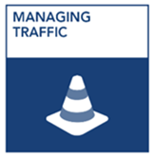  2.0 Set out work area. | Struck by Vehicle or construction plant. | 1 | - Barricade the work area, to prevent inadvertent access by public.  - Implement relevant Traffic Guidance Scheme (TGS) and ensure pedestrians have a designated, safe passage around the worksite.  - Ensure all operational flashing lights and reversing beepers on all plant are functional.  - Implement Traffic Guidance Scheme (TGS) and Traffic Management Plan (TMP)  NOTE: When working in higher risk areas additional traffic controllers may be required to implement more complex TGS’s – Consult Management immediately if the need is identified  Traffic Guidance Scheme Number:  (Please enter TGS Number) | Supervisor  Operator/Traffic Controller  Supervisor/Traffic Controller  Supervisor | 2
3.0 Operation- Combination Vacuum truck  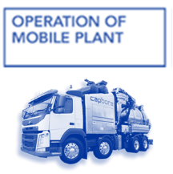 | Unsafe machine potential for injury to operator or  bystanders | 1 | - Pre-start checks are to be completed prior to operation and are to be submitted on our WHS monitor platform.  - All safety devices: emergency stops, reversing alarms, rotating flashing lights, communication device (radio), seat belts and fire extinguisher are effective and operational.  - Mobile plant operators hold the appropriate licenses and competencies for the plant they are required to operate.  - Mobile plant and vehicle operators always find a stationary position in a safe place prior to handling a mobile phone.  - Safety related deficiencies are resolved before equipment is put into operation.  - Mobile plant is always switched off and braking mechanisms are applied before being left unoccupied.  - TasWater customers made aware for potential of blowbacks through community correspondence prior to site arrival | Operators | 2
Steps in Activity | Potential Hazards | Risk Class | Risk Control Measure | Responsible  Person/s | Residual Risk Class
4.0  Electrical Hazards       | Electrocution  (Crossbore)  TasWater  Permit Required | 1 | - Conduct visual inspection for signs of underground electrical infrastructure in the project area. Visual Indicators include, but may not be limited to:  - ELECTRICAL: Green electrical turrets, armored black wire (XLPE) heading underground from power poles, buried cable signs), orange conduit coming up from the ground  - Conduct a visual inspection for overhead electrical infrastructure:  If personnel are authorised persons (Having completed UETTDREL14 Working safely Near Live Electrical Apparatus as a non-electrical worker) within the last 5 years, the following or the workers working in the vicinity of overhead electric lines are supervised by a person meeting the above training requirements can work within the following limits of approach:  • 1 m of positively identified low voltage conductors 240 V  and telecommunications cables.  • 3m from High Voltage power lines 11KV to 33 KV  • 8 m from Extra High Voltage 110 KV to 220KV  NOTE: Unauthorised persons are to maintain approach distances of 6.4m from LV & HV. From EHV the clearance is 10M  If the distance between the vehicle/boom/cassette or operating implement and encroach on the clearances above.  PROJECT HOLD POINT REFER: Work Near Overhead Power Lines– TasWater and contact TasWater Representative. Who will issue the TasWater permit, Working Near Over Head Powerlines.  - Ensure a spotter is always in place when maneuvering vehicle/boom/cassette or operating implement around the overhead electrical safety envelope. Spotter is to be authorised/trained.  - If gas or electrical indicators are known, conduct BYDA enquiry and review Tas Gas Networks & TasNetworks Before You Dig Australia  - All CCTV Operators and Combination Vacuum Truck Operators are to remain vigilant when conducting surveys or root cutting in areas where underground electrical distribution infrastructure is present. Services or Mains may have been drilled through the infrastructure being cleaned or inspected creating a crossbore hazard.  - If a blockage in the drain is prevalent first attempt to clear the blockage with a non-destructive jetting head (i.e. Penetrator) if the blockage fails to clear, refer to DBYD’s for potential Electrical main/service alignments that may compromise the drain  - If there is evidence of underground power or natural gas in the area of a blockage on the program refer to Management  PROJECT HOLD POINT management may facilitate underground asset locations or a CCTV survey on the perceived blockage prior to moving forward  - Ensure our Emergency Procedures are available for reference in the event of an emergency also ensure the projects Emergency Response Plan (ERP) is available for reference. | Supervisor All  Supervisor All  Supervisor All  Supervisor All  Supervisor All  TasWater  Supervisor  Operators  Supervisor  All | 2
6.0 Opening  manholes/pits | Manual handling  Open manholes/pits | 1 | - Refer to Paneltec SWP-30 Opening Manholes – Safe Handling  - Install Barriers/Man Hole Guard to remove Live Edge/Fall Zone | Operators | 2
Steps in Activity | Potential Hazards | Risk Class | Risk Control Measure | Responsible  Person/s | Residual Risk Class
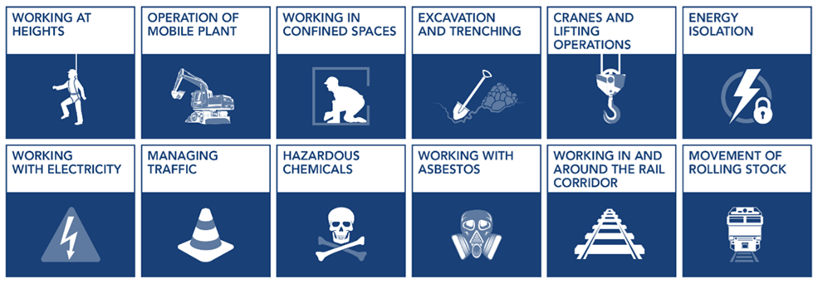 | Risk of Fall – Working at Heights  TasWater  Permit Required | 1 | - In all instances where the placement of Manhole Guards/Barricades can not be facilitated to remove the live edge/fall zone the following shall apply:  - PROJECT HOLD POINT REFER: TasWater Supervisor for Working at Heights Permit & Rescue Plan.  - Once a permit is authorised and obtained work can proceed complying with the requirements of the Working at Heights Permit & Rescue Plan. | Operators  Supervisor | 2
7.0 Confined Space Entry  (If required - Permit Entry Only*)  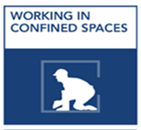 | Low Oxygen,  Hazardous Gases, Biological Hazards,  Engulfment  Slips, Trips and Falls  TasWater  Permit Required |  | - Entry to a confined space is not envisioned to be a regular occurrence throughout the program, however, entry may be required during the program for the following reasons:  - Jetting Head Deployment  - Jetting Head Retrieval  - Camera Deployment  - Camera Retrieval  - Entry to the confined space shall only take place after a Confined Space Entry Permit and Rescue Plan has been obtained from the TasWater Supervisor PROJECT HOLD POINT  - Once a permit is authorised and obtained, entry to the confined space shall only be undertaken by accredited trained personnel complying with the requirements of the Confined Space Entry Permit and Rescue Plan wearing the following PPE:  - Highly Visible Workwear – Long Pants & Shirt (Sleeves Down)  - Safety Gum Boots  - Hard Hat – No caps underneath  - Safety Glasses - AS/NZS1337  - Hearing Protection (Where Required)  - P2 Respirator/Face Shield  - Disposable Coveralls  - Construction Gloves Cut Factor >4 & Glove Clip | Supervisor  TasWater  Operators
Steps in Activity | Potential Hazards | Risk Class | - Risk Control Measure | Responsible | Residual Risk Class
8.0 Operating the Combination vacuum truck  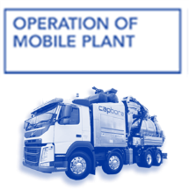 | Injury to operator or bystanders – high pressure- dirt and stones can be flicked around. | 1 | - All workers are to wear required PPE in accordance with TasWater Policy:  - Highly Visible Workwear – Long Pants & Shirt  (Sleeves Down)  - Safety Boots  - Hard Hat – No caps underneath  - Safety Glasses - AS/NZS1337  - Hearing Protection (Where Required)  - Face Shield in addition to Safety Glasses when cutting, grinding, using compressed air or high-pressure water jetting  - Construction Gloves Cut Factor >4 & Glove Clip  - Keep operating area clear of public access  - Stay alert and beware of the force of the water pressure coming out the end of the hose and when using the vacuum hose be aware of the suction pressure.  - Do not overreach or stand on unstable supports.  - Never aim the jet in the direction of persons or animals as the water jet comes out of the nozzle at high speed with high pressure.  - Do not leave the operating vacuum unattended. If the vacuum is not required switch off.  - Follow directions as per the operations manual.  - When cleaning pipes etc. the hose must first be in the pipe prior  to activating the control. | Supervisor  Operator All  Operators | 2
9.0 Unloading & Positioning & Using Motorised  Easement Hose Reel   | Injury to operator or bystanders – crush injury, high pressure- dirt and stones can be flicked around. | 1 | - Perform daily pre-start on the hose reel  - Always Unload and Load the Easement Reel on level ground, with the trailer attached to the tow vehicle using the ramps fitted to the trailer, Chock the trailer tyres.  - Always operate the Easement Reel according to the operating instructions  - Avoid turning the reel on slopes. If you must turn, turn slowly.  - Water pressure should not exceed NP, outlined in the instruction manual.  - Never place any part of your body in front of or near the high-pressure water jets  - Position the Easement Reel so the hose reel is Centre of pit opening to the directly opposite side of planned pipe entry for the sewer hose.  - Ensure there is adequate space to avoid sharp angles in the hose feed to pipe opening.  - Always endeavor to position Easement Reel as level as possible. Adjust track width to suit terrain  - Connect truck and jetting hose to reel and tighten with shifters to ensure a leak free connection.  - Select your required nozzle and fix to the sewer hose. (Refer Nozzle Performance  - Operate hose and leader in accordance with your Type B water Jetting Training | Operators  Operators | 2
  10.0 Flushing and or vacuuming pits and pipes | Striking pedestrians, members of the public or other workers  Spraying debris causing injury  Spraying debris causing  property damage | 1 | - All workers are to wear required PPE in accordance with TasWater Policy:  - Highly Visible Workwear – Long Pants & Shirt  (Sleeves Down)  - Safety Boots  - Hard Hat – No caps underneath  - Safety Glasses - AS/NZS1337  - Hearing Protection (Where Required)  - Face Shield in addition to Safety Glasses when cutting, grinding, using compressed air or high-pressure water jetting  - Construction Gloves Cut Factor >4 & Glove Clip  - Ensure appropriate work area is cordoned off to prevent access by the public.  - Observe the hose as it is being fed into pipe or pit.  Watch reel to ensure hose winds off correctly. | Supervisor  Operator  Supervisor | 2
 | Whipping hoses | 1 | - Ensure minimal slack in hose to prevent whipping.  - Before hose leaves pit ensure the water is shut off.  - Stand clear of hose when it is exiting pit or pipe as debris may be sprayed out.  - Only uncover pits required for access as pit covers will prevent uncontrolled water or debris spray.  5. Ensure minimal slack in hose to prevent whipping.  6. Before hose leaves pit ensure the water is shut off.  7. Stand clear of hose when it is exiting pit or pipe as debris may be sprayed out.  8. Only uncover pits required for access as pit covers will prevent uncontrolled water or debris spray.  9. Never point pressure spray at any person. | Operators | 2
11.0 Use of Hydro Powered Root Cutter | Hand injury  Bodily injury from cutting blade | 1 | - Ensure Crossbore checks have been conducted (See 4.0 Above)  - Use appropriate nozzle for first run of cleaning  - If obstruction doesn’t clear and roots are evident in water then cutting head can be prepared.  - Wear gloves when handling cutting blade.  - Do not operate cutter until safely positioned inside the drain.  - Maintain a grip on jetting hose to feel the reaction force of  cutter. | Operators | 2
12.0 Hose blockage | Entrapped hand, Manual handling | 2 | - Ensure vacuum is isolated prior to unblocking.  - Keep hands clear of hose.  - Use two operators when handling hose when clearing  blockages. | Operators | 3

ADDITIONAL HAZARDS IDENTIFIED | CONTROL MEASURES FOR RISK MITIGATION

FURTHER ON SITE SCENARIOS | DOCUMENTS FOR PROJECT REFERENCE | TASWATER DOCUMENT REFERENCE NUMBER
Emergencies - Gas Strike , Electrical Etc. | TasWater Emergency Response Plan | TBA
Community Relations, Complaints Etc. | TasWater Community & Stakeholder Plan | TBA
Environmental Controls, Incidents Etc. | TasWater Site Environmental Plan | TBA
Pre-Start | TasWater Pre-Start Safety Action Plan | TBA
Pre-Start | TasWater U-Take 5 | TBA

Personal Protective Equipment
All site personnel must wear the required PPE specified in the controls above, such as:
Safety Highly Visible  Vests/Workwear | Safety Boots | Sunscreen | Sun ring for Hard Hat (UV) | Sunglasses (Approved Safety) | Gloves specific to the task | White reflective overalls
Hard Hat at all Times | Safety Glasses | Hearing protection  where required | Long Sleeves and Pants | Dust masks | Respiratory Helmets if and  when required | Face Shield when using jetting hose

Workers may require Task Specific Training depending on activity each worker will be required to fulfill.
- All workers shall hold a current Construction Induction Card
- TasWater & TasWater Induction  - Activity Induction (SWMS & SWP’s)  - Site specific requirements (external) | - Vehicle License’s (Car or Truck depending on class of vehicle or mobile  plant driven) | - Plant Operators license’s or competency assessments where  required | - Competencies for Work Zone Traffic Management
- First Aid certificate training | - Manual Handling | - Fire Extinguisher training | - Fatigue Management Compliance

Legislation & Codes of Practice (refer to company Legislation register for applicable Australian Standards applicable to works)
Work Health & Safety Act 2012 and Work Health & Safety Regulations 2022
Codes of Practice and Other Guides
Confined Spaces - 2020 | Hazardous Manual Tasks - 2018 | Managing Noise & Preventing Hearing Loss at Work-2018 | Managing Risks of Plant in the Workplace - 2020
Construction Work - 2020 | How to Manage WH&S Risks - 2018 | Managing Risk of Falls at Workplaces - 2020 | Managing Electrical Risks in the Workplace -2020
Excavation Work - 2020 | First Aid in the Workplace - 2018 | Managing Work Environment & Facilities - 2018 | WHS Consultation Co-operation & Co-ordination - 2018
Welding Processes - 2018 | How to Safely Remove Asbestos - 2018 | Managing Risk of Hazardous Chemicals - 2018 | Safe Design of Structures - 2018
Guide for Managing Risks from High Pressure Water Jetting – Safe Work Aust 2020

Plant & Equipment for this activity
- All plant is inspected prior to sending out to site
- Daily pre-start checks are conducted on all plant and trucks by the operators and daily checklist filled out.
- All maintenance issues addressed prior to departure.
- Regular servicing as per manufactures specifications. Service History available on request to the office.

List of plant for this Activity
Combination Vacuum Recycler Truck
Engineering details/certificates/regulatory approvals/permits/electrical isolation (if applicable):

Implementation, Monitoring and Review of SWMS
The Supervisor on site has the responsibility to:
- Brief each team member on this SWMS before commencing work.
- Ensure control measures have been implemented prior to the start of works.
- Observe work being carried out.
- If controls documented in SWMS are not adequate, stop the work, review the SWMS, adjust as required and re-brief the team.
- Ensure team knows that work is to immediately stop if the SWMS is not being followed.
- Retain this SWMS on site for the duration of the high-risk construction work.
- All persons involved in these particular tasks on site must sign this document as read and understood.
SWMS attendance sheet — I have been given the opportunity to provide input into the development and review of this SWMS
Name (please print clearly) | Signature | Company | Date
Daily pre-start meetings will be held to ensure all workers are informed of control measures and additional safety hazards & controls to be noted on toolbox form.

