SAFE WORK METHOD STATEMENT
Persons responsible for supervising, inspecting work, work methods, plant &  equipment and tools | Supervisor/Foreman: | Date:
High Risk Construction Work: | REMOVAL OF ASBESTOS PIPE | Project:
SWMS prepared by Patrick Monaghan - Paneltec Group - Operations Manager and in consultation with management and workers – 2025.  SWMS Review Date: August 2026 unless required earlier Signature: |  | Location:
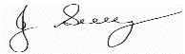
Approval to use this SWMS: “I certify that the attached SWMS has been reviewed by me, is endorsed for compliance with WorkSafe guidelines and is approved for use”

John Guy Director ‐ Paneltec Pty Ltd 0408 449 023 31/08/2025 – V12.0
Name Position  Signature Date


RISK MATRIX

Level | Description of Consequence or Impact | Consequence | Likelihood / Probability |  |  | HIERARCHY OF RISK CONTROL  The hierarchy of controls must be applied in the order below for all identified hazards.
L M U
Likely Moderate Unlikely
Level 1
Eliminate the hazard
H (1)  (High  level of harm) | Potential death, permanent disability or major structural failure/damage. Off-site environmental discharge/release not contained and significant long-term environmental harm. | H (1)  (High) | 1 | 1 | 2
Level 2
Substitute the hazard with something safer.
M (2)  (Medium  level of harm) | Potential temporary disability or minor structural failure/damage.  On-site environmental discharge/release contained, minor remediation required, short-term environmental harm. | M (2)  (Medium) | 1 | 2 | 3
Level 3
Isolate the hazard from people. Reduce the risks through engineering controls.
L (3)  (Low level of harm) | Incident that has the potential to cause persons to require first aid.  On-site environmental discharge/release immediately contained, minor level clean up with no short-term environmental harm. | L (3)  (Low) | 2 | 3 | 3
Level 4
Reduce exposure to the hazard using administrative actions.
Level Likelihood / Probability |  |  |  |  |  |  | Level 5  Use personal protective equipment
Likely | Could happen frequently
The control measures that you put
in place should be reviewed regularly to make sure they work as planned
Moderate | Could happen occasionally
Unlikely | May occur only in exceptional circumstances

ACTIVITY ANALYSIS

Steps in Activity | Potential Hazards | Risk  Class | Risk Control Measure | Responsible  Person/s | Risk Class After  Controls In Place
Planning  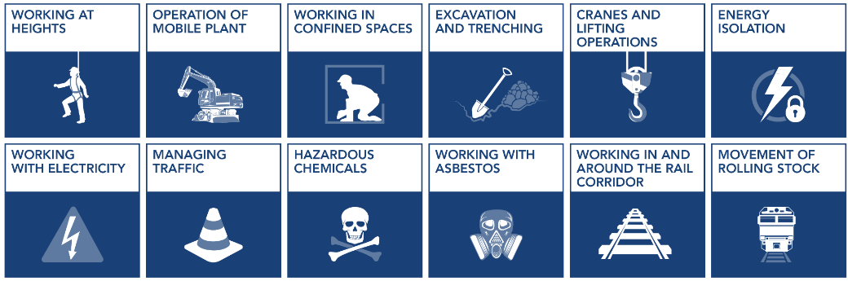 | Hazard: Inadequate planning  Risk: Unsafe work site | 1 | Workers must ensure all tools and equipment outlined in Safe Operating Procedure for Cutting of Asbestos Cement Pipes with Reciprocating Saw are on hand  Workers must ensure all personnel undertaking the AC repair are trained in CPCCDE3014A Remove non-friable asbestos (under 10sqm) | Asbestos  Removalist | 2
Arrival at worksite, site assessment   | Inadequate planning Unsafe work site | 1 | - Determine if the pipe or material the subject of work is ACM using the Asbestos register, where necessary.  ** Where there is doubt, the pipe or material must be treated as ACM***  - Calculate the area of AC pipe to be removed, using the table in the Safe Work Procedure 33 for Cutting of Asbestos Cement Pipework. Ensure saws are on hand. If greater than 10m2 a licensed contractor MUST complete the task. If under 10m2 only trained and competent persons to remove the asbestos containing material.  - Place signs alerting to the presence of asbestos.  - Erect barricades to delineate the asbestos removal area  - PPE (minimum): As soon as you are ready to handle, or work on, the pipe or material:  - Class P2 disposable respirator (class P3> can be used),  - Safety glasses  - Disposable overalls,  - Safety gumboots.  - Heavy-duty disposable gloves.  - Wash your face and hands before each work break.  - Do not consume any food or drink near exposed asbestos. | Asbestos  Removalist | 2
Cutting of Asbestos Pipe   | Dust Generation Asbestos Exposure  Asbestosis | 1 | - Lay large piece of geofabric underneath section of pipe to contain fibers and dust  - Perform positive fit check on personal respiratory protection  - Continuously dampen the pipe with surfactant (PVA 9:1 solution) prior to and during cutting process until completion  - Cut AC pipe with a reciprocating saw, chain cutters or handsaw  - The cut section of AC pipe shall be wrapped in the geofabric located underneath the pipe, by wrapping the fabric edges in on itself, ensuring all AC particles remain contained  - Ensure safe manual handling techniques are used when lifting the cut section of pipe from the trench  - Place wrapped pipe section in an asbestos waste bag  - Make sure the bag is no more than half filled and remove excess air to reduce the risk of handlers inhaling dust.  - Once you’ve filled the bag, twist the top of it tightly and fold the neck over in a gooseneck twist.  - Seal the bag with duct tape to fully enclose the ACM inside.  - Place the first bag into the second bag and repeat the sealing procedure  - Place the first bag into the second bag and repeat the sealing procedure.  - If bag size is inadequate for the length of cut pipe, triple wrap the section of pipe in 10-micron foricon plastic, seal with duct tape and tape asbestos waste bag to each end of wrapped pipe  - NOTE: No fragments of AC pipe material is to be left buried in the ground. | Asbestos  Removalist | 2
Steps in Activity | Potential Hazards | Risk  Class | Risk Control Measure | Responsible  Person/s | Risk Class After  Controls In Place
Decontamination of tools, equipment and PPE   | Exposure to Hazardous material  Asbestos Exposure  Public Health  Environmental | 1 | Ensure PPE is worn for this process  - All tools and equipment must be fully dismantled and cleaned (wiped down) using the industrial wet wipes  Using 1 surface of the wet wipe; refolded to expose a clean surface with each wipe to prevent recontamination  - All decontaminated tools and equipment must be stored in a sealable container (or double asbestos waste bags) with GHS Danger Asbestos label  - Exterior of storage container must be decontaminated using wet wipes and storage container placed outside of the contaminated work area  Decontaminate and remove PPE as outlined in Safe Operating Procedure for Cutting of Asbestos Cement Pipework | Asbestos  Removalist | 2
5.Disposal of asbestos containing waste   | Exposure to Hazardous material  Asbestos exposure  Dust Generation  Public Health  Environmental | 1 | All double wrapped asbestos waste shall be securely and safely loaded onto an EPA approved Paneltec vehicle and transported directly from the worksite to be disposed of in an asbestos waste bin. | Asbestos  Removalist | 2

Personal Protective Equipment
All site personnel must wear the required PPE specified in the controls above, such as:
Safety Hi‐vis  Vests/Shirts | Safety Boots | Sunscreen |  |  | Gloves specific to the task | White reflective overalls/night
Hard Hat & Sun Ring | Safety Glasses | Hearing protection  where required | Long clothing | Dust masks | Respiratory equipment (P2 Mask) | Disposable Overalls – Hood On

Workers may require Task Specific Training depending on activity each worker will be required to fulfill.
- All workers shall hold a current Construction Induction Card
- If required Client Site Induction  - Activity Induction (SWMS & SWP’s) | - Vehicle Licenses (Car or Truck depending on class of vehicle or mobile plant driven) | - Plant Operators licences or competency assessments where required | - Competencies for Work Zone Traffic Management
- First Aid certificate training | - Manual Handling training | - Fire Extinguisher training | - Fatigue Management Training

A Site Specific Induction & Toolbox Meeting will be held each day prior to the start of each job.

Legislation & Codes of Practice (refer to company Legislation register for applicable Australian Standards applicable to works)
Work Health & Safety Act 2012 and Work Health & Safety Regulations 2022
Codes of Practice
Confined Spaces ‐ 2020 | Hazardous Manual Tasks ‐ 2020 | Managing Noise & Preventing Hearing Loss at Work‐  2020 | Managing Risks of Plant in the Workplace ‐ 2018
Construction Work ‐  2020 | How to Manage WH&S Risks ‐ 2018 | Managing Risk of Falls at Workplaces ‐ 2020 | Managing Electrical Risks in the Workplace ‐2019
Excavation Work ‐ 2020 | First Aid in the Workplace ‐ 2018 | Managing Work Environment & Facilities ‐ 2020 | WHS Consultation Co‐operation & Co‐ordination ‐  2018
Welding Processes ‐  2021 | How to Safely Remove Asbestos ‐  2020 | Managing Risk of Hazardous Chemicals ‐ 2018 | How to Safely Remove Asbestos ‐ 2018
Plant & Equipment for this activity
- All plant is inspected prior to sending out to site
- Daily maintenance & service checks.
- Daily pre‐start checks are conducted on all plant and trucks by the operators and daily checklist filled out.
- Regular servicing at 250hr intervals or as per manufactures specifications. Service History available on request to the office.

WORK ACTIVITY BRIEFING

Implementation, Monitoring and Review of SWMS
The Supervisor on site has the responsibility to:
- Brief each team member on this SWMS before commencing work.
- Ensure control measures have been implemented prior to the start of works.
- Observe work being carried out.
- If controls documented in SWMS are not adequate, stop the work, review the SWMS, adjust as required and re‐brief the team.
- Ensure team knows that work is to immediately stop if the SWMS is not being followed.
- Retain this SWMS on site for the duration of the high‐risk construction work.
- All persons involved in these particular tasks on site must sign this document as read and understood.
SWMS attendance sheet — I have been given the opportunity to provide input into the development and review of this SWMS
Name (please print clearly) | Signature | Company | Date
Daily pre‐start meetings will be held to ensure all workers are informed of control measures and additional safety hazards & controls to be noted on toolbox form.

