Revision No: 010 Revision Date: 31/08/2025
Document No: IMS-04 CONTEXT OF THE ORGANISATION

UNDERSTANDING THE ORGANISATION AND ITS CONTEXT
Paneltec Pty Ltd (Paneltec) is a leading infrastructure repair and construction company providing expedited, quality services to Tasmania’s leading infrastructure and underground asset owners. Paneltec are acclaimed for their ability to facilitate safe and effective methods of rapid, non-destructive excavation techniques for the strategic construction and repair of natural gas, water and communication systems and or networks.

Paneltec takes pride in their operational response to unforeseeable emergency situations encountered by the States Infrastructure and Asset owners. Paneltec is also equipped with a large traffic management division, Viatec Traffic Solutions which allows the company to further facilitate the tactical delivery of the highest echelons in quality, safety and compliance for the primary contractors they value and support.

The factors which influence Paneltec’s purpose, Objectives and sustainability including Internal & External Factors and Interested Parties consist of;

    - Paneltec’s Director and Executive Management Team
    - Infrastructure Budget Allocation (Private Entities, Local, State and Federal Governments)
    - A review of Paneltec’s measurable objectives occurs annually for most requirements and six monthly with a selected few. This is undertaken by the Management team at the monthly managers meeting, this is documented within the meeting minutes and within the IMS Objectives & Targets Register (see 4.1.1 below)
    - Customers include TasWater, Tas Gas Networks, Tandem (Telstra), Cranes Combined, Shaw Contracting and Local Councils
    - Spending by TasWater on infrastructure repairs and construction
    - The continued roll out of the Tasmanian Natural Gas Distribution Network(s)

4.1.1 COMPLIANCE
Paneltec ensures compliance and harmonisation with ISO45001, ISO 9001 & ISO 14001 by measuring, blending and assigning appropriate compliance requirements to members of the management team.

The Paneltec Integrated Management System (IMS) Objectives and Targets Register has been established to assist in the measurement of the performance and efficiency of the IMS against planned compliance outcomes. The Objectives and Targets detailed in the Register are directly associated with the company’s core business activities and the related services provided by Paneltec. The Paneltec Managing Director shall be responsible for communicating information and responsibilities/ accountabilities relating to the company’s IMS objectives and targets to relevant personnel and third parties in line with the Paneltec Communication Policy. The Managing Director in consultation with senior personnel shall review and update, where required, IMS Objectives and Targets at least six monthly as part of the Management Review process. A copy of this register can be found at IMS-04-01.

UNDERSTANDING THE NEEDS AND EXPECTATIONS OF INTERESTED PARTIES
The Concept of Interested Parties extends beyond a focus solely on Paneltec’s Customer/Clients. The Director and Executive Management consider all Interested Parties to include:
- Paneltec Pty Ltd – Performance, Profitability, Compliant Platform, Environmental & Safety
- Paneltec’s executive management team
- Customers include TasWater, TasWater CDO, Tas Gas Networks, Tandem (Telstra), Lend Lease, Cranes Combined, Shaw Contracting and Local Tasmanian Councils- (Compliance)- Tendering & Quoting
- Regulatory Groups such as WorkSafe Tasmania
- The Civil Contractors Federation Tasmania (CCF)
- The Traffic Management Association of Australia (TMAA) – Compliance, Monitoring & Review eg agenda item at Monthly Management Meetings.

Revision No: 009 Revision Date: 31/08/2024
Document No: IMS-04 CONTEXT OF THE ORGANISATION

DETERMINING THE SCOPE OF THE QUALITY MANAGEMENT SYSTEM
Management have defined the boundaries of QMS Certification to the Paneltec depot, located at 19 Connector Park Drive, Kings Meadows TAS, 7250 and all associated work/construction sites that require attendance in our day to day duties.
The scope encompasses the following products and or services; Non-destructive (Vacuum) excavation, mechanical excavation, civil works, the repair, construction and installation of natural gas, water and communication infrastructure, traffic management, asphalting and all associated business management, administration and system compliance.

QUALITY MANAGEMENT SYSTEM AND ITS PROCESSES

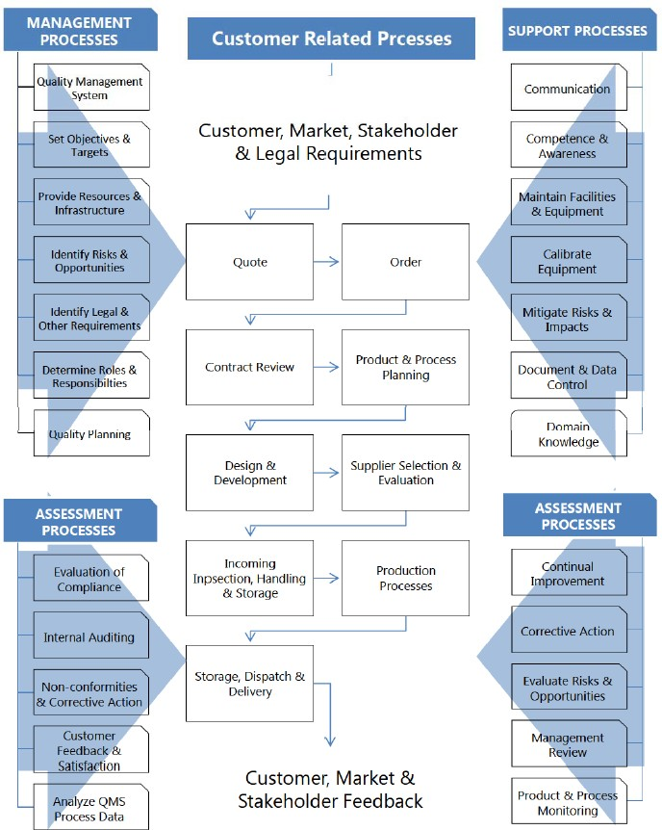

Revision No: 010 Revision Date: 31/08/2025
Document No: IMS-04 CONTEXT OF THE ORGANISATION

INTEGRATED MANAGEMENT SYSTEM MODEL
The system comprises:
- This Integrated Management System Manual
- System Procedures Manual – WH&S and Environmental Management Procedures & Forms






- Operating Procedures Manual – SWMS, SWP’s & Plant Hazard Assessments
OH&S Management ISO 45001:2018
Quality Management AS/NZS ISO 9001:2016
Environmental Management AS/NZS ISO 14001:2016






IMS (Quality) Procedures
- IMS-01 to IMS-09
INTEGRATED MANAGEMENT SYSTEM
MANUAL

System Procedures Manual







Operating Procedures Manual
System Procedures
Work Health & Safety Procedures
- WH&S-01 … Environmental Management Procedures
- EM-01 …
System Forms
- SF-01 ...

Safe Work Method Statements
- SWMS-01 ...
Safe Work Procedures
- SWP-01...
Plant Hazard Assessments - PR-01 Project Management Plans Inspection & Test Plans

