**Ministerul Educaţiei al Republicii Moldova**

**Universitatea Tehnică a Moldovei**

**Facultatea Calculatoare, Informatică şi Microelectronică**

**Raport**

Lucrare de laborator **№1**

Disciplina: Programarea in Retea

A îndeplinit: st.gr.FI-161 Panfil Nicolae

A controlat: Gavrilita Mihai

Chișinău 2019

**Laboratorul NR.1**

* Am creat un directoriu local de lucru in care se va afla fisierul de versionat *utilizind comanda mkdir pentru crearea directorului in linia de comanda a terminalului, iar navigarea prin: cd local-repo.*
* [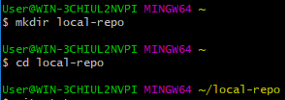](https://user-images.githubusercontent.com/43058513/52538156-d2a68f80-2d77-11e9-85f7-59a08c779e9f.PNG)
* Am initializat repozitorul GIT in acest director prin *git init* [2](https://user-images.githubusercontent.com/43058513/52538183-3a5cda80-2d78-11e9-9e48-1e64a2bfb990.PNG)
* Am modificat continutul directorului adaugand un fisier *README.md* prin comanda echo in care am inscris ***PR*** [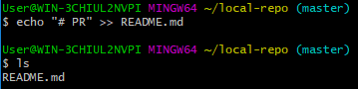](https://user-images.githubusercontent.com/43058513/52538185-40eb5200-2d78-11e9-8394-ff2fb9f2d750.PNG)
* Am modificat repozitoriul local, ori de cate ori s-a modifica directorul de lucru:
* *STAGE - git add*
* *HEAD - git commit -m "First commit"*
* [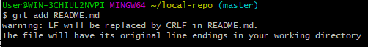](https://user-images.githubusercontent.com/43058513/52538291-a12ec380-2d79-11e9-9455-d285edeaf8e0.PNG) [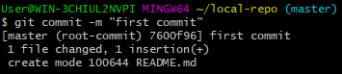](https://user-images.githubusercontent.com/43058513/52538294-b4419380-2d79-11e9-953e-c2cbb168a45a.PNG)
* Am adaugat repozitoriul distant *git remote add origin...*
* [6](https://user-images.githubusercontent.com/43058513/52538304-ca4f5400-2d79-11e9-893e-028c61cdc361.PNG)
* Am reinnoit repozitoriul distant origin, ramura master *git push -u origin master* [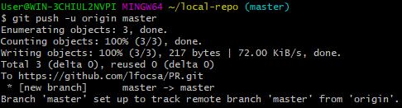](https://user-images.githubusercontent.com/43058513/52538340-2c0fbe00-2d7a-11e9-8ffe-d92f2168b7e8.PNG)

[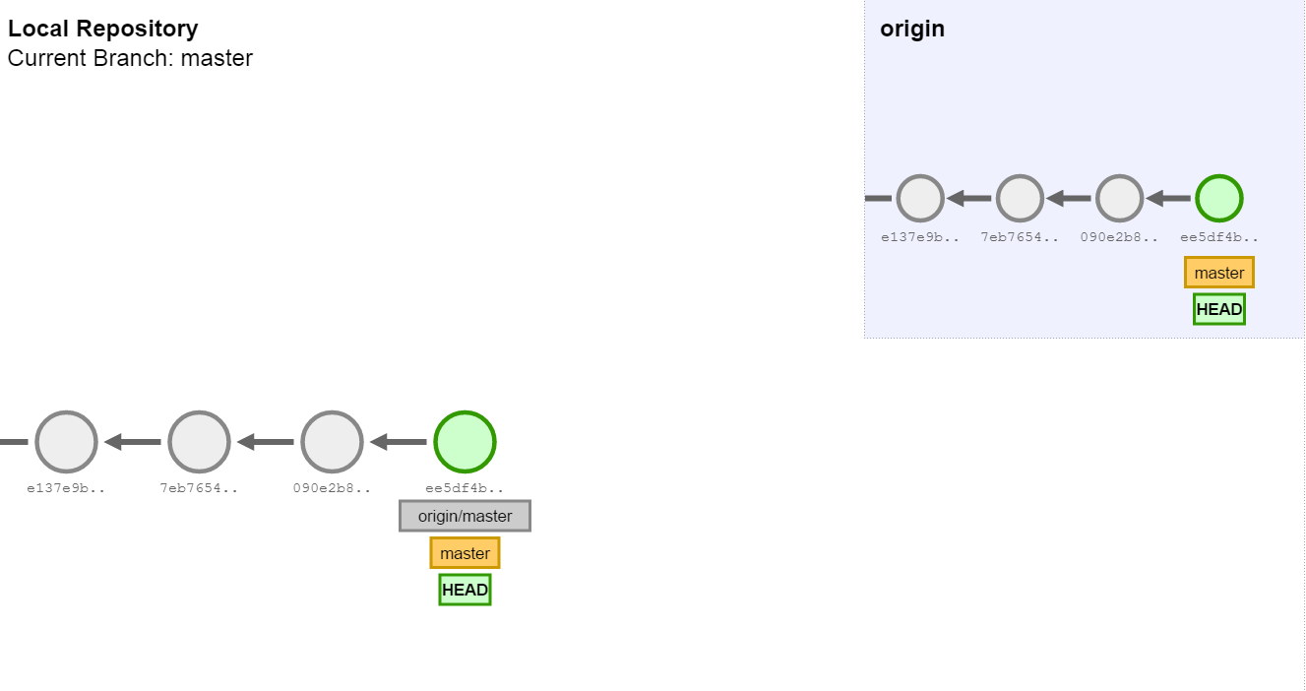](https://user-images.githubusercontent.com/43058513/52538347-3f228e00-2d7a-11e9-8490-e509d83faa93.png)

* Am utilizat comanda *git status* pentru a vedea starea directorului de lucru si repozitoriului local
* Am creat o ramura noua de dezvoltare **dev**
* [9](https://user-images.githubusercontent.com/43058513/52538356-53ff2180-2d7a-11e9-9446-e87f23901e5d.PNG)
* Am trecut in ramura nou creata *dev*
* [10](https://user-images.githubusercontent.com/43058513/52538367-65482e00-2d7a-11e9-89ed-85400a765197.PNG)

[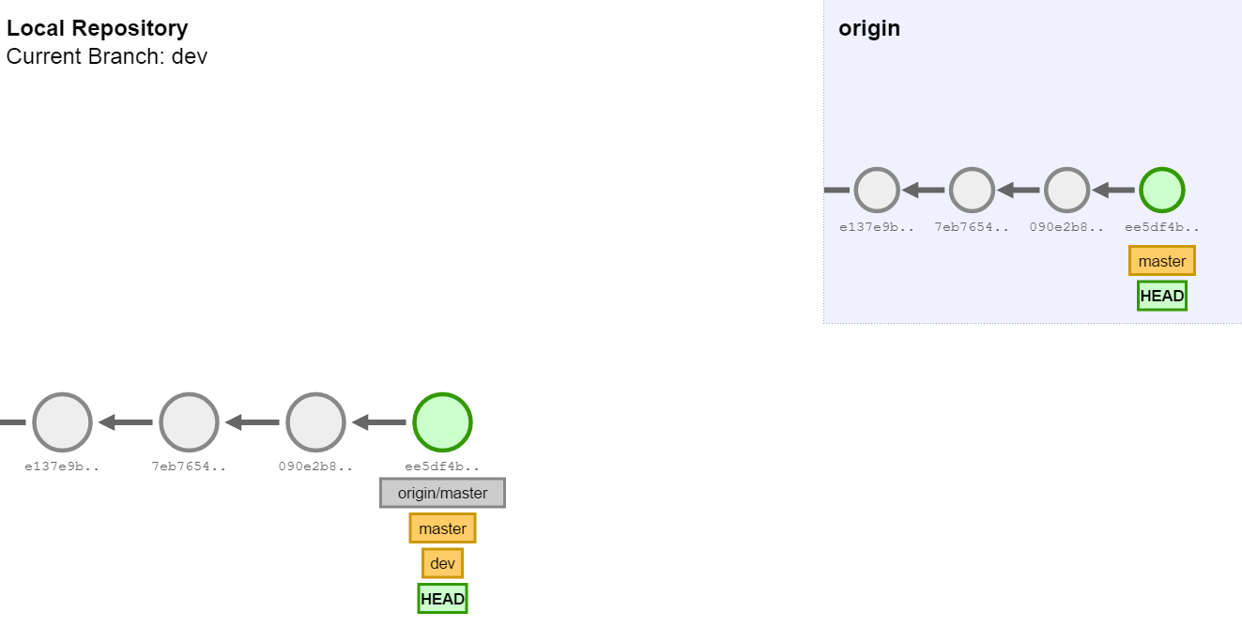](https://user-images.githubusercontent.com/43058513/52538374-7133f000-2d7a-11e9-915f-d16558853430.png)

* Am verificat daca sunt modificari in repozitoriul distant
* [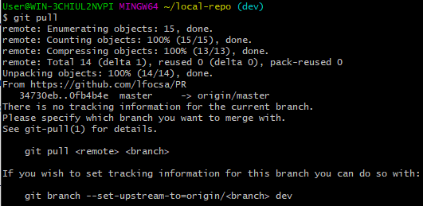](https://user-images.githubusercontent.com/43058513/52538377-80b33900-2d7a-11e9-86af-85a5e8db6bc1.PNG)
* Am reinnoit repozitoriul distant, aflindu-ma pe ramura dev
* [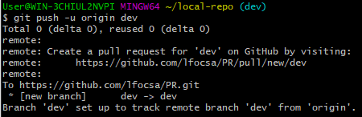](https://user-images.githubusercontent.com/43058513/52538382-932d7280-2d7a-11e9-9728-f19df2c137f2.PNG)
* Am trecut pe ramura principala de dezvoltare master
* [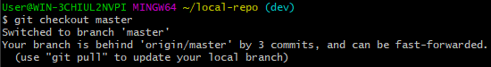](https://user-images.githubusercontent.com/43058513/52538389-aa6c6000-2d7a-11e9-8059-cdacc3620c14.PNG)
* [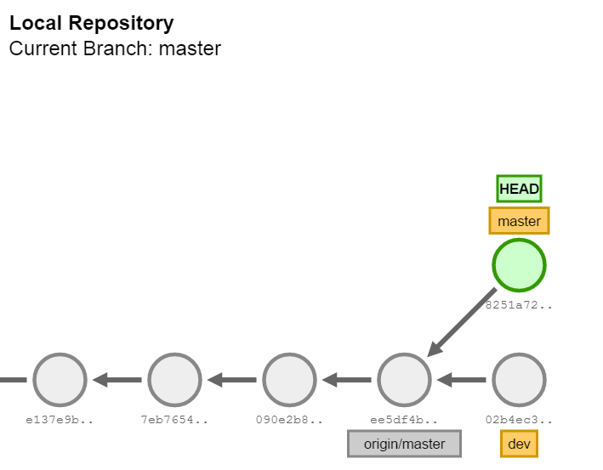](https://user-images.githubusercontent.com/43058513/52538392-b8ba7c00-2d7a-11e9-8d24-4e96f7af7015.png)
* Am unificat ramurile master si dev
* [16](https://user-images.githubusercontent.com/43058513/52538396-c6700180-2d7a-11e9-8d62-96fbf5f3318c.PNG)

[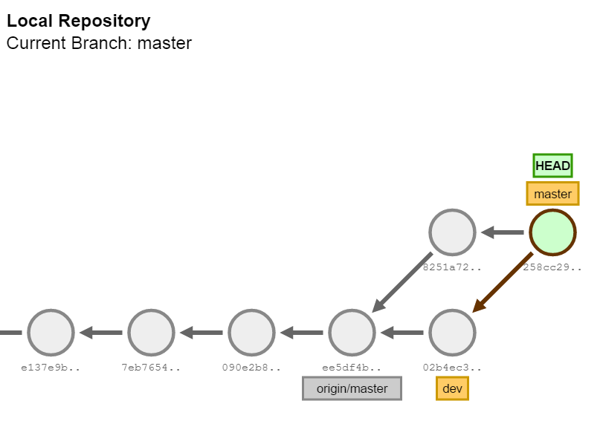](https://user-images.githubusercontent.com/43058513/52538400-d4258700-2d7a-11e9-88cc-153b7915c12b.png)