**Problem 1.**

Solution:

(1). State space: $X=\left\{0, 1, 2, ⋯\right\}$ state of equipment $x=0$– new.

Control space: $U=\left\{0, 1\right\}$ 0 - wait; 1 – replace.

Reward function for one period: $r\left(x, u\right)=\left\{\begin{aligned}R-K\left(1-γe^{-μx}\right)-c_{0} u=1 \\ R-\left(c_{0}+c_{1}x\right) u=0\end{aligned}\right.$

Dynamic programming equation:

$${v_{γ}}^{*}\left(x\right)=max⁡\{r\left(x, 1\right)+γ\sum_{j=0}^{∞}{p_{j}}{v_{γ}}^{*}\left(j\right); r\left(x, 0\right)+γ\sum_{j=0}^{∞}{p_{j}}{v_{γ}}^{*}\left(x+j\right)\}$$

(2) If there is no salvage value, the reward function for one period is:

$$r\left(x, u\right)=\left\{\begin{aligned}R-K-c_{0} u=1 \\ R-\left(c_{0}+c_{1}x\right) u=0\end{aligned}\right.$$

So the $r\left(x, u\right)$ is non-increasing because $c_{1}>0$ in the case $u=0$; and $R-K-c_{0}$ is a constant in the case $u=1$.

Further, $p_{j}$ and $γ(0<γ<1)$ are constant and do not depend on $x$. The function ${v_{γ}}^{*}\left(∙\right){v_{γ}}^{*}\left(∙+j\right)$ are non-increasing with respect to $x$, by induction assumption.

Denote

$$h\left(x\right)= r\left(x, 1\right)+γ\sum_{j=0}^{∞}{p_{j}}{v_{γ}}^{*}\left(j\right),$$

$$g\left(x\right)= r\left(x, 0\right)+γ\sum_{j=0}^{∞}{p_{j}}{v_{γ}}^{*}\left(x+j\right),$$

We conclude that $h\left(∙\right)$ and $g\left(∙\right)$ are non-increasing because they are sums of non-increasing functions.

Thus, for $x>y$

$$max⁡\{h\left(x\right); g\left(x\right)\}≤max⁡\{h\left(y\right); g\left(y\right)\}$$

We conclude that ${v_{γ}}^{*}\left(x\right)$ is non-increasing.

(3) The reward function for one period is $r\left(x, u\right)=\left\{\begin{aligned}-6+8e^{-0.2x} u=1 \\ 4+x u=0\end{aligned}\right. ,$

The probabilities of deterioration by j steps in one period are given by Poisson distribution:

$$p_{j}=\frac{1}{j!e}$$

Value iteration:

$$\left\{\begin{aligned}v^{*}(0)=max\{2+{0.37v}^{*}\left(0\right)+0.37v^{*}\left(1\right)+0.18v^{*}\left(2\right)⋯,4+0.37v^{*}\left(0\right)+0.37v^{*}\left(1\right)+0.18v^{*}\left(2\right)⋯\} \\ v^{*}(1)=max\{0.55+{0.37v}^{*}\left(0\right)+0.37v^{*}\left(1\right)+0.18v^{*}\left(2\right)⋯,5+0.37v^{*}\left(0\right)+0.37v^{*}\left(1\right)+0.18v^{*}\left(2\right)⋯\} \\ v^{*}\left(2\right)=\max\left\{-0.64+{0.37v}^{*}\left(0\right)+0.37v^{*}\left(1\right)+0.18v^{*}\left(2\right)⋯,6+0.37v^{*}\left(0\right)+0.37v^{*}\left(1\right)+0.18v^{*}\left(2\right)⋯\right\} \\ v^{*}\left(3\right)=\max\left\{-2.41+{0.37v}^{*}\left(0\right)+0.37v^{*}\left(1\right)+0.18v^{*}\left(2\right)⋯,7+0.37v^{*}\left(0\right)+0.37v^{*}\left(1\right)+0.18v^{*}\left(2\right)⋯\right\} \\ v^{*}\left(4\right)=\max\left\{-3.06+{0.37v}^{*}\left(0\right)+0.37v^{*}\left(1\right)+0.18v^{*}\left(2\right)⋯,8+0.37v^{*}\left(0\right)+0.37v^{*}\left(1\right)+0.18v^{*}\left(2\right)⋯\right\} \\ ⋯\end{aligned}\right.$$

MATLAB:

% [v_lo,n_it] = dne1_value_iteration_revised (0.9,10000);

function [v_lo,n_it] = dne1_value_iteration_revised (alpha,max_it)

i = 0;

n_it = max_it;

v=[0,0,0,0,0];

vv=[0,0,0,0,0];

v_lo=[0,0,0,0,0];

v_up=[0,0,0,0,0];

while (i < n_it)

vv(1) = max(2+alpha*(0.37*v(1)+0.37*v(2)+0.18*v(3)+0.06*v(4)+0.02*v(5)),4+alpha*(0.37*v(1)+0.37*v(2)+0.18*v(3)+0.06*v(4)+0.02*v(5)));

vv(2) = max(0.55+alpha*(0.37*v(1)+0.37*v(2)+0.18*v(3)+0.06*v(4)+0.02*v(5)),5+alpha*(0.37*v(1)+0.37*v(2)+0.18*v(3)+0.06*v(4)+0.02*v(5)));

vv(3) = max(-0.64+alpha*(0.37*v(1)+0.37*v(2)+0.18*v(3)+0.06*v(4)+0.02*v(5)),6+alpha*(0.37*v(1)+0.37*v(2)+0.18*v(3)+0.06*v(4)+0.02*v(5)));

vv(4) = max(-2.41+alpha*(0.37*v(1)+0.37*v(2)+0.18*v(3)+0.06*v(4)+0.02*v(5)),7+alpha*(0.37*v(1)+0.37*v(2)+0.18*v(3)+0.06*v(4)+0.02*v(5)));

vv(5) = max(-3.06+alpha*(0.37*v(1)+0.37*v(2)+0.18*v(3)+0.06*v(4)+0.02*v(5)),8+alpha*(0.37*v(1)+0.37*v(2)+0.18*v(3)+0.06*v(4)+0.02*v(5)));

v_lo = vv + min(vv-v)*alpha/(1-alpha);

v_up = vv + max(vv-v)*alpha/(1-alpha);

if (isequal(v_lo,v_up))

n_it=i;

end

i=i+1;

v=v_lo;

end

end

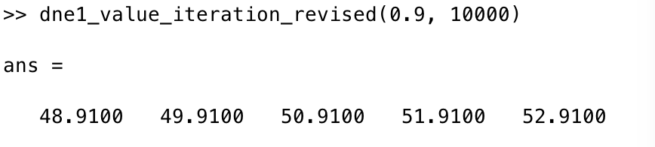

Policy iteration:

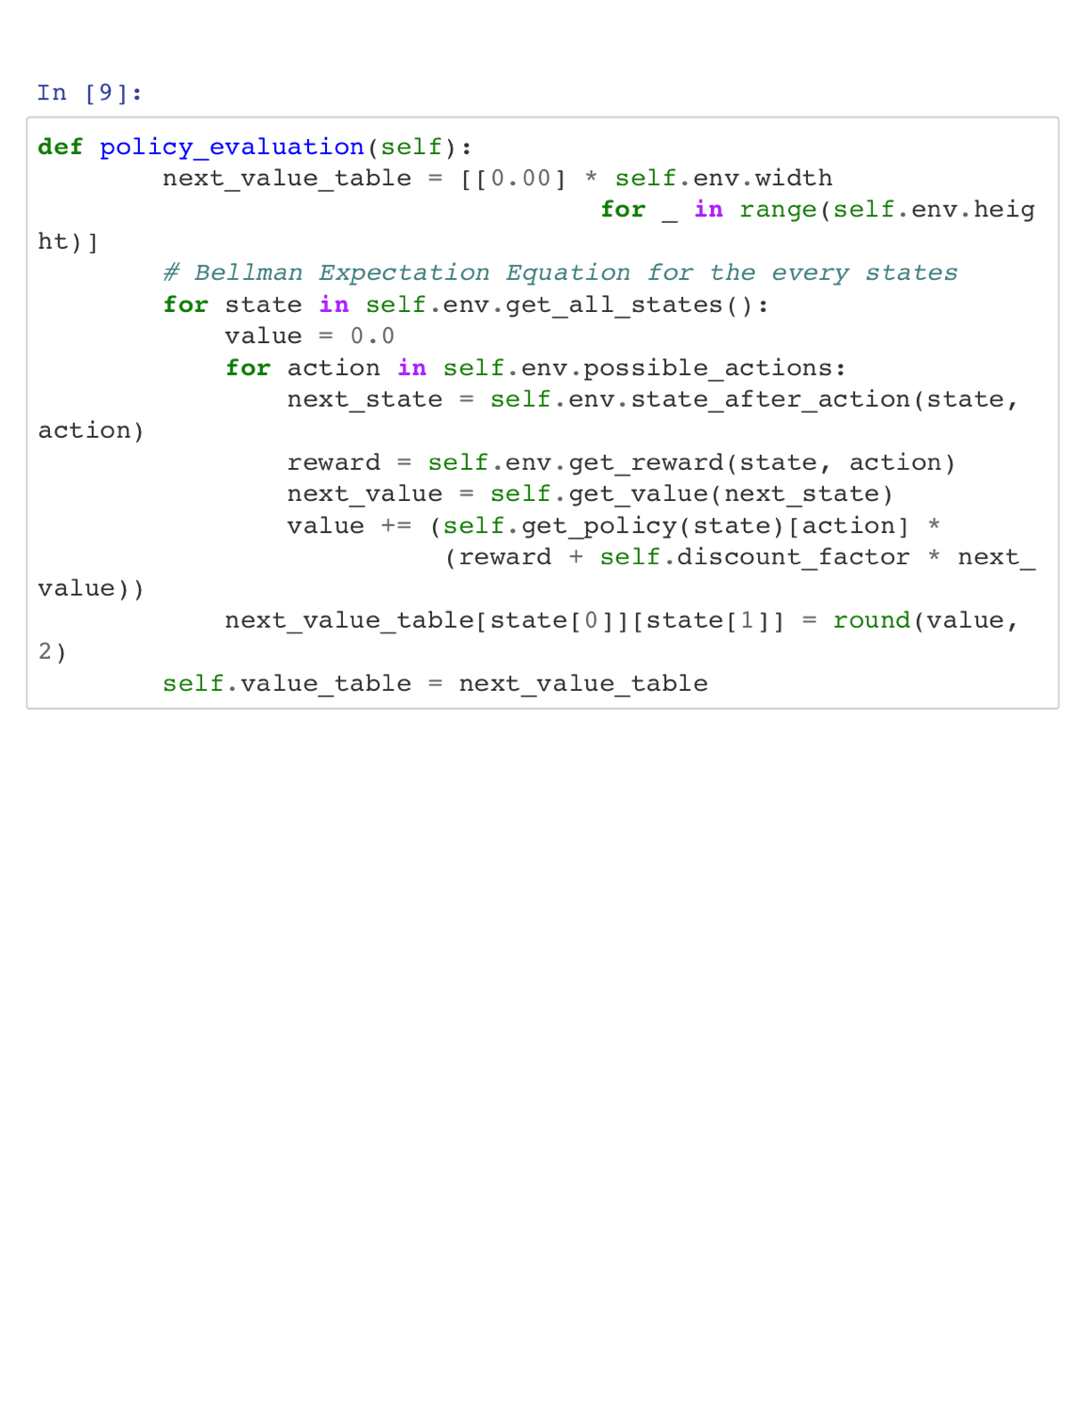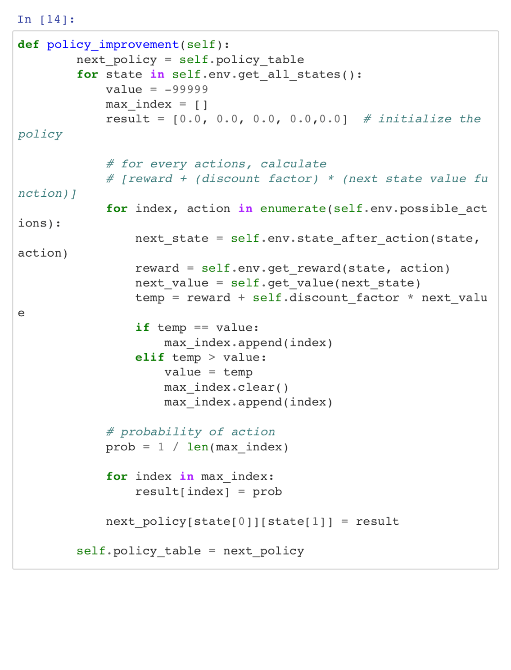

Linear programming:

% v = dne1_LP

function v = dne1_LP

clear();

f=[1;1;1;1;1];

A=[0.37,0.37,0.18,0.06,0.02;

0.37,0.37,0.18,0.06,0.02;

0.37,0.37,0.18,0.06,0.02;

0.37,0.37,0.18,0.06,0.02;

0.37,0.37,0.18,0.06,0.02;

0.37,0.37,0.18,0.06,0.02;

0.37,0.37,0.18,0.06,0.02;

0.37,0.37,0.18,0.06,0.02;

0.37,0.37,0.18,0.06,0.02;

0.37,0.37,0.18,0.06,0.02];

b=[2;4;0.55;5;-0.64;6;-2.41;7;-3.06;8];

v=linprog(f,A,b);

end

**Problem 2.**

Solution:

(1) State space: $X=\left\{x_{t}, t=0, 1, 2, ⋯\left|x_{t+1}=max⁡(0, x_{t}+u_{t}-d_{t}\right.)\right\}$

Control space: $U=\left\{u_{t}, t=0, 1, 2, ⋯\left|{0≤u}_{t}\right.≤12, u_{t}∈Z\right\}$

Dynamic programming equation:

$${v }^{*}(x)=\max_{u≥0}\left\{-5u-2(x+u)+E[10×min\left(x+u,d\right)+{0.8v^{*} \left(x+u-d\right)}_{+}]\right\}$$

(2) value iteration:

% [v_lo,n_it] = dne1_value_iteration_revised (0.8,10000);

function p=p(~)

alphabet=[0,1,2,3,4];

prob= [0.1,0.2,0.3,0.2,0.2];

p=randsrc(1,1,[alphabet;prob]);

end

function [v_lo,n_it] = dne1_value_iteration_revised (alpha,max_it)

i = 0;

n_it = max_it;

v=[0,0,0,0,0,0,0,0,0,0,0,0,];

vv=[0,0,0,0,0,0,0,0,0,0,0,];

v_lo=[0,0,0,0,0,0,0,0,0,0,0,];

v_up=[0,0,0,0,0,0,0,0,0,0,0,];

while (i < n_it)

vv(1) = max(2+alpha*(p*v(1)+p*v(2)+p*v(3)+p*v(4)+p*v(5)+p*v(6)+p*v(7)+p*v(8)+p*v(9)+p*v(10)+p*v(11)+p*v(12)),4+alpha*(p*v(1)+p*v(2)+p*v(3)+p*v(4)+p*v(5)+p*v(6)+p*v(7)+p*v(8)+p*v(9)+p*v(10)+p*v(11)+p*v(12)));

vv(2) = max(0.55+alpha*(p*v(1)+p*v(2)+p*v(3)+p*v(4)+p*v(5)+p*v(6)+p*v(7)+p*v(8)+p*v(9)+p*v(10)+p*v(11)+p*v(12)),5+alpha*(p*v(1)+p*v(2)+p*v(3)+p*v(4)+p*v(5)+p*v(6)+p*v(7)+p*v(8)+p*v(9)+p*v(10)+p*v(11)+p*v(12)));

vv(3) = max(2+alpha*(p*v(1)+p*v(2)+p*v(3)+p*v(4)+p*v(5)+p*v(6)+p*v(7)+p*v(8)+p*v(9)+p*v(10)+p*v(11)+p*v(12)),4+alpha*(p*v(1)+p*v(2)+p*v(3)+p*v(4)+p*v(5)+p*v(6)+p*v(7)+p*v(8)+p*v(9)+p*v(10)+p*v(11)+p*v(12)));

vv(4) = max(0.55+alpha*(p*v(1)+p*v(2)+p*v(3)+p*v(4)+p*v(5)+p*v(6)+p*v(7)+p*v(8)+p*v(9)+p*v(10)+p*v(11)+p*v(12)),5+alpha*(p*v(1)+p*v(2)+p*v(3)+p*v(4)+p*v(5)+p*v(6)+p*v(7)+p*v(8)+p*v(9)+p*v(10)+p*v(11)+p*v(12)));

vv(5) = max(2+alpha*(p*v(1)+p*v(2)+p*v(3)+p*v(4)+p*v(5)+p*v(6)+p*v(7)+p*v(8)+p*v(9)+p*v(10)+p*v(11)+p*v(12)),4+alpha*(p*v(1)+p*v(2)+p*v(3)+p*v(4)+p*v(5)+p*v(6)+p*v(7)+p*v(8)+p*v(9)+p*v(10)+p*v(11)+p*v(12)));

vv(6) = max(0.55+alpha*(p*v(1)+p*v(2)+p*v(3)+p*v(4)+p*v(5)+p*v(6)+p*v(7)+p*v(8)+p*v(9)+p*v(10)+p*v(11)+p*v(12)),5+alpha*(p*v(1)+p*v(2)+p*v(3)+p*v(4)+p*v(5)+p*v(6)+p*v(7)+p*v(8)+p*v(9)+p*v(10)+p*v(11)+p*v(12)));

vv(7) = max(2+alpha*(p*v(1)+p*v(2)+p*v(3)+p*v(4)+p*v(5)+p*v(6)+p*v(7)+p*v(8)+p*v(9)+p*v(10)+p*v(11)+p*v(12)),4+alpha*(p*v(1)+p*v(2)+p*v(3)+p*v(4)+p*v(5)+p*v(6)+p*v(7)+p*v(8)+p*v(9)+p*v(10)+p*v(11)+p*v(12)));

vv(8) = max(0.55+alpha*(p*v(1)+p*v(2)+p*v(3)+p*v(4)+p*v(5)+p*v(6)+p*v(7)+p*v(8)+p*v(9)+p*v(10)+p*v(11)+p*v(12)),5+alpha*(p*v(1)+p*v(2)+p*v(3)+p*v(4)+p*v(5)+p*v(6)+p*v(7)+p*v(8)+p*v(9)+p*v(10)+p*v(11)+p*v(12)));

vv(9) = max(2+alpha*(p*v(1)+p*v(2)+p*v(3)+p*v(4)+p*v(5)+p*v(6)+p*v(7)+p*v(8)+p*v(9)+p*v(10)+p*v(11)+p*v(12)),4+alpha*(p*v(1)+p*v(2)+p*v(3)+p*v(4)+p*v(5)+p*v(6)+p*v(7)+p*v(8)+p*v(9)+p*v(10)+p*v(11)+p*v(12)));

vv(10) = max(0.55+alpha*(p*v(1)+p*v(2)+p*v(3)+p*v(4)+p*v(5)+p*v(6)+p*v(7)+p*v(8)+p*v(9)+p*v(10)+p*v(11)+p*v(12)),5+alpha*(p*v(1)+p*v(2)+p*v(3)+p*v(4)+p*v(5)+p*v(6)+p*v(7)+p*v(8)+p*v(9)+p*v(10)+p*v(11)+p*v(12)));

vv(11) = max(2+alpha*(p*v(1)+p*v(2)+p*v(3)+p*v(4)+p*v(5)+p*v(6)+p*v(7)+p*v(8)+p*v(9)+p*v(10)+p*v(11)+p*v(12)),4+alpha*(p*v(1)+p*v(2)+p*v(3)+p*v(4)+p*v(5)+p*v(6)+p*v(7)+p*v(8)+p*v(9)+p*v(10)+p*v(11)+p*v(12)));

vv(12) = max(0.55+alpha*(p*v(1)+p*v(2)+p*v(3)+p*v(4)+p*v(5)+p*v(6)+p*v(7)+p*v(8)+p*v(9)+p*v(10)+p*v(11)+p*v(12)),5+alpha*(p*v(1)+p*v(2)+p*v(3)+p*v(4)+p*v(5)+p*v(6)+p*v(7)+p*v(8)+p*v(9)+p*v(10)+p*v(11)+p*v(12)));

v_lo = vv + min(vv-v)*alpha/(1-alpha);

v_up = vv + max(vv-v)*alpha/(1-alpha);

if (isequal(v_lo,v_up))

n_it=i;

end

i=i+1;

v=v_lo;

end

end

Policy iteration:

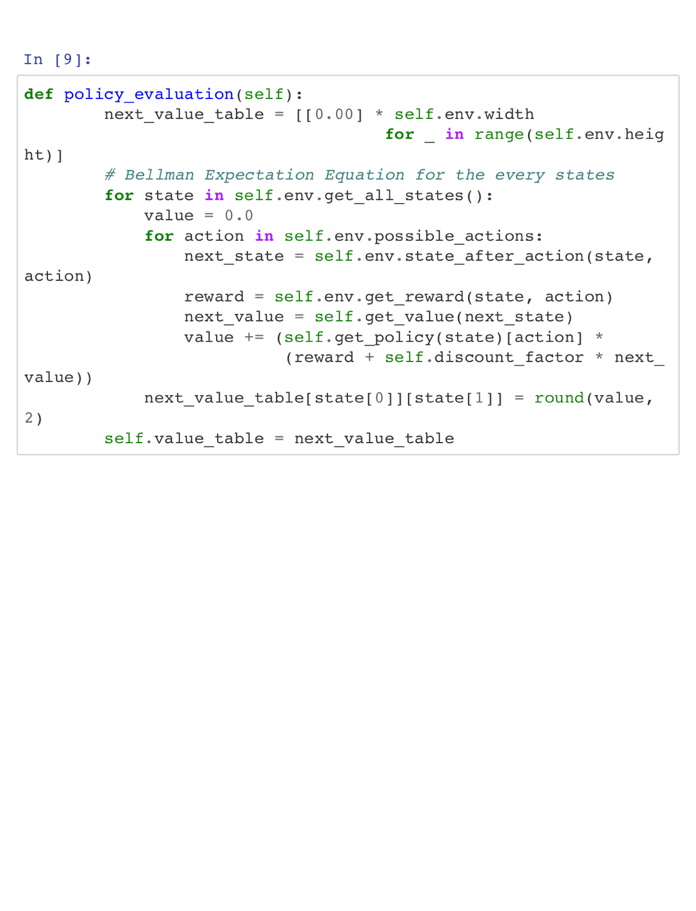

**Problem 3.**

Solution:

State space: $X=\left\{x_{ut}, t=0, 1, 2, ⋯;u=1,2,3 \left|x_{t+1}= x_{t}-r(t)\right.\right\}$

Control space: $U=\left\{u, u=1, 2, 3\right\}$

Reward function is $r\left(t\right)=r_{ut}x_{ut}$

Dynamic programming equation:

$$v^{*}\left(x\right)=max⁡\{r\left(x, 1\right)+γ\sum_{j=0}^{∞}{p_{j}}{v_{γ}}^{*}\left(j\right); r\left(x, 2\right)+γ\sum_{j=0}^{∞}{p_{j}}{v_{γ}}^{*}\left(x+j\right);r\left(x, 3\right)+γ\sum_{j=0}^{∞}{p_{j}}{v_{γ}}^{*}\left(j\right)\}$$

Policy:

$$π^{*}\left(x\right)=argmax⁡\{r\left(x, 1\right)+γ\sum_{j=0}^{∞}{p_{j}}{v_{γ}}^{*}\left(j\right); r\left(x, 2\right)+γ\sum_{j=0}^{∞}{p_{j}}{v_{γ}}^{*}\left(x+j\right);r\left(x, 3\right)+γ\sum_{j=0}^{∞}{p_{j}}{v_{γ}}^{*}\left(j\right)\}$$