**Problem 1.**

*Solution:*

1. State space: $X =\{-5, -4, -3, -2, -1, 0, 1, 2, 3, 4, 5\}$- your advantage at the moment

Control space: $U = \{0 (timid) , 1 (bold)\}$

Transition probabilities:

$$P\left\{x_{t+1} ={ x}_{t} -1 | { x}_{t},0\right\}= 0.1,$$

$$P\left\{x_{t+1} ={ x}_{t} | { x}_{t},0\right\}= 0.8,$$

$$P\left\{x_{t+1} ={ x}_{t}+1 | { x}_{t},0\right\}= 0.1$$

$$P\left\{x_{t+1} ={ x}_{t} -1 | { x}_{t},1\right\} = 0.55,$$

$$P\left\{x_{t+1} ={ x}_{t}+1 | { x}_{t},1\right\} = 0.45$$

For all other states $y∈X$, we have $P\{x_{t+1} =y|{ x}_{t},{ u}_{t}\}=0$;

Reward function for one period: $r_{t}(x,u)=0$.

Dynamic programming equations: The value function ${v_{t}}^{*}(x)$ expresses the probability to win at time $t$ if the state (score) is $x$.

$${v_{t}}^{*}\left(x\right)=\max\left\{\begin{aligned}0.8{v_{t+1}}^{*} \left(x\right)+0.1{v_{t+1}}^{*} \left(x-1\right)+0.1{v_{t+1}}^{*} \left(x+1\right), \\ 0.45{v_{t+1}}^{*}\left(x+1\right)+0.55{v_{t+1}}^{*}\left(x-1\right)\end{aligned}\right\},$$

$$t = 1,...,5$$

$$for t =1,x=0;$$

$$t =2,x=-1, 0, 1;$$

$$t =3,x=-2,-1, 0, 1, 2;$$

$$t = 4, x = -3,-2, -1, 0, 1, 2, 3;$$

$$t = 5, x = -4,-3,-2, -1, 0, 1, 2, 3, 4 ;$$

$${v_{6}}^{*}\left(x\right)=\left\{\begin{aligned}1, if x>0 \\ 0, if x<0 \\ 0.45, if x=0, u=1 \\ 0.50， if x=0, u=0\end{aligned}\right.$$

$${v_{t}}^{*}\left(x\right)=\left\{{0.45, if u=1 \atop 0.50, if u=0}, t>6\right.$$

|  |  |  |  |  |  |  |  |  |  |  |  |
| --- | --- | --- | --- | --- | --- | --- | --- | --- | --- | --- | --- |
| 0 |  |  |  |  |  |  |  |  |  |  |  |
| 0 | 0 |  |  |  |  |  | any |  |  |  |  |
| 0 | 0 | 0 |  |  |  |  | any | any |  |  |  |
| 0 | 0 | 0.1013 | 0.104 |  |  |  | any | bold | timid |  |  |
| 0 | 0.225 | 0.23 | 0.3038 | 0.3089 |  |  | bold | timid | bold | timid |  |
| 0.50 | 0.50 | 0.5513 | 0.555 | 0.5643 | 0.5684 | timid | timid | bold | timid | bold | timid |
| 1 | 0.95 | 0.91 | 0.8826 | 0.8603 |  |  | timid | timid | timid | timid |  |
| 1 | 1 | 0.995 | 0.987 |  |  |  | any | timid | timid |  |  |
| 1 | 1 | 1 |  |  |  |  | any | any |  |  |  |
| 1 | 1 |  |  |  |  |  | any |  |  |  |  |
| 1 |  |  |  |  |  |  |  |  |  |  |  |

Code:



 

1. Let the probability of wining in the case of a timid play be 0, 0.3, 0.6, 0.9, 0.12, 0.15, we can see the higher probability of wining, the more we choose to use timid way.

Code:

 

Output:

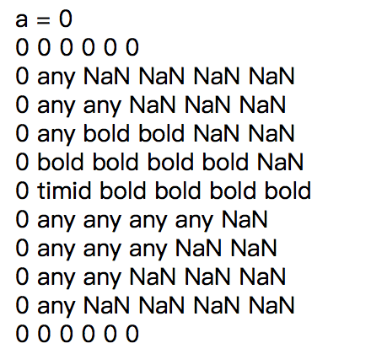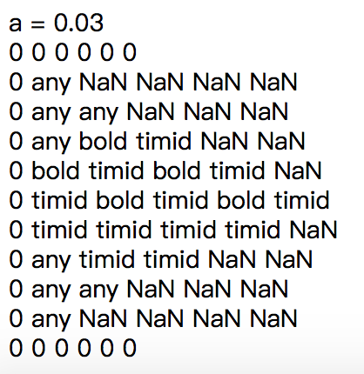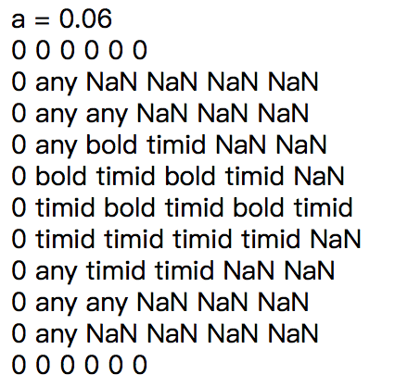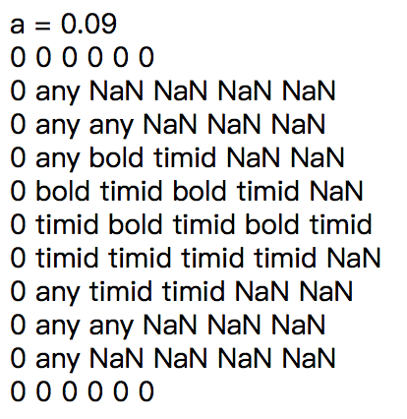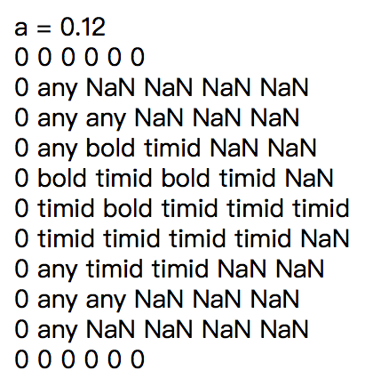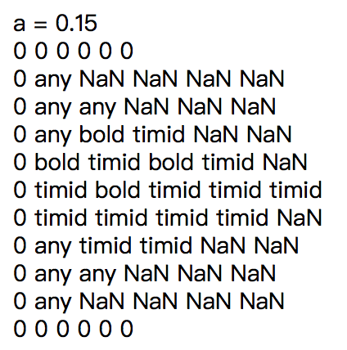

**Problem 2.**

*Solution:*

1. State space: $X =\{ 0, 1, 2, 3, 4\}$– the size of tree at that moment

Control space: $U = \{0 (maintain) , 1 (harvest)\}$

Transition probabilities:

$$P\left\{x_{t+1} ={ x}_{t} | { x}_{t}=0\right\}= 1,$$

$$P\left\{x_{t+1} =0 | { x}_{t}=1\right\}= 0.05,$$

$$P\left\{x_{t+1} =1 | { x}_{t}=1\right\}= 0.15,$$

$$P\left\{x_{t+1} =2 | { x}_{t}=1\right\}= 0.7,$$

$$P\left\{x_{t+1} =3 | { x}_{t}=1\right\}= 0.1,$$

$$P\left\{x_{t+1} =0 | { x}_{t}=2\right\}= 0.05,$$

$$P\left\{x_{t+1} =2 | { x}_{t}=2\right\}= 0.2,$$

$$P\left\{x_{t+1} =3 | { x}_{t}=2\right\}= 0.7,$$

$$P\left\{x_{t+1} =4 | { x}_{t}=2\right\}= 0.05,$$

$$P\left\{x_{t+1} =0 | { x}_{t}=3\right\}= 0.05,$$

$$P\left\{x_{t+1} =3 | { x}_{t}=3\right\}= 0.5,$$

$$P\left\{x_{t+1} =4 | { x}_{t}=3\right\}= 0.45,$$

$$P\left\{x_{t+1} =0 | { x}_{t}=4\right\}= 0.05,$$

$$P\left\{x_{t+1} =4 | { x}_{t}=4\right\}= 0.95$$

For all other states $x,y∈X$, we have $P\{x_{t+1} =y|{ x}_{t}=x\}=0$;

Reward function for one period:

$$r\left(x,u\right)=\left\{\begin{aligned}-10 x=0,u=0 \\ -30 x=0,u=1 \\ -11 x=1,u=0 \\ 115 x=1,u=1 \\ -12 x=2,u=0 \\ 140 x=2,u=1 \\ -13 x=3,u=0 \\ 165 x=3,u=1 \\ -14 x=4,u=0 \\ 210 x=4,u=1\end{aligned}\right.$$

Dynamic programming equations: The value function ${v_{t}}^{*}(x)$ expresses the biggest profit at time $t$ if the state (score) is $x$.

$${v_{t}}^{*}\left(0\right)=max\left\{r\left(0,0\right)+{v_{t+1}}^{*}\left(0\right), r(0,1)\right\}$$

$${v_{t}}^{*}\left(1\right)=max\left\{r\left(1,0\right)+{{0.05v}_{t+1}}^{*}\left(0\right)+{{0.15v}_{t+1}}^{*}\left(1\right)+{{0.7v}_{t+1}}^{*}\left(2\right)+{{0.1v}_{t+1}}^{*}\left(3\right), r(1,1)\right\}$$

$${v_{t}}^{*}\left(2\right)=max\left\{r\left(2,0\right)+{{0.05v}_{t+1}}^{*}\left(0\right)+{{0.2v}_{t+1}}^{*}\left(2\right)+{{0.7v}_{t+1}}^{*}\left(3\right)+{{0.05v}_{t+1}}^{*}\left(4\right), r(2,1)\right\}$$

$${v_{t}}^{*}\left(3\right)=max\left\{r\left(3,0\right)+{{0.05v}_{t+1}}^{*}\left(0\right)+{{0.5v}_{t+1}}^{*}\left(3\right)+{{0.45v}_{t+1}}^{*}\left(4\right), r(3,1)\right\}$$

$${v_{t}}^{*}\left(4\right)=max\left\{r\left(4,0\right)+{{0.05v}_{t+1}}^{*}\left(0\right)+{{0.95v}_{t+1}}^{*}\left(4\right), r\left(4,1\right)\right\}$$

1. I choose value iteration and policy iterations to solve this problem.

**Value iterations:**

I got $v^{*}={(-30, 115, 140, 165, 210)}^{T}$ in 4 iterations.

MATLAB Code:

% [v_lo,n_it] = dne1_value_iteration_revised (0.9,10000);

function [v_lo,n_it] = dne1_value_iteration_revised (alpha,max_it)

i = 0;

n_it = max_it;

v=[0,0,0,0,0];

vv=[0,0,0,0,0];

v_lo=[0,0,0,0,0];

v_up=[0,0,0,0,0];

while (i < n_it)

vv(1) = max(-10+alpha*v(1),-30);

vv(2) = max(-11+alpha*(0.05*v(1)+0.15*v(2)+0.7*v(3)+0.1*v(4)),115);

vv(3) = max(-12+alpha*(0.05*v(1)+0.2*v(3)+0.7*v(4)+0.05*v(5)),140);

vv(4) = max(-13+alpha*(0.05*v(1)+0.5*v(4)+0.45*v(5)),165);

vv(5) = max(-14+alpha*(0.05*v(1)+0.95*v(5)),210);

v_lo = vv + min(vv-v)*alpha/(1-alpha);

v_up = vv + max(vv-v)*alpha/(1-alpha);

if (isequal(v,vv))

n_it=i;

end

i=i+1;

v(1)=vv(1);

v(2)=vv(2);

v(3)=vv(3);

v(4)=vv(4);

v(5)=vv(5);

end

end

Output:

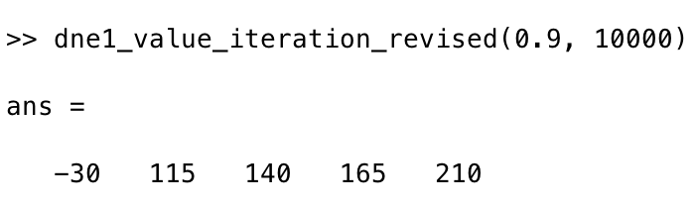

**Policy iterations:**

$π^{1}={(0, 0, 0, 0, 0)}^{T}$, $v^{1}$ is the solution of the system of equations

$$\left\{\begin{aligned}v^{1}\left(0\right)=-10+0.9v^{1}\left(0\right) \\ v^{1}\left(1\right)=-11+0.045v^{1}\left(0\right)+0.135\left(1\right)+0.63v^{1}\left(2\right)+0.09v^{1}\left(3\right) \\ v^{1}\left(2\right)=-12+0.045v^{1}\left(0\right)+0.18\left(2\right)+0.63v^{1}\left(3\right)+0.045v^{1}\left(4\right) \\ v^{1}\left(3\right)=-13+0.045v^{1}\left(0\right)+0.45\left(3\right)+0.405v^{1}\left(4\right) \\ v^{1}\left(4\right)=-14+0.045v^{1}\left(0\right)+0.885v^{1}\left(4\right)\end{aligned}\right.$$

So

$$\left\{\begin{aligned}v^{1}\left(0\right)=-100<-30 \\ v^{1}\left(1\right)=-138.7296<115 \\ v^{1}\left(2\right)=-144.4066<140 \\ v^{1}\left(3\right)=-150.2767<165 \\ v^{1}\left(4\right)=-160.8696<210\end{aligned}\right.$$

The policy maximize is $π^{1}={(1, 1, 1, 1, 1)}^{T}$, the $v^{2}$ is the solution of the system of equations. So the policy is $π^{2}={(1, 1, 1, 1, 1)}^{T}$, we have

$π^{*}={(1, 1, 1, 1, 1)}^{T}$, $v^{*}={(-30,115,140,164,210)}^{T}$.