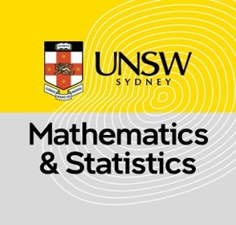
Prof. Paul Fearnhead
Biometrika, Editor
July 19, 2024
Dear Prof. Fearnhead,
We are pleased to submit our original research article titled “Flexible Max-Stable Processes for Fast and Efficient Inference” for consideration for publication in Biometrika.
In this manuscript, we propose an approximated likelihood inference method for max-stable processes, which relies on the angular density (also known as the spectral density) of the angular component. This method avoids computing partial derivatives of the exponent function, the complexity of which becomes intractable as the dimension increases. Our approximated likelihood method can be easily applied to very high-dimensional data, provided that the angular density only places mass on the interior of the angular space. We have established general conditions for a model to possess this property and derived two new models that satisfy this criterion: the skewed Brown-Resnick model, an extension of the Brown-Resnick model capable of modeling non-stationary extremal dependence, and the truncated extremal-t model, which is the equivalent of the extremal-t model but without mass on the subspaces of the angular space.
Since the approximated likelihood method essentially uses the Poisson likelihood over a threshold exceedance region to approximate max-stable processes, this method would be significantly biased if the Poisson points could take values on the boundary space while the max-stable processes could not. By removing the mass on the boundaries, the approximated likelihood method can achieve almost unbiased estimates with relatively large datasets. With moderate data, it can perform as well as the pairwise likelihood method and better for our skewed Brown-Resnick model. This new subclass of max-stable processes, whose angular densities place no mass on the boundaries, can be easily extended to r-Pareto processes and opens the gate for more spatial extreme models suited to real-world problems.
We believe that this manuscript is appropriate for publication in Biometrika because it presents innovative work in both theory and methodology for spatial extremes, along with efficient computational solutions.
This manuscript has not been published and is not under consideration for publication elsewhere. We have no conflicts of interest to disclose.
Thank you for your consideration.
Sincerely,
Peng Zhong, Ph.D.
Postdoctoral Fellow
University of New South Wales (UNSW), Sydney, Australia

