

**MTK** **Andes Tool Chains Usage**

Version: 0.03

Release date: 2014-5-28

© 2008 - 2014 MediaTek Inc.

This document contains information that is proprietary to MediaTek Inc.

Unauthorized reproduction or disclosure of this information in whole or in part is strictly prohibited.

Specifications are subject to change without notice.

**Revision History**

|  |  |  |  |
| --- | --- | --- | --- |
| Date | Revision | Author | Description |
| 2014.02.12 | First v0.01 | Jinchuan | Initial draft. |
| 2014.04.15 | v0.02 | Jinchuan | Add Andes Sight Setup  Add Q&A |
| 2014.05.28 | v0.03 | Jinchuan |  |
|  |  |  |  |
|  |  |  |  |
|  |  |  |  |
|  |  |  |  |

Contents

1. Install AndeSight 2

1-1: How to get AndeSight install files 2

1-2: Install AndeSight following the quick start : 4

2. Update Tool chains 4

3. Modify MT7681 configuration file 4

4. Select Cygwin to Compile MT7681 Source Code 4

5. Q&A 5

# Install AndeSight

## 1-1: How to get AndeSight install files

<http://www.andestech.com/cn/download/andesight-download.htm>

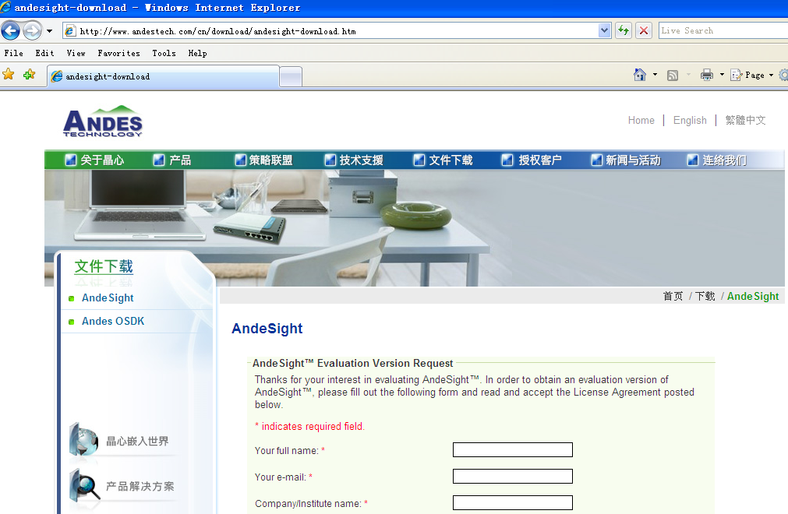

Access this websit, and fill information for application



Your will receive a email include AndeSight download path, after

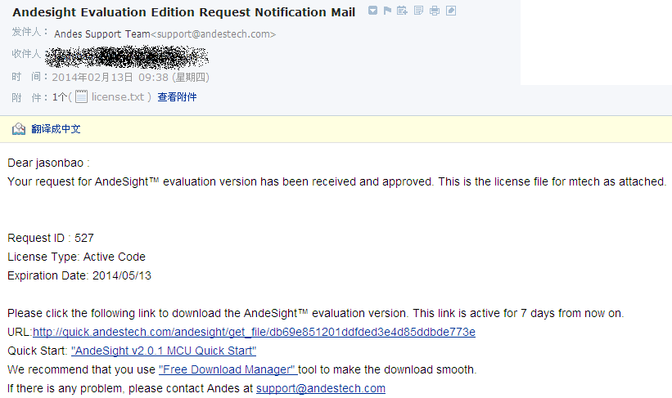

and there is a quick start for AndeSight installation

<http://forum.andestech.com/viewtopic.php?f=23&t=576&p=672>

## 1-2: Install AndeSight following the quick start :

AndeSight default install Path is : C:\Andestech\AndeSight14\

The toolchains install Path is : C:\Andestech\AndeSight14\toolchains\nds32le-elf-newlib-V2j

The config file in C:\Andestech\AndeSight***\toolchains\nds32le-elf-newlib-v2j\cygwin-andes.bat

must mapping the toolchain install path,

if the toolchian install path is changed, below path setting also need to be changed in cygwin-andes.bat

set TOP=C:\Andestech\AndeSight14\cygwin

set TOP=%TOP:\=/%

set TMP=C:\Andestech\AndeSight14\cygwin\cygwin_tmp

set PATH=C:\Andestech\AndeSight14\cygwin\bin;%CD%\bin

set HOME=%CD%\bin

IF EXIST "C:\Andestech\AndeSight14\cygwin\bin\bash.exe" set SHELL=/bin/bash

"C:\Andestech\AndeSight14\cygwin\bin\bash.exe" --login –i

For MTK MT7681 Project, a special tool chains should be used,

Thus, we need instead the original tool chains as MTK ones

# Update Tool chains

Decompress the MTK’s toolchains package “nds32le-elf-newlib-v2j.rar”

to C:\Andestech\AndeSight14\toolchains\nds32le-elf-newlib-V2j

The original one should be deleted or rename first.

# Modify MT7681 configuration file

Modify the configuration files in MT7681 folder: mak/compiler.mk

Add yellow line and delete gray line

#*******************************************************************************

# TOOLCHAINS DEFINE

#*******************************************************************************

#TOOLCHAINS = /root/Andestech/BSPv310/toolchains/nds32le-elf-newlib-v2j/bin

#TOOLCHAINS = /cygdrive/c/Andestech/BSPv310/toolchains/nds32le-elf-newlib-v2j/bin

TOOLCHAINS = /cygdrive/c/Andestech/AndeSight14/toolchains/nds32le-elf-newlib-v2j/bin

CROSS = $(TOOLCHAINS)/nds32le-elf

# Select Cygwin to Compile MT7681 Source Code

Click “Begin” Button on the Windows OS

Select  Toolchains->N9->nds32le-elf-newlib-V2j, a Cygwin window shall be opened

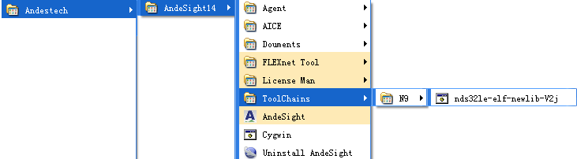

The Normal Compile message:

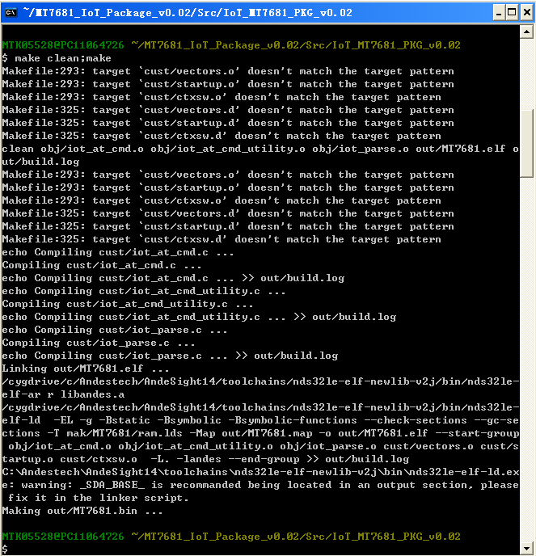

# Q&A

5-1: install AndeSight 之後Toolchains下面是空白的。請問要怎麼啟動Cygwin

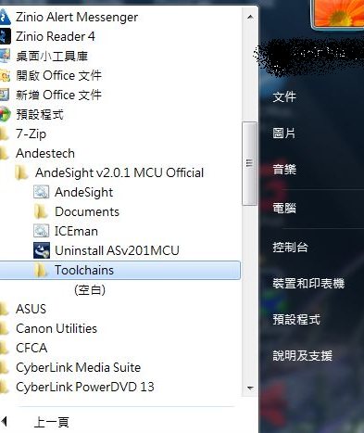

有人员在Win 7 OS下 可能不能打开Cygwin， 但相同安装档在**Win XP** 下可以

5-2：在 Cygwin 环境下编译时 提示：



原因是toolchains未安装 或者安装后在mak/compiler.mk  文件中的设定不对造成

解决方法： 参考第3章，将toolchians路径 设定到Package的MT7681 Source Code (mak/compiler.mk) 中