Bathroom mmWave Sensors (×3) — Network / Port Reference
For firewall configuration · TCP 6053 (ESPHome Native API)
■ Network Diagram (reference)
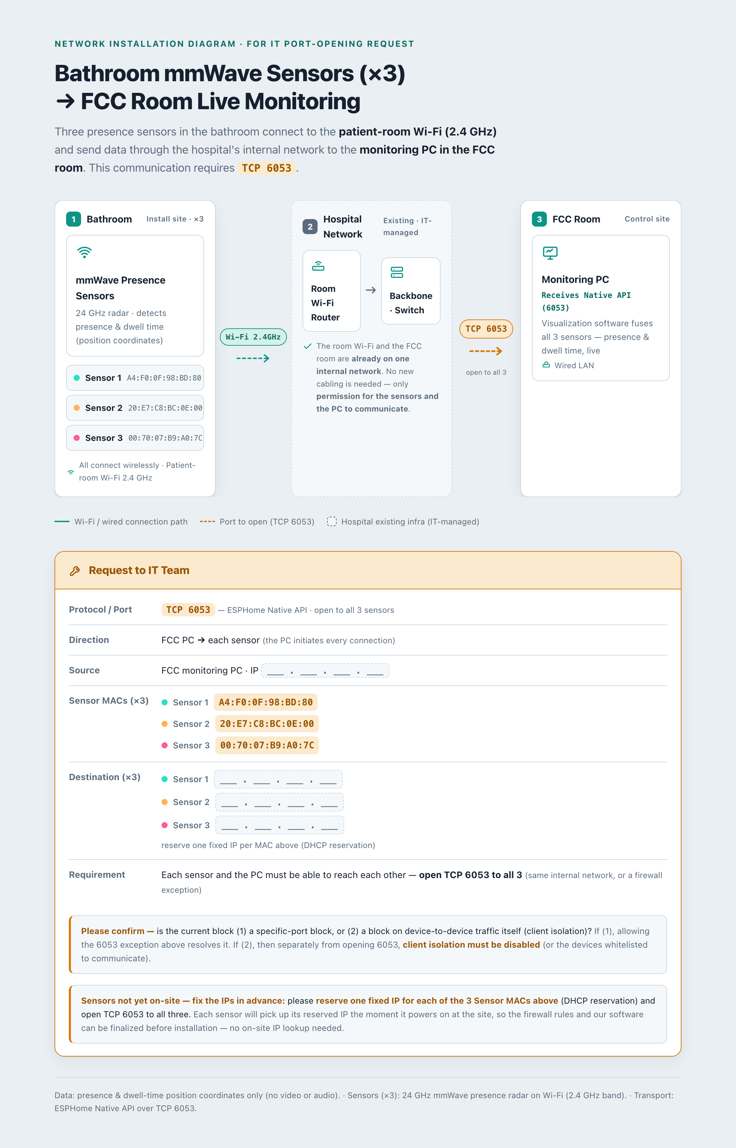
■ Requests
1. Could you please open TCP 6053 between the FCC monitoring PC and the three sensors?
2. For each sensor MAC, we would be grateful if you could reserve a fixed IP (DHCP reservation) and share the assigned IPs with us — the table below may be used.
3. We would also appreciate it if you could reserve a fixed IP for the FCC monitoring PC (or kindly let us know its fixed IP), so that the firewall source can be set correctly.
4. If device-to-device traffic is currently blocked, could you please allow this communication (or disable client isolation) as appropriate?
5. Lastly, could you kindly confirm whether the current block is (1) a specific-port block or (2) a block on device-to-device traffic (client isolation)?
■ Connection Details
Protocol / Port | TCP 6053 (open to all 3 sensors)
Direction | FCC PC -> each sensor (the PC initiates the connection)
Monitoring IP | ___ . ___ . ___ . ___ (please enter)
Inference server IP | ___ . ___ . ___ . ___ (please enter)
Data | Position coordinates only (no video or audio)
* Monitoring IP and Inference server IP are the IPs required for the MACS solution.
■ Sensor Information (targets for fixed-IP reservation)
The MAC addresses below are fixed. We would appreciate it if you could enter the fixed IP reserved for each MAC in the right-hand column.
Sensor | MAC Address (fixed) | Reserved IP (please enter)
Sensor 1 | A4:F0:0F:98:BD:80 | ___ . ___ . ___ . ___
Sensor 2 | 20:E7:C8:BC:0E:00 | ___ . ___ . ___ . ___
Sensor 3 | 00:70:07:B9:A0:7C | ___ . ___ . ___ . ___
* Sensors are not yet installed on-site. If a fixed IP is reserved for each MAC in advance, each sensor will connect on that IP automatically upon installation.
■ Please Confirm (type of block)
Whenever convenient, could you please let us know which of the following applies to the current block?
(1) Specific-port block -> opening the TCP 6053 exception above resolves it.
(2) Device-to-device traffic block (client isolation) -> separately from opening 6053, client isolation must be disabled (or the two devices whitelisted to communicate).

