**This is taking our model and using our data to predict with it.**

|  |  |  |  |  |
| --- | --- | --- | --- | --- |
| **Prediction Type** | **Number** | **Percentage** | **Average difference from lower limit** | **Average difference from upper limit** |
| Over estimation | 72 | 37.8% | 3.49 | 1.66 |
| Under estimation | 65 | 34.6% | -1.67 | -4.93 |
| Within Interval | 52 | 27.7% | 0.957 | -0.834 |

On average, if a prediction falls out of the actual range, and is an over estimation our model predicts $1.66 higher than the upper bound and $3.49 higher than the lower bound.

On average, if a prediction falls out of the actual range, and is an underestimation, our model predicts $1.67 lower than the lower bound and $4.93 lower than the upper bound.

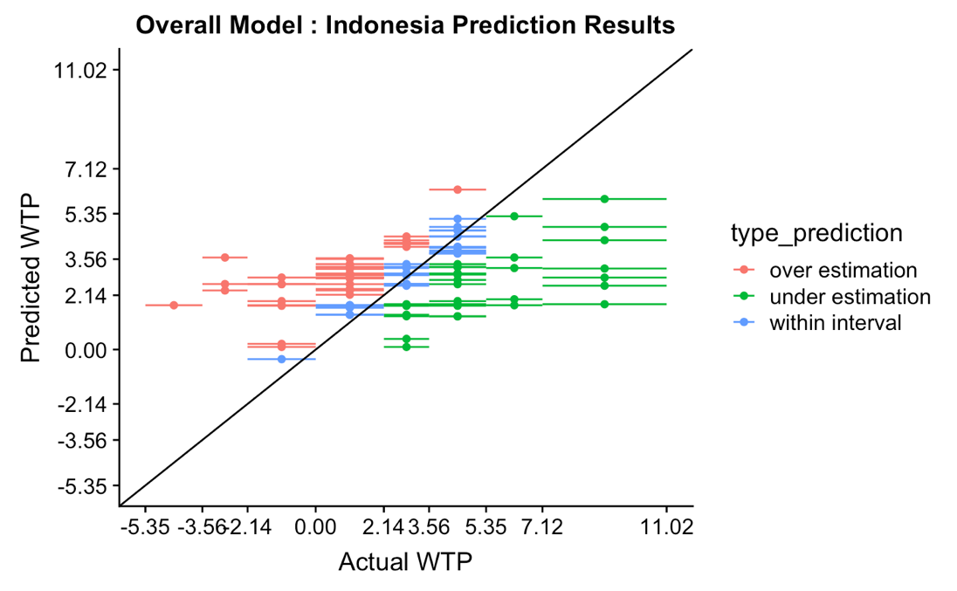

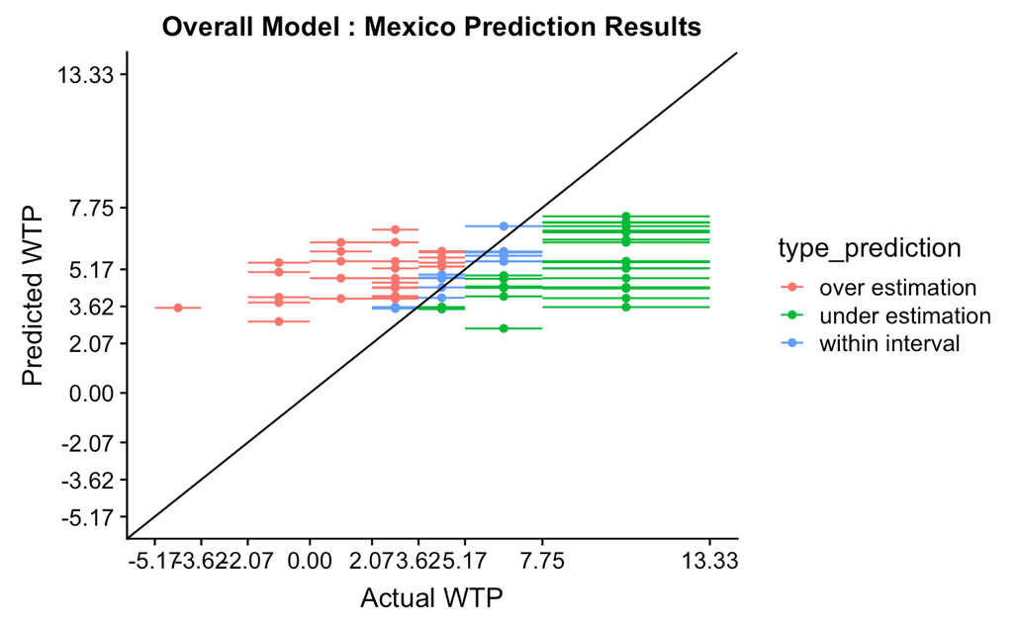

**Indonesia Model Predicted with Mexican Data**

|  |  |  |  |  |
| --- | --- | --- | --- | --- |
| **Prediction Type** | **Number** | **Percentage** | **Average difference from lower limit** | **Average difference from upper limit** |
| Over estimation | 25 | 30.9% | 4.11 | 2.35 |
| Under estimation | 39 | 48.1% | -2.11 | -6.02 |
| Within Interval | 17 | 21% | 0.811 | --1.1 |

On average, if a prediction falls out of the actual range, and is an over estimation our model predicts $2.35 higher than the upper bound and $4.11 higher than the lower bound.

On average, if a prediction falls out of the actual range, and is an underestimation, our model predicts $2.11 lower than the lower bound and $6.02 lower than the upper bound.

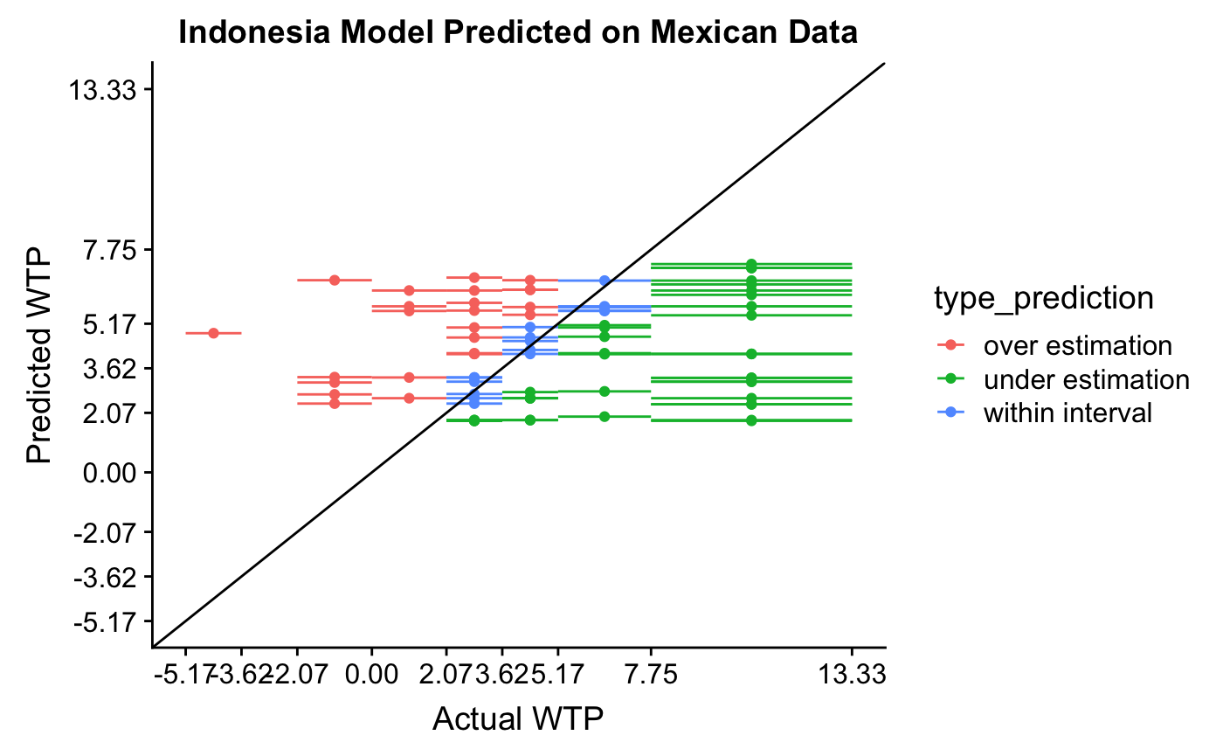

**Mexican Model Predicted with Indonesian Data**

|  |  |  |  |  |
| --- | --- | --- | --- | --- |
| **Prediction Type** | **Number** | **Percentage** | **Average difference from lower limit** | **Average difference from upper limit** |
| Over estimation | 22 | 20.6% | 4.16 | 2.32 |
| Under estimation | 75 | 70.1% | -3.42 | -5.34 |
| Within Interval | 10 | 9.3% | 0.737 | --1.4 |

On average, if a prediction falls out of the actual range, and is an over estimation our model predicts $2.32 higher than the upper bound and $4.16 higher than the lower bound.

On average, if a prediction falls out of the actual range, and is an underestimation, our model predicts $3.42 lower than the lower bound and $5.34 lower than the upper bound.

