**JAVASCRIPT UI & DOM**

**COLORING GAME**

/TEAMWORK by TEAM “Rusty Nail”/

**The team:**

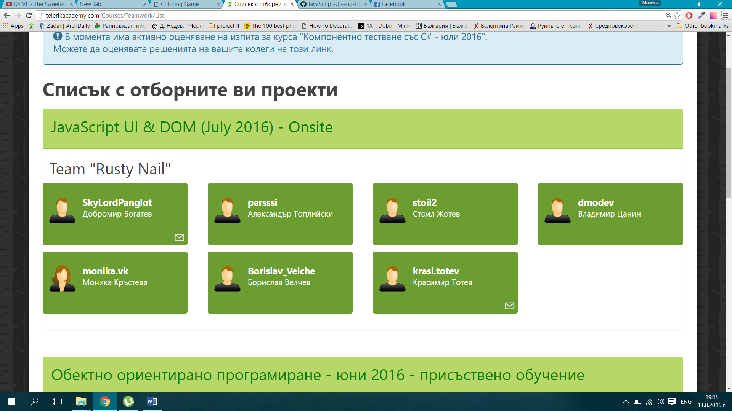

**Game description:**

The app is for coloring images. You can choose between 5 hand-made drawings of favorite movie characters or a blank sheet, where you can express yourself. Also a different coloring tools are provided – marker, crayon, pen – each with a specific behavior of coloring. You can choose between 10 different colors and 4 sizes. You can enjoy yourself and develop your computer coloring skills. And don’t worry if you make mistakes – there is an eraser and you can easy correct your mistakes. Enjoy the pleasant sound, which you can control from the icon in the upper left corner, and start coloring right now.

**The interface:**

**How it works:**

- Choose a picture or a blank sheet

- Choose tool for coloring/crayon, marker, pen/

- Choose the size and the color

- Don’t be afraid to make mistakes – use the eraser

- stop/start the music from the icon

**App organization:**

**-**