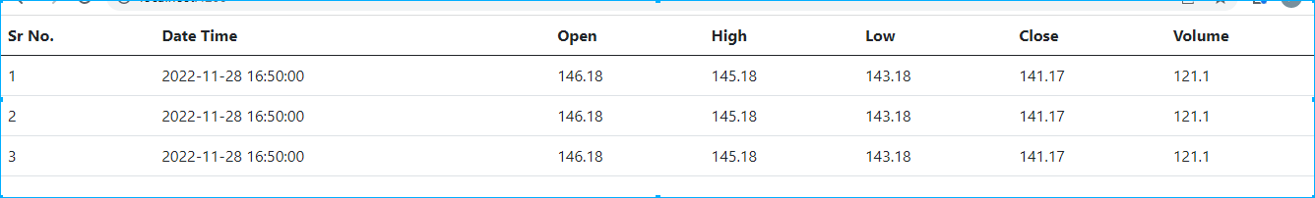

app.html code

<table class="table" >

  <thead>

    <tr>

      <th scope="col">Sr No.</th>

       <th scope="col">Date Time</th>

      <th scope="col">Open</th>

      <th scope="col">High</th>

      <th scope="col">Low</th>

      <th scope="col">Close</th>

      <th scope="col">Volume</th>

    </tr>

  </thead>

  <tbody>

    <tr *ngFor ="let task1 of userResponse index as i" >

      <td>{{i+1}}</td>

      <td>{{task1.datetime}}</td>

      <td>{{task1.open}}</td>

      <td>{{task1.high}}</td>

      <td>{{task1.low}}</td>

      <td>{{task1.close}}</td>

      <td>{{task1.volume}}</td>

    </tr>

  </tbody>

</table>

App.ts

import { Component } from '@angular/core';

import { TaskServiceService } from './task-service.service';

@Component({

  selector: 'app-root',

  templateUrl: './app.component.html',

  styleUrls: ['./app.component.scss']

})

export class AppComponent {

  title = 'Task';

  userResponse:any

constructor(private mainService:TaskServiceService){}

ngOnInit(): void {

  this.getUser()

}

getUser(){

  this.mainService.getData().subscribe((response:any)=>{

  console.log("this response"+response)

    this.userResponse=response

  })

}

}

Service.ts (service file)

import { HttpClient } from '@angular/common/http';

import { Injectable } from '@angular/core';

@Injectable({

  providedIn: 'root'

})

export class TaskServiceService {

  constructor(private _http:HttpClient) { }

  getData(){

    return this._http.get("http://localhost:3000/Time")

  }

}

Data in Json

{

    "Time": [

      { "id":1,

      "datetime":"2022-11-28 16:50:00",

        "open":146.1800,

        "high":145.1800,

        "low":143.1800,

        "close":141.1700,

        "volume":121.100

      },

      {"id":2,

      "datetime":"2022-11-28 16:50:00",

      "open":146.1800,

      "high":145.1800,

      "low":143.1800,

      "close":141.1700,

      "volume":121.100

      },

      {

        "id":3,

        "datetime":"2022-11-28 16:50:00",

        "open":146.1800,

        "high":145.1800,

        "low":143.1800,

        "close":141.1700,

        "volume":121.100

      }

    ]}