The Experiment Report of Machine Learning

October 24, 2019

Grade:
Undergraduate

Student ID：
201730683321

Supervisor:
Mingkui Tan

Author:
Xiaoxuan Peng
SUBJECT: SOFTWARE ENGINEERING

SCHOOL: SCHOOL OF SOFTWARE ENGINEERING

Linear Regression and Stochastic Gradient Descent

Abstract—This experiment intends to use closed-form solution and Stochastic Gradient Descent(SGD) for the linear regression problem.

INTRODUCTION
Linear regression model is the basic model for machine learning. We can use closed-form solution to find out the parameter $w$ and stochastic gradient descent to find the best parameter $w$ to minimize the loss function. In this experiment, I implement these two methods on a housing dataset.

METHODS AND THEORY
- Linear Regression Model
Consider function $f(x;w)$ with parameters $w∈R^{m}$ and
b $∈R$, also with input $x$ where $x_{j}∈R$ features for j from 1 to m.
The Model Function is:
$f(x;b,w)=w^{T}x+b$

- Loss Function
In this experiment, I use least squared loss function:

$$L_{D}(w)=\frac{1}{2}\sum_{i=1}^{m}{1}(y_{i}-\overset{^}{y_{i}})^{2}$$
The goal is use this loss function to find the best parameter $w$ :
$$w^{*}=arg\min_{w}⁡L_{D}(w)$$

C．Closed-form Solution
$\frac{∂L_{D}\left(w\right)}{∂w}=-X^{T}y+X^{T}Xw=0⇒X^{T}Xw=X^{T}y⇒w=(X^{T}X)^{-1}X^{T}y$

Solve for optimal parameter $w$ :
$w^{*}=(X^{T}X)^{-1}X^{T}y=\arg{\min_{w}}⁡L_{D}(w)$

D. Stochastic Gradient Descent
We use $d=-\frac{∂L_{D}w}{∂w}$ as the direction of optimization.

Gradient(vector of partial derivatives):
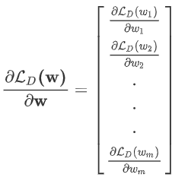
For L2-Loss, the gradient is:
$grad L(w)=X^{T}(Xw-y)$

Experiment
- Dataset
This dataset is a scaled housing dataset in LIBSVM Data with 506 samples and each sample has 13 features. The features are all scaled from -1 to 1 so we don’t need to normalize the data.

- Implementation
- Initialization
The dataset is split into two parts, 80% for training set and 20% for validation set, we don’t generate test set here.
I use random normal distribution to initialize parameter $w$ :
$$w∼N(μ=0,σ^{2}=1)$$

- Parameters
- There are no parameters in closed-form solution.
- There are two hyperparameters in stochastic gradient descent. The detailed information about these two hyperparameters is listed below.

Table 1-Hyperparameters in SGD

Parameters | Value
Learning rate | 0.0008
Number of epochs | 500

- Results
- Closed-form solution
The loss values are listed below. Figure 1 listed below shows the closed-form prediction on validation set.

Table 2-Loss values result
Items | Loss value
Initial training set | 270.285
Trained training set | 11.863
Trained validation set | 13.604

Figure 1-Closed-form prediction on validation set
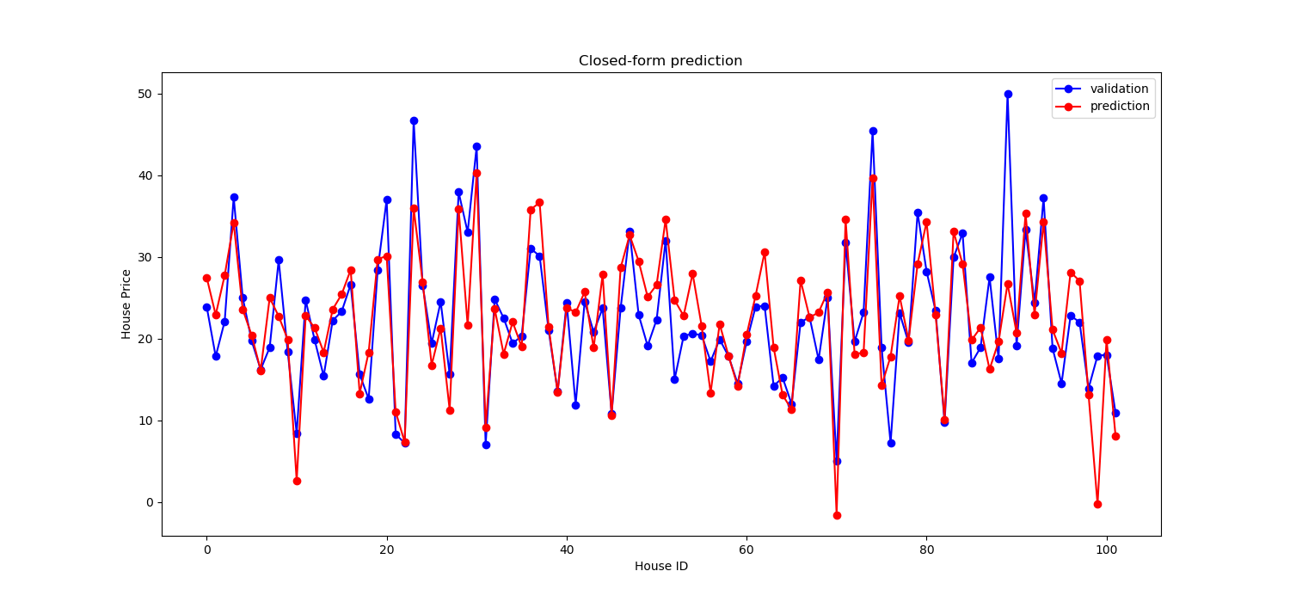

b) Stochastic Gradient Descent
The loss values are listed below. Figure 2 listed below shows the loss values on both training set and validation set. Figure 3 listed below shows the L2 norm of the $w_{k}$ and$w^{*}$ where $w_{k}$means the $w$after k-th epoch and $w^{*}$means the optimized $w$ solved by the closed-form solution.
Table 3 Loss values result(SGD)
Items | Loss value
Initial training set | 282.8
Trained training set | 11.456
Trained validation set | 15.432

Figure 2-Loss values in SGD
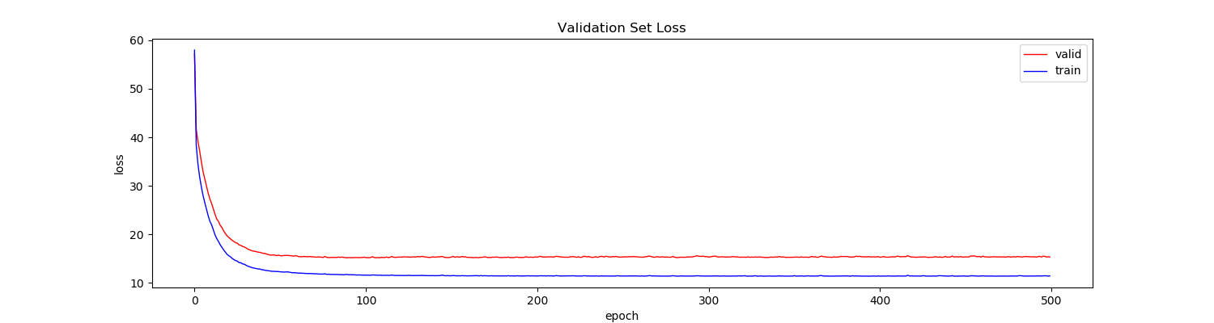

Figure 3-L2 norm of $w_{k}$and $w^{*}$

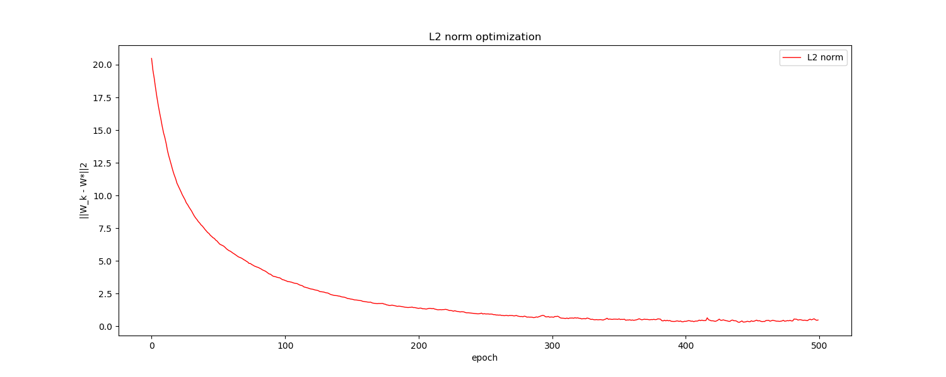

If I use a larger learning rate parameter, for example, learning rate is 0.05,, the figures similar to Figure 2 and Figure 3 are listed below. The results are not converged.

Figure 4-Loss values in SGD(large learning rate)
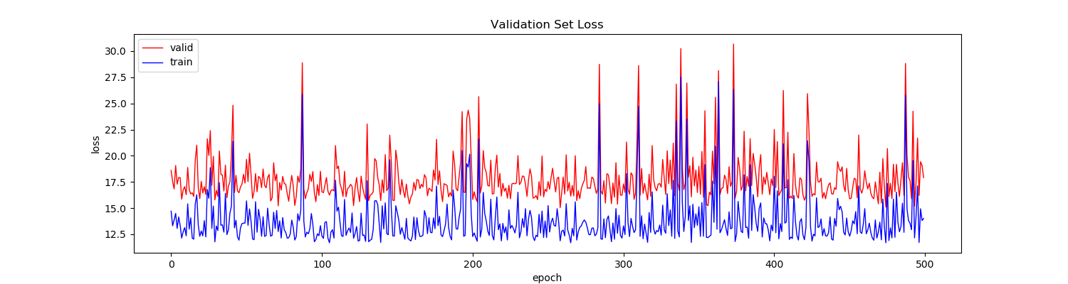

Figure 5-L2 norm of $w_{k}$and $w^{*}$(large learning rate)

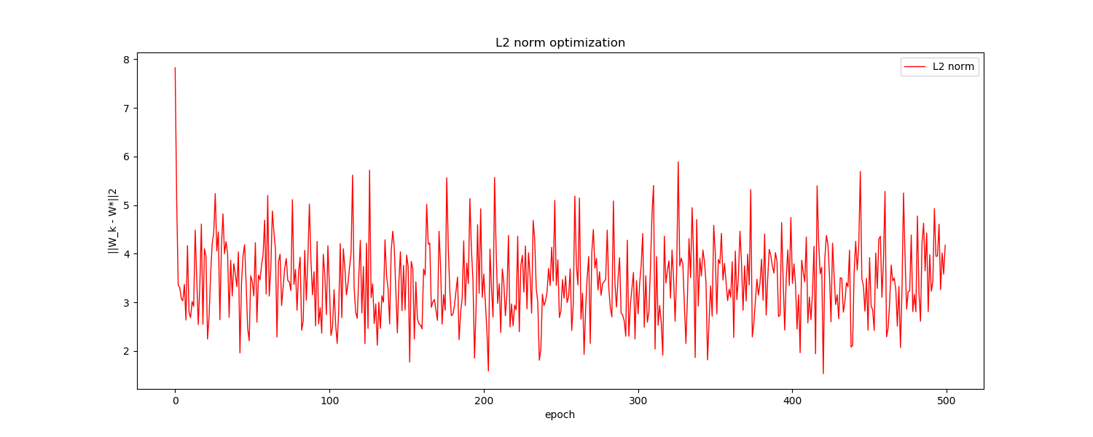

conclusion
Closed-form solution and Stochastic Gradient Descent are two basic methods of linear regression. As for Closed-form solution, there is a problem if the matrix is not invertible. As for SGD, we can minimize loss function well. Also, we must choose a proper hyperparameter, for example, if we use a large learning rate(LR)in this experiment, the result is not converged.

