The Experiment Report of Machine Learning

November 10, 2019

Grade:
Undergraduate

Student ID：
201730683321

Supervisor:
Mingkui Tan

Author:
Xiaoxuan Peng
SUBJECT: SOFTWARE ENGINEERING

SCHOOL: SCHOOL OF SOFTWARE ENGINEERING

Face Detection Based on Neural Network
Abstract—The experiment intends to use a given model to test the function about face detection based on neural network.

INTRODUCTION
There are many methods to implement face detection model, in this experiment, we use MTCNN(Multi-task Convolutional Nerual Network) to implement it. It contains three layers network structure, including P-Net(Proposal Network), R-Net(Refine Network) and O-Net(Output Network).

METHODS AND THEORY
- P-Net(Proposal Network)
It is called Proposal Network, and its basic structure is a fully connected Network. For the image pyramid constructed in the previous step, an FCN is used for preliminary feature extraction and calibration of Bounding Box Regression window and NMS for filtering most of the Windows.

- R-Net(Refine Network)
It is called Refine Network and it is basically constructed as a Convolutional Neural Network(CNN). Compared with the p-net in the first layer, a full connection layer is added, so the filtering of input data will be more rigorous. After p-net, a lot of prediction Windows will be left behind, and we will send all the prediction Windows into r-net. This network will filter out a large number of candidate boxes with relatively poor effects, and finally conduct Bounding Box Regression and NMS for the selected candidate boxes to further optimize the prediction results.

- O-Net(Output Network)
Fully known as Output Network, the basic structure is a relatively complex Convolutional Neural Network(CNN) with one more convolutional layer than R-net. The difference between O-net and R-net is that this layer will recognize the facial area through more supervision, and it will return the facial feature points of people, and finally output the facial feature points of five people.

Experiment
- Dataset
The dataset is WIDER FACE. The dataset contains 32,203 images and 393,703 labeled faces with a high degree of variability in scale, pose and occlusion as depicted in the sample images. WIDER FACE dataset is organized based on 61 event classes. For each event class, we randomly select 40%/10%/50% data as training, validation and testing sets.

- Implementation
- Initialization
- Net:
self.pre_layer = nn.Sequential(
nn.Conv2d(3, 10, kernel_size=3, stride=1), # conv1
nn.PReLU(), # PReLU1
nn.MaxPool2d(kernel_size=2, stride=2), # pool1
nn.Conv2d(10, 16, kernel_size=3, stride=1), # conv2
nn.PReLU(), # PReLU2
nn.Conv2d(16, 32, kernel_size=3, stride=1), # conv3
nn.PReLU() # PReLU3
)

# detection
self.conv4_1 = nn.Conv2d(32, 1, kernel_size=1, stride=1)
# bounding box regresion
self.conv4_2 = nn.Conv2d(32, 4, kernel_size=1, stride=1)

R-Net:
self.pre_layer = nn.Sequential(
nn.Conv2d(3, 28, kernel_size=3, stride=1), # conv1
nn.PReLU(), # prelu1
nn.MaxPool2d(kernel_size=3, stride=2), # pool1
nn.Conv2d(28, 48, kernel_size=3, stride=1), # conv2
nn.PReLU(), # prelu2
nn.MaxPool2d(kernel_size=3, stride=2), # pool2
nn.Conv2d(48, 64, kernel_size=2, stride=1), # conv3
nn.PReLU() # prelu3

)
self.fc = nn.Linear(64*2*2, 128)
self.prelu4 = nn.PReLU() # prelu4
# detection
self.conv5_1 = nn.Linear(128, 1)
# bounding box regression
self.conv5_2 = nn.Linear(128, 4)

- Net:
self.pre_layer = nn.Sequential(
nn.Conv2d(3, 32, kernel_size=3, stride=1), # conv1
nn.PReLU(), # prelu1
nn.MaxPool2d(kernel_size=3, stride=2), # pool1
nn.Conv2d(32, 64, kernel_size=3, stride=1), # conv2
nn.PReLU(), # prelu2
nn.MaxPool2d(kernel_size=3, stride=2), # pool2
nn.Conv2d(64, 64, kernel_size=3, stride=1), # conv3
nn.PReLU(), # prelu3
nn.MaxPool2d(kernel_size=2,stride=2), # pool3
nn.Conv2d(64,128,kernel_size=2,stride=1), # conv4
nn.PReLU() # prelu4
)
self.fc = nn.Linear(128*2*2, 256)
self.prelu5 = nn.PReLU() # prelu5
# detection
self.conv6_1 = nn.Linear(256, 1)
# bounding box regression
self.conv6_2 = nn.Linear(256, 4)
# lanbmark localization
self.conv6_3 = nn.Linear(256, 10)

- Parameters
Table 1 shown below listed some important parameters used in this experiment.

Table 1-Some Parameters in MTCNN_pytorch
Parameters | Values
Train_BATCH_SIZE | 128
Train_LR | 0.01
END_EPOCH | 10

- Results
Take an example here. Figure 1 shows the initial image that will be used in face detection model and Figure 2 shows the final image that has been used in face detection model.

Figure 1-Initial image
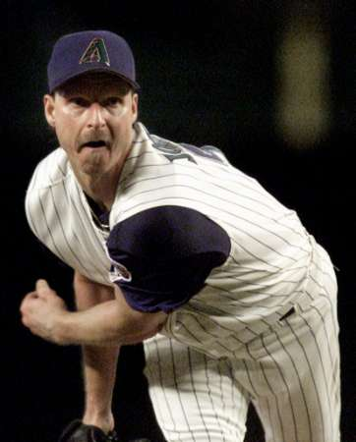

Figure 2-Result image
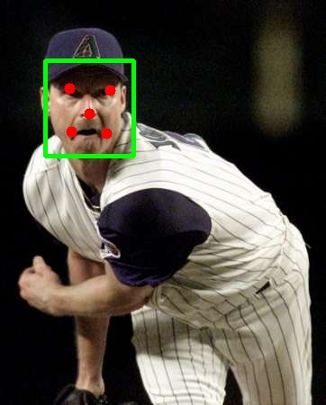

conclusion
In this experiment, I have learned that MTCNN is a powerful network structure used in face detection field. It puts face area detection and face key point detection together, and its theme framework is similar to cascade. The whole network can be divided into three layers: P-Net, R-Net and O-Net.

