The Experiment Report of Machine Learning

November 4, 2019

Grade:
Undergraduate

Student ID：
201730683321
20
Supervisor:
Mingkui Tan

Author:
Xiaoxuan Peng

SUBJECT: SOFTWARE ENGINEERING

SCHOOL: SCHOOL OF SOFTWARE ENGINEERING

Recommender System Based on Matrix Decomposition

Abstract—This experiment intends to use ALS or SGD or other methods to implement a recommender system based on matrix decomposition.

INTRODUCTION
Recommender system is a common technique to recommend something such as movies, goods for us based on our favourites. In the experiment, I use SGD to implement a small recommender system based on matrix decomposition.

METHODS AND THEORY
- Collaborative Filtering
Make automatic predictions (ﬁltering) about the interests of a user by collecting preferences or taste information from many other users (collaboration).
There are some types of collaborative filtering.

Memory-based CF: utilize the entire user-item database to generate a prediction.

Model-based CF: build a model from the rating data ( Matrix factorization, etc.) and use this model to predict missing ratings.
In this experiment, I use model-based CF.

- Matrix Factorization
·Give a rating matrix $R∈R^{mx⁡n}$, with sparse ratings from m users to n items.
·Assume rating matrix $R$ can be factorized into the multiplication of two low-rank feature matrices $P∈R^{\operatorname{mx}{k}}$
And $Q∈R^{kx⁡n}$

- Stochastic Gradient Descent(SGD) in Matrix Factorization
·SGD is to minimize the following objective function:

$$L=\sum_{u,i∈Ω}{`}(r_{u,i}-p_{u}^{T}q_{i})^{2}+λ_{p}‖p_{u}‖^{2}+λ_{q}‖q_{i}‖^{2}$$
Notes:
$$P=[p_{1},p_{2},···,p_{m}]^{T}∈R^{mx⁡k}$$
$$Q=[q_{1},q_{2},···,q_{n}]∈R^{kx⁡n}$$
$r_{u,i}$ denotes the actual rating of user u for item i
$Ω$ denotes the set of observed samples from rating matrix $R$
$λ_{p}$ , $λ_{q}$ are regularization parameters to avoid overfitting

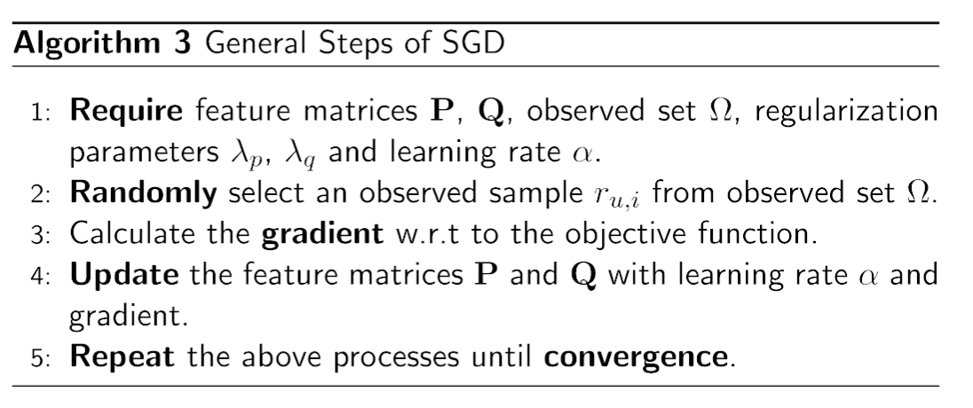

·Calculate the gradient and update the feature matrices
Objective function:
$$L=(r_{u,i}-p_{u}^{T}q_{i})^{2}+λ_{p}‖p_{u}‖^{2}+λ_{q}‖q_{i}‖^{2}$$
We randomly select an observed sample $r_{u,i}$
And then we calculate the prediction error:
$$E_{u,i}=r_{u,i}-p_{u}^{T}q_{i}$$
Also, we calculate the gradient:
$$\frac{∂L}{∂p_{u}}=E_{u,i}(-q_{i})+λ_{p}p_{u}$$

$$\frac{∂L}{∂q_{i}}=E_{u,i}(-p_{u})+λ_{q}q_{i}$$

Finally, we update the feature matrices $P$ and $Q$ with learning rate $α$:
$$p_{u}=p_{u}+α(E_{u,i}q_{i}-λ_{p}p_{u})$$

$$q_{i}=q_{i}+α(E_{u,i}p_{u}-λ_{q}q_{i})$$

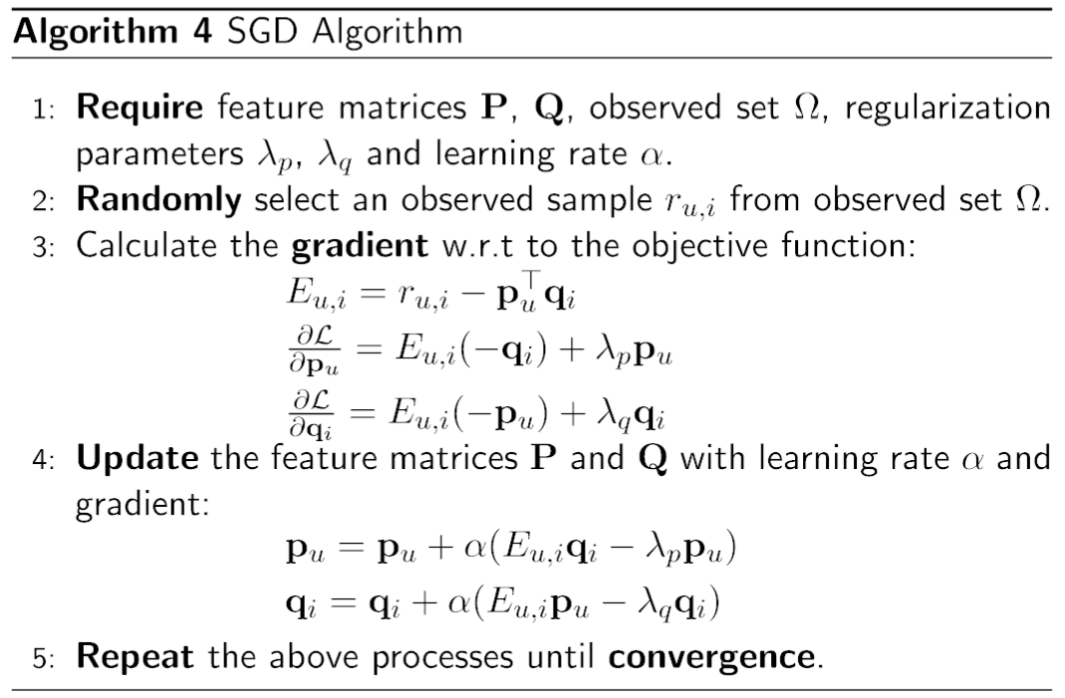

Experiment
- Dataset
This dataset is MovieLens-100k dataset. u.data in the dataset contains 10000 ratings on 1682 movies from 943 users. Each user has rated at least 20 movies. user_id and item_id are marked with the beginning of number 1. Also, the data is distributed randomly.

- Implementation

Initialization
In this experiment, I initialize the initial rating matrix with all zero and I initialize users matrix P and items matrix Q by random distribution method.

Parameters
Table 1 shown below shows all the parameters in the experiment.

Table 1-SGD on matrix decomposition
Parameters | Values
Learning rate | 0.0002
Number of iterations | 50
Penalty factor | 100
Number of potential features | 150

Results
Figure 1 shown below shows the result using the parameters listed above.

Figure 1-Loss value result
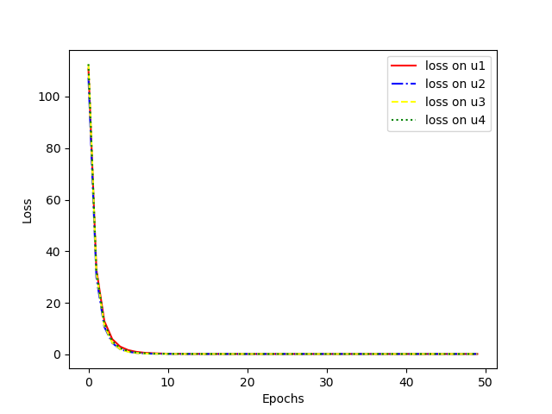
Figure 2 shown below shows the result using a smaller potential features. Here, potential features is 50. Initial loss value is small.
Figure 2-Loss value result(Smaller potential features)
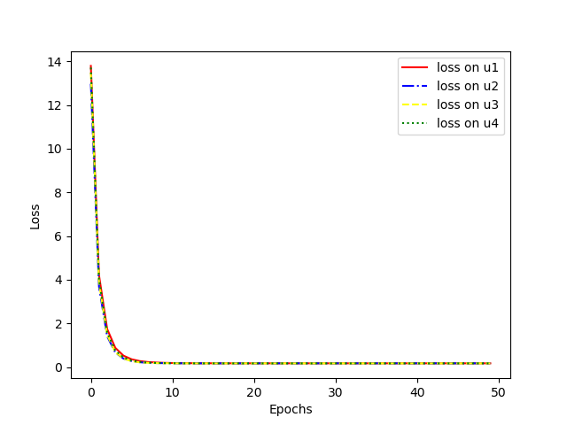
Figure 3 shown below shows the result using a larger potential features. Here, potential features is 350. Initial loss value is large.
Figure 3-Loss value result(Larger potential features)
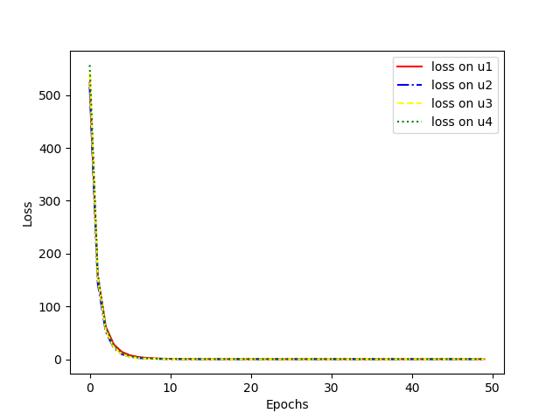

Figure 4 shown below shows the result using a larger penalty factor. Here, penalty factor is 800. Initial loss value is very small and it is very fast to converge.
Figure 4-Loss value result (Larger penalty factor)
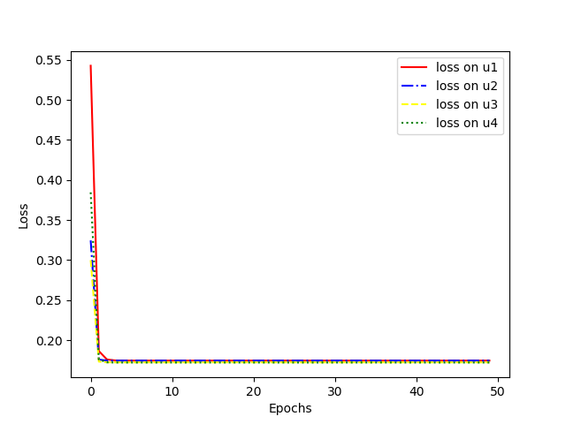
Figure 5 shown below shows the result using a smaller penalty factor. Here, penalty factor is 0.5. Initial loss value is large and it is slow to converge.
Figure 5-Loss value result(Smaller penalty factor)
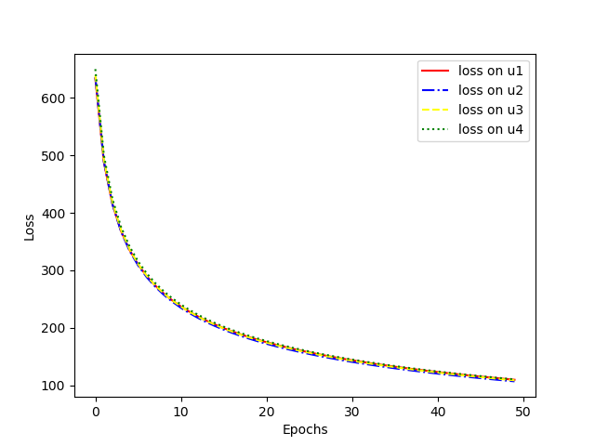

Figure 6 shown below shows the result using a smaller learning rate(LR). Here, learning rate is 1e-7. Initial loss value is very large and it is very slow to converge.
Figure 6-Loss value result(Smaller learning rate)
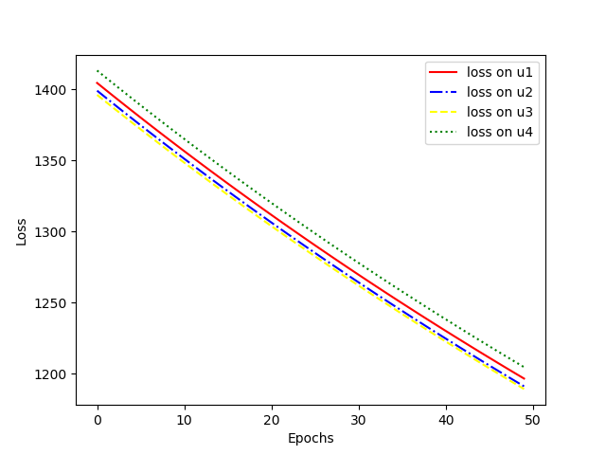
Figure 7 shown below shows the result using a larger learning rate(LR). Here, learning rate is 0.01. Initial loss value is very small and it is very fast to converge.
Figure 7-Loss value result(Larger learning rate)
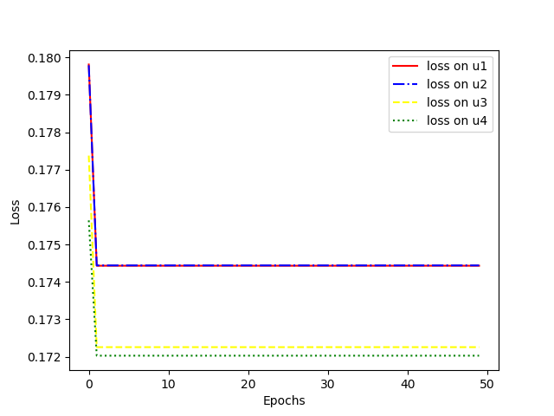

conclusion

Recommender system is a common technique to recommend something useful for users. There are many methods and models to implement a recommender system such as ALS, SGD, SVD.

Parameters will play an important role in the performance of the models. A large learning rate will make the loss function faster to converge or it won’t be converged. A small learning rate will make the loss function slower to converge. A large potential features will make the initial loss value larger. A small potential features will make the initial loss value smaller. Also, a large penalty factor will make the initial loss value smaller and it will be faster to converge in this experiment. A small penalty factor will make the initial loss value larger and it will be much slower to converge.

