The Experiment Report of Machine Learning

November 2, 2019

Grade:
Undergraduate

Student ID：
201730683321

Supervisor:
Mingkui Tan

Author:
Xiaoxuan Peng

SUBJECT: SOFTWARE ENGINEERING

SCHOOL: SCHOOL OF SOFTWARE ENGINEERING

Face Detection Based on AdaBoost Algorithm
Abstract—This experiment intends to use Adaboost to solve the face detection problem and combine the theory with the actual project.

INTRODUCTION
Adaboost is a kind of ensemble methods to combine some different weak classifiers to form a strong classifier. In this experiment, I use decision trees with a small height as the weak classifiers to form a strong classifier in face-detection problem.

METHODS AND THEORY
- Sample weight updating formula
$$w_{m+1}(i)=\frac{w_{m}(i)}{z_{m}}e^{-α_{m}y_{i}h_{m}(x_{i})}$$

$z_{m}=\sum_{i=1}^{n}{1}w_{m}(i)e^{-α_{m}y_{i}h_{m}(x_{i})}$ is normalization term, makes $w_{m}(i)$ become probability distributions.

$$w_{m+1}(i)=\{\begin{matrix}\frac{w_{m}(i)}{z_{m}}e^{-α_{m}} & \text{for right predictive sample} \\ \frac{w_{m}(i)}{z_{m}}e^{α_{m}} & \text{for wrong predictive sampl}\text{e}\end{matrix}$$

So in next round, $\frac{w_{wrong}(i)}{w_{right}(i)}=e^{2α_{m}}=\frac{1-ϵ_{m}}{ϵ_{m}}$ and $ϵ_{m}$<0.5, wrong samples will be more important.

- Evaluate the performance of the base learner

Base learner:
$$h_{m}\left(x\right):x↦\left\{-1,1\right\}$$

Error rate:
$$ϵ_{m}=p(h_{m}(x)≠y_{i})=\sum_{i=1}^{n}{1}w_{m}(i)I(h_{m}(x_{i})≠y_{i})$$
$ϵ_{m}<0.5 , or$ the performance of Adaboost is weaker than random classiﬁcation.

Important score of base learner:
$$α_{m}=\frac{1}{2}log⁡\frac{1-ϵ_{m}}{ϵ_{m}}$$
Make the base learner with lower $ϵ_{m}$more important.

- Additive model
Final learner:
$$H(x)=sign⁡(\sum_{m=1}^{M}{1}α_{m}h_{m}(x))$$
Note: $h_{m}(x)=\operatorname{sign}\left(w^{T}x\right)$ is a nonlinear function, so the Adaboost can deal with nonlinear problem.

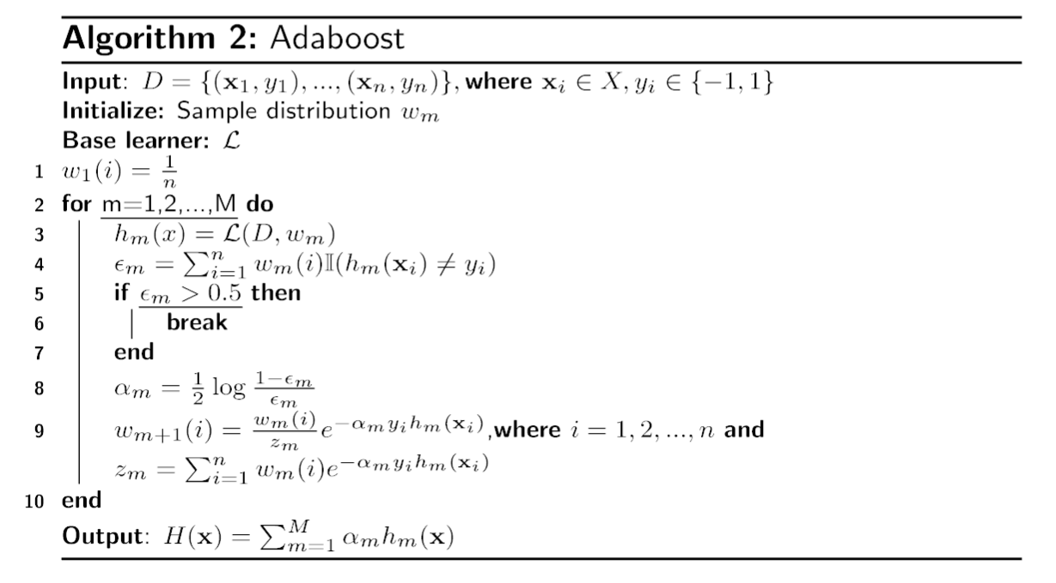

Experiment
- Dataset
This dataset contains 1000 images. There are 500 RGB images with face included and there are 500 RGB images without face.

- Implementation
- Initialization
The dataset is split into two parts, 70% for training set and 30% for validation set, we don’t generate test set here.
Also, I initialize parameter w with a vector filled with 1.

- Parameters
Table 1 shown below lists all the parameters.
Table 1-Parameters in Adaboost
Parameters | Values
DecisionTree-criterion | entropy
DecisionTree-max_depth | 2
DecisionTree-class_weight | balanced
Number of weak classifiers | 15

- Results

Face classification using Adaboost
Table 2 shown below list the result computed by classification_report() function in sklearn.metrics library.
Table 2-Final result in Adaboost
 | precision | recall | F1-score | support
face | 0.80 | 0.89 | 0.84 | 149
nonface | 0.88 | 0.77 | 0.82 | 151
accuracy |  |  | 0.83 | 300
Macro avg | 0.84 | 0.83 | 0.83 | 300
Weighted avg | 0.84 | 0.83 | 0.83 | 300

Face detection using Haar Feature-based Cascade Classifiers
Figure 1 shown below shows the initial image with a face, figure 2 shown below shows the result image after using face detection method.

Figure 1-initial image
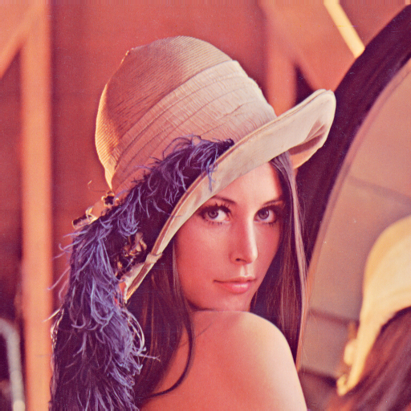

Figure 2-result image
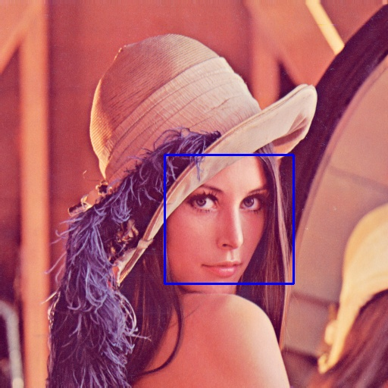

conclusion
- OpenCV library in python is a powerful library to process images.
- Adaboost is a useful ensemble method to combine some weak classifier(base learner) to form a strong classifier.
- As a weak classifier in the experiment, the height of the Decision tree should not be too deep, otherwise only a DecisionTreeClassifier can classify the face well.

