**TUNKU ABDUL RAHMAN UNIVERSITY OF MANAGEMENT AND TECHNOLOGY**

**FACULTY OF COMPUTING AND INFORMATION TECHNOLOGY**

**Assignment Title**

**BMCS2114 MACHINE LEARNING**

2024/2025

| Student’s name/ ID Number | : | Pang Zan Lam / 22WMR13622 |
| --- | --- | --- |
| Student’s name/ ID Number | : | Rishiiy A/L Tharmalingam / 22WMR15019 |
| Programme | : | RDS |
| Tutorial Group | : | G4 |
| Tutor’s name | : | Lim Siew Mooi |

Title

WORLD MARRIAGE DATASET

Abstract

This study utilizes the World Marriage Dataset, a comprehensive dataset detailing marital status by age and sex for 232 countries or regions from 1970 to 2019, to analyze global trends in marriage, divorce, and singlehood. With over 271,605 entries, the dataset provides valuable insights into how marital status varies across different age groups and between genders over time. The research aims to identify global and regional patterns in marital status, examine the impact of age on marital transitions, and assess the influence of data collection methods on reported statistics. Additionally, the study explores how socioeconomic and cultural factors may shape these trends. Findings from this analysis will contribute to a deeper understanding of demographic shifts and inform policies on marriage and family structures worldwide.

Keyword: World Marriage Dataset, Global trends, Marital status, Marriage, Divorce, Singlehood, Age, Gender, Data collection methods, Socioeconomic factors, Cultural factors, Demographic shifts, Policies on marriage and family structures.

Introduction

World Marriage encompasses diverse marriage practices and institutions worldwide, varying greatly between different cultures. From arranged marriages in South Asia to evolving concepts in the West, this field of study explores how cultural, economic, and social factors influence marriage. It delves into the implications for individual identity, gender roles, and family dynamics, providing insight into how marital institutions are shaped by global and local contexts.

Detailed data on marital status worldwide from 1970-2019 across 232 countries, offering a comprehensive overview. Dataset with 271,605 rows and 9 columns showcases marital status distribution by age group and gender. The dataset includes information on age groups, marital status, and sex in various countries/regions collected over almost 50 years. It also documents data collection methods, years of data collection, and information sources to maintain accuracy and reliability of statistics.Essential for researchers, sociologists, and policymakers investigating international marital patterns. It provides comprehensive information on marriage statuses in different demographics and regions, enabling thorough examination of societal trends. This source helps guide choices regarding family policies, social welfare, and demographic research, supporting historical examination and forecasting future patterns.

In accordance with these research aims, a series of relevant research inquiries and hypotheses have been crafted to steer our empirical investigation. Through tackling these queries and validating the proposed hypotheses, this study aspires to enrich the expanding body of knowledge concerning this world marriage dataset.

Literature Review

A)Kmeans clustering

App 1: Identifying country groups based on marriage patterns

K-means clustering has been extensively utilized in demographic research to uncover patterns within populations, especially when examining the intersection of socio-cultural and economic factors. In the context of Mozambique, marriage patterns are intricately linked to ethnic identity, as demonstrated by Carlos (2003), who used multivariate analysis on data from the 1997 Census and MDHS to investigate the influence of ethnicity on marriage behaviors across five ethnic groups. The study revealed that even when controlling for socio-economic and demographic factors, cultural distinctions between matrilineal and patrilineal groups significantly shaped marriage patterns. Matrilineal groups exhibited earlier marriages, lower rates of polygyny, and higher incidences of marital dissolution compared to their patrilineal counterparts. These findings highlight the importance of ethnicity in influencing demographic behavior, and K-means clustering proves to be an effective tool for grouping countries or ethnic groups based on similar marriage patterns, offering valuable insights into how cultural and socio-economic characteristics shape marriage dynamics in sub-Saharan Africa.

App 2: Analyze marriage patterns' ties to demography

K-means clustering has proven to be an effective method for analyzing patterns of assortative matching in marriage, particularly when examining multidimensional traits such as age, education, and health-related behaviors. In the context of marital patterns, the Separable Extreme Value (SEV) model has been extended to analyze homogamy across multiple characteristics, as demonstrated in a study focused on parents in the Campania region of Italy (Guerriero, 2020). The study found that marital patterns are strongly influenced by assortative matching, where individuals tend to marry partners with similar traits, particularly in education and health consciousness. By clustering these multidimensional traits, K-means helps to capture the underlying structure of the marriage market, illustrating how a few key indices of attractiveness drive sorting behaviors. This approach provides valuable insights into the role of assortative matching in contributing to social inequality, particularly through the transmission of human capital and health behaviors, highlighting the utility of K-means in understanding complex socio-demographic patterns

B) Hierarchical Clustering

App 1: Segmenting Age Groups by Marital Status Across Countries

Hierarchical Clustering is a powerful technique for segmenting age groups by marital status and examining patterns related to well-being. Research on the relationship between marital status and well-being, such as a study involving 11,131 Canadians, highlights important variations across age groups in subjective and objective well-being measures (James, 1992). This analysis found that single individuals tended to be healthier than their married counterparts, with the causal link between marriage and well-being supported primarily in life satisfaction, rather than health outcomes. Hierarchical Clustering can help identify distinct clusters of individuals based on marital status, age, and well-being indicators, shedding light on whether marriage causally improves well-being or if happier, healthier individuals are simply more likely to marry. By segmenting age groups in this way, researchers can better understand how marriage impacts different demographics, providing insights into the selection hypothesis versus the causality argument in well-being research. This clustering method is especially useful for policymakers and scholars interested in marital status and health outcomes.

App 2: Analyze marriage patterns evolution with algorithms.

Hierarchical Clustering offers an insightful approach for analyzing the evolution of marriage patterns, especially in relation to assortative matching based on traits like age, education, and health-related behaviors. The Separable Extreme Value (SEV) model, applied in a study of marital patterns in the Campania region of Italy, revealed that homogamy where individuals tend to marry those with similar traits is a dominant feature in the marriage market (Guerriero, 2020). By using a multidimensional analysis, the study found that sorting in marriages can be largely explained by key indices of attractiveness such as education and health consciousness. Hierarchical Clustering can further enhance this analysis by organizing individuals into distinct clusters based on these traits, allowing for a deeper exploration of how assortative matching reinforces social inequality. This method is particularly useful for examining how multidimensional factors influence marital patterns and for understanding the broader social implications of these patterns, such as the distribution of human capital and health behaviors in the population.

C) DBSCAN

App 1: Identifies country marriage patterns, outliers, and exceptional behaviors

DBSCAN clustering, known for identifying clusters of varying shapes and densities, is a valuable tool for exploring complex demographic transitions, such as those seen in France during the 18th and 19th centuries. In investigating why France experienced an earlier demographic transition compared to other European countries, exploratory methods like DBSCAN can classify regions based on marriage patterns and fertility control mechanisms. The study by Faustine (2021) highlights how the French fertility transition was not a linear process but was driven by cultural shifts, modernity, and advancements in gender equality. By clustering French counties based on these influential factors, DBSCAN allows researchers to capture the diverse and non-uniform nature of demographic changes, providing deeper insights into how societal upheavals, like the French Revolution, impacted population dynamics. This method underscores the importance of considering cultural and societal influences in understanding demographic transitions, as well as their broader implications for fertility control and economic development.

App 2: Longitudinal data tracks marriage patterns, informs policy decisions.

DBSCAN clustering, with its ability to identify patterns in complex, non-linear datasets, offers an effective approach for analyzing longitudinal data on marriage patterns and relationship dynamics. Research on intimate communication, personal strengths, vulnerabilities, and the influence of stress on relationship quality provides critical insights into factors that contribute to long-lasting and satisfying adult partnerships (Thomas & Bradbury, 2004). DBSCAN could be employed to group couples based on relationship trajectories, identifying clusters of partnerships characterized by high levels of social support and positive emotions, as well as those vulnerable to stress and conflict. These clusters can offer a deeper understanding of how intimate relationships evolve over time and help policymakers develop targeted interventions to improve relationship quality. By applying DBSCAN to longitudinal data, researchers can inform social policies aimed at fostering enduring partnerships by addressing key relational factors such as emotional resilience, stress management, and communication skills.

D) Gaussian Mixture Model (GMM)

App 1: Identify subpopulations within marriage patterns for understanding

Gaussian Mixture Model (GMM) clustering provides a powerful framework for understanding complex sub-populations within marriage patterns by modeling heterogeneous behaviors in mate selection. The integration of psychological and demographic approaches, as demonstrated in agent-based simulations, sheds light on how individual mate search behaviors based on satisficing heuristics can generate population-level marriage timing distributions (Todd and Billari, 2005). The study highlights the importance of considering individual heterogeneity in producing realistic patterns of marriage timing, suggesting that psychological mechanisms, such as decision-making heuristics, play a crucial role. GMM clustering can capture the diverse sub-populations that arise from such individual-level behaviors, allowing researchers to identify distinct groups based on marriage timing, preferences, and socio-demographic factors. By bridging individual and population-level analyses, GMM clustering offers valuable insights into how personal mate selection strategies contribute to broader marriage patterns, facilitating a deeper understanding of marriage dynamics and informing policies that address demographic changes.

App 2: Study applies marriage patterns to demographics

Gaussian Mixture Model (GMM) clustering offers a robust method for analyzing demographic shifts in marriage patterns, particularly in projecting future trends of late singlehood in East Asian societies. Using large-scale population data, studies have explored how marriage matches norms according to age and education that affect the universality of marriage, as demonstrated by projections of late singlehood in countries like Japan, South Korea, and Taiwan (Albert et al., 2020). GMM clustering helps to identify subpopulations within these societies, allowing for a nuanced understanding of how demographic changes and evolving marriage norms shape marriage patterns. By applying counterfactual scenarios that incorporate gender-symmetrical norms, researchers have projected a substantial increase in late singlehood, with minimal impact from shifts toward gender equality in marriage expectations. This approach provides valuable insights into the broader implications of declining marriage rates for fertility, population growth, and social reproduction in East Asia, emphasizing the importance of understanding marriage patterns in demographic analyses.

E) Spectral Clustering

App 1: Identifying marriage patterns in countries, complex relationships.

Spectral Clustering, known for its ability to identify clusters in complex, high-dimensional data, offers a valuable approach for analyzing marriage patterns across diverse regions in Asia. Comparative studies of marriage systems in East, Southeast, and South Asia reveal significant changes in recent decades, driven by both cultural traditions and demographic shifts (Jones, 2010). Spectral Clustering can help uncover regional variations by grouping countries or populations based on marriage trends such as delayed, early, and arranged marriages. In East and Southeast Asia, traditional arranged marriages are declining, while delayed marriages are becoming more common, with implications for fertility rates and social structures. In contrast, early and consanguineous marriages continue to persist in South Asia, reflecting cultural continuity despite broader societal changes. By using Spectral Clustering, researchers can explore these complex relationships and provide insights into how evolving marriage systems are shaping demographic trends, offering a deeper understanding of the social transformations occurring across Asia.

App 2: Geospatial analysis studies marriage patterns' impact.

Spectral Clustering is an effective method for analyzing complex geospatial data, making it suitable for studying the relationship between armed conflict and the incidence of child marriage. A recent geospatial analysis examined the impact of conflict on child marriage rates across 56 countries, using georeferenced data combined with microdata from over 2 million women (Oliver, 2023). The study found that conflict zones experience a significant rise in child marriages, with an increase of 4.5% to 16.4%, and higher risks in areas affected by more severe conflicts. Spectral Clustering can help identify patterns in the spatial distribution of these incidents, revealing clusters of regions where conflict exacerbates vulnerabilities to child marriage. This clustering approach allows researchers to detect areas with the greatest need for intervention, providing critical insights for policymakers aiming to address the intersection of armed conflict and child marriage. By highlighting these geospatial relationships, Spectral Clustering can inform targeted responses in fragile settings.

Problem Statement

Understanding global trends in marital status across different age groups and genders is crucial for social scientists, policymakers, and demographers. The World Marriage Dataset provides comprehensive data on the marital status such as married, divorced and single of populations segmented by age and sex for 232 countries from 1970 to 2019. The dataset offers a unique opportunity to analyze patterns and trends in marital status across different regions and over time. However, the large volume and diverse sources of data require systematic analysis to uncover meaningful insights.

Objectives

i) Identify Global Marital Status Trends by Age and Sex

ii) Examine Regional Differences in Marital Status

iii) Analyze Changes Over Time from 1970 until 2019

iv) Assess the Impact of Age on Marital Status

v) Evaluate Data Collection Methods and Their Influence on Findings

vi) Explore Socioeconomic and Cultural Influences on Marital Status

By addressing these objectives, this research aims to provide a comprehensive understanding of global marital status trends, enabling better-informed decisions in social policy, economic planning, and cultural studies.

Research Methodology

4.1 Data collection and preparation

This dataset encompasses world marriage datasets from 1970 to 2019 recorded in the countries or different regions of the world with 271605 rows and 9 columns in this dataset. (<https://www.kaggle.com/datasets/dataanalyst001/world-marriage-dataset>).

A subset sample data with 458,452 records is extracted from 1970 to 2019. Upon performing feature selection, 8 features were used in this crime analysis as shown in Table 1.

| Features | Description |
| --- | --- |
| Country | The country of focus |
| Age Group | The age range of the surveyed individuals |
| Sex | The gender of the surveyed individuals |
| Marital Status | The marital status of the individuals, categorized as either "Divorced" or "Married" or "Single" |
| Data Process | The method used to collect the data. |
| Data Collection (Start Year) | The year when data collection began. |
| Data Collection (End Year) | The year when data collection ended. |
| Data Source | The source of the data. |

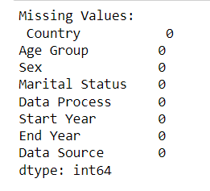

Figure 1: Missing value represented in percentage

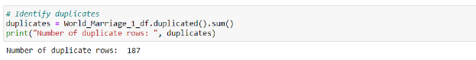

Figure 2 : Duplicate rows found in the dataset

Data collection and preparation are pivotal phases in the research methodology of any project. Our dataset is sourced from kaggle dataset , a trusted and authoritative platform known for providing comprehensive datasets related to world marriage.

As shown in figure 1, this dataset does not contain any missing values but according to figure 2, there are some duplicate rows that are found in this dataset. values. In order to solve it, a few approaches have been taken in order to remove the duplicate values. Additionally, we have conducted Exploratory Data Analysis (EDA), a crucial step that involves visually and statistically exploring the dataset to gain insights, identify patterns, and uncover relationships between variables.

4.2 Exploratory Data Analysis (EDA)

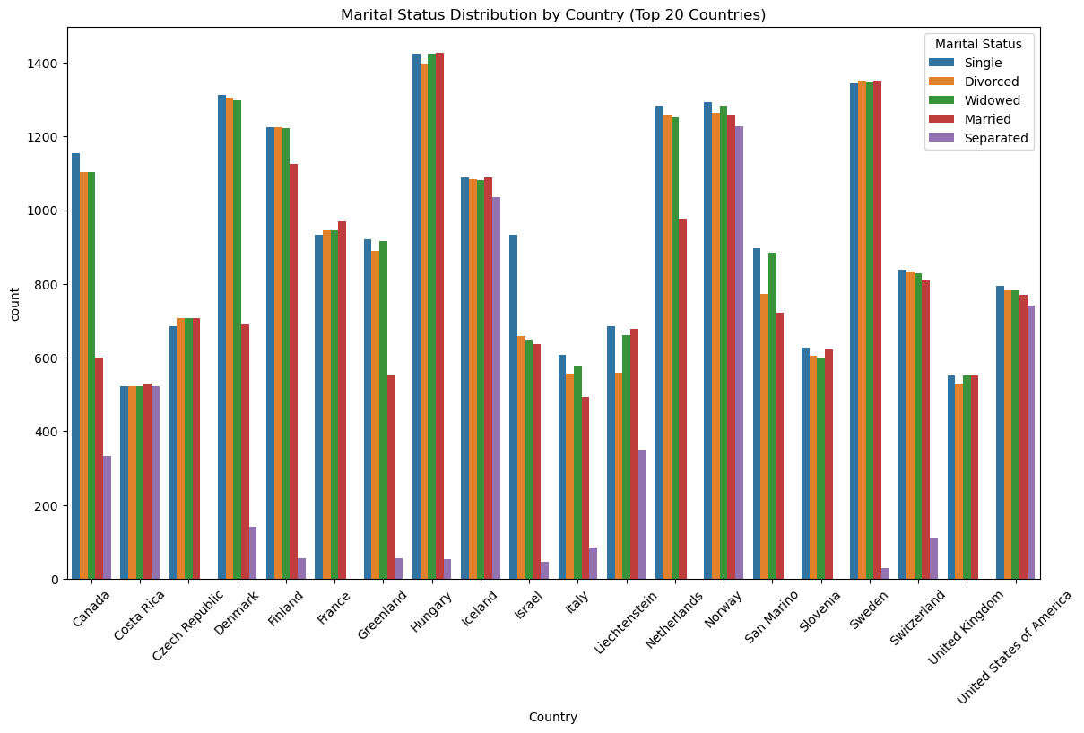

Figure 3: World marital status for top 20 countries

As shown in figure 3, world marital status for top 20 countries that divided by marital status that includes single, divorced,widowed, married and separated.

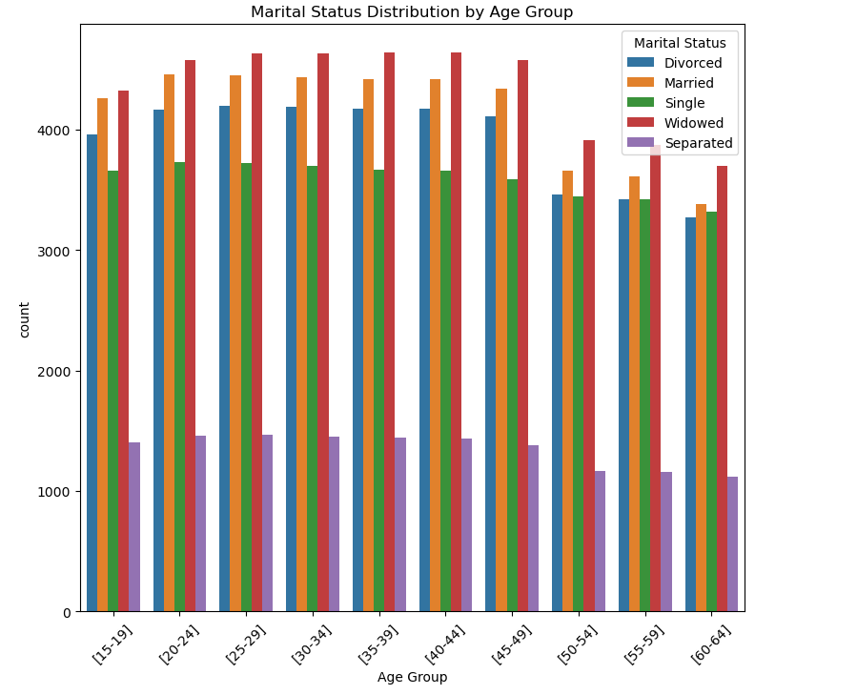

Figure 4: Marital status distribution by age group

As shown in figure 4, world marital status for age group that divided by marital status that includes single, divorced,widowed, married and separated.

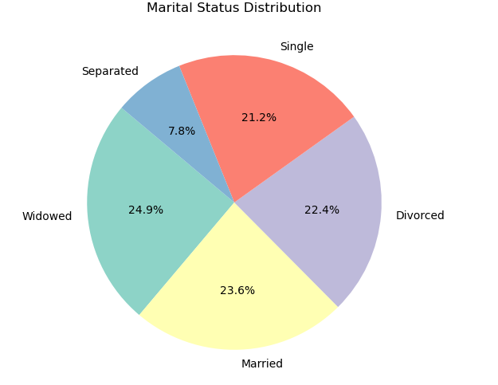

Figure 5: As shown in figure 5, world marital status for distribution that divided by marital status that includes single, divorced,widowed, married and separated.

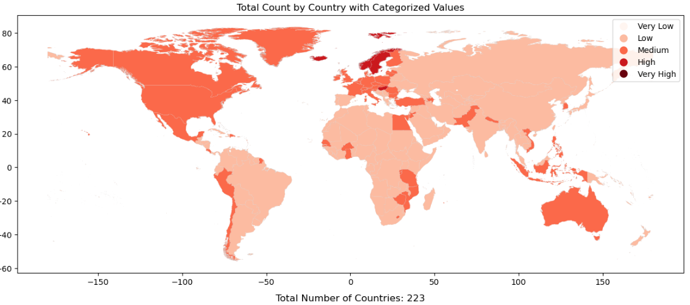

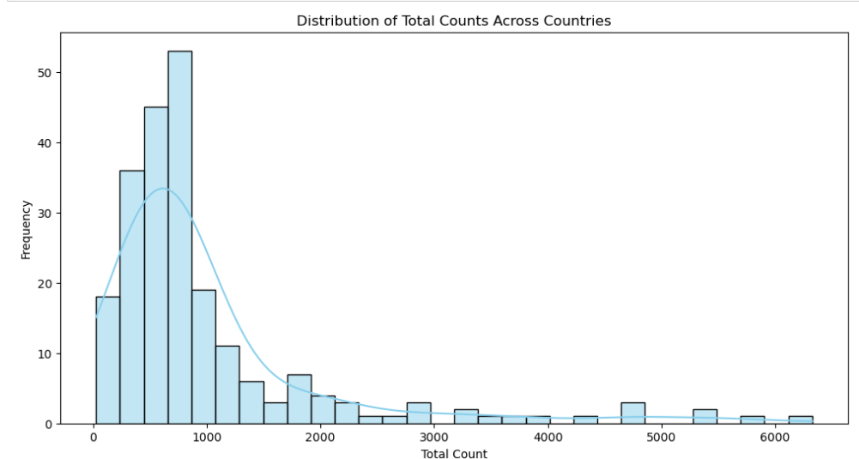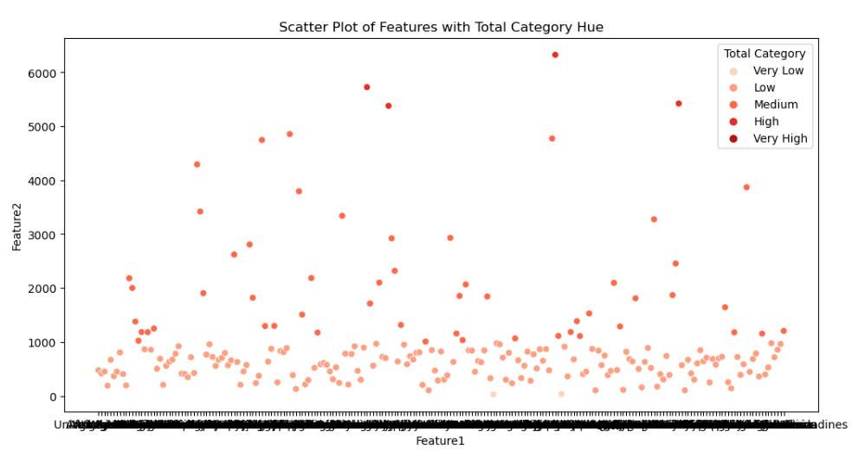

This figures shows that total count by country with categorized values, scatter plot of features with total category and distribution of total counts across countries.

Results and Discussions

A)Kmeans clustering

App 1: Identifying country groups based on marriage patterns

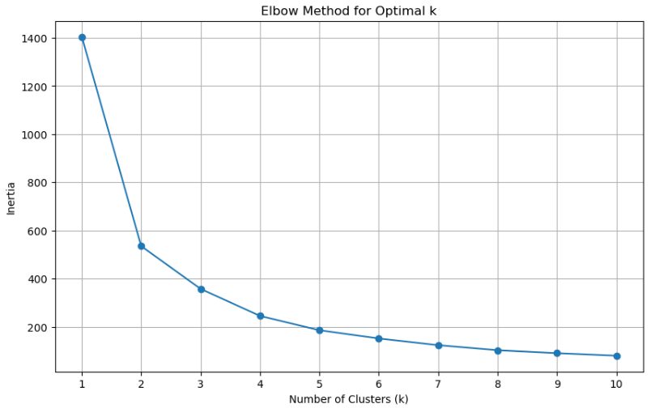 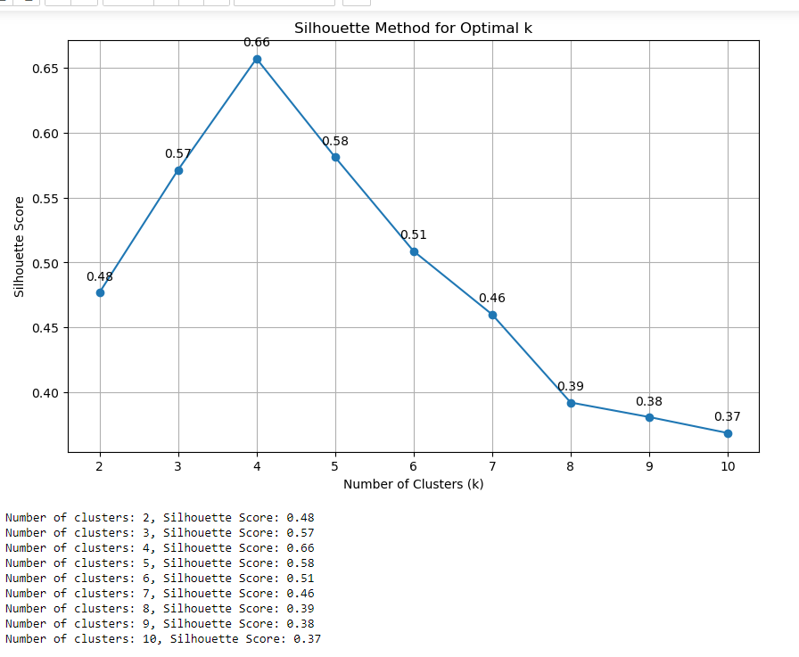

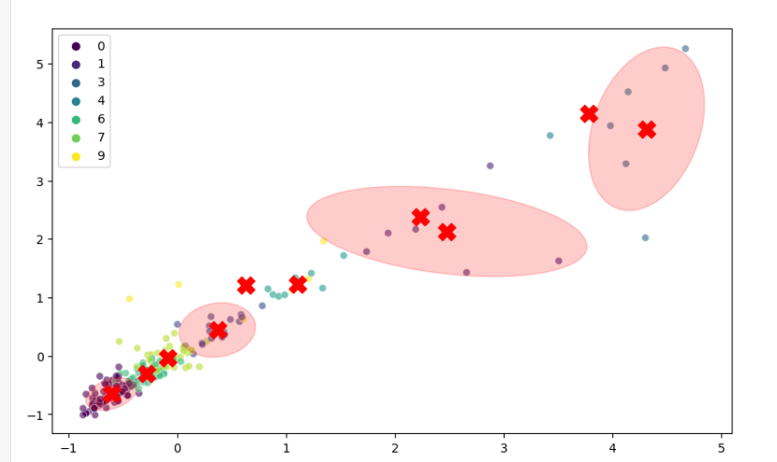

K-means clustering has effectively grouped countries based on their marriage patterns, utilizing both the elbow method and silhouette scores to determine the optimal number of clusters. The elbow method suggested the ideal number of clusters by identifying a point where the within-cluster variance decreases sharply, while the silhouette score provided additional validation of cluster cohesion and separation. The clustered dataset highlights distinct groups of countries with similar marriage patterns, offering valuable insights into how marital trends align across different regions. Overall, K-means clustering, supported by these methods, has provided a robust framework for understanding and analyzing the global distribution of marriage patterns.

App 2: Analyze marriage patterns' ties to demography

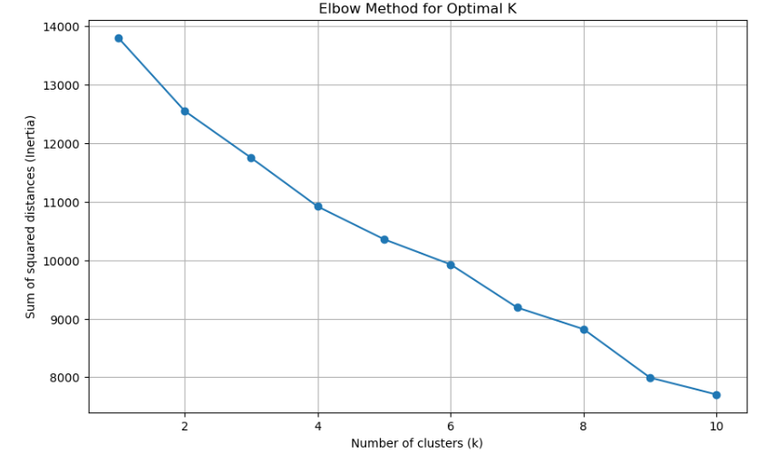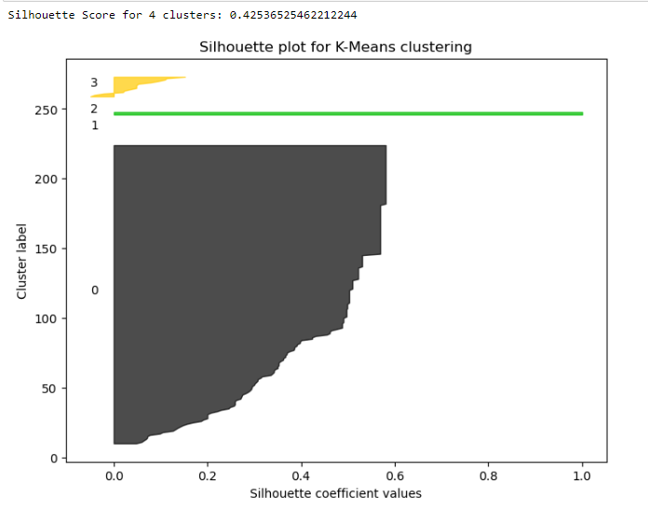

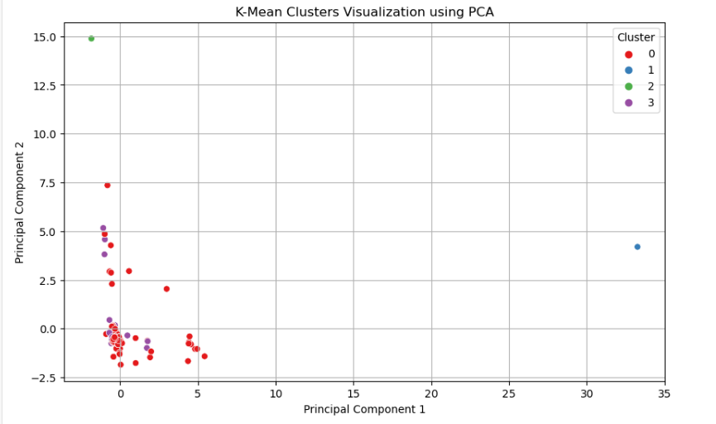

K-means clustering has effectively analyzed the ties between marriage patterns and demographic factors. The elbow method determined the optimal number of clusters by identifying a significant reduction in within-cluster variance, while the silhouette method validated the quality of these clusters, ensuring adequate cohesion and separation. This approach has successfully grouped countries based on how demographic factors influence marriage patterns, revealing distinct patterns and relationships. Overall, K-means clustering, supported by these methods, has provided a comprehensive understanding of how demographic variables are linked to marital trends, enhancing our insight into the interplay between marriage patterns and demographic characteristics.

B) Hierarchical Clustering

App 1: Segmenting Age Groups by Marital Status Across Countries

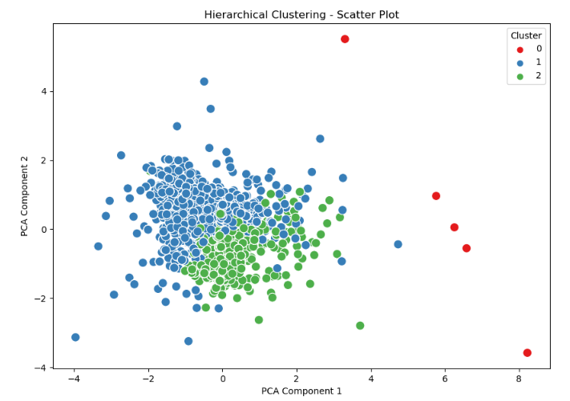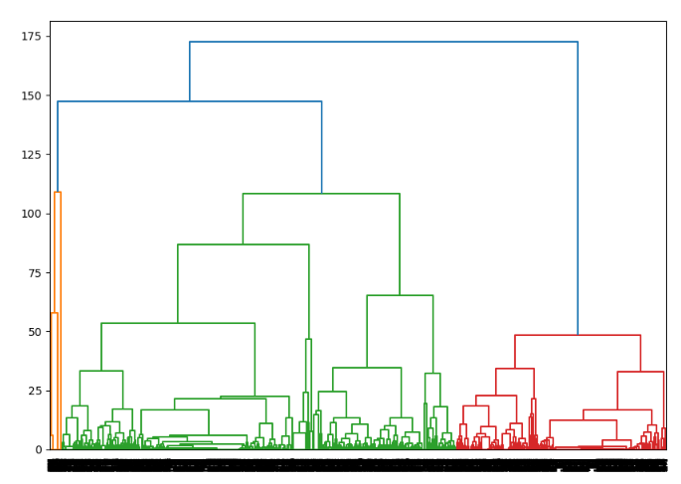

Hierarchical clustering effectively segmented age groups by marital status across various countries, revealing distinct patterns and relationships. The dendrogram highlighted clusters where similar marital status distributions are observed across different age groups, suggesting cultural, economic, or social similarities among these regions. The scatter plot visually represented these clusters, showcasing the relationships between countries and their marital status patterns. This analysis provides a clearer understanding of global marriage patterns, demonstrating that hierarchical clustering is a valuable tool for interpreting complex data and identifying meaningful segments within the dataset.

App 2: Analyze marriage patterns evolution with algorithms.

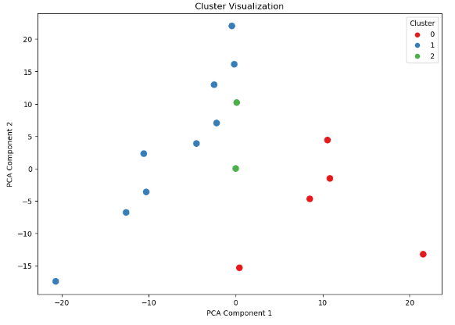

Hierarchical clustering has successfully analyzed the evolution of marriage patterns over time, revealing insightful trends and transitions. The scatter plot illustrates the clusters of countries based on changes in marital status across different years, showcasing how these patterns evolve and group together over time. The silhouette score of 0.39 indicates a moderate level of cluster cohesion and separation, suggesting that the clustering algorithm has identified reasonably distinct patterns in the data. This analysis highlights the effectiveness of hierarchical clustering in capturing and visualizing the temporal evolution of marriage patterns, providing valuable insights into how marital trends shift across regions and periods.

C) DBSCAN

App 1: Identifies country marriage patterns, outliers, and exceptional behaviors

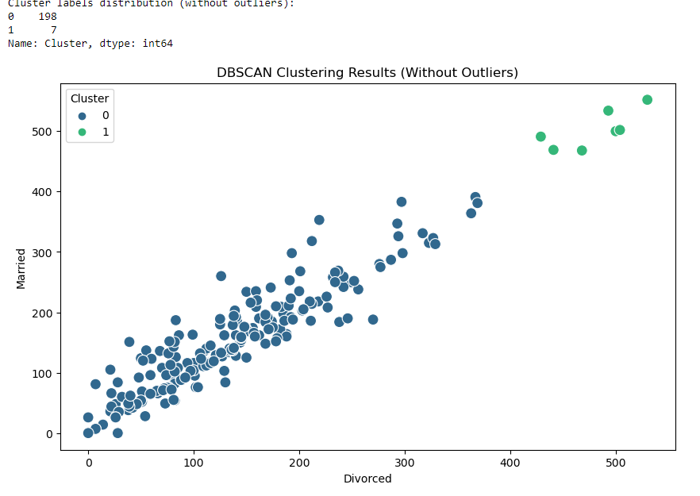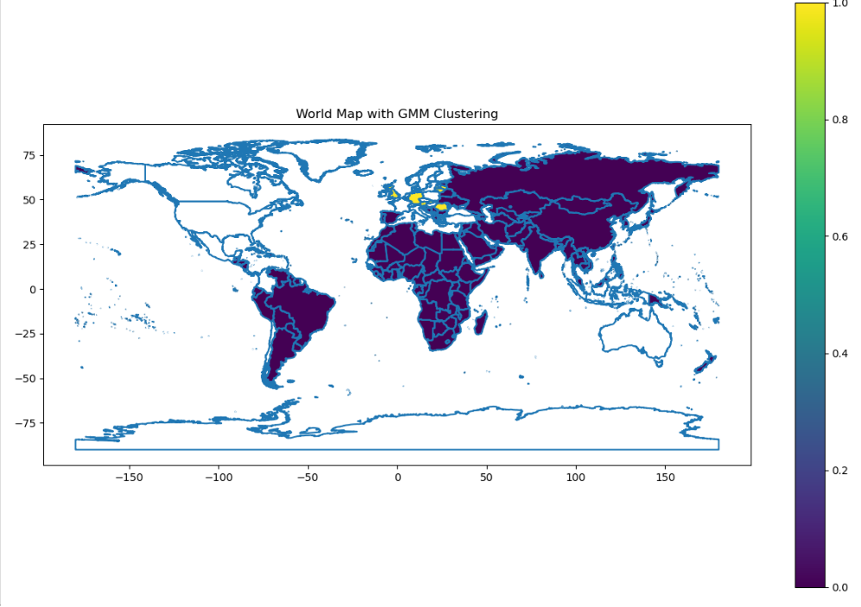

DBSCAN has adeptly identified country marriage patterns, highlighting clusters of countries with similar marital status distributions while also pinpointing outliers and exceptional behaviors. The clustering results reveal distinct groups where countries exhibit similar marriage patterns, while the world map visualization provides a geographical perspective on these clusters. Outliers identified by DBSCAN represent unique cases with atypical marriage patterns, offering insights into exceptional behaviors or anomalies in the data. Overall, DBSCAN's ability to handle varying cluster shapes and detect outliers has proven valuable in understanding global marriage patterns and identifying countries with distinct or unusual marital behaviors.

App 2: Longitudinal data tracks marriage patterns, informs policy decisions.

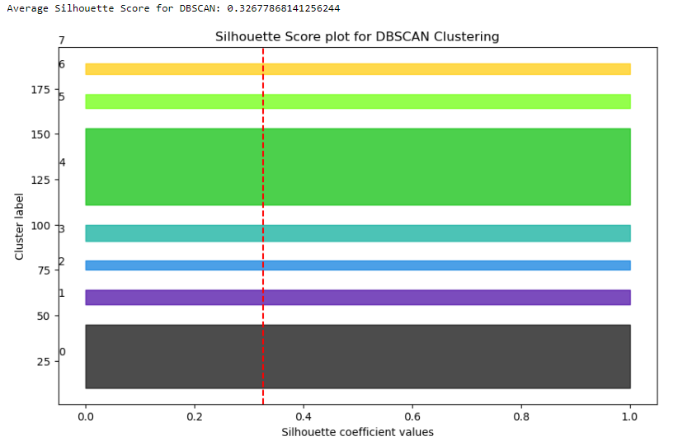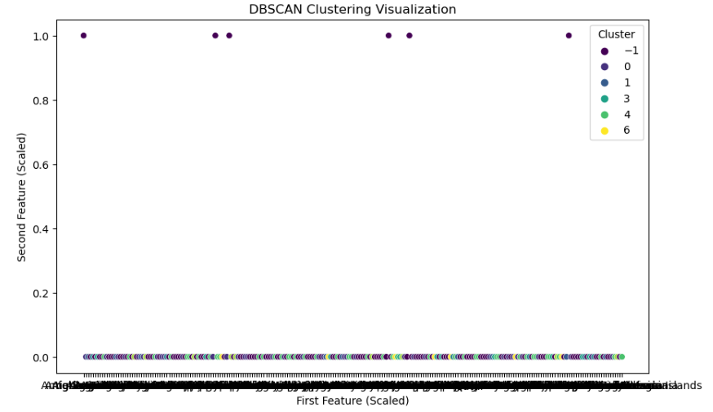

DBSCAN has effectively analyzed longitudinal data on marriage patterns, providing valuable insights for informing policy decisions. The clustering results reveal distinct groups of countries with similar marital trends over time, while the silhouette score indicates that the clusters are well-defined with adequate cohesion and separation. By identifying clusters and outliers, DBSCAN highlights key patterns and exceptional cases in marriage data, offering a comprehensive view of how marriage patterns evolve. This analysis supports informed policy-making by identifying trends and anomalies that can guide targeted interventions and strategies. Overall, DBSCAN's capabilities in handling longitudinal data and detecting outliers have proven instrumental in understanding and addressing evolving marriage patterns.

D) Gaussian Mixture Model (GMM)

App 1: Identify subpopulations within marriage patterns for understanding

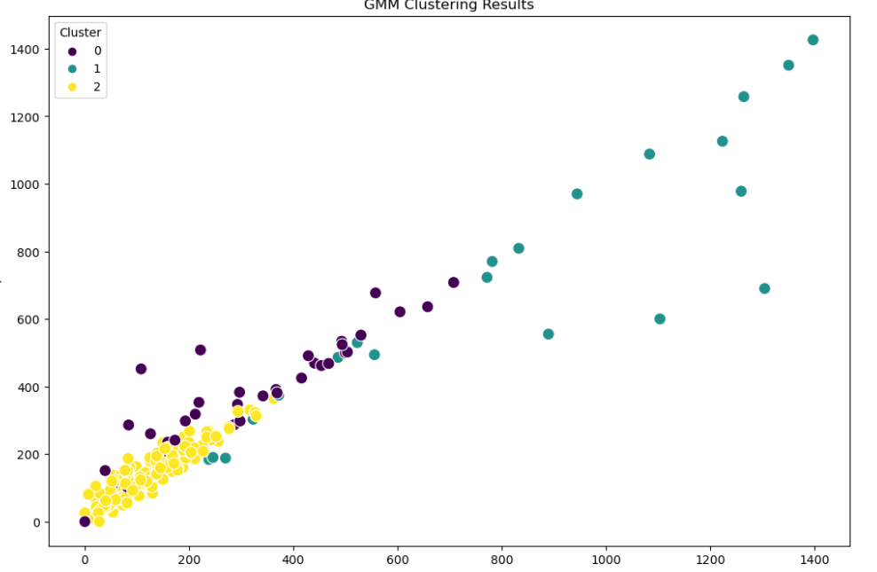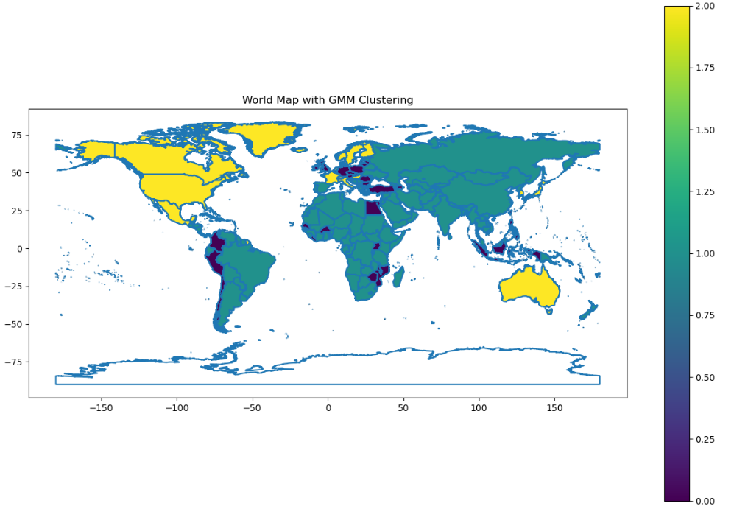

The Gaussian Mixture Model (GMM) has effectively identified subpopulations within marriage patterns, providing a nuanced understanding of marital trends across different regions. The clustering results illustrate how GMM can uncover underlying subpopulations that exhibit distinct marriage behaviors, revealing more detailed insights than traditional clustering methods. The world map visualization of GMM clustering highlights these subpopulations geographically, showing how different regions align with specific marital patterns. Overall, GMM has proven to be a powerful tool for understanding the complexity of marriage patterns by identifying and visualizing distinct subpopulations within the global dataset.

App 2: Study applies marriage patterns to demographics

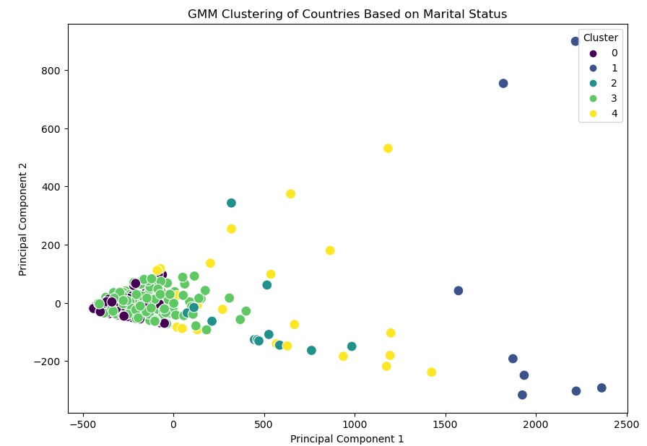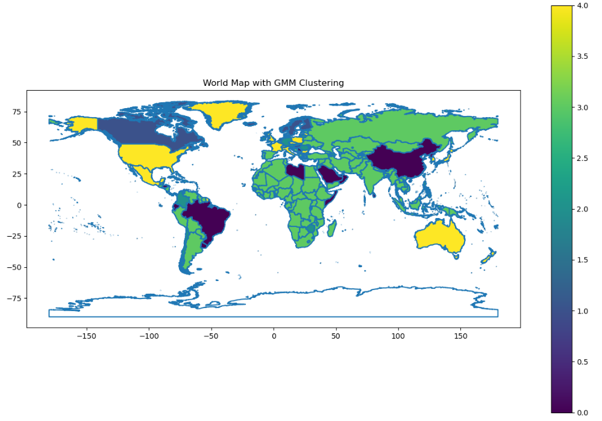

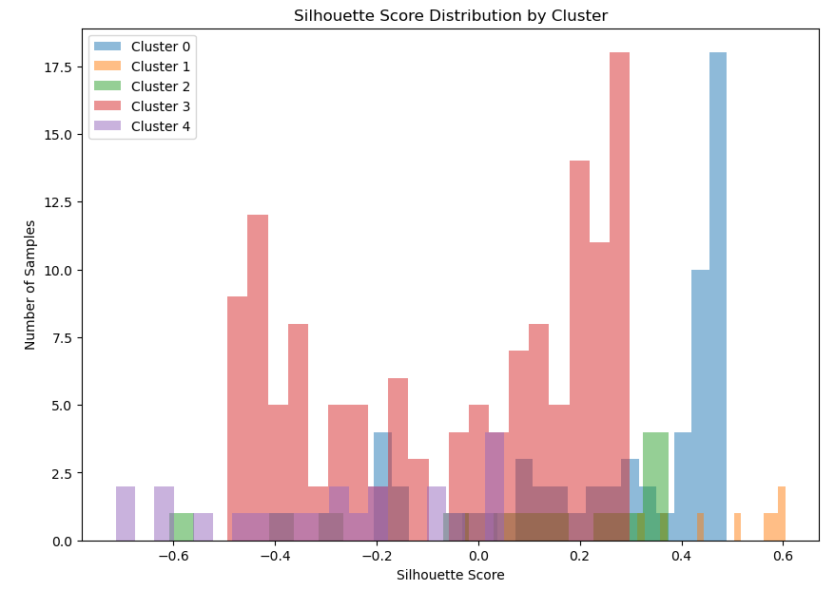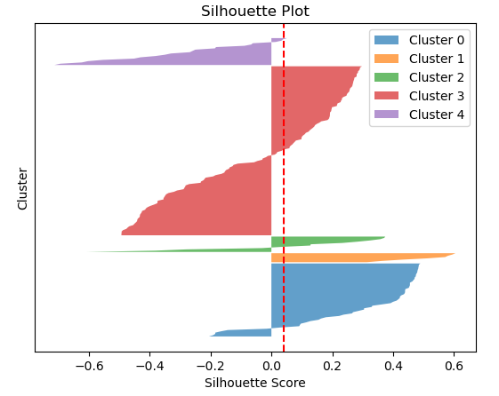

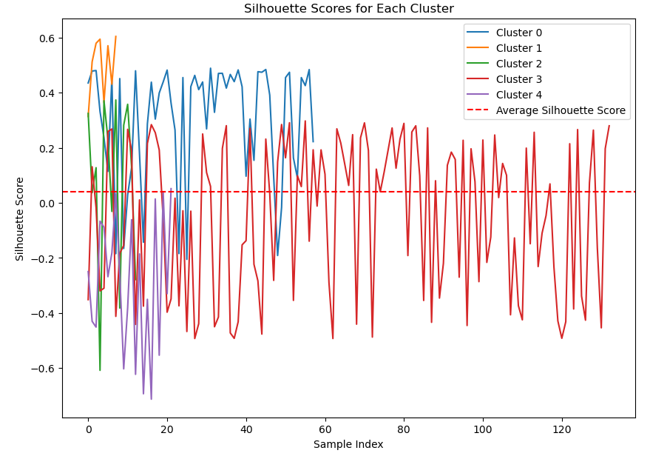

The Gaussian Mixture Model (GMM) has effectively applied marriage patterns to demographic factors, revealing intricate subpopulations and their relationships. The silhouette score and silhouette plot indicate that the clustering is generally well-defined, with clear distinctions between the identified subpopulations. The clustering results demonstrate how different demographic variables are associated with varying marriage patterns, offering a deeper understanding of these relationships. The world map visualization of GMM clustering further illustrates how these subpopulations are geographically distributed, highlighting regional differences and patterns. Overall, GMM has provided valuable insights into how demographic factors influence marriage patterns, enhancing our comprehension of these complex interactions.

E) Spectral Clustering

App 1: Identifying marriage patterns in countries, complex relationships.

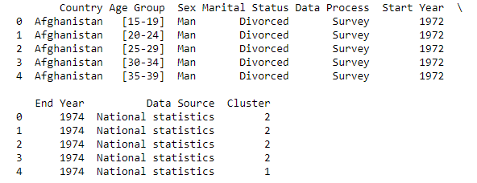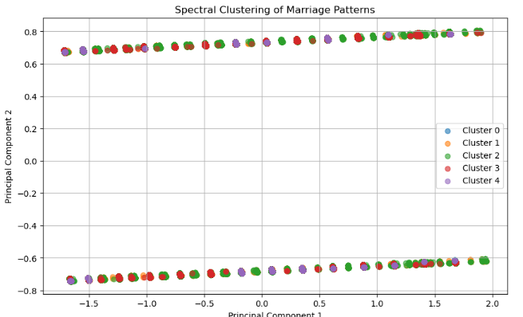

Spectral clustering has effectively identified complex marriage patterns across countries, uncovering intricate relationships within the dataset. The scatter plot visually represents the clusters of countries based on their marital status distributions, highlighting how countries with similar patterns are grouped together. This method has revealed nuanced relationships and variations in marriage patterns that may not be apparent through other clustering approaches. The clustered dataset demonstrates how spectral clustering captures and differentiates complex patterns, providing a deeper understanding of global marital dynamics and the interconnectedness of various regions.

App 2: Geospatial analysis studies marriage patterns' impact.

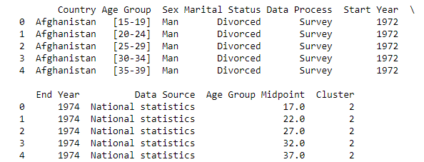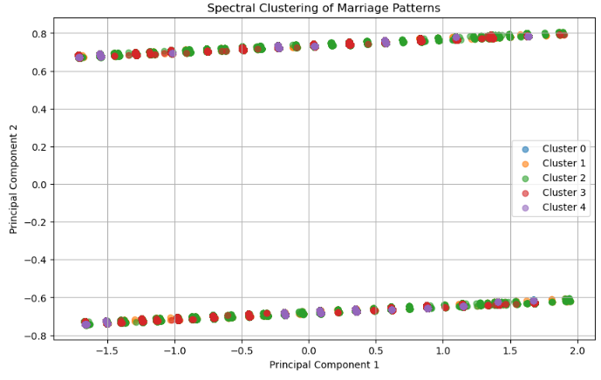

Spectral clustering has effectively supported the geospatial analysis of marriage patterns and their impact. The scatter plot reveals how countries are grouped based on the similarities in their marital status distributions, highlighting the spatial patterns and relationships between regions. The clustered dataset demonstrates how these groupings reflect the geographical distribution of marriage patterns, offering insights into how marital trends vary across different locations. Overall, spectral clustering has provided a valuable framework for understanding the spatial dynamics of marriage patterns, enhancing our ability to analyze and interpret the impact of these patterns on a global scale.

7.0 Conclusion and Technical Future Recommendations

This study leveraged the World Marriage Dataset to analyze global marital status trends from 1970 to 2019, across 232 countries, focusing on differences by age and gender. The analysis revealed distinct patterns in marriage, divorce, and singlehood across different regions, age groups, and sexes. Notably, shifts in marital status were evident over time, reflecting evolving societal norms, economic conditions, and demographic changes. The dataset proved valuable in identifying age-specific trends, with clear transitions between marital statuses, particularly during middle adulthood. The findings suggest that socio-cultural and economic factors play significant roles in shaping marital status distributions globally.

The analysis underscored the importance of examining the quality and consistency of data collection methods, as discrepancies in these can lead to varying insights. Additionally, the exploration of correlations between marital status and broader socioeconomic indicators highlighted the potential for more comprehensive studies that incorporate external factors such as education, employment, and cultural influences.

7.1 Technical Future Recommendations

Advanced Machine Learning Models for Classification. Implement machine learning classification models (e.g., decision trees, random forests, or gradient boosting) to predict marital status based on demographic factors, such as age, sex, and region. This could assist in identifying key predictors of marital status transitions.

Automated Data Cleaning and Preprocessing.Develop automated pipelines for data cleaning and preprocessing to handle missing values, outliers, and inconsistent data entries more efficiently. Techniques such as anomaly detection or imputation algorithms could be integrated to improve data quality.

Deeper Age-Group Analysis. Conduct more granular analyses by breaking age groups into smaller intervals. This could uncover finer trends, such as when transitions from singlehood to marriage or marriage to divorce are most common within specific age ranges.

8.0 References

Arnaldo,C.(2024),Ethnicity and Marriage Patterns in Mozambique,African Population Studies vol. 19, 144-164

<http://www.bioline.org.br/pdf?ep04008>

Kuswanto, H., Oktaviana, P. P., & Ferry Efendi Nelwati Nelwati,Hema Malini. (2024). Prevalence of and factors associated with female child marriage in Indonesia. *PLoS One, 19*(7)<https://www.proquest.com/docview/3076243303/903A8AD275934FAEPQ/10?accountid=38945&sourcetype=Scholarly%20Journals>

WHITE, J. M. (1992). Marital Status and Well-Being in Canada. Journal of Family Issues, 13(3), 390–409. <https://doi.org/10.1177/019251392013003008>

Chiappori, P.-A., Ciscato, E., & Guerriero, C. (2024). Analyzing matching patterns in marriage: Theory and application to Italian data. Quantitative Economics, 15(3), 737–781. <https://csef.it/wp-content/uploads/guerriero.pdf>

Perrin, F. (2021). On the origins of the demographic transition: rethinking the European marriage pattern. Cliometrica,16,431-475.

<https://link.springer.com/article/10.1007/s11698-021-00237-2>

webcoordinator@msd.govt.nz. (2004). Understanding and Altering the Longitudinal Course of Intimate Partnerships - Ministry of Social Development. Govt.nz; MSD. <https://www.msd.govt.nz/about-msd-and-our-work/publications-resources/journals-and-magazines/social-policy-journal/spj23/understanding-and-altering-the-longitudinal-course-of-intimate-partnerships-pages1-30.html>

Todd, P. M., Billari, F. C., & Simao, J. (2005). Aggregate Age-at-Marriage Patterns From Individual Mate-Search Heuristics. Demography, 42(3), 559–574. <https://citeseerx.ist.psu.edu/document?repid=rep1&type=pdf&doi=9f8acec4f2e40d695496dbd699354d6cadeef76a>

Esteve, A., Kashyap, R., Garcia Roman, J., Cheng, Y.-H. A., Fukuda, S., Nie, W., & Lee, H. (2020). Demographic change and increasing late singlehood in East Asia, 2010–2050. Demographic Research, 43, 1367–1398.

<https://doi.org/10.4054/demres.2020.43.46>

Jones, Gavin. (2010). Changing Marriage Patterns in Asia. SSRN Electronic Journal. 10.2139/ssrn.1716533. <https://www.researchgate.net/publication/228275712_Changing_Marriage_Patterns_in_Asia>

Fiala, Oliver. (2024). Child marriage in conflict settings: a geospatial analysis. SN Social Sciences. 4. 10.1007/s43545-024-00940-7. <https://www.researchgate.net/publication/382079387_Child_marriage_in_conflict_settings_a_geospatial_analysis>