**Assessment Rubric**

Name(s) and ID: Pang Zan Lam 22WMR13622,

Rishiiy A/L Tharmalingam 22WMR15019

Assignment Group: Group 6

# Project Part A – Shortlist promising models (40%) – CLO3

|  |  |  |  |  |  |
| --- | --- | --- | --- | --- | --- |
| **No** | **Item** |  | **Criteria** |  | **Marks** |
| **Poor** | **Accomplished** | **Good** |
| 1 | Problem statement (10) | No or very little discussion on existing problem and the project  The proposed project already exists, or with very minor change.  No discussion or very little of introduction given to the related system or technology.  0-4 | Little discussion on existing problem and introduction of proposed project.  Minor ideas are modified from existing system(s). Introduction to the related system is given, but no evaluation provided.  5-7 | Good discussion and evaluation of existing problem and the proposed project.  Ideas modified from existing system, with some creative ideas are added.  Good discussion and evaluation of the related system.    8-10 |  |
| 2 | Programming (20) | The end product fails with many logic errors, many actions lacked exception handling. Solutions are over-simplified. Programming skill needs improvement.    Evaluation steps of different models are not automated.  0-7 | Major parts are logical, but some steps to complete a specific job may be tedious or unnecessarily complicated. Program algorithm demonstrates acceptable level of complexity. The student is qualified to be a programmer. Some evaluation steps are automated.  8-15 | Correct and logical flow, exceptions are handled well. Demonstrates appropriate or high level of complex algorithms and programming skills.  Almost all evaluation steps are automated.  16-20 |  |
| 3 | Degree of completion  (10) | Too much still remain to be done. Basic requirements are not fulfilled.  The end product produces enormous errors, faults or incorrect results.  Limited performance metrics are used.  0-4 | All required features present in the interface within the required scope, but some are simplified. Or one or two features are missing. The system is able to run with minor errors.  Some performance metrics are shown.  5-7 | All required features present in the interface within or beyond the required scope.  No bugs apparent during demonstration.  Various performance metrics are shown.  8-10 |  |
|  | | |  | Sum of Score |  |

# Project Part B – Fine-tune the system (40%) – CLO3

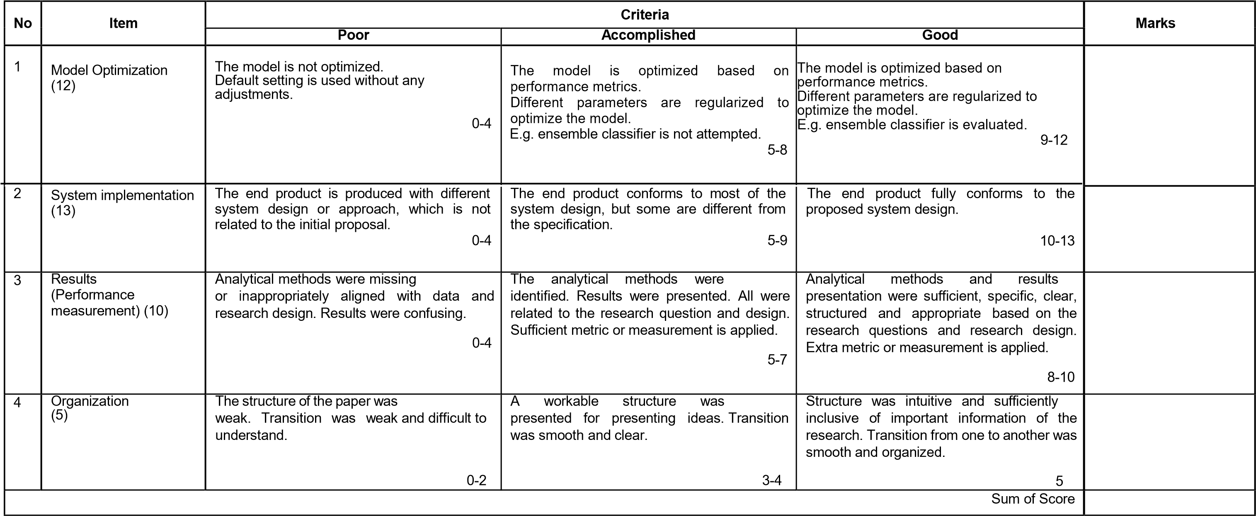

# Output and Presentation (20%) – CLO2

|  |  |  |  |  |  |
| --- | --- | --- | --- | --- | --- |
| **No** | **Item** | **Criteria** | | | **Marks** |
| **Poor** | **Accomplished** | **Good** |
| 1 | Output (10) | Inadequate information/outputs needed are generated.  Most of the information/outputs generated are less accurate.  Results visualization is overly cluttered or the design seems inappropriate for the problem area. Lack of information that is useful for the user.    0-4 | Adequate information/outputs needed are generated.  The information/output generated are accurate, but some with errors.  Pleasant looking, clean, well-organized results visualization  The information displayed is helpful for the user, but some details are omitted.    5-7 | All the necessary information/outputs are generated.  All or most of the information/outputs generated are accurate. Minor errors can be ignored.  The results are visually pleasing and appealing.  Great use of colors, fonts, graphics and layout.  The information displayed is helpful to the users and complete with necessary details.    8-10 |  |
| 2 | Presentation  (10) | The presentation was unclear.  Results were presented without justifications and reasons.  Results were not supported with machine learning concepts and theories.  0-4 | The presentation is well organized for the most part, but more clarity with transitions is needed.  Answers to the research question and system performances supported machine learning concepts and theories.  5-7 | The presentation was concise and straight to the point.  The results were presented and illustrated in easily interpretable graphs or charts.  The research question and system performance were answered and identified.    8-10 |  |
|  |  | Sum of Score | | |  |