Donavan Kemp Backstory Book
An illustrated character guide for Brodey
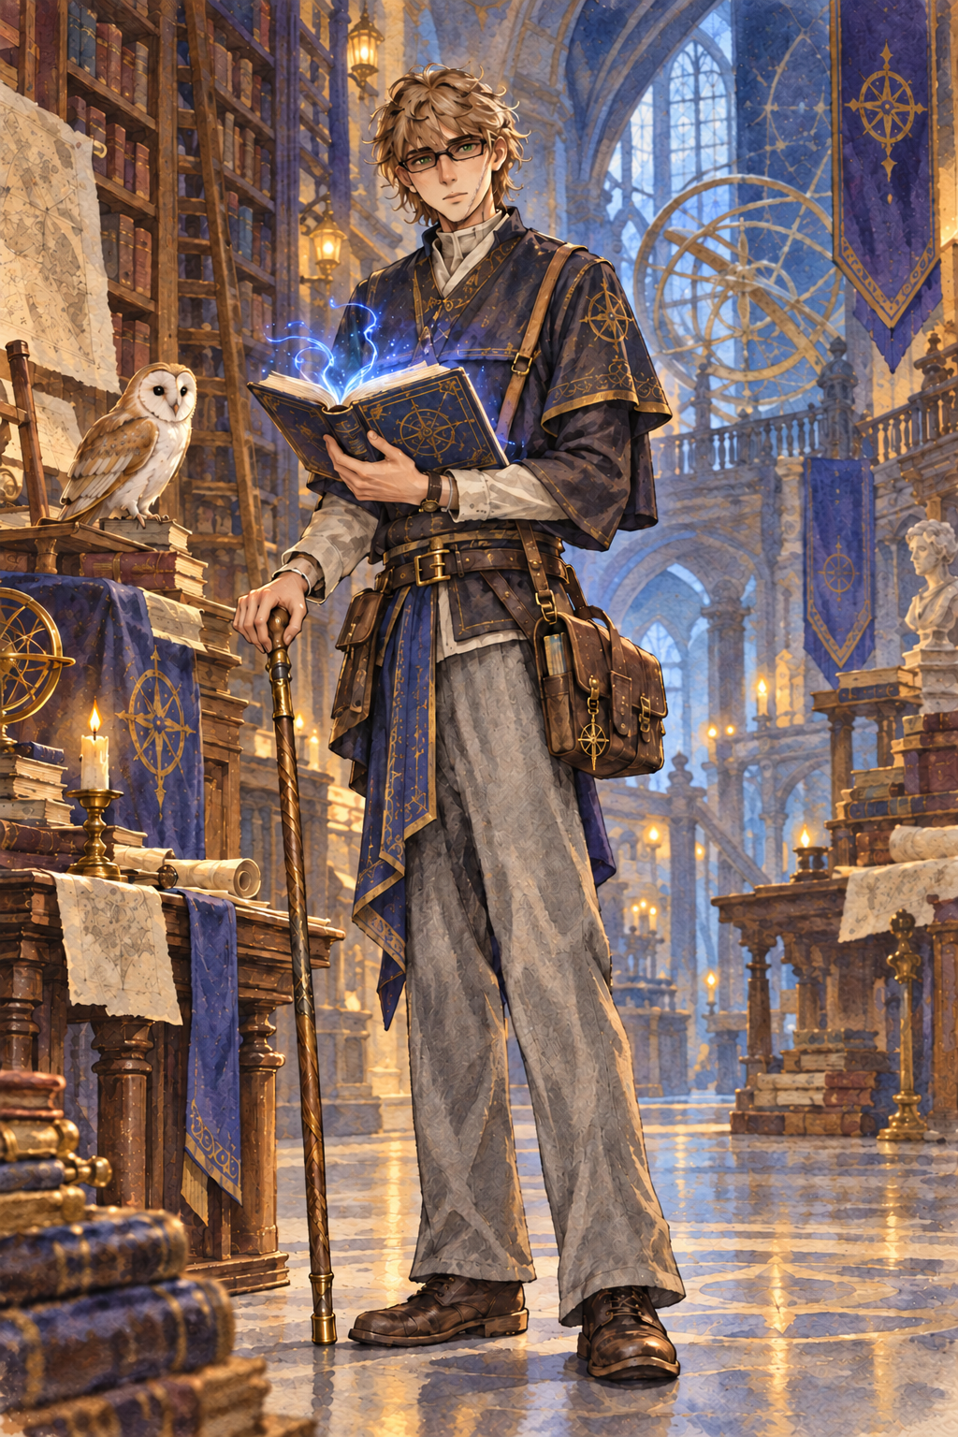
Human Wizard Sage Field Researcher

READER GUIDE

Using This Book
This book gathers the confirmed details of Donavan Kemp into one playable history. The narrative sections establish his family, education, marriage, research work, and purpose. The final pages separate confirmed canon from choices Brodey can still make at the table.

Character at a Glance
Field | Confirmed Detail
Name | Donavan Kemp
Identity | Human wizard and Sage
Age | 25
Alignment | Neutral Good
Home | The Kemp Archive and Arcane University in an elven metropolis
Work | Field researcher for the Archive
Family | Second of four siblings and husband of Dianna Kemp
Companion | Barn owl familiar
Driving concern | Protecting people who are exploited by those with greater power
Great ambition | Discovering multiversal secrets and artifacts that can deepen his magic

HOME

The Kemp Archive and Arcane University
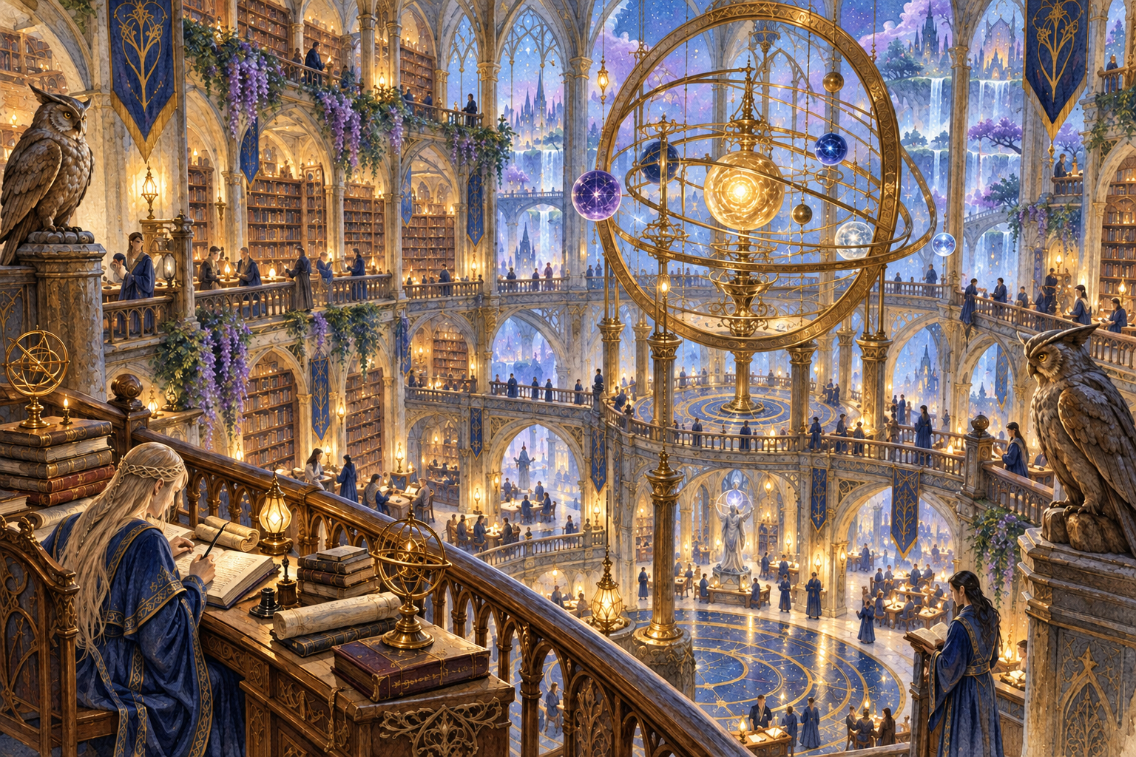
The central hall and planar orrery of the Kemp Archive
The Kemp Archive rises inside a great elven metropolis. It serves as a library, university, research center, and family home. Its collections cover arcane mastery, history, science, mathematics, and the accumulated reports of generations of field researchers.
The Archive does more than preserve old knowledge. Its scholars gather and distribute reliable information so governments and powerful institutions cannot easily bury inconvenient truths. That mission gives the Archive allies among ordinary people and enemies among those who profit from secrecy.
The Kemp family acts as the institution's hereditary steward, but the faculty extends far beyond the bloodline. Not every professor is a Kemp, and the university depends on scholars from many peoples, planes, and magical traditions.

EARLY YEARS

A Child Among the Stacks
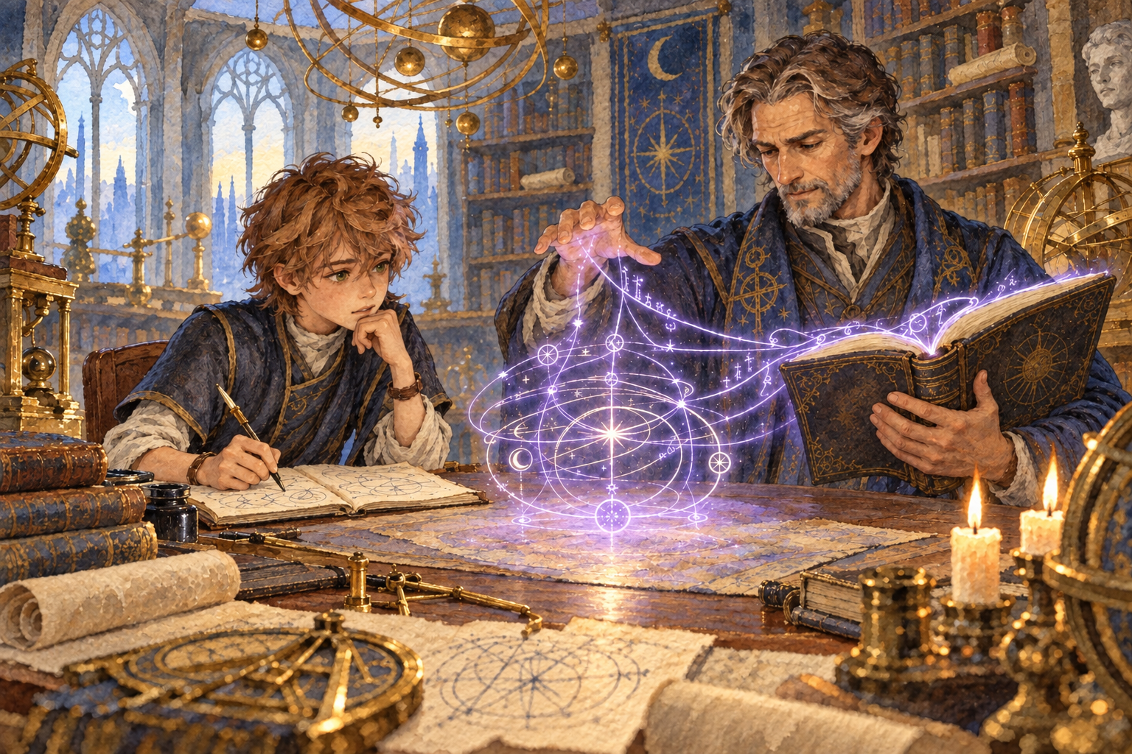
Favian teaches Donavan to see structure inside magic
Donavan grew up surrounded by books, arguments, experiments, and visitors carrying stories from distant worlds. He learned early that every answer created another question. His intelligence appeared quickly, but curiosity mattered more to him than praise. He wanted to understand how things fit together.
His uncle Favian became his lifelong teacher. Favian trained him in magical theory while insisting on careful observation and exact records. He also described a deeper art practiced by the Archive's greatest Scribes: a way of ordering written magic so that a spellbook becomes an active expression of the Weave.
Donavan has not completed that transformation. His present work is the beginning of it. Every recovered inscription, translated fragment, and correctly recorded spell moves him closer to the tradition Favian promised he could one day master.

FAMILY

The Kemp Family Ledger
The Archive is an institution, but it is also Donavan's family home. Its corridors hold the people who taught him, challenged him, and gave him reasons to return after each expedition.
Person | Connection | Known Detail
Markus Kemp | Father | Deceased. The circumstances of his death remain open for the campaign.
Vivian Kemp | Mother | Alive and connected to the family at the Archive.
Favian Kemp | Uncle and teacher | Donavan's lifelong instructor in magic and the ordered Weave.
Lilian Kemp | Eldest sibling | The firstborn of the four Kemp children.
Donavan Kemp | Second-born | Wizard, Sage, and field researcher.
Conner Kemp | Younger brother | Third-born in the family.
Nilla Kemp | Youngest sister | The youngest of the Kemp siblings.
Dianna Kemp | Wife | Blue tiefling mathematician and university professor.
Gavin Barter | Childhood best friend | A halfling who knew Donavan before his years in the field.
Kemps with sufficient magical ability usually serve through one of three traditions. Order of Scribes wizards preserve and expand knowledge. Arcane Tricksters recover information and investigate hidden threats. Eldritch Knights protect the Archive, its scholars, and its sealed collections. Donavan is training toward the first path.

FIELD WORK

Seven Years Beyond the Shelves

A discovery matters only if it can be understood and preserved
Donavan chose field research rather than a permanent desk at the university. For seven years he has explored ruins, followed rumors, compared local accounts, and sent his findings back to the Archive. His work carries him beyond the safety of catalogued knowledge into places where the facts are incomplete and the witnesses may have reasons to lie.
His barn owl familiar accompanies him as observer, messenger, and quiet company. Donavan's satchel holds ink, parchment, books, measuring tools, and whatever fragments survive the journey home. He prefers careful documentation to dramatic claims, but his curiosity can still pull him toward mysteries that a more cautious scholar would leave untouched.
The secrets of the multiverse remain his greatest intellectual pursuit. He is especially interested in objects that could strengthen his magic or reveal how written spells connect to the deeper architecture of reality.

MARRIAGE

Dianna and the Shape of Magic
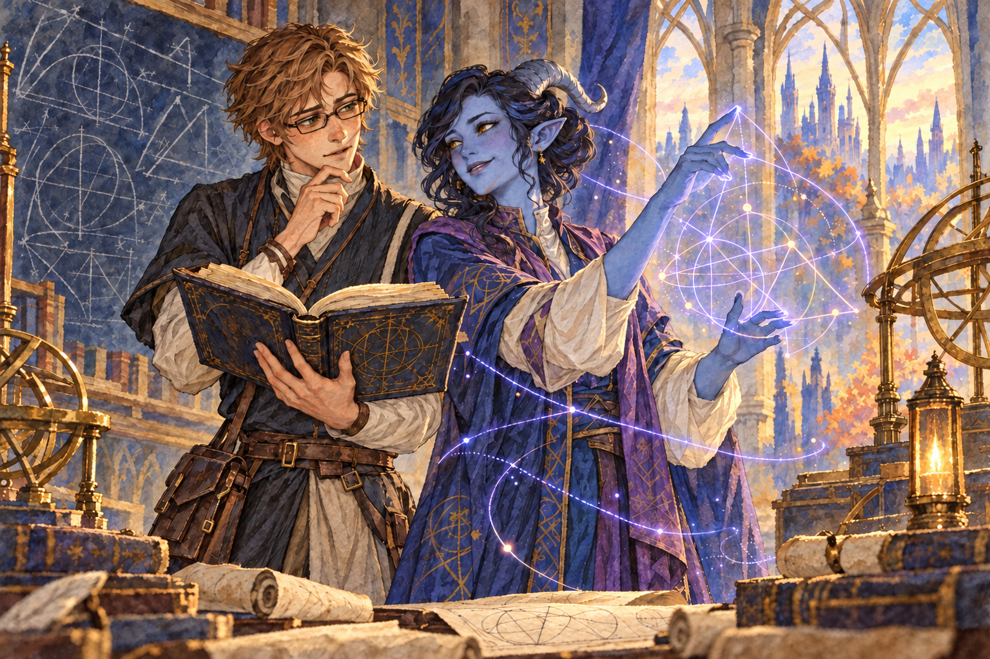
Dianna's mathematics gives Donavan another language for the Weave
Donavan met Dianna during his years of travel. She is a blue tiefling mathematician whose mind works with the same intensity as his own, though she approaches mysteries through proof, proportion, and structure. Their shared respect became love, and they married.
They spent a full year together at the Archive, where Dianna now teaches mathematics and lives in Donavan's quarters. Her work offers him a new way to understand the ordered patterns Favian described. The relationship between mathematical form and arcane notation may become central to Donavan's eventual mastery of the Scribes tradition.
Donavan continues to travel, returning to Dianna between expeditions. The arrangement gives him freedom to pursue his research, but it also creates a constant pull between the discoveries beyond the Archive and the life waiting for him inside it.

CHARACTER

The Scholar on the Road
Donavan is a slim young man with tousled light brown hair and green eyes often seen through narrow dark spectacles. A healed scar runs from his chin to the middle of his left cheek. He dresses for travel without abandoning the habits of a scholar. Books, ink, loose parchment, and small tools fill the pouches at his belt and the satchel across his shoulder. A long walking staff supports him on the road and gives his owl a familiar perch.

Habits and Preferences
- He reads whenever travel leaves him a quiet moment.
- He draws objects, ruins, and magical diagrams to supplement his written notes.
- He loves owls and trusts the patient attention they represent.
- His favorite meal is a meat-heavy stew served with sourdough bread.
- He favors black, gold, blue, and purple in clothing and personal objects.

ROLEPLAYING CORE

Beliefs and Ambitions

Protective Instinct
Donavan finds it difficult to remain an observer when someone is being bullied, exploited, or used by a more powerful person. He knows that knowledge creates leverage, so he pays attention to who controls a story and who is prevented from speaking.

Ideal
Knowledge should expose abuses of power rather than protect them. The Archive's commitment to accurate records gives Donavan a practical way to serve that belief.

Bond
Donavan's strongest ties lead back to the Archive: Dianna, his siblings, his mother, Favian, and the body of knowledge his family has sworn to preserve. Every expedition is partly an attempt to bring something valuable home to them.

Suggested Flaw
Donavan's desire to understand dangerous secrets can outrun his caution. An artifact that promises greater magical insight may tempt him to keep studying after the sensible moment to stop. This interpretation fits the existing notes but remains a choice for Brodey.

Long Term Goal
He wants to uncover secrets of the multiverse and find items capable of expanding his magic. The Fey Realm is one of the places he most wants to visit and study. Behind that ambition is a deeper question: whether power can be increased without allowing it to control the scholar who pursues it.

MAGIC

Magic and Method
Donavan approaches magic as research. He observes, records, tests, and revises. His spellbook is both a practical tool and the center of his developing relationship with the ordered Weave.
Use | Spells | Character Meaning
Cantrips | Dancing Lights, Mind Sliver, Prestidigitation | Subtle control, mental pressure, and practical magical experimentation
Protection | Mage Armor, Shield | A cautious scholar's answer to physical danger
Force | Magic Missile, Catapult, Burning Hands | Direct options when observation gives way to action
Research | Detect Magic, Comprehend Languages | Tools for identifying the nature and history of discoveries
Preparation | Alarm, Find Familiar | Security, vigilance, and the barn owl companion

Languages and Training
Donavan speaks Common, Elvish, Giant, and Sylvan. His strongest academic skills are Arcana, History, Investigation, and Religion. He is most effective when the party needs someone to connect a strange object, old account, magical signature, or religious symbol to a larger pattern.
He is training toward the Order of Scribes. The campaign can treat each recovered text or breakthrough in the Weave as another step toward that identity.

CAMPAIGN SETTING

The Archive at Play
The following locations develop the Archive without changing Donavan's confirmed history. They give the Dungeon Master and Brodey places to anchor future scenes.
The Central Orrery A brass model that tracks celestial bodies and planar relationships. Its movements may reveal crossings before portals appear.
The Scribes College The university division that trains wizards in magical notation, preservation, and the ordered structure of spellbooks.
The Lantern Stacks Public collections, reading rooms, and lecture alcoves used by students, visiting scholars, and citizens.
The Quiet Vaults Restricted rooms for cursed texts, politically dangerous records, unstable artifacts, and research that cannot yet be released.
The Field Office A crowded center where reports arrive, expeditions are assigned, and contradictory accounts are compared.
The Kemp Residence Family quarters within the Archive, including the rooms shared by Donavan and Dianna when he is home.

Adventure Pressure
- A government tries to suppress records proving an abuse of power.
- One of Donavan's field reports arrives altered, though his original notes remain intact.
- A sealed artifact begins changing nearby books and the memories of their readers.
- Favian disappears while investigating the power hidden inside Kemp spellbooks.
- Evidence suggests Markus died while protecting a secret in the Quiet Vaults.

PLAYER DECISIONS

Questions for Brodey
These details are intentionally open. Answering them during play will deepen Donavan without forcing decisions before they matter.
- What is the barn owl familiar's name, personality, and relationship with Donavan?
- How did Markus die, and what does Donavan believe happened?
- Where did Donavan first meet Dianna, and what made them trust one another?
- What was Donavan's most important discovery during his first seven years in the field?
- How did Donavan receive the scar that runs from his chin to his left cheek?
- Why does he wear dark spectacles, and does the walking staff have a magical or personal history?
- Which multiversal secret or magical item is he currently pursuing?
- What does Lilian, Conner, or Nilla think about Donavan's long absences?
- What would make Donavan refuse to share a discovery with the Archive?

At the Table
- Ask what a discovery means, who benefits from it, and who might want it hidden.
- Sketch unfamiliar objects and ruins while other characters discuss their next move.
- Step in when power is being used to humiliate or exploit someone weaker.
- Write to Dianna or the Archive after major discoveries.
- Let curiosity create risk when forbidden knowledge promises a real answer.
Prepared from Brodey's sketch, character sheet, and campaign notes

