Donavan Kemp Player Handout
The established backstory and table guide for Brodey
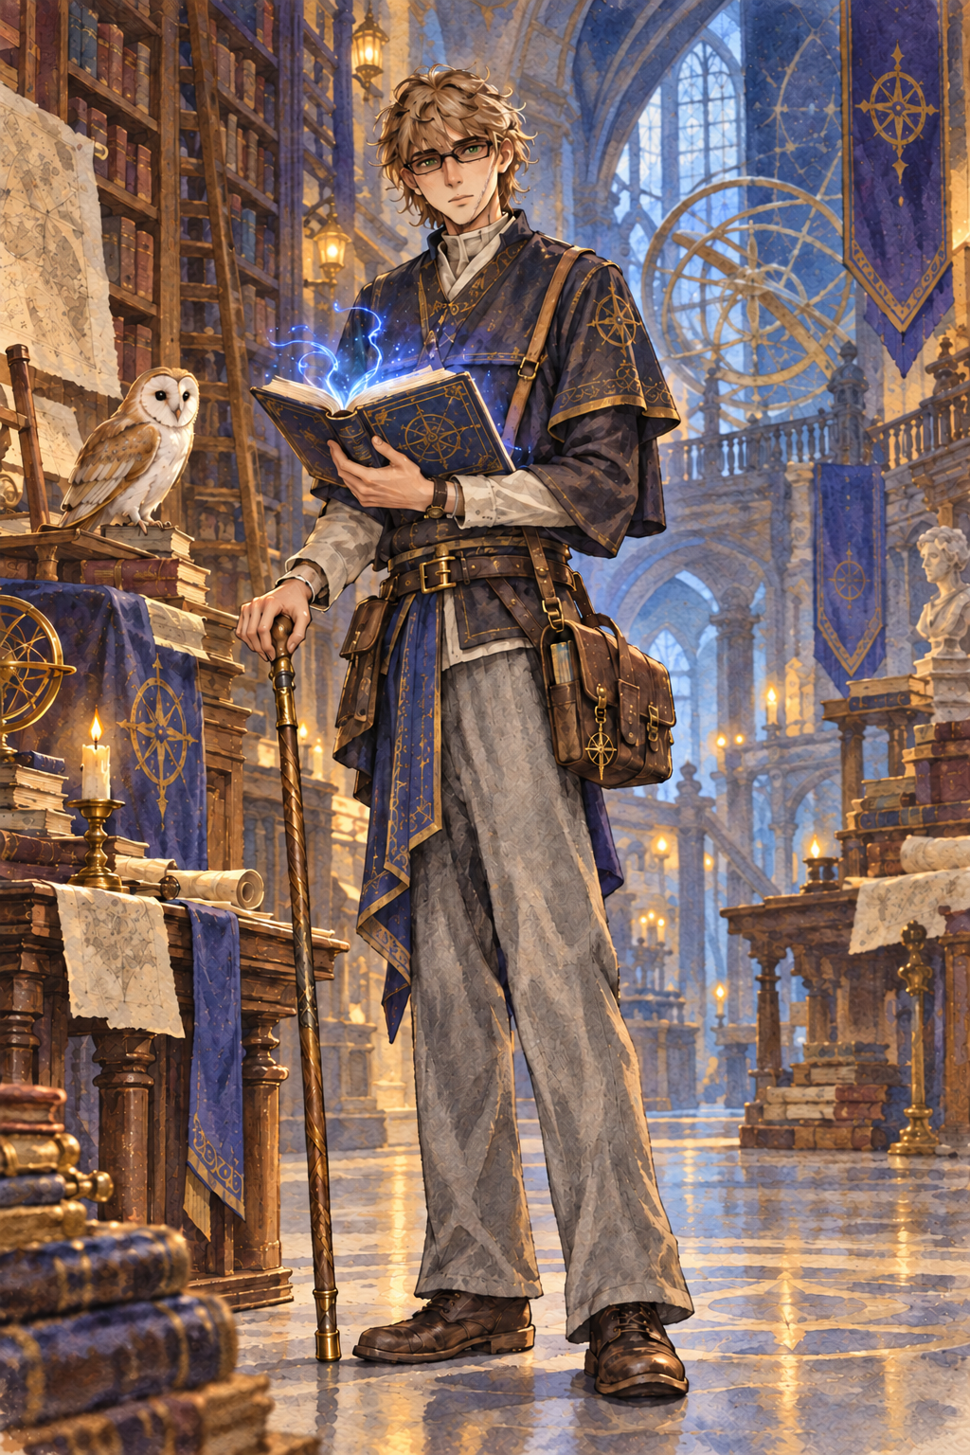
Human Wizard Sage Field Researcher
Use this handout to understand what Donavan knows, what matters to him, and how to portray him. Facts that remain undecided are kept together on the final page.

QUICK REFERENCE

Donavan in One Minute
Donavan Kemp is a twenty-five-year-old human wizard from the Kemp Archive and Arcane University, an institution inside a great elven metropolis. He grew up among scholars and now serves the Archive as a field researcher. He is intelligent, curious, quietly protective, and most comfortable when he can observe a mystery before acting.
Field | Established Detail
Identity | Human wizard, Sage, Neutral Good
Age and build | 25 years old, 5 feet 10 inches, 155 pounds
Appearance | Light brown hair, green eyes, narrow dark spectacles, and a healed scar from his chin to the middle of his left cheek
Home | The Kemp Archive and Arcane University in an elven metropolis
Work | Field researcher for seven years
Companion | A barn owl familiar whose name and personality are still open
Great strength | Intelligence 18 and a disciplined researcher's mind
Great concern | People being bullied or exploited by someone more powerful
Great ambition | Secrets of the multiverse and objects that could deepen his magic

How to Portray Him
- Ask careful questions before making a claim.
- Take notes, sketch strange objects, and compare what witnesses say.
- Step forward when power is being used to humiliate or exploit someone weaker.
- Let curiosity overcome caution when forbidden knowledge promises a real answer.

BACKSTORY

The Life Donavan Remembers
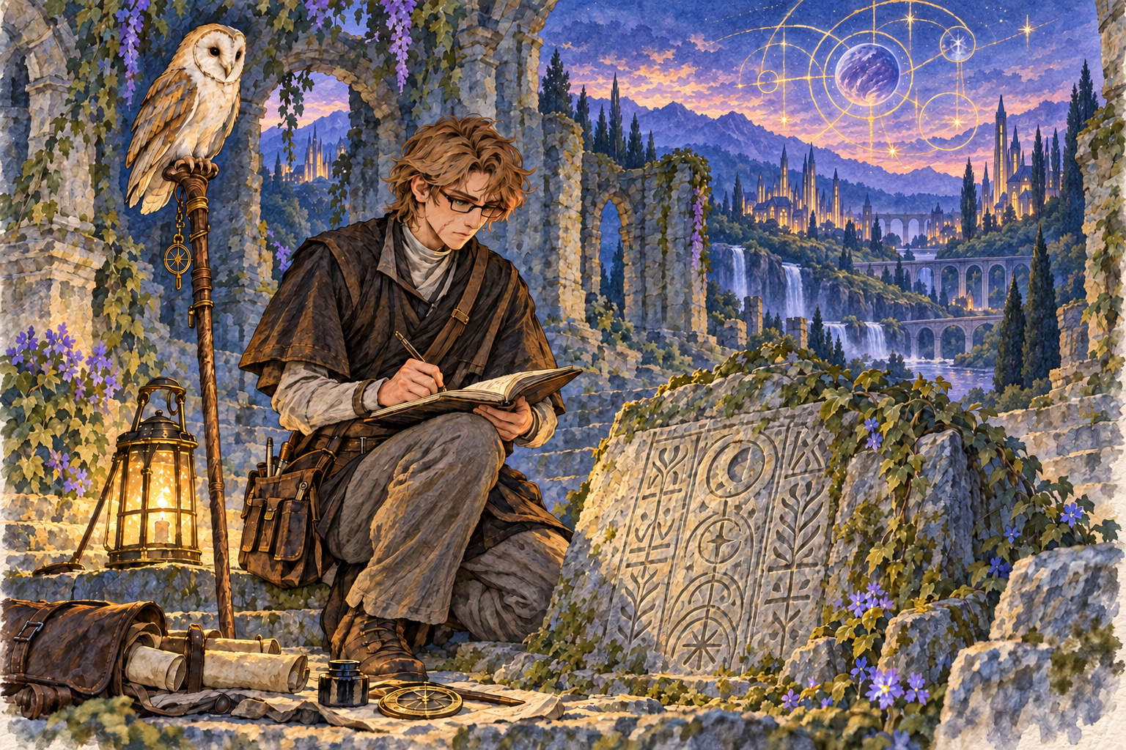
Seven years of field work taught Donavan to distrust easy answers

Child of the Archive
Donavan was raised inside the Archive as the second of four Kemp children. Books, experiments, lectures, travelers, and arguments about evidence were ordinary parts of childhood. His uncle Favian became his lifelong teacher and showed him how written magic can reveal the deeper order of the Weave.

The Road Beyond the Shelves
Rather than remain at a permanent university desk, Donavan became a field researcher. For seven years he has explored ruins, followed rumors, compared local accounts, and sent his findings home. His satchel carries ink, parchment, books, measuring tools, and whatever fragments survive the journey.

What Pulls Him Home
The Archive is not only his employer. It is his family home, the place where his mother and siblings live, and the home he shares with his wife Dianna between expeditions. Every discovery is partly an attempt to bring something useful back to them.

RELATIONSHIPS

The People Brodey Should Know
These are Donavan's established relationships. Their personalities and present conflicts can grow during play, but the connections below are part of his known history.
Person | Connection | What Donavan Knows
Markus Kemp | Father | Deceased. The cause of his death has not yet been established.
Vivian Kemp | Mother | Alive and connected to the family at the Archive.
Favian Kemp | Uncle and teacher | Donavan's lifelong instructor in magic and the ordered Weave.
Lilian Kemp | Older sister | The eldest of the four Kemp siblings.
Conner Kemp | Younger brother | The third-born Kemp child.
Nilla Kemp | Youngest sister | The youngest of the four siblings.
Dianna Kemp | Wife | A blue tiefling mathematician who teaches at the Archive and lives there.
Gavin Barter | Childhood friend | A halfling who knew Donavan before his years in the field.

Dianna and Donavan
Dianna studies mathematics with the same intensity Donavan brings to magic. Her work gives him another language for the patterns Favian taught him to seek in the Weave. Donavan travels, while Dianna teaches and lives at the Archive; returning to her is one of the strongest pulls on him when an expedition runs long.

HOME

The Kemp Archive
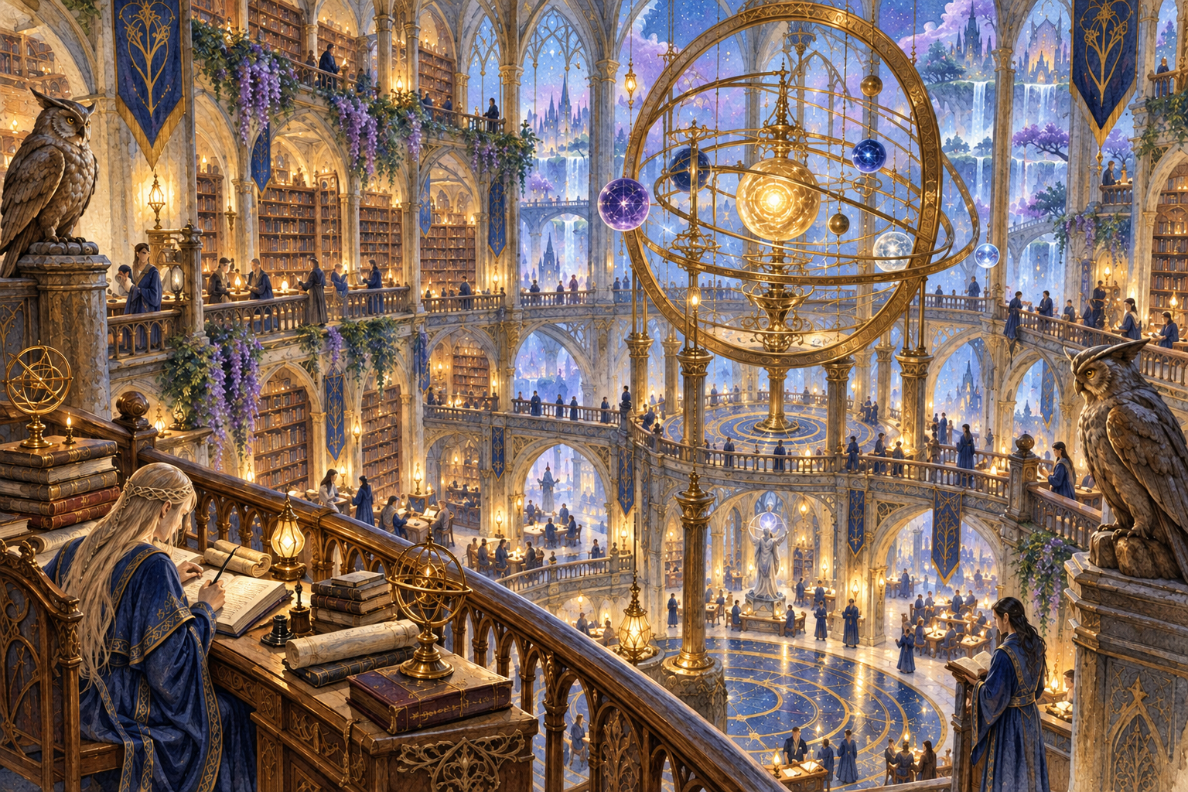
The Archive is a university, research center, library, and family home
The Archive collects knowledge of magic, history, science, mathematics, and distant places. Its scholars do more than preserve records: they gather and distribute reliable information so governments and other powerful institutions cannot easily bury inconvenient truths.

The Three Kemp Traditions
Order of Scribes Wizards who preserve, organize, and expand magical knowledge. Donavan is training toward this path.
Arcane Tricksters Investigators who recover hidden information and pursue threats that operate through secrecy.
Eldritch Knights Defenders of the Archive, its scholars, and its sealed collections.
The Archive is not in the Fey Realm. It stands in an elven metropolis. The Fey Realm is one of the places Donavan hopes to visit and study in the future.

ROLEPLAYING

Playing Donavan at the Table

Beliefs
Ideal Knowledge should expose abuses of power rather than protect them.
Bond His strongest ties are Dianna, his family, Favian, and the Archive's mission.
Suggested flaw His desire to understand dangerous secrets can outrun his caution, especially when an artifact promises greater magical insight.

Habits and Preferences
- He reads whenever travel leaves him a quiet moment.
- He draws objects, ruins, and magical diagrams beside his written notes.
- He loves owls and trusts the patient attention they represent.
- His favorite meal is a meat-heavy stew served with sourdough bread.
- He favors black, gold, blue, and purple in clothing and personal objects.

Useful Prompts
- What does the evidence actually prove?
- Who benefits if this information stays hidden?
- Can this object be studied without letting it control us?
- What should I send back to the Archive and what is too dangerous to share?
Donavan does not need to dominate every conversation. His strongest moments come when he notices a pattern, records something others dismissed, protects someone vulnerable, or accepts a risk because the answer matters too much to ignore.

MAGIC AND DECISIONS

What Donavan Can Do
Use | Spells | Meaning
Cantrips | Dancing Lights, Mind Sliver, Prestidigitation | Control, mental pressure, and practical magical experimentation
Protection | Mage Armor, Shield | Survive danger long enough to understand it
Force | Magic Missile, Catapult, Burning Hands | Direct action when observation is no longer enough
Research | Detect Magic, Comprehend Languages | Identify discoveries and recover their meaning
Preparation | Alarm, Find Familiar | Security, vigilance, and the barn owl companion

Skills and Languages
Donavan speaks Common, Elvish, Giant, and Sylvan. His strongest academic skills are Arcana, History, Investigation, and Religion. He is most useful when the party needs to connect a strange object, old account, magical signature, or religious symbol to a larger pattern.

Choices That Still Belong to Brodey
- Name the barn owl familiar and decide what its personality is like.
- Decide how Donavan received the scar from his chin to his left cheek.
- Decide why he wears dark spectacles and whether his walking staff has a personal history.
- Choose his most important discovery from seven years of field work.
- Choose the multiversal secret or magical item he is currently pursuing.
- Decide what Donavan believes about Markus's death.
Until Brodey chooses these answers, they should remain open rather than being treated as hidden canon.

