Ringgo Paul Player Guide
The beginner handbook for Cade
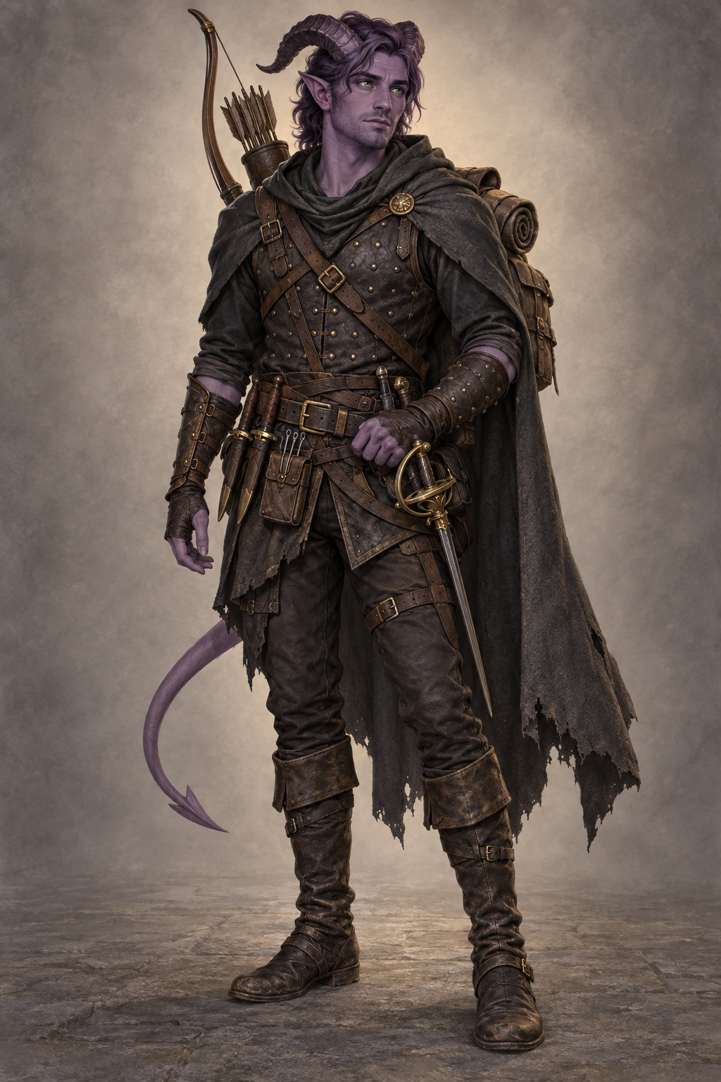
Tiefling Rogue Criminal Spy Level 1
This guide explains Ringgo's numbers, abilities, equipment, tactics, and place in The Echo Below. Keep it beside the character sheet during play.

QUICK REFERENCE

Ringgo in One Minute

Ringgo Paul is a thirty-year-old tiefling from Baldur's Gate. He earned his living as a spy and assassin before leaving that life and fleeing the criminal world. The road to Phandalin is a chance to earn honest coin by keeping people alive.
Field | Current Value
Player | Cade
Identity | Male tiefling rogue 1 with the Criminal Spy background
Build | Medium, age 30, 6 feet tall, 190 pounds
Defense | Armor Class 16, maximum hit points 10, Hit Die 1d8
Turn order | Initiative +4 and walking speed 30 feet
Training | Proficiency bonus +2
Awareness | Passive Perception 12, Insight 10, Investigation 10
Senses | Darkvision 60 feet and resistance to fire damage

What Ringgo Does Best
- Scout ahead carefully, notice threats, and report what he finds.
- Use Stealth +8 to hide and create favorable attacks.
- Attack distracted enemies for an extra 1d6 Sneak Attack damage.
- Use Deception, Persuasion, thieves' tools, and underworld knowledge when a fight is unnecessary.

CHARACTER STATISTICS

Abilities and Saving Throws
Most uncertain actions use one rule: roll a d20, add the relevant modifier, and compare the result with the number set by the Dungeon Master. A saving throw is the same kind of roll, but it resists danger that is happening to Ringgo.
Ability | Score and Modifier | Saving Throw | What It Means for Ringgo
Strength | 7 minus 2 | minus 2 | Weak at lifting, grappling, and forced movement
Dexterity | 19 plus 4 | plus 6 trained | Attacks, stealth, balance, initiative, and Armor Class
Constitution | 14 plus 2 | plus 2 | Health, endurance, and concentration checks
Intelligence | 10 plus 0 | plus 2 trained | Reasoning, memory, investigation, and lore
Wisdom | 10 plus 0 | plus 0 | Awareness, intuition, survival, and medicine
Charisma | 18 plus 4 | plus 4 | Deception, persuasion, presence, and tiefling magic

Reading the Numbers
Ability modifier The smaller plus or minus number is usually what you add to a d20 roll.
Proficiency Ringgo adds another +2 when he has training in the weapon, saving throw, skill, or tool being used.
Expertise Expertise doubles the proficiency bonus. Ringgo's Stealth is +8 because it uses Dexterity +4 and doubled proficiency +4.
Advantage Roll two d20s and use the higher result. With disadvantage, use the lower. If both apply, roll once normally.
Beginner habit Describe what Ringgo tries before reaching for a die. The Dungeon Master decides whether a roll is needed and which bonus applies.

SKILLS

Every Skill Modifier
A filled proficiency circle on the character sheet means Ringgo is trained in that skill. Stealth has Expertise. The remaining bonuses come from the related ability score even when he lacks special training.
Skill | Bonus | Skill | Bonus
Acrobatics | +6 trained | Animal Handling | +0
Arcana | +0 | Athletics | minus 2
Deception | +6 trained | History | +0
Insight | +0 | Intimidation | +4
Investigation | +0 | Medicine | +0
Nature | +0 | Perception | +2 trained
Performance | +4 | Persuasion | +6 trained
Religion | +0 | Sleight of Hand | +6 trained
Stealth | +8 expertise | Survival | +0

Skills to Reach for Often
Stealth plus 8 Hide, move quietly, shadow someone, or approach without being noticed.
Deception plus 6 Maintain a cover story, conceal intent, bluff, or misdirect suspicion.
Persuasion plus 6 Build trust, negotiate, or convince someone through honest reasoning.
Sleight of Hand plus 6 Conceal a small object, manipulate something unnoticed, or perform delicate misdirection.
Acrobatics plus 6 Keep balance, escape a grapple, tumble through difficult movement, or land safely when allowed.
Perception plus 2 Spot ambushes, hidden movement, sounds, and environmental danger.
Expertise check Stealth is clearly Ringgo's first Expertise choice. The exported sheet does not visibly identify the second choice. Confirm whether it is thieves' tools before Session 1.

COMBAT BASICS

How a Turn Works
At the start of combat, roll initiative: d20 + 4. When Ringgo's turn arrives, he can move up to 30 feet and take one action. He may also use one bonus action or one reaction only when a rule specifically allows it.
Part of the Round | What Cade Decides
Movement | Move up to 30 feet before or after the action. Breaking movement into two parts is allowed.
Action | Usually Attack, Hide, Dash, Disengage, Dodge, Help, Search, Ready, or use an object.
Bonus action | At level 1, mainly a second dagger attack when fighting with two light weapons. Cunning Action begins at level 2.
Reaction | One response between turns, commonly an opportunity attack when an enemy leaves Ringgo's reach.
Communication | Ringgo can speak briefly during the turn without spending an action.

Simple Combat Routine
- Choose a target already threatened by one of Ringgo's allies. This often enables Sneak Attack.
- Use the shortbow from a safe position or the rapier when Ringgo must fight in melee.
- Roll d20 + 6 to attack. If the total equals or exceeds the target's Armor Class, the attack hits.
- Roll the weapon's damage and add 1d6 Sneak Attack when its conditions are met.
- Move behind cover or away from obvious danger when doing so will not trigger an opportunity attack.

Staying Alive at Level 1
Ringgo has 10 hit points. He is accurate and hard to hit, but one strong attack can still drop him. Fight beside the party, use range and cover, and do not remain surrounded. Disengage uses his action until Cunning Action arrives at level 2.

ATTACKS

Weapons and Sneak Attack
Weapon | Attack | Normal Damage | Best Use
Rapier | +6 | 1d8 + 4 piercing | Strongest melee strike; finesse weapon
Shortbow | +6 | 1d6 + 4 piercing | Ranged attack at 80 feet; long range to 320 feet with disadvantage
Dagger | +6 | 1d4 + 4 piercing | Finesse, light, and thrown 20 feet; long range 60 feet
Second dagger | +6 | 1d4 piercing | Bonus-action attack after attacking with the other dagger; do not add +4 damage
Unarmed strike | +0 | 0 bludgeoning on sheet | Emergency only; use a weapon whenever possible

Sneak Attack Checklist
- Ringgo hit with the rapier, a dagger, the shortbow, or another finesse or ranged weapon.
- Ringgo has advantage on the attack, or a conscious ally is within 5 feet of the target.
- Ringgo does not have disadvantage on the attack.
- Ringgo has not already used Sneak Attack during that turn.
When all conditions are met, add 1d6 damage after the attack hits. Sneak Attack does not require hiding, surprise, or literal sneaking. It represents striking when the target is distracted or exposed.
Critical hit Roll twice as many damage dice. A critical rapier Sneak Attack rolls 2d8 + 2d6, then adds Dexterity +4 once.
Missed first attack A bonus-action dagger attack can still deliver Sneak Attack if it hits and qualifies.
Reaction attack An opportunity attack on someone else's turn may qualify for Sneak Attack again because it occurs on a different turn.
Weapon labels The sheet prints Nick beside daggers and Vex beside the rapier and shortbow. Those are 2024 mastery properties. Ringgo's feature page lists the 2014 rogue features and does not list Weapon Mastery, so ignore Nick and Vex unless the Dungeon Master confirms otherwise.

ROGUE TACTICS

Stealth Positioning and Restraint

Ringgo survives by choosing the ground and avoiding unnecessary fights

Hiding
Ask whether Ringgo can break line of sight or use darkness, cover, or a distraction. If the Dungeon Master allows the attempt, roll Stealth +8. A successful hiding place can make Ringgo harder to locate and may grant advantage on his next attack. Attacking usually reveals his position.

Positioning
- Stay near enough to support the party but far enough to avoid being surrounded.
- Choose enemies beside an ally so Sneak Attack works without requiring Ringgo to hide.
- Use doors, corners, elevation, darkness, and furniture as practical terrain.
- If escape matters more than damage, Dash, Disengage, Hide, Help, or retreat instead of attacking.

Outside Combat
Ringgo can scout routes, watch a meeting, read criminal signs, open locks, inspect traps, create a cover story, or quietly remove evidence. State the goal and method. A failed roll changes the situation; it does not mean Cade chose the wrong idea.

ABILITIES

Rogue and Tiefling Features
Feature | How It Works Now
Expertise | Double proficiency for two chosen proficiencies. Stealth is confirmed at +8; confirm the second choice.
Sneak Attack | Once per turn, add 1d6 damage after a qualifying finesse or ranged weapon attack hits.
Thieves' Cant | Ringgo understands criminal jargon, coded conversation, and simple underworld signs. A hidden spoken message takes longer to convey.
Darkvision | See in darkness to 60 feet as dim light and without color. It does not make darkness as clear as daylight.
Hellish Resistance | Ringgo has resistance to fire. Fire damage is normally halved after other adjustments.
Thaumaturgy | An at-will magical cantrip using Charisma. It requires an action, spoken words, and a target or point within 30 feet.

Using Thaumaturgy
Thaumaturgy creates harmless supernatural signs. Ringgo can make his voice boom, alter nearby flames, cause a harmless tremor, create a brief sound, open or slam an unlocked door or window, or briefly change the appearance of his eyes. It does not deal damage or force someone to obey him.

Features Coming Soon
Tiefling spell save When an Infernal Legacy spell calls for a saving throw, Ringgo's current spell save DC is 14: 8 + proficiency 2 + Charisma 4.
Rogue level 2 Cunning Action lets Ringgo Dash, Disengage, or Hide as a bonus action.
Character level 3 Infernal Legacy grants one casting of Hellish Rebuke between long rests. Rogue level 3 also grants a subclass and increases Sneak Attack to 2d6 under the 2014 progression.
Character level 5 Infernal Legacy grants one casting of Darkness between long rests.
Assassin title Ringgo is already an assassin by profession and history. Assassin becomes a formal rogue subclass choice at level 3 only if Cade wants those mechanics.

EQUIPMENT

What Ringgo Carries
Category | Items | Practical Use
Armor and weapons | Studded leather, rapier, shortbow, 20 arrows, and two daggers | Armor Class 16 and the weapons listed on the attack page
Professional tools | Thieves' tools, playing card set, hooded lantern, ball bearings, bell, string, and common clothes | Locks, traps, cover identities, light, alarms, and distractions
Travel gear | Backpack, bedroll, mess kit, hammer, two crowbars, two 50-foot ropes, ten torches, two waterskins, and two tinderboxes | Camping, climbing, forcing objects, light, and ordinary travel
Supplies | Two oil flasks, five candles, fifteen days of rations, and ten entries labeled Potion | Consumables that must be tracked when used
Money | 15 gold pieces | Starting spending money
Magic items | None attuned | No attunement choices at level 1

Training and Languages
Armor Light armor.
Weapons Simple weapons, hand crossbows, longswords, rapiers, and shortswords.
Tools Thieves' tools, playing cards, and land vehicles.
Languages Common, Infernal, and Thieves' Cant.

Check Before Session 1
- The sheet lists 130.5 pounds carried but only 105 pounds of carrying capacity. Remove at least 25.5 pounds if the table tracks weight normally.
- Confirm whether the duplicated crowbar, rope, waterskin, tinderbox, and ration entries are intentional.
- Ask what the ten items labeled Potion actually are. Do not assume they are healing potions until confirmed.
- Confirm Ringgo's second Expertise choice and whether the campaign uses 2014 or 2024 weapon mastery rules.

BACKSTORY AND ROLEPLAYING

Playing Ringgo

Ringgo learned espionage and murder in the criminal world of Baldur's Gate. He survived by treating each contract as a transaction: a name, a payment, and a problem made to disappear. He has now left that life and is trying to escape the people, habits, and expectations that came with it.
Cade decides which contract finally broke Ringgo's obedience, who may still be looking for him, and how much of the truth he tells his companions. The journey near Phandalin is a chance to earn coin by keeping people alive and to discover whether honest work can become more than a temporary disguise.
Optional breaking point One possible version is that Ringgo refused to kill a dock clerk carrying a ledger that exposed a protection racket, falsified evidence to buy the clerk time, and fled when his employers discovered the betrayal. This becomes canon only if Cade chooses it.

Roleplaying Compass
Ideal Redemption. A person's past does not have to decide the rest of that person's life.
Bond Someone or something from the life he left still matters enough that escape alone cannot settle the debt. Cade chooses the detail.
Flaw When frightened or cornered, Ringgo instinctively reaches for lies, threats, and violence.
Temptation A contract offers dangerous certainty: one target, one solution, and no room for doubt.
Question Can he use the skills that made him dangerous without allowing those skills to decide who he remains?

CAMPAIGN

What Cade Needs to Know
The Echo Below begins near Phandalin with a job connected to Gundren Rockseeker. The first story is about missing friends, a dangerous road, a troubled frontier town, and a lost mine. Later, Waterdeep becomes the party's home while the campaign expands into mysteries beneath and beyond the city.

The Party
Trista A human monk with a criminal past, a sharp eye for hidden value, and a desire to help people with less power. Gundren once gave her a second chance.
Donavan Kemp A human wizard and field researcher who records evidence and believes knowledge should expose abuses of power.
Ringgo A skilled scout and former assassin trying to prove that dangerous talents can be used to protect instead of exploit.

How Ringgo Fits
- Trista may understand his past without excusing it. Their choices can show two different ways of leaving criminal life behind.
- Ringgo learned that written evidence can get people killed. Donavan believes careful records can protect people. Their disagreement can become trust rather than hostility.
- Ringgo understands temptation and responsibility before he understands the campaign's larger mystery. He does not begin with secret knowledge about it.
- Waterdeep may become the first place where Ringgo stops trying to disappear and begins caring whether people expect him home.

What the Campaign Rewards
Conversation, stealth, research, careful planning, combat, and retreat are all valid approaches. Cade controls Ringgo's decisions. A personality flaw creates interesting pressure; it never forces Ringgo to betray the party or repeat his worst choices.

NEW PLAYER GUIDE

The Rules Cade Will Use Most
Situation | What to Do
Trying something uncertain | Describe the attempt. When asked, roll a d20 and add the named skill or ability modifier.
Making an attack | Choose a weapon and target, roll d20 + 6, then roll damage only if the attack hits.
Taking damage | Subtract damage from current hit points. Fire damage is normally halved because Ringgo resists it.
Short rest | After at least 1 hour, Ringgo may spend his one Hit Die and recover 1d8 + 2 hit points.
Long rest | After a full night's rest, Ringgo normally restores all hit points, his spent Hit Die, and spent long-rest abilities.
At 0 hit points | Ringgo falls unconscious. At the start of his turn, roll a death save: 10 or higher succeeds. Three successes stabilize him; three failures kill him. A natural 1 counts as two failures; a natural 20 restores 1 hit point.
Heroic Inspiration | If the Dungeon Master awards it, follow the table's stated rule for spending it and mark it on the sheet.

Useful Things to Say
- I want to look for an exit before we enter.
- Can I hide here, and what would Ringgo need for cover?
- Is one of my allies beside that enemy so Sneak Attack applies?
- I want to use Thieves' Cant or my criminal background to recognize this sign.
- I do not want to kill this person. Can Ringgo disable, threaten, distract, or escape instead?

Session Checklist
- Keep a d20, d4, d6, and d8 ready.
- Track current hit points, arrows, spent Hit Dice, gold, and consumable equipment.
- Ask before assuming Ringgo is hidden, has advantage, or can use Sneak Attack.
- Say what Ringgo wants and let the Dungeon Master translate that intention into rules.
- When uncertain, choose the action that sounds true to Ringgo and learn the rule afterward.
Rules basis This guide follows the 2014 rogue and legacy tiefling features printed on Ringgo's sheet. The Dungeon Master has final authority over edition choices, optional rules, and table rulings.

