Assignment

Command - curl -s http://public-dns.info/nameserver/br.csv | cut -d, -f1 | shuf | tail -n 50 | xargs -i timeout 1 ping -c1 -w 1 {} | grep "time=" | awk '{print substr($7, 6, length($7)) " " substr($4, 1, length($4) -1)}' | sort -n | awk '{print $2 " " $1 "ms"}' | head -n 10

curl
Transfers data from or to a server, using one of the protocols: HTTP, HTTPS, FTP, FTPS, SCP, SFTP, TFTP, DICT, TELNET, LDAP or FILE. (To transfer multiple files use wget or FTP.)

curl [options] [url]

-o : saves the downloaded file on the local machine with the name provided in the parameters.

-O :This option downloads the file and saves it with the same name as in the URL.

-C – :This option resumes download which has been stopped due to some reason. This is useful when downloading large files and was interrupted.

-u : curl also provides options to download files from user authenticated FTP servers.

-T : This option helps to upload a file to the FTP server.

-s : Silent mode, doesn’t show any progress ir error messages.

Cut
The cut command in UNIX is a command for cutting out the sections from each line of files and writing the result to standard output. It can be used to cut parts of a line by byte position, character and field. Basically the cut command slices a line and extracts the text. It is necessary to specify option with command otherwise it gives error. If more than one file name is provided then data from each file is not precedes by its file name.

cut [option] ... [file]...

-b(byte): To extract the specific bytes

-c (column): To cut by character use the -c option.

-f (field): List of the fields number specified must be separated by comma

shuf – The shuf command generates random permutations from input lines to standard output. If given a file or series of files it will shuffle the lines and write the result to standard output.

Tail - output the last part of files

-n --lines Output the last n lines

grep – Print lines matching a pattern

grep [options] Pattern [File]

-c : This prints only a count of the lines that match a pattern
-h : Display the matched lines, but do not display the filenames.
-i : Ignores, case for matching
-l : Displays list of a filenames only.
-n : Display the matched lines and their line numbers.
-v : This prints out all the lines that do not matches the pattern
-e exp : Specifies expression with this option. Can use multiple times.
-f file : Takes patterns from file, one per line.
-E : Treats pattern as an extended regular expression (ERE)
-w : Match whole word
-o : Print only the matched parts of a matching line,
with each such part on a separate output line.

-A n : Prints searched line and nlines after the result.
-B n : Prints searched line and n line before the result.
-C n : Prints searched line and n lines after before the result.

Awk
Awk is a utility that enables a programmer to write tiny but effective programs in the form of statements that define text patterns that are to be searched for in each line of a document and the action that is to be taken when a match is found within a line. Awk is mostly used for pattern scanning and processing. It searches one or more files to see if they contain lines that matches with the specified patterns and then performs the associated actions.

Sort
SORT command is used to sort a file, arranging the records in a particular order. By default, the sort command sorts file assuming the contents are ASCII.

-o write result to FILE instead of standard output
-r to perform a reverse-order sort
-n to sort numerically
-nr to reverse the numeric data
-k sort a table on the basis of any column number
-c check whether the file is already sorted or not
-u to sort and remove duplicates
-M to sort by month

head
To print the top N number of data of the given input. By default, it prints the first 10 lines of the specified files.
-n lines
-c bytes
-q It is used if more than 1 file is given. Because of this command, data from each file is not precedes by its file name.
-v data from the specified file is always preceded by its file name

curl -s http://public-dns.info/nameserver/br.csv | cut -d, -f1

Output-

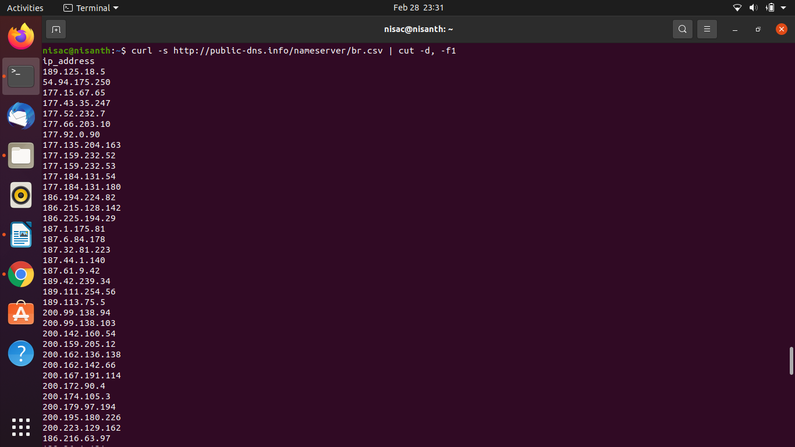

curl -s http://public-dns.info/nameserver/br.csv | cut -d, -f1 | shuf | tail -n 50

Output-

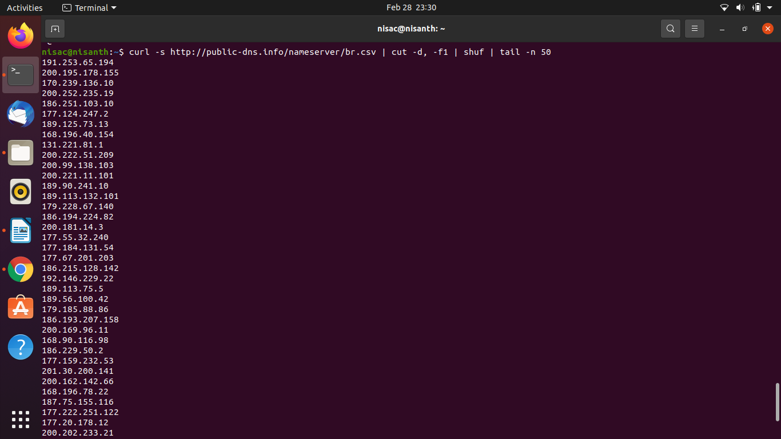

curl -s http://public-dns.info/nameserver/br.csv | cut -d, -f1 | shuf | tail -n 50 | xargs -i timeout 1 ping -c1 -w 1 {}

Output-

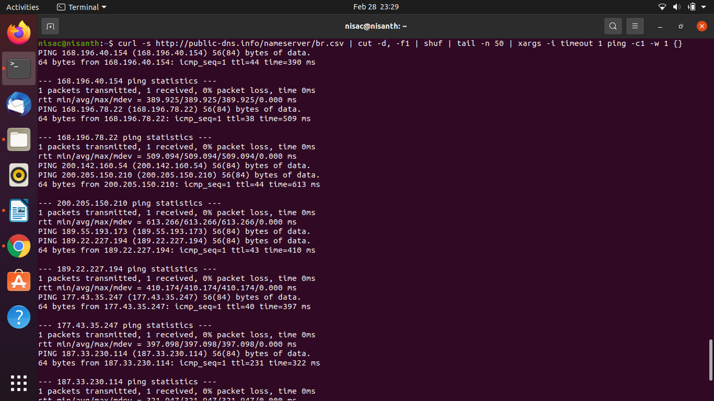

curl -s http://public-dns.info/nameserver/br.csv | cut -d, -f1 | shuf | tail -n 50 | xargs -i timeout 1 ping -c1 -w 1 {} | grep "time="

Output-

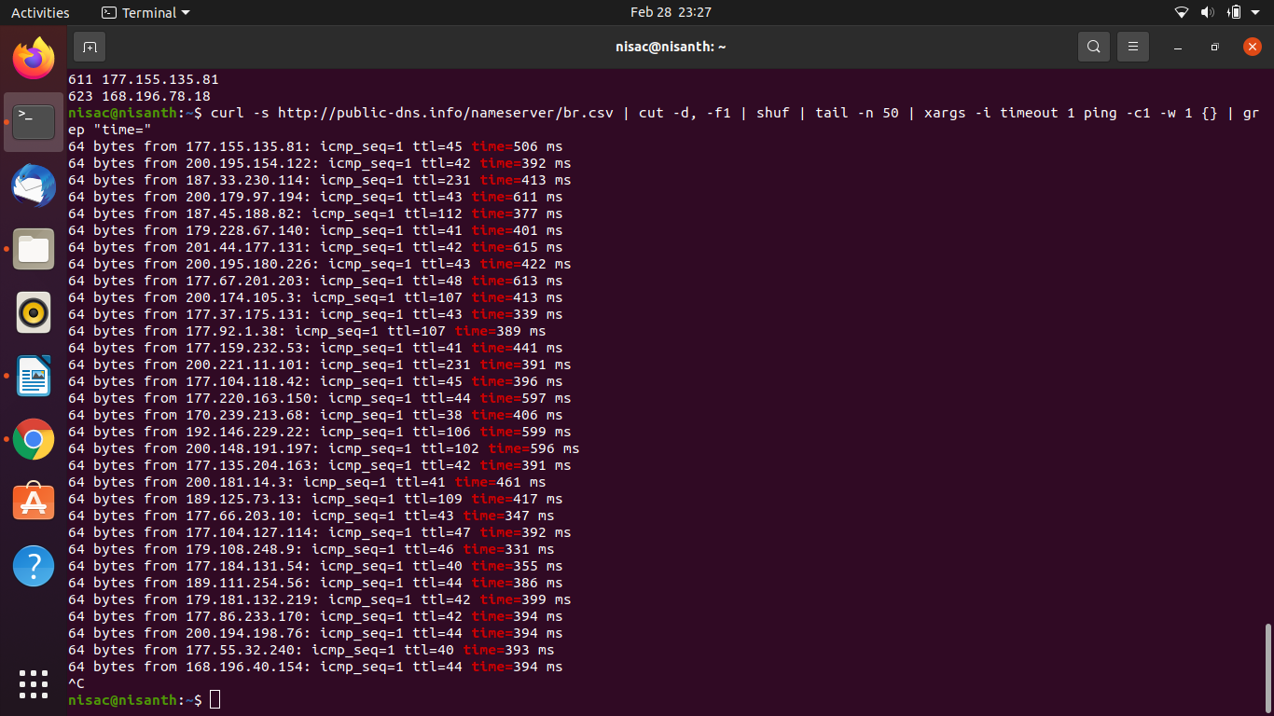

curl -s http://public-dns.info/nameserver/br.csv | cut -d, -f1 | shuf | tail -n 50 | xargs -i timeout 1 ping -c1 -w 1 {} | grep "time=" | awk '{print substr($7, 6, length($7)) " " substr($4, 1, length($4) -1)}'

Output-

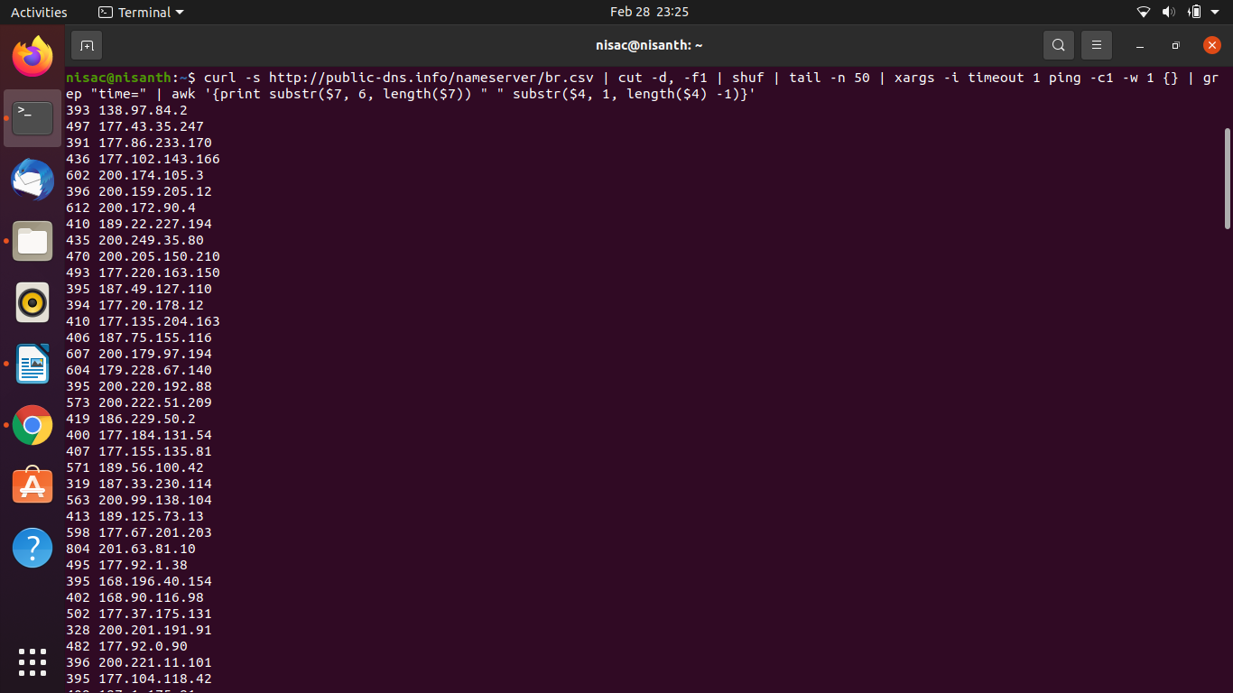

curl -s http://public-dns.info/nameserver/br.csv | cut -d, -f1 | shuf | tail -n 50 | xargs -i timeout 1 ping -c1 -w 1 {} | grep "time=" | awk '{print substr($7, 6, length($7)) " " substr($4, 1, length($4) -1)}' | sort -n

Output-

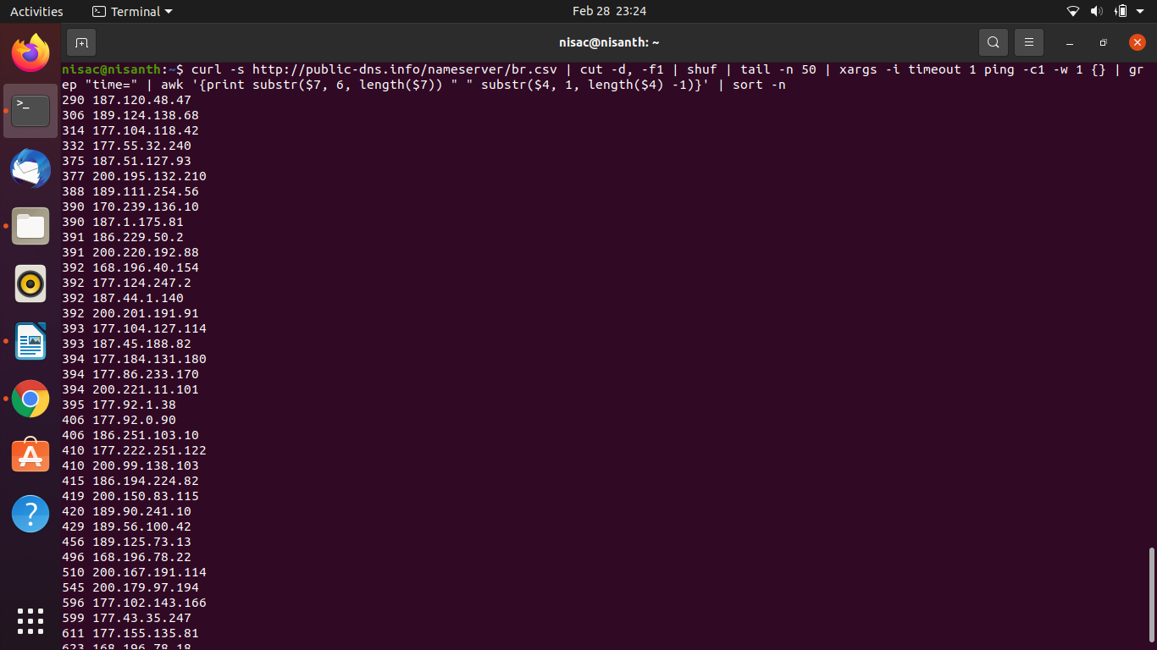

curl -s http://public-dns.info/nameserver/br.csv | cut -d, -f1 | shuf | tail -n 50 | xargs -i timeout 1 ping -c1 -w 1 {} | grep "time=" | awk '{print substr($7, 6, length($7)) " " substr($4, 1, length($4) -1)}' | sort -n | awk '{print $2 " " $1 "ms"}'

Output-

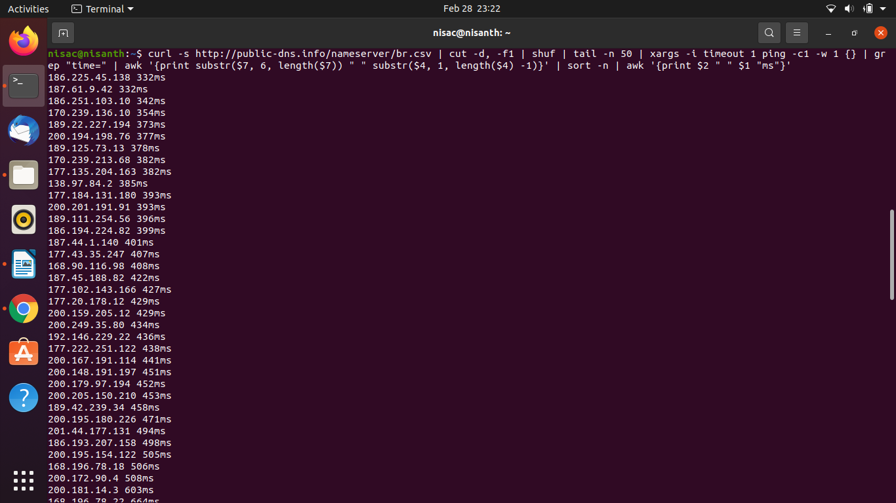

curl -s http://public-dns.info/nameserver/br.csv | cut -d, -f1 | shuf | tail -n 50 | xargs -i timeout 1 ping -c1 -w 1 {} | grep "time=" | awk '{print substr($7, 6, length($7)) " " substr($4, 1, length($4) -1)}' | sort -n | awk '{print $2 " " $1 "ms"}' | head -n 10

Output-
