Explorify

* [Home(current)](http://docs.google.com/index.html)
* [Discover](http://docs.google.com/discover/discover.html)
* About us
* Contact us

Sign in Log in

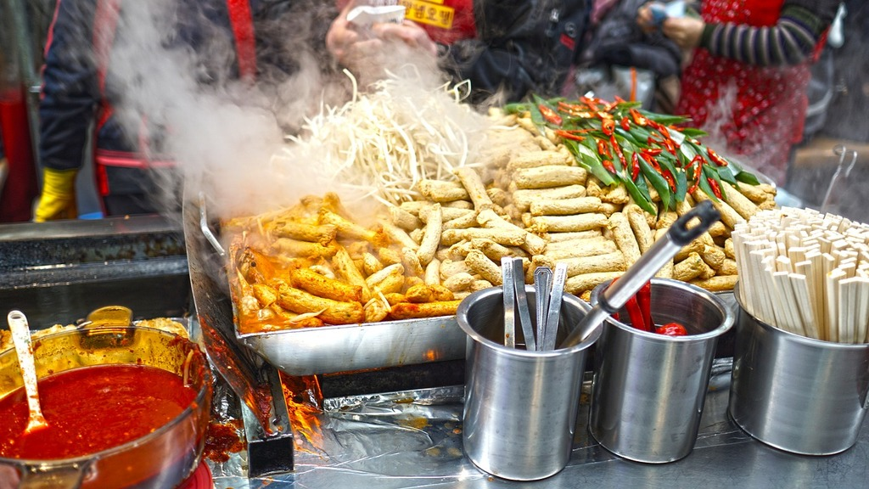

[V V PURAM](http://docs.google.com/discover/Cuisines/show.html)

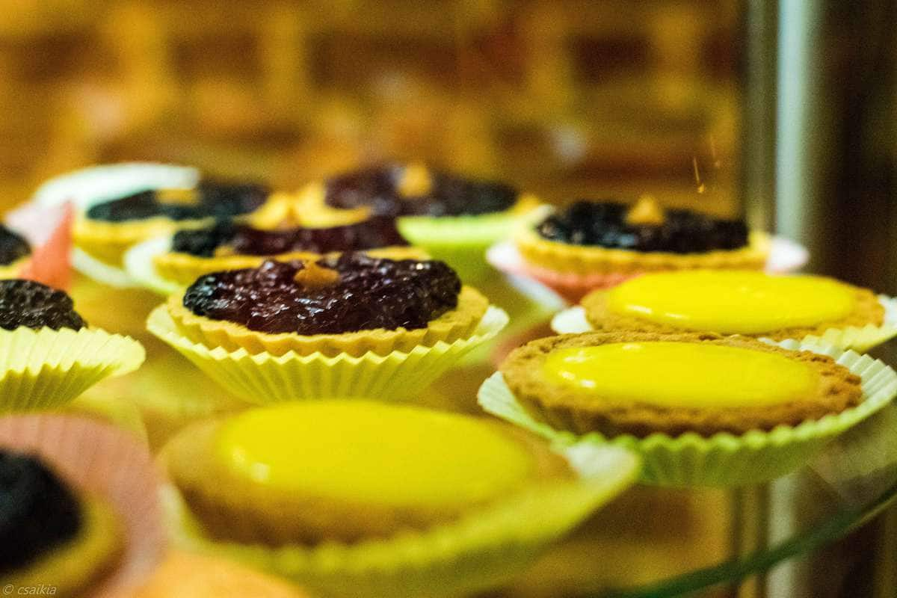

GLEN BAKE HOUSE

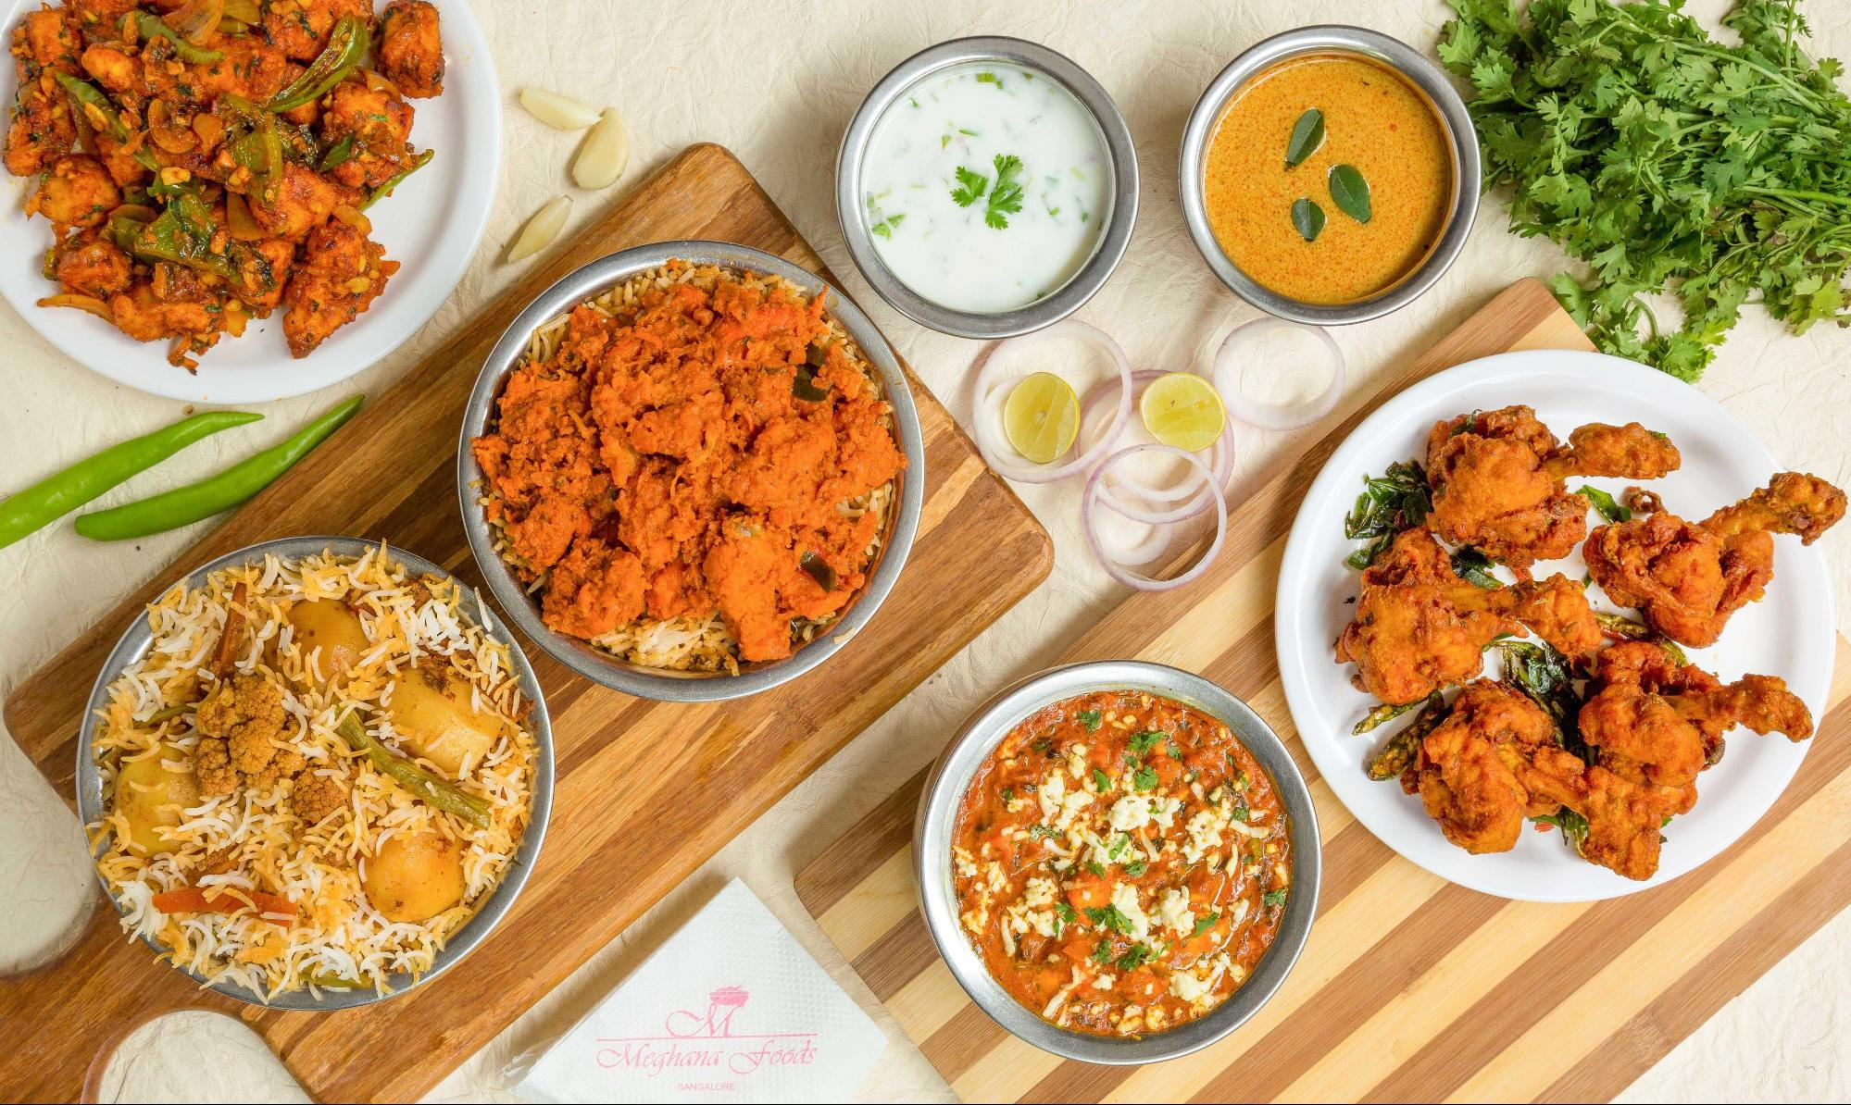

MEGHNA FOODS

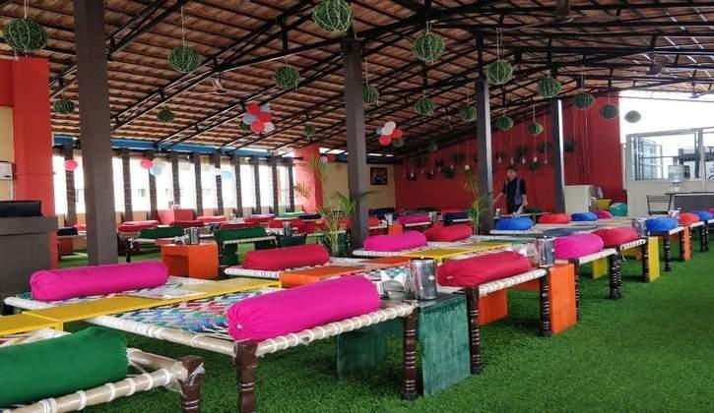

KAPOORS CAFE

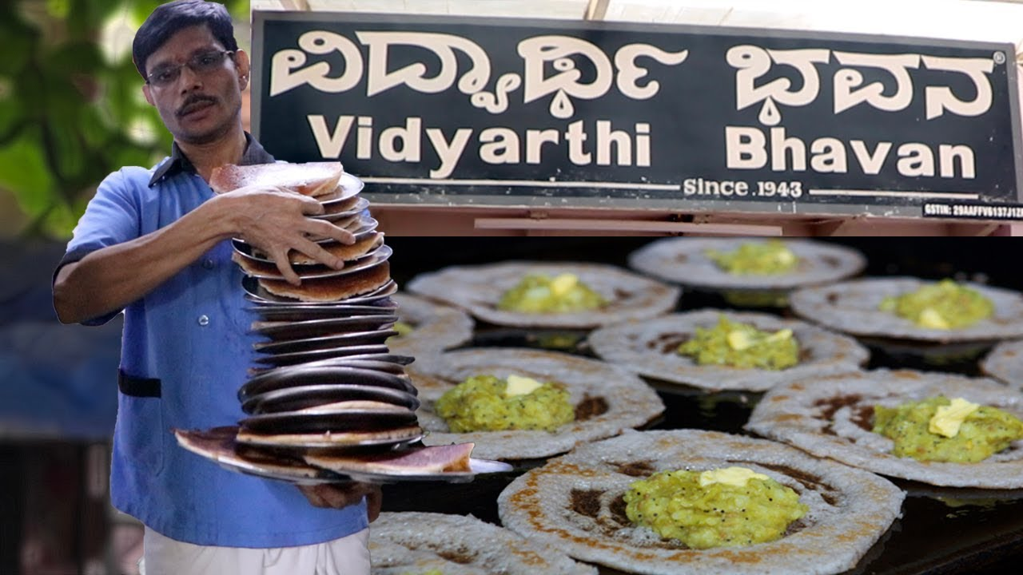

VIDYARTHI BHAVAN

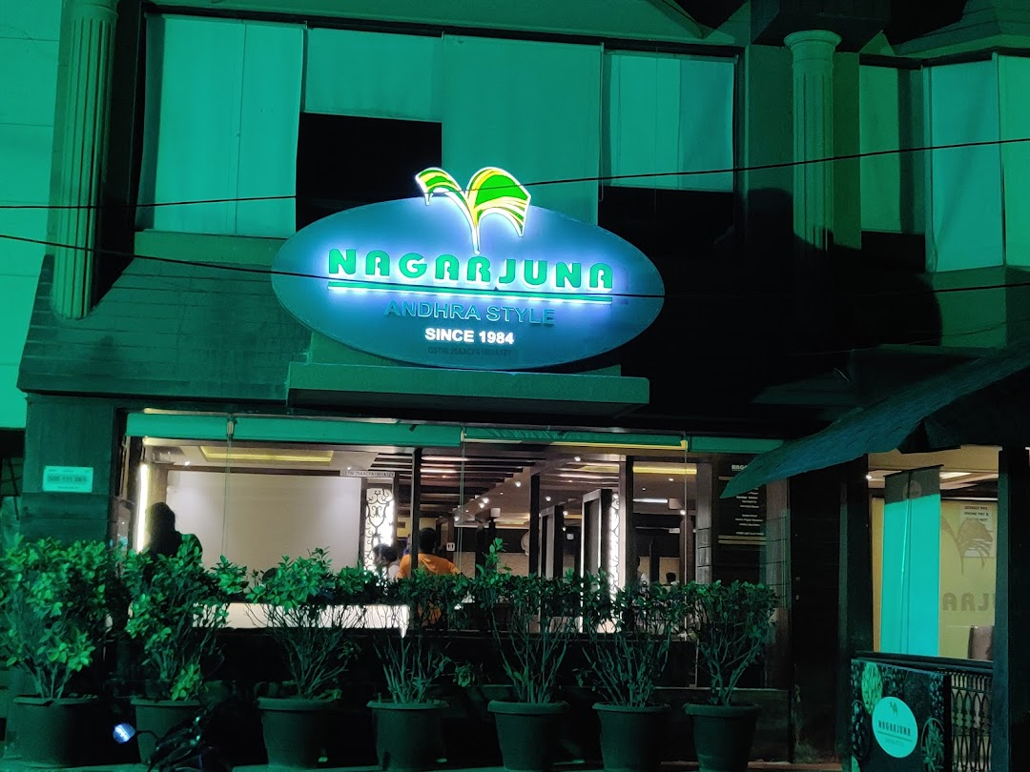

NAGARJUNA

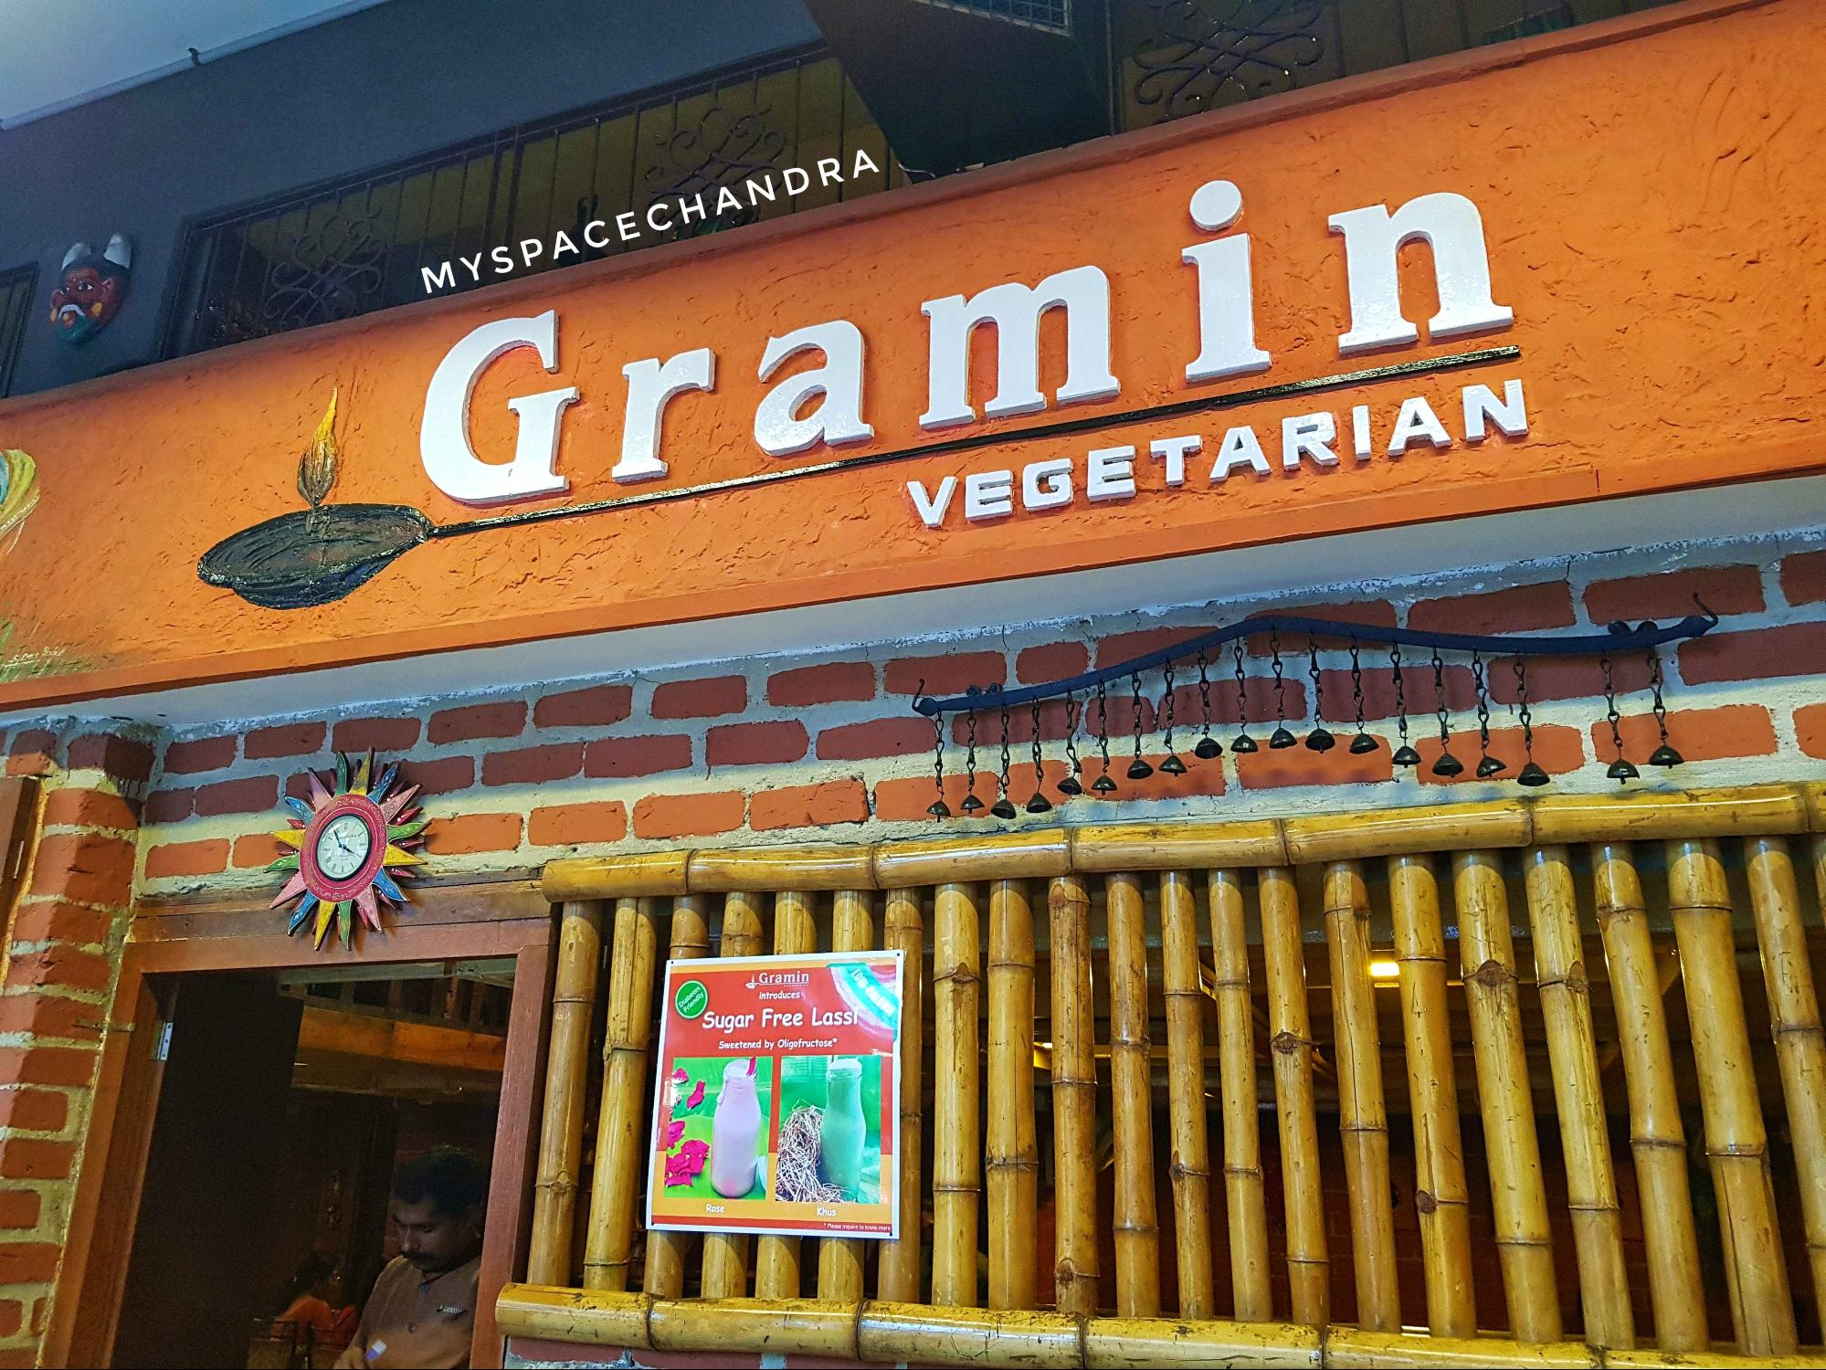

GRAMIN

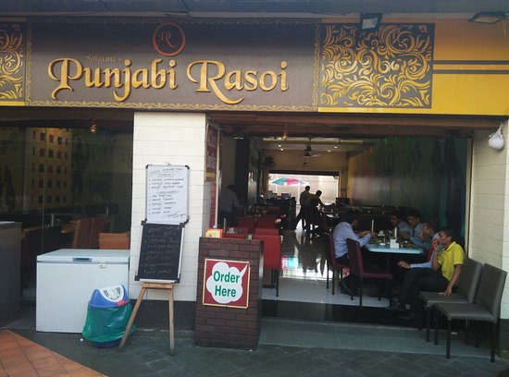

PUNJABI RASOI

© Explorify All Rights Reserved