**PROGRAMME:**

**1)**

#include<stdio.h>

#include<stdlib.h>

float e,a[50];

int n,c,j;

int ls()

{

int i;

for(i=0;i<n;i++)

{

c++;

if(e==a[i])

{

c++;

return i;

}

c++;

}

c++;

return -1;

}

int bs(int f,int l)

{

int m;

m=(f+l)/2;

if(e==a[m])

{

c++;

return m;

}

else if(f==l)

{

c=c+2;

return -1;

}

if(e<a[m])

{

c=c++;

l=m-1;

}

else if(e>a[m])

{

c=c+2;

f=m+1;

}

bs(f,l);

}

int main()

{

int op;

printf("1.Linear Search 2.Binary Search \n");

scanf("%d",&op);

switch(op)

{

case 1:

printf("Give the array size\n");

scanf("%d",&n);

printf("Give the array elements\n");

for(int i=0;i<n;i++)

{

scanf("%f",&a[i]);

}

printf("Give the element that has to be searched\n");

scanf("%f",&e);

if(ls()!=-1)

{

printf("The value of c is %d\n",c);

printf("The first instance of the element was found at %d position\n",ls()+1);

}

else

printf("Element not found\n");

break;

case 2:

printf("Give the array size\n");

scanf("%d",&n);

printf("Give the sorted array elements\n");

for(int i=0;i<n;i++)

{

scanf("%f",&a[i]);

}

printf("Give the element that has to be searched\n");

scanf("%f",&e);

if(bs(0,n-1)!=-1)

{

printf("The value of c is %d\n",c);

printf("The first instance of the element was found at %d position\n",bs(0,n-1)+1);

}

else if(bs(0,n-1)==-1)

printf("Element not found\n");

break;

default:

printf("Invalid input\n");

break;

}

return 0;

}

**OUTPUT:**

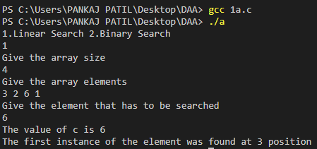

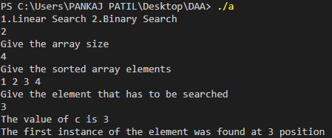

**2)**

#include<stdio.h>

#include<stdlib.h>

int c=0;

struct m

{

float min;

float max;

};

struct m mam(int f,int l,float a[])

{

struct m mm,mml,mmr;

int mid;

if(f==l)

{

c++;

mm.min=a[f];

mm.max=a[l];

return mm;

}

c++;

if(l==f+1)

{

if(a[f]>a[l])

{

mm.min=a[l];

mm.max=a[f];

}

else

{

mm.min=a[f];

mm.max=a[l];

}

c=c+2;

return mm;

}

c++;

mid=(f+l)/2;

mml=mam(f,mid,a);

mmr=mam(mid+1,l,a);

if(mml.min<mmr.min)

mm.min=mml.min;

else

mm.min=mmr.min;

if(mml.max>mmr.max)

mm.max=mml.max;

else

mm.max=mmr.max;

c=c+2;

return mm;

}

void main()

{

int n,i;

printf("Give the number of elements\n ");

scanf("%d",&n);

float a[n];

printf("Give the array elements \n");

for(i=0;i<n;i++)

scanf("%f",&a[i]);

struct m minmax=mam(0,n-1,a);

printf("The minimum and maximum numbers are %f %f\n",minmax.min,minmax.max);

printf("The value of c is %d\n",c);

}

**OUTPUT:**

