Summary Report – Heat-Sink Surrogate Model
Expert Thermal / XThermal Assessment – Task 1 technical summary

1. Assumptions and justifications
- Fixed geometry from the provided script: 90×116×27 mm sink, 60 fins × 0.8 mm, base 2.5 mm, Al 6061-T6, air properties at 25 °C, die 52.5×45 mm, TIM thickness 0.1 mm.
- Physics mode = script for the dataset and ML work so results match the provided Python code (R_jc = 0.2 °C/W, no separate base conduction term). A reference mode (R_jc = 0.1 + R_cond) is implemented for comparison with the PDF report formulas.
- Parameter ranges: TDP 30–250 W; Air velocity 0.5–15 m/s; TIM conductivity k_tim 1–12 W/m·K (covers paste/pad grades used in electronics cooling).
- Sampling: Latin Hypercube, N = 3000, plus all 8 corners of the design box.
- Flow regime: Re ≈ 37–1100 → always laminar; convective h ~ V^(1/3).
- Physics note: R_total does not depend on TDP in this analytical model. TDP only scales Tj = Tamb + TDP · R_total.

Script vs reference discrepancy
Source | R_total (°C/W) | Tj @ 150 W (°C)
Provided script / mode=script | 0.3692 | 80.38
PDF formulas / mode=reference | 0.2755 | 66.33
Excel reference (project notes) | ~0.3730 | ~80.96
Script and Excel agree within ~1%; the PDF R_jc=0.1 + R_cond path is ~25% lower.

2. Key model results
Nominal case (150 W, 1 m/s, 4 W/m·K, script mode): Re = 73.4 (laminar), h = 23.3 W/m²K, R_total = 0.369 °C/W, Tj = 80.4 °C.
Sweep range (3008 samples): R_total ≈ 0.268–0.442 °C/W; Tj ≈ 33–136 °C.
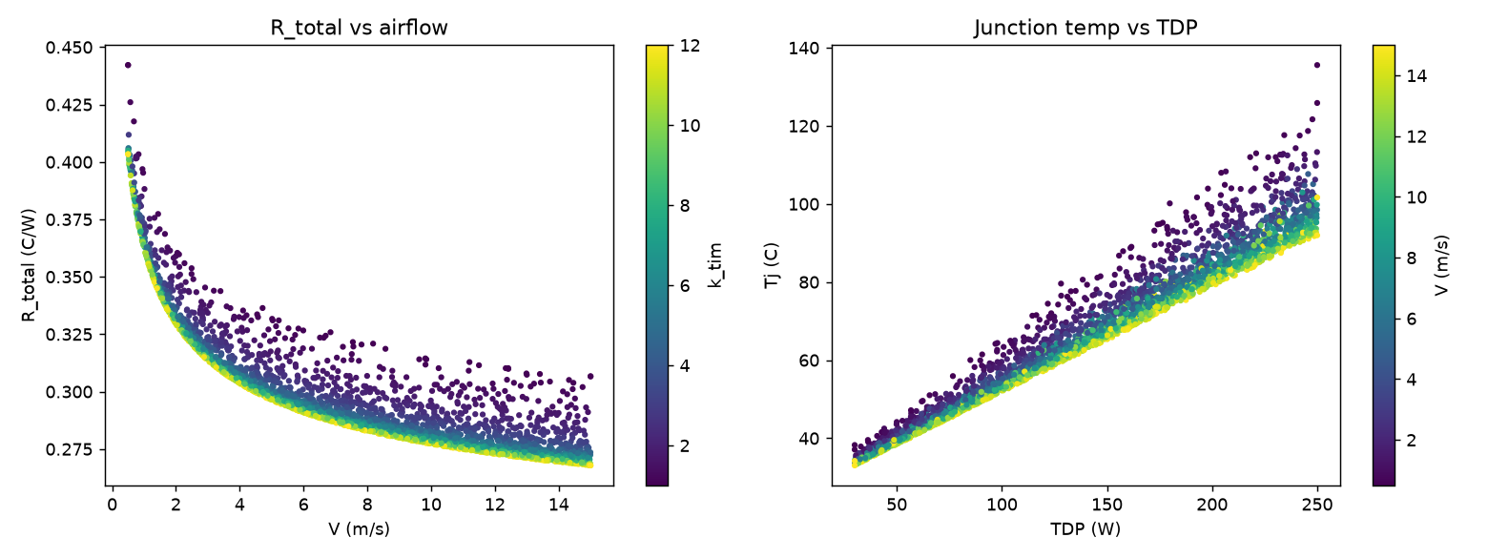
Design space
Inverse design (keep Tj ≤ 85 °C, k_tim = 4 W/m·K):
TDP (W) | Min V physics (m/s) | Min V surrogate (m/s)
100 | 0.50 | 0.50
150 | ~0.60 | ~0.55
200 | ~5.59 | ~5.35
250 | not feasible within 15 m/s | —
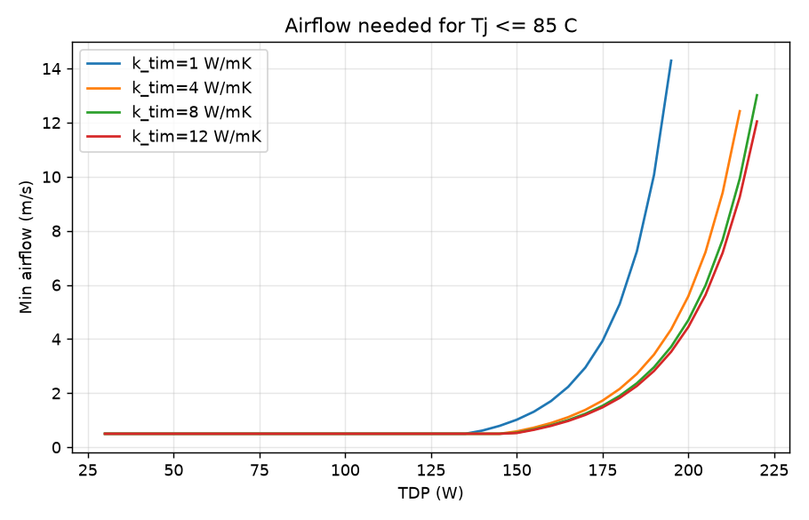
Inverse design

3. ML accuracy comparison
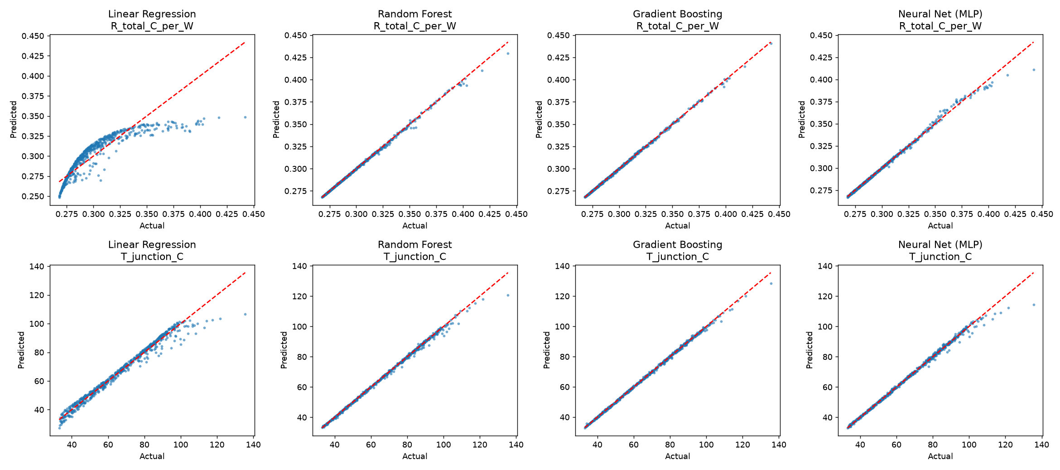
Predicted vs actual
Target | Model | Features | MAE | RMSE | R² | CV R²
R_total | Linear Regression | raw | 0.0105 | 0.0148 | 0.748 | 0.744
R_total | Linear Regression | physics | ~0 | ~0 | 1.000 | 1.000
R_total | Random Forest | raw | 0.00046 | 0.00115 | 0.998 | 0.998
R_total | Gradient Boosting | raw | 0.00046 | 0.00070 | 0.999 | 0.999
R_total | MLP | raw | 0.00086 | 0.00204 | 0.995 | 0.997
Tj | Linear Regression | raw | 1.998 | 3.073 | 0.976 | 0.982
Tj | Random Forest | raw | 0.482 | 1.028 | 0.997 | 0.998
Tj | Gradient Boosting | raw | 0.381 | 0.625 | 0.999 | 0.999
Tj | MLP | raw | 0.651 | 1.424 | 0.995 | 0.997
Model justification: Linear Regression is the transparent baseline (exact for R_total with physics features). Random Forest / Gradient Boosting handle raw nonlinear inputs; GB is the production pick. MLP is a neural baseline, slightly weaker here.
Validation: tuned GB on 1000 fresh points R² ≈ 0.9994 (R_total) / 0.9995 (Tj). Extrapolation V>8: tree models fail on R_total (R² < 0); linear + physics features stays exact. Prefer hybrid: ML predicts R_total, then Tj = 25 + TDP·R.

4. Correlations / sensitivities
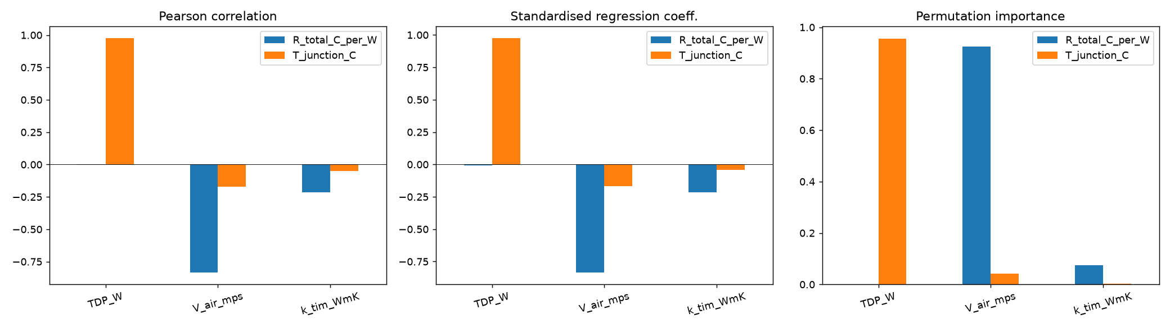
Sensitivity
Driver | Effect on R_total | Effect on Tj
Air velocity V | Strongest (Pearson ≈ −0.84; perm. importance ≈ 93%) | Secondary
TDP | Negligible | Dominant (Pearson ≈ 0.98; perm. importance ≈ 96%)
k_tim | Mild (Pearson ≈ −0.22) | Small
Design takeaway: airflow is the lever for resistance; power dominates junction temperature; TIM helps less than airflow in this range.

5. Limitations
- Surrogate learns an analytical correlation, not CFD/lab data — optimistic noise-free R².
- Missing: fin efficiency, spreading resistance, bypass, radiation, natural convection.
- Fixed geometry; trees do not extrapolate safely outside training V.
- Script vs PDF reference discrepancy affects absolute Tj.

6. Improvements
- Geometry DOFs + fin efficiency / spreading; train on CFD/test data; uncertainty (ensembles/GP); physics-informed features / PINNs.
- Product demo: streamlit run app.py; CLI: python predict.py 150 1 4.

7. Reproduce
pip install -r requirements.txt
python run_all.py
Notebook: HeatSink_Project_Notebook.ipynb

Task 3 – AI Use Case Evaluation
Engineering software platform (thermal / XThermal context)
Suggests 5 AI features. For each: problem solved, data required, AI type, and how to validate.

1. AI-assisted input validation & missing-parameter detection
Problem it solves
Users often leave gaps (missing TIM thickness, inconsistent units, TDP outside sink capability). Bad inputs waste engineer time and produce silent wrong results.
Data required
- Schema of required/optional fields per calculation type
- Historical valid/invalid job logs (ranges, units, failure reasons)
- Catalog of default materials / TIM grades
AI type
Combination: rules + ML (anomaly / range scoring) + light GenAI for plain-language explanations (“k_tim=0.05 looks like W/m·K mistyped as paste thickness”).
How to validate
- Confusion matrix on labeled past jobs (false-accept / false-reject rates)
- A/B: % of calculations that complete without rework
- Expert review of flagged vs accepted edge cases

2. ML surrogate for fast thermal prediction (what Task 1 builds)
Problem it solves
Full analytical sweeps, CFD, or nested design loops are too slow for interactive “what-if” exploration. Engineers need sub-second estimates of R_total and Tj.
Data required
- Parameter sweeps from trusted physics models (this project) and later CFD / lab measurements
- Geometry, airflow, TIM, power, ambient metadata
AI type
Classical ML (Gradient Boosting / RF) with optional physics-informed features; later physics-aware / hybrid models.
How to validate
- MAE / RMSE / R² vs held-out physics points (as in results/ml_accuracy.csv)
- Fresh-point and extrapolation tests (results/validation.csv)
- Hybrid check: ML predicts R_total, then Tj = Tamb + TDP·R vs direct physics
- Acceptance gates: e.g. |ΔTj| < 1 °C inside training envelope

3. Thermal design recommendations (inverse / constrained design)
Problem it solves
Engineers ask “what minimum airflow / TIM / fin count keeps Tj ≤ 85 °C?” Trial-and-error is slow; inverse design turns the surrogate into a recommendation tool.
Data required
- Trained surrogate + physics fallback
- Constraint library (Tj limit, max fan speed, max pressure drop, cost/weight caps)
- Feasible component catalog (fans, TIMs, sink SKUs)
AI type
ML surrogate + optimization / workflow AI (search over V, k_tim, catalog SKUs); GenAI only for explaining the recommendation in context.
How to validate
- Re-evaluate recommended designs with the physics model (and CFD spot-checks)
- Compare to known feasible/infeasible cases (e.g. 250 W not feasible within 15 m/s for this sink)
- Track recommendation acceptance rate by thermal engineers

4. Knowledge retrieval from engineering documents (RAG)
Problem it solves
Specs, TIM datasheets, correlation validity ranges, and past project reports are scattered. Engineers need fast, cited answers instead of hunting PDFs.
Data required
- Indexed corpus: datasheets, internal SOPs, past reports, correlation notes
- Chunking metadata (doc type, revision, material family)
- Access-control tags
AI type
GenAI + RAG (retrieval-augmented generation); not a standalone LLM guessing numbers.
How to validate
- Golden Q&A set with expected citations
- Measure faithfulness (answer grounded in retrieved chunks) and citation accuracy
- Human thermal-SME review before production use for safety-critical guidance

5. Result summarization & automated report generation
Problem it solves
After a sweep or optimization, stakeholders need a short narrative: assumptions, key Tj/R numbers, risks, and recommended next action — not raw CSVs.
Data required
- Structured run outputs (tables, plots, sensitivity ranks)
- Report templates (customer vs internal)
- Optional: past approved report language for tone/style
AI type
GenAI + workflow AI (template fill → LLM narrative → human approve). Numbers must come from the calculation engine, not from the LLM.
How to validate
- Checklist: every number in the narrative matches source tables
- Reviewer edit distance / approval time
- Spot audits for hallucinated claims or missing limitations

Priority suggestion for a thermal product
Priority | Feature | Why first
1 | Surrogate + limit check | Immediate interactive value; Task 1 already demos this
2 | Input validation | Cuts support load and bad runs
3 | Inverse recommendations | Turns prediction into design decisions
4 | Report generation | Speeds delivery once results are trusted
5 | RAG over docs | High leverage once corpus is curated
Safety principle: ML/GenAI may propose; physics (or CFD/test) remains the source of truth for acceptance-critical numbers.

