

* What is Red hat:

Red Hat is a software company that provides open-source solutions and enterprise software products, particularly in the area of Linux operating systems. Red Hat is known for developing the Red Hat Enterprise Linux operating system, which is widely used in enterprise environments. Red Hat also provides a variety of other open-source software products and services, including middleware, virtualization, cloud computing, and storage solutions. In 2019, Red Hat was acquired by IBM, but it continues to operate as a separate business unit within IBM.

* History of Red hat:

Red Hat was founded in 1993 by Bob Young and Marc Ewing. The company's name was derived from Ewing's Cornell University lacrosse team cap, which had a red and white pattern and Red Hat Software was born in 1995, with Young as CEO. In the early days, Red Hat was a distributor of the Linux operating system and provided technical support to its customers.

In 1995, Red Hat released its first commercial Linux distribution, Red Hat Linux 2.0. This distribution was based on the Slackware Linux distribution and included additional software packages and user-friendly tools for installation and configuration.

Over the next few years, Red Hat continued to develop and release new versions of its Linux distribution, which gained popularity among businesses and governments looking for a stable and reliable operating system. In 1999, Red Hat went public and became the first open-source software company to do so.

In the early 2000s, Red Hat shifted its focus to enterprise software and began developing the Red Hat Enterprise Linux operating system. This operating system was designed for use in mission-critical environments, and Red Hat provided technical support and other services to its enterprise customers.

Red Hat also expanded its product offerings to include middleware, virtualization, and cloud computing solutions. In 2018, Red Hat announced that it was being acquired by IBM for $34 billion, making it one of the largest software acquisitions in history. The acquisition was completed in 2019, and Red Hat continues to operate as a separate business unit within IBM.

* Red hat used for

Red Hat is primarily used for developing and deploying enterprise-level applications in a variety of industries, such as finance, healthcare, government, and telecommunications. Red Hat provides a wide range of open-source software solutions, including the popular Red Hat Enterprise Linux operating system, which is used to power servers, workstations, and supercomputers.

* RHEL, Fedora, SUSE Linux, and CentOS are all Linux-based operating systems, but they have some key differences:

1.**Red Hat** **Enterprise Linux (RHEL)**: RHEL is a commercially supported Linux distribution designed for enterprise use. It is known for its stability, security, and long-term support, and is widely used in mission-critical environments such as data centers, cloud computing, and financial services. RHEL provides regular updates and patches, as well as long-term support for each release, typically up to 10 years.

2. **Fedora**: Fedora is a community-supported Linux distribution that is sponsored by Red Hat. It is known for its cutting-edge features, rapid development, and focus on open-source technologies. Fedora is often used by developers and enthusiasts who want to try out the latest Linux technologies and features. It provides regular updates and releases, with a new version typically coming out every six months. Fedora is also used as a testing ground for new features that may later be incorporated into RHEL.

3.**SUSE Linux**: SUSE Linux is a commercially supported Linux distribution that is known for its stability, security, and scalability. It is widely used in enterprise environments and is particularly popular in Europe. SUSE provides both community-supported and commercially supported versions of its distribution. The commercially supported version provides long-term support and updates, as well as access to enterprise-level support and services.

4.**CentOS**: CentOS is a community-supported Linux distribution that is based on the same source code as RHEL. CentOS provides a free, open-source alternative to RHEL, with similar features and functionality. CentOS is often used by organizations and individuals who want to use RHEL but do not want to pay for commercial support. CentOS provides regular updates and releases, with support typically provided by the community.

*Community-supported is open-source software that requires no cost and supported by a community of developers/users that provide feedback and updates to the software. Commercially-supported is still open source based on a community release, but is created and consistently supported by a vendor.

* RHEL (Red Hat Enterprice Linux)

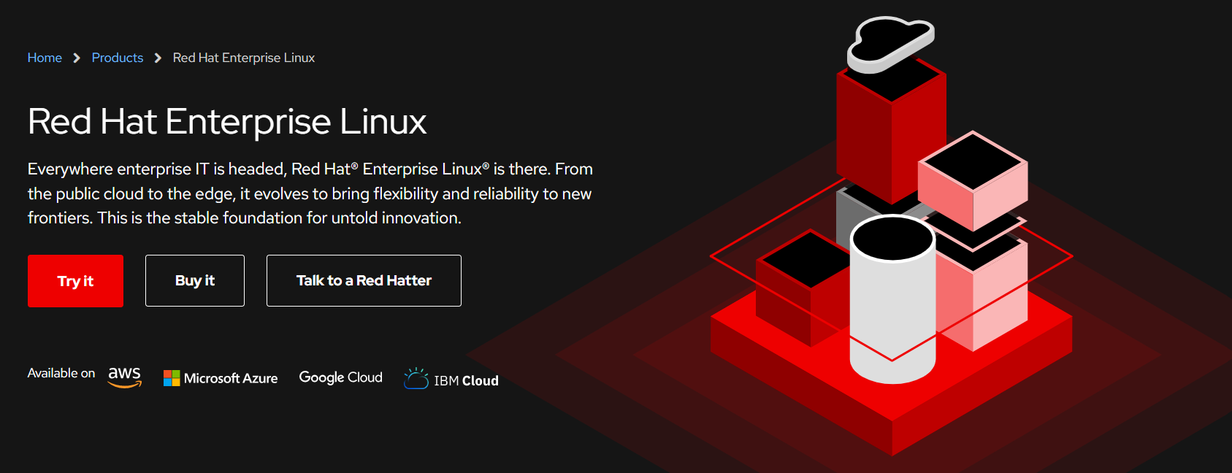

Linux distributions, also known as distros, are different versions of the Linux operating system that are based on the Linux kernel and a collection of software tools and applications. There are hundreds of Linux distributions available, each with its own unique features, package management system, desktop environment, and user interface.

**Some of the most popular Linux distributions are:**

**Ubuntu**: Ubuntu is a free and open-source Linux distribution based on Debian. It is one of the most popular and user-friendly Linux distributions, with a focus on ease of use and simplicity.

**Fedora**: Fedora is a community-supported Linux distribution sponsored by Red Hat. It is known for its cutting-edge features and rapid development cycles, and is often used by developers and enthusiasts who want to try out the latest Linux technologies.

Debian: Debian is a free and open-source Linux distribution that is known for its stability and security. It is widely used in enterprise environments and provides a vast collection of software packages.

**CentOS**: CentOS is a community-supported Linux distribution that is based on the same source code as Red Hat Enterprise Linux (RHEL). It provides a free, open-source alternative to RHEL, with similar features and functionality.

**Arch Linux**: Arch Linux is a lightweight and flexible Linux distribution that is known for its simplicity and minimalism. It is often used by experienced Linux users who want more control over their system and prefer a do-it-yourself approach.

**openSUSE**: openSUSE is a free and open-source Linux distribution that is known for its stability, security, and ease of use. It is widely used in enterprise environments and provides both community-supported and commercially supported versions of its distribution.

* Variants of Red Hat Linux:

The initial edition of RHEL came on the market as **"Red Hat Linux Advanced Server"**, for bearing the name originally. Red Hat renamed Red Hat Linux Advanced Server to the **"Red Hat Enterprise Linux AS"** name and included two more versions, Red Hat Enterprise Linux WS and Red Hat Enterprise Linux ES, in 2003.

Red Hat utilizes strict trademark rules to limit free re-distribution of the officially supported editions of Red Hat Enterprise Linux but freely offers its source code. All third-party derivatives can be re-distributed and built by stripping away paid components like the trademarks of Red Hat. Examples contain community-supported distributions such as **AlmaLinux** and **Rocky Linux** and commercially forked such as **Oracle Linux**.

There are new versions that replace the former RHEL Desktop/WS/ES/AS in Red Hat Enterprise Linux:

* RHEL Advanced Platform (or former AS)
* RHEL former ES (restricted to two CPUs)
* RHEL Desktop with Multi-OS and Workstation option
* RHEL Desktop with only Workstation option (or former WS)
* RHEL Desktop with only Multi-OS option
* RHEL Desktop (or former Desktop)

Also, Red Hat had revealed its Red Hat Global Desktop Linux version ***"*for emerging markets*"***.

## Version History of RHEL

**Naming Convension:**  
All releases are given a codename chosen by the developer's vote. The codenames do not have a particular pattern (unlike Debian or Ubuntu).

* **RHEL 9**  
  RHEL 9 was revealed at Red Hat Summit on 10 May 2022 and was officially published on 17 May 2022. In this system version, GNOME 40 and Linux Kernel 5.14.0 versions were introduced. RHEL 9 was the first edition which was CentOS Stream based, while historically, Red Hat Enterprise Linux was based on Fedora Linux directly.
* **RHEL 8**  
  RHEL 8 was based on GNOME 3.28, Fedora 28, systemd 239, glibc 2.28, GCC 8.2, upstream Linux Kernel 4.18, and the switch to Wayland. The initial beta was disclosed on 14 November 2018. RHEL 8 was officially published on 7 May 2019. IBM has finished the transition of the POWER9 and POWER8 servers to little-endian mode with the release of Red Hat Enterprise Linux 8.
* **RHEL 7**  
  RHEL 7 was based on GNOME 3.8, Fedora 19, systemd 208, and upstream Linux Kernel 3.10. The first beta was disclosed on 11 December 2013, and a publication candidate was there on 15 April 2014. RHEL 7 was officially published on 10 June 2014.
* **RHEL 6**  
  RHEL 6 was forked through Fedora 12 and included several backported aspects from Fedora 14 and 13.
* **RHEL 5**  
  RHEL 5 utilized Linux Kernel 2.6.18-8 on 15 March 2007, 15 years ago.
* **RHEL 4**  
  RHEL 4 announced Linux Kernel 2.6 versions and developed attributed to ext3 and ext2 file systems.
* **RHEL 3**  
  RHEL 3 utilized Linux Kernel 2.4.21-4 on 22 October 2003, 19 years ago.
* **RHEL 2.1**  
  RHEL 2.1 AS utilized Linux Kernel 2.4.9-e.3 on 26 March 2002, 20 years ago.

**NOTE: \*** Difference between upstream and downstream

(In linux distributions the term 'upstream' (also applied to kernel) refers to the original version (as is released by software developers) of a program/software (kernel in your case) while 'downstream' refers to the software provided by linux distribution.)

* **RHEL 7 (Red Hat Enterprise Linux 7)**

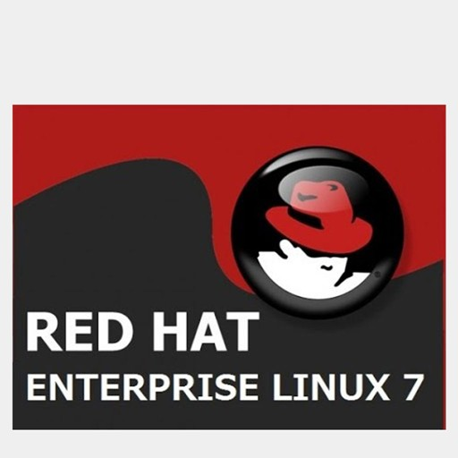

In this release, Red Hat brings together improvements across the server, systems, and the overall Red Hat open source experience. Among others, Red Hat Enterprise Linux 7 introduces:

* XFS as the default file system;
* a new boot loader and a fully redesigned graphical installer;
* the **systemd** system and service manager;
* the kernel patching utility, **kpatch**, Technology Preview, which allows users to patch the kernel without rebooting;
* the **Docker** environment that allows users to deploy any application as a lightweight and portable container;
* the Hardware Event Report Mechanism (HERM) that refactors the Error Detection and Correction (EDAC) mechanism of dual in-line memory module (DIMM) error reporting;
* the **OpenLMI** project providing a common infrastructure for the management of Linux systems.
* **RHEL 8 (Red Hat Enterprise Linux 8)**

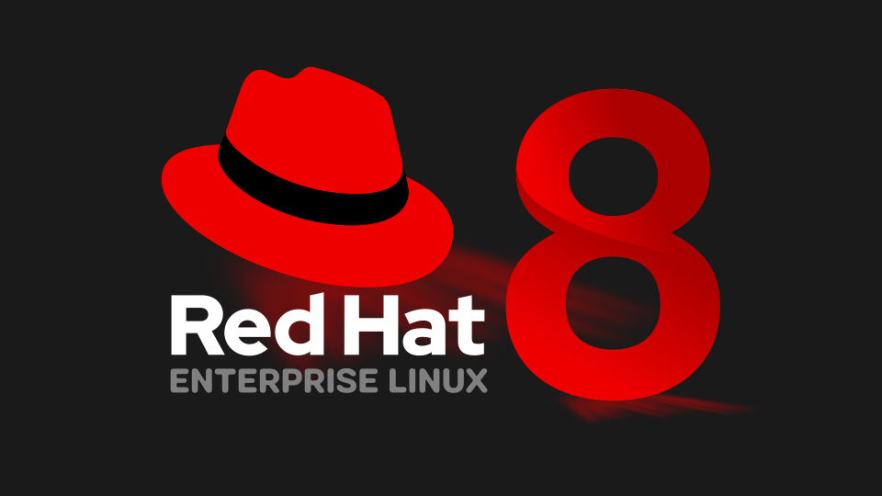

Red Hat Enterprise Linux 8 (*Ootpa*) is based on [Fedora 28](https://en.wikipedia.org/wiki/Fedora_Linux_release_history#Fedora_Linux_28), upstream [Linux kernel](https://en.wikipedia.org/wiki/Linux_kernel) 4.18, GCC 8.2, glibc 2.28, [systemd](https://en.wikipedia.org/wiki/Systemd" \o "Systemd) 239, GNOME 3.28, and the switch to [Wayland](https://en.wikipedia.org/wiki/Wayland_(display_server_protocol)). The first beta was announced on November 14, 2018. Red Hat Enterprise Linux 8 was officially released on May 7, 2019.

With Release 8 of Red Hat Enterprise Linux, IBM has completed transition of POWER8 and POWER9 servers to [little-endian mode](https://en.wikipedia.org/wiki/Endianness).

The name *Ootpa* was a tribute to Larry Troan. His son, Eric Troan was Red Hat's first head engineer and his username was *ewt*, so his father was given the name *ewt's pa*, pronounced *Ootpa.*

* **RHEL 9 (Red Hat Enterprise Linux 9)**

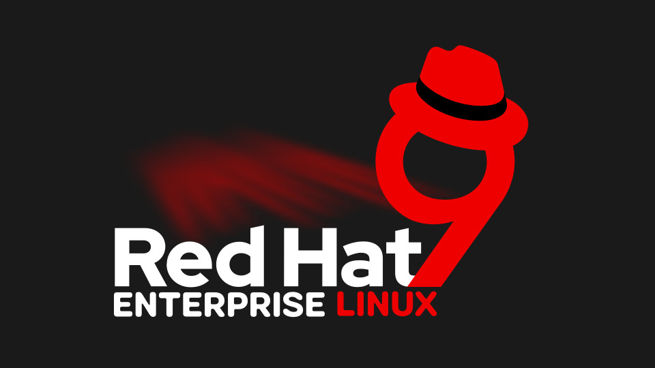

Red Hat Enterprise Linux 9 was announced at Red Hat Summit on May 10, 2022 and was officially released on May 17, 2022. In this version of the system introduced a Linux Kernel 5.14.0 and Gnome 40.

RHEL 9 was the first to be based on [CentOS Stream](https://en.wikipedia.org/wiki/CentOS_Stream), itself based on Fedora Linux, while historically RHEL was based directly on Fedora Linux.

The first beta for Red Hat Enterprise Linux 9 (*Plow*), based on [Fedora Linux 34](https://en.wikipedia.org/wiki/Fedora_Linux_release_history#Fedora_Linux_34), was released on November 3, 2021.

Red Hat Enterprise Linux 9 (*Plow*) was released on May 18, 2022. The name *Plow* was the Appalachian Trail nickname for Tim Burke, one of the founders of RHEL and retired leader of RHEL engineering

* **What is the difference between RHEL 7, 8 and 9**

|  |  |  |  |
| --- | --- | --- | --- |
| **Features** | **RHEL 7** | **RHEL 8** | **RHEL 9** |
| Date of Release | 09 June 2014 | 07 May 2019 | 17 May 2022 |
| Default File System | XFS | XFS | XFS |
| Kernel Version | 3.10 | 4.18 | 5.14 |
| Kernel Code Name | Maipo | Ootpa | Plow |
| Package Management | YUM | DNF, YUM | DNF, YUM |
| Network Time Synchronization | Using either ntp or chronyd. | Using only Chronyd. The ntp implemenation is not supported in RHEL8. | Uses chronyd daemon provided by the chrony package |
| Supported Hardware Architecture | - 64-bit AMD  - 64-bit Intel  - IBM POWER7  - IBM System z | - AMD and Intel 64-bit architectures - The 64-bit ARM architecture - IBM Power Systems - IBM Z | - AMD and Intel 64-bit architectures (x86) - The 64-bit ARM architecture  - IBM Power Systems,  - 64-bit IBM Z |
| Repositories | Red Hat Enterprise Linux 7 Server (RPMs) | - BaseOS  - AppStream | - BaseOS  - AppStream |
| Dynamic Programming Languages Versions. | | - Python 2 (2.7.X)    - PHP 5.4    - Ruby 2.0.0 | - Python 3  - Perl 5.26    - PHP 7.2    - Ruby 2.5    - Node.js 16 |
| Desktop GUI and Graphics | | X.Org server is the default display server in RHEL 7. | The default display server is ‘Wayland’ used by Gnome Display Manager in RHEL 8.  Wayland 1.15 |
| Max. RAM Supported | | 12 TB | 24 TB |
| Compiler/toolchain | | GCC 4.8.x | GCC 8.2.1 |
| Default Databases | | MariaDB is the default implementation of MySQL in Red Hat Enterprise Linux 7 | The following database servers are available in RHEL8*:  - MySQL 8.0 - MariaDB 10.3 - PostgreSQL 10 and PostgreSQL 9.6 - Redis 5.0 |

~~~~~~~~~~~~~~~~~~~~~~~~~~~~~~~~~~~~~~~~~~~~~~~~~~~~

# Network Time Protocol (NTP)

**Network Time Protocol** (NTP) is an internet protocol used to synchronize with computer clock time sources in a network.

### How does NTP work?

The following three steps are involved in the NTP time synchronization process:

1. The NTP [client](https://www.techtarget.com/searchenterprisedesktop/definition/client) initiates a time-request exchange with the NTP server.
2. The client is then able to calculate the link delay and its local offset and adjust its local clock to match the clock at the server's computer.
3. As a rule, six exchanges over a period of about five to 10 minutes are required to initially set the clock.

### What are stratum levels?

Degrees of separation from the UTC source are defined as strata. The various strata include the following:

* **Stratum 0.** A reference clock receives true time from a dedicated transmitter or satellite navigation system. It is categorized as stratum 0.
* **Stratum 1.** A device is directly linked to the reference clock.
* **Stratum 2.** A device receives its time from a stratum 1 computer.
* **Stratum 3.** A device receives its time from a stratum 2 computer.

NTP is a built-on UDP, where **port 123** is used for NTP server communication and NTP clients use port 1023 (for example, a desktop).

