Create 3 VMs – (GUI)

1. Master node (processor- 2, cores/pro- 4, 8 GB RAM, Disk space> 200 (300))
2. Worker node-1 (processor- 2, cores/pro- 4, 8 GB RAM, Disk space> 200 (260))
3. Worker node-2 (processor- 2, cores/pro- 4, 8 GB RAM, Disk space> 200 (260))

From here everything has to be done on all 3 vms

* Start internet servies on all vms

#ip a

#ifup ens33

* Change hostnames of the nodes-

#

#su

(do this in all vms)

* Note the ip of all

Master- 192.168.195.128

Node1- 192.168.195.129

Node2- 192.168.195.130

* Make entries in hosts file in all vms

#vi /etc/hosts

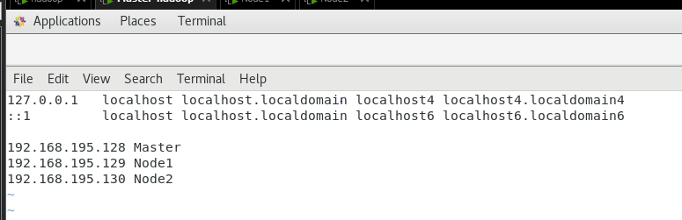

* Copying all the necessary ambari file from base machine into every vms for installation. Use WinSCP for copying. These 3 files needs to be copied.

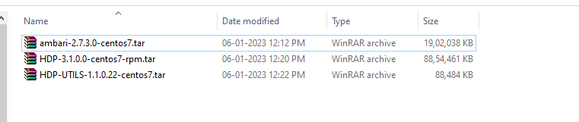

* In Winscp-

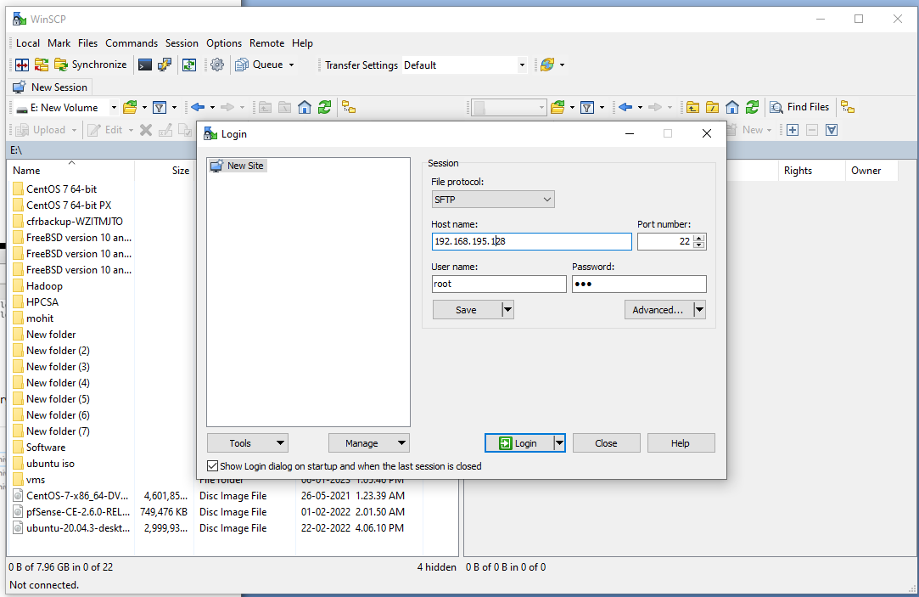

* Drag the file that needs to be copied and drop on the location.

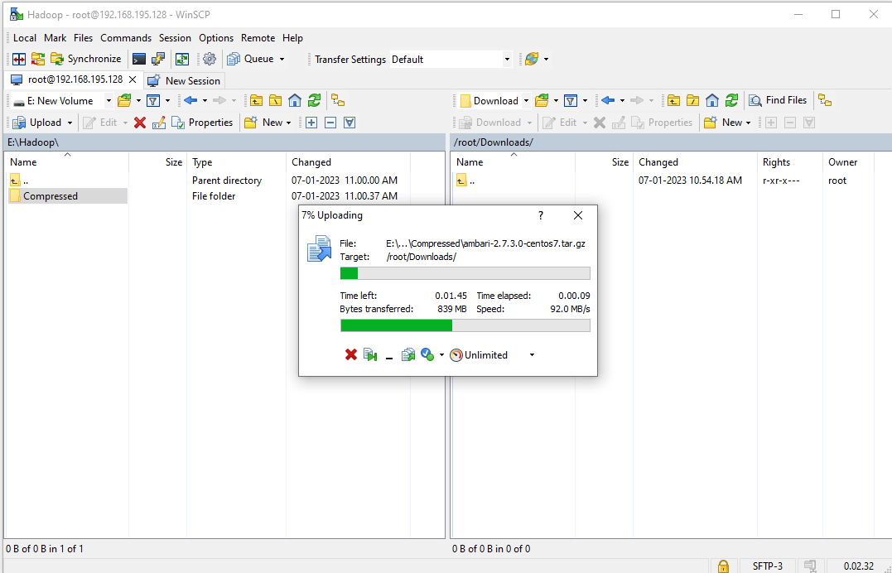

* Try pinging all the nodes, they should communicate with new hostnames.
* Adding webserver-

#yum install –y webserver*

* #systemctl start httpd
* #systemctl enable httpd
* #systemctl stop firewalld
* vi /etc/selinux/config
* selinux=disabled
* **Making three separate folders** or directories namely ambari ,hdp ,hdp-utils at location - /var/www/html

#mkdir /var/www/html/ambari

#mkdir /var/www/html/hdp

#mkdir /var/www/html/hdp-utils

* **Copying these tar file** in Downloads/Compressed/ to /var/www/html/ (in all there respective folders)
* #cd Downloads/Compressed/

#ls

#cp ambari-2.7.3.0-centos7.tar.gz /var/www/html/ambari

(can delete the tar file from the downloads folder as is it copied now in ambari to save space)

* #cd Downloads/Compressed/

#ls

#cp HDP-3.1.0.0-centos7-rpm.tar.gz /var/www/html/hdp

* #cd Downloads/Compressed/

#ls

#cp HDP-UTILS-1.1.0.22-centos7.tar.gz /var/www/html/hdp-utils

* **untar** all files in their respective folders

#cd /var/www/html/ambari

#tar –xvf ambari-2.7.3.0-centos7.tar.gz

#cd /var/www/html/hdp

#tar –xvf HDP-3.1.0.0-centos7-rpm.tar.gz

#cd /var/www/html/hdp-utils

#tar –xvf HDP-UTILS-1.1.0.22-centos7.tar.gz

* #yum install –y **createrepo** (location- /var/www/html/ambari/ambari/centos7/2.7.3.0-139)
* #yum install –y createrepo (location- /var/www/html/hdp/HDP/centos7/3.1.0.0-78)
* #yum install –y createrepo (location- /var/www/html/hdp-utils/HDP-UTILS/centos7/1.1.0.22)
* **Copying .repo file to /etc/yum.repos.d**

#cd /var/www/html/ambari/ambari/centos7/2.7.3.0-139

#cp ambari.repo /etc/yum.repos.d

# cd /var/www/html/hdp/HDP/centos7/3.1.0.0-78

#cp hdp.repo /etc/yum.repos.d

* # vi /etc/yum.repos.d/ambari.repo

* # vi /etc/yum.repos.d/hdp.repo

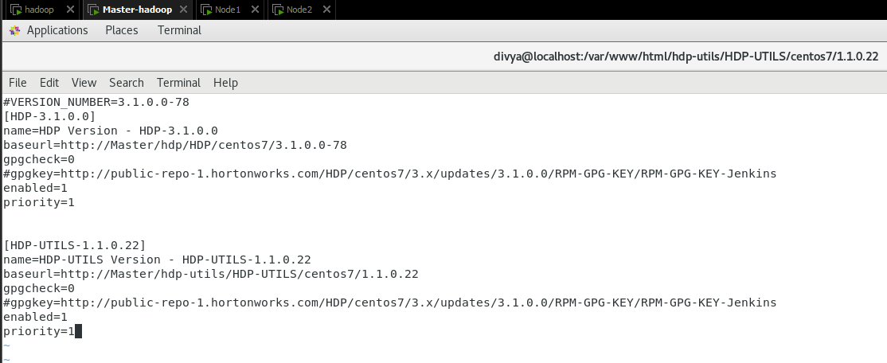

* #yum repolist
* Note the entries in ambari, hdp-utils and hdp, it should be non-zero.
* Once the files are managed in server, don’t do manually the same thing in nodes use the command on server to sync the files –
* NODE1

#rsync /etc/yum.repos.d/ambari.repo root@Node1:/etc/yum.repos.d/

#rsync /etc/yum.repos.d/hdp.repo root@Node1:/etc/yum.repos.d/

* NODE2

#rsync /etc/yum.repos.d/ambari.repo root@Node2:/etc/yum.repos.d/

#rsync /etc/yum.repos.d/hdp.repo [root@Node2:/etc/yum.repos.d/](mailto:root@Node2:/etc/yum.repos.d/)

* We are still on master-

# yum install ambari-server.x86_64 –y

#yum install ambari-agent.x86_64 -y (*****Do this also in every node )

* # vim /etc/ambari-agent/conf/ambari-agent.ini **** Check for hostname ....hostname = Master (in every node)

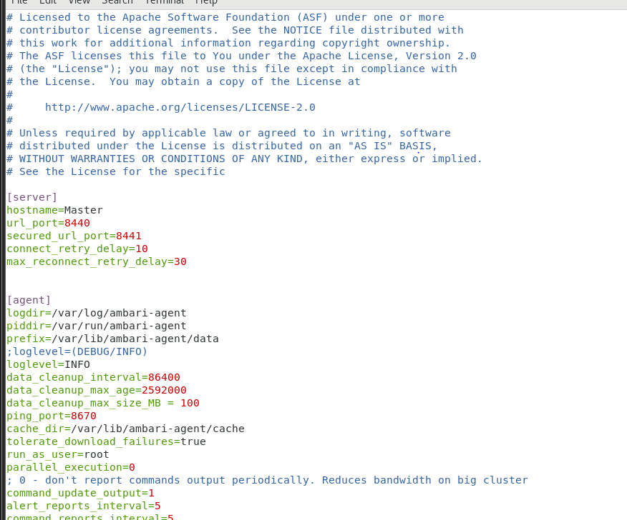

* #ambari-server setup -s
* #ambari-server start
* #ambari-agent start (****Do this also in every node )
* Add Chinese code from >>> <https://www.cnblogs.com/nshuai/p/13404273.html> (on server only)

# cd /usr/lib/ambari-server/web/javascripts/

# ls

# vi app.js (@line number #39892)

* # ambari-server stop
* # ambari-server reset
* # ambari-server start
* Go to Browser and give Master node name 🡪 (<http://Master:8080>)

Username- admin

Password- admin

* Launch wizard.

* Keep only redhat7, remove everything else and Add the baseurl in /etc/yum.repos.d/hdp.repo like below and next

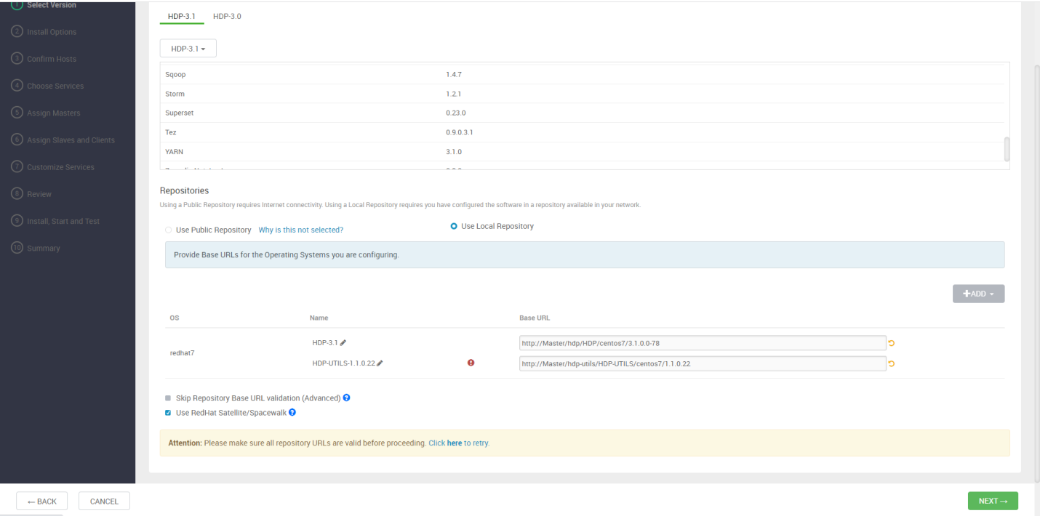

Register and confirm

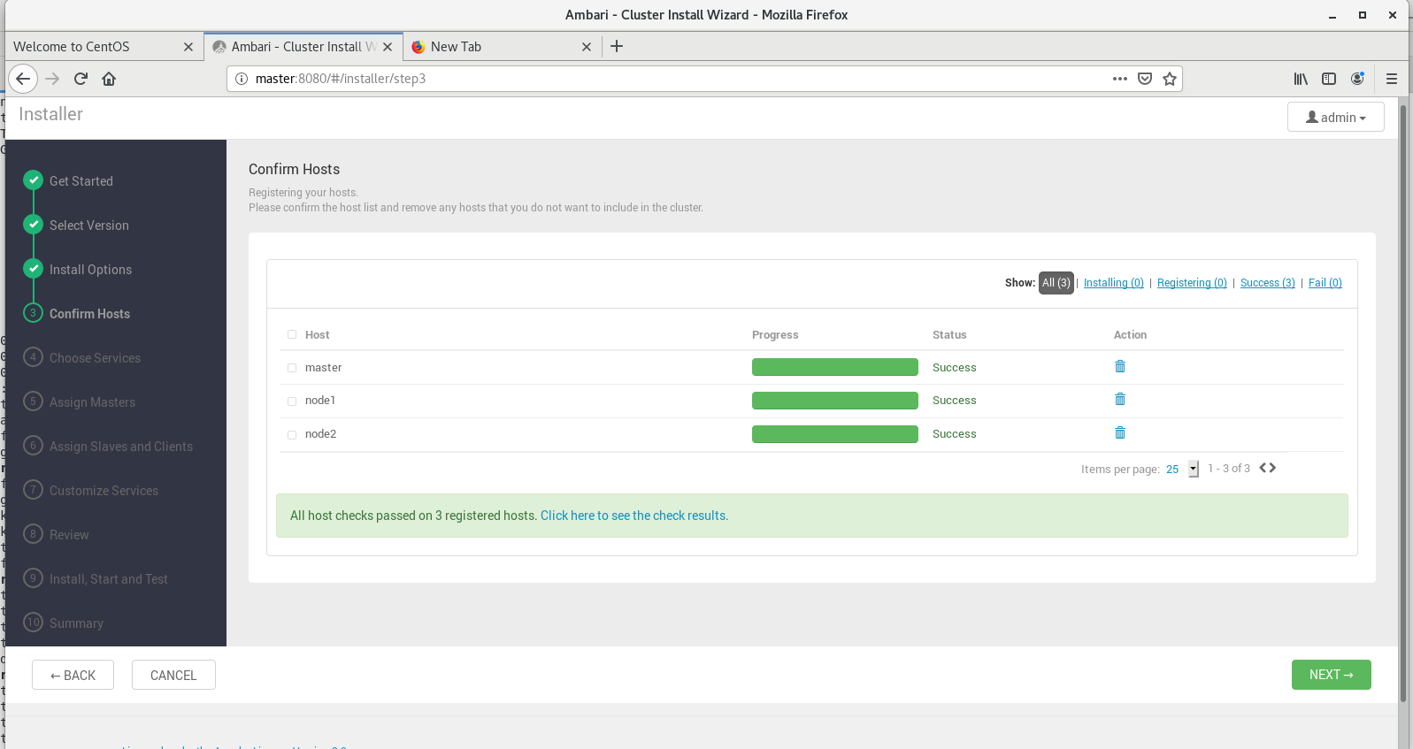

* Select this 7 services uncheck else

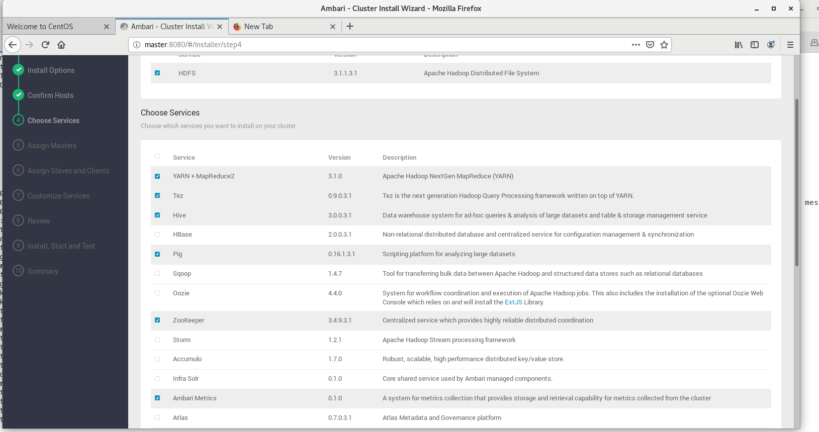

* In the below step just click next.

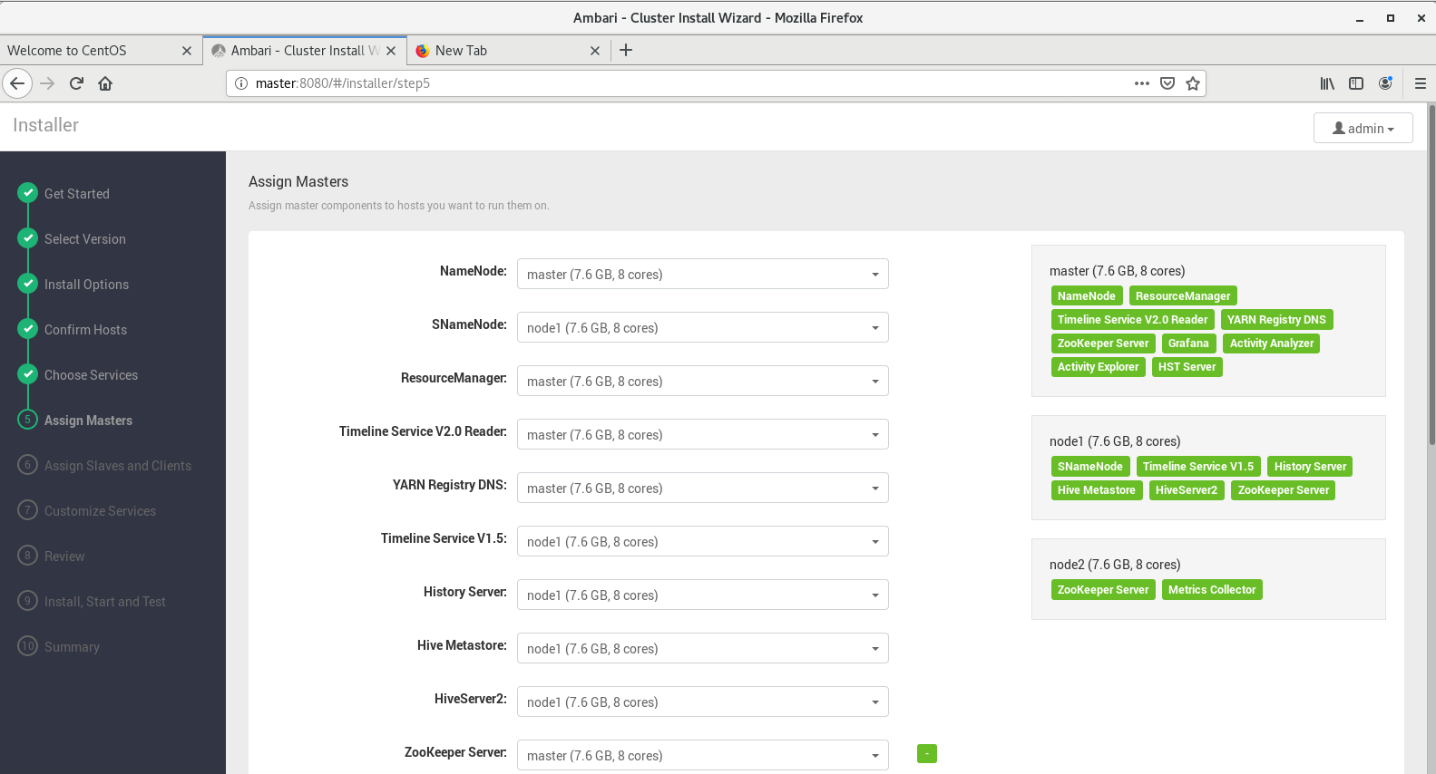

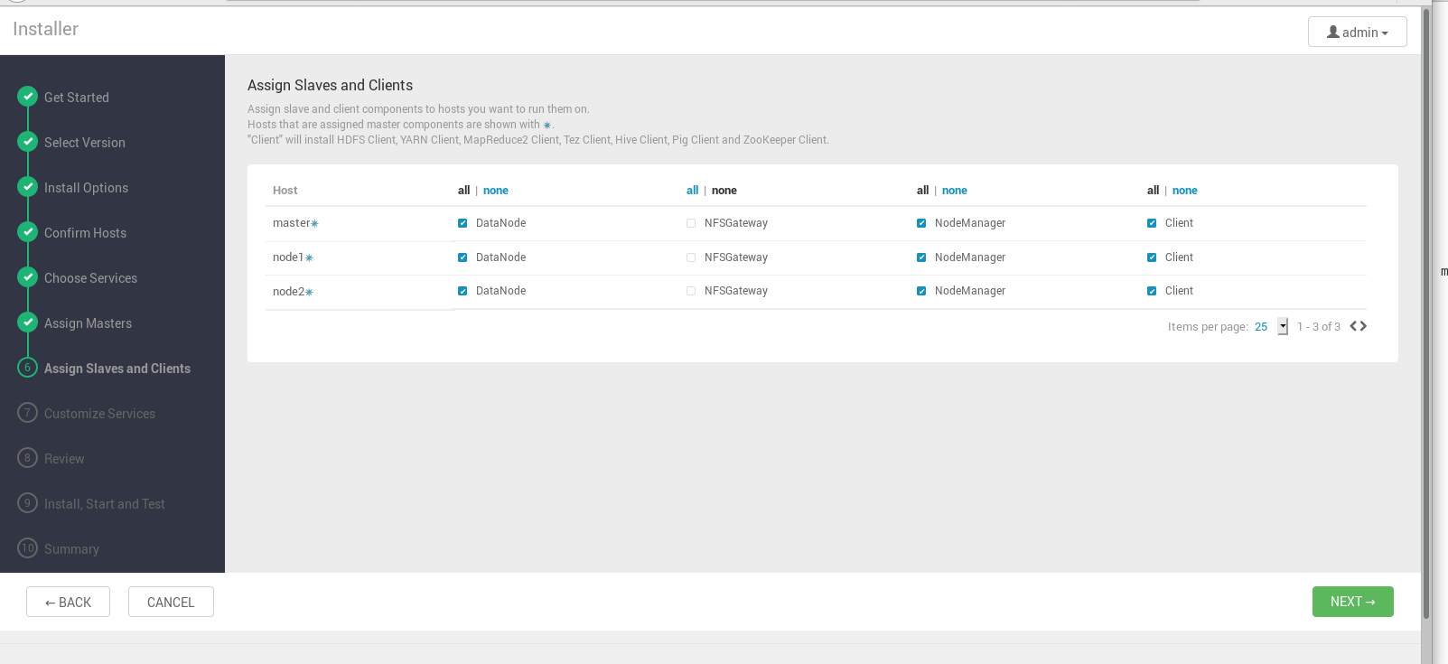

* In the below step- passwd is admin, admin

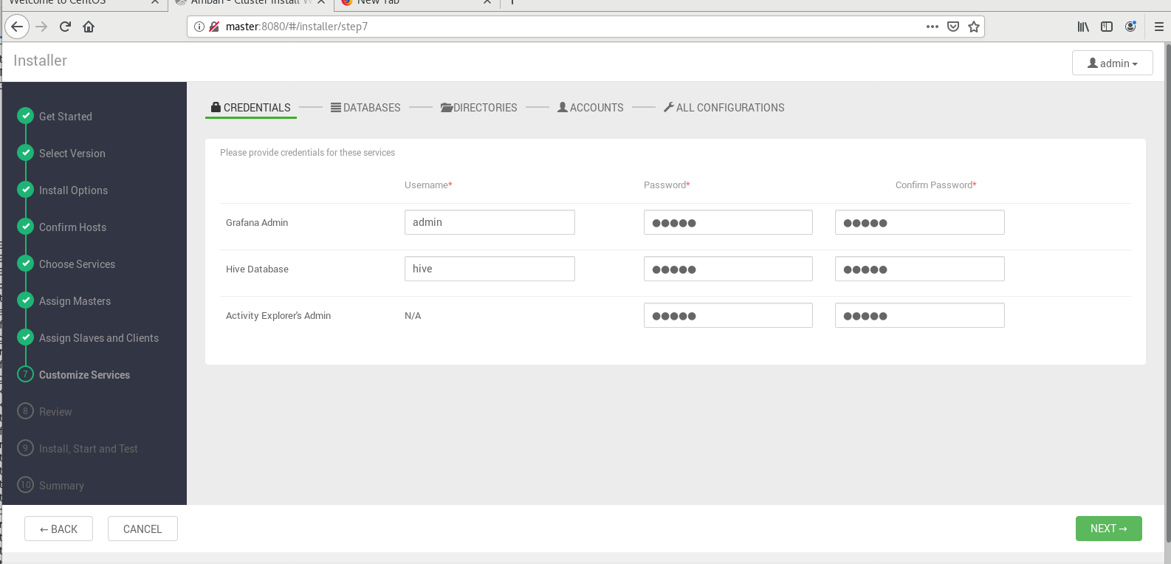

* Download the link given in blue that’ll go in downloads folder

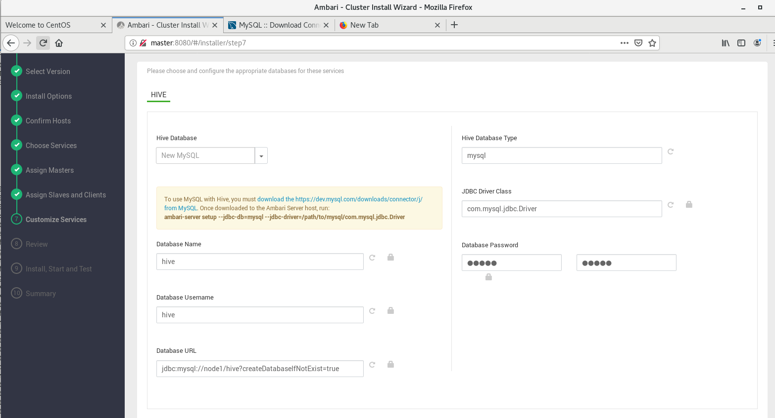

* Select redhat, and then in drop down the third one (Red hat 7) . In below step

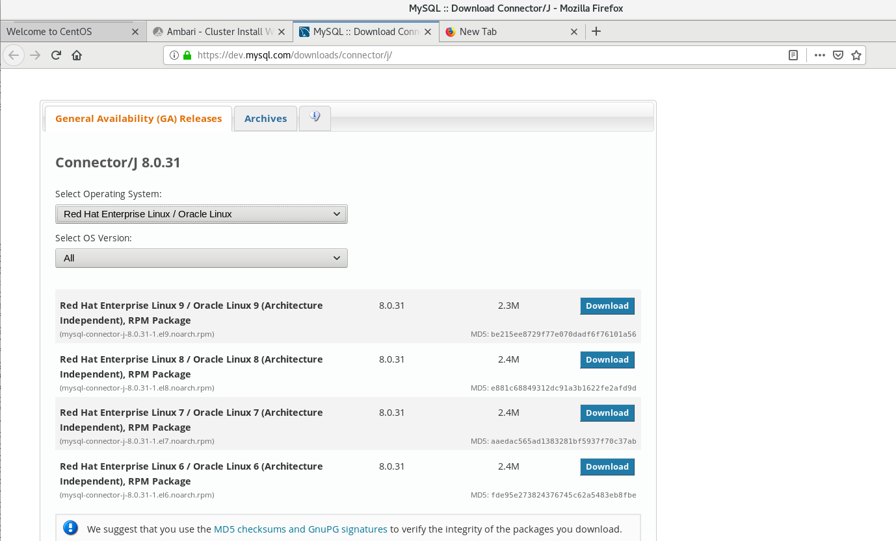

* No thanks just download, save.
* Now download mysql and follow below commands :>>>>>>>>

# cd /root/Downloads/

# ls

# rpm -ivh mysql-connector-j-8.0.31-1.el7.noarch.rpm

# cd /usr/share/java

# ls

# pwd >>> /usr/share/java/mysql-connector-j.jar

# ambari-server setup --jdbc-db=mysql --jdbc-driver=/usr/share/java/mysql-connector-j.jar



Next

* Do nothing just next in 7th step .

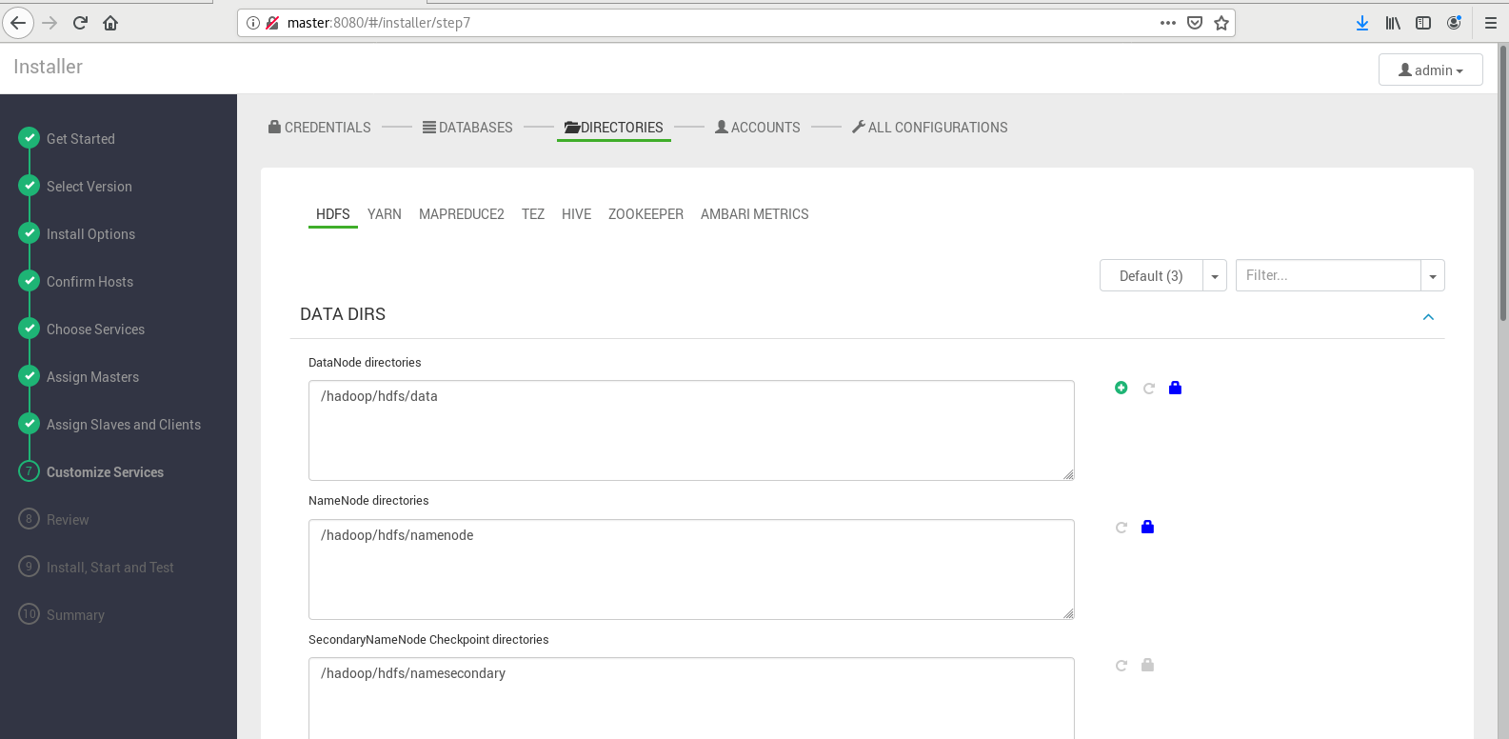

* In 8th step- below- deploy

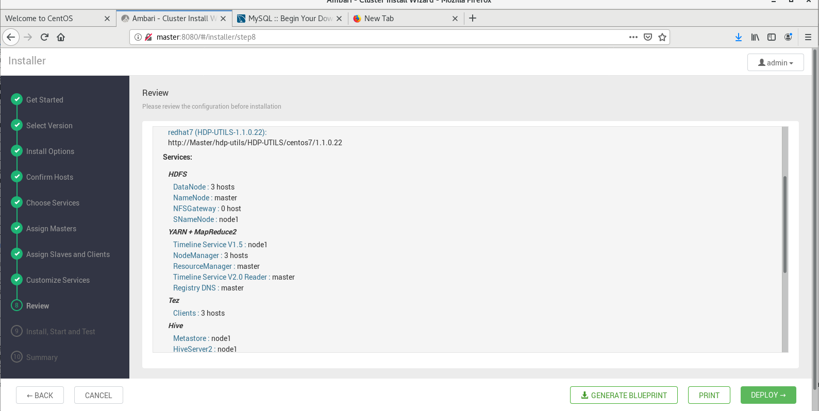

Let the below step complete nd next-

