|  |  |
| --- | --- |
| Student Name |  |
| Student Roll No |  |
| Division |  |
| Department |  |
| Academic Year |  |

**Note:** At the end of this lab manual there is a Lab evaluation summary sheet. It is

the responsibility of every student to get that sheet signed from his/her Subject Incharge after every lab. If He / She fail to do so, that particular unsigned lab will be marked zero.

**Contents**

INTRODUCTION 9

Lab Manual # 1 11

Basic 11

* 1. A typical C++ environment 12
  2. Program No 1 13
     1. Out Put of Program No 1 13
  3. Declare Variables 13
  4. Program No 2 Example Of Assignment Operator 13
     1. Out Put of Program No 2 14
  5. Arithmetic Operators 14
     1. Precedence 14
  6. Program No 3 15
     1. Code of Program No 3 15
  7. Program No 4 16
     1. Code of Program No 4 16
  8. Program No 5 16
     1. Code of Program No 5 17
     2. Out Put of Program No 5 17
  9. Program No 6 18

Lab Manual # 2 19

if / if-else Statements 19

* 1. Que No 1 Largest value among three 20
     1. Code Area 20
  2. Que No 2 Grade Program using nested if else 21
  3. Que No 3 vowel / Consonant 22
     1. Code 22
  4. Que No 4 Even / Odd 23
     1. Code Area 23
  5. Que No 5 Capital / Small Letter 24
     1. Code Area 24
  6. Que No 6 Ice / water / steam 25
     1. Code Area 25

Lab Manual # 3 26

Switch Statement 26

* 1. Que No 1 Switch statement 27
     1. Code Area 27

Lab Manual # 4 30

For/while Loops 30

* 1. Example 31
     1. Output 31
  2. Example Of While Loop 31
     1. Output 31
  3. Flow chart of while Loop 32
  4. Factorial Definition 32
     1. Code of Factorial Program 32
  5. For loop 33
     1. Example of for loop 33
     2. Write the output of the program step by step 33
     3. Final Output 33
  6. Flow Chart of Table 2 34
     1. Write a program for the above flow chart 34
  7. Example 35
  8. QUE NO 1 Terminate program on entering zero 35
     1. Code 35
  9. QUE NO 2 Factorial program 36
     1. Code 36
  10. QUE NO 3 Fibonacci series 37
      1. Code 37
  11. Que No 4 . Armstrong number 38
      1. Code 38
  12. QUE NO 5 Largest among user defined numbers 39
      1. Code 39
  13. Nested loops Table 12 *12 40
      1. Code 40
  14. Series using nested loops 41
      1. Code for Series 1 41
      2. Code for series 2 42
      3. Code for series 3 43

Lab Manual # 5 44

Do-while loop 44

* 1. do-while loop syntax 45
     1. Flow Chart of do-while loop 45
  2. QUE 1 Calculate the sum of user defined numbers 46
     1. Code 46
  3. QUE NO 2 Calculate factorial of user defined numbers 47
     1. Code 47
  4. Que 3 Calculator 48
     1. Code 48

Lab Manual # 6 49

Function 49

* 1. Built In Function 50
     1. Out Put 50
  2. Write types of Function 50
  3. Write Syntax Of function (Prototype, call & body of function) 50
  4. Que No 1 square () functioin 51
     1. Code 51
  5. Que No 2 Finding average using function 52
     1. Code 52
  6. Que No 3 53
  7. Que No 4 finding area of rectangle 54
     1. Code 54
  8. Que No 5 Check date program 55
     1. Code 55
  9. Que No 6 Leap Year program 56
     1. code 56
  10. Que No 7 Finding largest using if else in function 57
      1. Code 57
  11. QueNo 8 58
      1. Code 58
  12. Comparison of functions 59
  13. Que No 9 Swap by using function 59
      1. Code 59
  14. Provide an Example of Functions Overloading 60
  15. Que 10 Find Factorial from -1 to 10 using function 61

Lab Manual # 7 62

1-D Arrays / Strings 62

* 1. Introduction 63
  2. Que No 1 Displaying age of persons using array 63
     1. Code 63
  3. Que No 2 Changing values between arrays 64
     1. Code 64
  4. Que No 3 65
     1. Code 65
  5. Que No 4 66
     1. Code 66
  6. Que No 5 67
     1. Code 67
  7. Que No 6 68
     1. Code 68
  8. Que No7 69
     1. Code 69

7. 9 Que No 8 70

* 1. Strings 71
     1. Example of Strings 71
     2. Que No 9 Get the name from user 72
  2. The String I/O Function gets() & puts() 72
  3. The String I/O Function gets() & puts() 72
  4. strcpy & strcmp 73
     1. strcpy & strcmp example 73
  5. Que No 9 String Deletion 74

Lab Manual # 8 75

2-D Arrays 75

* 1. Que No 1 Shows sale of Pharmaceutical distribution company 76
     1. Code 76
  2. Que no 2 Adding two matrices 77
     1. Code 77
  3. Que no 3 Printing matrix in reserve 78
     1. Code 78
  4. Que no 4 Transpose of a Matrix 79
     1. Code 79
  5. Que no 5 Agent Program 80
     1. Code 80

Lab Manual # 9 81

Structures 81

* 1. Introduction 82
  2. Structure Example 82
     1. Output 82
     2. Description 83
  3. Que No 1 Area of rooms 84
     1. Code 84
  4. Que No 2 Phone Number Program 85
     1. Code 85
  5. Que No 3 Employee record 86
     1. Code 86
  6. Que No 4 Memory size of a structure 87
     1. Code 87
  7. Que No 5 Average Age Program 88
     1. Code 88
  8. Que No 6 Nested Structure 89
     1. Code 89
  9. Que No 7 Access of structure data members with pointer to structure 90

Lab Manual # 10 91

Pointers 91

* 1. Introduction to Pointers 92
     1. Example of Pointers 92
  2. Pointer To Arrays 92
  3. Que No 1 Print the values from array 93
  4. Que No 2 Print the values and memory address from an array 93
  5. Pointer Arithmetic 94
     1. Example of Pointer arithmetic 94
     2. Output 94
  6. Que No 3 Accessing values by Arithmetic operator 95
     1. Code 95
  7. Que No 4 Moving in array through pointers 96
     1. Code 96
  8. Pointer Comparison 96
     1. Pointer Comparison Example 97
  9. Que No 4 Question Max 97
     1. Code 97
  10. Pointer to functions 98
      1. Que No 5 Swap the same values using pointers. 98
  11. Que No 6 Returning more than one values from a function 99
      1. Code 99

Lab Manual # 11 100

Files 100

* 1. Introduction to Files 101
  2. Files of C 101
  3. Files in C++ 102
     1. Open a file 102
  4. Que No 1 Create a text file 103
     1. Code 103
  5. Que No 2 Read from the file 104
     1. Code 104
  6. Que No 3 Write data through variable 105
     1. code 105
  7. String with Embedded blanks 106
     1. Code 106

Lab Evaluation Summary 107

## INTRODUCTION

**T**he objective of this lab manual is to give students step-by-step examples to become familiar with programming concepts, design, and coding.

##### F E AT U R E S

To ensure a successful experience for instructors and students alike, these lab munals includes the following features:

* **Lab Objectives**—Every lab has a brief description and list of learning objectives
* **Materials Required**—Every lab includes information on hardware, software, and other materials you will need to complete the lab
* **Completion Times**—Every lab has an estimated completion time so that you can plan your activities more accurately
* **Activity Sections**—Labs are presented in manageable sections; where appropriate, additional Activity Background information is provided to illustrate the importance of a particular project
* **Step-by-Step Instructions**—Every lab provides steps to enhance technical proficiency; some labs include Critical Thinking exercises to challenge students
* **Review Questions**—Some labs include review questions to help reinforce concepts presented in the lab

##### SOFTWA R E REQUIREMENTS

* Computer running Windows 98,Windows Me,Windows 2000, Windows XP
* Recommended compiler is Microsoft Visual C++ .NET or Microsoft Visual Studio

##### COMPLETING THE LAB ASSIGNMENTS

Some lab assignments require written answers to complete an exercise, while others are programming assignments that require you to work with a C++ compiler.

* Check with your instructor for instructions on completing the written assignments. For example, you can print pages directly from the appropriate PDF file, and then write directly on the page.
* To complete the programming assignments, use the compiler that your instructor recommends or requires. Print all the documentation assigned, including program code, program prompts, input, and output displayed on the screen, input files, and output files.You can submit your written answers and the printed documentation with a lab cover sheet for grading. If your instructor requires an electronic copy of your work, e-mail the completed assignment to your instructor or include a removable disk with your work.Your instructor will tell you what is

needed, but be sure to submit the .cpp, .h, and any .srt or .txt files that you create, as well as any input and output files. Also include your name or ID in the titles of all your files. To provide program documentation, compile and run your program, copy the prompts, input, and output (if appropriate), and paste them as a block comment at the end of your program. Use the Copy and Paste features of your C++ program development kit to do so. After you paste the comment in the program, either print the program file from your text editor or submit the program file to your instructor electronically.

# Lab Manual # 1

**Basic**

#### A typical C++ environment

Program is created in the editor and stored on disk.



Disk

Editor

Preprocessor program processes the code.



Disk

Preprocessor

### Compiler creates object

Disk

Compiler

code and stores it on disk.

### Linker links the object code with the libraries

Disk

Linker

Primary Memory

Loader puts program in memory.

Disk

Loader

|  |
| --- |
|  |
|  |
|  |
|  |
|  |
|  |
|  |

Primary Memory

|  |
| --- |
|  |
|  |
|  |
|  |
|  |
|  |
|  |

CP

### CPU takes each instruction and executes it, possibly storing new data

* 1. **Program No 1** #include <iostream.h> main ( )

{

cout << ― Welcome to Air University ―;

}

##### Out Put of Program No 1

#### Declare Variables

Declare 3 Integer Type & 3 float type Variables.

|  |  |
| --- | --- |
| INT | Float |
|  |  |
|  |  |
|  |  |

#### Program No 2 Example Of Assignment Operator

#include <iostream> using namespace std; int main ()

{

int a, b; a = 10;

b = 4;

a = b; b = 7;

cout << "a :"; cout << a; cout << " b :"; cout << b; return 0;

}

##### Out Put of Program No 2

|  |
| --- |
|  |

#### Arithmetic Operators

Write Arithmetic Operators

|  |
| --- |
|  |
|  |
|  |
|  |

##### Precedence

Write precedence of the arithmetic operators

|  |
| --- |
|  |
|  |
|  |
|  |
|  |

#### Program No 3

Write a program in C++ that display following output

***** *****

***** *****

***** *****

***** *****

***** *****

***** *****

***** *****

***** *****

***** *****

***** *****

***** *****

############################### ############################### ###############################

##### Code of Program No 3

|  |
| --- |
|  |

#### Program No 4

Write a programin C++ which prints following output,

$*********************************************$

$*********************************************$

$* Welcome to Air University *$

$* School of Engineering *$

$* lsamabad. *$

$**********************************************$

$**********************************************$

##### Code of Program No 4

|  |
| --- |
|  |

#### Program No 5

Write a program in C++, which takes radius from the user and calculate the area of sphere i.e

Area=4pr2

(Hint p = 3.1416

Area = 4 * 3.1416 * r * r)

##### Code of Program No 5

|  |
| --- |
|  |

##### Out Put of Program No 5

|  |
| --- |
|  |

#### Program No 6

Write a program to find the number of bytes occupied by various data types using the sizeof operator?

int a; char b; float c; long int d; bool e;

unsigned int j; unsigned long k;

* + 1. **Code**

|  |
| --- |
|  |

# Lab Manual # 2

**if / if-else Statements**

#### Que No 1 Largest value among three

Write a program in C++ that take input of three integer‘s numbers from user. Find the largest number among three of them.

##### Code Area

|  |
| --- |
|  |

#### Que No 2 Grade Program using nested if else

Write a program in C++ using if/else operator with nested statements to find the grade of a student.

The detail is as follow.

grade >= 90 ➔ Grade A grade >= 80 ➔ Grade B grade >=70 ➔ Grade C grade >=60 ➔ Grade D

* + 1. **Code Area**

|  |
| --- |
|  |

#### Que No 3 vowel / Consonant

Write a program in C++ to input a single character and print a message― It is

vowel" if it is vowel otherwise print message "It is a "consonant― Use if-else structure and OR (||) operator only

##### Code

|  |
| --- |
|  |

#### Que No 4 Even / Odd

Write a Program in C++ that take an Integer Value from the user and tell that the number is EVEN or ODD.

##### Code Area

|  |
| --- |
|  |

#### Que No 5 Capital / Small Letter

Write a program in C++ that take a single character from the user, and tells it's a Small Letter or it's a CAPITAL letter using nested if statement only.

##### Code Area

|  |
| --- |
|  |

#### Que No 6 Ice / water / steam

Make a program in C ++ that tells the form of Water whether it is Ice, Water or Steam. Display the menu also as under.

Temperature Less than 0 = ICE

Temperature Greater than 0 & Less than 100 = Water Temperature Greater than 100 = STEAM

##### Code Area

|  |
| --- |
|  |

# Lab Manual # 3 Switch Statement

#### Que No 1 Switch statement

Write a program in C++ using switch statement that contain option as under Enter 1--> To Find Largest Number Among Three Variables.

Enter 2--> To Find ODD or EVEN Enter 3--> To Find Condition of Water Enter 4--> To Find Grade Of Student

**Detail of Option 3**

Temperature Less than 0 = ICE

Temperature Greater than 0 & Less than 100 = Water Temperature Greater than 100 = STEAM

**Detail of option 4**

grade >= 90 ➔ Grade A grade >= 80 ➔ Grade B grade >=70 ➔ Grade C grade >=60 ➔ Grade D

##### Code Area

|  |
| --- |
|  |

|  |
| --- |
|  |

|  |
| --- |
|  |

# Lab Manual # 4

**For/while Loops**

#### Example

int sum ;

sum = 1+2+3+4+5+ +10 ;

cout << sum ;

##### Output

|  |
| --- |
|  |

#### Example Of While Loop

int sum , number ; sum = 0 ;

number = 1 ;

while ( number <= 1000 )

{

sum = sum + number ; number = number + 1 ;

}

cout << ― The sum of the first 1000 integer starting from 1 is ‖ << sum ;

##### Output

|  |
| --- |
|  |

#### Flow chart of while Loop

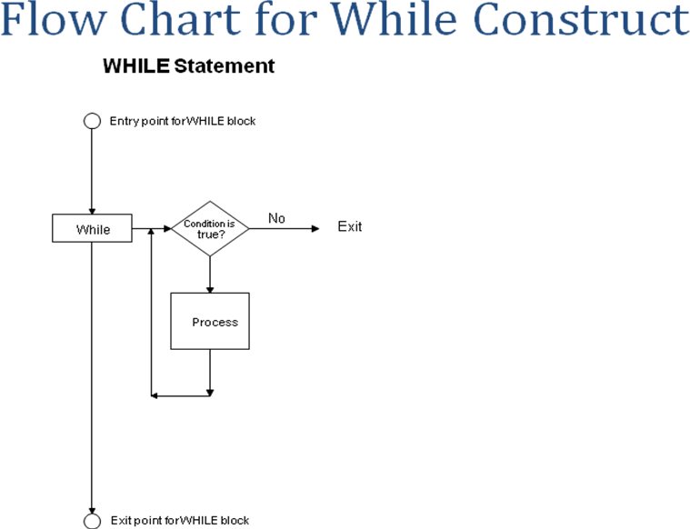

#### Factorial Definition

n! = n*(n-1)*(n-2)*(n-3)…………*3*2*1 **Out Put**

##### Code of Factorial Program

int number ; int factorial ; factorial = 1 ;

cout << ―Enter the number of Factorial‖ ; cin >> number ;

while ( number >= 1 )

{

factorial = factorial * number ; number = number – 1 ;

}

cout << ―Factorial is‖ << factorial ;

#### For loop

for ( *initialization condition* ; *termination condition* ; *increment condition* )

{

*statement ( s ) ;*

}

##### Example of for loop

int counter ;

for( counter = 0 ; counter < 10 ; counter = counter + 1 ) cout << counter;

##### Write the output of the program step by step

|  |  |
| --- | --- |
|  |  |
|  |  |
|  |  |
|  |  |
|  |  |
|  |  |
|  |  |
|  |  |

##### Final Output

|  |
| --- |
|  |

#### Flow Chart of Table 2

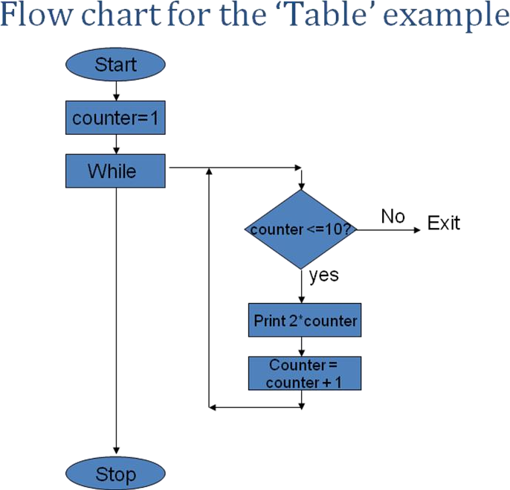

#### Write a program for the above flow chart

|  |
| --- |
|  |

#### Example

Write a Program That Display numbers from 1,2,3,4,5,6,7.8.9 10000

* + 1. **Code**

|  |
| --- |
|  |

#### QUE NO 1 Terminate program on entering zero

Write a Program in C++ that Exit on entering 0, Using While Loop.

##### Code

|  |
| --- |
|  |

#### QUE NO 2 Factorial program

Write a Program in C++ that calculate the factorial of a user defined number, using for loop

#### Code

|  |
| --- |
|  |

#### QUE NO 3 Fibonacci series

Write a Program in C++ that shows The Fibonacci series 1 1 2 3 5 8 13 ….. Using wile loop

##### Code

|  |
| --- |
|  |

#### Que No 4 . Armstrong number

Write a Program in C++ that check the user defined number is Armstrong or not.i.e 153 is an Armstrong number

|  |  |  |  |
| --- | --- | --- | --- |
| (1)3 | + (5) 3 | + (3)3 |  |
| 1 | + 125 | + 27 | = 153 |

##### Code

|  |
| --- |
|  |

#### QUE NO 5 Largest among user defined numbers

Write a Program in C++ that takes Integer values from user, and then find the largest number among all the Integers, and display the largest number on the screen. Use While loop to control the Input, Terminate the Program on entering zero. Find the Largest Integer Using If Statement.

##### Code

|  |
| --- |
|  |

#### Nested loops Table 12 *12

Write a program in C++ that prints a tables Starting from 1 ➔12. i.e

|  |  |  |  |  |  |  |  |  |  |  |
| --- | --- | --- | --- | --- | --- | --- | --- | --- | --- | --- |
| 1 2 | 3 | 4 | 5 | 6 | 7 | 8 | 9 | 10 | 11 | 12 |
| 2 4 | 6 | 8 | 10 | 12 | 14 | 16 | 18 | 20 | 22 | 24 |
| 3 6 | 9 | 12 | 15 | 18 | 21 | 24 | 27 | 30 | 33 | 36 |
| 4 8 | 12 | 16 | 20 | 24 | 28 | 32 | 36 | 40 | 44 | 48 |
| 5 10 | 15 | 20 | 25 | 30 | 35 | 40 | 45 | 50 | 55 | 60 |
| 6 12 | 18 | 24 | 30 | 36 | 42 | 48 | 54 | 60 | 66 | 72 |
| 7 14 | 21 | 28 | 35 | 42 | 49 | 56 | 63 | 70 | 77 | 84 |
| 8 16 | 24 | 32 | 40 | 48 | 56 | 64 | 72 | 80 | 88 | 96 |
| 9 18 | 27 | 36 | 45 | 54 | 63 | 72 | 81 | 90 | 99 | 108 |
| 10 20 | 30 | 40 | 50 | 60 | 70 | 80 | 90 | 100 | 110 | 120 |
| 11 22 | 33 | 44 | 55 | 66 | 77 | 88 | 99 | 110 | 121 | 132 |
| 12 24 | 36 | 48 | 60 | 72 | 84 | 96 | 108 | 120 | 132 | 144 |

##### Code

|  |
| --- |
|  |

#### Series using nested loops

Develop a code in C++ that generate the following series .Use nested while loop!

**Series No.1 Series No.2 Series No.3**

|  |  |  |
| --- | --- | --- |
| 1 | 1 | 1 |
| 1 2 | 2 2 | 2 3 |
| 1 2 3 | 3 3 3 | 4 5 6 |
| 1 2 3 4 | 4 4 4 4 | 7 8 9 10 |

##### Code for Series 1

|  |
| --- |
|  |

##### Code for series 2

|  |
| --- |
|  |

* + 1. **Code for series 3**

|  |
| --- |
|  |

# Lab Manual # 5 Do-while loop

#### do-while loop syntax

do

{

statements ;

}

while ( condition ) ;

#### Flow Chart of do-while loop

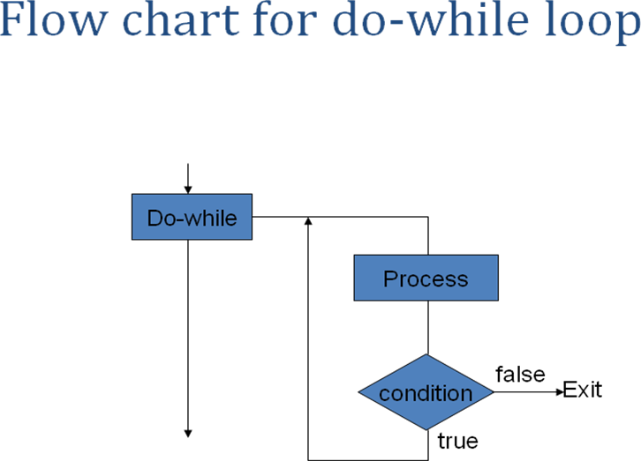

#### QUE 1 Calculate the sum of user defined numbers

Develop a program in C++ that take integer type values from user & calculate the sum from ‗0‘ to number entered, using do while loop.

*Number = 5*

*1+2+3+4+5 = 15*

##### Code

|  |
| --- |
|  |

#### QUE NO 2 Calculate factorial of user defined numbers

Develop a program in C++ that calculate the factorial of a given number. Use for loop to calculate the factorial, & do – while loop to perform the operation as many times as user want.

##### Code

|  |
| --- |
|  |

#### Que 3 Calculator

Create the equivalent of a four-function calculator. The program should Ask the user to enter a number, an operator, and another number (10 + 20), using floating point.It should then carry out the specified arithmetical operation: adding, subtracting, multiplying, or dividing the two numbers. Use switch statement to select the operation. Finally, display the Result.

##### Code

|  |
| --- |
|  |

# Lab Manual # 6 Function

#### Built In Function

#include <cmath> // defines the sqrt() function #include <iostream.h>

int main()

{ // tests the sqrt() function:

for (int x=0; x <=9; x++)

cout << "\t" << x << "\t" << sqrt(x) << endl;

}

##### Out Put

|  |
| --- |
|  |

#### Write types of Function

|  |
| --- |
|  |
|  |
|  |
|  |

#### Write Syntax Of function (Prototype, call & body of function)

|  |
| --- |
|  |

#### Que No 1 square () functioin

Write a program in C++ that has a function of square (). The user should enter the number and the code should display the square of the given number.

##### Code

|  |
| --- |
|  |

#### Que No 2 Finding average using function

Get three integers numbers from user, Pass them to function, Add them and find the average in function body, Display the Average in function body

##### Code

|  |
| --- |
|  |

#### Que No 3

Write a code that take numbers from user and displays its cube. The Code should reads integers and prints their cubes until the user inputs the sentinel value 0. Each integer read should be passed to the cube() function by the call cube(n). The value returned by the function should replaces the expression cube(n) and then should be passed to the output object cout.

* + 1. **Code**

|  |
| --- |
|  |

#### Que No 4 finding area of rectangle

Write a function that finds the area of the rectangle on providing length and width. Get Length & width from user in main() Call the function area() Calculate the length and return the area Display the result in main()

##### Code

|  |
| --- |
|  |

#### Que No 5 Check date program

Get month ,day & year from user in main() Call the function printDate(int, int, int), Put a check in printDate() using if statement (month < 1 || month > 12 || day < 1 || day > 31 || year < 0) & if it violates the rule display ―*Must Enter a Valid Date”,* Using switch Statement get the month, Day and year are displayed normally, Termination should be on entering 0 in months

##### Code

|  |
| --- |
|  |

#### Que No 6 Leap Year program

A leap year is a year in which one extra day (February 29) is added to the regular calendar. Most of us know that the leap years are the years that are divisible by 4. For example, 1992 and 1996 are leap years. Most people, however, do not know that there is an exception to this rule: centennial years are not leap years. For example, 1800

and 1900 are not leap years. Furthermore, there is an exception to the exception: centennial years which are divisible by 400 are leap years. Thus, the year 2000 is a leap year.

* Make a program that full fills the above criteria using functions
* The program should terminate on entering 0
* The return type should be Boolean i.e bool isLeapYear(int);

##### code

|  |
| --- |
|  |

#### Que No 7 Finding largest using if else in function

Write a program in C++ that take two numbers from user and find the largest among two using function.

* The Conditions are

*if (a==b)*

*"A, B are the same“ a = b, (values) else if (a < b)*

*"A & B are not same “ a != b (values) " A is less than B “ a < b (values)*

##### Code

*else*

*"A is Greater than B “ a > b (values)*

|  |
| --- |
|  |

#### QueNo 8

Develop a program in C++ that has function printTempOpinion() which prints *"Cold" on if the temperature is below 10, "OK" if the temperature is in the range 20 -> 30,"Hot" if the temperature is above 30.*

* + 1. **Code**

|  |
| --- |
|  |

#### Comparison of functions

Difference between Passing By Value Versus Passing By Reference

|  |  |
| --- | --- |
| **By Value** | **By Reference** |
|  |  |
|  |  |
|  |  |
|  |  |
|  |  |
|  |  |
|  |  |

#### Que No 9 Swap by using function

Develop a program that swap the two values using function by reference

i.e After swap

a = 22.2 a = 44.4

b = 44.4 b = 22.2

* + 1. **Code**

|  |
| --- |
|  |

#### Provide an Example of Functions Overloading

|  |
| --- |
|  |

* 1. **Que 10 Find Factorial from -1 to 10 using function**

|  |
| --- |
|  |

# Lab Manual # 7

**1-D Arrays / Strings**

#### Introduction

They are special kind of data type In C++ each array has

* + - name
    - data type
    - size
* They occupy continuous area of memory

#### Que No 1 Displaying age of persons using array

Write a program in C++ that take age of five persons and then just display the age of each person by using arrays.

##### 7.2.1 Code

|  |
| --- |
|  |

#### Que No 2 Changing values between arrays

Develop a Program that takes array elements from user and then transfer those elements to another array. Size of array will be 10

##### 7.3.1Code

|  |
| --- |
|  |

#### Que No 3

Develop a program that takes 5 array elements from user. Swap position [2] element with position [4] element.

##### 7.4.1 Code

|  |
| --- |
|  |

#### Que No 4

Write a program to input data into two different arrays and then to add the two arrays and store the result in the third array.

##### 7.5.1 Code

|  |
| --- |
|  |

#### Que No 5

Write a program in C++, to input data into an array. Enter a value from the Keyboard and find out the location of the entered value in the array. If the entered number is found in the array, display the message "Number Found―else display ―Number Not Found‖

##### 7.6.1 Code

|  |
| --- |
|  |

#### Que No 6

Write a program that takes input from user and checks if the word is Palindrome or Not

##### 7.7.1Code

|  |
| --- |
|  |

#### Que No7

Find the Average of 10 numbers passed to an array, using function. The Array should be controlled by while loop.

##### 7.8.1 Code

|  |
| --- |
|  |

#### 9 Que No 8

Write a Program in C++ that do the bubble sorting in Array.

Hint

* + Array Elements are entered by user in ―main function‖, the elements are user Defined. Terminate on *“zero”*
  + Make a separate function *“sort()”* to do the bubble sort.
  + Pass array elements to function *“sort()”.*
  + Function should sort the array elements.
  + Display the sorted array elements in main.

**7.9.1 Code**

|  |
| --- |
|  |

#### Strings

A string constant is a one-dimensional array of characters terminated by a null ( ‗\0‘ ). For example,

char name[ ] = { 'H', 'A', 'E', 'S', 'L', 'E', 'R', '\0' } ;

##### Example of Strings

|  |
| --- |
| /* Program to demonstrate printing of a string */ main( )  {  char name[ ] = "Klinsman" ; int i = 0 ;  while ( i <= 7 )  {  cout<<name[i]; i++ ;  }  } |
| /* Program to demonstrate printing of a string */ main( )  {  char name[ ] = "Klinsman" ; int i = 0 ;  while (name[i] !=‘\0‘)  {  cout<<name[i]; i++ ;  }  } |

##### Que No 9 Get the name from user

Write a program that gets the name from user and then print back on the screen.

|  |
| --- |
|  |

#### The String I/O Function gets() & puts()

cin & cout are not so versatile because they ignore charters after white space, so to over come this problem C/C++ uses puts & gets function from library file

<stdio.h>

#### The String I/O Function gets() & puts()

Write a program that gets the name from user and then print back on the screen using gets and puts functions.

|  |
| --- |
|  |

|  |
| --- |
|  |

#### strcpy & strcmp

|  |
| --- |
|  |

##### strcpy & strcmp example

|  |
| --- |
|  |

|  |
| --- |
|  |

#### Que No 9 String Deletion

Write a program in C++ that take string from user and then enter the position to delete. Make a separate function for string deletion

|  |
| --- |
|  |

# Lab Manual # 8 2-D Arrays

#### Que No 1 Shows sale of Pharmaceutical distribution company

A Distributor of a Pharmaceutical Company has 4 Districts, for supply the medicine. He requires a program that can display the sales of all his Districts. Write a Program in C++ Using two Dimensional Array that shows the Following Output. The Program should display the Sale, Districts wise and up to Months i.e

##### Code

|  |
| --- |
|  |

#### Que no 2 Adding two matrices

Write a program in C++ that take two matrices and then Add them After inserting two matrices first display the both matrices and then add them and show the result. i.e

##### Code

|  |
| --- |
|  |

#### Que no 3 Printing matrix in reserve.

Enter the values in a matrix and print it in reverse Column order

##### Code

|  |
| --- |
|  |

#### Que no 4 Transpose of a Matrix

Write a Program in C++ that Display the Transpose of a Matrix.

##### Code

|  |
| --- |
|  |

#### Que no 5 Agent Program

Write a program in C++, which take Agent code (123,258,..) and Traveling expense (Rs = 5000, 6000,…) of the agent. Find the agent who had spent most money in all, Display the agent code and amount after searching in 2 D Array.

##### Code

|  |
| --- |
|  |

# Lab Manual # 9 Structures

#### Introduction

* + - A Structure is a collection of simple variables. The Variables in a structure can be of different types. Some can be int, some can be float, and so on.
    - The data items in a structure are called the members of the structure.
    - The structure is a kind of blue print specifying what information is necessary for a single part.

#### Structure Example

|  |
| --- |
| struct part  {  int modelnumber; int partnumber; float cost;  };  int main ()  {  part part1, part2; part1.modelnumber = 1111;  part1.partnumber = 111;  part1.cost = 111.11;  part2.modelnumber = 222;  part2.partnumber = 2222;  part2.cost = 222.222;  cout<<"\nModel of Part1 = "<<part1.modelnumber; cout<<"\nPart of part 1 = "<<part1.partnumber; cout<<"\nCost of part1 = "<<part1.cost<<endl;  cout<<"\nModel of part2 = "<<part2.modelnumber; cout<<"\nPart of part2 = "<<part2.partnumber; cout<<"\nCost of part2 = "<<part2.cost<<endl; return 0;  } |

##### Output

|  |
| --- |
| Model of Part1 = 1111 Part of part 1 = 111 Cost of part1 = 111.11 Model of part2 = 222 Part of part2 = 2222 Cost of part2 = 222.222 |

##### Description

The structure definition serves only as a blueprint for the creation of variables of type part. It does not itself create any structure variables; that is, it does not set aside any space in memory or even name any variables. This is unlike the definition of a simple variable, which does set aside memory.

|  |
| --- |
|  |

#### Que No 1 Area of rooms

Write a program in C++ that shows the area of 3 room's. Using Structure namely "distance". Take input of feet & inches from user for variable d1 (feet & inches), assign variable d2 = {10, 5.25} values. Now add feet and inches of d1 & d2 and store in d3.

Display d1 (feet & inches) d2 (feet & inches) d3 (feet & inches) separately. Put Condition if d1 & d2 inches increase by 12 it become a foot.

##### 9.3.1 Code

|  |
| --- |
|  |

#### Que No 2 Phone Number Program

A phone number, such as 212- 767-8900, can be thought of as having three parts: the area code (212), the exchange (767), and the number (8900). Write a program that uses a structure to store these three parts of a phone number separately. Call the structure phone. Create two structures variables of type phone. Initialize one, and have the user input a number for the other one. Then display both numbers. The interchange might look like this:

##### 9.4.1 Code

|  |
| --- |
|  |

#### Que No 3 Employee record

Create a structure called emp that contains three members,

*int id, char name[100], float sal.*

Ask the user to fill in data for three employees and then display information for each employee.

*Hint*

* + - *Variable of struct emp will be array*
    - *Use while / for loop to control array*

##### 9.5.1 Code

|  |
| --- |
|  |

#### Que No 4 Memory size of a structure

Write a program using ―sizeof()‖ function that calculate the size of structure

##### Code

|  |
| --- |
|  |

#### Que No 5 Average Age Program

Write a program to calculates the average age and average GPA of a class having 10 students. Also determine the grade of the class and the student with max GPA. Use a student structure and manipulate it to get the desired result.

##### Code

|  |
| --- |
|  |

#### Que No 6 Nested Structure

Write a program that contains nested structure

##### Code

|  |
| --- |
|  |

#### Que No 7 Access of structure data members with pointer to structure

|  |
| --- |
|  |

# Lab Manual # 10 Pointers

## Introduction to Pointers

int *myptr ;

myptr is pointer to an integer

##### Example of Pointers

|  |
| --- |
| #include<iostream.h> void main ()  {  int var1 = 10; int var2 = 20; int var3 = 30;  cout<<&var1<<endl  <<&var2<<endl; int *ptr;  ptr = &var1; cout<<ptr<<endl; ptr = &var2; cout<<ptr<<endl;  } |

## Pointer To Arrays

|  |
| --- |
| #include<iostream.h> void main ()  {  int array[5] = {31,54,77,52,93};  for(int j =0; j<5; j++)  {  cout<<array[j]<<endl;  }  } |
| #include<iostream.h> void main ()  {  int array[5] = {31,54,77,52,93};  int* ptr;  ptr = array;  for(int j =0; j<5; j++)  {  cout<<*(ptr++)<<endl;  }  } |

#### Que No 1 Print the values from array

Write a program that prints the values from an array using pointer variable. The array is given below

int y [ 10 ]= {6,2,3,12};

|  |
| --- |
|  |

#### Que No 2 Print the values and memory address from an array

Write a program that prints the values from an array using pointer variable. The array is given below

int y [ 10 ]= {6,2,3,12};

|  |
| --- |
|  |

#### Pointer Arithmetic

int x =10 ; int *yptr ; yptr = &x ;

*yptr += 3 ; yptr += 3 ;

##### Example of Pointer arithmetic

|  |
| --- |
| long* pnumber = NULL;  long number1 = 10, number2 = 20;  pnumber = &number1;  *pnumber += 2;  cout<<"\nnumber1 = "<<number1  <<" &number = "<<pnumber; pnumber = &number2;  number1 = *pnumber *4;  cout<<"\nnumber1 = "<<number1  <<" pnumber = "<<pnumber  <<"pnumber = "<<*pnumber; |

##### Output

|  |
| --- |
| number1 = 12 &number = 0x0012FF78 number1 = 80 pnumber = 0x0012FF74 pnumber = 20  Press any key to continue |

#### Que No 3 Accessing values by Arithmetic operator

Write a program that displays the values using pointer variable from an array given below using Arithmetic Increment operator .

int y[5]={22,33,44,55,66};

##### Code

|  |
| --- |
|  |

#### Que No 4 Moving in array through pointers

Write a program that display only 6th element of an array given below using pointers.

int y [10] ={11,22,33, 44,55,**66**,77,88,99,110}

##### Code

|  |
| --- |
|  |

#### Pointer Comparison

|  |
| --- |
| if ( y1 > y2 ) if ( y1 >= y2 ) if ( y1 == y2 ) |
| if ( *y1 > *y2 ) |

##### Pointer Comparison Example

|  |
| --- |
| int y [10]={11,22,33,44,55,66,77,88,99,110} ;  int *y1, *y2; y1= &y[0];  y2= &y[3];;  cout <<"\n Y1= "<<*y1; cout <<"\n Y2= "<<*y2;  if (*y1 < *y2)  cout<<"\nY1 is Smaller"<<endl;  else  cout<<"\nY2 is smaller"<<endl; |

#### Que No 4 Question Max

Write a program that take two numbers an input from user. Find the maximum from both of them using the dereference pointer comparison

##### Code

|  |
| --- |
|  |

#### Pointer to functions

|  |
| --- |
| main( )  {  int a = 10, b = 20 ; swapv ( a, b ) ;  cout<<”\na =”<<a<<” b= ”<<b;  }  swapv ( int x, int y )  {  int t ; t = x ; x = y ; y = t ;  cout<<”\nx = ”<<x<<” y = ”<<y;  } |

The above given code is swapping the values without pointers.

#### Que No 5 Swap the same values using pointers.

|  |
| --- |
|  |

#### Que No 6 Returning more than one values from a function

Write a program that gets the radius from user, pass radius to a function areaperi() and function areaperi() returns ―area‖ and ―perimeter‖ by reference

Using a call by reference intelligently we can make a function return more than one value at a time, which is not possible ordinarily.

##### Code

|  |
| --- |
|  |

# Lab Manual # 11 Files

#### Introduction to Files

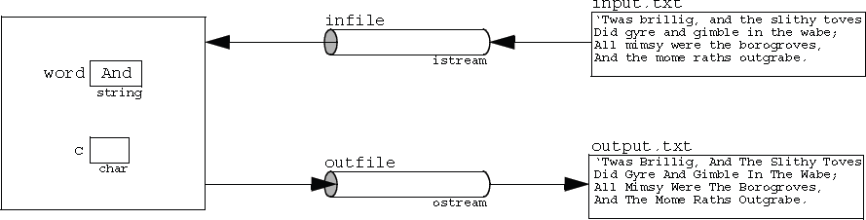File processing in C++ is very similar to ordinary interactive input and output because the same kinds of stream objects are used. Input from a file is managed by an ifstream object the same way that input from the keyboard is managed by the istream object cin. Similarly, output to a file is managed by an ofstream object the same way that output to the monitor or printer is managed by the ostream object cout. The only difference is that ifstream and ofstream objects have to be declared explicitly and initialized with the external name of the file which they manage. You also have to #include the <fstream> header file (or <fstream.h> in pre-Standard C++) that defines these classes

Notice that the program has four objects: an ifstream object named infile, an ofstream object named outfile, a string object named word, and a char object named c.

The advantage of using external files instead of command line redirection is that there is no limit to the number of different files that you can use in the same program.

#### Files of C

|  |
| --- |
| //Program that create / open a file #include<stdio.h> #include<conio.h>  void main ()  {  FILE *fptr; char ch;  fptr = fopen("first.txt","w");  while((ch =getche()) != '\r') putc(ch,fptr);  fclose(fptr);  } |

#### Files in C++

|  |
| --- |
| include <fstream> using namespace std; int main ()  {  ofstream myfile; myfile.open ("first.txt");  myfile << "This is my first file \n"; myfile.close();  return 0;  } |

This Code will creates a file ―first.txt‖ and insert a sentence into it in the same way we are used to do with cout<< but using the myfile stream instead

#### Open a file

Open (filename, mode);

* + - * Mode is optional parameter with a combination of the following flags

ios::in Open for input operations. ios::out Open for output operations.

ios::binary Open in binary mode. Set the initial position at the end of the file.

ios::ate If this flag is not set to any value, the initial position is the beginning of the file.

ios::app All output operations are performed at the end of the file, appending the content to the current content of the file. This flag can only be used in streams open for output-only operations.

ios::trunc If the file opened for output operations already existed before, its previous content is deleted and replaced by the new one.

All these flags can be combined using the bitwise operator OR (|). For example, if we want to open the file example.bin in binary mode to add data we could do it by the following call to member function open(): ofstream myfile;myfile.open ("example.bin", ios::out | ios::app | ios::binary);

#### Que No 1 Create a text file

Write a program that create a text file ―example.txt‖. Open that file and write two line in it

―This is a line and This is another line‖ and close the file. If the file is unable to create or open then show a message ―ERROR Unable to open a file‖.

##### Code

|  |
| --- |
|  |

#### Que No 2 Read from the file

Write a program that read the text from file ―example.txt‖.

If the file is unable to open then show a message ―ERROR Unable to open a file‖.

##### Code

|  |
| --- |
|  |

#### Que No 3 Write data through variable

Write a program that create a text file ―fdata.txt‖. Open that file and write the values through variables as under. After successful writing show a message ―File written successfully‖ .

##### code

char ch = 'x'; int j = 77;

double d = 6.02;

string str1 = "How are u? "; string str2 = "Pretty Good";

|  |
| --- |
|  |

#### String with Embedded blanks

Write a program that creates a file **“test.txt”** and write the following lines in that file

If we don‘t work hard,

We will not be able to score high & might some our class fellow get flunked repeating the semester again

Write these lines one by one in the same format given above

* + 1. **Code**

|  |
| --- |
|  |

#### Lab Evaluation Summary

|  |  |  |  |  |  |
| --- | --- | --- | --- | --- | --- |
| **Lab #** | **Lab Topics** | **Date conducted** | **Total Marks** | **Marks Obtained** | **Signature** |
| **1** | Basic |  |  |  |  |
|  |
| **2** | If, if-else, Nested if else |  |  |  |  |
|  |
| **3** | Switch Statement |  |  |  |  |
|  |
| **4** | For loop, While loop |  |  |  |  |
|  |
| **5** | Do- while loop |  |  |  |  |
|  |
| **6** | Function |  |  |  |  |
|  |
| **7** | Arrays, Strings |  |  |  |  |
|  |
| **8** | Two Dimensional Arrays |  |  |  |  |
|  |
| **9** | Simple and Multilevel Inheritance |  |  |  |  |
|  |
| **10** | Multiple and Hierarchical Inheritance |  |  |  |  |
|  |
| **11** | Files |  |  |  |  |
|  |
| **Total** | | |  |  |  |

**Note:** It is the responsibility of every student to get this sheet signed from his/her lab engineer after every lab.