

Malaviya National Institute of Technology (MNIT) Jaipur
Project title:
Decoding Consumer Behavior: A Data-Driven Approach to Retail Decision Making Using an Automated Analytics Pipeline

Prepared By: Pankaj Kumar Saini
Programme :B.Tech 3rd Year

TABLE OF CONTENTS
- Introduction & Problem Statement
- Project Objectives
- Tools & Technologies Used
- Step-by-Step Project Workflow
  - 4.1 Excel File Structure
  - 4.2 Python Reads the Excel File
  - 4.3 Python Inserts Data into MySQL
  - 4.4 Power BI Connects to MySQL
  - 4.5 Building the Power BI Dashboard
- Challenges & Problems Faced
- Final Output & Results
- Conclusion

1. INTRODUCTION & PROBLEM STATEMENT

1.1 Project Overview
This project presents a complete end-to-end data analytics pipeline. It extracts raw consumer transaction data stored in Excel, processes it with Python, loads it into a MySQL relational database, and visualizes key business metrics in an interactive Power BI dashboard.

1.2 Problem Statement
A fast-growing retail company operating through both online and offline channels observed inconsistent sales performance, shifting customer preferences, and declining repeat-purchase rates across several product categories. Although the company collected large volumes of customer transaction data, management lacked clear visibility into the factors actually driving purchasing decisions and long-term loyalty.
Specific business challenges:
- Certain products performed well only during specific seasons, but inventory planning was not optimised accordingly.
- Marketing campaigns generated traffic, yet conversion rates remained inconsistent across different customer groups.
- Customers from different age groups and regions exhibited different shopping behaviours, making personalised marketing difficult.
- Discounts and free shipping increased sales temporarily, but the company was unsure whether they improved profitability or customer retention in the long run.
- Online and offline sales channels exhibited different purchasing patterns, but these insights were not being effectively utilised.
- Customer reviews, ratings, and payment preferences potentially influenced buying behaviour, but their impact had not been quantified.

2. PROJECT OBJECTIVES
- Improve customer retention and loyalty by identifying behavioral patterns associated with repeat purchases.
- Increase sales and revenue by uncovering high-performing products, regions, and customer segments.
- Optimize marketing campaigns and discount strategies by quantifying their true impact on profitability and retention.
- Identify profitable customer segments using demographic and behavioural attributes such as age group, gender, and location.
- Enhance product and inventory planning by detecting seasonal demand trends and category-level performance.
- Deliver a more personalised shopping experience by understanding channel-specific purchasing patterns (online vs. offline).
- Automate the data pipeline from Excel to MySQL using Python, eliminating manual data entry and reporting errors.
- Build an interactive Power BI dashboard that enables non-technical stakeholders to explore data and derive insights independently.

3. TOOLS & TECHNOLOGIES USED
Tool / Technology | Version / Type | Purpose
Microsoft Excel | .xlsx Format | Raw data storage — customer_shopping_behavior.xlsx
Python | Python 3.14.4 | Core scripting for data extraction, transformation, loading
pandas | Python Library | Reading Excel, data cleaning, DataFrame operations
mysql-connector-python | Python Library | Connecting Python to MySQL, executing SQL queries
MySQL | 8.0.31.msi | Relational database storing structured consumer data
Power BI Desktop | BI Tool | Dashboard creation and data visualisation

4. STEP-BY-STEP PROJECT WORKFLOW

4.1 Excel File Structure — customer_shopping_behavior.xlsx
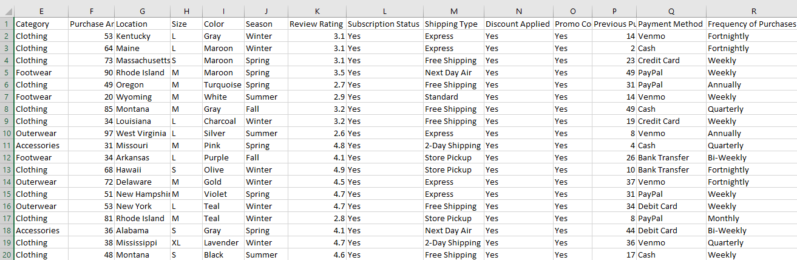
Dataset- F:\Data analytics project\customer_shopping_behavior.csv
4.2 Python Reads the Excel File — load_data.py
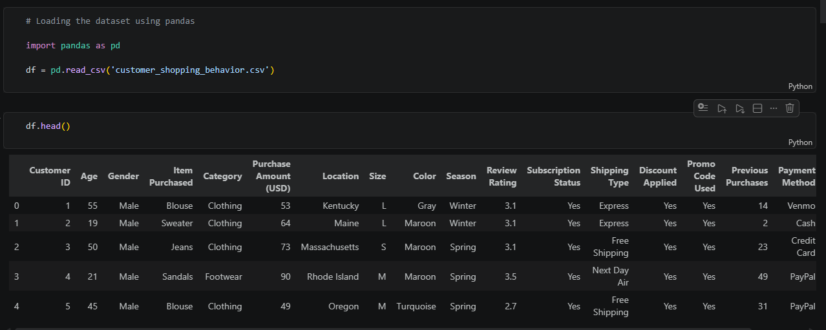
Link-F:\Data analytics project\Customer_Shopping_Behavior_Analysis.ipynb
4.3 Python Inserts Data into MySQL
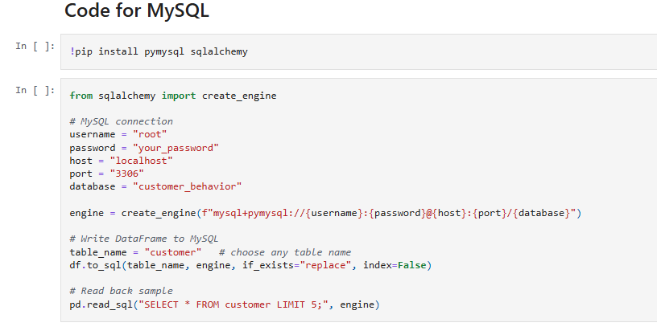
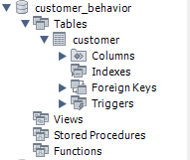
link-F:\Data analytics project\Customer_Shopping_Behavior_Analysis.ipynb
4.4 Power BI Connects to MySQL
1. Install MySQL Connector/NET  2. Open Power BI Desktop  3. Get Data → More → Database → MySQL Database  4. Click Connect  5. Enter:  Server: localhost:3306  Database: customer_shopping_behavior | 6.Click ok  7. Enter MySQL Username & Password  8. Click Connect  9. Select tables  10. Click Load  11. MySQL data is successfully loaded
4.5 Building the Power BI Dashboard
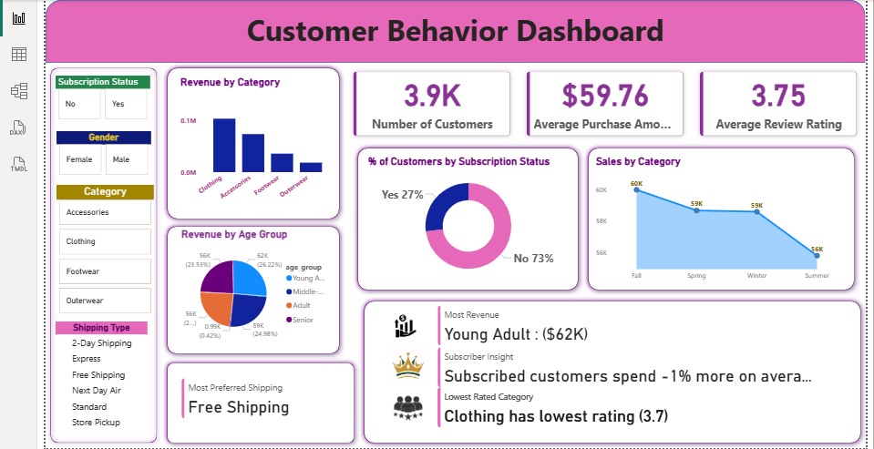
Link-F:\Data analytics project\customer_behavior_dashboard.pbix

KPI Overview
Metric | Value | What It Means
Total Customers | 3.9K | Dataset covers 3,900 unique customers
Average Purchase Amount | $59.76 | A typical customer spends ~$60 per transaction
Average Review Rating | 3.75 / 5 | Customer satisfaction is moderate — room for improvement

Revenue by Category
Clothing leads revenue, followed by Accessories, Footwear, and Outerwear at the bottom. Action: Invest in Clothing & Accessories inventory; run promotions on Footwear and Outerwear to lift their numbers.

Revenue by Age Group
Age Group | Revenue | Share
Young Adult | $62K | 26.22%
Middle-Age | $62K | 26.22%
Adult | $59K | 24.98%
Senior | $56K | 24.58%
All four groups contribute nearly equally (~25% each). Young Adults and Middle-Age are tied at the top; Seniors spend the least. Action: Target Young Adults via social media and influencer marketing for highest ROI.

Subscription Status
73% of customers are non-subscribers. Only 27% are subscribed. Action: Introduce exclusive benefits (discounts, early access) to convert non-subscribers into loyal recurring customers.

Sales by Season
Season | Sales
Fall | 60K — Peak
Spring | 59K
Winter | 59K
Summer | 56K — Lowest
Fall is the strongest season. Summer drops by 4K compared to Fall — the only notable dip. Action: Maximize stock and marketing in Fall. Run Summer-specific promotions to recover the 4K gap.

Most Preferred Shipping
Free Shipping is the #1 choice across all customers — showing clear price sensitivity. Action: Set a minimum order value to qualify for free shipping, pushing average order value higher.

Bottom Insight Cards

Insight | Finding | Business Meaning
Most Revenue | Young Adult ($62K) | Most valuable customer segment
Subscriber Spending | ~1% more than non-subscribers | Subscription program exists but benefits are too weak to drive significant extra spending — needs improvement
Lowest Rated Category | Clothing (3.7 / 5) | Highest revenue category but worst satisfaction — serious long-term risk

The Most Critical Finding — Clothing Contradiction
Clothing earns the most revenue but has the lowest rating (3.7). Customers are buying it but not satisfied. Left unaddressed this leads to declining repeats, negative reviews, and eventual revenue loss.
Action: Investigate product quality, sizing accuracy, and delivery condition in the Clothing category immediately.

Overall Business Priorities

Area | Priority
Fix Clothing satisfaction gap | High — urgent
Convert 73% non-subscribers | High
Grow Young Adult & Middle-Age segment | Medium
Summer sales recovery | Medium
Strengthen subscription benefits | Medium
Use Free Shipping as a marketing tool | Low — already working

5. CHALLENGES & PROBLEMS FACED

Challenge 1 — Excel Data Was Messy and Inconsistent
When the Excel file was loaded into pandas, data was not clean. The Gender column had values like "male", "Male", "MALE" — all meaning the same thing but treated as different categories. Similarly Shipping_Type had trailing spaces like "Free Shipping " which created duplicate entries in Power BI slicers and wrong counts.
Solution:
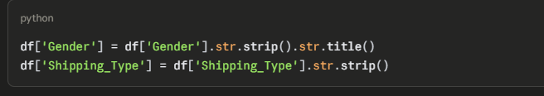

Challenge 2 — Age Group Column Did Not Exist in Raw Data
The Revenue by Age Group chart required an Age_Group column (Young Adult, Middle-Age, Adult, Senior) but the original Excel file only had a numeric Age column. There was no ready-made field available for grouping in Power BI.
Solution: Created a calculated column directly in Power BI using DAX:
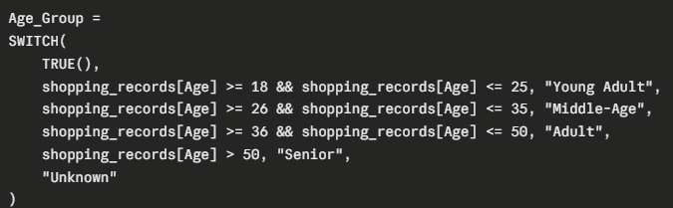

Challenge 3 — KPI Cards Not Updating When Slicer Was Clicked
After the dashboard was fully built, the slicers for Gender, Category, and Subscription Status were tested. All charts updated correctly when a filter was applied — but the three KPI cards at the top (Total Customers, Avg Purchase Amount, Avg Rating) stayed frozen on the overall numbers and did not respond to slicer selections.
Solutiom:
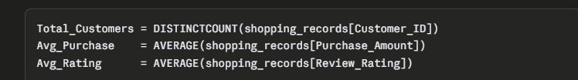
FINAL OUTPUT & RESULTS
A fully interactive single-page Customer Behavior Dashboard in Power BI connected live to MySQL database . The dashboard reads from the table which was populated by the Python pipeline from customer_shopping_behavior.xlsx.
Any time the Excel data is updated and the Python script is re-run, the dashboard reflects the latest numbers automatically on refresh.

CONCLUSION
The dashboard successfully converted 3,900 rows of raw Excel data into 7 clear business findings. The most urgent issue is the Clothing quality gap — high revenue but low satisfaction. The biggest growth opportunity is converting the 73% non-subscribers into loyal customers. And the easiest revenue win is setting a free shipping threshold to push average order value above the current $59.76.

