OUTPUTS
TASK 1:
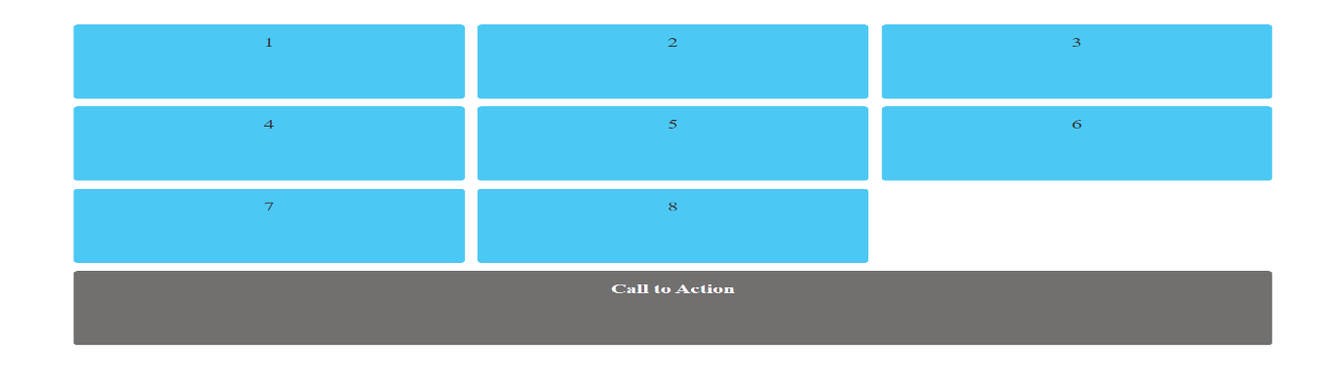
TASK 2:
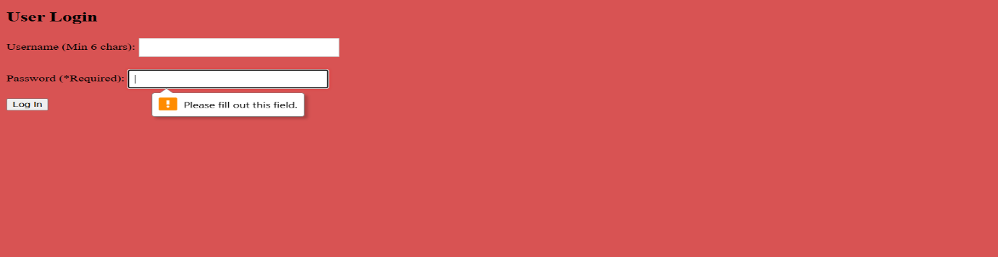
TASK 3:

TASK 4:
