- Array list and LinkedList:
package thursday27_11;

import java.util.*;

public class arraylist {
public static void main(String[] args) {
ArrayList var = new ArrayList();
var.add(1018);
var.add("pankaj");
var.add(true);
var.add("e");
var.add(1.236);
var.add(1544566);
var.add("r");

Iterator itr = var.iterator();
while (itr.hasNext()) {
System.out.print(itr.next()+" ");
}
System.out.print("\n");

LinkedList list = new LinkedList();
list.add(1545);
list.add("pankajvinod");
list.add(1.236);
list.add(false);
list.add("f");

Iterator prt = list.iterator();
while (prt.hasNext()) {
System.out.print(prt.next() + " ");
}

System.out.print("\n");

ListIterator li = list.listIterator(list.size());
while (li.hasPrevious()) {
System.out.print(li.previous()+" ");
}
System.out.print("\n");

for(int i = 0; i<list.size();i++){
System.out.print(list.get(i)+" ");
}
}
}
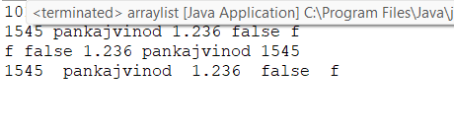
- SET:
package thursday27_11;
import java.util.*;
public class set {
public static void main(String[] args) {
hasset ob = new hasset();
ob.run();
linkhash ob1 = new linkhash();
ob1.run();
treeset ob2 = new treeset();
ob2.run();
}

}
class hasset{
void run(){
HashSet<Integer> hs = new HashSet<Integer>();
hs.add(58);
hs.add(68);
hs.add(541);
System.out.println(hs);
Iterator itr = hs.iterator();
while(itr.hasNext()){
System.out.print(itr.next()+" ");
}
System.out.println("\n");
}
}

class linkhash{
void run(){
LinkedHashSet<Integer> ls = new LinkedHashSet<Integer>();
ls.add(89);
ls.add(54);
ls.add(41);
Iterator itr = ls.iterator();
while(itr.hasNext()){

System.out.print(itr.next()+" ");
}
System.out.println("\n");
}
}

class treeset{
void run(){
TreeSet<String> ts = new TreeSet<String>();
ts.add("Pankaj");
ts.add("Niju");
ts.add("Barath");
System.out.println(ts);
}
}
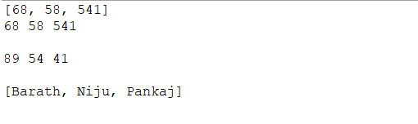
- MAP:
package thursday27_11;

import java.util.*;

public class map {
public static void main(String[] args) {
hashmap ob = new hashmap();
ob.run();
lhmap ob1 = new lhmap();
ob1.run();
treemap ob2 = new treemap();
ob2.run();
}
}

class hashmap {
void run() {
HashMap<Integer, String> hm = new HashMap<Integer, String>();
hm.put(101, "Pankaj");
hm.put(102, "Niju");
hm.put(103, "Barath");
Iterator itr = hm.values().iterator();
while(itr.hasNext()){
System.out.print(itr.next()+" ");
}
System.out.println("\n");
}
}

class lhmap{
void run(){
LinkedHashMap<Integer, String> lhm = new LinkedHashMap<Integer, String>();
lhm.put(154, "pankaj");
lhm.put(145, "virat");
lhm.put(158,"Dhoni");
Iterator itr = lhm.values().iterator();
while(itr.hasNext()){
System.out.print(itr.next()+" ");
}
System.out.println("\n");
}
}

class treemap{
void run(){
TreeMap<Integer, String> lhm = new TreeMap<Integer, String>();
lhm.put(201, "Rohith");
lhm.put(202, "virat");
lhm.put(203,"Starc");
Iterator itr = lhm.values().iterator();
while(itr.hasNext()){
System.out.print(itr.next()+" ");
}
System.out.println("\n");
for(String i : lhm.values()){
System.out.print(i+" ");
}
}
}
