**Project Structure:**

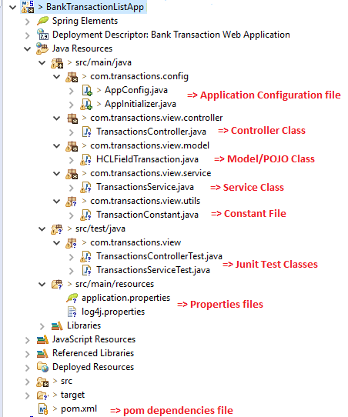

**Build and Deployment Steps:**

1. Please install maven and set environment variable like below

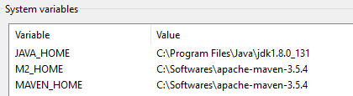

1. Please go to the directory where your application pom.xml file is located and open the same path in command prompt.

For my case the path is: ***C:\new_workspace\BankTransactionListApp***

1. Run the below command to clean the project first

***C:\new_workspace\BankTransactionListApp>mvn clean***

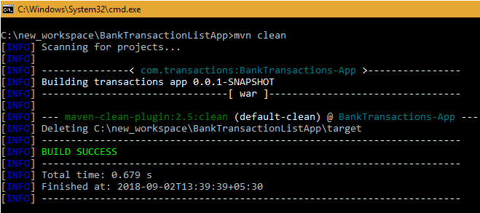

1. Then build and deploy the application by using below command, I am here using Tomcat 7 as embedded web container.

C***:\new_workspace\BankTransactionListApp>mvn tomcat7:run***

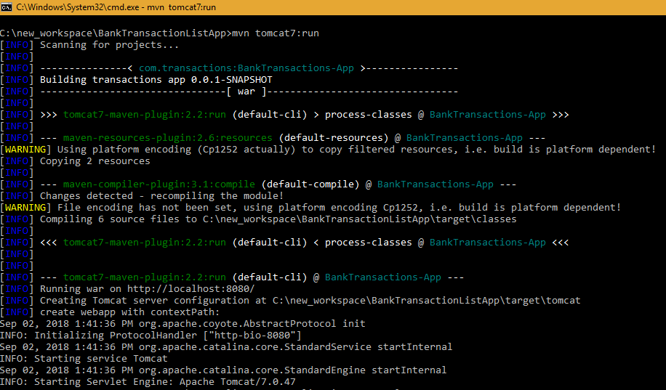

1. When you get the below message that means application is built and deployed successfully.

*2018-09-02 14:03:51 INFO DispatcherServlet:508 - FrameworkServlet 'dispatcher': initialization completed in 341 ms*

*2018-09-02 14:03:51 DEBUG DispatcherServlet:139 - Servlet 'dispatcher' configured successfully*

*Sep 02, 2018 2:03:51 PM org.apache.coyote.AbstractProtocol start*

*INFO: Starting ProtocolHandler ["http-bio-8080"]*

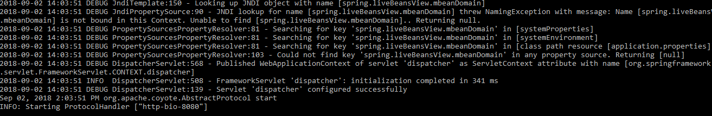

1. To test the application, I have used Postman as all api are secured using https header authentication key. As of now I have hardcoded the value if property file, but it can also be generated dynamically through database/api or any other authenticated or identity server.

***authorization_code = ABCD1234TEST567XYZ***

1. [***http://localhost:8080/transactions/getAllTransactionList***](http://localhost:8080/transactions/getAllTransactionList)

When we provide correct authentication code in header. Getting below correct result.

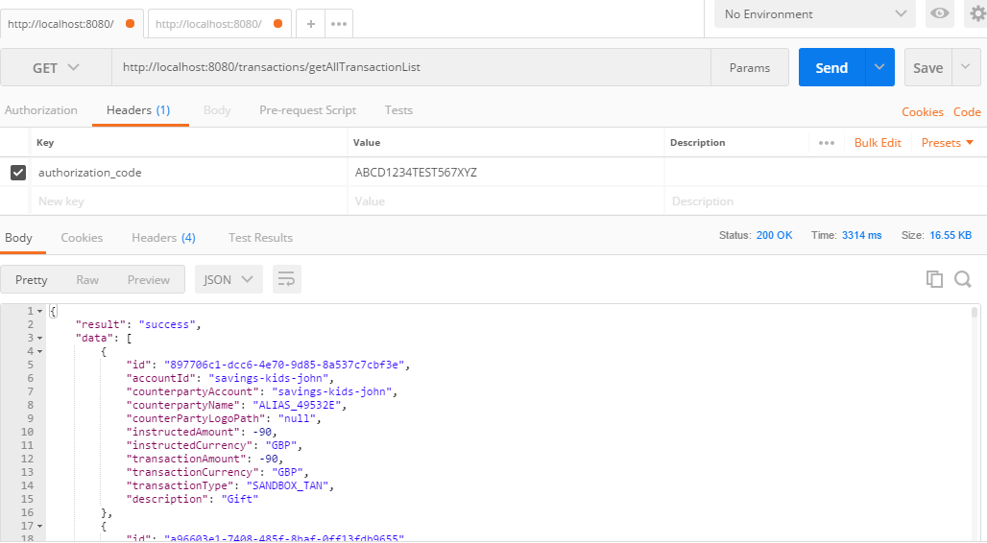

When we provide wrong authentication code or no code in header, getting below error.

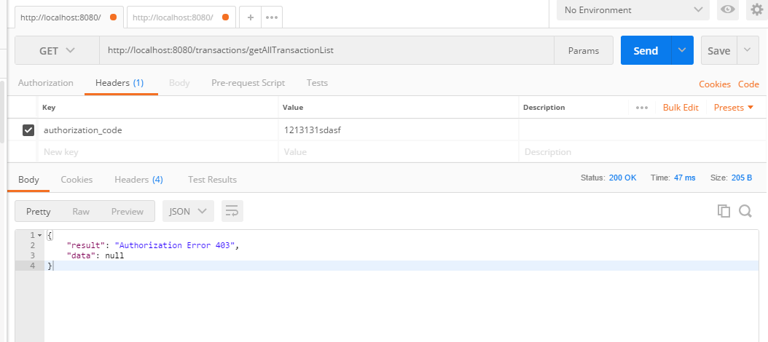

1. [***http://localhost:8080/transactions/getTransactionsListByTransactionType/{transactionType}***](http://localhost:8080/transactions/getTransactionsListByTransactionType/%7btransactionType%7d)

transactionType = SANDBOX_TAN or sandbox-payment or null

With correct authentication code, getting correct result as below.

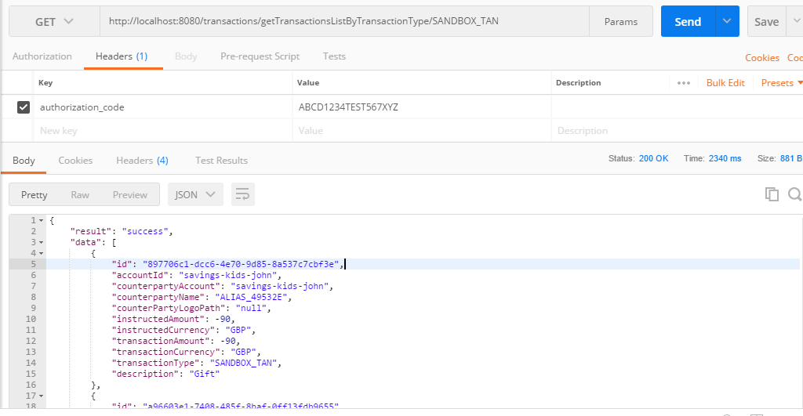

Without any authentication code or with different authentication code, getting below error.

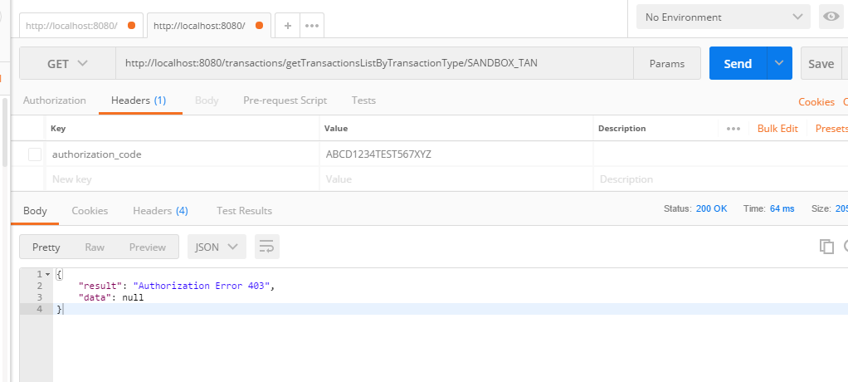

1. [***http://localhost:8080/transactions/getTotalAmountByTransactionType/{transactionType}***](http://localhost:8080/transactions/getTotalAmountByTransactionType/%7btransactionType%7d)

transactionType = SANDBOX_TAN or sandbox-payment or null

With correct authentication code, getting correct result as below.

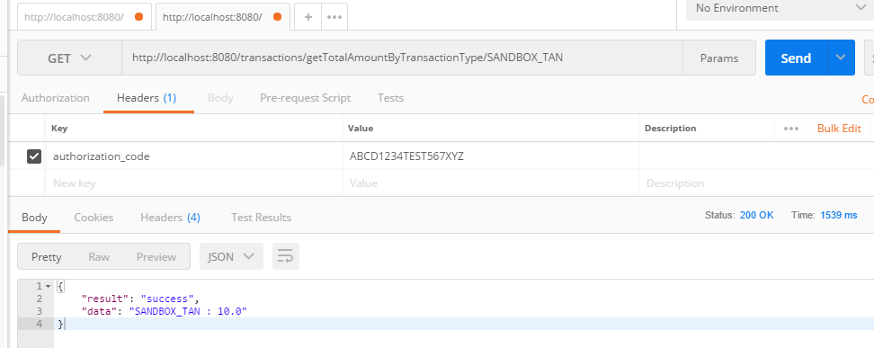

Without any authentication code or with different authentication code, getting below error.

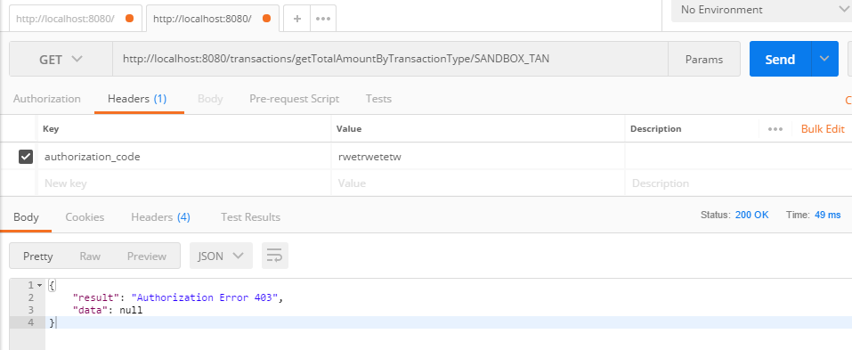

1. **Log file:**

log4j.appender.file.File=${catalina.home}/logs/banktransactionapp.log -> written in log4j.properties file

Path: C:\new_workspace\BankTransactionListApp\target\tomcat\logs

