|  |
| --- |
| Auditorium Seat Management System! |
|  |
| ***A report submitted in partial fulfilment of the***  ***requirement*** ***for the award of degree of***  ***BACHELORS OF ENGINEERING***  ***in***  ***ELECTRONICS AND COMMUNICATION ENGINEERING*** |
|  |
| ***By*** |
| **Pankaj Saha: 18BEC1180**  **Nandita Rajput: 18BEC1178**  **Abhishek Sharma: 18BEC1172** |
|  |
| ***under the guidance of***  ***Mr. Ashish Sharma*** |
| ***Assistant Professor*** |
| ***Electronics and Communication Engineering*** |
| **Electronics and Communication Engineering**  **UIE, Chandigarh University** |

TABLE OF CONTENTS:

|  |  |
| --- | --- |
| CONTENTS | PAGE NO. |
| 1. AUDITORIUM SEAT MANAGEMENT SYSTEM  1.1 Problem identification  1.2 Feature finalization  1.3 Design, flow and tools  1.4 Best Possible Design  1.4.1 Flowchart  1.4.2 Code  1.5 Simulation/Outcome  1.6 Conclusion and future scope  1.7 References  1.8 Cost Analysis | 5  5-7  7-8  8-11  12-13  13  13  14 |

**Quote: -** We see portability in electronics being a continuing requirement, higher functionality, better battery life, requiring lower power for the actual electronics.

ACKNOWLEDGEMENT:

We three students of Electronics and Communication Engineering of 3rd year in CHANDIGARH UNIVERSITY, GHARUAN have prepared a project named as “***AUDITORIUM SEAT MANAGEMENT SYSTEM***”. We wholeheartedly express our sincere gratitude to *Associate Director Dr. Harjot Gill* and our mentor *Prof. Ashish Sharma* who guided us to the completion of this project. We are also thankful to all our teachers for explaining in critical topics related to the project. We also take this opportunity to express deep sense of gratitude to team members their cordial supports, valuable information and guidance, which helped us in completing this task through various stages. We would also like to thank all of the faculty members of all other respective departments for their intimate cooperation throughout the period of project completion. We are grateful for their cooperation during the period of my assignment.

Lastly, we would like to thanks the almighty and our parents for their moral support and my friends with whom we shared our day-to-day experience and receive lots of suggestions that improved our quality of works.

(1) Pankaj Saha [18BEC1180]

(2) Nandita Rajput [18BEC1178]

(3) Abhishek Sharma [18BEC1172]

**ABSTRACT**

‘Auditorium Seat Management system’ is one of the prominent solutions to solve problem like social distancing in managing seats in Auditorium during this crucial time. Previously, managing seat for auditoriums were done via manual process, which acts as a fuel for time consumption and other issues.

Our project focuses on absolutely zero indulgence of human’s presence. Functioning of this Project is as simple as Booking a movie ticket via online portals. Hereby, our project deals with latest electronic component and also its somewhat cost effective. From setting up a switch for counter to connecting a servo motor to automatically open/close the entrance and exit point.

Sensor’s the one of the most important components to transfer physical signals to electrical sensor. Hence, we have used a flex sensor, to provide us with pressure value, when an attendee occupies his/her seat in Auditorium. Moreover, this project does solve most of the problem with ease and almost with 90% efficiency

**Disclaimer:** - This project is based on the sole idea of our 3 members only, violating and

copying this material would be a matter of copyright issue.

**LIST OF FIGURES:**

Fig: - 1.3.1- Interfacing LCD with Arduino Uno.

Fig: - 1.3.2- Interfacing switches with Arduino Uno.

Fig: - 1.3.3- Interfacing Servo Motor with Arduino Uno.

Fig: - 1.4.1-Complete Schematic of the project.

Fig: - 1.5.1-Result of Simulation.

Fig: - 1.5.2-Result of Simulation.

Fig: - 1.5.3-Resut of Simulation.

**1) PROBLEM IDENTIFICATION.**

*This Project”* ***AUDITORIUM SEAT MANAGEMENT SYSTEM****” focuses on solving plethora of problems mentioned below:*

**1**. Prominently, it focuses on how to manage a number of people in auditoriums in an efficient way. We all know that when we are attending a seminars or any programs, there creates a chaotic situation about finding a vacant seat because of the poor visibility in the hall due to darkness .So, we have come up with an idea that in a hall we will be placing LED’S connected with pressure sensor in the seats .When there is no one sitting in the seat then LED’s will keep glowing which will be pointing that seats are vacant and when someone sits in the seat, pressure sensor will sense some pressure and will turn the LED as LOW. We will be giving thorough details about its working in next slides.

**2**. We all know that how the whole world is suffering from the deadly COVID-19. We know that this virus is not going to go anytime soon. In this lockdown period we should be thinking of various innovations that would help us in coping up with this virus because we have to live with this situation. So, in this “*AUDITORIUM SEAT MANAGEMENT SYSTEM*” we can maintain social distancing between the people. In the hall we will place LED’s in the alternate seats or leaving two gaps between the seats. Then, we will follow the same procedure of glowing the LED’s. By following this, people will easily recognise where they have to sit maintaining required distancing.

**3**. Another application of this project is in the car parking system at night where instead of pressure/flex sensor we will be applying ultrasonic sensor rest all the functions would be 19. We the vacant spaces in the parking will glow and when a car enters then the ultrasonic sensor will sense the object and make the LED turn off if the car has been parked.

**4.** This project will help in time management. People will not ruin their time in searching for their seats. The glowing seat will help them to locate their seats from far away.

**2) FEATURE FINALIZATION.**

In this project the components which we have used are as follows:

**1. Arduino UNO 2. Flex Sensor**

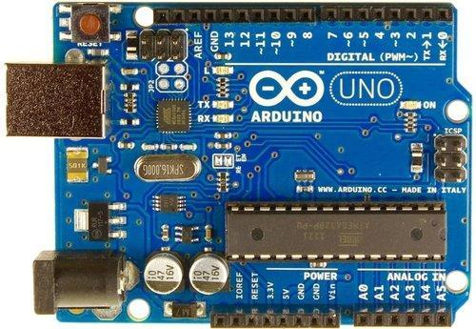 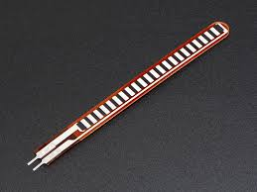

**3. LED 4. Resistor**

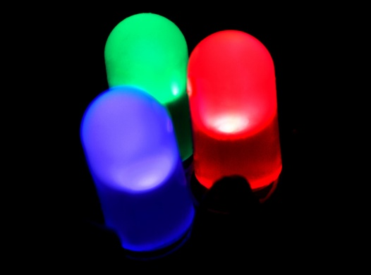 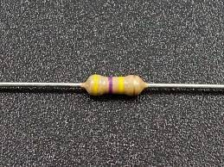

**5. SWITCH 6. LCD** 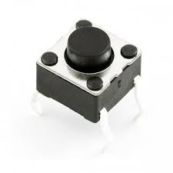 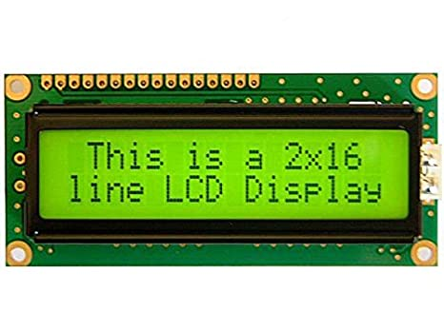

**7.SERVO MOTOR 8. POTENTIOMETER**

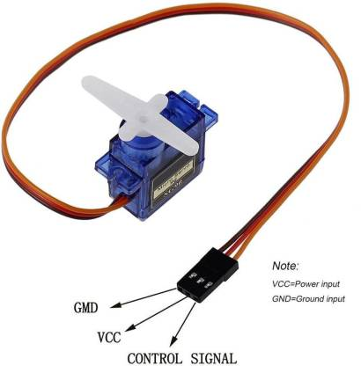 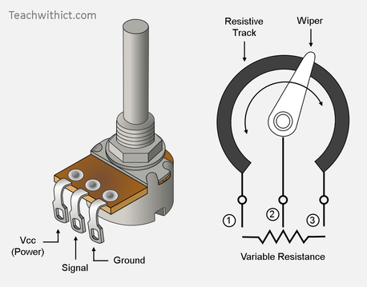

In this project we have kept an entry switch which will get pressed whenever a person enters in the auditorium. As the switch will keep getting pressed with every new entrance, the value of the count will keep getting increased. We will set a maximum capacity of auditorium at for e.g., 50 or 100.When the limit of count value will be crossed then the LCD board will print a message that” HOUSEFULL! YOU CAN’T ENTER”. Similarly, if the person has to go out then the exit button will be pressed and simultaneously the value of the count will decrease that will provide a vacant seat.

We will mainly look two into cases:

**CASE 1**. If there is no one in the auditorium and seats are vacant then all the seats will glow.

**CASE 2.** Suppose if 10 out of 50 people enter in the auditorium then our vacant spaces left will be 40. When these people will sit on the seats, each seat will sense the bending or pressure and flex sensor will sense it and turn off the LED which is connected to it. Similarly, this will happen with every seat that will sense pressure and LEDs will go off.

**3) DESIGN FLOW.**

(a) Initially we just interfaced LCD with Arduino Uno.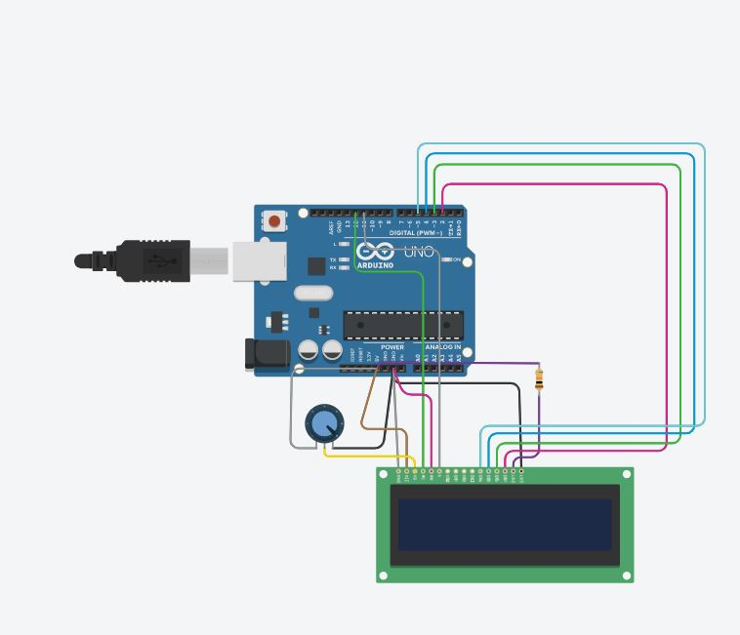

Fig: - 1

(b) Interfacing switches with Arduino Uno. 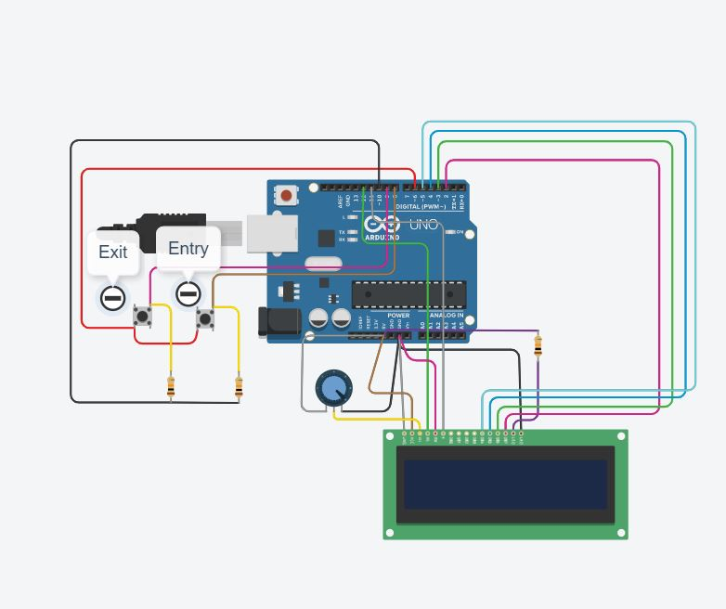 Fig: - 2

(c) Interfacing Servo Motor with Arduino Uno. 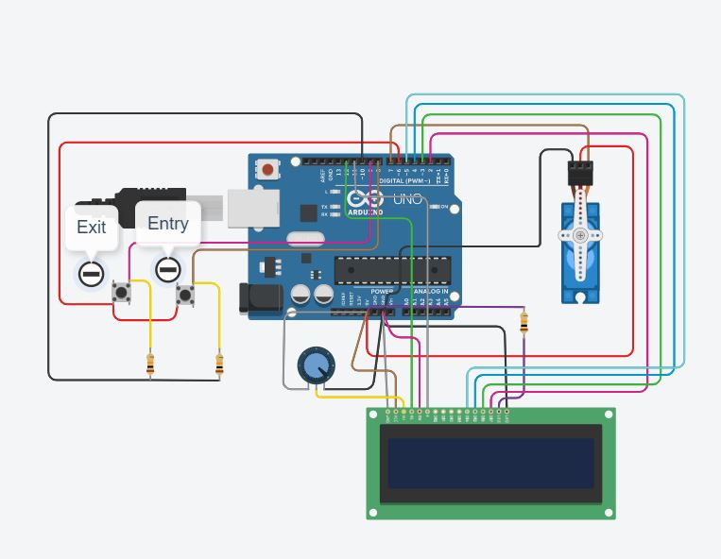

Fig: - 3

**4) BEST POSSIBLE DESIGN**.

***Constraint***: - Due to insufficient availability of digital I/O pin of arduino uno, demonstrating our project for all six seats is quite incompatible/challenging task for us. Hence to test our project, we have estimated one seat as a prototype to troubleshoot for every possible existing case as stated above.

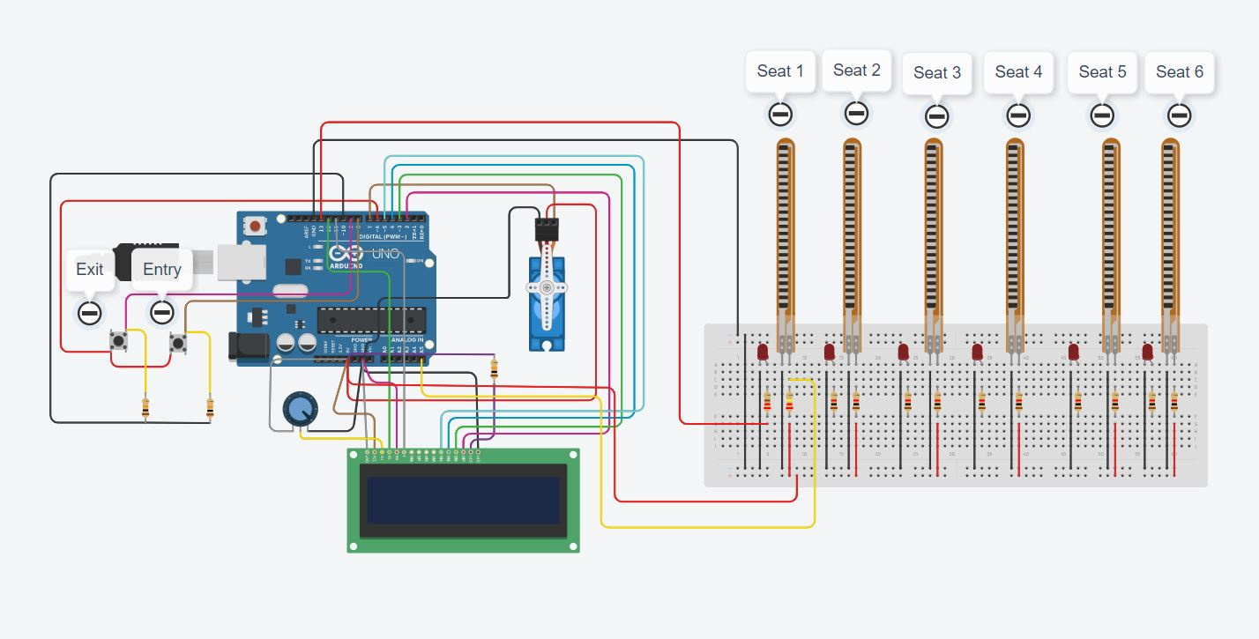

Fig: - 4

**4.1) FLOW CHART.**

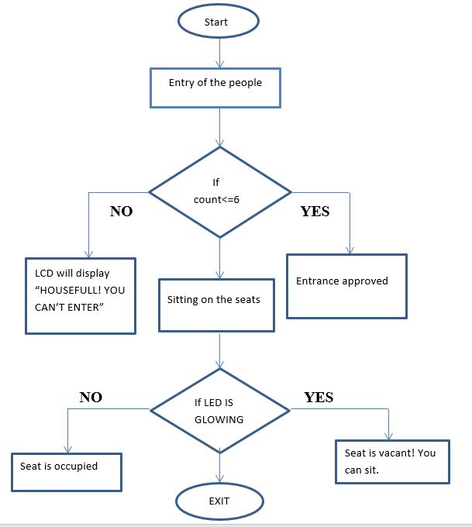

**4.2) CODE.**

#include <Servo.h>

#include<LiquidCrystal.h>

LiquidCrystal lcd(12,11,5,4,3,2);

Servo myservo; //It will create an object name (myservo) for motor. int flexval=0;

#define ServoM 7

#define Exit 9

#define In 8

#define Pwr 6

#define Gnd 10

#define BarLow 90

#define BarUp 177

#define CAPACITY 6

void setup()

{

myservo.attach(ServoM);

lcd.begin(16,2);

lcd.setCursor(0,0);

lcd.print("Auditorium Seat");

lcd.setCursor(3,1);

lcd.print("MMT System!");

delay(5000);

lcd.clear();

pinMode(Gnd, OUTPUT);

pinMode(A5,INPUT);

pinMode(13,OUTPUT);

pinMode(Pwr, OUTPUT);

pinMode(Exit, INPUT);

pinMode(In, INPUT);

digitalWrite(Gnd, LOW);

digitalWrite(Pwr, HIGH);

myservo.write(BarLow);

digitalWrite(13,HIGH);

Serial.begin(9600);

delay(1000);

}

int Available= 6;

void loop()

{

flexval=analogRead(A5);

Serial.print("Pressure Value: ");

Serial.println(flexval);

if (Available == 1)

{

if(flexval>=250)

{

digitalWrite(13,LOW);

}

else

{

digitalWrite(13,HIGH);

}

lcd.clear();

lcd.setCursor(0,0);

lcd.print("Space Left For");

lcd.setCursor(3,1);

lcd.print(Available);

lcd.setCursor(5,1);

lcd.print("Attendee!");

}

else

{

if (Available >= 1)

{

lcd.clear();

lcd.setCursor(0,0);

lcd.print("Space Left For");

lcd.setCursor(3,1);

lcd.print(Available);

lcd.setCursor(5,1);

lcd.print("Attendee!");

if (flexval>=250)

{

digitalWrite(13,LOW);

}

else

{

digitalWrite(13,HIGH);

}

}

else

{

lcd.clear();

lcd.setCursor(3,0);

lcd.print("HOUSEFULL!");

lcd.setCursor(1,1);

lcd.print("CAN'T ENTER");

digitalWrite(13,LOW);

}

}

if(digitalRead(In)==1)

{

if(Available != 0)

{

Available--;

myservo.write(BarUp);

delay(3000);

myservo.write(BarLow);

}

}

if(digitalRead(Exit)==1)

{

if(Available != CAPACITY)

{

Available++;

myservo.write(BarUp);

delay(3000);

myservo.write(BarLow);

}

}

delay(500);

}

**5) SIMULATION/OUTCOME.**

***Constraint***: - Due to insufficient availability of digital I/O pin of arduino uno, demonstrating our project for all six seats is quite incompatible/challenging task for us. Hence to test our project, we have estimated one seat as a prototype to troubleshoot for every possible existing case as stated above.

(a). This simulation result depicts that when all the 6 seats are vacant then, LED will glow in all 6 vacant seats. *Due to constraint, we are displaying/portraying the result with the help of one seat as a prototype*

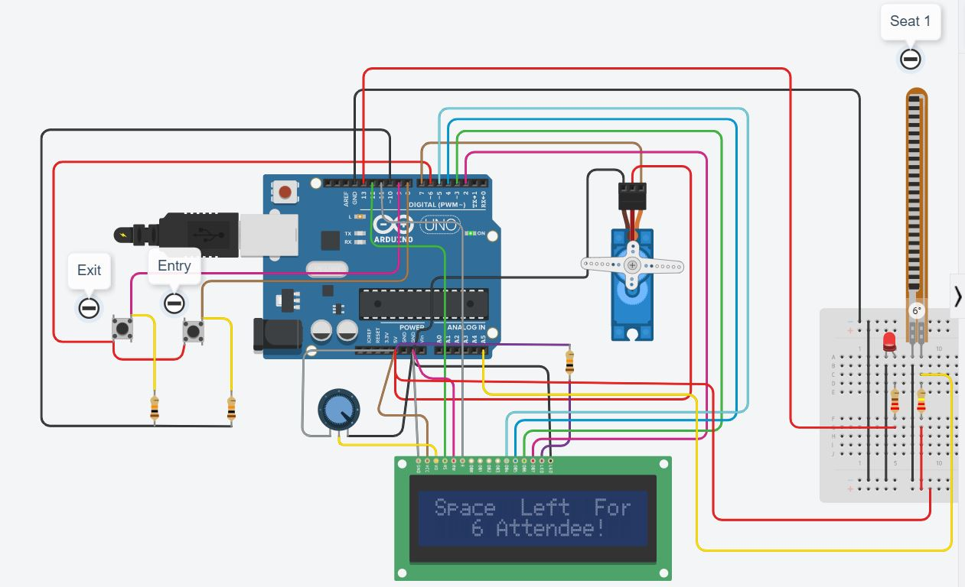

Fig: - 5

(b). If any attendee enters the auditorium, then the counter decreases its value by one. Therefore, it’s obvious that the attendee will occupy one out of six seats available. Hence when the seat gets occupied, simultaneously pressure measured by the flex sensor gets stored and compared with threshold 250 val. As a result, since applied pressure is more than threshold, which indicates that the seat is occupied and hence the Led of that particular seat gets turned off, and the remaining 5 LEDs of vacant seats remain turned on and vice versa.

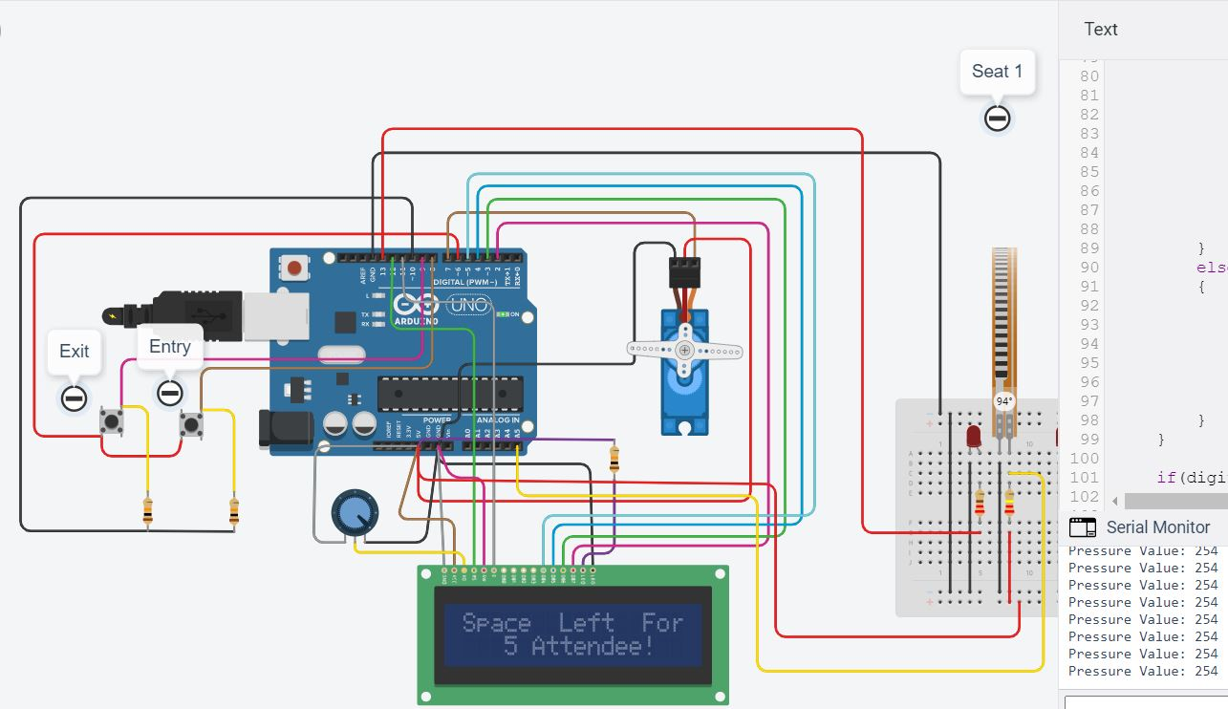

Fig: - 6

(c). When the value of counter is 0, it states that all the seats are occupied by the attendees. Hence a ‘Housefull You Can’t Enter’ message will be shown in the LCD screen outside the auditorium entrance/corridor. Since all seats are occupied, therefore the LEDs will also remain OFF for all seats.

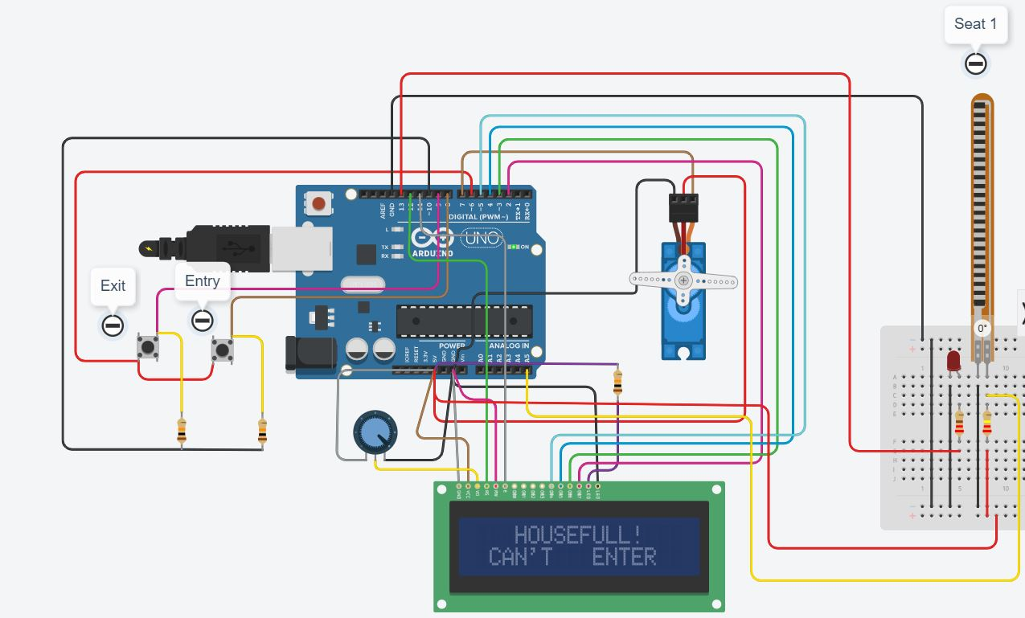

Fig: - 7

**6) CONCLUSION AND FUTURE SCOPE.**

“AUDITORIUM SEAT MANAGEMENT SYSTEM” will be extremely beneficial for the effective management and to reduce time consumption and chaos between people. With the feature of maintaining social distancing, it will be useful in the fight against COVID-19 as well. This project can also be applicable in car parking system which has been discussed earlier. The hardware part of the project helped us to understand Arduino. We also had a chance to practice circuit designing on Arduino. We part helped us to have a better understanding of embedded systems programming and project management skills. The prototype is developed and its successfully working in TinkerCad and performance of the system is found satisfactory. We have completed the project on time and matched the project objectives. We are sure that the experience that we have gained while doing this project will help us throughout our future career.

**7) REFERENCES.**

Alan G. Smith, Introduction to Arduino.

Eng. Abdullah Ali Abdullah, Simple Arduino.

. <http://en.m.wikipedia.org/wiki/Arduino>

. [www.engineerexperiences.com/advantages-and-disadvantages.html](http://www.engineerexperiences.com/advantages-and-disadvantages.html)

. [www.arduino.cc/en/guide/introduction](http://www.arduino.cc/en/guide/introduction)

. [www.arduino.cc](http://www.arduino.cc/)

. [www.elettorial.com](http://www.elettorial.com)

Disclaimer: - This project is based on the sole idea of our 3 members only, violating

and copying this material would be a matter of copyright issue.

**8) COST ANALYSIS.**

|  |  |  |  |
| --- | --- | --- | --- |
| **S. No.** | **Component / Material** | | **Price (in Rs.)** |
| 1. | Arduino Uno | | Rs 450 |
| 2. | LCD (16*2) | | Rs 120 |
| 3. | Servo Motor | | Rs 300 |
| 4. | Breadboard | | Rs 300 |
| 5. | Potentiometer | | Rs 250 |
| 6. | LED | | Rs 2/1pcs |
| 7. | Resistor | | Rs 3/1pcs |
| 8. | Jumper Wires | | Rs 499 |
| **Total** | | Rs 2000 | |

**ECE ARCHIVES PROJECT SUBMISSION FORM**

Project Code: **CU/ECE/20__/Sem____/UID______________ (To be filled by Office)**

Project Name: Auditorium Seat Management System.

Name and UID of student: Pankaj Saha (18BEC1180)

Team Members:

|  |  |  |  |  |
| --- | --- | --- | --- | --- |
| **S. No.** | **Name** | **UID** | **Semester** | **Contact No.** |
| 1. | Abhishek Sharma | 18BEC1172 | 6 | 7006857915 |
| 2. | Nandita Rajput | 18BEC1178 | 6 | 6005501770 |
| 3. | Pankaj Saha | 18BEC1180 | 6 | 7407351957 |
| 4. |  |  |  |  |
| 5. |  |  |  |  |

**Section to be filled by Project Mentor**

**Status (Please tick, whichever applicable)**

|  |  |  |  |
| --- | --- | --- | --- |
| Working |  | Not Working |  |
| **Marks Awarded** | | **60** |  |

Project Mentor Details:

Name: Ashish Sharma Employee ID: E10096

Sign 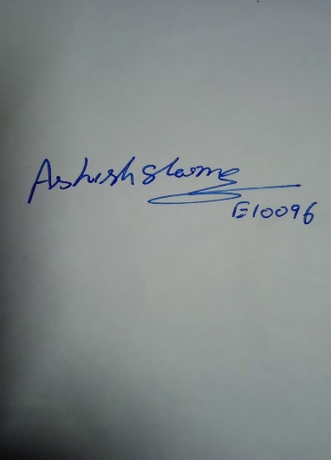 Date: 5/05/21

**Section to be filled by Project Examiner(s)**

**Status (Please tick, whichever applicable)**

|  |  |  |  |
| --- | --- | --- | --- |
| Working |  | Not Working |  |

Project Examiner Signatures:

Internal _______________________________ Employee ID ______________

External _______________________________ Employee ID ______________

Date __________________________________