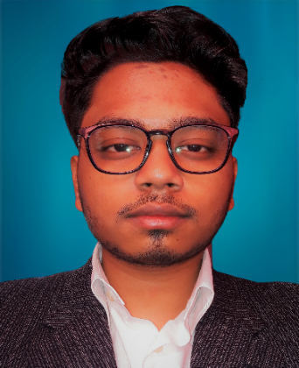

**PANKAJ SAHA**

**Address**: 2B - Ishaana Residency,

Siliguri-734001, West Bengal.

**E-mail**: uie.18bec1180@gmail.com

**University Id:** [18BEC1180@cuchd.in](mailto:18BEC1180@cuchd.in)

**Phone**: +91 7407351957

**LinkedIn**: pankaj-saha-837a21183

**GitHub**: Pankaj740

**PROFESSIONAL SUMMARY**

Looking for an entry-level position in Analysis domain (Software Developer) where I can utilize my extensive knowledge about the area gained during my ECE degree. Well versed with EDA skills and excellence in analyzing case studies. Proficient in English language skills and have astonishing programming skills.

**TECHNICAL COMPETENCIES**

Python | Data Structure and Algorithms | SQL| Database | Computer Networks and Operating System | IBM db2 and Watson Studio | Machine Learning | MS Office | Tinker Cad | Jupyter Notebook | PyCharm.

**INTERPERSONAL SKILLS**

Team Player **|** Decision Making **|** Logical Skill | Management & Coordination **|** Problem

Solving **|** Adaptability and Flexibity | Goal Oriented.

**INTERESTS & HOBBIES**

Programming **|** Table Tennis **|** Cricket **|**

Sci-Fi and Thriller movies.

**LANGUAGES KNOWN**

English **|** Hindi **|** Bengali **|** Nepali

**PERSONAL DETAILS**

Mother’s Name:

**Mamata Saha**

Father’ Name:

**Santosh Saha**

D.O.B.: **18/09/1999**

**EDUCATION**

**(1) Bachelors in Electronics and Communication Engineering Chandigarh University, Gharuan.**

*Session: 2018-2022 | Score: 8.06 CGPA (till 6th Semester)*

**(2). Intermediate (CBSE) |SHMD School, Jaigaon, West Bengal.**

*Session: 2016-2017 | Percentage: 74.5%*

**(3). Matriculation (CBSE) | SHMD School, Jaigaon, West Bengal.**

*Session: 2014-2015 | Score: 7.6 CGPA*

**TRAINING & PROJECTS**

**(1) Chandigarh University | Patent**

September 2019 - February 2020

Worked with (prof) Nitin Sharma (Chandigarh University) to file a patent

based on **“***MULTI-FACTOR AUTHENTICATION METHOD***”.** (CU-748)

**(2) Project – Virtual Assistant. [Named – Lisa]**

December 2020 - February2021

* Designed a program to work as a personal virtual assistant.
* Python and PyCharm were used in building the project.

Algorithms used were. [Text to speech, speech recognition and other python libraries like: PyAudio, Pywhatkit etc.]

**(3) Project – Exploratory Data Analysis using Python.**

May 2021 - June 2021

* Performed EDA on ***IMDB dataset*** with proper feature engineering and data visualization.
* Performed EDA on a ***Loan case study for approval of Credit application***.

Algorithms used were: [Data Wrangling, Data Analysis, Data Visualization]

Libraries used were: [ Pandas, NumPy, Matplotlib]

**(4) Project – Electronics (TinkerCad)**

August 2020 - March 2021

* Auditorium Management and Seating Arrangement Mechanism.

[A simulation that would guide users to occupy the vacant seats in auditorium with ease and following social distancing].

[Sensors, Arduino, etc. were used to build this simulation].

(Group of 3members)

**ACADEMIC ACHIEVEMENTS**

* Google Kickstart 2021 Round-A (Ranked - 9074)
* TECHGIG open coding round 2021 (Overall Rank – 360)
* TCS NQT February 2021 [Cognitive subject (NVR): - 1313.90/1800] (72.99%)
* TCS NQT February 2021 [Computer Skills (32/50)] (64%)
* Secured 3rd position in Hackathon 2019 at Chandigarh University.

**CERTIFICATIONS & AWARDS**

* IBM Data Science Professional Certificate. [Coursera]
* Python programming, University of Michigan. [Coursera]
* INFAthon Participation Certificate (January-2021)
* Wipro Talent hunt Future Skill. (NASCOM) (January-2021)

**EXTRA CURRICULAR & CO-CURRICULAR ACHIEVEMENTS**

* Python (5*) HackerRank.
* Secured 1st Position in Science Exhibition (Class 11).
* Was Captain of School Senior Football Team. (2014-2016)