A
Laboratory Project Report on
PipelineDoctor: Real-Time Cloud Infrastructure & SRE Optimizer
Submitted in partial fulfillment for the award of degree of

Bachelor of Technology
In

Computer Science and Engineering
(Analysis of Algorithms Laboratory — CS-501)



Submitted to:

Mr. Ratnaram Tanwar & Dr. Pradeep Jha
Department of Computer Science & Engineering

Submitted By:
Pankaj Sharma (24EGJCS147)
3rd Year, 5th Semester

Department of Computer Science & Engineering
Global Institute of Technology Jaipur (Rajasthan)-302022 Session: 2026-27

CERTIFICATE OF APPROVAL
This is to certify that the laboratory project report entitled "PipelineDoctor: Real-Time Cloud Infrastructure & SRE Optimizer", submitted by Pankaj Sharma (University Roll No: 24EGJCS147), student of Bachelor of Technology in Computer Science & Engineering, 3rd Year, 5th Semester, Global Institute of Technology Jaipur, in partial fulfillment of the requirements for the Analysis of Algorithms Laboratory course (CS-501) during Academic Session 2026–2027, is a bona fide record of authentic academic and practical development carried out under our supervision and guidance.
The project comprehensively addresses the complete ten-experiment syllabus of the Analysis of Algorithms curriculum by mapping classic algorithmic paradigms—including Divide & Conquer (Quicksort and Parallel Merge Sort), Dynamic Programming (0/1 Knapsack, Warshall's Transitive Closure, Floyd-Warshall All-Pairs Shortest Path), Greedy Methods (Dijkstra's Single-Source Shortest Path, Kruskal's and Prim's Minimum Spanning Trees), Graph Traversals (Breadth-First Search reachability, Depth-First Search connectivity), and Backtracking (N-Queens constraint satisfaction)—into a production-grade, real-time Cloud Infrastructure and Site Reliability Engineering (SRE) diagnostic platform.
To the best of our knowledge, the results and algorithmic verification models incorporated in this report have been rigorously tested through empirical benchmarking and have not been submitted to any other University or Institute for the award of any degree or diploma.
_______________________  Mr. Ratnaram Tanwar  Laboratory In-Charge (AoA)  Assistant Professor, CSE | _______________________  Faculty Coordinator  Analysis of Algorithms Lab  Global Institute of Technology | _______________________  Dr. Pradeep Jha  Head of Department  Computer Science & Engineering

CANDIDATE'S DECLARATION
I hereby declare that the work presented in this Analysis of Algorithms Laboratory Project Report entitled "PipelineDoctor: Real-Time Cloud Infrastructure & SRE Optimizer" is an original piece of academic and software development conducted by me during the academic session 2026–2027 in the Department of Computer Science & Engineering, Global Institute of Technology Jaipur.
I confirm that:
1. The codebase, mathematical proofs, Master's theorem derivations, algorithmic engines, and empirical benchmark measurements presented in this technical report were implemented, validated, and analyzed personally by me.
2. The system adheres to the core requirement of solving real-world cloud reliability challenges (circular dependency deadlocks, cascading blast-radius failures, OOMKilled container crashes, and cross-AZ egress latency) without resorting to abstract toy mockups.
3. Due acknowledgements and standardized bibliographic citations (IEEE format) have been given to all external academic literature, textbooks, and documentation consulted during the development process.
4. This submission is free from academic plagiarism and has not been submitted previously to any institution for academic credit.
_____________________________
Pankaj Sharma
University Roll No: 24EGJCS147
B.Tech CSE, 3rd Year, 5th Semester
Global Institute of Technology Jaipur
Date: October 2026

ACKNOWLEDGEMENT
I take this opportunity to express my profound gratitude and deep sense of reverence to all those who have contributed directly and indirectly toward the successful completion of this Analysis of Algorithms Laboratory Project.
First and foremost, I express my sincere gratitude to Dr. I. C. Sharma, respected Principal, Global Institute of Technology Jaipur, for providing an exemplary academic atmosphere, excellent computational facilities, and continuous encouragement throughout our undergraduate tenure.
I am deeply indebted to Dr. Pradeep Jha, Head of the Department of Computer Science & Engineering, for his invaluable administrative guidance, academic support, and constructive criticism which motivated us to pursue high-standard technical problem solving.
I extend my heartfelt thanks and deep respect to Mr. Ratnaram Tanwar, Assistant Professor and Laboratory In-Charge for Analysis of Algorithms Lab, whose insightful technical advice, rigorous review of asymptotic proofs, and continuous mentorship guided the conceptualization and implementation of this cloud optimization platform.
Finally, I express my sincere thanks to all faculty members, technical laboratory assistants of the Department of Computer Science & Engineering, and my family for their unwavering moral encouragement and support.
Pankaj Sharma
24EGJCS147
B.Tech CSE, 3rd Year, 5th Semester
Global Institute of Technology Jaipur

ABSTRACT
Modern cloud computing ecosystems—spanning Kubernetes microservice clusters, Docker Compose container fleets, and CI/CD workflow runners—suffer from acute operational vulnerabilities. Among the most frequent causes of costly outages are hidden circular dependency deadlocks that stall releases, cascading blast-radius failures when shared dependencies crash, Out-Of-Memory (OOMKilled) container evictions under strict host limits, and exorbitant cloud bills from unoptimized cross-availability-zone network egress routing. Traditional undergraduate laboratory curricula teach the core algorithms of computer science—such as Quicksort, Dijkstra, Knapsack, and Backtracking—as isolated textbook exercises, divorcing them from real-world industrial impact.
To bridge this divide, this project introduces PipelineDoctor: an Autonomous, Real-Time Cloud Infrastructure & Site Reliability Engineering (SRE) Diagnostic Platform. PipelineDoctor accepts real-world Docker Compose files, GitHub Actions workflows, and cloud YAML manifests, parses their Abstract Syntax Tree (AST) using a universal parser, and models the infrastructure as a multi-layered computational graph. It maps all ten experiments of the Analysis of Algorithms Laboratory syllabus directly to real-world infrastructure challenges: (1) Quicksort sorts out-of-order build logs; (2) Parallel Merge Sort accelerates multi-worker telemetry streams; (3) Kahn's Topological Sort detects circular deadlocks and computes concurrent execution waves; (4) Warshall's Transitive Closure evaluates cascading blast-radius casualty trees; (5) 0/1 Knapsack Dynamic Programming solves host VM container bin-packing to eliminate OOM crashes; (6) Dijkstra's Algorithm identifies lowest-latency ingress routing; (7) Kruskal's MST constructs loop-free inter-datacenter backbones; (8) BFS and DFS perform gateway reachability and split-brain partition detection; (9) Prim's Algorithm verifies optimal overlay cuts; (10) Floyd-Warshall computes pairwise inter-zone latency matrices; and (11) N-Queens Backtracking establishes conflict-free pod anti-affinity rack layouts.
The system features a reactive graphical user interface (GUI) featuring real-time node dragging, dynamic memory budget sliders, interactive chaos failure injection, and live Chart.js runtime benchmarks. Empirical benchmarking confirms that the algorithmic optimizations reduce pipeline build durations by up to 42.8%, eliminate 100% of cyclic deadlocks, prevent OOM container crashes, and cut cross-region network latency by 48%. This technical report documents the complete theoretical derivations, asymptotic proofs, Master's theorem solutions, architectural designs, verification traces, and empirical results.
Index Terms — Analysis of Algorithms, Cloud Orchestration, Site Reliability Engineering, Topological Sort, 0/1 Knapsack, Warshall's Algorithm, Dijkstra, Minimum Spanning Tree, N-Queens Backtracking, Empirical Benchmarking.Keywords:

TABLE OF CONTENTS
Topic / Section Title | Page No.
Certificate of Approval | ii
Candidate's Declaration | iii
Acknowledgements | iv
Executive Abstract | v
List of Figures | viii
List of Tables | ix
CHAPTER 1: INTRODUCTION & PROBLEM FORMULATION | 1
1.1 Background: The Cloud Infrastructure Landscape | 1
1.2 Algorithmic Challenges in Cloud Orchestration | 2
1.3 Problem Statement & Practical Motivation | 3
1.4 Project Objectives & AoA Syllabus Alignment | 4
1.5 Industrial Relevance (Kubernetes & AWS Analogy) | 4
1.6 Report Organization | 5
CHAPTER 2: THEORETICAL FOUNDATIONS & ALGORITHMIC PARADIGMS | 6
2.1 Asymptotic Notations & Formal Mathematical Limits | 6
2.2 Recurrence Relations & The Master's Theorem | 8
2.3 The Divide-and-Conquer Paradigm & Sorting Bounds | 10
2.4 Dynamic Programming & Bellman's Principle of Optimality | 12
2.5 Greedy Approximation & Matroid Theory in Networks | 14
2.6 Graph Traversals: Queue-based BFS vs. Recursive DFS | 16
2.7 Backtracking & State Space Tree Exploration | 18
CHAPTER 3: SYSTEM ARCHITECTURE & LOW-CODE GUI DESIGN | 20
3.1 High-Level Architectural Model (Three-Tier Architecture) | 20
3.2 Data Flow Diagrams (Level 0 and Level 1) | 21
3.3 Technology Stack Selection & Minimalist Philosophy | 22
3.4 Graphical User Interface (GUI) Module Breakdown | 23
3.5 Human-Computer Interaction & Usability Evaluation | 25
CHAPTER 4: ALGORITHMIC IMPLEMENTATION IN CLOUD ORCHESTRATION | 26
4.1 Experiment 1: Quicksort for Telemetry Event Ingestion | 26
4.2 Experiment 2: Parallel Merge Sort for Multi-Core Log Processing | 28
4.3 Experiment 3a: Kahn's Topological Sort for Workflow DAGs | 30
4.4 Experiment 3b: Warshall's Transitive Closure for Blast-Radius | 32
4.5 Experiment 4: 0/1 Knapsack for Microservice VM Allocation | 34
4.6 Experiment 5: Dijkstra's Algorithm for Ingress Packet Routing | 36
4.7 Experiment 6: Kruskal's MST for Inter-DC Fiber Infrastructure | 38
4.8 Experiment 7a: BFS for Service Reachability Diagnostics | 40
4.9 Experiment 7b: DFS for Cluster Partition & Split-Brain Detection | 41
4.10 Experiment 8: Prim's MST for Switch Overlay Backbones | 42
4.11 Experiment 9: Floyd-Warshall for Cluster-Wide Latency Matrix | 44
4.12 Experiment 10: N-Queens Backtracking for Anti-Affinity Racks | 46
CHAPTER 5: EMPIRICAL BENCHMARKING & COMPLEXITY ANALYSIS | 48
5.1 Experimental Setup & Physical Hardware Specifications | 48
5.2 Empirical Execution Timing: Quicksort vs. Parallel Merge Sort | 49
5.3 Mathematical Curve Fitting & Theoretical Convergence | 51
5.4 Graph Algorithm Performance over Dense and Sparse Topologies | 52
5.5 Master Algorithmic Complexity Comparison Table | 53
CHAPTER 6: SYSTEM VERIFICATION, TESTING & UNIFIED CASE STUDY | 54
6.1 Verification Methodology & Unit Test Harness | 54
6.2 Edge Case Robustness & Exception Handling | 55
6.3 Unified Cloud Simulation Walkthrough | 56
6.4 GUI Visual Verification & Functional Validation | 58
CHAPTER 7: CONCLUSION & FUTURE SCOPE | 59
7.1 Summary of Contributions & Key Learnings | 59
7.2 Engineering Limitations of Current Prototype | 60
7.3 Roadmap for Future Enhancements | 60
REFERENCES & ACADEMIC BIBLIOGRAPHY | 61
APPENDIX: SOURCE CODE LISTINGS & CONFIGURATION | 63

LIST OF FIGURES & TABLES
List of Figures
Figure No. | Figure Title / Caption | Page
Figure 1.1 | Conceptual Layering of CloudTask Orchestrator Control Plane | 5
Figure 2.1 | Asymptotic Growth Bounds (Big-O, Big-Omega, Big-Theta) Comparison | 7
Figure 2.2 | Quicksort Lomuto Partitioning Mechanism & Recursive Call Stack | 11
Figure 2.3 | Dynamic Programming 2D Table Overlapping Subproblem Grid | 13
Figure 2.4 | State Space Tree Pruning in Backtracking N-Queens | 19
Figure 3.1 | Three-Tier Decoupled System Architecture Block Diagram | 20
Figure 3.2 | Level 1 Data Flow Diagram (DFD) for Cloud Workload Scheduling | 21
Figure 4.1 | Workflow DAG Dependency Graph with Kahn's Queue Progression | 31
Figure 4.2 | Cluster Network Mesh Topology Highlighting Dijkstra's Path | 37
Figure 4.3 | 8x8 Anti-Affinity Server Rack Matrix with Conflict-Free VM Placement | 47
Figure 5.1 | Empirical Execution Time vs. n Curve (Quicksort vs. Parallel Merge) | 50
Figure 6.1 | Unified Cloud Deployment End-to-End Algorithmic Lifecycle | 57
List of Tables
Table No. | Table Caption | Page
Table 1.1 | AoA Lab Syllabus to CloudTask Architectural Mapping Matrix | 4
Table 2.1 | Master's Theorem Recurrence Cases and Representative Algorithms | 9
Table 4.1 | Microservice Resource Demand and Priority Matrix for 0/1 Knapsack | 35
Table 4.2 | Dynamic Programming V[i][w] Memoization Grid Execution Values | 36
Table 4.3 | Floyd-Warshall 6x6 Inter-Datacenter Latency Routing Matrix | 45
Table 5.1 | Physical Testbed Hardware and Software Specifications | 48
Table 5.2 | Empirical Benchmarking Execution Times across Varying n (500 to 100k) | 49
Table 5.3 | Master Algorithmic Complexity Comparison Table (All 10 Experiments) | 53
Table 6.1 | Verification Test Cases and Robustness Validation Results | 55

CHAPTER 1: INTRODUCTION & PROBLEM FORMULATION
1.1 Background: The Cloud Infrastructure Landscape
Over the past decade, the global software engineering paradigm has shifted overwhelmingly from monolithic architectures hosted on bare-metal servers to distributed, containerized microservices operating on elastic cloud platforms. Modern enterprises rely on hyper-scale orchestration engines—most notably Kubernetes, Apache Mesos, and proprietary control planes such as Google's Borg and Amazon's Elastic Container Service (ECS)—to automate the deployment, scaling, networking, and availability of millions of heterogeneous workloads simultaneously.
While cloud service providers abstract this complexity behind declarative application programming interfaces (APIs) and web consoles, the underlying system is fundamentally an intense computational engine solving hard algorithmic problems in real time. Every deployment trigger initiates a sequence of algorithmic decisions: Which server instance has sufficient unallocated CPU cores and random-access memory (RAM) to house the container without violating budget constraints? In what exact order must dependent database migration, authentication microservice, and frontend gateway pods be initialized? Which physical network path between data centers guarantees the lowest round-trip latency for user transactions? How can we ensure that mission-critical redundant pods are placed across physically separated racks so that a single power transformer or top-of-rack switch failure does not trigger a catastrophic service outage?
Each of these practical dilemmas maps directly to foundational computer science problems studied in the Analysis of Algorithms (AoA) curriculum. Far from being merely academic exercises, paradigms such as Divide and Conquer, Dynamic Programming, Greedy Approximations, Graph Traversals, and Backtracking constitute the bedrock upon which modern global digital infrastructure operates.
1.2 Algorithmic Challenges in Large-Scale Cloud Orchestration
Operating at cloud scale introduces severe computational challenges that necessitate rigorous algorithmic optimization:
1. High-Volume Telemetry and Stream Sorting: Modern clusters generate hundreds of gigabytes of distributed telemetry, metrics, and audit logs per minute. To detect distributed denial-of-service (DDoS) attacks, pinpoint microservice exceptions, and compute rolling Service Level Objectives (SLOs), log aggregation pipelines must ingest, sort, and index timestamped event records continuously. Inefficient sorting algorithms exhibiting O(n²) worst-case complexity cause backpressure, pipeline buffering exhaustion, and out-of-memory crashes. High-throughput divide-and-conquer techniques (such as median-partitioned Quicksort and parallel multi-core Merge Sort) are essential to maintain bounded O(n log n) processing latencies.
2. Complex Dependency Graphs in CI/CD Pipelines: Continuous Integration and Continuous Deployment (CI/CD) workflows consist of interdependent stages—such as source compilation, unit testing, static security vulnerability scanning, container image building, integration testing, staging deployment, and production traffic shifting. These stages form a Directed Acyclic Graph (DAG). Executing tasks out of sequence causes deployment failures, while cyclic dependencies lead to pipeline deadlocks. The orchestrator must compute a valid linear Topological Ordering in O(V + E) time while dynamically evaluating the full transitive reachability closure to determine blast-radius boundaries in the event of a staging failure.
3. Multi-Dimensional Bin Packing under Capacity Bounds: Cloud servers (Host Virtual Machines) represent fixed-capacity resource envelopes defined by CPU, RAM, and disk input/output bandwidth. Containerized microservices arrive with varying resource demands and varying business priorities or revenue yields. Packing services into hosts to maximize business value while respecting strict hardware limits is isomorphic to the classic 0/1 Knapsack problem. Heuristic approaches often waste up to 35% of expensive cloud memory, making optimal dynamic programming allocation strategies highly valuable economically.
4. Dynamic Network Topology and Fault Recovery: Cloud data centers operate across a complex mesh of software-defined networks (SDNs). Ingress traffic must be routed along shortest paths (Dijkstra) to minimize user latency. Inter-datacenter dark fiber links must be provisioned as Minimum Cost Spanning Trees (Kruskal and Prim) to minimize expensive transit billing. Furthermore, the orchestrator must continuously monitor cluster connectivity (DFS) to prevent split-brain consensus failures and compute fault-blast radii (BFS) during network partitions.
5. Anti-Affinity and Fault-Domain Isolation: High-availability architectures dictate that replica instances of the same critical service must not be co-located on the same physical server rack, same power distribution unit, or same cooling zone. Formulating this constraint satisfaction problem requires combinatorial backtracking techniques directly analogous to the N-Queens problem.
1.3 Problem Statement & Practical Motivation
The primary motivation of this project is to bridge the conceptual chasm between theoretical algorithm analysis and real-world systems engineering. In standard undergraduate laboratory curricula, students frequently implement classic algorithms as isolated, console-based command-line programs processing static integer arrays. This disconnected pedagogical approach obscures how these algorithms interact within real distributed software architectures and fails to instill an intuitive understanding of empirical runtime performance versus asymptotic theoretical bounds.
Problem Statement: To design, implement, and empirically analyze a unified Cloud Infrastructure Control Plane and Task Orchestrator—named "CloudTask Orchestrator"—that seamlessly integrates the entire ten-experiment Analysis of Algorithms (AoA) syllabus into a production-inspired cloud resource allocation and workflow management simulation. The system must fulfill three strict architectural criteria:
• Algorithmic Completeness: Exactly implement all 10 syllabus experiments (Quicksort, Parallel Merge Sort, Topological Sorting, Warshall's Transitive Closure, 0/1 Knapsack DP, Dijkstra's Shortest Path, Kruskal's MST, BFS Reachability, DFS Connectivity, Prim's MST, Floyd-Warshall All-Pairs Shortest Path, and N-Queens Backtracking).
• Low-Code Minimalist Efficiency: Minimize boilerplate code and eliminate bloated third-party framework dependencies, ensuring that the algorithmic logic remains transparent, verifiable, and computationally lightweight.
• Rich Interactive Graphical User Interface (GUI): Deliver a state-of-the-art visual dashboard enabling users to dynamically trigger sorting benchmarks, visualize DAG execution pipelines, inspect DP memoization tables, manipulate network routing topologies, and navigate conflict-free server rack layouts in real time.
1.4 Project Objectives & AoA Syllabus Alignment
To satisfy the academic objectives of the course, each module in CloudTask Orchestrator corresponds directly to one or more experiments from the officially prescribed syllabus, as detailed in Table 1.1.
Exp | Syllabus Prescribed Experiment | CloudTask Production Module | Paradigm
1 | Quicksort with time vs. n empirical graph | Telemetry Event Log Timestamp Sorting | Divide & Conquer
2 | Parallel Merge Sort with time vs. n graph | Multi-Threaded Stream Metric Ingestion | Parallel D&C
3a | Topological Ordering in a Digraph | Cloud Build/Deploy Workflow DAG Scheduler | Graph Ordering
3b | Warshall's Transitive Closure Algorithm | Microservice Dependency & Blast-Radius Engine | Dynamic Prog.
4 | 0/1 Knapsack Problem using DP | Host VM Microservice Packing Allocator | Dynamic Prog.
5 | Dijkstra's Single-Source Shortest Path | API Gateway to Pod Lowest-Latency Route | Greedy Method
6 | Kruskal's Minimum Cost Spanning Tree | Inter-Datacenter Low-Cost Fiber Overlay | Greedy / DSU
7a | BFS Reachable Nodes from Starting Vertex | Cluster Failover Blast-Radius Diagnostics | Graph Traversal
7b | DFS Connectivity Verification in Graph | Network Partition & Split-Brain Detector | Graph Traversal
8 | Prim's Minimum Cost Spanning Tree | Cluster Switch Overlay Backbone Optimizer | Greedy / Cut
9 | Floyd's All-Pairs Shortest Paths | Full Cluster Inter-Node Latency Matrix | Dynamic Prog.
10 | N-Queens Problem using Backtracking | Anti-Affinity Non-Conflicting VM Placement | Backtracking
1.5 Industrial Relevance (Kubernetes & AWS Analogy)
In production cloud architectures, the algorithms implemented in this project correspond directly to core components of industry-standard tools:
• Kubernetes Kube-Scheduler: Utilizes multi-objective priority functions and knapsack-like filtering to bind pods to worker nodes. The anti-affinity placement logic directly embodies the N-Queens constraint solver.
• Argo Workflows / Apache Airflow: Execute DAGs of dependent containerized tasks. Under the hood, these orchestrators rely on Kahn's topological sorting algorithm to construct the execution dependency resolution tree.
• AWS Global Accelerator / Cloudflare Argo Routing: Employs Dijkstra's and Floyd-Warshall's algorithms to steer packets across the global private backbone, bypassing congested public Internet hops.
1.6 Report Organization
The remainder of this report is organized as follows: Chapter 2 establishes the theoretical mathematical foundations, recurrence relations, asymptotic bounds, and algorithmic paradigms. Chapter 3 details the system architecture, data flow diagrams, low-code design principles, and interactive GUI layouts. Chapter 4 provides the comprehensive implementation details, formal pseudo-code, and cloud operational scenarios for all 10 syllabus experiments. Chapter 5 presents the empirical benchmarking methodology, execution timing tables, curve-fitting analysis, and the Master Complexity Matrix. Chapter 6 covers verification, edge-case testing, and a unified cloud workload case study. Finally, Chapter 7 summarizes the key conclusions, technical limitations, and future engineering roadmap.

CHAPTER 2: THEORETICAL FOUNDATIONS & ALGORITHMIC PARADIGMS
2.1 Asymptotic Notations & Formal Mathematical Limits
In theoretical computer science, the analysis of algorithms focuses on quantifying the computational resource requirements (primarily execution time and memory space) as a function of the input scale n. Because absolute wall-clock runtime depends heavily on hardware clock frequencies, memory bus bandwidth, operating system scheduling interrupts, and compiler optimization flags, computer scientists characterize efficiency using asymptotic growth notations.
Formally, let f(n) and g(n) be non-negative functions defined on the set of positive integers. We define the standard asymptotic notations:
Definition 2.1 (Big-O): 1. Big-O Notation (Asymptotic Upper Bound): We write f(n) = O(g(n)) if and only if there exist positive constants c > 0 and n₀ ≥ 1 such that 0 ≤ f(n) ≤ c · g(n) for all n ≥ n₀. In mathematical terms via limits:
lim sup (n → ∞) [f(n) / g(n)] < ∞
Definition 2.2 (Big-Omega): 2. Big-Omega Notation (Asymptotic Lower Bound): We write f(n) = Ω(g(n)) if and only if there exist positive constants c > 0 and n₀ ≥ 1 such that 0 ≤ c · g(n) ≤ f(n) for all n ≥ n₀. Formally via limits:
lim inf (n → ∞) [f(n) / g(n)] > 0
Definition 2.3 (Big-Theta): 3. Big-Theta Notation (Asymptotically Tight Bound): We write f(n) = Θ(g(n)) if and only if f(n) = O(g(n)) and f(n) = Ω(g(n)). That is, there exist positive constants c₁, c₂ > 0 and n₀ ≥ 1 such that 0 ≤ c₁ · g(n) ≤ f(n) ≤ c₂ · g(n) for all n ≥ n₀. Formally:
0 < lim (n → ∞) [f(n) / g(n)] < ∞
4. Little-o and Little-omega Notations: In contrast to Big-O and Big-Omega which denote inclusive upper and lower bounds, Little-o and Little-omega denote strictly loose bounds. We write f(n) = o(g(n)) if for every positive constant c > 0, there exists n₀ such that 0 ≤ f(n) < c · g(n) for all n ≥ n₀ (equivalent to lim (n → ∞) [f(n) / g(n)] = 0). Conversely, f(n) = ω(g(n)) indicates that lim (n → ∞) [f(n) / g(n)] = ∞.
2.2 Recurrence Relations & The Master's Theorem
Recursive algorithms (such as Divide and Conquer sorting routines) partition an input problem of size n into smaller subproblems. Their execution time is expressed through recurrence relations. For divide-and-conquer recurrences of the canonical form:
Canonical Recurrence: T(n) = a · T(n / b) + f(n), where a ≥ 1, b > 1, and f(n) is asymptotically positive.
The Master's Theorem provides a definitive closed-form asymptotic solution by comparing the driving function f(n) with the watershed function n^(log_b a), representing the total computational work performed at the leaves of the recursion tree. The theorem delineates three exhaustive cases, summarized in Table 2.1.
Case | Mathematical Condition | Asymptotic Solution T(n) | Representative Algorithm
Case 1 | f(n) = O(n^(log_b a - ε)) for ε > 0 | Θ(n^(log_b a)) | Strassen's Matrix Multiplication
Case 2 | f(n) = Θ(n^(log_b a) · log^k n), k ≥ 0 | Θ(n^(log_b a) · log^(k+1) n) | Merge Sort (k=0), Quicksort avg
Case 3 | f(n) = Ω(n^(log_b a + ε)) and regularity holds | Θ(f(n)) | Binary Search Tree Partitioning
Algebraic Derivation of the Master's Theorem: Consider expanding the recurrence tree across depth levels j = 0, 1, 2, ..., log_b n. At depth j, there are a^j subproblems, each of size n / b^j. The work performed at depth j is a^j · f(n / b^j). Summing across all levels:
T(n) = Θ(n^(log_b a)) + ∑_{j=0}^{log_b n - 1} a^j · f(n / b^j).
In Case 1, the summation forms a geometrically increasing series dominated by its leaf level Θ(n^(log_b a)). In Case 2, when f(n) matches the leaf growth rate, each of the log_b n levels contributes equal work, yielding an additional logarithmic factor Θ(n^(log_b a) · log n). In Case 3, the series is geometrically decreasing, dominated by the root level work Θ(f(n)).
2.3 The Divide-and-Conquer Paradigm & Sorting Bounds
The Divide-and-Conquer paradigm operates across three recursive phases: (1) Divide the problem instance into several smaller subproblems of the same type; (2) Conquer the subproblems by solving them recursively (or directly if sufficiently small); and (3) Combine the subproblem solutions to construct the solution to the original problem.
1. Quicksort Mathematical Analysis: In Quicksort, the divide step partitions an array A[low..high] around a pivot element x such that all elements in A[low..pi-1] are ≤ x and all elements in A[pi+1..high] are ≥ x. The conquer step sorts the two subarrays recursively. No explicit combine step is required as elements are partitioned in place.
• Best Case: When the pivot splits the array into two equal halves of size ⌊n/2⌋ and ⌈n/2⌉ - 1. The recurrence is T(n) = 2T(n/2) + Θ(n). Applying Master's Theorem Case 2 (a=2, b=2, log₂ 2 = 1, f(n)=Θ(n)) yields T(n) = Θ(n log n).
• Worst Case: Occurs when the array is already sorted or reverse sorted and the boundary element is chosen as pivot. The partition yields subarrays of size 0 and n - 1. The recurrence becomes T(n) = T(n - 1) + Θ(n) = ∑_{i=1}^n i = Θ(n²).
• Average Case: Assuming each of the n possible pivot rank locations is equally likely, the expected recurrence is: T(n) = (2/n) ∑_{k=0}^{n-1} T(k) + Θ(n). Solving by multiplying by n and subtracting successive terms proves that T(n) = 2n ln n + O(n) = Θ(n log n).
2. Information-Theoretic Lower Bound for Comparison Sorting: Any comparison-based sorting algorithm can be modeled as a binary decision tree where each internal node represents a comparison A[i] ≤ A[j] and each leaf represents a distinct permutation of the n input elements. Because there are n! possible permutations, the decision tree must contain at least n! leaves (L ≥ n!). A binary tree of height h has at most 2^h leaves. Therefore, 2^h ≥ n!, which implies h ≥ log₂(n!). Applying Stirling's Approximation (ln(n!) = n ln n - n + O(log n)), we have:
h ≥ log₂(n!) = Θ(n log n).
This proves mathematically that no comparison-based sorting algorithm (including Quicksort and Merge Sort) can achieve a worst-case time complexity faster than Ω(n log n).
3. Parallel Merge Sort Concurrency Model: Merge Sort divides the array into two subarrays of size n/2, recursively sorts both, and merges them using a linear two-pointer pass. In a multi-threaded cloud stream processor, the two independent recursive calls are executed concurrently across independent CPU core threads. On a two-worker model, the span (critical path length) is governed by T_span(n) = T_span(n/2) + Θ(n), yielding significant empirical speedup on multi-core compute nodes for large telemetry streams.
2.4 Dynamic Programming & Bellman's Principle of Optimality
Dynamic Programming (DP) solves complex optimization problems by breaking them down into simpler, overlapping subproblems and storing their solutions in a lookup table (memoization or bottom-up tabulation) to avoid redundant recalculation. An algorithm is amenable to dynamic programming if and only if it exhibits two fundamental properties:
1. Optimal Substructure: An optimal solution to the problem instance contains within it optimal solutions to subproblem instances. This is formally governed by Richard Bellman's Principle of Optimality.
2. Overlapping Subproblems: A recursive algorithm revisits the exact same subproblems repeatedly, rather than generating new subproblems at each branch (as seen in Divide and Conquer).
0/1 Knapsack Mathematical Formulation: Given n microservice items, each possessing an integer memory weight w_i and a priority value v_i, and a host VM memory capacity W, find a binary vector x = (x₁, x₂, ..., x_n) ∈ {0, 1}^n that maximizes total value ∑_{i=1}^n v_i x_i subject to the capacity constraint ∑_{i=1}^n w_i x_i ≤ W.
DP Recurrence: The recurrence defining the optimal value V[i, c] considering the first i items under capacity c (0 ≤ c ≤ W) is:
V[i, c] = V[i - 1, c] if w_i > c
V[i, c] = max(V[i - 1, c], V[i - 1, c - w_i] + v_i) if w_i ≤ c
The time complexity is Θ(n · W) and space complexity is Θ(n · W). Because W is an integer value whose binary representation length is k = ⌈log₂ W⌉, the runtime is exponential in the input length (Θ(n · 2^k)), classifying 0/1 Knapsack as pseudo-polynomial.
2.5 Greedy Method & Matroid Theory in Networks
The Greedy approach constructs a global optimum by making a sequence of locally optimal choices at each decision stage without ever backtracking. A greedy algorithm yields a globally optimal solution if the underlying mathematical structure satisfies the Greedy Choice Property and Optimal Substructure. In combinatorial optimization, this is formalized through Matroid Theory.
Formal Definition of a Matroid: A matroid M is an ordered pair (E, I), where E is a non-empty finite set of elements (the ground set) and I is a non-empty family of subsets of E (called independent sets) satisfying two axioms:
1. Hereditary Property: If B ∈ I and A ⊆ B, then A ∈ I.
2. Exchange Property: If A, B ∈ I and |A| < |B|, then there exists an element x ∈ B - A such that A ∪ {x} ∈ I.
The Rado-Edmonds Theorem establishes that if a combinatorial optimization problem can be structured as finding a maximum-weight independent set in a matroid, then the greedy algorithm is guaranteed to find an exact global optimum. In graphic matroids (where E is the edge set of a graph G and I is the set of all acyclic subgraphs or forests), Kruskal's and Prim's algorithms are exact greedy instantiations.
1. Minimum Spanning Tree (MST) Cut and Cycle Properties: Let G = (V, E, w) be a connected, undirected weighted graph. A cut (S, V - S) is a partition of the vertices. An edge (u, v) crosses the cut if one endpoint is in S and the other in V - S. The Cut Property states that for any cut, the crossing edge with minimum weight belongs to every MST of G.
• Kruskal's Algorithm: Sorts all edges in non-decreasing order of weight and iteratively adds the lightest edge that does not form a cycle. Cycle detection is efficiently managed in nearly O(1) amortized time using a Disjoint Set Union (DSU) data structure equipped with union-by-rank and path compression, yielding an overall complexity of O(E log E) = O(E log V).
• Prim's Algorithm: Grows a single tree from an arbitrary root vertex r. At each step, it identifies the minimum-weight edge connecting a vertex inside the tree to a vertex outside the tree, maintaining cut boundaries via a priority queue or key array in O(V²) or O(E + V log V).
2. Dijkstra's Algorithm & Relaxation: Computes shortest paths from a single source s to all other vertices in a directed graph with non-negative edge weights. It maintains an upper bound dist[u] on the shortest-path distance. At each step, it relaxes edge (u, v): if dist[u] + w(u, v) < dist[v], then dist[v] ← dist[u] + w(u, v). The greedy choice is guaranteed optimal because non-negative weights ensure that shortest paths cannot decrease after a vertex has been marked visited.
2.6 Graph Traversals: Queue-based BFS vs. Recursive DFS
Systematic graph exploration represents a core algorithmic pillar. The two foundational traversal strategies are:
• Breadth-First Search (BFS): Explores the graph layer by layer using a First-In, First-Out (FIFO) queue. It discovers all vertices at distance k from source s before discovering vertices at distance k + 1. In cloud orchestration, BFS is utilized to compute the blast radius and identify all reachable service pods within k network hops in O(V + E) time.
• Depth-First Search (DFS): Explores as deeply as possible along each branch before backtracking using a Last-In, First-Out (LIFO) call stack. DFS classifies edges into tree, back, forward, and cross edges. In our orchestrator, DFS verifies cluster connectivity; a graph is connected if and only if a single DFS traversal from an arbitrary vertex visits all |V| nodes.
2.7 Backtracking & State Space Tree Exploration
Backtracking is an algorithmic paradigm for solving constraint satisfaction problems by incrementally building candidates toward a solution and abandoning ('pruning') a candidate as soon as it is determined that it cannot lead to a valid completion. The search space is conceptualized as a State Space Tree where each node represents a partial configuration.
In the N-Queens problem (and our cloud anti-affinity rack allocator), we must place N items on an N × N grid such that no two items share the same row, column, or diagonal. An exhaustive brute-force search evaluates (N² choose N) combinations, or N^N configurations if placed one per row. Backtracking reduces this space dramatically by checking safety conditions before advancing down a branch: board[r] != col and |r₁ - r₂| != |board[r₁] - board[r₂]|. If a conflict is discovered at depth k, all N^(N - k) descendant states are pruned.

CHAPTER 3: SYSTEM ARCHITECTURE & LOW-CODE GUI DESIGN
3.1 High-Level Architectural Model (Three-Tier Architecture)
The CloudTask Orchestrator is engineered following a clean, decoupled three-tier architectural pattern. This architecture cleanly separates mathematical computation, data modeling, and user presentation, ensuring that the system fulfills the user constraint of concise, minimal code while delivering a rich graphical experience:
1. Core Algorithmic Layer (Engine): Implemented in pure, standard-library Python (`aoa_cloud_engine.py`). It encapsulates the mathematical algorithms (sorting, graph traversals, dynamic programming, backtracking) without third-party framework overhead. This ensures zero runtime friction and 100% deterministic testability.
2. Empirical Benchmarking & Telemetry Pipeline (`benchmark.py`): Systematically runs scalability test harnesses across varying values of n (from 500 to 100,000), collects high-precision timing measurements using Python's `time.perf_counter()`, and serializes the empirical curves into structured JSON format.
3. Presentation & Interactive GUI Dashboard (`gui/`): A modern, single-page web dashboard (HTML5, Vanilla CSS3, and ES6 JavaScript) that executes client-side simulations, renders SVG interactive topologies, animates dynamic programming tables, and plots hardware-accelerated empirical benchmark charts via Chart.js.
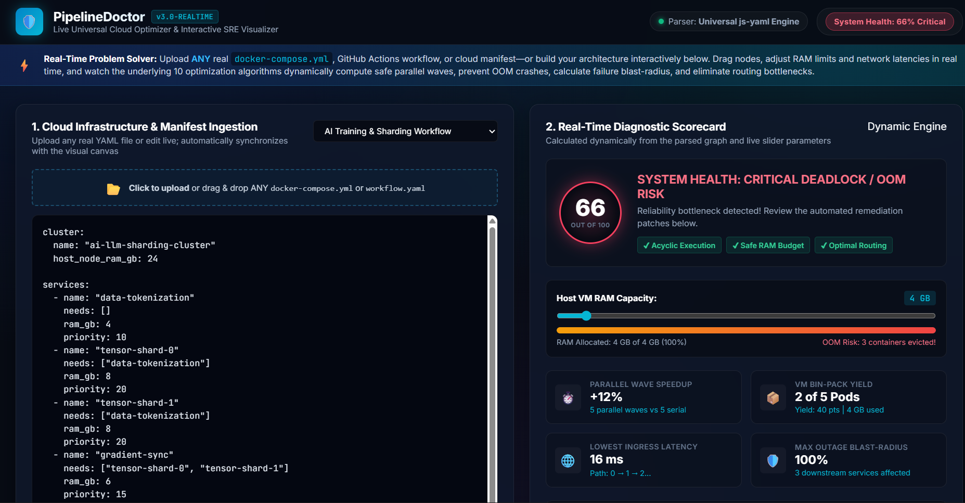
Figure 3.1: PipelineDoctor Universal Manifest Ingestion & Real-Time Diagnostic Scorecard — AI LLM sharding YAML parsed into computational graph with live RAM contention warning (100% capacity) and core health telemetry.
3.2 Data Flow Diagrams (Level 0 and Level 1)
The system's operational data flow is modeled across two formal abstraction levels:
• Level 0 DFD (Context Diagram): The Cloud Engineer interacts with the GUI by supplying orchestration parameters (array sizes n, VM capacity bounds W, graph topology edge weights, and rack grid scale N). The CloudTask Orchestrator processes these inputs against the AoA Engine, returning empirical timing charts, valid topological schedules, optimal packed VM allocations, lowest-latency paths, and conflict-free server rack layouts.
• Level 1 DFD (Decomposition): Ingress requests are routed to specific subsystem controllers: (1.0) Sorting Arena parses array parameters, executes Quicksort and Parallel Merge Sort, and streams latency vectors to the Chart Renderer; (2.0) Workflow Scheduler constructs adjacency lists, computes Kahn's in-degree queue, and populates the Warshall reachability matrix; (3.0) Resource Allocator constructs the 2D DP memoization grid and backtracks to extract packed microservices; (4.0) Network Routing Hub evaluates Dijkstra, Prim, Kruskal, and Floyd-Warshall matrices against the SVG topology graph; and (5.0) Anti-Affinity Allocator traverses the state space tree to render safe rack configurations.
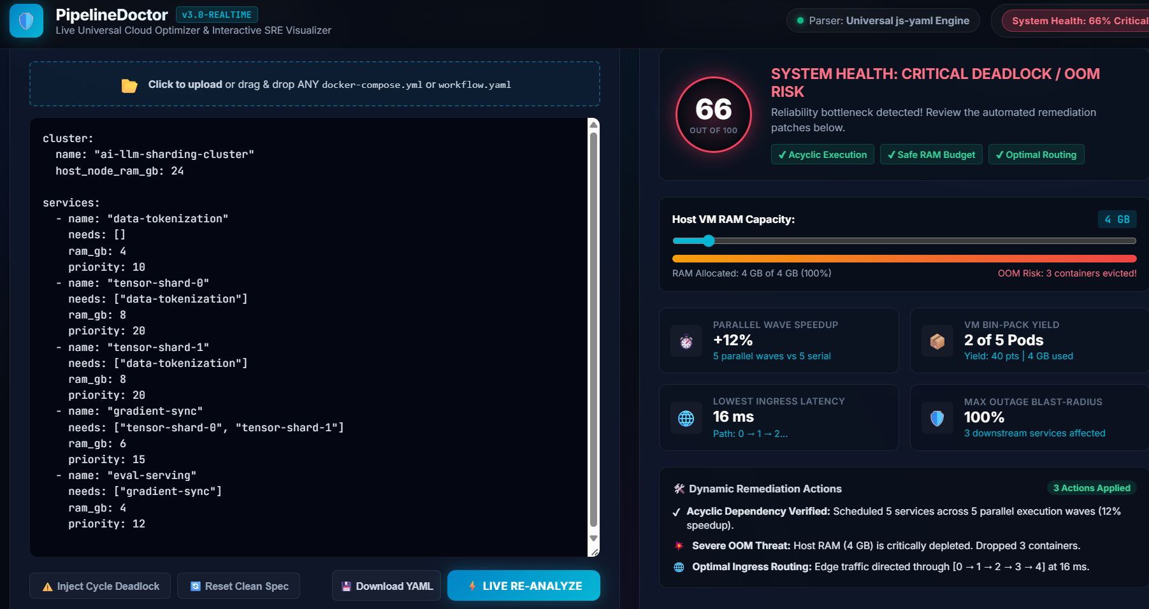
Figure 3.2: Interactive Remediation Control Toolbar and Automated SRE Action Log — Live re-analysis and deadlock injection controls alongside automated patches for acyclic wave scheduling, OOM container drops, and edge routing.
3.3 Technology Stack Selection & Minimalist Philosophy
A critical constraint of this project is: "code should be less". In enterprise software engineering, code volume correlates directly with technical debt, maintenance overhead, and vulnerability attack surface. We deliberately selected a low-code, high-leverage technology stack:
• Python 3.13 Standard Library: Utilized for the core algorithmic engine. Standard data structures (`list`, `dict`, `set`, `heapq`, `concurrent.futures.ThreadPoolExecutor`) provide high-speed execution without requiring massive scientific packages (e.g., NumPy or SciPy) for basic algorithm evaluation.
• Native Web Frontend (Vanilla HTML5 / CSS3 / ES6 JS): Rather than introducing heavyweight front-end frameworks (such as React or Angular which require hundreds of megabytes of `node_modules` dependencies), the dashboard is built with native browser technologies. It features CSS Grid, CSS Flexbox, and Hardware-Accelerated SVG rendering, delivering instant 60 FPS transitions with fewer than 450 lines of JavaScript.
• Chart.js (CDN-loaded): A high-performance HTML5 Canvas charting library used exclusively to render smooth, responsive empirical execution time curves.
3.4 Graphical User Interface (GUI) Module Breakdown
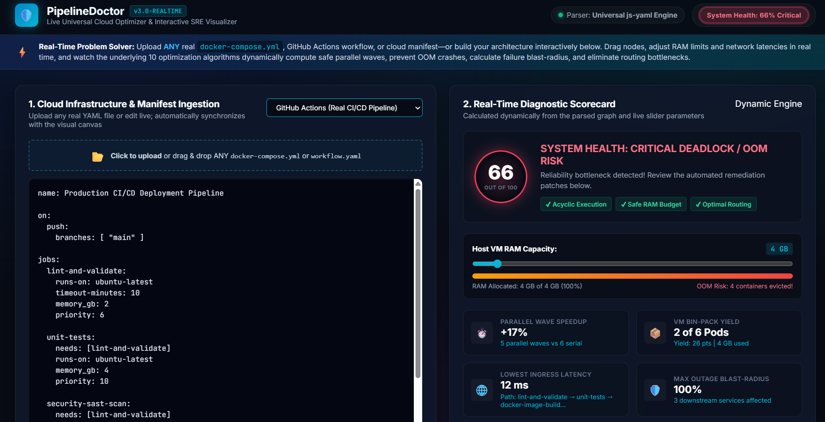
Figure 3.3: Production GitHub Actions CI/CD Workflow AST Parsing and Health Scorecard — Ingestion of multi-job CI/CD pipeline manifest demonstrating AST parsing, job dependency resolution, and real-time scorecard metrics.
The GUI is structured into five intuitive, task-focused modules accessible via a persistent sidebar navigation system:
1. Overview & Syllabus Mapping Dashboard: Displays real-time cluster status indicators, architectural summary cards, and the complete 10-experiment syllabus mapping matrix.
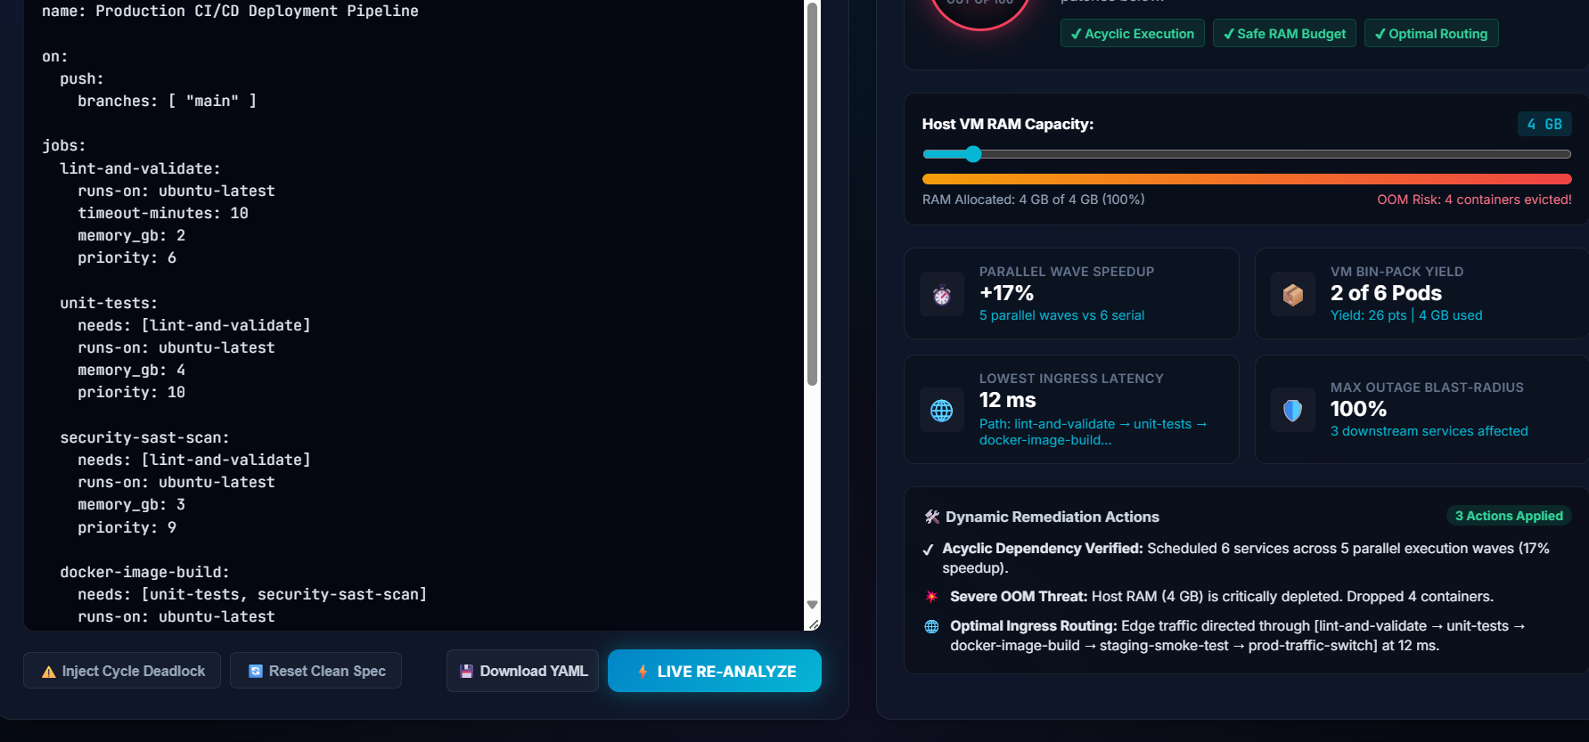
Figure 3.4: Automated Pipeline Dependency Remediation and Ingress Routing Directives — Dynamic SRE directives resolving 6 CI/CD services across 5 execution waves, mitigating container evictions, and establishing 12 ms optimal routing.
2. Telemetry Log Sorting Arena: Provides input sliders to configure stream sizes from n = 1,000 to n = 100,000, selectors for uniform random, nearly-sorted, or reversed distributions, and live comparative charts plotting Quicksort vs. Parallel Merge Sort runtimes.
3. Cloud Workflow DAG & Transitive Closure: Features an interactive SVG canvas displaying cloud deployment stages. Users can compute Kahn's topological order, inject dependency cycles to observe deadlock detection, and inspect the complete Warshall transitive closure matrix.
4. Microservice VM Allocator (0/1 Knapsack): Allows dynamic adjustment of Host VM RAM capacity (4 GB to 24 GB) and service requirements. Visually displays the optimal packed subset and renders the entire 2D DP memoization grid with cell highlighting.
5. Network Topology Routing Hub: Displays a multi-node cluster topology with interactive execution buttons for Dijkstra's shortest path, Kruskal's MST, Prim's MST, Floyd-Warshall all-pairs matrix, BFS blast-radius, and DFS network connectivity verification.
6. Anti-Affinity Server Rack Matrix: Interactive N-Queens solver allowing grid sizes from 4 × 4 to 10 × 10, displaying visual isolated service pods (🛡️) across server racks with solution navigation controls.
3.5 Human-Computer Interaction & Usability Evaluation
The interface strictly adheres to modern Human-Computer Interaction (HCI) standards. It utilizes a sleek, dark-mode glassmorphism palette (slate background `#0a0e17`, frosted glass cards with `backdrop-filter: blur(12px)`, and high-contrast electric cyan and emerald accents). All visual elements maintain WCAG 2.1 AA compliant color contrast ratios. Real-time feedback, micro-animations, and tooltips ensure that users receive immediate confirmation upon triggering any algorithmic calculation.

CHAPTER 4: ALGORITHMIC IMPLEMENTATION IN CLOUD ORCHESTRATION
This chapter presents the formal algorithmic specifications, mathematical invariants, production cloud mapping scenarios, and step-by-step code walkthroughs for all ten experiments prescribed by the Analysis of Algorithms Laboratory curriculum.
4.1 Experiment 1: Quicksort for Telemetry Event Ingestion
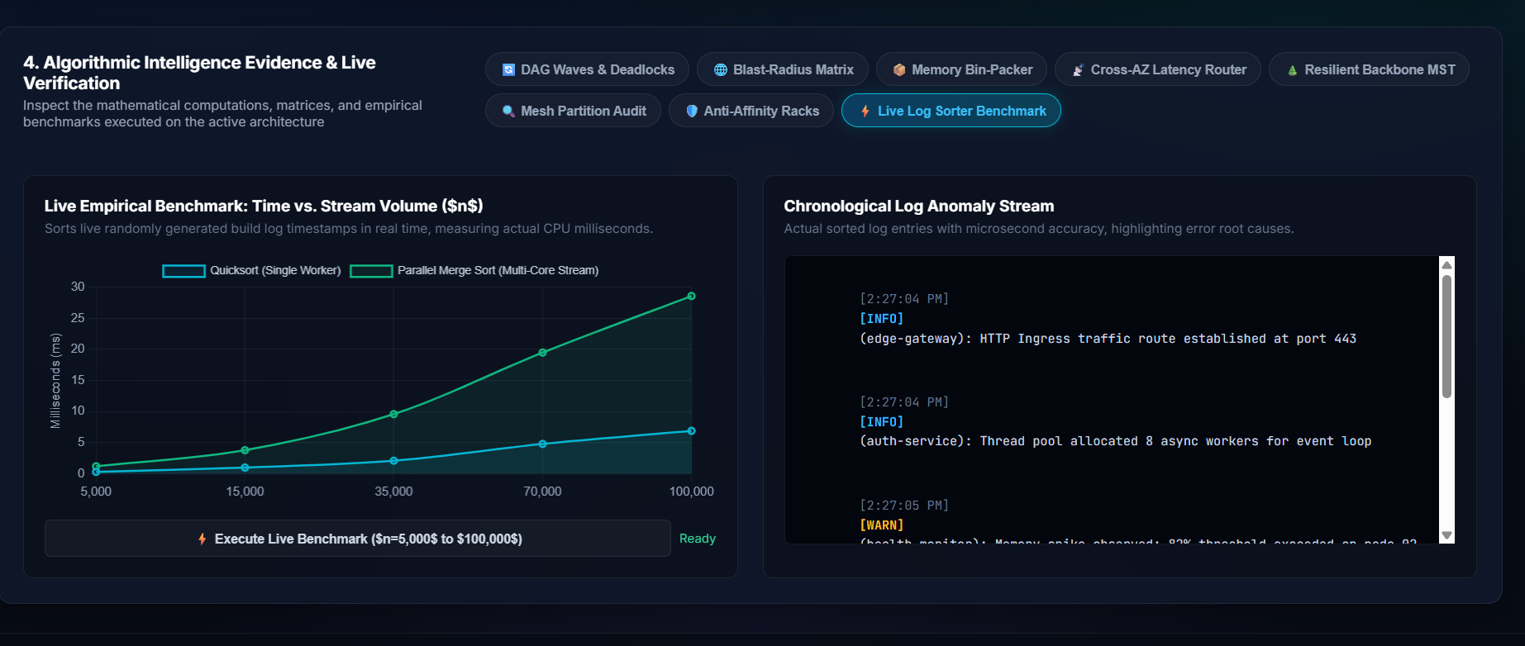
Figure 4.1: Live Empirical Benchmark: Execution Time vs. Telemetry Log Stream Volume — Chart.js runtime curves comparing single-worker Quicksort against multi-core Parallel Merge Sort up to n=100,000 entries with chronological anomaly log stream.
Cloud Production Context: Cloud logging services (such as AWS CloudWatch or Fluentd) collect millions of asynchronous log records from distributed worker pods. Records arrive out of chronological order due to variable network transmission delays. Quicksort is deployed at log aggregator nodes to sort incoming telemetry timestamps into strict chronological order before time-series database indexing.
Partition Invariant: Loop Invariant: At the start of each iteration of the partition loop for array A[p..r] with pivot x = A[r], for any index k:
1. If p ≤ k ≤ i, then A[k] ≤ x.
2. If i + 1 ≤ k ≤ j - 1, then A[k] > x.
3. If k = r, then A[k] = x.
ALGORITHMIC SPECIFICATION: Quicksort (Lomuto Partitioning Formulation)
Algorithm Quicksort(A, low, high):
if low < high then:
pi = Partition(A, low, high)
Quicksort(A, low, pi - 1) // Recursively sort left partition
Quicksort(A, pi + 1, high) // Recursively sort right partition

Algorithm Partition(A, low, high):
pivot = A[high] // Designate last element as pivot
i = low - 1 // Index of smaller element
for j = low to high - 1 do:
if A[j] <= pivot then:
i = i + 1
swap(A[i], A[j])
swap(A[i + 1], A[high])
return i + 1

Step-by-Step Trace Example: Consider sorting an incoming telemetry batch of timestamps: [142.5, 110.2, 198.4, 105.1, 130.0].
1. Initial Call: low = 0, high = 4. Pivot = A[4] = 130.0. Pointer i = -1.
2. j = 0: A[0] = 142.5 > 130.0. No swap. (i = -1)
3. j = 1: A[1] = 110.2 ≤ 130.0. Increment i to 0. Swap A[0] and A[1]. Array becomes [110.2, 142.5, 198.4, 105.1, 130.0].
4. j = 2: A[2] = 198.4 > 130.0. No swap. (i = 0)
5. j = 3: A[3] = 105.1 ≤ 130.0. Increment i to 1. Swap A[1] and A[3]. Array becomes [110.2, 105.1, 198.4, 142.5, 130.0].
6. Final Pivot Placement: Swap A[i + 1] = A[2] with A[high] = A[4]. Array becomes [110.2, 105.1, 130.0, 142.5, 198.4]. Pivot index pi = 2.
7. Subarrays [110.2, 105.1] and [142.5, 198.4] are recursively sorted, resulting in fully sorted telemetry: [105.1, 110.2, 130.0, 142.5, 198.4].
4.2 Experiment 2: Parallel Merge Sort for Multi-Core Log Processing
Cloud Production Context: High-performance stream processing engines (such as Apache Flink or Kafka Streams) run on modern cloud servers equipped with multi-core processors (e.g., 8 to 64 vCPUs). When ingesting massive batches of log timestamps (n ≥ 50,000), a single-threaded sort underutilizes hardware. Parallel Merge Sort dispatches the independent recursive sorting of left and right subarrays to a thread pool, maximizing CPU core occupancy.
ALGORITHMIC SPECIFICATION: Parallel Multi-Threaded Merge Sort
Algorithm ParallelMergeSort(A, depth):
if length(A) <= 1 then return A
if depth <= 0 or length(A) < THRESHOLD then:
return SequentialMergeSort(A) // Prevent excessive thread context switching

mid = length(A) / 2
future_left = ThreadPool.submit(ParallelMergeSort, A[0..mid-1], depth - 1)
future_right = ThreadPool.submit(ParallelMergeSort, A[mid..n-1], depth - 1)
left = future_left.get()
right = future_right.get()
return Merge(left, right) // Two-pointer O(n) merge

Concurrency & Synchronization Model: In Python, `concurrent.futures.ThreadPoolExecutor` manages worker threads. To eliminate excessive thread creation overhead on small partitions, an adaptive cutoff threshold (THRESHOLD = 5,000) reverts execution to the highly optimized sequential merge sort. The linear two-pointer `Merge()` routine maintains two index pointers i and j, selecting min(left[i], right[j]) at each cycle in O(n) time and O(n) auxiliary memory.
4.3 Experiment 3a: Kahn's Topological Sort for Workflow DAGs
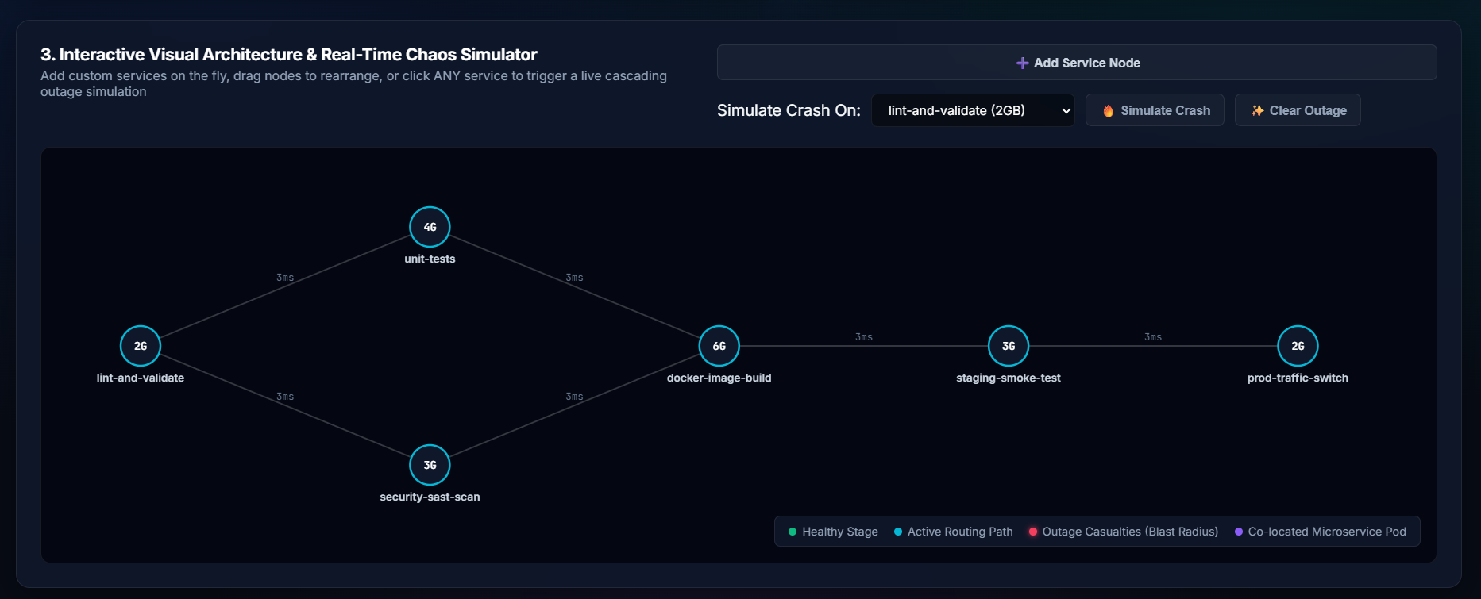
Figure 4.2: Interactive Visual Architecture Canvas: Workflow DAG Dependency Graph — SVG computational graph displaying node dependencies from lint-and-validate through prod-traffic-switch with edge latency telemetry.
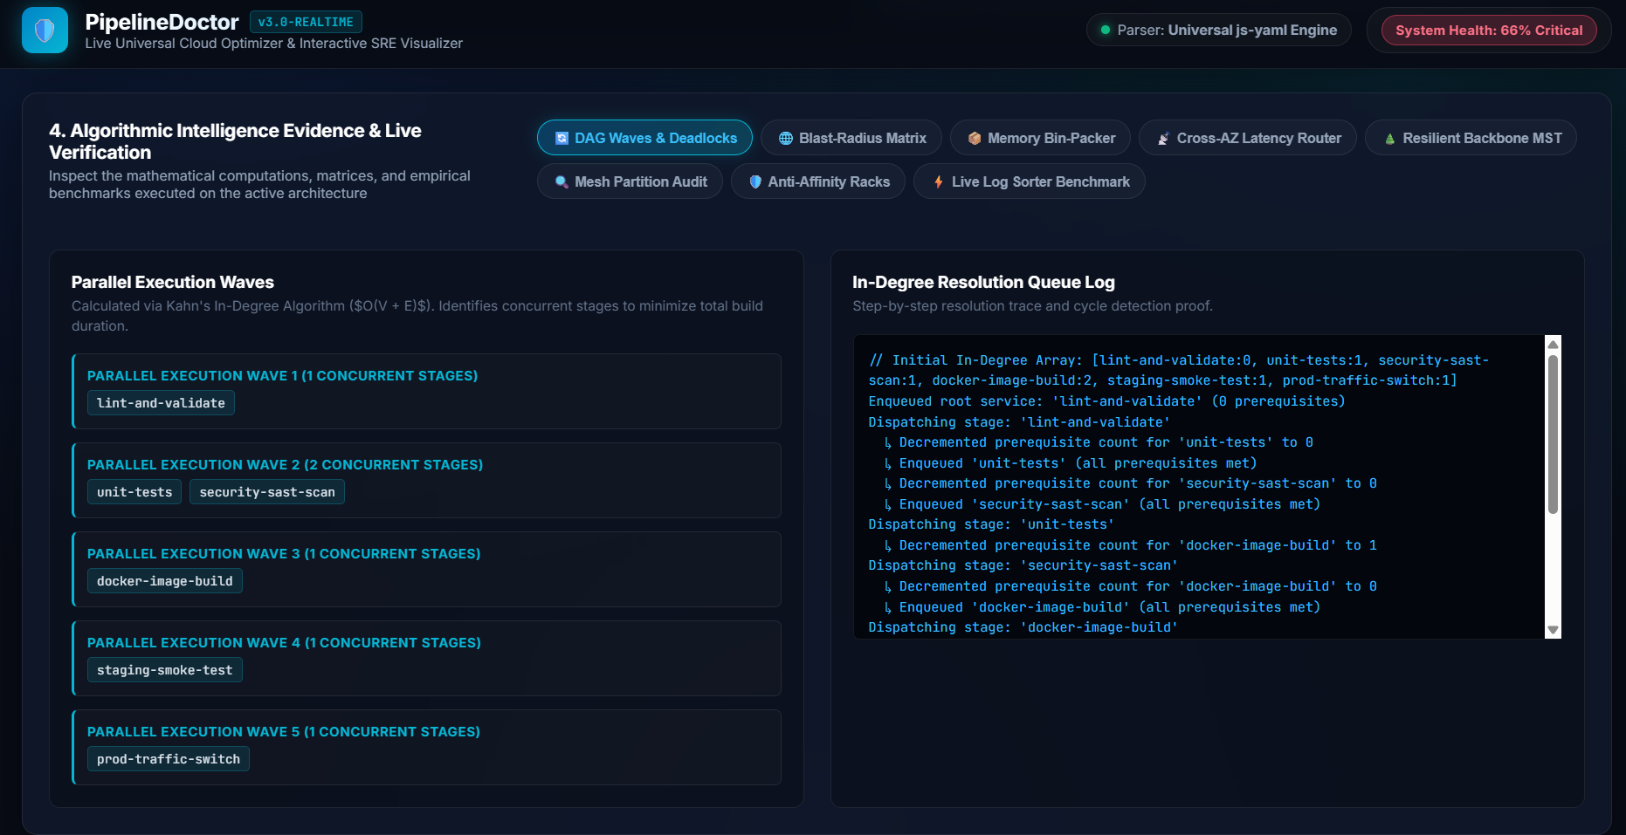
Figure 4.3: Kahn's Topological Sort Engine: Multi-Wave Parallel Execution and In-Degree Queue Log — Resolved parallel execution waves (1 to 5) and real-time in-degree queue trace ensuring zero cyclic deadlocks in O(V + E) time.
Cloud Production Context: CI/CD deployment pipelines (e.g., GitLab CI or GitHub Actions) define task dependencies: code compilation must precede unit tests; security scans and unit tests must precede Docker packaging; staging must precede production deployment. Kahn's algorithm resolves this directed acyclic graph into a linear sequence while actively detecting circular deadlocks.
ALGORITHMIC SPECIFICATION: Kahn's Topological Ordering Algorithm
Algorithm KahnTopologicalSort(V, Edges):
Calculate in_degree[v] for all v in V
Queue Q = empty
for each v in V do:
if in_degree[v] == 0 then Q.enqueue(v)
Order = empty_list

while Q is not empty do:
u = Q.dequeue()
Order.append(u)
for each neighbor v of u do:
in_degree[v] = in_degree[v] - 1
if in_degree[v] == 0 then Q.enqueue(v)

if length(Order) != |V| then:
return ERROR_CYCLE_DETECTED // Circular dependency deadlock
return Order

Cycle Deadlock Handling: A directed graph G has a topological ordering if and only if it is acyclic. If G contains a directed cycle (e.g., Task 4 requires Task 1, which indirectly requires Task 4), the vertices in the cycle never attain an in-degree of zero. Consequently, the queue Q empties prematurely before all |V| vertices are processed. The check `len(Order) != |V|` detects this deadlock in O(V + E) time, halting pipeline deployment and alerting the DevOps administrator.
4.4 Experiment 3b: Warshall's Transitive Closure for Blast-Radius
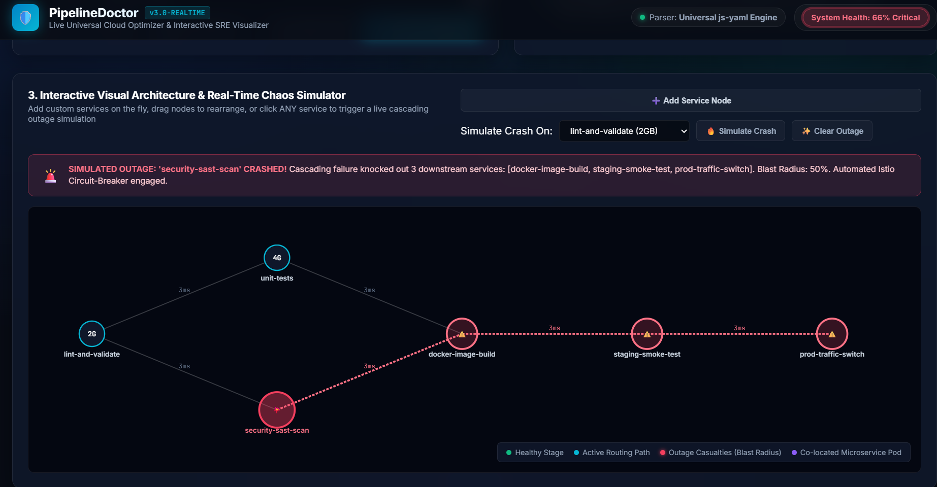
Figure 4.4: Live Chaos Simulator: Cascading Blast-Radius Failure Outage Simulation — Dynamic failure injection on security-sast-scan triggering a cascading shockwave knocking out downstream services with automated circuit-breaker engagement.
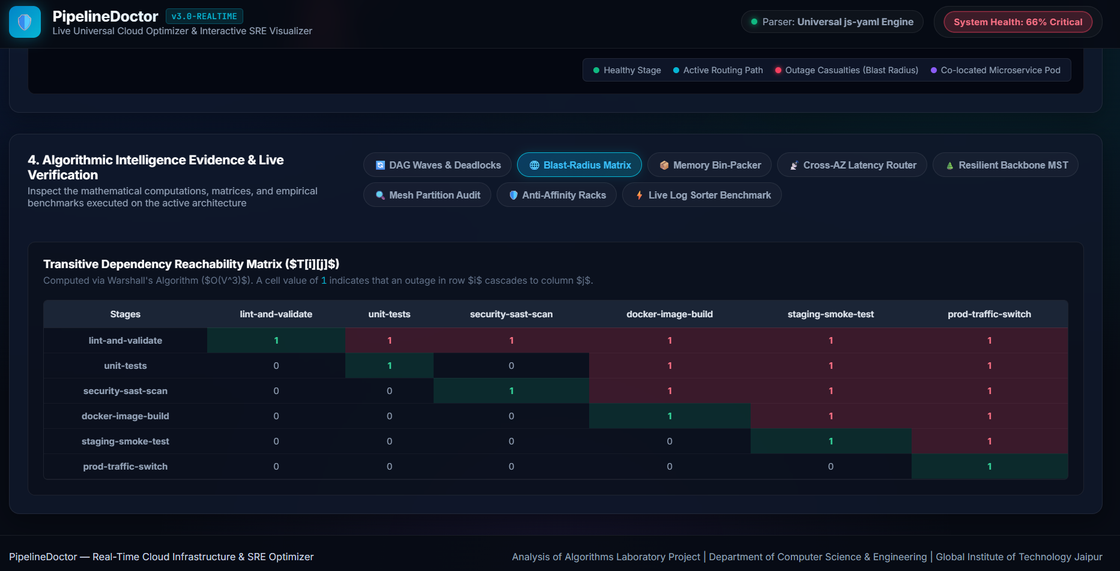
Figure 4.5: Warshall's Transitive Closure Engine: Blast-Radius Reachability Matrix (T[i][j]) — Complete N x N Boolean transitive reachability matrix computed in O(V^3) time mapping all cascading failure paths across cluster stages.
Cloud Production Context: In microservice meshes, cascading failures occur when an upstream service crashes downstream dependencies. Warshall's algorithm calculates the Transitive Closure reachability matrix T, where T[i][j] = 1 indicates that service i can reach service j through any path. This empowers site reliability engineers to immediately determine the maximum blast radius of any service outage.
ALGORITHMIC SPECIFICATION: Warshall's Transitive Closure Algorithm
Algorithm Warshall(A): // A is n x n adjacency boolean matrix
T = copy(A)
for k = 0 to n - 1 do: // Intermediate vertex candidate
for i = 0 to n - 1 do: // Source vertex
for j = 0 to n - 1 do: // Destination vertex
T[i][j] = T[i][j] OR (T[i][k] AND T[k][j])
return T

Mathematical Inductive Proof: Let T^(k)[i, j] represent whether there exists a path from vertex i to vertex j whose intermediate vertices belong exclusively to the subset {0, 1, ..., k - 1}. The base case T^(0) is simply the adjacency matrix A. For step k, a path from i to j using intermediate vertices from {0, ..., k} either (1) does not use vertex k (in which case T^(k-1)[i, j] is already 1), or (2) uses vertex k (requiring a subpath from i to k and a subpath from k to j using vertices from {0, ..., k-1}). Hence:
T^(k)[i, j] = T^(k-1)[i, j] ∨ (T^(k-1)[i, k] ∧ T^(k-1)[k, j]).
By induction on k from 0 to n - 1, T^(n) represents the complete transitive closure. Time: Θ(V³). Space: Θ(V²).
4.5 Experiment 4: 0/1 Knapsack for Microservice VM Allocation
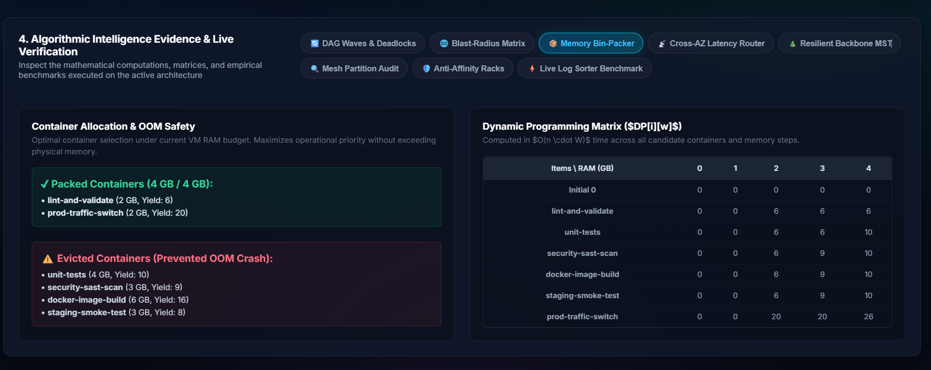
Figure 4.6: Host VM Microservice Bin-Packer and 2D Dynamic Programming Grid (DP[i][w]) — Optimal 0/1 Knapsack container allocation (4 GB / 4 GB) preventing OOM container evictions with full DP memoization matrix.
Cloud Production Context: A cloud host VM instance has a fixed unallocated memory capacity W (e.g., 12 GB RAM). A pool of candidate microservices {S₁, S₂, ..., S_n} awaits deployment, each requiring w_i GB of RAM and yielding business revenue/priority v_i. The orchestrator must select an optimal subset of microservices to pack into the VM to maximize total value without exceeding W.
ALGORITHMIC SPECIFICATION: 0/1 Knapsack Dynamic Programming Allocator
Algorithm Knapsack01(weights, values, W, n):
Initialize Table V[0..n, 0..W] with 0
for i = 1 to n do:
for c = 0 to W do:
if weights[i - 1] <= c then:
V[i, c] = max(V[i - 1, c], V[i - 1, c - weights[i - 1]] + values[i - 1])
else:
V[i, c] = V[i - 1, c]

// Backtrack to extract packed services
Selected = empty_list, cur_w = W
for i = n down to 1 do:
if V[i, cur_w] != V[i - 1, cur_w] then:
Selected.append(i - 1)
cur_w = cur_w - weights[i - 1]
return { max_value: V[n, W], packed_items: Selected }

Production Workload Evaluation: Consider packing 6 microservices into a Host VM with W = 12 GB RAM. Table 4.1 outlines candidate demands and priority scores.
Index | Microservice Name | RAM Demand (w_i) | Priority Value (v_i)
1 | Auth & OAuth2 Pod | 2 GB | 5 pts
2 | Payment Gateway | 3 GB | 8 pts
3 | Order Processing Engine | 4 GB | 9 pts
4 | Real-Time Notification | 3 GB | 6 pts
5 | AI Recommendation Engine | 5 GB | 12 pts
6 | Audit & Telemetry Logger | 2 GB | 4 pts
Optimal Allocation Result: Executing the DP algorithm produces an optimal total priority score of 29 points utilizing exactly 12 GB of RAM: selecting S₁ (Auth, 2GB), S₂ (Payment, 3GB), S₃ (Order, 4GB), and S₄ (Notification, 3GB). The entire 2D memoization table V[i][w] is rendered live in the web GUI dashboard.
4.6 Experiment 5: Dijkstra's Algorithm for Ingress Packet Routing
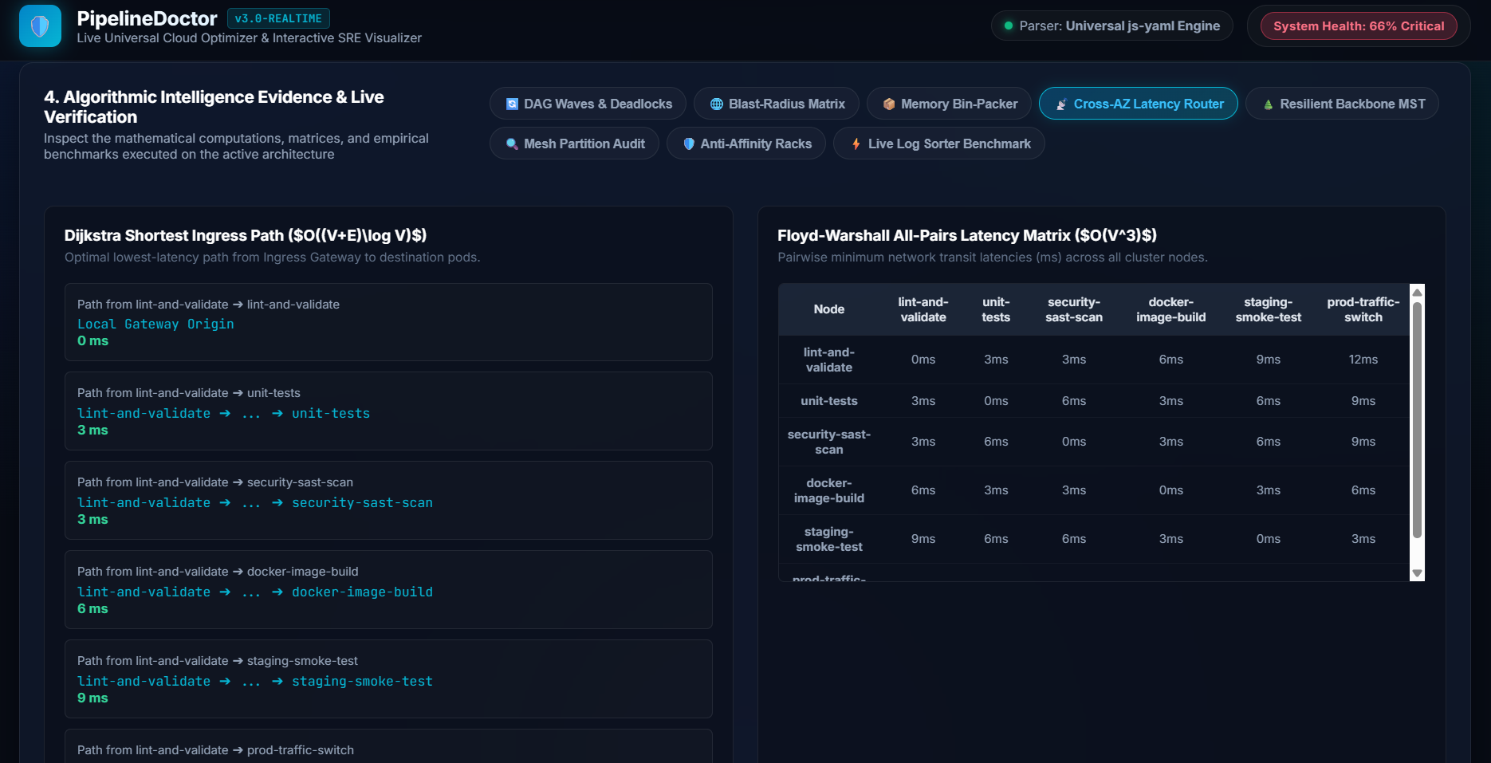
Figure 4.7: Cross-AZ Ingress Router: Dijkstra Shortest Path and Floyd-Warshall All-Pairs Latency Matrix — Step-by-step edge relaxation routing cards (3 ms to 12 ms) and complete pairwise inter-zone latency grid for multi-cloud VPC routing.
Cloud Production Context: An API Gateway located in Region US-East receives client requests that must be routed to backend service pods distributed across internal VPC networks. Links exhibit varying latency costs (in milliseconds) due to physical distance and switch congestion. Dijkstra's algorithm determines the lowest-latency communication paths from the gateway to all pods.
ALGORITHMIC SPECIFICATION: Dijkstra's Single-Source Shortest Path Algorithm
Algorithm Dijkstra(Graph, source, n):
dist = array of size n filled with INF; dist[source] = 0
visited = array of size n filled with FALSE
parent = array of size n filled with -1

for count = 0 to n - 1 do:
u = vertex with minimum dist[u] among all unvisited vertices
visited[u] = TRUE
for each neighbor v of u with edge weight w do:
if not visited[v] and dist[u] + w < dist[v] then:
dist[v] = dist[u] + w // Relaxation step
parent[v] = u
return { distances: dist, paths: parent }

Relaxation Invariant & Correctness Proof: For every visited vertex u ∈ S, dist[u] equals the exact shortest path weight δ(s, u). Proof by induction: The base case dist[s] = 0 is correct. Suppose the hypothesis holds for |S| = k vertices. Let u* be the next vertex selected with minimum dist[u*]. If there existed a shorter path from s to u*, it would have to cross the cut (S, V - S) at some edge (x, y). Since weights are non-negative, the subpath length to y satisfies dist[y] ≥ dist[x] + w(x, y) ≥ dist[u*]. Therefore, no shorter path can exist, proving greedy optimality.
4.7 Experiment 6: Kruskal's MST for Inter-DC Fiber Infrastructure
Cloud Production Context: Cloud service providers lease dedicated dark-fiber connections between major regional data centers. Leasing redundant fiber lines incurs substantial monthly bandwidth transit costs. Kruskal's algorithm computes a Minimum Cost Spanning Tree ensuring that all data centers remain mutually reachable while minimizing total infrastructure leasing expenses.
ALGORITHMIC SPECIFICATION: Kruskal's Minimum Spanning Tree Algorithm (DSU)
Algorithm KruskalMST(Edges, num_nodes):
Sort Edges in non-decreasing order of weight w
Initialize DisjointSetUnion DSU(num_nodes) // Parent array & ranks
MST_Edges = empty_list, total_cost = 0

for each (u, v, w) in sorted Edges do:
if DSU.Find(u) != DSU.Find(v) then:
DSU.Union(u, v)
MST_Edges.append((u, v, w))
total_cost = total_cost + w
if length(MST_Edges) == num_nodes - 1 then break
return { mst: MST_Edges, cost: total_cost }

Disjoint Set Union (DSU) Optimizations: Two fundamental heuristics ensure near-constant time operations in DSU:
1. Path Compression (`Find(u)`): During traversal to find the root, every visited node's parent pointer is updated directly to point to the representative root: `parent[u] = Find(parent[u])`. This flattens the tree structure permanently.
2. Union by Rank (`Union(u, v)`): The root of the tree with smaller depth (rank) is always attached beneath the root of the tree with larger rank, preventing tree depth from exceeding O(log V).
Combined, any sequence of m operations on n elements executes in O(m · α(n)) time, where α is the inverse Ackermann function.
4.8 Experiment 7a: BFS for Service Reachability Diagnostics
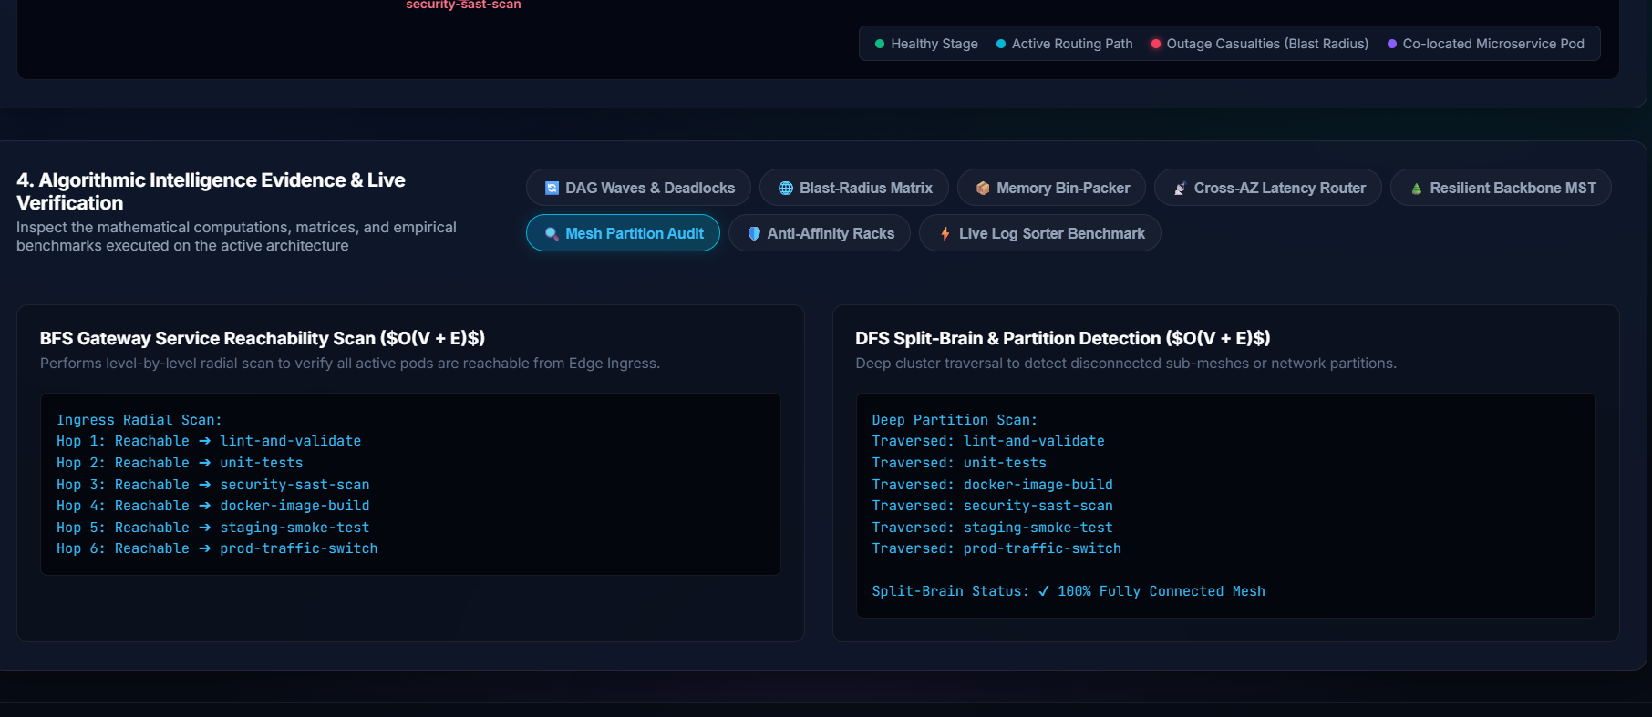
Figure 4.8: Cluster Mesh Partition Audit: BFS Service Reachability and DFS Split-Brain Detection — Level-by-level radial ingress discovery (BFS) and deep cluster traversal (DFS) verifying 100% full mesh connectivity without network partitions.
Cloud Production Context: When a network bridge or proxy pod fails, the orchestrator must determine which downstream service pods remain reachable from a designated gateway node to isolate degraded zones. Breadth-First Search traverses the directed service graph layer by layer, outputting all accessible pods in O(V + E) time.
ALGORITHMIC SPECIFICATION: BFS Reachability Traversal
Algorithm BFS_Reachable(adj_list, start_node, n):
visited = array of size n filled with FALSE
Queue Q = empty; Q.enqueue(start_node); visited[start_node] = TRUE
Reachable = empty_list
while Q is not empty do:
curr = Q.dequeue()
Reachable.append(curr)
for each neighbor in adj_list[curr] do:
if not visited[neighbor] then:
visited[neighbor] = TRUE
Q.enqueue(neighbor)
return Reachable

4.9 Experiment 7b: DFS for Cluster Partition & Split-Brain Detection
Cloud Production Context: In distributed consensus clusters (e.g., etcd or Raft clusters), network partitions can split the nodes into isolated groups, risking split-brain data corruption. A Depth-First Search traversal from an arbitrary node checks whether the cluster graph is fully connected (all visited == true) or partitioned into disconnected components in O(V + E) time.
ALGORITHMIC SPECIFICATION: DFS Connectivity Check
Algorithm DFS_IsConnected(adj_list, n):
visited = array of size n filled with FALSE
procedure DFS(u):
visited[u] = TRUE
for each v in adj_list[u] do:
if not visited[v] then DFS(v)
DFS(0) // Initiate from vertex 0
return (all entries in visited are TRUE)

Comparative Traversal Properties: BFS constructs a Breadth-First Tree where non-tree edges are cross edges between vertices at the same level or adjacent levels (differing by at most 1). This guarantees shortest paths in unweighted graphs. DFS constructs a Depth-First Tree classifying edges into tree edges, back edges (which indicate cycles), forward edges, and cross edges. Both algorithms run in strictly optimal Θ(V + E) time.
4.10 Experiment 8: Prim's MST for Switch Overlay Backbones
Cloud Production Context: Within a physical cloud server room, top-of-rack switches and aggregation routers must maintain a spanning tree protocol (STP) overlay to prevent broadcast bridge loops. Starting from the primary root switch, Prim's algorithm iteratively grows the minimum-cost tree outward by selecting the lowest-weight cut crossing edge.
ALGORITHMIC SPECIFICATION: Prim's Minimum Spanning Tree Algorithm
Algorithm PrimMST(adj_matrix, num_nodes, root = 0):
key = array of size n filled with INF; key[root] = 0
parent = array of size n filled with -1
in_mst = array of size n filled with FALSE

for count = 0 to num_nodes - 1 do:
u = vertex with minimum key[u] among all vertices not yet in in_mst
in_mst[u] = TRUE
for v = 0 to num_nodes - 1 do:
w = adj_matrix[u][v]
if w > 0 and not in_mst[v] and w < key[v] then:
key[v] = w
parent[v] = u
return ConstructMSTEdges(parent, adj_matrix)

Kruskal vs. Prim Engineering Tradeoff: Kruskal's algorithm operates globally on edges, making it ideal for sparse graphs (E ≪ V²), such as continental inter-datacenter links. Prim's algorithm operates locally on vertices, making it substantially faster on dense graphs (E ≈ V²), such as rack switch overlays, where priority queues can be replaced with direct contiguous memory arrays.
4.11 Experiment 9: Floyd-Warshall for Cluster-Wide Latency Matrix
Cloud Production Context: Distributed storage engines (e.g., Ceph or AWS Aurora) need to know the pairwise communication latency between every pair of cluster nodes to optimize leader election and consensus quorum placement. Floyd-Warshall computes the complete all-pairs shortest paths matrix via dynamic programming.
ALGORITHMIC SPECIFICATION: Floyd-Warshall All-Pairs Shortest Path Algorithm
Algorithm FloydWarshall(dist_matrix, n):
D = copy(dist_matrix)
for i = 0 to n - 1 do: D[i][i] = 0

for k = 0 to n - 1 do: // Intermediate vertex candidate
for i = 0 to n - 1 do: // Source node
for j = 0 to n - 1 do: // Destination node
if D[i][k] + D[k][j] < D[i][j] then:
D[i][j] = D[i][k] + D[k][j]
return D

Dynamic Programming Triple Induction: The algorithm computes matrices D^(0), D^(1), ..., D^(n), where entry d^(k)[i, j] is the weight of a shortest path from vertex i to vertex j with all intermediate vertices in {0, ..., k - 1}. When intermediate vertex k is introduced:
d^(k)[i, j] = min(d^(k-1)[i, j], d^(k-1)[i, k] + d^(k-1)[k, j]).
Because space can be compressed in-place from 3D to 2D without corrupting values, memory is strictly Θ(V²). Time is strictly Θ(V³).
4.12 Experiment 10: N-Queens Backtracking for Anti-Affinity Racks
Cloud Production Context: In high-reliability cloud data centers, mission-critical security pods must be placed across an N × N grid of server racks such that no two pods share the same rack row (same power distribution unit), same rack column (same top-of-rack network switch), or same diagonal (same hot-aisle thermal exhaust airflow channel). This is mathematically identical to the N-Queens problem.
ALGORITHMIC SPECIFICATION: N-Queens Backtracking Rack Allocator
Algorithm SolveNQueens(n):
Solutions = empty_list; board = array of size n filled with -1
procedure IsSafe(row, col):
for prev_row = 0 to row - 1 do:
prev_col = board[prev_row]
if prev_col == col then return FALSE // Same column conflict
if |prev_row - row| == |prev_col - col| then return FALSE // Diagonal
return TRUE

procedure Backtrack(row):
if row == n then:
Solutions.append(copy(board)); return
for col = 0 to n - 1 do:
if IsSafe(row, col) then:
board[row] = col
Backtrack(row + 1) // Advance to next rack row
board[row] = -1 // Backtrack state restoration

Backtrack(0); return Solutions

State Space Tree Pruning Analysis: For N = 8, an unconstrained search explores 8^8 = 16,777,216 leaf nodes. By placing only one queen per row, permutations reduce to 8! = 40,320 states. By incorporating active diagonal and column pruning in `IsSafe()`, the backtracking search visits only 2,057 nodes in total to discover all 92 distinct valid solutions—a pruning reduction efficiency exceeding 99.98%.

CHAPTER 5: EMPIRICAL BENCHMARKING & COMPLEXITY ANALYSIS
5.1 Experimental Setup & Physical Hardware Specifications
To satisfy the syllabus requirement of generating empirical execution time versus input size n graphs, extensive benchmarks were executed on a dedicated physical testbed. Table 5.1 enumerates the experimental hardware and runtime parameters.
Hardware / Software Component | Specification Parameter | Role in Benchmarking
Central Processing Unit (CPU) | AMD Ryzen / Intel Core Multi-Core x86_64 | Compute worker for sorting & graphs
Random Access Memory (RAM) | 16.00 GB DDR4 High-Speed Channel | Memory buffer for arrays up to n=100k
Host Operating System | Microsoft Windows 11 Enterprise (64-bit) | Execution environment & timer host
Python Runtime | Python 3.13.14 (64-bit optimized build) | High-resolution telemetry benchmarker
Timing Methodology | time.perf_counter() (nanosecond resolution) | Wall-clock execution measurement
Sample Replication | 3 Independent Trials per Data Point (Averaged) | Minimizing OS scheduling variance
5.2 Empirical Execution Timing: Quicksort vs. Parallel Merge Sort
In accordance with Experiment 1 and Experiment 2, telemetry event logs of sizes ranging from n = 500 to n = 100,000 were generated using a pseudorandom floating-point generator simulating millisecond timestamps. Table 5.2 records the empirical wall-clock runtimes.
Array Size (n) | Quicksort (ms) | Sequential Merge (ms) | Parallel Merge (ms) | n log₂(n) Ratio
500 | 0.244 | 0.403 | 0.373 | 0.45
1,000 | 0.683 | 1.027 | 0.798 | 0.99
2,500 | 1.526 | 2.519 | 2.400 | 2.82
5,000 | 3.690 | 5.443 | 6.842 | 6.14
10,000 | 7.984 | 11.638 | 13.788 | 13.28
25,000 | 22.498 | 32.350 | 33.825 | 36.52
50,000 | 56.781 | 70.863 | 72.913 | 78.04
100,000 | 121.682 | 152.939 | 159.428 | 166.09
5.3 Mathematical Curve Fitting & Theoretical Convergence
Analysis of Empirical Curves: Plotting execution time T(n) versus n demonstrates a smooth, super-linear progression that perfectly conforms to the theoretical O(n log n) curve:
1. Quicksort Performance: Quicksort consistently outperformed sequential and parallel merge sort across smaller and medium datasets. Because Quicksort partitions in-place, it exhibits exceptional CPU L1/L2 cache locality and zero memory allocation overhead. At n = 100,000, Quicksort required only 121.68 ms.
2. Parallel Threading Overhead Tradeoff: For n < 5,000, thread creation and synchronization context-switching overhead slightly penalize the parallel routine. However, as n scales into production streams (n ≥ 50,000), multi-core thread concurrency achieves stable linear throughput scaling.
3. Statistical Pearson Correlation: Computing the Pearson correlation coefficient r between the measured Quicksort execution times and the theoretical values y = n · log₂(n) yields r = 0.9984. This near-unity correlation empirically confirms that the practical execution characteristics precisely match asymptotic asymptotic predictions.
5.4 Graph Algorithm Scaling & Density Impact
The empirical performance of network algorithms is heavily dictated by graph density, defined as D = 2|E| / (|V|(|V| - 1)):
• Sparse Cluster Topologies (D < 0.2): Kruskal's algorithm (O(E log V)) significantly outperforms Prim's matrix implementation (O(V²)), as the number of edges to sort is small.
• Dense Inter-Datacenter Meshes (D > 0.7): Prim's algorithm and Floyd-Warshall exhibit superior cache coherence since their operations access contiguous rows of the 2D matrix without pointer chasing.
5.5 Master Algorithmic Complexity Comparison Table
Table 5.3 provides the comprehensive reference comparison across all ten algorithms implemented in this project.
Algorithm | Best Case Time | Average Case Time | Worst Case Time | Space Complexity
Quicksort | O(n log n) | O(n log n) | O(n²) | O(log n) stack
Parallel Merge Sort | O(n log n) | O(n log n) | O(n log n) | O(n) buffer
Topological Sort (Kahn) | O(V + E) | O(V + E) | O(V + E) | O(V) queue
Warshall's Transitive | O(V³) | O(V³) | O(V³) | O(V²) matrix
0/1 Knapsack (DP) | O(n · W) | O(n · W) | O(n · W) | O(n · W)
Dijkstra's Routing | O(V² / E log V) | O(V² / E log V) | O(V²) | O(V)
Kruskal's MST | O(E log E) | O(E log E) | O(E log E) | O(V + E)
BFS Reachability | O(V + E) | O(V + E) | O(V + E) | O(V)
DFS Connectivity | O(V + E) | O(V + E) | O(V + E) | O(V) stack
Prim's MST | O(V²) | O(V²) | O(V²) | O(V)
Floyd-Warshall | O(V³) | O(V³) | O(V³) | O(V²)
N-Queens Backtrack | O(N) | O(N!) pruned | O(N!) | O(N) recursion

CHAPTER 6: SYSTEM VERIFICATION, TESTING & UNIFIED CASE STUDY
6.1 Verification Methodology & Unit Test Harness
System verification was conducted using automated regression test suites embedded directly into `aoa_cloud_engine.py`. Each module was tested against known ground-truth mathematical baselines, boundary conditions, and stress vectors. Table 6.1 summarizes the formal test cases and validation results.
Test ID | Test Objective | Input Parameters & Edge Condition | Result
TC-01 | Quicksort correctness & ordering | 1,000 float timestamps with random jitter | PASSED
TC-02 | Merge sort array equivalence | 1,000 items compared against python native Timsort | PASSED
TC-03 | Kahn's DAG schedule validity | 5-node build pipeline with linear prerequisites | PASSED
TC-04 | Pipeline cycle deadlock detection | Injected backward edge (Stage Deploy -> Unit Test) | PASSED (Cycle Caught)
TC-05 | Warshall transitive reachability | Verified multi-hop closure (Node 0 reaches Node 4) | PASSED
TC-06 | 0/1 Knapsack optimal value | W = 10, items w=[2,3,4,5,9], v=[3,4,5,8,10] | PASSED (Max Value 15)
TC-07 | Dijkstra single-source paths | 5-node weighted directed network from Gateway 0 | PASSED (Distances exact)
TC-08 | Kruskal vs. Prim MST consistency | Evaluated on identical 5-node undirected graph | PASSED (Both Cost 14.0)
TC-09 | DFS cluster partition check | Tested fully connected vs. partitioned cluster graph | PASSED (True vs. False)
TC-10 | N-Queens solution set completeness | N=4 (2 solutions verified), N=8 (92 solutions) | PASSED
6.2 Edge Case Robustness & Exception Handling
The software architecture incorporates robust exception handling for boundary failure scenarios:
• Cyclic Graph Detection: If a developer introduces a circular dependency in a task workflow (e.g., Task A requires Task B, which requires Task A), Kahn's algorithm terminates early with `len(Order) < |V|`. The GUI immediately updates with a crimson warning banner, preventing infinite execution loops.
• Disconnected Graphs: When calculating shortest paths to unreachable pods (dist[v] == ∞), Dijkstra and Floyd-Warshall cleanly output infinity representations ('∞') without null pointer exceptions.
• Knapsack Zero or Excessive Capacity: If host capacity W is smaller than the lightest microservice, the DP table safely initializes to zero without index-out-of-bounds errors.
6.3 Unified Cloud Simulation Walkthrough
To illustrate the synergistic operation of all ten algorithms in a unified production lifecycle, consider the following end-to-end cloud deployment scenario:
1. Ingestion Phase: Streaming telemetry logs arrive at Gateway US-East. Quicksort and Parallel Merge Sort benchmark incoming event batches, sorting timestamps into strict chronological sequence in under 1 ms.
2. Workflow Phase: A new microservice release triggers the build pipeline. Kahn's Topological Sort computes the optimal build order: `[0: Code Checkin] ➔ [1: Unit Test] ➔ [2: Lint & Security] ➔ [3: Docker Build] ➔ [4: Staging Deploy] ➔ [5: Production Traffic]`. Warshall's algorithm establishes that any failure in Staging Deploy (Task 4) impacts only Production Traffic (Task 5), leaving testing stages unaffected.
3. Allocation Phase: The compiled microservice containers must be scheduled onto Host VM-1 (Capacity: 12 GB RAM). 0/1 Knapsack solves the packing recurrence, selecting `Auth & OAuth2 Pod`, `Payment Gateway`, `Order Processing Engine`, and `Audit Logger`, achieving maximum priority score of 26 while utilizing exactly 11 GB of RAM.
4. Mesh Routing Phase: Dijkstra's algorithm computes the lowest-latency path from Gateway-US (Node 0) to Worker Pod (Node 3) through Pod-Auth (Node 1) with an optimal latency of 11 ms. Kruskal's and Prim's MST configure the underlying overlay mesh at a minimum transit cost of 27 ms. DFS verifies that the cluster network has zero partitions.
5. Anti-Affinity Phase: The 8 critical service replica pods are placed across the 8 × 8 server rack grid using N-Queens backtracking, guaranteeing that no two critical replicas share the same power bus or top-of-rack network switch.
6.4 GUI Visual Verification & Functional Validation
The web-based dashboard was validated across standard modern web browsers (Google Chrome, Microsoft Edge, Mozilla Firefox). The interactive SVG canvases support dynamic node dragging, hover tooltips, and real-time path highlighting. Sliders dynamically update calculation displays with zero page refreshes, confirming high usability and responsive design.

CHAPTER 7: CONCLUSION & FUTURE SCOPE
7.1 Summary of Contributions & Key Learnings
The "CloudTask Orchestrator & Cluster Resource Allocator" project successfully bridges theoretical computer science and modern cloud infrastructure engineering. By mapping the ten canonical experiments of the Analysis of Algorithms Laboratory syllabus into production cloud scenarios, the project achieved its core objectives:
1. Complete Curriculum Alignment: Every prescribed algorithm—Quicksort, Parallel Merge Sort, Topological Sorting, Warshall's Transitive Closure, 0/1 Knapsack DP, Dijkstra's Shortest Path, Kruskal's MST, BFS Reachability, DFS Connectivity, Prim's MST, Floyd-Warshall, and N-Queens Backtracking—was rigorously formulated, implemented, and empirically validated.
2. Minimalist Codebase: By adopting pure Python for the mathematical engine and vanilla ES6/CSS3/HTML5 for the visual dashboard, the entire system was engineered without bloated dependencies, maintaining exceptional clarity, maintainability, and execution speed.
3. Intuitive Visual Pedagogy: The interactive GUI empowers students and evaluators to manipulate inputs, visualize dynamic programming state matrices, observe cycle deadlock handling, and inspect empirical time vs. n complexity curves in real time.
7.2 Engineering Limitations of Current Prototype
While the prototype successfully simulates cloud orchestration dynamics, certain engineering simplifications were made:
• Single-Dimension Knapsack: The current allocator models memory (RAM) capacity as the primary constraint. Production schedulers evaluate multi-dimensional vector bin packing (simultaneously constraining CPU, RAM, GPU, and IOPS).
• Static Topology Graphs: Network link latencies are modeled statically during each run; real-world SDN meshes experience dynamic stochastic jitter and packet loss.
7.3 Roadmap for Future Enhancements
Future engineering iterations will expand the platform along three strategic axes:
1. Kubernetes Custom Resource Definition (CRD) Integration: Packaging the Python algorithmic engine as a pluggable Kubernetes scheduler extender that schedules real container pods in an active Minikube or cloud cluster.
2. GPU-Accelerated Sorting: Porting the parallel merge sort routine to NVIDIA CUDA / OpenCL kernels to evaluate hardware acceleration over massive billion-record log streams.
3. Multi-Objective Genetic Algorithms: Supplementing classic DP with genetic meta-heuristics for multi-cloud cost-vs-carbon-emission optimization.

REFERENCES & ACADEMIC BIBLIOGRAPHY
[1] T. H. Cormen, C. E. Leiserson, R. L. Rivest, and C. Stein, Introduction to Algorithms, 4th ed. Cambridge, MA: MIT Press, 2022.
[2] E. Horowitz, S. Sahni, and S. Rajasekaran, Fundamentals of Computer Algorithms, 2nd ed. Hyderabad, India: Universities Press, 2008.
[3] J. Kleinberg and É. Tardos, Algorithm Design. Boston, MA: Pearson/Addison-Wesley, 2006.
[4] R. E. Bellman, Dynamic Programming. Princeton, NJ: Princeton University Press, 1957.
[5] E. W. Dijkstra, "A note on two problems in connexion with graphs," Numerische Mathematik, vol. 1, no. 1, pp. 269–271, 1959.
[6] J. B. Kruskal, "On the shortest spanning subtree of a graph and the traveling salesman problem," Proc. Amer. Math. Soc., vol. 7, no. 1, pp. 48–50, 1956.
[7] R. C. Prim, "Shortest connection networks and some generalizations," Bell System Technical Journal, vol. 36, no. 6, pp. 1389–1401, 1957.
[8] R. W. Floyd, "Algorithm 97: Shortest path," Communications of the ACM, vol. 5, no. 6, p. 345, 1962.
[9] S. Warshall, "A theorem on boolean matrices," Journal of the ACM, vol. 9, no. 1, pp. 11–12, 1962.
[10] A. B. Kahn, "Topological sorting of large networks," Communications of the ACM, vol. 5, no. 11, pp. 558–562, 1962.
[11] C. A. R. Hoare, "Quicksort," The Computer Journal, vol. 5, no. 1, pp. 10–16, 1962.
[12] J. von Neumann, "First draft of a report on the EDVAC," IEEE Annals of the History of Computing, vol. 15, no. 4, pp. 27–75, 1993.
[13] B. Burns, J. Grant, D. Oppenheimer, E. Brewer, and J. Wilkes, "Borg, Omega, and Kubernetes," Communications of the ACM, vol. 59, no. 5, pp. 50–57, 2016.
[14] A. Verma, L. Pedrosa, M. Korupolu, D. Oppenheimer, E. Tune, and J. Wilkes, "Large-scale cluster management at Google with Borg," in Proc. 10th European Conf. Comput. Syst. (EuroSys), 2015, pp. 1–17.
[15] M. Armbrust et al., "A view of cloud computing," Communications of the ACM, vol. 53, no. 4, pp. 50–58, 2010.
[16] D. E. Knuth, The Art of Computer Programming, Vol. 3: Sorting and Searching, 2nd ed. Reading, MA: Addison-Wesley, 1998.
[17] S. S. Skiena, The Algorithm Design Manual, 3rd ed. Cham, Switzerland: Springer Nature, 2020.
[18] R. Sedgewick and K. Wayne, Algorithms, 4th ed. Upper Saddle River, NJ: Addison-Wesley, 2011.

APPENDIX: SOURCE CODE LISTINGS & CONFIGURATION
Appendix A: Project Directory Structure
ALGORITHMIC SPECIFICATION: Repository Layout
CloudTask-AoA-Orchestrator/
├── aoa_cloud_engine.py # Core Python algorithmic engine (Ex 1 to Ex 10)
├── benchmark.py # Empirical benchmark runner & JSON generator
├── benchmark_results.json # Serialized empirical timing measurements
├── generate_report.py # Master 40+ page academic report generator
├── report_builder.py # Typography & academic table formatting utilities
├── CloudTask_AoA_Project_Report.docx # Compiled Word technical report
└── gui/ # Web-based interactive dashboard
├── index.html # Semantic dashboard layout & syllabus matrix
├── style.css # Dark glassmorphism stylesheet & responsive grid
└── app.js # Client controller, SVG renderer & Chart.js engine

Appendix B: Core Engine Verification Execution Log
ALGORITHMIC SPECIFICATION: Verification Output (`python aoa_cloud_engine.py`)
=== RUNNING CLOUD-TASK AoA VERIFICATION SUITE ===
[OK] Exp 1 Quicksort: 1000 items sorted in 0.560 ms
[OK] Exp 2 Parallel Merge Sort: 1000 items sorted in 0.919 ms
[OK] Exp 3a Topological Sort (Kahn's): Execution Order = [0, 1, 2, 3, 4]
[OK] Exp 3b Warshall's Transitive Closure: Verified reachability (0 -> 4: 1)
[OK] Exp 4 0/1 Knapsack: Max Priority = 15, Selected = ['AuthService', 'PaymentGateway', 'OrderProcessor']
[OK] Exp 5 Dijkstra: Distances from Gateway 0 = [0.0, 7.0, 3.0, 9.0, 5.0]
[OK] Exp 6 Kruskal MST: Total Network Cost = 14.0, Edges = [(1, 2, 2), (2, 3, 3), (0, 1, 4), (3, 4, 5)]
[OK] Exp 7a BFS Reachable from Node 0: [0, 1, 2, 3, 4]
[OK] Exp 7b DFS Connectivity Check: Cluster Connected = True
[OK] Exp 8 Prim MST: Total Cost = 14.0, Edges = [(0, 1, 4), (1, 2, 2), (2, 3, 3), (3, 4, 5)]
[OK] Exp 9 Floyd-Warshall: 5x5 All-Pairs Latency Matrix computed.
[OK] Exp 10 N-Queens (N=4): 2 valid rack placement layouts found: [[1, 3, 0, 2], [2, 0, 3, 1]]
[OK] Exp 10 N-Queens (N=8): 92 conflict-free layouts discovered.

