An
Industrial Training Report on
Web Development
Submitted in partial fulfillment for the award of degree of

Bachelor of Technology
In

Computer Science and Engineering

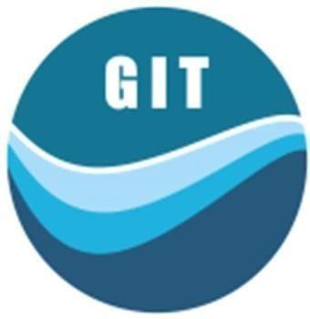

Submitted to:

Dr. Pradeep Jha
HOD-CSE/IT/AI&DS/IOT/CYBER SECURITY Dept.

Submitted By:
Pankaj Sharma 24EGJCS147
2nd Year, 3rd Semester

Department of Computer Science & Engineering
Global Institute of Technology Jaipur (Rajasthan)-302022 Session: 2025-26

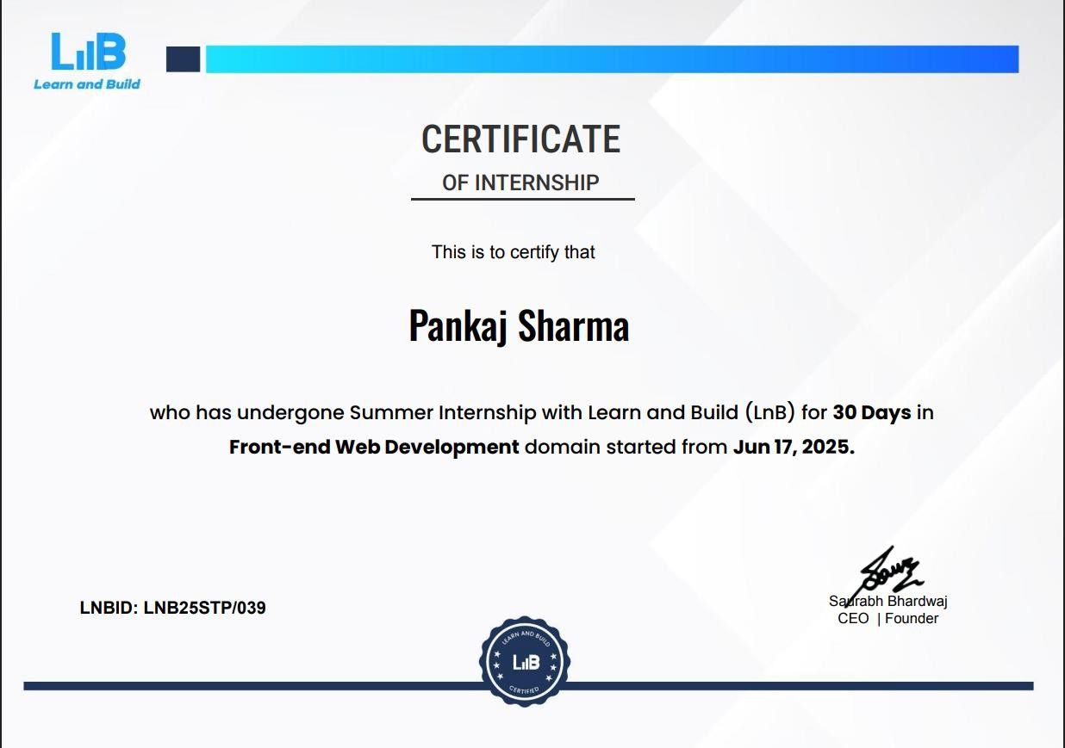

Acknowledgement

I take this opportunity to express my deep sense of gratitude to my coordinator Mr. Asharam Gurjar Assistant Professor Department of Computer Science and Engineering, Global Institute of Technology, Jaipur, for his valuable guidance and cooperation throughout the Practical Training work. He provided constant encouragement and unceasing enthusiasm at every stage of the Practical Training work.
I am grateful to our respected Dr. I. C. Sharma, Principal GIT for guiding me during Industrial Training period.
I express my indebtedness gratitude to Dr. Pradeep Jha, Head of Department of Computer Science and Engineering, Global Institute of Technology, Jaipur for providing me ample support during my Industrial Training period.
Without their support and timely guidance, the completion of our Industrial Training would have seemed a farfetched dream. In this respect we find ourselves lucky to have mentors of such a great potential.

Place: GIT, Jaipur

Pankaj Sharma
24EGJCS147
B.Tech. III Semester, II Year, CSE

Abstract

Full stack web development is the scenario of acting on each, the front-end and back-end of a program. It is a term largely used for those operating in web development. The developers have background on making program and user expertise for front-end, and even have robust information in an exceedingly programming language that's used for handling the logic of the appliance, therefore back-end.

Full stack could be a layer of software system or web development consisting of the frontend and also the back-end parts of associate application. Front-end is what the users can see or act with on your application. Back-end part is what users don't see, like application's logic, database, server, etc. A full stack web developer is comfortable operating with each, back-end and front-end technologies that build a web site or application perform properly.

Full Stack Developers have the specified technical information of each and every facet of development – frontend, back end, working of various operating systems in accordance to the required environments of programming as well as tools for programming.

Full stack developers are also termed as “developer generalists”, as they will produce any complicated application from scratch, provided they have understood how each and every technical layer ought to act with the other. As Full stack web development refers to the both of each front-end and back-end of an online application, web application, the development method contains 3 layers, i.e., the logic layer (back-end layer), the presentation layer (frontend layer) and the information layer (database layer).

Table of Contents
Certificate..................................................................................
Acknowledgement i
Abstract ii
Chapter-1 1
Web development 1
What is Full-Stack Web Development? 3
Full-Stack Developer 3
Chapter-2 5
What is JavaScript? 5
Programming Paradigm 8
JavaScript Libraries: A Definition 12
JavaScript frameworks: A Definition 12
What is difference between library and framework in JS? 13
What Are JavaScript Libraries Used For? 14
Comparison between Java and JavaScript 16
Chapter-3 19
Node.js 20
Background of Node.js 20
Non-Blocking Programming in Node.js 21
Node Package Manager (NPM) 22
Applications of Node.js 23
Express.js 23
Introduction to Express.js 23
Structure of an Express.js application 24
Understanding Middleware 24
MongoDB 25
Introduction to MongoDB 25
Pros and Cons of MongoDB 26
React.js 27
Introduction to React.js 27
Some concepts of React.js 29
Chapter-4 31
Projects 31
Portfolio Website 31
Introduction 31
Technologies Used 32
Website Structure 32
Features 37
Chapter -5 38
Conclusion 38
References 41

List of Figures

Figure 1.1: Full Stack Development Overview 1
Figure 2.1 Javascript Popularity 11
Figure 2.2 Difference between libraries and framework 13
Figure 3.1 A 3-tier MERN Architecture 19
Figure 3.2 Structure of an Express.js app 24
Figure 4.1 Portfolio Website 31
Figure 4.2 Portfolio Website Structure 32
Figure 4.3 Navigation Bar 33
Figure 4.4 About Section 34
Figure 4.5 Projects Section 35
Figure 4.6 Socials Section 36

List of Abbreviations

API | Application Programming Interface
NPM | Node Package Module
MVC | Model-View-Controller
HTTP | Hypertext Transfer Protocol
NoSQL | Non- Structured Query Language
JSON | JavaScript Object Notation
BSON | Binary JSON
RDBMS | Relational Database Management System
HTML | Hypertext Markup Language
MVVM | Model-View-View Model
JSX | JavaScript XML
SPA | Single Page Application
URL | Uniform Resource Locator
UI | UserInterface

Chapter-1

Introduction and Objective

Web development
Web development is the work involved in developing a website for the Internet (World Wide Web) or an intranet (a private network). Web development can range from developing a simple single static page of plain text to complex web applications, electronic businesses, and social network services. A more comprehensive list of tasks to which Web development commonly refers, may include Web engineering, Web design, Web content development, client liaison, client-side/server-side scripting, Web server and network security configuration, and e-commerce development.

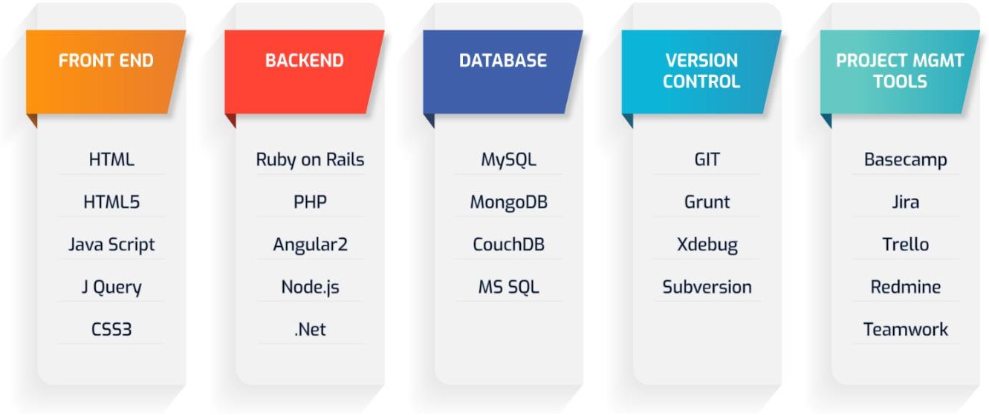

Figure 1.1 Full Stack Development Overview

Among Web professionals, "Web development" usually refers to the main non-design aspects of building Web sites: writing markup and coding. Web development may use content management systems (CMS) to make content changes easier and available with basic technical skills.

For larger organizations and businesses, Web development teams can consist of hundreds of people (Web developers) and follow standard methods like Agile methodologies while developing Web sites. Smaller organizations may only require a single permanent or contracting developer, or secondary assignment to related job positions such as a graphic designer or information systems technician.

Nowadays, the demand for full-stack developers has rapidly increased than ever before. According to a survey taken by Indeed, the highest demand also comes with an impressive average salary of $110,770 in the US. [1] The term full-stack developer refers to a person who can technically work on both front-end and back-end development of a dynamic website or web-based applications.

In the past, web development was mainly based on the LAMP stack (Linux, Apache, MySQL, PHP or Perl) and Java (Java EE, Spring), which consists of various programming languages. With the capabilities to work on both the client- side and server-side, JavaScript eases web development with the MERN stack's emergence. The stack comprises four primary technologies: MongoDB, Express.js, React.js, and Node.js. In this bachelor's thesis, the main goal was to study each component's nature in the stack and create a social platform that can connect people.
The thesis will primarily split into two main parts. The theoretical part focuses on giving a deep understanding of each component in the stack and related technologies to carry out the final project. Later it will dive into practical implementation of the social platform.
The outcome is a platform that has sufficient features to demonstrate the connections of each of the components in the MERN stack. Users can sign up, sign in and sign out. After signing in, users can create a post with upload photo functionality.

Moreover, users can also like and comment on other user's posts and reset the password. Due to the limited scope of this thesis, a notification system was not implemented. The knowledge acquired from this thesis can be applied to build various kinds of applications.

What is Full-Stack Web Development?
Full Stack Web development is the coding or programming that enables website functionality, per the owner's requirements. It mainly deals with the non-design aspect of building websites, which includes coding and writing markup.

The web development hierarchy is as follows:

- Client-side coding.
- Server-side coding.
- Database technology

Full-Stack Developer
Full stack developers are free to use any set of languages that are compatible with each other and the overall application framework. JavaScript is a popular language often used by full-stack developers as it’s one of the very few languages that can be used both on the front end and back end. Companies will most likely hire a full stack developer for smaller or medium-size projects. Some popular languages are:
- Front end: HTML, CSS, JavaScript.
- Back end: Python, Java, R, Ruby, Node.js, PHP.

Full-Stack developers are usually divided into front-end devs, back-end devs, and full-stack devs. A front-end dev takes care of all the visual aspects of the website (layout, navigation bar, etc.), its interactivity, and binds together all its elements.

Back-end devs take care of less visible tasks that ensure the website runs smoothly, such as managing the website’s hosting services, database, and applications. Back-end devs might need to engineer solution to server issues by using additional server-side languages such as Python, Ruby, Java, and PHP.

Full-stack devs are developers able to do both front-end and back-end tasks at the same time. Web development is the work involved in developing a website for the Internetoran intranet. Web development can range from developing a simple single static page of plain text to complex web-based internet applications, electronic businesses, and social network services.

Chapter-2

JavaScript

JavaScript , often abbreviated as JS, is a programming language that is one of the core technologies of the World Wide Web, alongside HTML and CSS. As of 2022, 98% of websites use JavaScript on the client side for webpage behaviour, often incorporating thirdparty libraries. All major web browsers have a dedicated JavaScript engine to execute the code on users' devices.
JavaScript is a high-level, often just-in-time compiled language that conforms to the ECMAScript standard.[10] It has dynamic typing, prototype-based object-orientation, and first- class functions. It is multi-paradigm, supporting event-driven, functional, and imperative programming styles. It has application programming interfaces (APIs) for working with text, dates, regular expressions, standard data structures, and the Document Object Model (DOM).
The ECMAScript standard does not include any input/output (I/O), such as networking, storage, or graphics facilities. In practice, the web browser or other runtime system provides JavaScript APIs for I/O.
JavaScript engines were originally used only in web browsers, but are now core components of some servers and a variety of applications. The most popular runtime system for this usage is Node.js.
Although Java and JavaScript are similar in name, syntax, and respective standard libraries, the two languages are distinct and differ greatly in design.

What is JavaScript?

JavaScript is a cross-platform, object-oriented scripting language used to make webpages interactive (e.g., having complex animations, clickable buttons, popup menus, etc.). There are also more advanced server-side versions of JavaScript such as Node. JavaScript is a programming language that adds interactivity to your website. This happens in games, in the behaviour of responses when buttons are pressed or with data entry on forms; with dynamic styling; with animation, etc.

Features of JavaScript: -
- Scripting Language. JavaScript is a lightweight scripting language made for client-side execution on the browser. ...
- Interpreter Based
- Event Handling
- Light Weight.
- Control Statements.
- Objects as first-class citizens. ...
- Functions as First-class citizens (supports functional programming)

JavaScript statements are commands to the browser JavaScript code is a sequence of statements JavaScript statements are separated with semicolon Multiple statement on one line is allowed JavaScript statements can be grouped together in code blocks You can break a code line after an operator or a comma. A function in JavaScript is similar to a procedure—a set of statements that performs a task or calculates a value, but for a procedure to qualify as a function, it should take some input and return an output where there is some obvious relationship between the input and the output. A callback is a function passed as an argument to another function. qualify as a function, it should take some input and return an output where there is some obvious relationship This technique allows a function to call another function. A callback function can run after another function has finished. JavaScript is a high-level, often just-in-time compiled language that conforms to the ECMAScript standard.[10] It has dynamic typing, prototype-based object-orientation, and first- class functions. It is multi-paradigm, supporting event-driven, functional, and imperative programming styles. It has application programming interfaces (APIs) for working with text, dates, regular expressions, standard data structures, and the Document Object Model (DOM).

JavaScript statements are commands to the browser JavaScript code is a sequence of statements JavaScript statements are separated with semicolon Multiple statement on one line is allowed JavaScript statements can be grouped together in code blocks You can break a code line after an operator or a comma. A function in JavaScript is similar to a procedure—a set of statements that performs a task or calculates a value, but for a procedure to qualify as a function, it should take some input and return an output where there is some obvious relationship between the input and the output. A callback is a function passed as an argument to another function. qualify as a function, it should take some input and return an output where there is some obvious relationship This technique allows a function to call another function. A callback function can run after another function has finished. JavaScript is a high-level, often just-in-time compiled language that conforms to the ECMAScript standard.[10] It has dynamic typing, prototype-based object-orientation, and first- class functions. It is multi-paradigm, supporting event-driven, functional, and imperative programming styles. It has application programming interfaces (APIs) for working with text, dates, regular expressions, standard data structures, and the Document Object Model (DOM).
it takes less time to code, allowing data science startups to reach conclusions quickly and build better products.
The most important feature of JavaScript is that functions are objects. That's it. Understanding this will open up a whole new understanding of the JavaScript language. In JavaScript, functions are objects.
JavaScript was invented by Brendan Each in 1995. It was developed for Netscape 2, and became the ECMA-262 standard in 1997. After Netscape handed JavaScript over to ECMA, the Mozilla foundation continued to develop JavaScript for the Firefox browser.

JavaScript is a lightweight, interpreted programming language. It is designed for creating network- centric applications. It is complementary to and integrated with Java. It is very easy to implement because it is integrated with a HTML. It is open and cross-platform.
We cannot treat JavaScript as a full-fledged programming language. It lacks the following important features:

Client-side JavaScript does not allow the reading or writing of files. It has been kept for the security reason.
JavaScript could not use for networking applications because there is no such support available. JavaScript doesn't have any multithreading or multiprocessor capabilities.
JavaScript. Yes, JavaScript is used widely in frontend development, but in recent years is used for backend development too. Node. js (a JavaScript runtime) makes that possible by providing backend functionality.

Programming Paradigm
Object Oriented Programming (OOP) and Functional Programming (FP) are programming paradigms. Roughly speaking, following a programming paradigm is writing code compliant with a specific set of rules. For example, organizing the code into units would be called OOP, avoiding side effects would be called FP.
Each programming paradigm is made of specific features; however, your favourite language does not have to provide all of the features to fall into one paradigm. In fact, OOP can live without inheritance or encapsulation, thus we can say that JavaScript (JS) is an OOP language with inheritance and without encapsulation.
Now that you have a little understanding of what a programming paradigm is (hopefully), let's have a quick look at the very basics of OOP and FP.
There are not many features involved in such a simple case. In OOP the code is often divided up into classes, and typically supports inheritance and polymorphism. But I won't go into further details since I'm afraid I'm already outside the scope of your question.
JavaScript is a high-level, often just-in-time compiled language that conforms to the ECMAScript standard.[10] It has dynamic typing, prototype-based object-orientation, and first- class functions. It is multi-paradigm, supporting event-driven, functional, and imperative programming styles. It has application programming interfaces (APIs) for working with text, dates, regular expressions, standard data structures, and the Document Object Model (DOM).

JavaScript statements are commands to the browser JavaScript code is a sequence of statements JavaScript statements are separated with semicolon Multiple statement on one line is allowed JavaScript statements can be grouped together in code blocks You can break a code line after an operator or a comma. A function in JavaScript is similar to a procedure—a set of statements that performs a task or calculates a value, but for a procedure to qualify as a function, it should take some input and return an output where there is some obvious relationship between the input and the output. A callback is a function passed as an argument to another function. There are not many features involved in such a simple case. In OOP the code is often divided up into classes, and typically supports inheritance and polymorphism. But I won't go into further details since I'm afraid I'm already outside the scope of your question.
JavaScript is a high-level, often just-in-time compiled language that conforms to the ECMAScript standard.[10] It has dynamic typing, prototype-based object-orientation, and first- class functions. It is multi-paradigm, supporting event-driven, functional, and imperative programming styles. It has application programming interfaces (APIs) for working with text, dates, regular expressions, standard data structures, and the Document Object Model (DOM). use jQuery(opens in a new tab) (one of the more ubiquitous JS libraries) to add an autocomplete feature to a search bar on your site, you’d insert the appropriate jQuery code snippet into your project’s code. Then, when a user enters text into the search bar, the jQuery code snippet retrieves the feature from the jQuery library and displays it in your user’s web browser. You can read more about exactly how JavaScript libraries like jQuery do what they do (including a look at jQuery code examples) in our Tech 101: What is jQuery guide, but the big takeaway is that libraries are specialized tools for specific coding needs, not an all-in-one tool or template for formatting your entire project. full toolset that help shape and organize your website or web application. When you’re trying to define frameworks in the context of JavaScript framework vs library, think of it this way: JavaScript libraries are like pieces of furniture that add style and function to an already constructed house. Frameworks, on the other hand, are a template you use to build the house itself.

Frameworks provide a structure (like a skeleton, or a scaffolding…or a framework) to base your entire project around. This structure is created through page templates (provided by the framework) with specific areas set aside for inserting framework code (versus the library format, where the developer decides where to implement library code). The upside to using JavaScript Actually, JS can be used as a FP language as long as you take care of side effects, there is no built- in mechanism for that. The following code is an example of such a programming style. The "zip with" function comes from the Haskell world. It merges two lists using the given function, as it happens, add(point[i], vector[i]). libraries are like pieces of furniture that add style and function to an already constructed house. Frameworks, on the other hand, are a template you use to build the house itself.
Frameworks provide a structure (like a skeleton, or a scaffolding…or a framework) to base your entire project around. This structure is created through page templates (provided by the framework) with specific areas set aside for inserting framework code (versus the library format, where the developer decides where to implement library code).
The upside to using JavaScript Actually, JSFunctional Programming
In FP, the code is essentially a combination of functions. Moreover, the data is immutable, which leads to writing programs with no side effects. In functional code, a function is not able to change the outside world, and the output value depends only on the given arguments.

Actually, JS can be used as a FP language as long as you take care of side effects, there is no built- in mechanism for that. The following code is an example of such a programming style. The "zip with" function comes from the Haskell world. It merges two lists using the given function, as it happens, add(point[i], vector[i]).

JavaScript statements are commands to the browser JavaScript code is a sequence of statements JavaScript statements are separated with semicolon Multiple statement on one line is allowed JavaScript statements can be grouped together in code blocks You can break a code line after an operator or a comma. A function in JavaScript is similar to a procedure—a set of statements that performs a task or calculates a value, but for a procedure to qualify as a function, it should take some input and return an output where there is some obvious relationship between the input and the output.

A callback is a function passed as an argument to another function. This technique allows a function to call another function. A callback function can run after another function has finished.
JavaScript was invented by Brendan Eich in 1995, and became an ECMA standard in 1997. ECMAScript is the official name of the language. ECMAScript versions have been abbreviated to ES1, ES2, ES3, ES5, and ES6. Since 2016, versions are named by year (ECMAScript 2016, 2017, 2018,2019,2020).
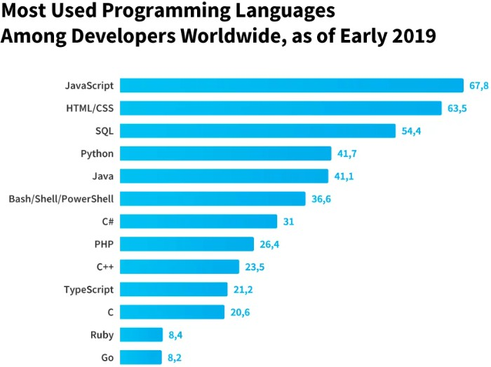

Figure 2.1 JavaScript Popularity

JavaScript Libraries: A Definition

Generally speaking, JavaScript libraries are collections of prewritten code snippets that can be used (and reused) to perform common JavaScript functions. JavaScript library code can be plugged into the rest of your project’s code on an “as needed” basis. If you were going to use jQuery(opens in a new tab) (one of the more ubiquitous JS libraries) to add an autocomplete feature to a search bar on your site, you’d insert the appropriate jQuery code snippet into your project’s code. Then, when a user enters text into the search bar, the jQuery code snippet retrieves the feature from the jQuery library and displays it in your user’s web browser. You can read more about exactly how JavaScript libraries like jQuery do what they do (including a look at jQuery code examples) in our Tech 101: What is jQuery guide, but the big takeaway is that libraries are specialized tools for specific coding needs, not an all-in-one tool or template for formatting your entire project.

Examples:
- React JS
- jQuery

JavaScript frameworks: A Definition

While JavaScript libraries are a specialized tool for on-demand use, JavaScript frameworks are a full toolset that help shape and organize your website or web application. When you’re trying to define frameworks in the context of JavaScript framework vs library, think of it this way: JavaScript libraries are like pieces of furniture that add style and function to an already constructed house. Frameworks, on the other hand, are a template you use to build the house itself. Frameworks provide a structure (like a skeleton, or a scaffolding…or a framework) to base your entire project around. This structure is created through page templates (provided by the framework) with specific areas set aside for inserting framework code (versus the library format, where the developer decides where to implement library code).

The upside to using JavaScript frameworks is the overall efficiency and organization they bring to a project—your code will be neatly structured, and the framework will offer readymade solutions for common coding problems. On the other hand, all of that structure can be the downside of working with a framework—any JavaScript code you write on top of JS frameworks needs to follow rules and conventions specific to the framework, limiting the freedom you have when using a library. You can learn more about the ins and outs of JavaScript frameworks (including which ones are in demand right now) from our Tech 101: What is a JavaScript Framework guide, and our article on Which JavaScript Framework Should You Learn First. (back to top).

Examples:
- Angular
- Vue
- Ember.js

What is difference between library and framework in JS?

When you're trying to define frameworks in the context of JavaScript framework vs library, think of it this way: JavaScript libraries are like pieces of furniture that add style and function to an already constructed house. Frameworks, on the other hand, are a template you use to build the house itself.

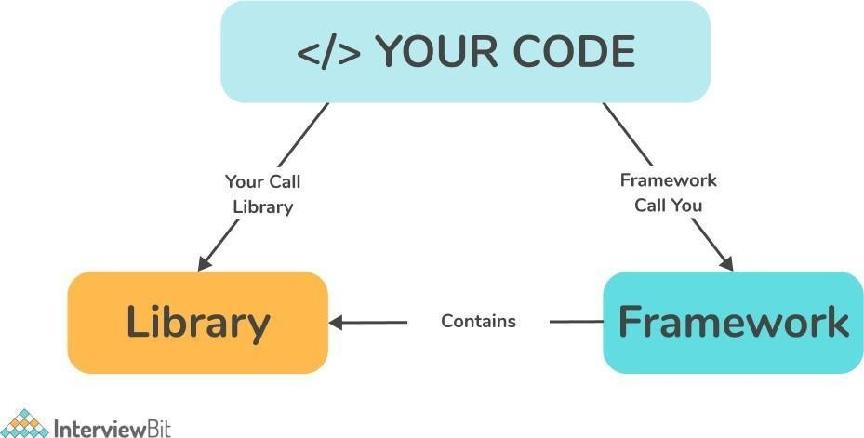

Figure 2.2 Difference between libraries and framework

What Are JavaScript Libraries Used For?

As we’ve said, JavaScript libraries are used to perform specific functions. There are around 83 of them, each created to serve some purpose, and we are going to cover some of their usability in this section.
You can use JavaScript libraries for:

Data Visualization in Maps and Charts
Data visualization in applications is crucial for users to view the statistics clearly in the admin panel, dashboards, performance metrics, and more.
Presenting these data in charts and maps helps you analyze that data easily and make informed business decisions.
Examples: Chart.js, Apexcharts, Algolia Places

DOM Manipulation
Document Object Model (DOM) represents a web page (a document) as objects and nodes that you can modify using JavaScript. You can change its content, style, and structure.
Examples: jQuery, Umbrella JS

Data Handling
With the enormous amounts of data that businesses now deal with daily, handling and managing them properly is essential. Using a JavaScript library makes it easier to handle a document following its content while adding more interactivity.
Examples: D3.js

Database
Effective database management is necessary to read, create, delete, edit, and sort data. You can also use sophisticated queries, auto-create tables, synchronize and validate data, and much more.
Examples: TaffyDB, ActiveRecord.js

Forms
Use JS libraries to simplify form functions, including form validation, synchronization, handling, conditional capabilities, field controls, transforming layouts, and more.
Examples: wForms, LiveValidation, Validanguage, qForms

Image Effects
Users can add effects to images and make them stand out using JS libraries. Effects include blurring, lightening, embossing, sharpening, grayscale, saturation, hue, adjusting contrast, flipping, inverting, reflection, and so on.
Examples: ImageFX, Reflection.js

Fonts
Users can incorporate any font they wish to make their web page more compelling based on the content type.
Examples: typeface.js

Math and String Functions
Adding mathematical expressions, date, time, and strings can be tricky. For example, a date consists of many formats, slashes, and dots to make things complex for you. The same holds when it comes to matrices and vectors.
Use JavaScript libraries to simplify these complexities in addition to manipulating and handling URLs effortlessly.
Examples: Date.js, Sylvester, JavaScript URL Library

User Interface and Its Components
You can provide a better user experience via web pages by making them more responsive and dynamic, decreasing the number of DOM operations, boosting page speed, and so forth. Examples: ReactJS, Glimmer.js

And those are just the most common use cases. Other uses of JavaScript libraries include:

  - Creating a custom dialog box
  - Creating keyboard shortcuts
  - Switching platforms
  - Creating rounded corners
  - Affecting data retrieval/AJAX
  - Aligning page layouts
  - Creating navigation and routing
  - Logging and debugging

The Most Popular JavaScript Libraries
  - jQuery library.
  - React library.
  - D3.js library.
  - Underscore library.
  - Lodash library.
  - Algolia Places library.
  - Anime.js library.
  - Animate On Scroll library.

Comparison between Java and JavaScript
Java is an object-oriented programming language. JavaScript is an object-based scripting language. Java applications can run in any virtual machine (JVM) or browser.
JavaScript code used to run only in the browser, but now it can run on the server via Node. JavaScript is a lightweight programming language (“scripting language”) and is used to make web pages interactive. It can insert dynamic text into HTML. JavaScript is also known as the browser’s language. JavaScript (JS) is not similar or related to Java. Both the languages have a C-like syntax and are widely used in client-side and server-side Web applications, but there are few similarities only.

Features of JavaScript are as follows:
  - JavaScript was created in the first place for DOM manipulation. Earlier websites were mostly static, after JS was created dynamic Web sites were made.
  - Functions in JS are objects. They may have properties and methods just like another object. They can be passed as arguments in other functions.
  - Can handle date and time.
  - Performs Form Validation although the forms are created using HTML.
  - No compiler is needed.

Java is an object-oriented programming language and has a virtual machine platform that allows you to create compiled programs that run on nearly every platform. Java promised, “Write Once, Run Anywhere”.
Features of Java are as follows:

Platform Independent: The compiler converts source code to bytecode and then the JVM executes the bytecode generated by the compiler.
Object-Oriented Programming Language
Organizing the program in the terms of collection of objects is a way of object oriented programming, each of which represents an instance of the class. There are 4 pillars of OOP’s concept:
- Abstraction
- Encapsulation
- Inheritance
- Polymorphism

- Simple: Java is one of the simple languages as it does not have complex features like pointers, operator overloading, multiple inheritances, and Explicit memory allocation.

- Robust: Java language is robust which means reliable. It is developed in such a way that it puts a lot of effort into checking errors as early as possible, that is why the java compiler is able to detect even those errors that are not easy to detect by another programming language.

- Secure: In java, we don’t have pointers, and so we cannot access out-of-bound arrays i.e it shows Array Index Out Of Bound Exception if we try to do so.

- Distributed: We can create distributed applications using the java programming language. Remote Method Invocation and Enterprise Java Beans are used for creating distributed applications in java.

- Multithreading: Java supports multithreading. It is a Java feature that allows concurrent execution of two or more parts of a program for maximum utilization of the CPU.

Chapter-3

MERN Stack

MERN stands for MongoDB, Express.js, React.js and Node.js. With MongoDB as Database, Express.js is a web server framework (integrated with Node.js), React.js is a web client library, and Node.js is a server-side platform. It helps developers to develop Web apps based solely on full-stack JavaScript.

MERN combines four cutting-edge technologies today, from the front-end to the backend development, which Facebook strongly supports, so developers do not need to learn any other technology such as .NET, PHP, or Java. It saves developers time and effort to learn different technologies for application development. Due to the same JavaScript platform, the stack is supported by a vast number of open-source packages and a dedicated community for programmers to increase scalability and maintain software products.
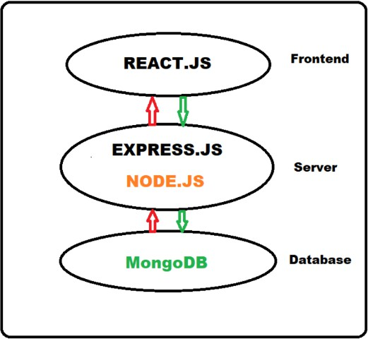

Figure 3.1 A 3-tier MERN Architecture

As depicted in Figure 2, the MERN stack starts with the core Node.js, a server- side technology with very high performance and fast response to all tasks, including large and complex data.

MERN does not need to use TypeScript, just the flexible foundation of React - the most popular and influential front-end technology today.

Node.js

Background of Node.js
None of us are unfamiliar with the Google Chrome web browser, and there is nothing new that this browser can open web pages and run JavaScript on the websites. The JavaScript code's execution is thanks to a JavaScript engine located inside a Chrome browser called V8. V8 has proven to be a powerful engine, written in C ++; V8 can interpret and execute JavaScript very quickly.

Faced with the apparent fact about the power of V8, the idea popped into the founders' minds to separate this V8 from Chrome and form an application capable of executing the JavaScript code on the server-side. In 2009, Ryan Dahl created Node.js to achieve that goal.
It should be easy to understand when Node has the same role as JVM (Java Virtual Machine). Like the JVM, Node.js is considered a platform, an environment for the applications to run on. If JVM executes the byte code, Node.js executes the JavaScript code. Programmers always use high-level languages such as Java, Scala, Groovy, or Kotlin to write the source code on the application programming side when working on the JVM. This source code will be compiled into byte code. Nevertheless, Node.js itself can understand and execute JavaScript on the Node.js platform, so the language written on the application side can be JavaScript, or languages capable of compiling into JavaScript like Typescript.

The birth of Node.js brought a breath of fresh air into the programming world. It has gained popularity among developers' top server-side platform choices and is used in major systems such as Netflix, LinkedIn, and Uber. The following is a ranking of the most popular libraries/platforms according to a StackOverflow survey in 2020.

Non-Blocking Programming in Node.js
The Node.js platform is versatile, perhaps not because of the V8 engine or the ability to support the JavaScript language, but in the Non-Blocking style of programming. Operations related to Non-Blocking in Node.js are mostly related to IO, such as reading and writing data to disk or calling Web APIs, for example. Furthermore, the use of NonBlocking operations makes applications written on a Node.js platform capable of using computational resources (CPU) most efficiently.

In the creation of the Non-Blocking mechanism, Node.js applications operate according to the Event Loop design pattern. The illustration below explains this design in more detail:

Event Queue: Considering as a repository to store Events (events). Event here can be understood as a particular process in the program. Each event contains information to classify what that event is and the accompanying data. Because it is a queue structure, the Event Queue will operate on the principle of First In First Out (FIFO). This ensures that the order in which the Events are retrieved for processing is the same as the order they are put into the Event Queue.

Main Thread: Saying this is the Main Thread because it will be the source and the end of the program. This main Thread is responsible for processing computation when receiving Events from the Event Queue. This is also the only Thread of the Node application that the programmer has control over. That is also the reason why it is still said that a Node application is single-threaded. Because of that, programmers will not have a headache about concurrency problems between threads like in some other platforms like Java.

Node API: The unit responsible for handling IO operations. IO operations will be handled here by the multi-threaded mechanism. Moreover, each IO operation after completion will return the result as an event, and this event will be put in the Event Queue
With the above three components, the way a Node application behaves like this:

- The Main Thread will run the computation processing statements declared in the source code. Wherever IO manipulation is involved, the Main Thread will make a Non-Blocking call to the Node API and then continue to execute other commands without waiting for the other IO operation to complete.
- When receiving a request from Main Thread, Node API will directly handle IO manipulation by different Threads. Once the IO operation is completed, the Node API will wrap the result as an Event and place it into the Event Queue.
- Events in the Event Queue will be processed by the Main Thread one after another. In the Main Thread, the code used to handle Events is usually declared as callback.

The above process is repetitive, creating a cycle of events in the application. The programming will be imposed in a way that is geared towards event handling instead of the traditional sequential way of thinking.

Node Package Manager (NPM)
NPM (short for Node Package Manager) is used and comes together to support each development of Node.js. [10] Most libraries are available on NPM, so it is relatively easy to include them just by running npm install <package> command line to download them.

NPM is being maximized and operating based on two prominent roles as follows:
NPM is a Software Registry and is being used very extensively to publish open-source Node.js projects. One can understand that: it is an online platform that allows all users to publish and share several other toolswritten in JavaScript. It has crossed over 1.3 million code packages as of April 2020.
NPM is one of the command-line tools that can help interact with other online platforms such as servers or web browsers. It is also a utility that can assist with package installation, package uninstallation, version management, and server-driven management. Also, NPM is used tomanage the dependencies needed to run the projects.

Applications of Node.js

Websocket servers: Websocket is a protocol formed to support two-way communication between the client and the server to connect and exchange data with each other quickly and accurately. The protocol is implemented over TCP, and they are used for web applications.
Ad Server: Running ads and controlling views will take time. Therefore, Node.js will be a platform that brings many benefits to customers. It is easier for ad servers to capture information.
Cloud Services: Cloud services on electronic devices such as phones, iPad, etc.

RESTful APIs.
Real-time applications.
Microservices: The idea of microservices is to split an extensive application into small services and connect them.

Express.js

Introduction to Express.js

Express.js is released under an open-source license, has a large community of support, and used for commercial applications. Hence, developers can completely rest assured to use this framework for their projects, from small projects to large projects.

Express.js has a ton of support packages and provides additional features for developers to a better program. Nevertheless, it does not slow down the speed of Node.js. The famous Node.js platform today is using Express.js as a core function.

According to the GitHub repository, Express.js was founded by TJ Holowaychuk and was first released on May 22, 2010, with version 0.12. In June 2014, project management rights were acquired by StrongLoop. IBM acquired StrongLoop in September 2015. In January 2016, Express.js was managed by the Nodejs Foundation.

Structure of an Express.js application

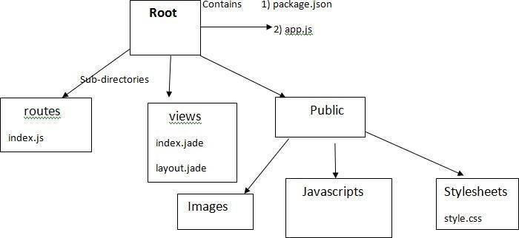
Figure 3.2 Structure of an Express.js app

As illustrated in Figure 2, the project directory structure using Express.js is divided into three parts: Routes, Views, and Public. Express.js build web applications following the MVC (Model, View, Controller) design pattern.
app.js: contains all the logic setup for the applications to run.
package.json: contains all the installed packages.
routes: contains all the routing-related logic present in the application.
views: contains the views/templates for the application.
Public: contains static files such as images, JS codes and CSS settings for the application.

Understanding Middleware

Middleware is computer software that connects software components or applications together. Software of this type consists of services that allow interaction between processes running on one or more different machines. Middleware technology has been developed to provide interoperability, catering to commonly used distributed architectures to support and simplify complex distributed applications.

When working with Express.js, developers use various middleware functions with different functionalities:
Functions receive the request, response of 1 cycle of HTTP request/response.
Functions can correct requests and responses before sending them to the next() middleware function.
Functions can update or terminate the request/response cycle.
The middleware function in Express.js often takes three parameters: the request (req) object, the response (res) object, and the next() function. Figure 6 below illustrate a custom middleware used in the project.

Code for custom middleware:

exports.addFollowing = (req, res, next) => { User.findByIdAndUpdate(
req.body.userld ,
{ $push: { following: req.body.followld } }, (err, result) => {
if (err) {
return res.status(400).json({error : err});
}
next();
}
);
};

MongoDB

Introduction to MongoDB
MongoDB was first born by MongoDB Inc. in October 2007. It was part of the PaaS (Platform as a Service) product like Windows Azure and Google App Engine. It was later made open source in 2009.

MongoDB is a document-oriented database and a NoSQL database. Therefore, MongoDB will often avoid the relational database's table-based structure to adapt to all documents such as JSON, available in a very flexible schema called BSON.

Pros and Cons of MongoDB
The outstanding advantages of MongoDB convincing the choice of current users are:

- Since MongoDB uses data in the JSON form, each collection has different sizes and documents. Nevertheless, they are very flexible when it comes to archiving.
- MongoDB data is usually not bound to each other; it does not support join query like in RDBMS, so when users insert, delete or update, it will not spend too much time to check if it satisfies the constraints like in RDBMS or not.
- MongoDB is easy to scale. In MongoDB, the concept “cluster” refers to clusters of nodes containing data to communicate with each other. Adding a new node to the cluster helps users expand the system quickly.
- The unique identifier _id will always be indexed automatically, so the speed of querying information will consistently achieve the highest performance.
- Data query will be cached to RAM with little access to the hard drive so the read and write speed is faster.

In addition to many outstanding advantages as above, MongoDB still does have its drawbacks:
- It is not applicable to any transaction models that require a high degree of accuracy due to its non-binding nature.
- There is no transaction mechanism to banking service applications.

- Data takes RAM as the centre of the action, so it requires a large amount of RAM when operating.

- Any change to the default data is not written to the hard drive immediately, so the chance of losing data from the cause of an unexpected power failure is very high.

React.js

Introduction to React.js
React.js is a JavaScript library built by Facebook engineers, being used by many famous companies to develop their products such as Yahoo, Airbnb, Facebook,
Instagram. It is better suited for large, scalable projects rather than small projects.

Features of React.js
The React.js mindset is to build reusable components that make it easy to break down problems and test. It helps us quickly manage and extend the system; if it is Angular, it requires optimal structure and coding style.
React.js always keeps components stateless (as much as possible), making it easy to manage because it is like a static HTML page. It takes inputs from the outside and only displays it against those inputs, explaining why it is reuse and easy for testing.

Strengths of React.js
React.js is a performance-minded view rendering framework. Many of the heavyweights on the MVVM (Model-View-ViewModel) framework take a long time to display large amounts of data, such as lists. However, with React.js, that is no longer an issue, as it just shows what changes.
balancing. The proposed concept is an extension of, rather than a replacement for, traditional exploration process. 6.2 Future Scope The work covered in the thesis tries to solve various issues, which emerged as a result of literature survey. Still there are many unopened questions left and are of interest were identified and are mentioned below: 97 • Web Security At Client Side In this research work we proposed PECA, but it still has shortcomings. For example, when web document is required to be save in the portable extended memory it reduces the security due to decentralization of data. During updates at client side malicious codes may transfer to the client machine. So, a web security framework is required at the client side to make PECA more secure and better performer.

So in near future, PECA and SWAM may be merged. • Server Side Load Balancing Load balancing is a concept which is still under research. Everyday new frame-works, algorithms and models are being developed and existing models are up- dated. There is a vast scope for future enhancement. For example, the users are sending arbitrary data as a query on the web, and hence web-centric queries can be optimized at server level to reduce server load to improve the server Department of Information Technology, DBATU University, Lonere. 21 Web Development performance. Further, implementation of our work is pending and hence an improvement may be recommended in the same. • Ant Based Technology for Collective Intelligence At Server Side The developers are distributing server’s data to reduce the server’s load. This mechanism is increasing the requirement of collective intelligence. In this research work, ant technology for collective intelligence is used, but this is framework is based on client’s query. There are still many unopened questions. For example, what and how much data is available in near servers? Are the servers are reliable? What is the credibility of these servers? In particular the server must have all the relevant information of their server.

One of React.js more strengths is the virtual DOM (Document Object Model) - which is hidden inside every view and is the reason why React.js achieves good performance. When a view requests a call, everything is included in a virtual copy of the DOM. React.js compares the virtual DOM and the real DOM after the call completes and makes the changes indicated in the above comparison.

For example, if we are looking at a list of 20 products displayed by React.js and change the 2nd product, only that product is re-displayed, and the remaining 19 products remain the same (no need to display reload or reload the page). React.js used the so-called virtual DOM to increase performance by outputting a virtual view, then checking the difference between the virtual rendering and what is in the DOM and creating a patch.

Some concepts of React.js

Component
React.js is built around components, not using templates like other frameworks. The user can create a component by extending the component as follows.
Class welcome extends component{ render(){
return <h1>Hello, {this.props.name}</h1>;
}
}
Export default Welcome;

A component in React.js

The most crucial method is render, which is triggered when the component is ready to be rendered on the page.

In that function, the user will return a description of what the user wants React.js to render on the page. As in the example above, the user renders an h1 tag containing the greeting and the name.

The render function is a specific description of the UI at any given time. If the data is changed, React.js will update the UI with the corresponding data. One can understand that React.js will automatically call the render function to update the UI when the data changes.

Prop
Props here are properties of a component; users can change the props of the component by passing data from the outside. Props can be an object, function, string, number, etc. The render function is a specific description of the UI at any given time. If the data is changed, React.js will update the UI with the corresponding data. One can understand that React.js will automatically call the render function to update the UI when the data changes.
import PropTypes from ‘prop-types’ import React from ‘react’;

class Greeting extends React.Component { render() {
return (
<hl>Hello, {this.props.name}</h1> ); }} Greeting.propTypes = {
name: PropTypes.string }
When a prop is passed to the component, it is immutable. That is, its data is not changed like a "pure" function.
Function sum(a,b){
return a+b;
}
The function is called "pure" because it does not change its input value and always returns the same result for the same inputs.

We consider the second function as shown below:
fucntion sum(sum,a) sum+=a;
}
Here the above function changed its input sum value, and this makes it not a "pure" function. All React.js components must act as "pure" function.

State
A React.js component has two ways to get props and state information. Unlike props, the state of a component is not passed from the outside. A component determines its own state. To create a state for the component, we will have to declare it in the constructor function.

class posts extends component{ constructor(){
super(); this.state = {
posts: [],
};
}
}
State in React.js

Chapter-4

Projects

Portfolio Website

Introduction

This project presents the design and development of a fully responsive Portfolio Website created to showcase personal skills, projects, and social profiles in a professional and visually appealing manner. The website is built using HTML, CSS, JavaScript, Bootstrap, and React for selected interactive components. It highlights the developer’s identity, technical skills, work samples, and contact details in a clean, modern UI.

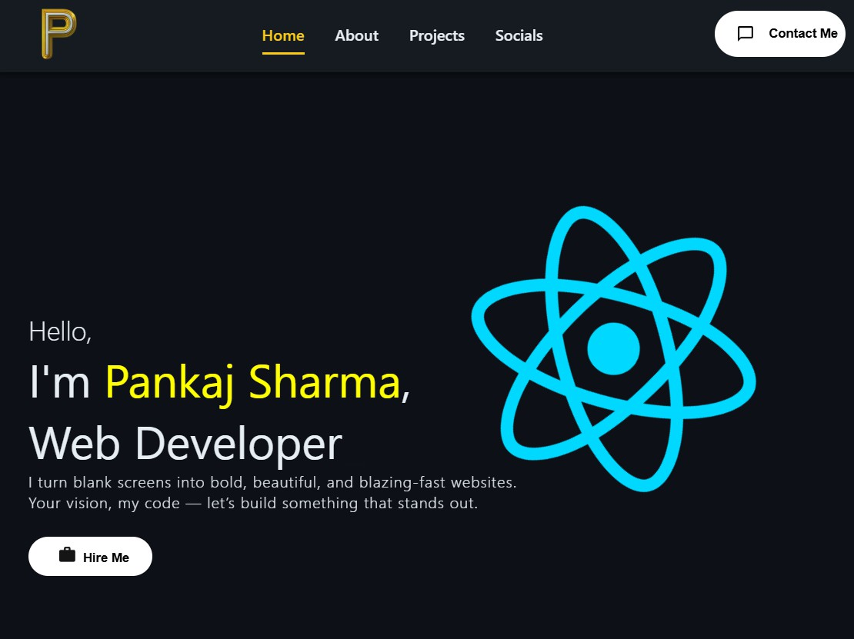
Figure 4.1 Portfolio Website.

Technologies Used

Frontend Technologies
- HTML5 – Structure and content
- CSS3 – Styling and layouts
- Bootstrap – Components and responsive grids
- JavaScript – Interactivity and DOM handling
- React – Selected dynamic UI parts (Hero component, Navbar animation)

Design Tools
- Google Fonts
- Font Awesome / Icon libraries
- EmailJS
- Typewriter – To change roles

Website Structure
The portfolio is divided into the following major sections:
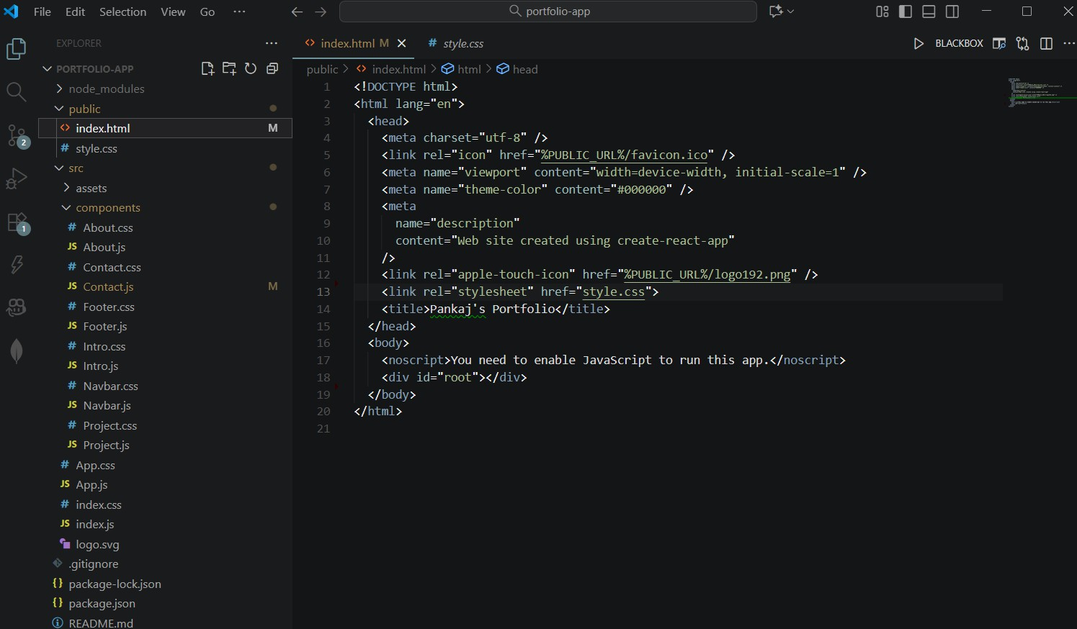
Figure 4.2 Portfolio Website Structure.

Navigation Bar
A fixed navigation bar containing:
- Home
- About
- Projects
- Socials
- Contact Me button
The navbar adjusts automatically on smaller screens using a responsive hamburger menu.

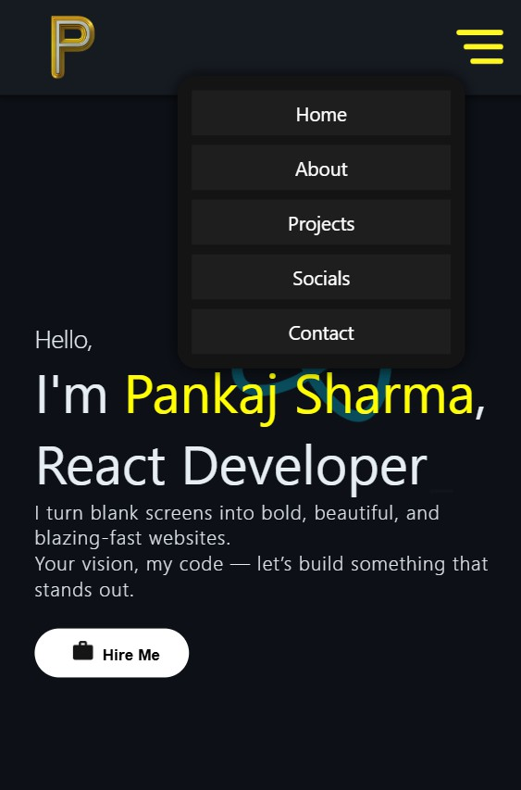
Figure 4.3 Navigation Bar

Home Section (Hero Area)
This is the first impression of the website. It includes:
- Greeting text
- Developer’s name highlighted in yellow
- Role: Web Developer / React Developer
- A large animated React icon
- A "Hire Me" button

About Section
The About page describes:
- Developer’s knowledge
- Technical stack
- Specializations
- Focus areas: performance-driven design, usability, responsiveness Each skill is displayed inside a visually styled card.
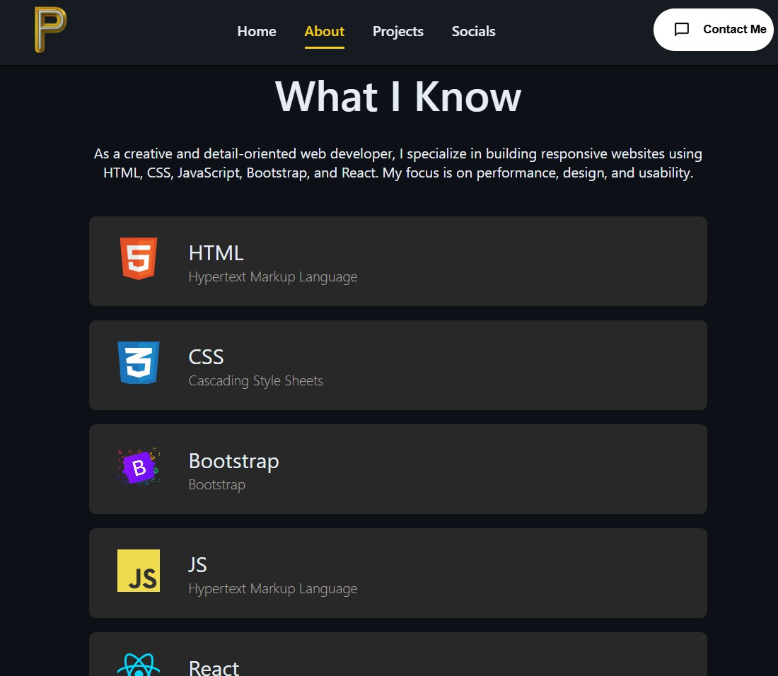
Figure 4.4 About Section

Projects Section
This section showcases the developer’s projects in card format. Each project card contains:
- Project image
- Project title
- Technology stack used (HTML, CSS, JavaScript, React) The section is aligned centrally with smooth spacing.
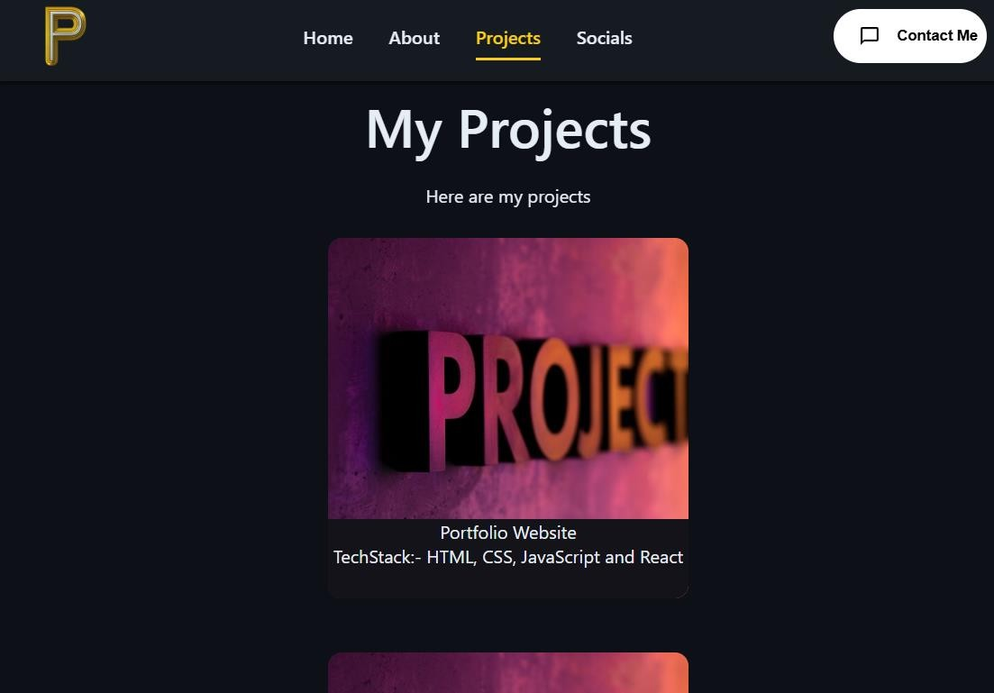
Figure 4.5 Projects Section

Socials Section
Displays icons for:
- LinkedIn
- GitHub
- Instagram
These icons link directly to the respective social media profiles.

Contact Section
Includes a fully functional contact form with fields:
- Name
- Email
- Message
The forms are neatly spaced with dark-themed, minimal UI.
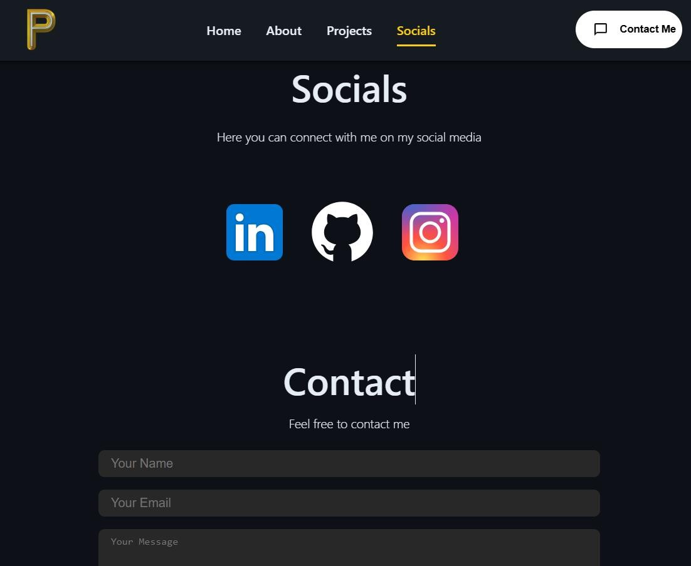
Figure 4.6 Socials Section

Features
- Fully responsive layout
- Modern UI with dark theme
- Animated navigation
- Smooth scrolling
- Professional project showcase section
- Mobile-friendly hamburger menu
- Social media integration
- Contact form with clean design

Chapter -5

Conclusion
This chapter summarizes the main success of this research work and discusses an about future research work to achieve the ultimate goal in the field of performance of web accessibility, web security, load balancing and collective intelligence. An in depth literature survey was carried out and the critical analysis of the same raised the following major shortcomings and challenges in the web-centric query optimization techniques.

Network is congested due to heterogeneous data (i.e., text, images, videos etc), heavy weight of web applications and repetition of queries. Due to these problems the access time of web applications is very high, which reduces the overall performance of the web.

Web-centric queries are neither efficient nor secure.

Huge information is available on the servers but the load on servers is not still balanced. In industry the developers distribute the huge information of servers by introducing more servers which produce requirement of the collective intelligence.

Further, to search the efficient and relevant server is also a big challenge. The diagnostic thought to above challenges guides towards the design of following efficient approach, model and frameworks:

Portable Extended Cache Memory to reduce Web Traffic.

In this approach, it is desired to conserve the heavy data at the client side. The experiments were performed on few dummy web sites of different sizes while saving 96 heavy data at client side. Difference in the access times of different web sites via traditional method and with the proposed approach was compared. A major improvement in the access time was observed in contrast to Department of Information Technology, DBATU University, Lonere. 20 Web Development that by using traditional methods. Also, an attempt was made to reduce server load and network traffic congestion and it actually resulted into reduction of response time and hence an improved web performance could be observed.

- Secure Web Access Model for sensitive data (SWAM) SWAM in the context of biometric recognition is being proposed. The proposed security model SWAM provide an interface to the authorized user’s and reduce the threats regarding their sensitive areas. Online web services will be more secure using the online SWAM. Collective Intelligence based Framework for Load Balancing of Webservers Collective Intelligence based Framework for Load Balancing of Web Servers is being proposed. The aim of this work is to find the overall best server with shortest path and hence online balancing of web servers could be achieved with the help of collective intelligence based framework for online load.

Huge information is available on the servers but the load on servers is not still balanced. In industry the developers distribute the huge information of servers by introducing more servers which produce requirement of the collective intelligence. Further, to search the efficient and relevant server is also a big challenge. The diagnostic thought to above challenges guides towards the design of following efficient approach, model and frameworks: Portable Extended Cache Memory to Reduce Web.

Traffic (PECA) In this approach, it is desired to conserve the heavy data at the client side. The experiments were performed on few dummy web sites of different sizes while saving 96 heavy data at client side. Difference in the access times of different web sites via traditional method and with the proposed approach was compared. A major improvement in the access time was observed in contrast to Department of Information Technology, DBATU University, Lonere. 20 Web Development that by using traditional methods. Also, an attempt was made to reduce server load and network traffic congestion and it actually resulted into reduction of response time and hence an improved web performance could be observed.

- Secure Web Access Model for sensitive data (SWAM) SWAM in the context of biometric recognition is being proposed. of performance of web accessibility, web security, load balancing and collective intelligence. An in depth literature survey was carried out and the critical analysis of the same raised the following major shortcomings and challenges in the web-centric query optimization techniques.

- Network is congested due to heterogeneous data (i.e., text, images, videos etc), heavy weight of web applications and repetition of queries. Due to these problems the access time of web applications is very high, which reduces the overall performance of the web.
- Web-centric queries are neither efficient nor secure.

- Huge information is available on the servers but the load on servers is not still balanced. In industry the developers distribute the huge information of servers by introducing more servers which produce requirement of the collective intelligence. Further, to search the efficient and relevant server is also a big challenge. The diagnostic thought to above challenges guides towards the design of following efficient approach, model and frameworks: Portable Extended Cache Memory to Reduce Web.

Traffic (PECA) In this approach, it is desired to conserve the heavy data at the client side. The experiments were performed on few dummy web sites of different sizes while saving 96 heavy data at client side. Difference in the access times of different web sites via traditional method and with the proposed approach was compared.

References

https://www.w3schools.com/html/

https://www.w3schools.com/css/css_rwd_intro.asp

https://developer.mozilla.org/en-US/docs/Web/JavaScript

https://www.mongodb.com/why-use-mongodb

https://react.dev/learn/installation

https://stackoverflow.com/

https://www.udemy.com/course/the-web-developer-bootcamp

https://www.geeksforgeeks.org/batch/skill-up-full-stack-web-development

GitHub Repository, “Portfolio Website Project Code”, https://github.com/Pankaj7437/Portfolio-App

