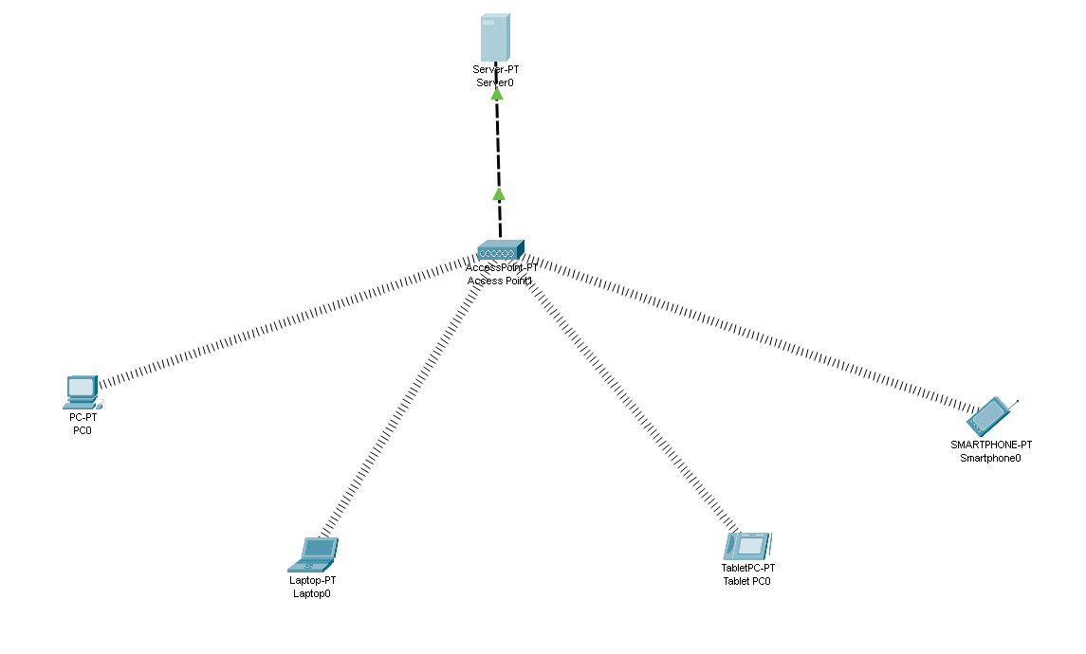

Click on server and then set the ip address

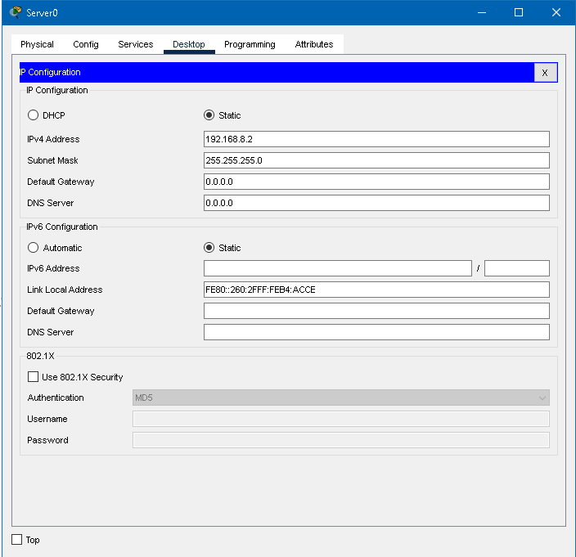

Then open service turn on DHCP setting

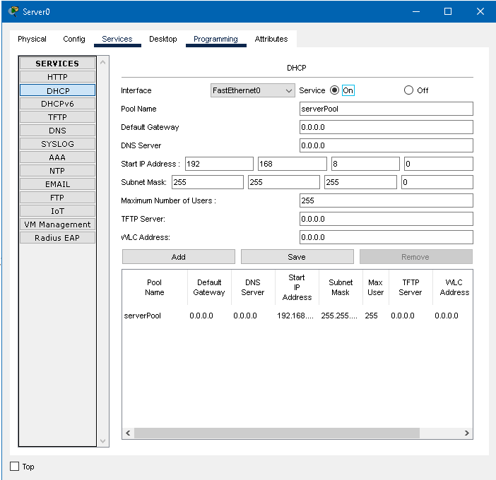

Then turn on pc’s DHCP setting

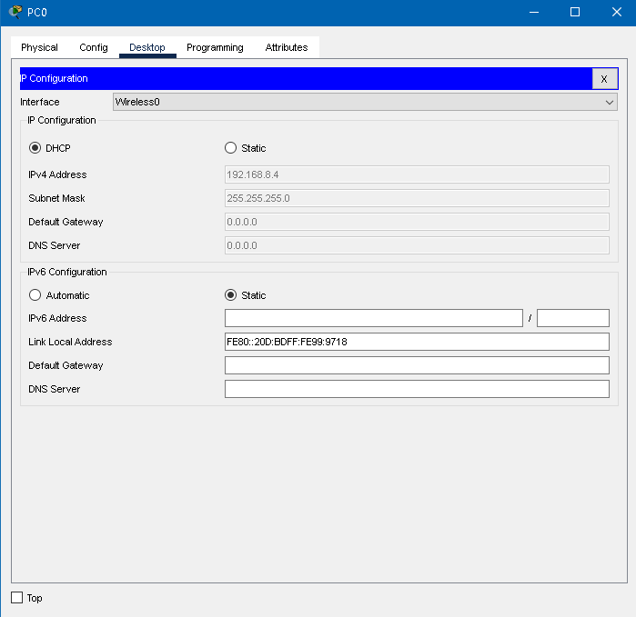

Then check the ping

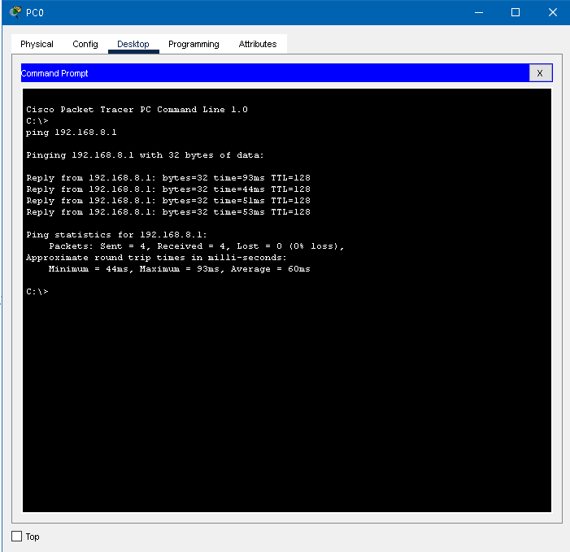

For SSID

SSID is a service set identifier it is used as a mail to identify a wireless router to connect.

Wireless router have default SSID when first setup and can be rename to more descriptives.

Give the SSID of access point as “col_wifi”.

Open accesspoint settings and set the SSID as col_wifi. After that connection is lost.

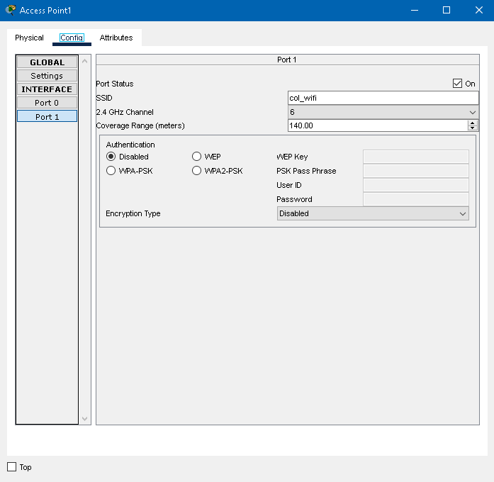

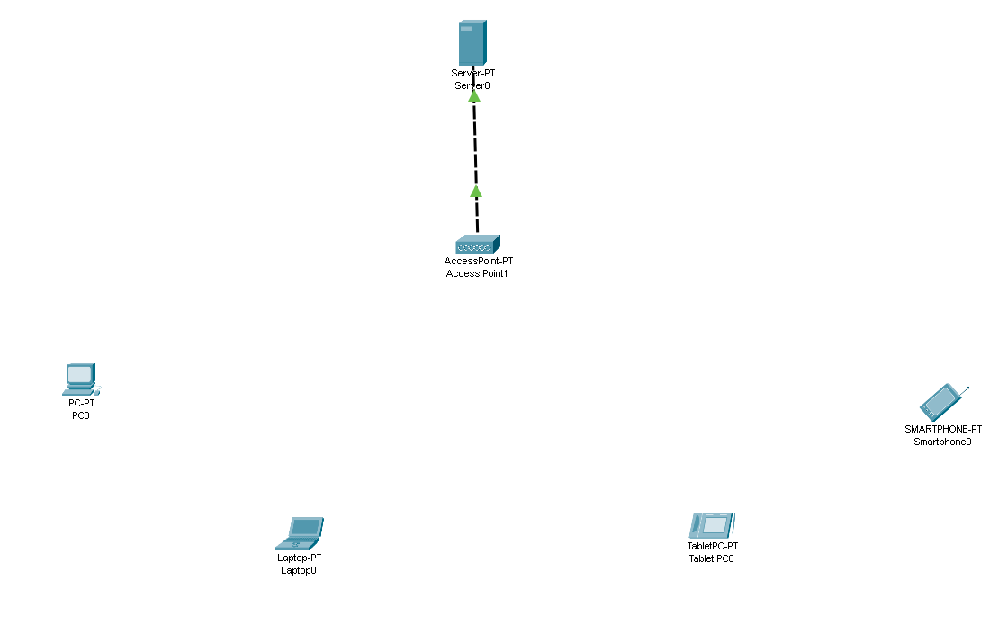

Set the SSID to pc and laptop

Open pc settings and set the SSID as col_wifi

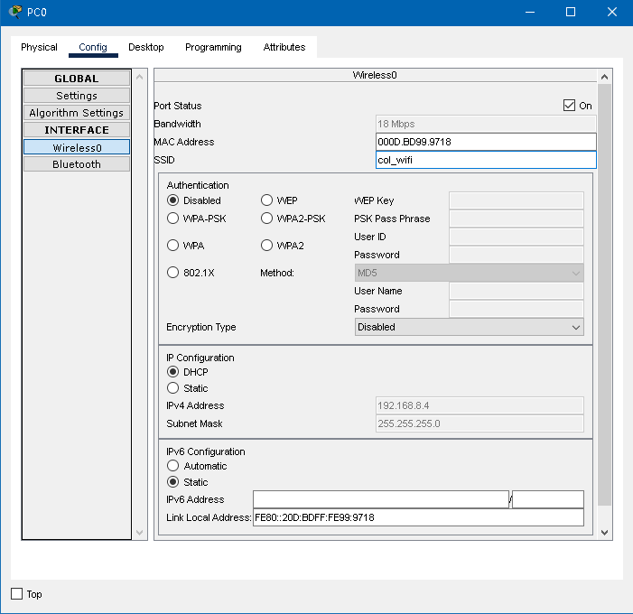

After that pc network will be automatically connected

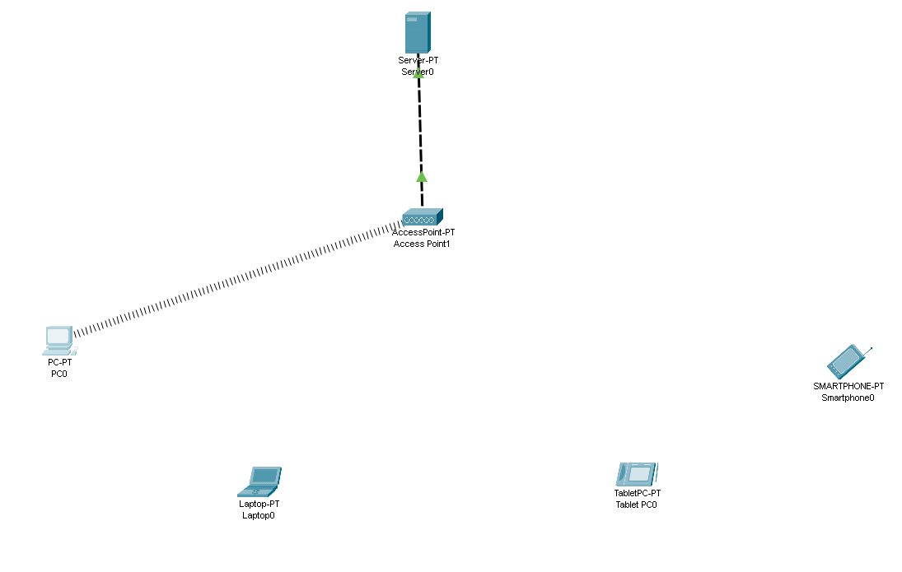

Check the ping and then connect the device

