Documentation for Graded Assignment on Dockerizing a Plain HTML Page With Nginx

* The objective of this assignment is to familiarize yourself with Docker and containerization by Dockerizing a simple HTML page using Nginx as the web server.
* Basic HTML Page:

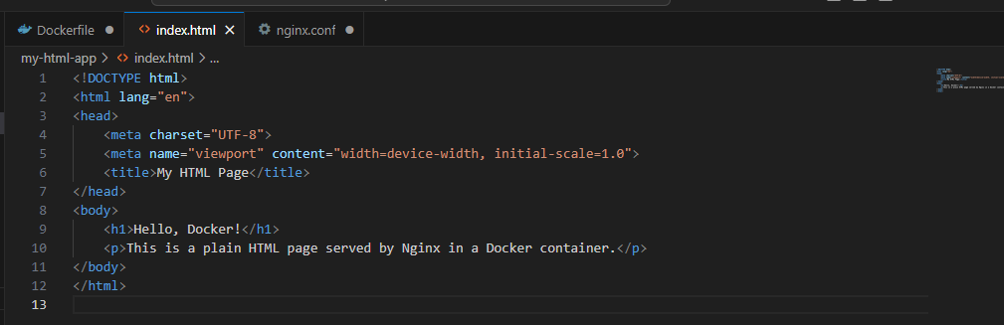

-Nginx Configuration:

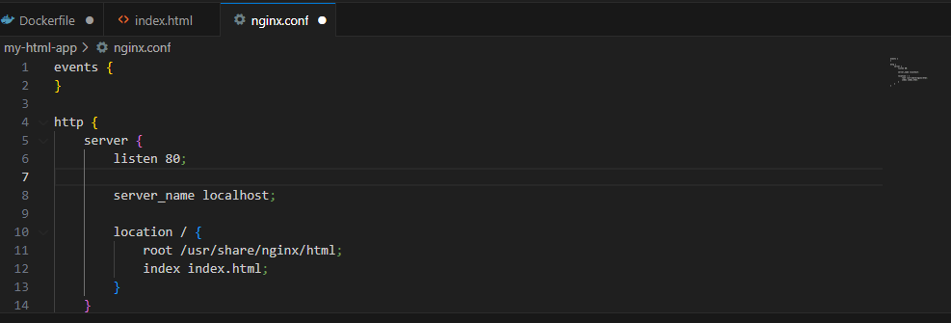

Dockerfile:

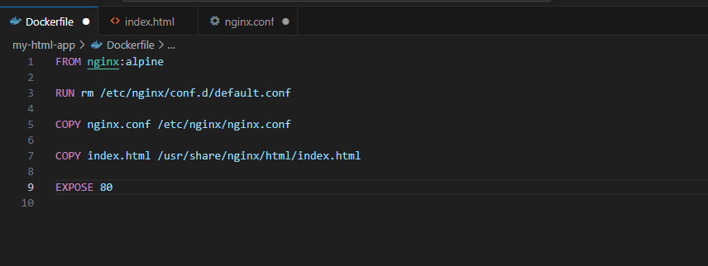

Building the Docker Image:

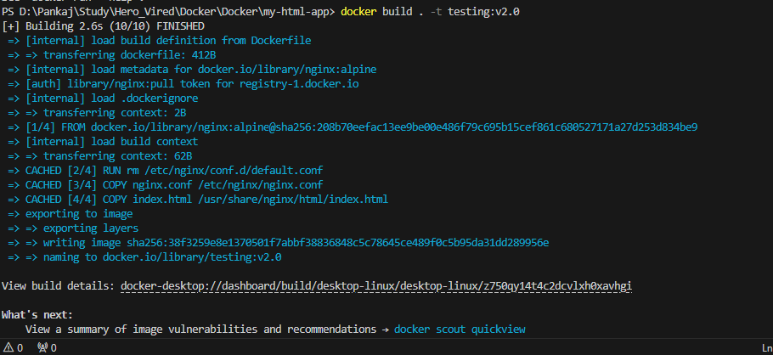

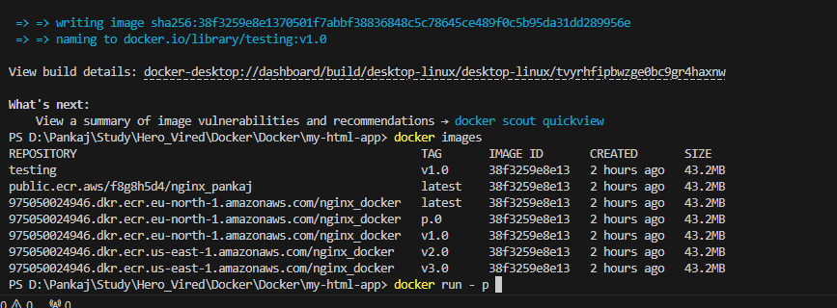

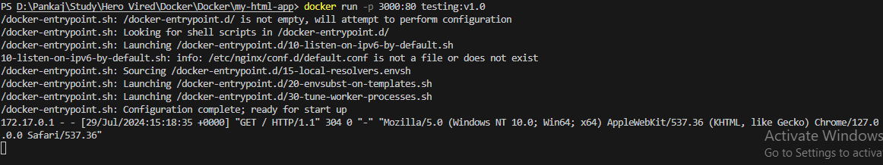



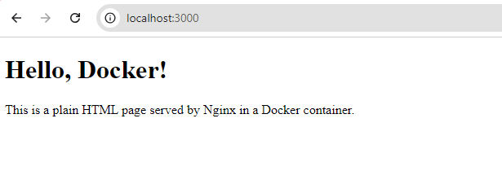

Push the image on ECR:



