Unit I: Introduction to Python and Basic Syntax
Total Lectures: 5 Duration: 60 minutes each
Teaching Approach: AKIDE+ — Arriving, Knowledge Activating, Informing, Deepening, and Evaluating
The five lessons progressively develop students' ability to use the Python environment, write simple programs using print() and variables, take user input, apply type conversion, and analyse dynamic typing and dynamic binding through testing and debugging.

The AKIDE+ Lesson Cycle
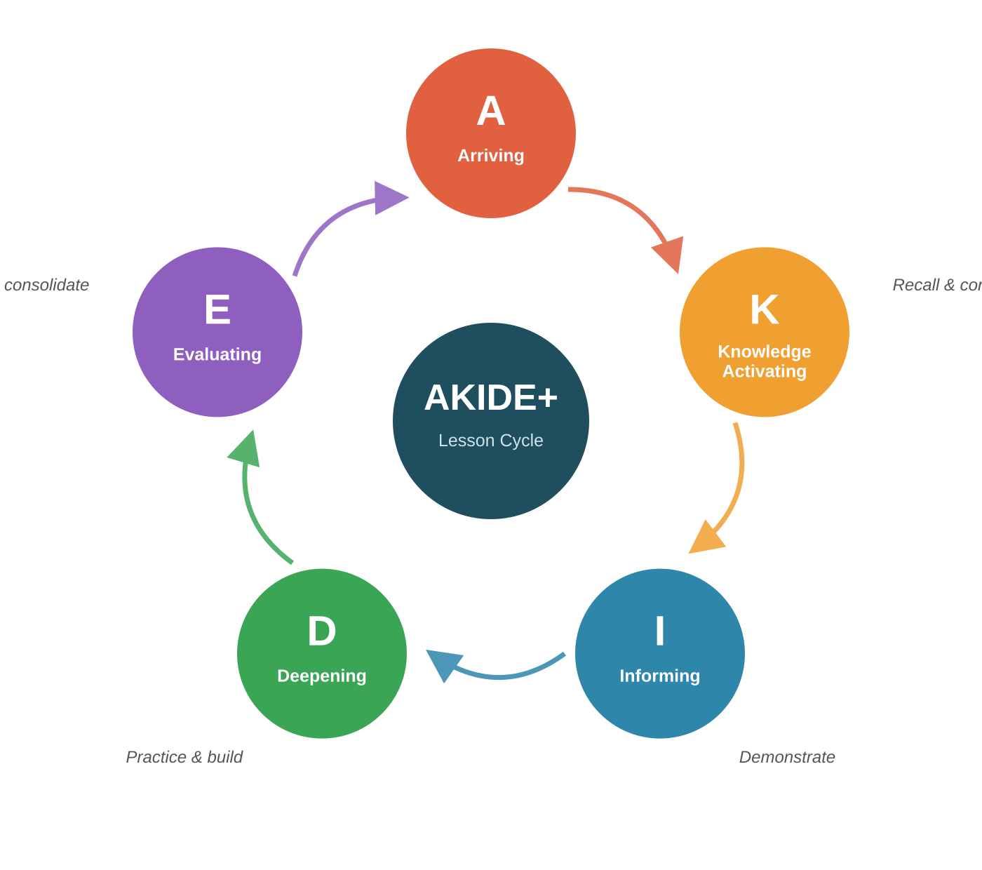 | Every lecture cycles through the same five phases. Each phase carries a colour used consistently in the timing tables that follow — use it as a quick visual cue when planning or facilitating a session.  A Arriving — hooks students into the topic with a relatable question or example  K Knowledge Activating — surfaces prior knowledge before new content is introduced  I Informing — faculty demonstrates the concept step by step  D Deepening — students build, test, and debug a program (occurs twice)  E Evaluating — quick formative check consolidates the learning  S Summary — wrap-up and an open-ended bridge to the next lesson

Unit I Learning Journey
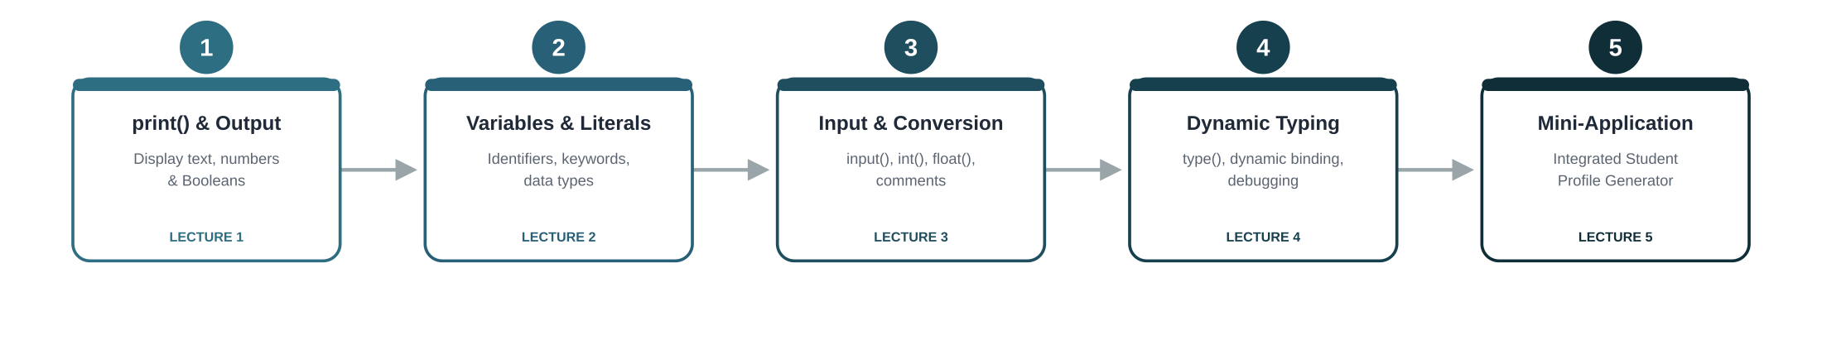
Each lecture keeps its own colour throughout the document, so the tables and headings below map back to this journey at a glance.

Lecture 1 | Python Environment, print() Function, and Basic Program Execution

Lesson Outcomes
By the end of the lesson, students will be able to:
✓ Execute a simple Python program in the selected development environment.
✓ Construct print() statements to display text, numeric, and Boolean literals.
✓ Diagnose and correct basic syntax errors in output statements.

Phase | Time | Teaching–Learning Flow | Faculty Role | Student Activity | Evidence / Formative Check
A  Arriving | 0–5 min | Introduce the unit context: “How can a computer display useful information for a user?” Present a simple expected output such as a student welcome message. | Establish the purpose of Python programming and clarify the lesson outcomes. | Observe the displayed output and predict what instructions may produce it. | Oral predictions from students.
K  Knowledge  Activating | 5–12 min | Ask students to recall where they have seen computer-generated messages: ATM screens, mobile apps, websites, gaming interfaces, or digital receipts. | Facilitate Think–Pair–Share and connect responses to program output. | Discuss examples with a peer and identify information displayed by each system. | Students identify at least one real-life system output.
I  Informing | 12–22 min | Demonstrate the Python environment, program file creation, running a script, and use of print() for text, numbers, and Boolean values. | Demonstrate step by step, connecting each command to the displayed output. | Follow the demonstration and run a basic print() program. | Students successfully execute one Python script.
D  Deepening | 22–38 min | Students write a “Welcome to BSDU” program that displays their name, programme, city, and a motivational message using separate print() statements. | Provide scaffolding for file creation, quotation marks, brackets, and execution. | Write, run, observe, and refine the program individually. | Faculty observes correct syntax and successful execution.
D  Deepening | 38–48 min | Introduce intentionally faulty print() statements with missing quotation marks, brackets, or commas. Students predict the error, run the code, and correct it. | Prompt students to read the error message rather than immediately supplying the correction. | Work in pairs to identify, correct, and rerun faulty statements. | Corrected output and a brief verbal explanation of one error.
E  Evaluating | 48–55 min | Invite selected pairs to display one correct and one corrected print() statement. Consolidate the relationship between program instruction and output. | Provide formative feedback on syntax, readability, and systematic debugging. | Explain one correction made during the activity. | Peer responses and faculty questioning.
S  Summary | 55–60 min | Summarise Python execution, output statements, literals, and syntax correction. Ask: “How might a program display information differently for different users?” | Conclude and connect the question to variables and input in the next lesson. | Write a one-minute response. | Exit response identifies the need to store or receive user-specific information.

Lecture 2 | Variables, Identifiers, Keywords, Data Types, and Literals

Lesson Outcomes
By the end of the lesson, students will be able to:
✓ Select valid and meaningful identifiers for storing program data.
✓ Construct variable assignments using integer, float, string, and Boolean literals.
✓ Distinguish variables, keywords, and identifiers in a Python code fragment.

Phase | Time | Teaching–Learning Flow | Faculty Role | Student Activity | Evidence / Formative Check
A  Arriving | 0–5 min | Revisit the previous open-ended question: “How can one program display different names or messages?” Display a fixed-output welcome program from Lecture 1. | Invite students to identify the limitation of fixed text in a program. | Recall the role of print() and suggest how information may be stored for later use. | Oral responses connect stored information with variables.
K  Knowledge  Activating | 5–12 min | Present names such as student_name, totalMarks, class, 2value, _count, and for. Ask students to classify them as usable or unusable program names. | Create manageable cognitive dissonance by asking why some familiar words cannot be used as variable names. | Discuss classifications in pairs and justify choices. | Pair responses reveal prior assumptions about names and rules.
I  Informing | 12–25 min | Explain variables, assignment, identifiers, keywords, naming conventions, basic data types, and literals. Demonstrate meaningful variable naming using student-related data. | Use code examples and highlight the distinction between a variable name and its stored value. | Annotate a short code fragment by labelling variable, identifier, keyword, literal, and output. | Students complete annotation accurately.
D  Deepening | 25–40 min | Students create a “Student Record Display” program using variables for name, roll number, percentage, attendance status, and programme. | Guide students to use meaningful identifiers and appropriate literal types. | Write and run the program individually; compare output with a partner. | Program executes and displays all stored values.
D  Deepening | 40–50 min | In groups, students receive a mixed code sheet containing valid identifiers, invalid identifiers, keywords, and literals. They classify and correct the invalid identifiers. | Probe reasoning: “Why is this invalid?” and “How would you rename it professionally?” | Collaboratively classify and revise names. | Group worksheet or board response.
E  Evaluating | 50–55 min | Conduct a rapid code-reading check: faculty displays a short program and asks students to identify the data type of each value. | Correct misconceptions about strings, numeric values, and Boolean literals. | Respond individually using written slips or digital polling. | Quick-response accuracy.
S  Summary | 55–60 min | Summarise variable assignment, naming rules, keywords, identifiers, data types, and literals. Ask: “If every student enters a different age or height, how can the program receive that information while running?” | Bridge to input() and type conversion. | Record a one-sentence answer. | Exit response indicates the need for user input.

Lecture 3 | User Input, Comments, and Type Conversion

Lesson Outcomes
By the end of the lesson, students will be able to:
✓ Construct Python programs that accept user information through input().
✓ Apply int() and float() conversion functions to process numeric user input.
✓ Document input, processing, and output stages using appropriate comments.

Phase | Time | Teaching–Learning Flow | Faculty Role | Student Activity | Evidence / Formative Check
A  Arriving | 0–5 min | Revisit the previous question about receiving user-specific data. Display two runs of the same program with different user-entered names. | Invite students to compare the outputs and infer what changed. | Identify that the program receives information during execution. | Students explain the role of user input.
K  Knowledge  Activating | 5–12 min | Present a task: “Create a program that asks a student for name, age, and height, then displays a profile.” Ask students to decide which inputs are textual and which must be numeric. | Facilitate group reasoning without initially explaining conversion syntax. | In pairs, prepare a simple input–process–output plan. | Students identify expected inputs and outputs.
I  Informing | 12–25 min | Demonstrate input(), string input behaviour, int(), float(), and comments. Show why numeric input may require conversion before calculation. | Explain only after students encounter the need to process numeric data. | Follow the demonstration and annotate the input, conversion, and output lines. | Students distinguish raw input from converted values.
D  Deepening | 25–42 min | Students develop a “Student Profile and Age Projection” program. It accepts name, age, height, and semester; converts suitable values; and displays the student’s age after five years. | Support students through guiding questions on suitable variable names, conversion, and output labels. | Write, test, and debug the program individually. | Successful program execution with correct converted values.
D  Deepening | 42–50 min | Students exchange programs in pairs. Each peer tests the program using a new input set and checks whether comments clearly describe the code sections. | Provide a short peer-review prompt focused on clarity, conversion, and output correctness. | Test a peer’s program and suggest one specific revision. | Peer feedback and revised code.
E  Evaluating | 50–55 min | Present conversion examples such as "25", "18.5", "Python", and "True". Students predict whether int() or float() conversion will work. | Ask students to justify predictions before running examples. | Predict, test, and explain results. | Correct prediction and explanation of one failed conversion.
S  Summary | 55–60 min | Summarise input(), comments, data conversion, and testing with varied values. Ask: “Can one variable hold different kinds of values at different times in a Python program?” | Connect to dynamic typing and dynamic binding. | Record an initial prediction. | Exit response captures students’ assumptions.

Lecture 4 | Dynamic Typing, Dynamic Binding, and Program Debugging

Lesson Outcomes
By the end of the lesson, students will be able to:
✓ Trace changes in the value and type of a Python variable during execution.
✓ Analyse dynamic typing and dynamic binding using type() and example programs.
✓ Correct simple type-related runtime errors in Python programs.

Phase | Time | Teaching–Learning Flow | Faculty Role | Student Activity | Evidence / Formative Check
A  Arriving | 0–5 min | Display the question from the previous lesson: “Can one variable hold different kinds of values?” Ask students to revisit their predictions. | Encourage students to state their reasoning before testing it. | Share predictions with a peer. | Initial ideas are surfaced without immediate correction.
K  Knowledge  Activating | 5–15 min | Present the code below without running it: value = 25, value = "BSDU", print(value + 10). Ask students to predict the output or error. | Facilitate discussion and identify misconceptions about variables and values. | Predict individually, discuss in pairs, and justify the expected result. | Students submit a prediction with a reason.
I  Informing | 15–27 min | Demonstrate dynamic typing and dynamic binding by assigning integer, string, float, and Boolean values to the same variable. Use type() to inspect each state. | Relate each reassignment to the earlier student predictions. | Prepare a trace table showing variable name, value, and type after each assignment. | Completed trace table.
D  Deepening | 27–42 min | Students create and run a “Variable Type Tracker” program. They assign and reassign values to one variable, print the value and its type after every change, and add explanatory comments. | Provide prompts for systematic observation rather than only code completion. | Develop, execute, and refine the tracker program. | Correct trace of changing values and types.
D  Deepening | 42–50 min | Pairs debug type-related code fragments, including attempts to combine strings and numbers incorrectly. They revise the code using type conversion or appropriate output formatting. | Ask students to explain whether the correction requires conversion, reassignment, or a change in expression. | Diagnose, correct, and test assigned faulty snippets. | Corrected code and verbal reasoning.
E  Evaluating | 50–55 min | Conduct a short “code-to-output” exercise. Students identify the final value and type of a variable after a sequence of assignments. | Use responses to reinforce that type is associated with the current object/value bound to the name. | Solve independently and compare with a partner. | Individual written response.
S  Summary | 55–60 min | Summarise dynamic typing, dynamic binding, type(), and type-related debugging. Ask: “How can we combine input, variables, conversion, output, and type checking in one useful program?” | Set up the integrated programming task for the final lecture. | Note a possible application idea. | Student-generated application idea.

Lecture 5 | Integrated Python Mini-Application — Student Profile Generator

Lesson Outcomes
By the end of the lesson, students will be able to:
✓ Develop a simple Python program that accepts, converts, stores, and displays student information.
✓ Test and refine the program using varied input values and expected outputs.
✓ Explain how variables, comments, input, output, type conversion, and dynamic typing operate in the program.

Phase | Time | Teaching–Learning Flow | Faculty Role | Student Activity | Evidence / Formative Check
A  Arriving | 0–5 min | Revisit the Unit I learning journey through a short sequence: print() → variables → input() → conversion → dynamic typing. Introduce the mini-application challenge. | State the challenge: build a console-based Student Profile Generator. | Recall the function of each concept and identify its role in the proposed application. | Oral concept-mapping responses.
K  Knowledge  Activating | 5–12 min | In small groups, students analyse the application requirement and decide required inputs, variable names, conversions, output headings, and type-checking statements. | Encourage students to prepare a simple input–process–output design before coding. | Prepare a brief program logic plan with peers. | Group plan identifies inputs, conversions, and outputs.
I  Informing | 12–20 min | Demonstrate how to organise a short Python program into commented sections: program purpose, input, conversion, processing, output, and type inspection. | Model code organisation and testing discipline without providing the complete solution. | Annotate the suggested program structure. | Students identify the role of each section.
D  Deepening | 20–42 min | Students individually or in pairs create the Student Profile Generator. The program accepts name, programme, semester, age, height, and percentage; converts numeric values; displays a formatted profile; and prints the type of selected variables. | Provide scaffolding through questions, checkpoints, and troubleshooting support. | Write, run, test, debug, and improve the program. | Working program with correct input, conversion, and formatted output.
D  Deepening | 42–50 min | Students add a dynamic-typing demonstration by reassigning one variable with a value of another type and printing its revised type. | Check that students can explain the difference between original and reassigned values. | Add, run, and explain the reassignment segment. | Correct dynamic-typing demonstration.
E  Evaluating | 50–55 min | Conduct peer testing. Each group exchanges one test case and checks whether the partner’s program handles expected values correctly and produces readable output. | Guide peer feedback toward correctness, clarity, comments, and meaningful identifiers. | Test another program and provide one improvement suggestion. | Peer test record and correction made.
S  Summary | 55–60 min | Consolidate Unit I through a short reflection: “Which error did you correct, and what did it teach you about Python programming?” Ask: “How might this profile program be extended to make decisions based on student data?” | Link the answer to the next unit on operators and control flow. | Submit an individual reflection. | Reflection demonstrates metacognition and readiness for conditional logic.

