BSDU
ID1104 — Course Delivery Notes
Unit I: Introduction to Python and Basic Syntax

Unit Overview
This document consolidates the Knowledge segment (K) of Unit I into a structured, five-hour teaching sequence. The approach blends concise deductive explanation, discovery through code observation, Think–Pair–Share discussion, guided code tracing, and formative reflection. Application activities (A1–A3) are addressed separately within the practical component of the course.

Knowledge Segments Covered
- K1 — Python environment and the print() function
- K2 — Variables, keywords, identifiers, dynamic typing, and dynamic binding
- K3 — Basic data types and literals
- K4 — Type conversion between different data formats

Lesson Map
Lesson | Title | Focus | Duration
1 | Python Environment and Output Using print() | K1 | 60 min
2 | Variables, Keywords, and Identifiers | K2 | 60 min
3 | Dynamic Typing and Dynamic Binding | K2 | 60 min
4 | Basic Data Types and Literals | K3 | 60 min
5 | Type Conversion Between Data Formats | K4 | 60 min

Lesson 1: Python Environment and Output Using print()
Duration: 60 minutes Knowledge Focus: K1 — Basic elements of the Python environment and the use of print() for output.

Lesson Outcomes
- Identify the main elements of a Python programming environment.
- Interpret the purpose and output of simple Python print() statements.
- Differentiate between Python code, comments, and displayed output.

The Python Environment
A Python program is written in an editor, executed by the interpreter, and its result is shown in a terminal or output area. Recognising these three components is the first step to reading and running any Python program.
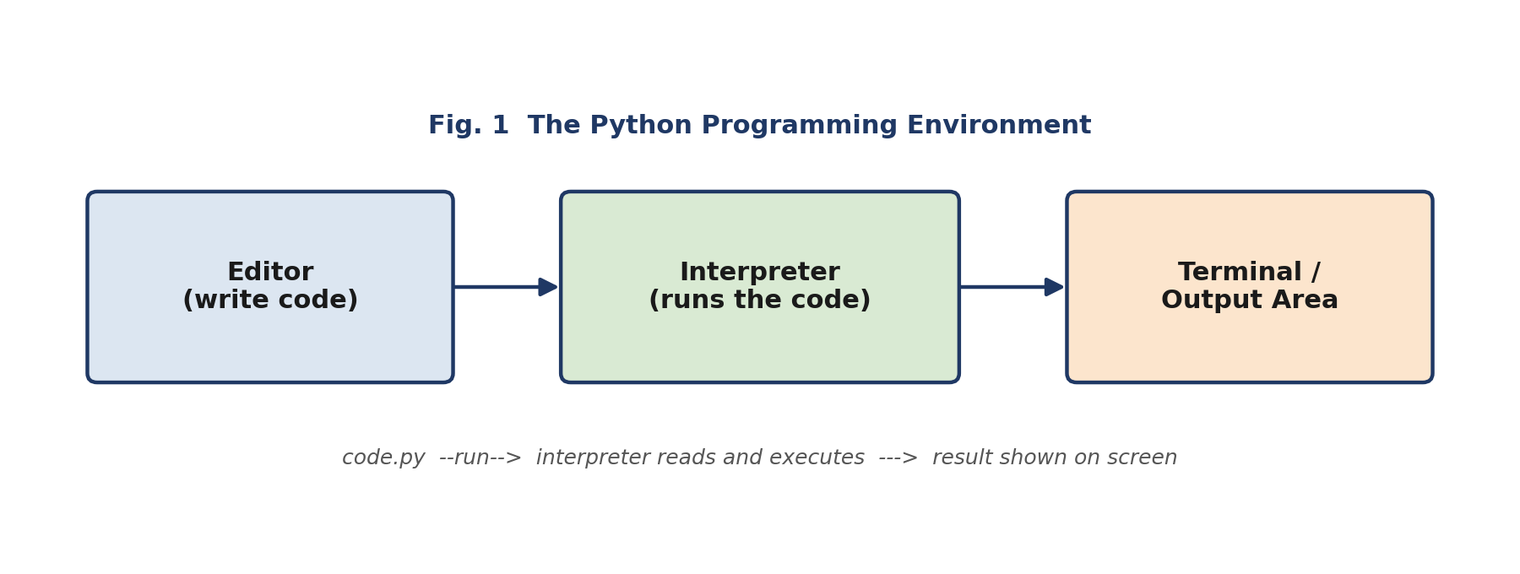
Fig. 1 — The Python Programming Environment

Code Reference: print() Statements
# Displaying text
print("Hello, World!")

# Displaying an arithmetic expression
print(5 + 3)

# Combining text and a value
print("Total:", 100)
Predict the output of each statement before running it — this habit builds a reliable mental model of how print() behaves.

Lesson Flow
Time | Teaching–Learning Flow | Faculty Role | Student Activity | Evidence / Formative Check
0–5 min | Opening seed: display “Calculate and display the total bill” and ask how a computer shows its result. | Pose the context and elicit prior exposure to programming interfaces. | Individually note possible ways a program may communicate results. | Oral responses identifying screen output.
5–12 min | Introduce Python and demonstrate the environment: editor, interpreter/terminal, program file, run command, output area. | Demonstrate the environment using VS Code, Python IDLE, or another approved editor. | Observe and label the visible environment components in a worksheet. | Students identify editor, code area, terminal/output area, and run command.
12–20 min | Demonstrate basic print() statements with text, numbers, and arithmetic expressions; predict output before execution. | Explain syntax briefly; use prediction before revealing output. | Think–Pair–Share: predict output of three statements. | Responses to output-prediction prompts.
20–30 min | Discovery activity: pairs of correct and incorrect print() statements; identify patterns in quotation marks, parentheses, and placement. | Facilitate discovery; consolidate the observed syntax rules. | Compare code snippets and state why one succeeds or fails. | Pair worksheet with corrected statements.
30–42 min | Explain output readability: labels, line breaks, and combining text with values at an introductory level. | Demonstrate clear versus unclear output presentation. | Analyse two output samples and identify the more user-friendly one. | One written justification using output terminology.
42–52 min | Guided code tracing: trace a short program containing multiple print() statements and arithmetic expressions. | Ask probing questions; correct misconceptions. | Write the expected output before running the program. | Trace-sheet accuracy.
52–60 min | Summary and reflection: revisit environment, execution, and print(). Close with: “What might make a program’s output useful to a real user?” | Consolidate core points and collect exit tickets. | Submit one print() statement and one doubt/question. | Exit ticket.

Lesson 2: Variables, Keywords, and Identifiers
Duration: 60 minutes Knowledge Focus: K2 — Variables, keywords, and identifiers.

Lesson Outcomes
- Distinguish variables, identifiers, and Python keywords.
- Evaluate whether a proposed identifier follows Python naming rules.
- Interpret variable assignment statements in simple Python programs.

Variables as Named References
A variable is a name linked to a value stored in memory. Assignment uses the = operator to attach a name to a value.
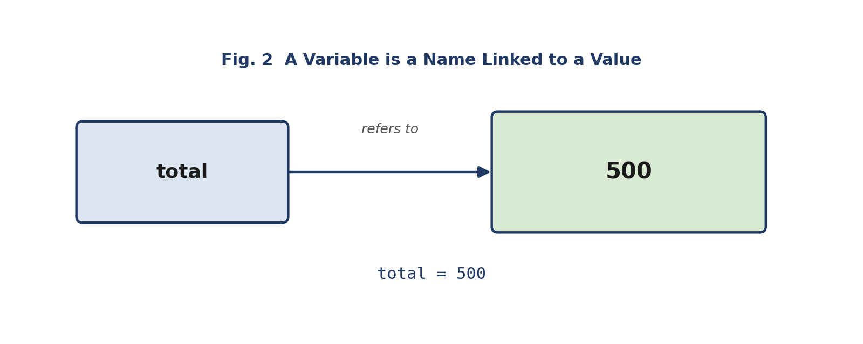
Fig. 2 — A Variable is a Name Linked to a Value

Code Reference: Identifiers and Assignment
# Valid statements
total = 500
student_name = "Aman"

# Invalid identifiers (will raise a SyntaxError)
# class = "BCA" -> "class" is a reserved keyword
# student-name = "Aman" -> hyphens are not allowed
# 2marks = 90 -> identifiers cannot start with a digit

Lesson Flow
Time | Teaching–Learning Flow | Faculty Role | Student Activity | Evidence / Formative Check
0–5 min | Recap: review print() through two output-prediction questions. | Prompt recall and connect output with stored values. | Respond individually, then compare with a peer. | Quick oral check.
5–12 min | Cognitive-dissonance prompt: total = 500, class = "BCA", student-name = "Aman", 2marks = 90 — which can run and why? | Avoid immediate explanation; invite justification. | Classify statements as valid or invalid. | Initial classification responses.
12–25 min | Explain variables as named references to values; introduce the assignment operator, identifiers, naming conventions, and keywords. | Give concise explanation and relate each rule to the opening examples. | Annotate examples: variable name, assignment operator, and assigned value. | Annotated code sheet.
25–35 min | Think–Pair–Share: classify names such as student_name, totalMarks, for, student-name, _count; correct where needed. | Facilitate peer discussion and clarify keyword restrictions. | Classify identifiers and propose improved names. | Pair response sheet.
35–45 min | Demonstrate reassignment using score = 75 followed by score = 82. | Connect changed values to later program output. | Predict the output after each assignment. | Individual output prediction.
45–53 min | Guided code-reading task: analyse a short student-profile script and identify variables, identifiers, literals, and keywords. | Scaffold with one solved example. | Mark elements in the supplied code. | Checked annotation sheet.
53–60 min | Summary and reflection: consolidate identifier rules and assignment. Leave: “If a variable can receive a new value, what might happen to its data type?” | Link forward to dynamic typing. | Write one valid identifier, one invalid identifier, and the reason. | Exit ticket.

Lesson 3: Dynamic Typing and Dynamic Binding
Duration: 60 minutes Knowledge Focus: K2 — Dynamic typing and dynamic binding.

Lesson Outcomes
- Trace changes in a variable’s value and associated data type during program execution.
- Analyse examples that demonstrate dynamic typing and dynamic binding.
- Differentiate between a variable name and the value currently associated with it.

Same Name, Changing Type
In Python, a variable name can be re-bound to values of different types over the course of a program. The name itself does not change — only the value (and therefore the type) it currently refers to.
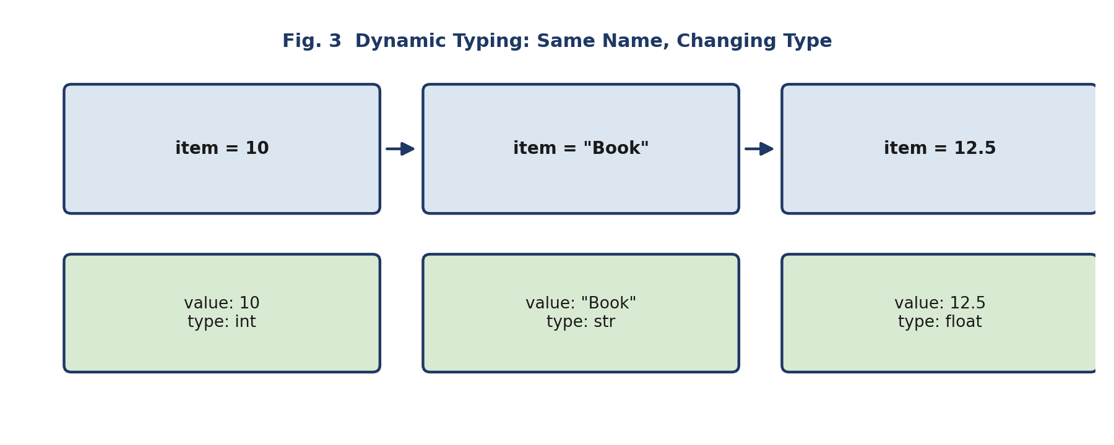
Fig. 3 — Dynamic Typing: Same Name, Changing Type

Code Reference: type()
item = 10
print(type(item)) # <class 'int'>

item = "Book"
print(type(item)) # <class 'str'>

item = 12.5
print(type(item)) # <class 'float'>

Lesson Flow
Time | Teaching–Learning Flow | Faculty Role | Student Activity | Evidence / Formative Check
0–5 min | Recap: review variables, identifiers, and reassignment through a short code trace. | Ask students to state the final value of a reassigned variable. | Predict final output. | Oral response.
5–12 min | Seed example: item = 10, item = "Book", item = 12.5. Ask: “Has the name changed? What has changed?” | Encourage observation before introducing terminology. | Discuss observations in pairs. | Pair explanation.
12–24 min | Explain dynamic typing and dynamic binding through visual tracing of name-to-value association. | Use a table or board diagram showing statement, value, and type. | Complete a partially filled tracing table. | Completed trace table.
24–34 min | Demonstrate type() for observing the type of integer, float, string, and Boolean values. | Run sample statements and invite output predictions. | Predict data type before execution. | Accuracy of prediction.
34–45 min | Collaborative analysis: groups receive code fragments that reassign variables using different values. | Guide groups through questions rather than direct correction. | Trace program state and present findings. | Group tracing sheet.
45–53 min | Compare fixed-type declarations conceptually with Python’s dynamic handling, without extending into another language’s syntax. | Clarify that the focus is Python behaviour. | Write a two-column comparison: “variable name” and “current value/type.” | Individual notebook response.
53–60 min | Summary and reflection: consolidate dynamic typing and binding. Leave: “What kinds of values can Python store, and how can we recognise them?” | Address common confusion between value change and variable name change. | Submit a one-minute explanation of dynamic typing. | One-minute paper.

Lesson 4: Basic Data Types and Literals
Duration: 60 minutes Knowledge Focus: K3 — Basic Python data types and literals.

Lesson Outcomes
- Classify Python values as integer, float, string, Boolean, or None.
- Analyse the role of literals in Python assignment statements.
- Select appropriate basic data types for simple information items.

Classifying Values
Values that look similar on screen may belong to different types. Recognising the type behind a literal is essential before combining values in expressions.
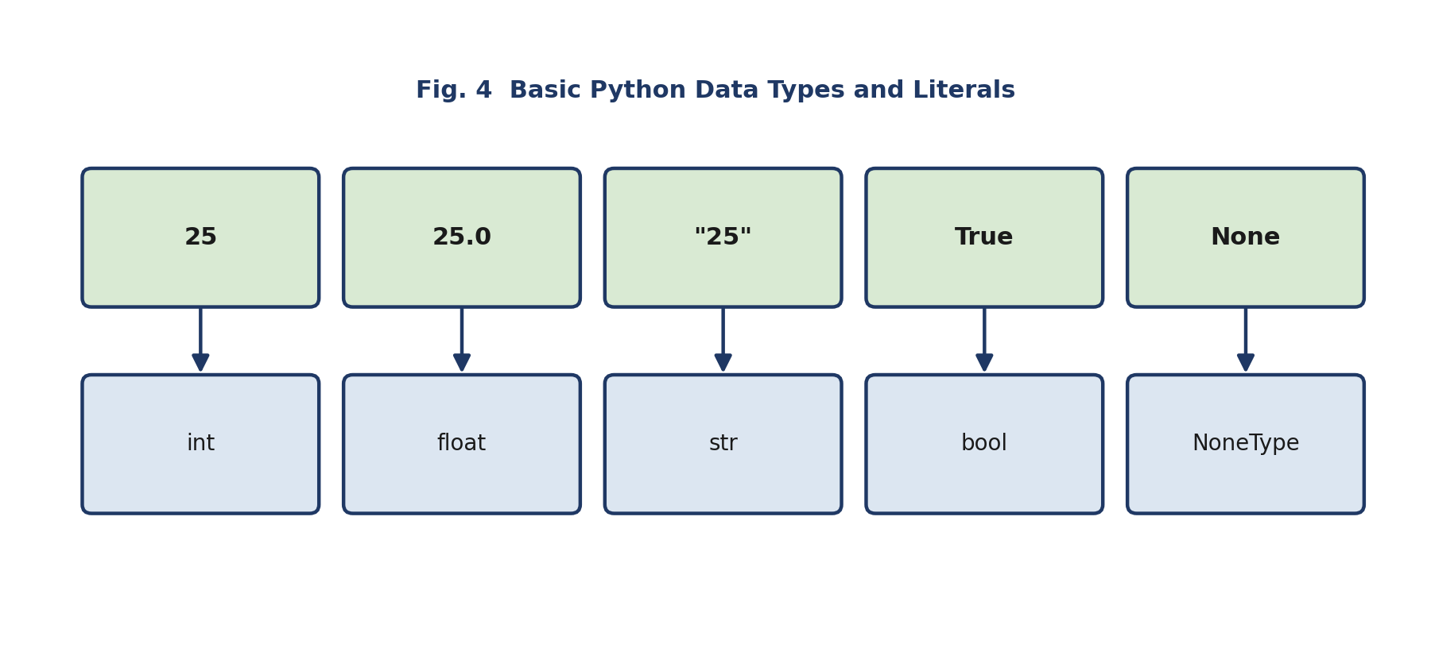
Fig. 4 — Basic Python Data Types and Literals

Code Reference: Data Types
age = 18 # int
name = "Riya" # str
is_active = True # bool
gpa = 8.7 # float
middle_name = None # NoneType

Lesson Flow
Time | Teaching–Learning Flow | Faculty Role | Student Activity | Evidence / Formative Check
0–5 min | Recap: revisit type() and identify the type of values from the previous lesson. | Use rapid questioning. | Respond using hand signals or response cards. | Immediate response check.
5–12 min | Discovery prompt: 25, 25.0, "25", True, None. Ask: “Which values look similar but behave differently?” | Encourage observation and comparison. | Discuss distinctions in pairs. | Pair-generated observations.
12–25 min | Explain integer, float, string, Boolean, and None types; introduce literals as directly written values in code. | Present concise definitions with Python examples. | Record examples and add one example of each type. | Notebook check.
25–35 min | Classification task: students sort printed/digital value cards into data-type groups. | Monitor and question ambiguous classifications. | Categorise values collaboratively. | Correctly sorted cards or digital response.
35–44 min | Guided analysis of assignment statements: age = 18, name = "Riya", is_active = True. | Model analysis of one statement. | Identify identifier, literal, and data type in remaining examples. | Worksheet responses.
44–53 min | Contextual decision task: select appropriate data types for name, semester, percentage, attendance status, optional middle name. | Facilitate reasoning; highlight that type selection depends on intended use. | Justify their selections in small groups. | Short group explanation.
53–60 min | Summary and reflection: consolidate data types and literals. Leave: “What should Python do when a value needs to be used in another data format?” | Bridge to type conversion. | Exit ticket: classify five literals. | Exit-ticket accuracy.

Lesson 5: Type Conversion Between Data Formats
Duration: 60 minutes Knowledge Focus: K4 — Type conversion between different data formats.

Lesson Outcomes
- Interpret the purpose of type conversion in Python.
- Trace the results of conversion using int(), float(), and str().
- Analyse simple conversion errors caused by incompatible values.

Why Convert Types?
A value read as text (such as user input) cannot be used directly in a numeric calculation. Explicit conversion reshapes a value into the type an operation requires.
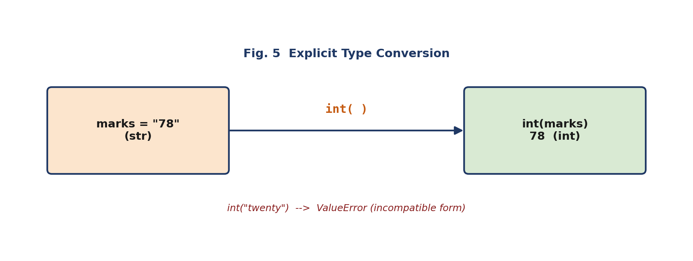
Fig. 5 — Explicit Type Conversion

Code Reference: int(), float(), str()
marks = "78"
# marks + 2 -> TypeError: cannot add str and int

print(int(marks) + 2) # 80
print(float("15.5")) # 15.5
print(str(90)) # "90"

# Invalid conversion
# int("twenty") -> ValueError: invalid literal for int()

Lesson Flow
Time | Teaching–Learning Flow | Faculty Role | Student Activity | Evidence / Formative Check
0–5 min | Recap: classify "45" and 45, then compare their possible use in a calculation. | Pose the contrast without resolving it immediately. | Predict whether both values behave identically. | Oral justification.
5–15 min | Problem seed: marks = "78"; ask why marks + 2 may not produce the intended numerical result. | Facilitate discussion and collect hypotheses. | Think–Pair–Share on the cause and possible correction. | Pair response.
15–28 min | Explain explicit type conversion using int(), float(), and str(). Demonstrate valid conversions and output tracing. | Use short demonstrations; ask prediction questions before execution. | Trace value and type before and after conversion. | Conversion-trace table.
28–38 min | Analyse int("25"), float("15.5"), str(90), and an invalid conversion such as int("twenty"). | Explain that conversion depends on whether the source value has a compatible form. | Identify expected result or error for each example. | Individual response sheet.
38–48 min | Integrative code reading: a short program that receives text input, converts selected values, and displays labelled output. | Guide students to identify source type, target type, and reason for conversion. | Annotate conversion statements in the program. | Annotated code submission.
48–55 min | Unit-level conceptual review: connect environment, output, variables, dynamic typing, data types, literals, and type conversion via a concept map. | Facilitate collaborative consolidation. | Build a group concept map and explain one connection. | Group concept map.
55–60 min | Summary, formative check, and open-ended question: short five-question quiz. Leave: “How can these concepts combine into a useful interactive Python program?” | Review quiz responses and preview the practical application segment. | Complete quiz and write one remaining doubt. | Quiz and muddiest-point note.

Unit I Knowledge-Segment Evidence
By the end of the five hours, students should produce:
- Python-environment component labelling sheet
- print() output-prediction sheet
- Identifier and keyword classification worksheet
- Dynamic typing and dynamic binding trace table
- Data-type and literal classification sheet
- Type-conversion trace table
- Unit concept map
- Five-question formative quiz and reflection notes

