Lesson Flow
Unit II
Operators and Control Flow

Unit Overview
At BSDU, this six-lesson Problem-Based Learning (PBL) sequence addresses Unit II through a single running problem: the basic Guessing Game. Students encounter the problem before receiving formal explanations of operators, decisions, loops, indentation, and loop-control statements. Across six lessons, they progressively analyse the requirements, identify what they need to learn, test alternative logic, and develop a justified solution design.

The Problem-Based Learning Cycle
Each lesson advances the same problem through five moves: encountering or extending the Problem, analysing it into inputs, outputs, decisions, and repeated actions, identifying what needs to be Learned, Designing and Testing a partial solution, and Reflecting before the next extension is introduced.
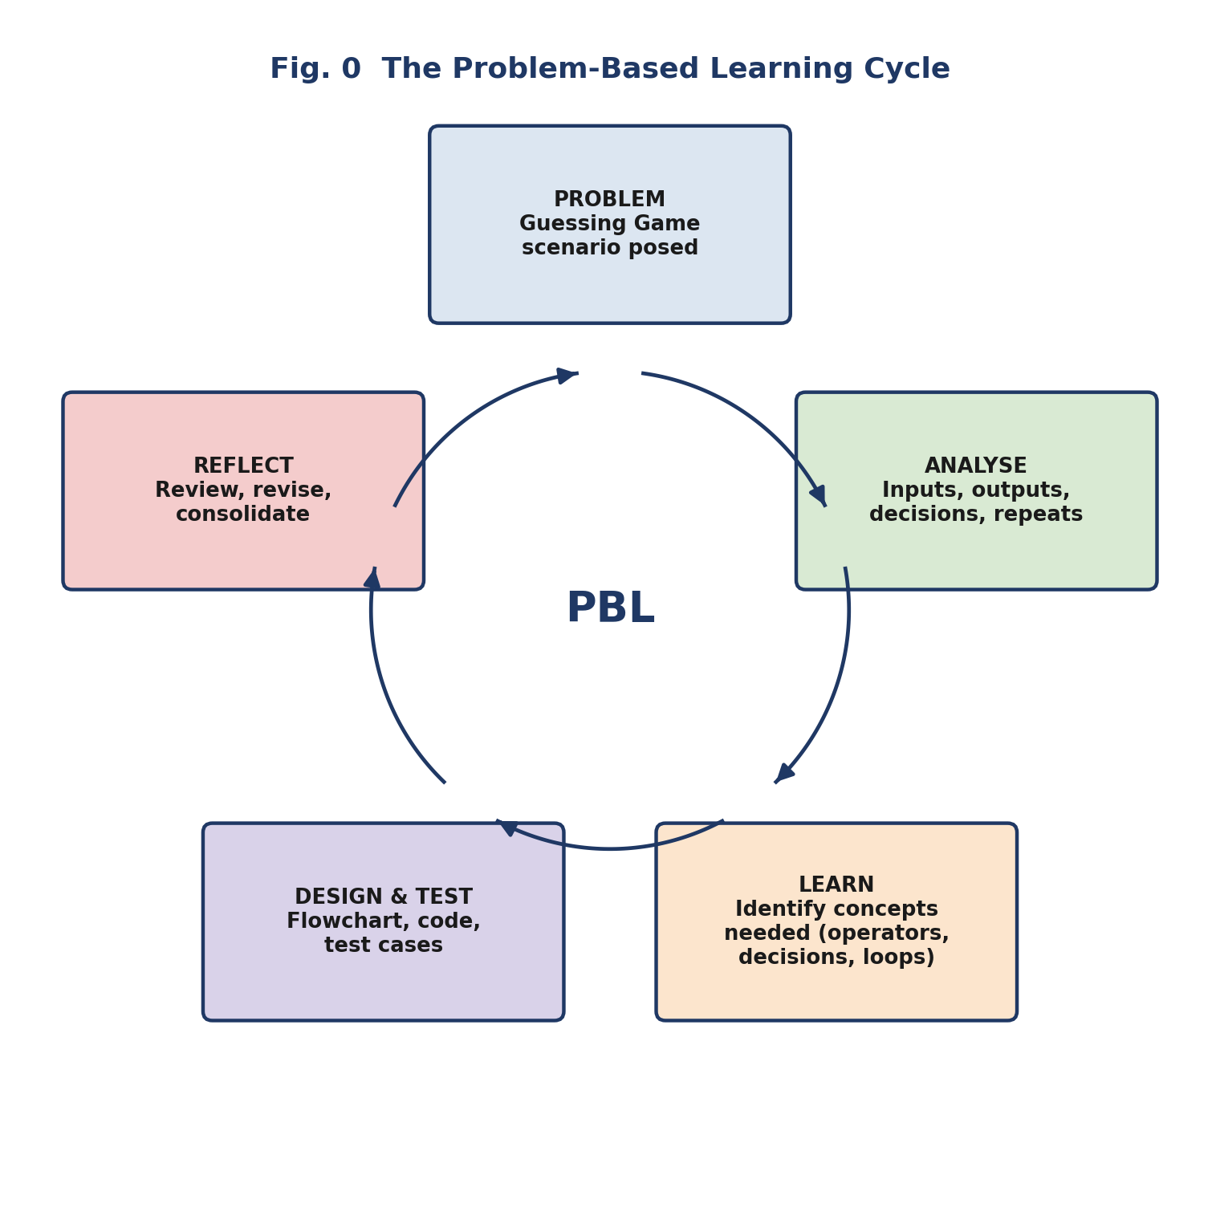
Fig. 0 — The Problem-Based Learning Cycle

Knowledge Elements Covered
- K1 — Arithmetic, logical, and assignment operators
- K2 — if-else, nested if-else, and the significance of indentation
- K3 — while, for, nested loops, and break, continue, pass

Related Course Outcome
Construct Python solutions using conditional statements, iterative constructs, and loop-control statements for defined logical and repetitive-processing tasks.

Lesson Map
Lesson | Title | Focus | Duration
1 | Understanding the Problem and Identifying Required Logic | Problem framing | 60 min
2 | Using Operators to Represent Rules and Conditions | K1 | 60 min
3 | Designing Decisions through if-else and Indentation | K2 | 60 min
4 | Handling Multiple Conditions through Nested if-else | K2 | 60 min
5 | Repeating Actions through while, for, and Nested Loops | K3 | 60 min
6 | Controlling Loop Execution with break, continue, and pass | K3 | 60 min

Problem Artefacts
- Problem-analysis sheet
- Flowcharts and pseudocode
- Code-trace sheets
- Test-case table
- Individual reflection log
- Basic Guessing Game logic design

Lesson 1: Understanding the Problem and Identifying Required Logic
Duration: 60 minutes Knowledge Focus: Introduction to the central problem; identifying arithmetic, comparison, decision, repetition, and termination needs.

Lesson Outcomes
- Analyse the requirements of a basic number-guessing problem.
- Identify the information, actions, decisions, and repeated processes required in a solution.
- Formulate questions about the Python concepts needed to design the solution.

The Problem
A user must guess a secret number within five attempts. The program should indicate whether the guess is too high, too low, or correct — before any operator or control-flow syntax is introduced, students sort this problem into what it must receive, display, compare, repeat, and stop.
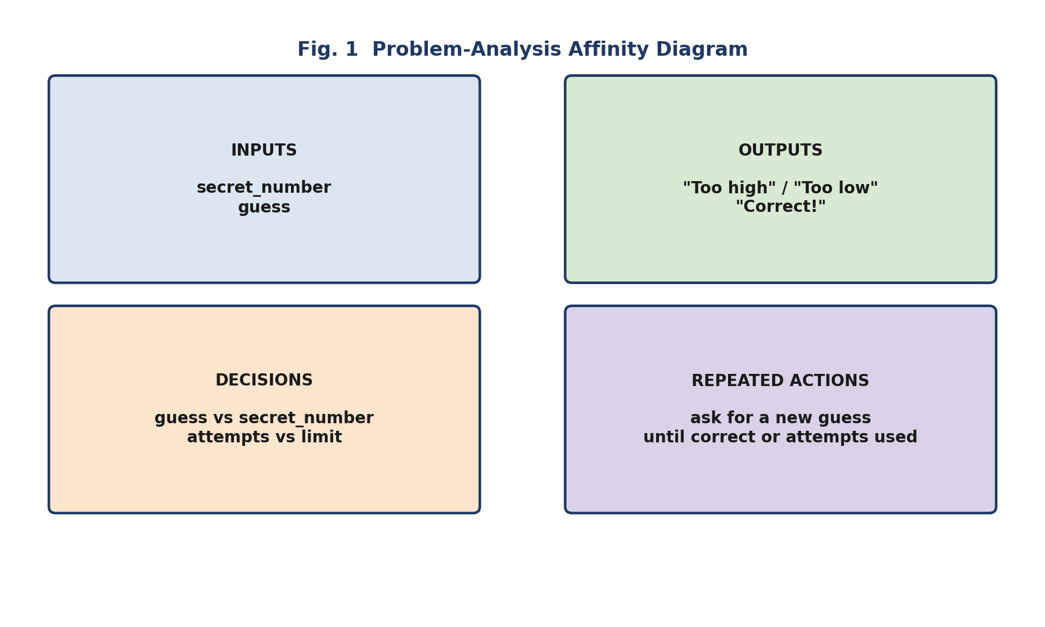
Fig. 1 — Problem-Analysis Affinity Diagram

Working Vocabulary (No Syntax Yet)
# What the program will eventually need — in plain terms:
secret_number # chosen value the user must guess
guess # value entered by the user
attempts # how many tries have been used

# Still open: how do we compare, decide, and repeat?

Lesson Flow
Time | Teaching–Learning Flow | Faculty Role | Student Activity | Evidence / Formative Check
0–5 min | Problem briefing: a user must guess a secret number within five attempts; indicate too high, too low, or correct. | Introduce the problem without explaining operators or control-flow syntax. | Listen, identify initial requirements, and note unfamiliar aspects. | Initial individual notes.
5–12 min | Prior-knowledge activation: recall variables, input, type conversion, and output from Unit I. | Connect the problem to prior Python learning. | Suggest how a program can store a secret number and receive a guess. | Oral responses and board notes.
12–22 min | Problem analysis: groups prepare an affinity diagram under four headings — inputs, outputs, decisions, repeated actions. | Facilitate collaborative inquiry using guiding questions. | Identify what the program must receive, display, compare, repeat, and stop. | Group problem-analysis sheet.
22–32 min | Knowledge-gap identification: “How will the program compare a guess with the secret number? Decide the message? Count attempts?” | Help students formulate learning issues without supplying solutions. | Develop a “Need to Learn” list. | Group list of required concepts.
32–42 min | Initial solution attempt: prepare a rough flowchart using ordinary language and symbols. | Encourage incomplete but reasoned attempts; avoid premature correction. | Draft a flowchart for one guess attempt. | Rough flowchart.
42–52 min | Peer critique: exchange flowcharts and identify missing conditions, repeated actions, or stopping conditions. | Guide critique through prompts: “What happens if the guess is wrong?” | Review and revise the flowchart. | Peer-feedback notes.
52–60 min | Debrief and reflection: summarise the problem structure; introduce operators as the first learning issue. | Consolidate learning and collect reflections. | Write one identified problem requirement and one concept they need to learn. | Exit ticket.

Lesson 2: Using Operators to Represent Rules and Conditions
Duration: 60 minutes Knowledge Focus: Arithmetic, comparison, logical, and assignment operators.

Lesson Outcomes
- Analyse expressions involving arithmetic, comparison, logical, and assignment operators.
- Select suitable operators for stated rules in the Guessing Game problem.
- Trace the values and Boolean results produced by Python expressions.

Turning Rules into Expressions
Plain-language rules — “guess is correct”, “attempts are less than five” — become Python expressions built from comparison, logical, and assignment operators.
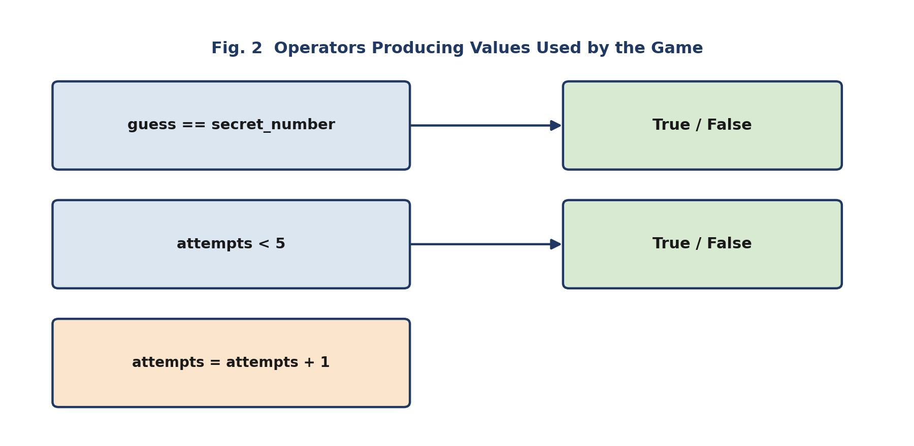
Fig. 2 — Operators Producing Values Used by the Game

Code Reference: Operators
guess == secret_number # comparison -> True or False
attempts < 5 # comparison -> True or False
guess > 0 and guess <= 100 # logical AND of two comparisons

attempts = attempts + 1 # assignment + arithmetic

# A common flaw to diagnose and correct:
# if guess = secret_number: -> SyntaxError (use == , not =)

Lesson Flow
Time | Teaching–Learning Flow | Faculty Role | Student Activity | Evidence / Formative Check
0–5 min | Recap: revisit the problem-analysis sheet; identify where comparison and counting are needed. | Link the lesson to the previous problem formulation. | Respond with examples such as guess comparison and attempt counting. | Oral responses.
5–15 min | Problem trigger: express “Guess is correct,” “Guess is above secret number,” “Attempts < 5,” “Guess is between 1 and 100” as program-ready rules. | Encourage students to propose symbols and expressions. | Develop candidate expressions using guess, secret_number, attempts. | Group expression sheet.
15–25 min | Concept clarification: explain arithmetic, comparison, logical, and assignment operators through the student-generated expressions. | Provide concise explanation after students have experienced the need for the concepts. | Annotate expressions with operator names and expected results. | Annotated worksheet.
25–35 min | Guided tracing: predict results for guess == secret_number, attempts < 5, guess > 0 and guess <= 100. | Model one trace, then scaffold progressively. | Trace values and determine True or False. | Individual trace table.
35–45 min | Collaborative task: correct flawed expressions, such as using = instead of == in a condition. | Ask groups to justify why the corrected expression represents the intended rule. | Diagnose and correct expressions. | Corrected expression set with explanations.
45–53 min | Integrative task: add an attempt counter to the earlier flowchart, showing where attempts = attempts + 1 belongs. | Connect assignment and arithmetic operators to the evolving solution. | Revise their flowchart. | Revised flowchart.
53–60 min | Summary and reflection: “Once the program obtains a True or False result, how should it choose the next action?” | Consolidate operator use in decision-making. | Submit one valid condition and one assignment statement for the problem. | Exit ticket.

Lesson 3: Designing Decisions through if-else and Indentation
Duration: 60 minutes Knowledge Focus: if-else statements and the significance of indentation.

Lesson Outcomes
- Construct decision logic for high, low, and correct guesses.
- Analyse the role of Boolean conditions in if-else statements.
- Diagnose indentation errors that alter Python control flow.

From Comparison to Feedback
Against a secret number of 25, guesses of 18, 25, and 37 must each trigger different feedback. Indentation is what defines which statements belong to which branch.
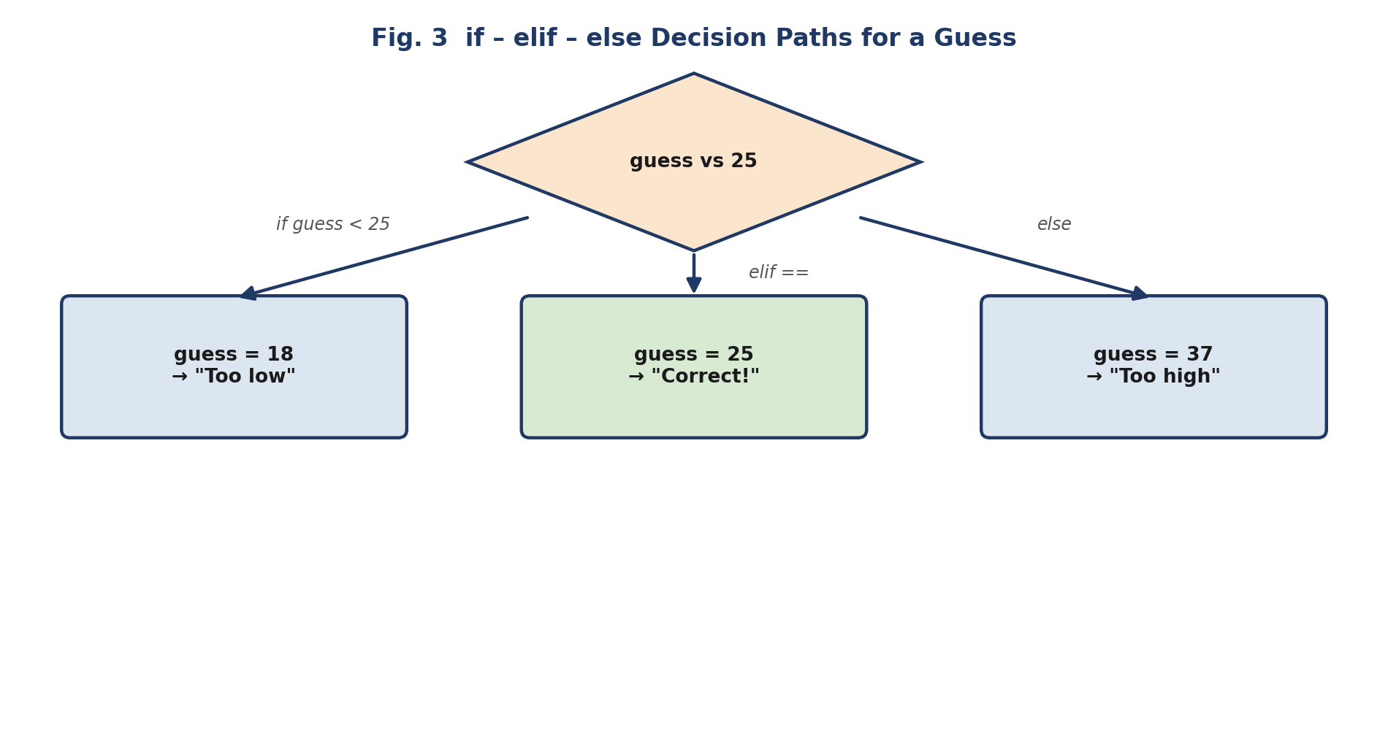
Fig. 3 — if – elif – else Decision Paths for a Guess

Code Reference: if / elif / else
if guess < secret_number:
print("Too low")
elif guess == secret_number:
print("Correct!")
else:
print("Too high")

# Indentation controls the block — not braces or semicolons.

Lesson Flow
Time | Teaching–Learning Flow | Faculty Role | Student Activity | Evidence / Formative Check
0–5 min | Recap: identify which Lesson 2 expressions can determine whether a guess is high, low, or correct. | Reinforce the relationship between conditions and decisions. | Suggest comparison expressions. | Quick oral check.
5–15 min | Problem extension: secret number 25; what distinct feedback for guesses 18, 25, and 37? | Ask students to articulate decision branches before introducing syntax. | Draft decision paths in plain language. | Decision-path chart.
15–25 min | Concept construction: convert decision paths into if, elif, else structure; explain blocks and indentation. | Demonstrate how indentation establishes the body of a decision block. | Compare plain-language logic with Python syntax. | Annotated code handout.
25–35 min | Indentation diagnosis: display snippets with correct and incorrect indentation; predict output or errors before execution. | Create manageable cognitive dissonance and ask students to justify predictions. | Identify which statements belong to each decision block. | Code-diagnosis worksheet.
35–45 min | Guided problem-solving: develop conditional logic for the Guessing Game feedback messages. | Provide prompts only when needed: “Which condition must be checked first?” | Write and trace a decision block. | Group code draft.
45–53 min | Peer review: checklist — condition correctness, complete branch coverage, meaningful messages, valid indentation. | Facilitate critique and formative feedback. | Review another group’s code and recommend corrections. | Peer-review checklist.
53–60 min | Summary and reflection: “Can one decision be placed inside another when rules become more specific?” | Preview nested conditions. | Write one reason indentation matters in Python. | Exit response.

Lesson 4: Handling Multiple Conditions through Nested if-else
Duration: 60 minutes Knowledge Focus: Nested if-else statements and structured decision logic.

Lesson Outcomes
- Analyse a multi-condition problem requiring nested decisions.
- Construct nested if-else logic with correct indentation.
- Evaluate whether a decision condition should be placed at the outer or inner level.

Two Questions, Not One
Adding the rule “valid guesses are 1 to 100” raises a design question: should the program check validity first, or compare with the secret number first? The outer condition guards entry to the inner comparison.
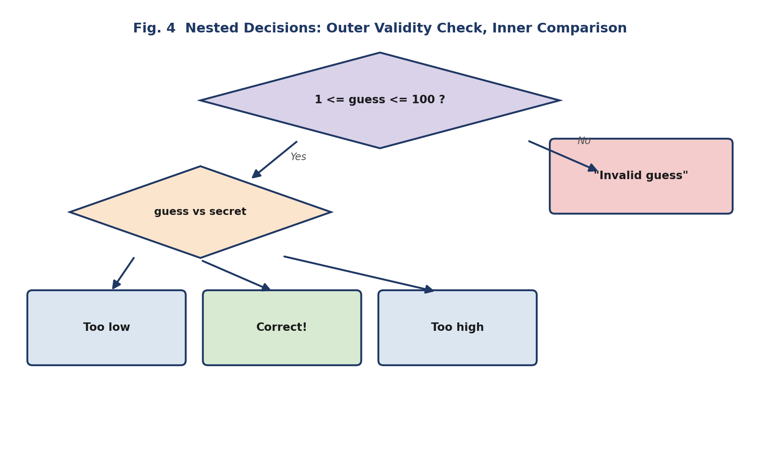
Fig. 4 — Nested Decisions: Outer Validity Check, Inner Comparison

Code Reference: Nested if-else
if 1 <= guess <= 100:
if guess < secret_number:
print("Too low")
elif guess == secret_number:
print("Correct!")
else:
print("Too high")
else:
print("Invalid guess")

Lesson Flow
Time | Teaching–Learning Flow | Faculty Role | Student Activity | Evidence / Formative Check
0–5 min | Recap: review the three outcomes of a guess — low, correct, high. | Link basic decisions to more complex rules. | Trace a simple if-elif-else fragment. | Quick code trace.
5–15 min | Problem complication: add “only guesses from 1 to 100 are valid.” Which should be checked first — validity or comparison? | Present an ill-structured decision-order issue. | Discuss alternative decision sequences in groups. | Group rationale.
15–25 min | Problem representation: create a flowchart that first manages valid/invalid input, then gives high/low/correct feedback. | Guide students to distinguish outer and inner decisions. | Draw a nested decision flowchart. | Flowchart check.
25–35 min | Concept clarification: explain nested if-else statements using the flowchart developed by students. | Make explicit the relationship between nesting and decision hierarchy. | Convert the flowchart into structured pseudocode. | Pseudocode draft.
35–45 min | Collaborative deliberate practice: repair a nested conditional program with misplaced else statements or inconsistent indentation. | Ask students to trace each path before making changes. | Correct the code and explain the changed control flow. | Corrected code with annotations.
45–53 min | Open-ended task: compare a nested decision structure with an if-elif-else alternative; justify which is clearer. | Encourage evaluation rather than a single prescribed answer. | Present and defend a design choice. | One-minute group presentation.
53–60 min | Summary and reflection: “How can the program repeat this decision process until the problem is resolved?” | Consolidate nesting and preview iteration. | Record one nested decision rule in the project logbook. | Reflection log.

Lesson 5: Repeating Actions through while, for, and Nested Loops
Duration: 60 minutes Knowledge Focus: while loops, for loops, and nested loops.

Lesson Outcomes
- Distinguish between while and for loops in stated programming situations.
- Construct iterative logic for repeated guessing attempts.
- Trace the execution of a loop and identify the changing state of loop variables.

Condition-Controlled vs. Count-Controlled Repetition
“Allow guesses until correct” needs a while loop — the number of repeats is not known in advance. “Display a table from 1 to 10” needs a for loop — the number of repeats is fixed.
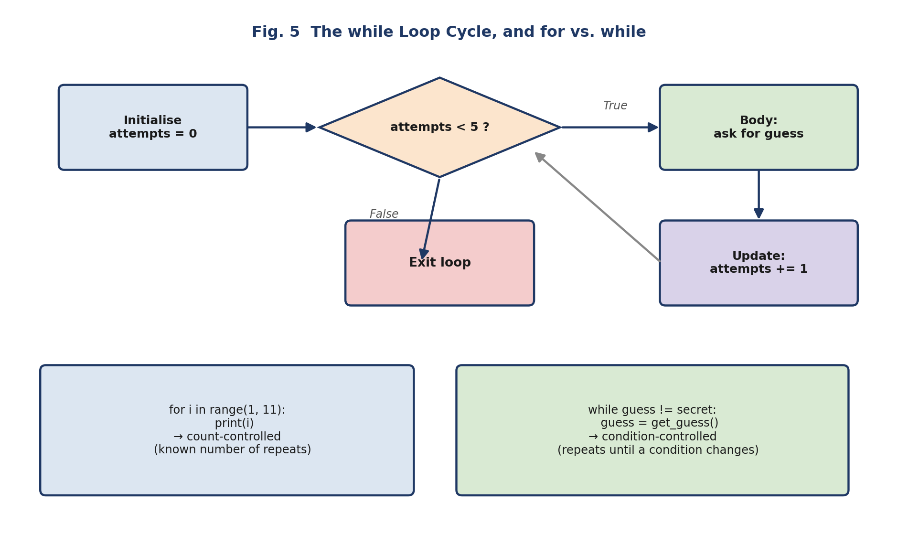
Fig. 5 — The while Loop Cycle, and for vs. while

Code Reference: Loops
attempts = 0
while attempts < 5:
guess = int(input("Enter your guess: "))
attempts = attempts + 1

for i in range(1, 11):
print(i)

# Nested loop — one repetition inside another
for row in range(3):
for col in range(3):
print(row, col)

Lesson Flow
Time | Teaching–Learning Flow | Faculty Role | Student Activity | Evidence / Formative Check
0–5 min | Recap: revisit the unresolved issue — the Guessing Game must allow multiple attempts. | Connect repetition directly to the central problem. | Identify what must repeat and what must change on each attempt. | Oral responses.
5–15 min | Problem trigger: compare “Allow guesses until correct” and “Display a multiplication table 1–10.” | Elicit the need to distinguish condition-controlled and count-controlled repetition. | Decide which needs a while loop and which can use a for loop. | Group classification.
15–25 min | Concept construction: explain while and for loops, loop condition, iteration variable, and update logic. | Use a live trace rather than a lecture-only explanation. | Complete a loop-trace table. | Individual trace table.
25–35 min | Guided problem-solving: integrate a while loop into the Guessing Game flowchart to manage attempts. | Prompt students to specify initialisation, condition, body, and update. | Revise the solution flowchart and pseudocode. | Updated flowchart and pseudocode.
35–45 min | Nested-loop exploration: a pattern-display or repeated-table problem — how can one repetition occur inside another? | Introduce nested loops after students identify the need for two changing values. | Trace a simple nested-loop execution visually. | Nested-loop trace sheet.
45–53 min | Collaborative task: compare a while and for solution for a fixed number of attempts; identify strengths and limitations. | Encourage reasoning about readability, known repetitions, and stopping conditions. | Present comparison using a two-column chart. | Comparison chart.
53–60 min | Summary and reflection: “What should happen if the correct guess is found before all attempts are used?” | Prepare students for loop-control statements. | Write an exit response identifying the need for early termination. | Exit ticket.

Lesson 6: Controlling Loop Execution with break, continue, and pass
Duration: 60 minutes Knowledge Focus: break, continue, pass; integration of Unit II concepts.

Lesson Outcomes
- Analyse the effect of break, continue, and pass in a loop.
- Integrate operators, conditional statements, loops, and loop-control logic into a Guessing Game solution.
- Test a proposed solution against normal, boundary, and invalid-input cases.

Three Situations, Three Controls
A correct guess should stop the loop; an invalid guess should not consume an attempt; an unfinished branch can be reserved with a placeholder. break, continue, and pass each answer one of these needs.
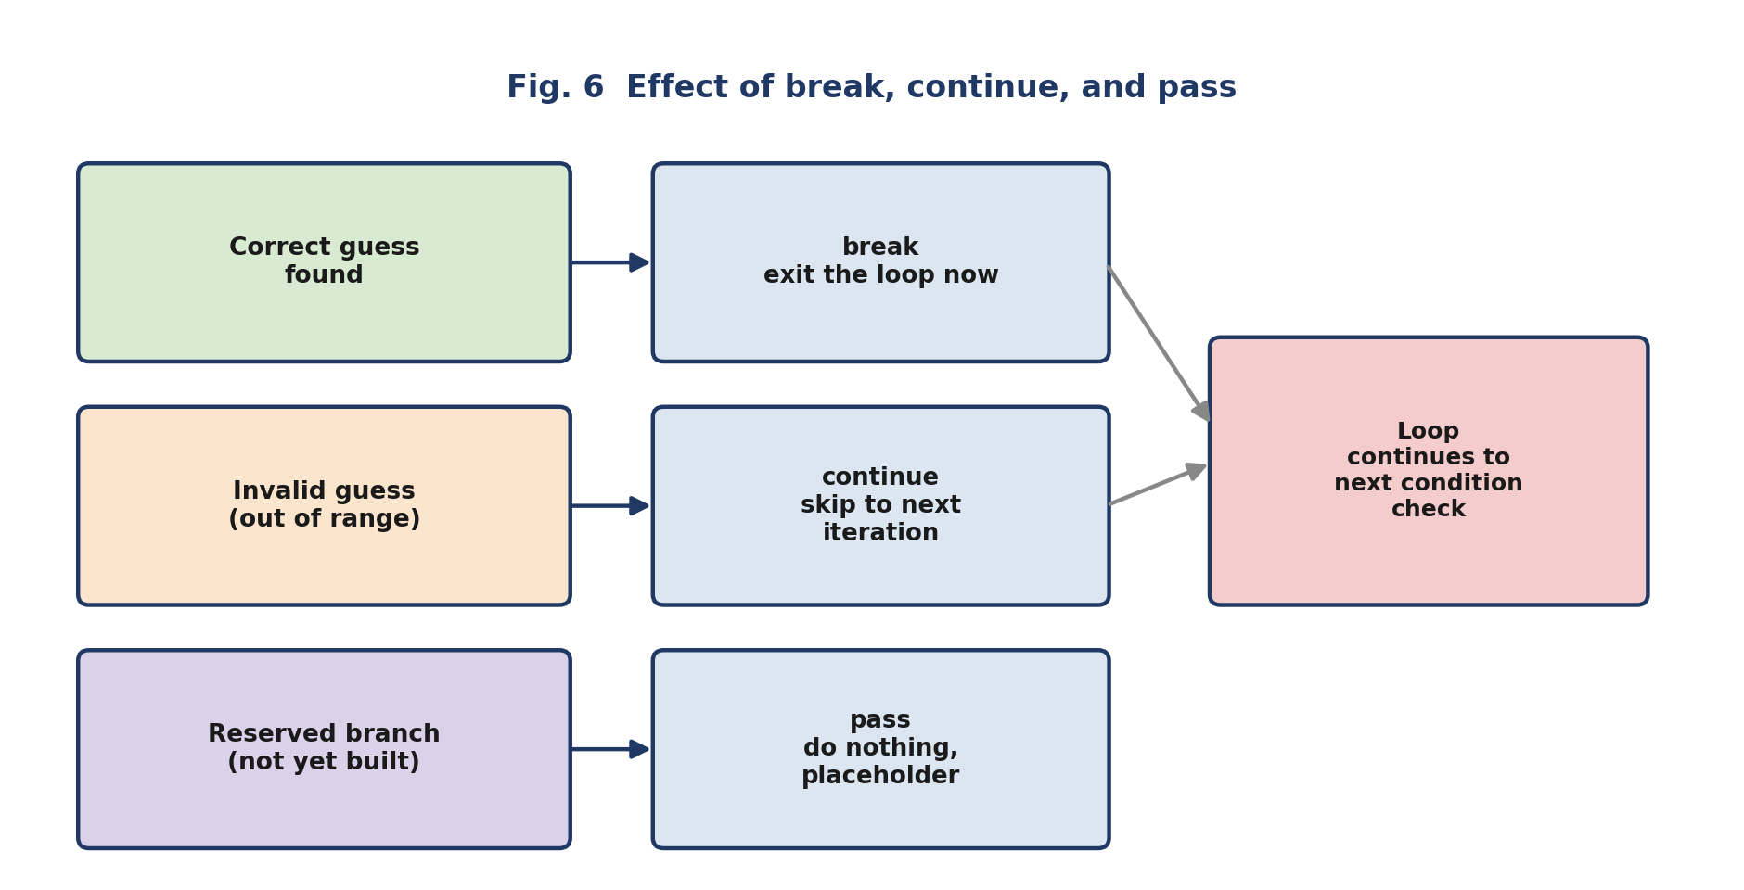
Fig. 6 — Effect of break, continue, and pass

Code Reference: break, continue, pass
attempts = 0
while attempts < 5:
guess = int(input("Enter your guess: "))

if not (1 <= guess <= 100):
print("Invalid guess — try again")
continue # does not count as an attempt

attempts = attempts + 1

if guess == secret_number:
print("Correct!")
break # stop the loop immediately
elif guess < secret_number:
print("Too low")
else:
print("Too high")

if attempts == 3:
pass # reserved for a future hint feature

Lesson Flow
Time | Teaching–Learning Flow | Faculty Role | Student Activity | Evidence / Formative Check
0–5 min | Recap: review the loop logic from Lesson 5. Should the loop continue after a correct guess? | Surface the need for explicit loop control. | Predict the consequence of continuing unnecessarily. | Oral responses.
5–15 min | Problem trigger: correct guess before attempts used; invalid guess that should not consume an attempt; an unfinished branch for future enhancement. | Invite students to propose appropriate control actions. | Match situations with stop, skip, or placeholder behaviours. | Group matching sheet.
15–25 min | Concept clarification: explain break, continue, and pass through the three problem situations. | Demonstrate each statement with a short code trace. | Annotate how control moves after each statement. | Control-flow trace table.
25–38 min | Integrated problem-solving task: complete pseudocode or Python logic using operators, conditions, a loop, attempt counting, and loop control. | Coach groups through questions; do not provide a ready-made complete solution. | Develop and revise the solution collaboratively. | Group pseudocode/code draft.
38–48 min | Testing and critique: create test cases — correct first guess, low guess, high guess, final-attempt success, unsuccessful completion, invalid-range guess. | Emphasise testing as evidence-based evaluation of logic. | Execute or trace the solution against test cases. | Test-case table with expected and observed results.
48–55 min | Reflection and refinement: identify one logic error, one improvement, and one design decision they can justify. | Facilitate peer feedback and consolidation. | Revise the flowchart or code based on evidence. | Revised artefact and reflection note.
55–60 min | Unit debrief: summarise how the problem required expressions, decisions, iteration, indentation, and loop control. | Consolidate conceptual and procedural learning. | Submit an individual concept map linking Unit II topics. | Concept map and exit reflection.

