Data analysis Project steps

* Create a problem statement
* Identify the data you want to analyse.
* Explore and clean the data
* Analyse the data to get useful insights
* Present the data in terms of reports or

Dashboards using visualization

Business problem

In recent Years, city hotel and resort hotel have seen high cancellation rates. each hotel is now dealing with a number of issues as a result including fewer revenues and less than ideal hotel room use. consequently, lowering cancellation rates is both hotels primary goal in order to increase their efficiency in generating revenue, and for us to offer thorough business advice to address this problem.

This analysis of hotel booking cancellation as well as other factors that have no bearing on their business and yearly revenue generation are the main topic of this report

**Assumptions**

1. No unusual occurrences between 2015 and 2017 will have a substantial impact on the data used.
2. The information is still current and can be used to analyse a hotels possible plan in an efficient manner
3. There are no unanticipated negative to the hotel employing any advised technique
4. The hotels are not current using any of the suggested solutions.
5. The biggest factor affecting the effectiveness of earning income is booking cancellations.
6. Cancellation results in vacant rooms for the booked length of time
7. Clients make hotel reservation the same year they make cancellations

**Research question**

1. What are the variables that affect hotel reservation cancellations?
2. How can we make hotel reservation cancellations better
3. How will hotel be assisted in making pricing and Promotional decisions

Hypothesis

1. More cancellation occurs when prices are higher
2. When there is a longer waiting list, customers tend to cancel more frequently
3. The majority of clients are coming from offline travel agents to make their reservations.

Analysis and findings

1. The accompanying bar graph shows the percentage of reservations that are cancelled And those that are not. It is obvious that there are still a significant number of reservations that have not been cancelled. There are still 37% of clients who cancelled their reservation, which has a significant impact on the hotel’s earnings

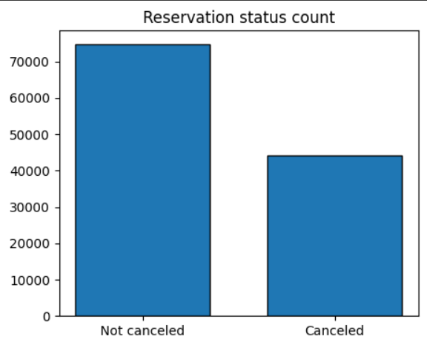

1. In comparison to resort hotel, city hotel has more booking. it’s possible that resort hotels are more expensive than those in cities

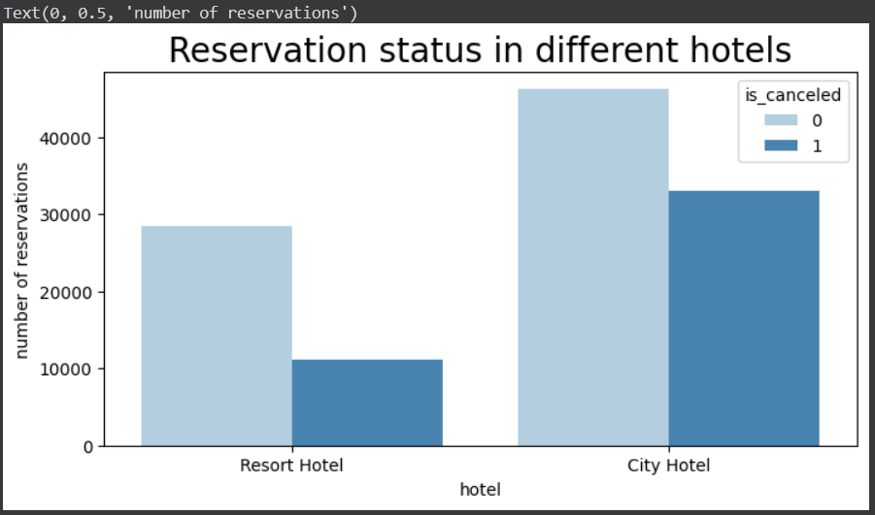

1. The line graph above shows that on certain days, the average daily rate for a city hotel is less than that of a resort hotel, and on other days, it is even less. it goes without saying that weekends and holidays may see a rise in resort hotel rate

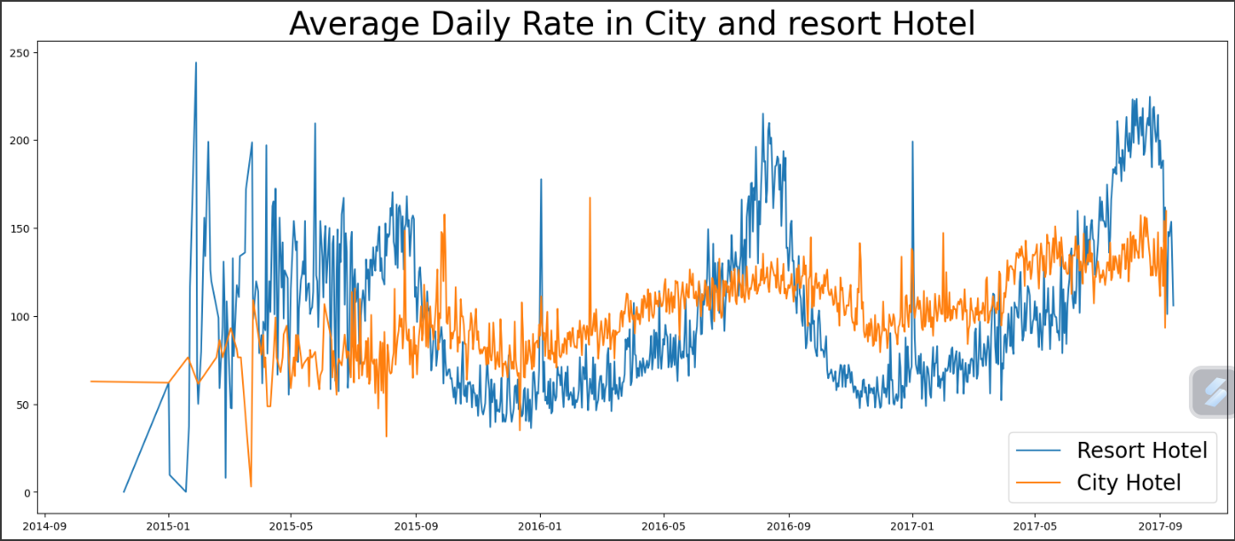

1. We have developed the grounded bar graph to analyse the months with the highest and lowest reservation levels according to reservations and number of cancelled reservations are largest in the month of august. whereas January is the month with the most cancelled reservations.

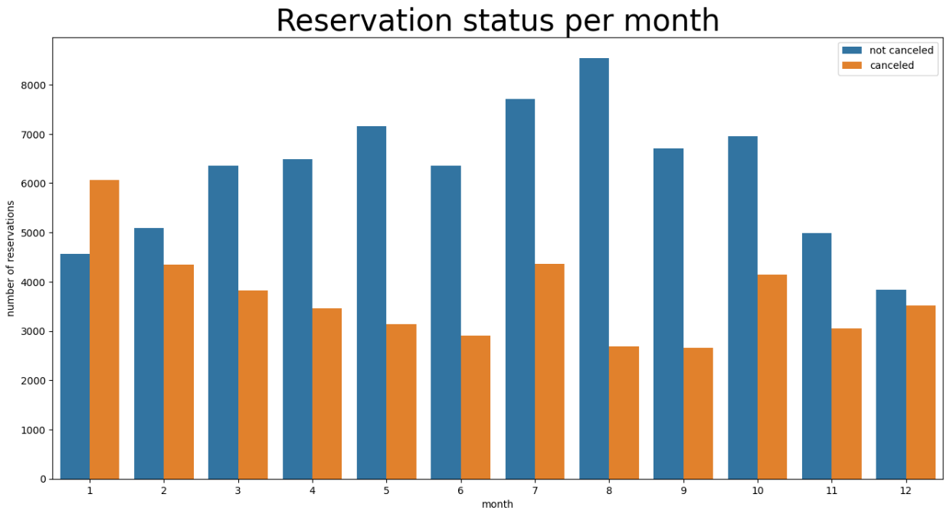

1. This bar graph demonstrates that cancellation are most common when prices are greatest and are least common when they are lowest. therefore the cost of the accommodation is solely responsible for the cancellation

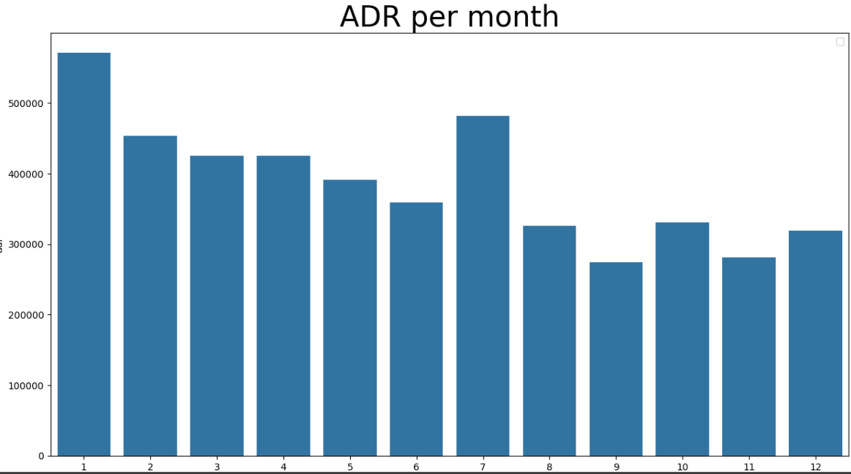

1. Now,let see which country has the highest reservation cancellation .ther top country is Portugal with the highest number of cancellations

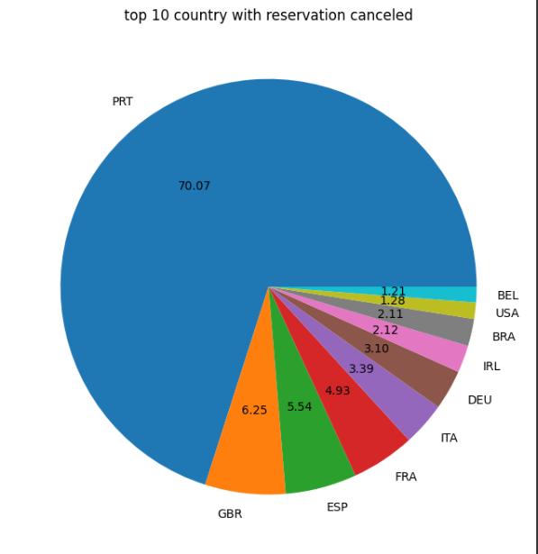

1. As seen in the graph reservation are cancelled when the average daily rate is higher than when when it is not cancelled. it clearly proves all the above analysis that the higher prices lead to higher cancellation

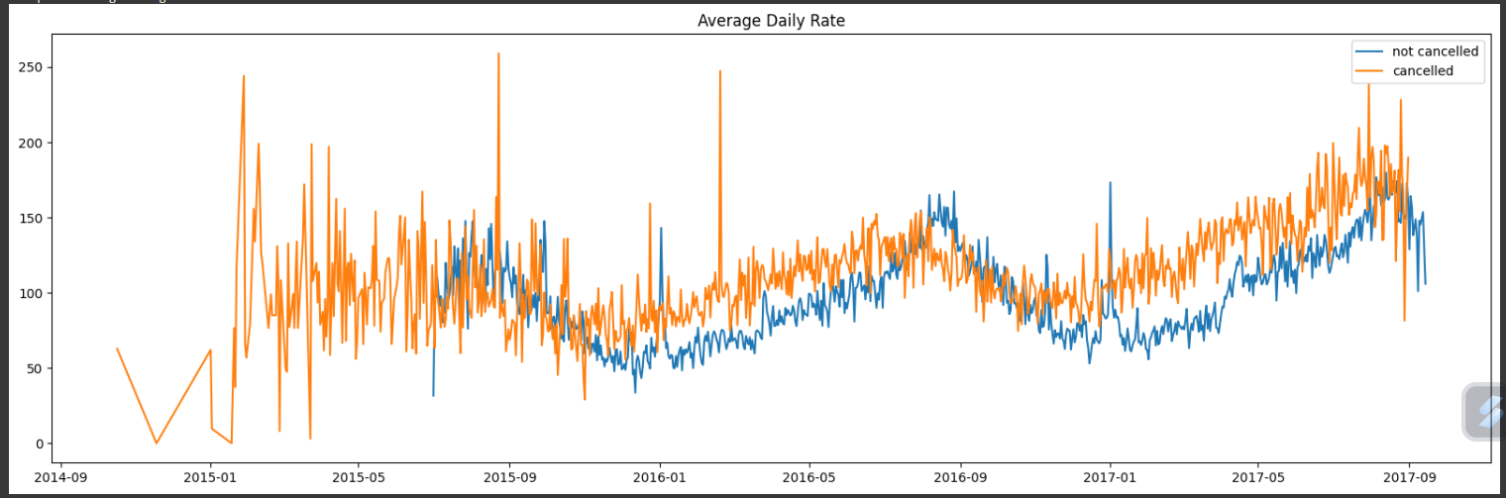

**Suggestion**

1. Cancellation rate rise as the price does. in order to prevent cancellations of reservation, hotels could work on their pricing strategies and try to lower the rate for specific hotel based on locations. they can also provide some discounts ot the consumers
2. As the ratio of the cancellation and not cancellation of resort hotel is higher in the resort hotel than the city hotels. So, the hotels, should provide a reasonable discount on the room prices on weekends or on holidays.
3. In the month of January, hotels can start campaigns or marketing with a reasonable amount ot increase their revenue as the cancellation is the highest in this month
4. They can also increase the quality of their hotels and their services mainly in Portugal to reduce the cancellation rate.