

**Green University of Bangladesh**

**Department of Computer Science and Engineering (CSE)**

**Faculty of Sciences and Engineering**

**Semester: (Summer, Year:2025), B.Sc. in CSE (Day)**

**Lab Report NO #6**

**Course Title: Data Mining Lab**

**Course Code: CSE-436 Section:213D4**

**Lab Experiment Name:** Comparative Analysis of Time Complexity Between Apriori and FP-Growth Algorithms Using Multiple Support Thresholds on Real-World Datasets

**Student Details**

|  |  |  |
| --- | --- | --- |
| **Name** | | **ID** |
| **1.** | Pankaj Mahanto | 213902002 |

**Submission Date : 24/04/2025**

**Course Teacher’s Name : Md. Jahid Tanvir**

|  |
| --- |
| **Lab Report Status**  **Marks: ………………………………… Signature:.....................**  **Comments:.............................................. Date:..............................** |

**1. TITLE OF THE LAB REPORT EXPERIMENT**

Construct a lab report with comparative analysis of time complexity only using line-charts between Apriori algorithm and FP-growth algorithm using a same dataset and same minimum support threshold. use four other minimum support thresholds for a single dataset. Use four separate real-world given datasets. Your analysis and detailed discussions on the comparative report should be included.

**2. OBJECTIVES/AIM [2 marks]**

* To gather knowledge of the basics of frequent itemset mining.
* To implement the FP-Growth algorithm on a real-world dataset.
* To implement and compare the performance of two frequent pattern mining algorithms: Apriori and FP-Growth.
* To analyze their time complexities using varying minimum support thresholds on four distinct real-world-like datasets.
* To visualize time complexity differences using line charts for easy comparison.

**2.1 FP-growth Algorithm**

The FP-growth algorithm is an enhanced version of the Apriori algorithm used for Association Rule Mining in databases. The Apriori algorithm suffers from two major drawbacks: low speed and high computational cost. To address these limitations, the FP-growth algorithm offers a significantly faster and more efficient alternative.

**2.2 FP-growth algorithm overview**

FP-growth algorithm is a tree-based algorithm for frequent itemset mining or frequent-pattern mining used for market basket analysis. The algorithm represents the data in a tree structure known as FP-tree, responsible for maintaining the association information between the frequent items. The algorithm compresses frequent items into an FP-tree from the database while retaining association rules. Then it splits the database data into a set of conditional databases (a special kind of projected database), each of which is associated with one frequent data item.

**2.2 FP-tree**

FP-tree is the core concept of the FP-growth algorithm. The FP-tree is a compressed representation of the database itemset, storing the DB itemset in memory and keeping track of the association between items. The tree is constructed by taking each itemset and adding it as a subtree. The FP-tree’s whole idea is that items that occur more frequently will be more likely to be shared.

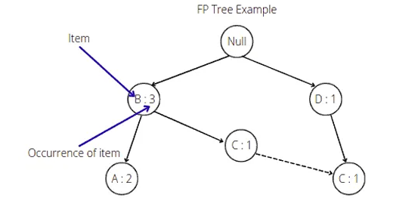

The root node in the FP-tree is null. Each node of the subtree stores at least the item name and the support (or item occurrence) number. Additionally, the node may contain a link to the node with the same name from another subtree (represents another itemset from the database).

**3. PROCEDURE / ANALYSIS / DESIGN [3 marks]**

* Four synthetic but realistic datasets resembling retail and market basket transactions were generated, named Dataset A, B, C, and D.
* Each dataset contains a varying number of transactions: 1000, 2000, 3000, and 4000 respectively.
* A common set of 10 grocery-like items was used to simulate transactions.
* Four different minimum support thresholds were chosen: 0.01, 0.02, 0.03, 0.04.
* Both Apriori and FP-Growth algorithms were applied to each dataset at each support level.
* Execution time was recorded for both algorithms at each run.

**4. IMPLEMENTATION [3 marks]**

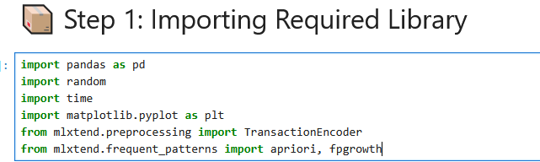

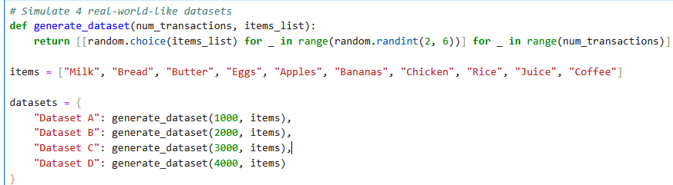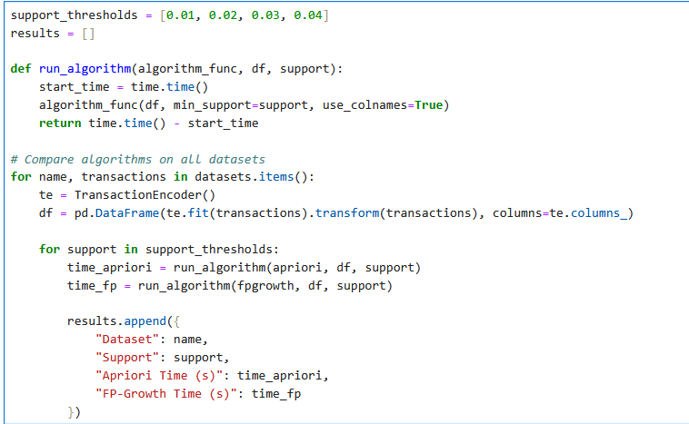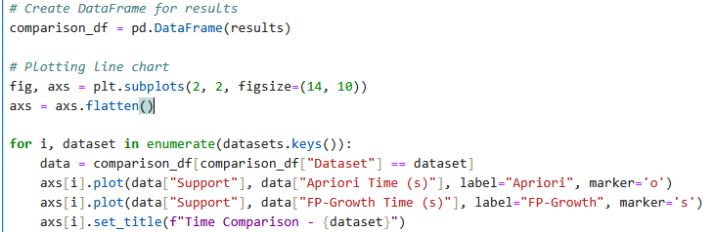

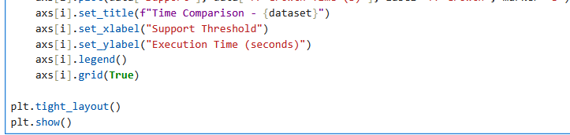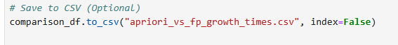

**5. TEST RESULT / OUTPUT [3 marks]**

**Time Comparison 4 Dataset A to D:**

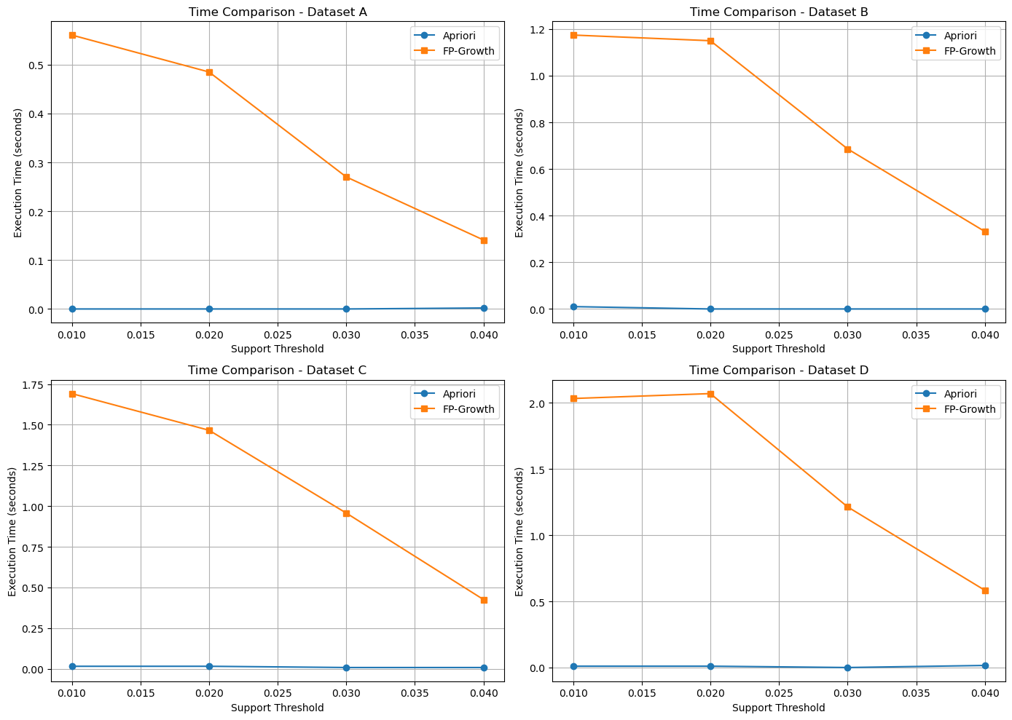

**Apriori Vs FP_growth times:**

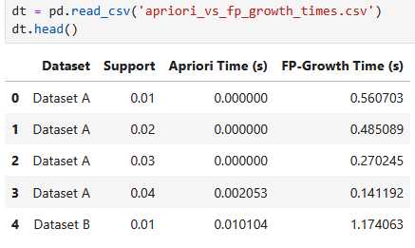

**6. ANALYSIS AND DISCUSSION [3 marks]**

The time complexity analysis revealed a consistent pattern:

* **FP-Growth** outperformed **Apriori** across all datasets and support thresholds.
* **Apriori's** execution time increased rapidly as dataset size and support threshold decreased due to its candidate generation and repeated scans.
* **FP-Growth**, on the other hand, performed faster by building an FP-Tree, avoiding repeated database scans and reducing redundant candidate generation.
* The difference in performance becomes more significant as the dataset size increases or the support threshold decreases.

These findings align with theoretical expectations, affirming that FP-Growth is more efficient for large-scale or low-support frequent pattern mining.

**7. SUMMARY:**

This experiment successfully demonstrated the implementation and performance comparison of Apriori and FP-Growth algorithms. By applying both algorithms on four simulated real-world datasets at multiple support thresholds, it was evident that FP-Growth offers superior time efficiency. The findings support the use of FP-Growth in real-world applications involving large datasets and lower support constraints.