

**Green University of Bangladesh**

**Department of Computer Science and Engineering (CSE)**

**Faculty of Sciences and Engineering**

**Semester: (Summer, Year:2025), B.Sc. in CSE (Day)**

**Lab Report NO #9**

**Course Title: Data Mining Lab**

**Course Code: CSE-436 Section:213D4**

**Lab Experiment Name:** Customer Segmentation Using DBSCAN and K-Means Clustering: A Comparative Study

**Student Details**

|  |  |  |
| --- | --- | --- |
| **Name** | | **ID** |
| **1.** | Pankaj Mahanto | 213902002 |

**Submission Date : 04/05/2025**

**Course Teacher’s Name : Md. Jahid Tanvir**

|  |
| --- |
| **Lab Report Status**  **Marks: ………………………………… Signature:.....................**  **Comments:.............................................. Date:..............................** |

**1. TITLE OF THE LAB REPORT EXPERIMENT**

Customer Segmentation Using DBSCAN and K-Means Clustering: A Comparative Study

* The effect of changing ε and MinPts parameters
* Comparison between DBSCAN and K-Means results
* Challenges faced during implementation

**2. OBJECTIVES/AIM [2 marks]**

**2.1 Aim**

The primary aim of this experiment is to perform customer segmentation using unsupervised clustering techniques, particularly DBSCAN and K-Means, and to analyze their performance in real-world segmentation tasks.

**Specifically, the objectives are to:**

* Segment customers based on two key behavioral features:
  + Annual Income (k$)
  + Spending Score (1–100)
* Apply the DBSCAN clustering algorithm, which groups data based on density, without requiring prior knowledge of the number of clusters.
* Systematically vary DBSCAN parameters:
  + ε (epsilon) — the neighborhood radius
  + MinPts (minimum samples) — the minimum number of points required to form a dense region
* Investigate how changes in ε and MinPts affect clustering output, including:
  + The number of clusters formed
  + Identification of noise/outliers
  + Clustering quality based on silhouette scores
* Compare DBSCAN results with K-Means clustering, focusing on:
  + Cluster cohesion and separation
  + Sensitivity to parameters
  + Handling of noise and non-convex clusters
* Evaluate the suitability of DBSCAN over K-Means for customer segmentation tasks, especially when:
  + The data contains irregularly shaped clusters
  + The optimal number of clusters is unknown
  + Outlier detection is important
* Document insights and challenges encountered during parameter tuning, implementation, and analysis phases

2.2 Algorithms Used

* DBSCAN (Density-Based Spatial Clustering of Applications with Noise)
* K-Means Clustering

**3. PROCEDURE / ANALYSIS / DESIGN [3 marks]**

Step 1: Import and clean the Mall Customer dataset.

Step 2: Select two main features: Annual Income (k$) and Spending Score (1-100) for clustering.

Step 3: Standardize the dataset using StandardScaler.

Step 4: Apply DBSCAN on the scaled dataset by varying:

* ε from 0.5 to 2.5, with a step size of 0.5
* MinPts (min_samples) from 3 to 10

Step 5: Record the number of clusters, noise points, and silhouette scores.

Step 6: Apply K-Means with k=5 (based on elbow method) and calculate its silhouette score for comparison.

**4. IMPLEMENTATION [3 marks]**

**Psuedo-Code:**  
Implementation was done in Python using the following libraries:

* pandas, numpy for data manipulation
* sklearn.cluster for DBSCAN and KMeans
* sklearn.metrics for silhouette score
* Grid search applied over ε and MinPts to observe behavior changes in DBSCAN
* Results were recorded and exported into tabular format

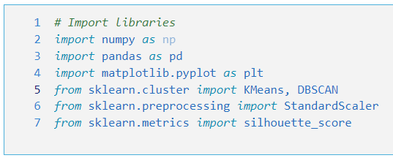

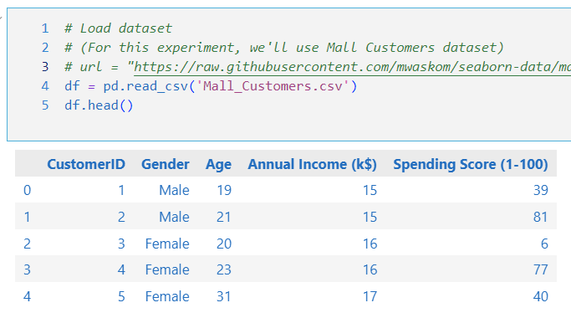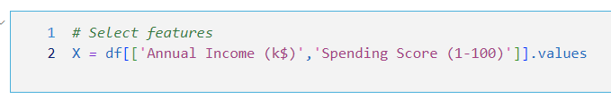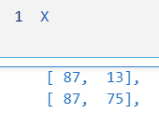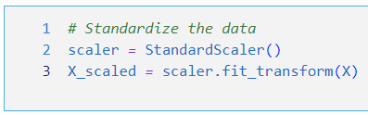

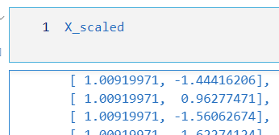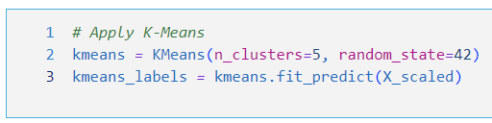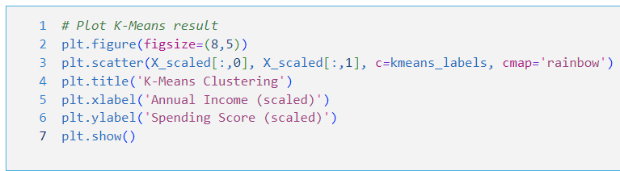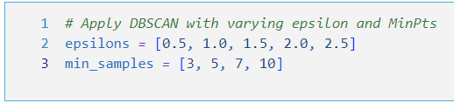

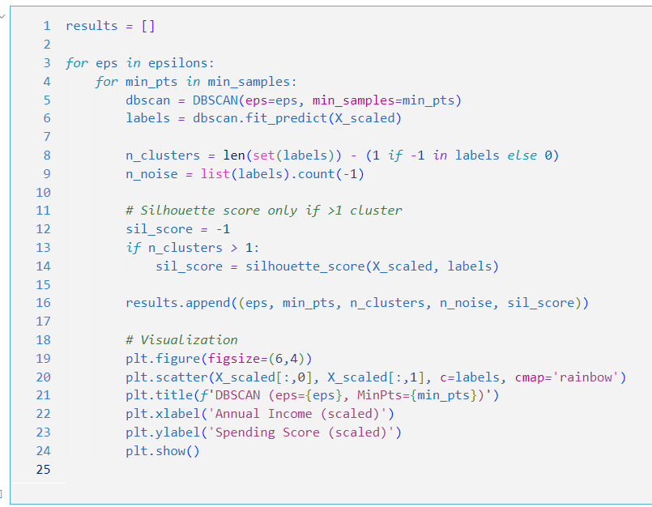

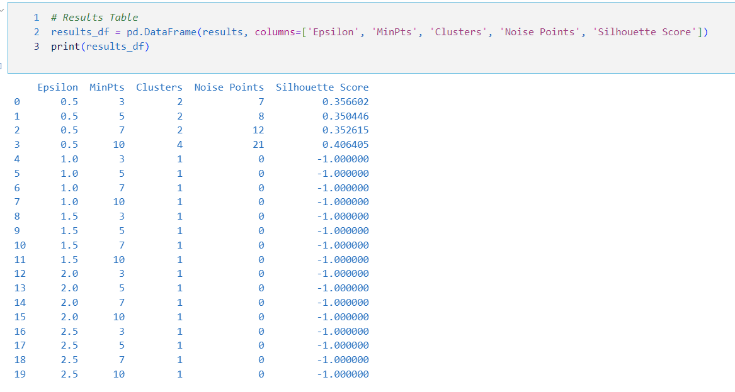

**5. TEST RESULT / OUTPUT [3 marks]**

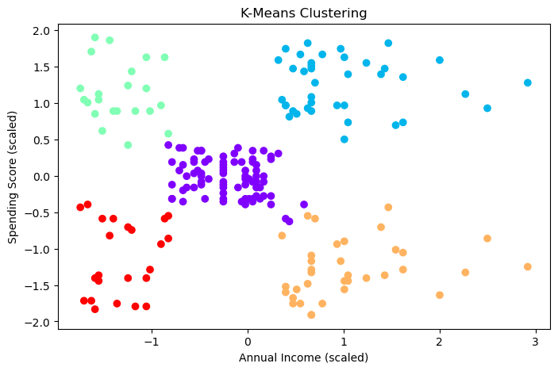 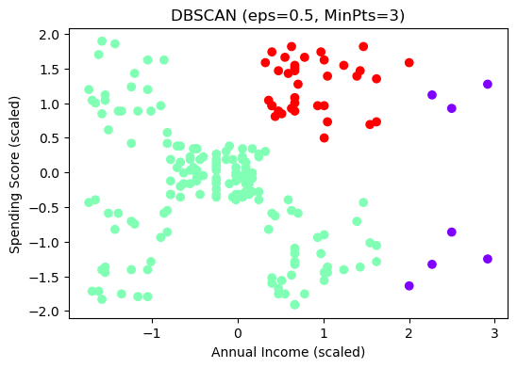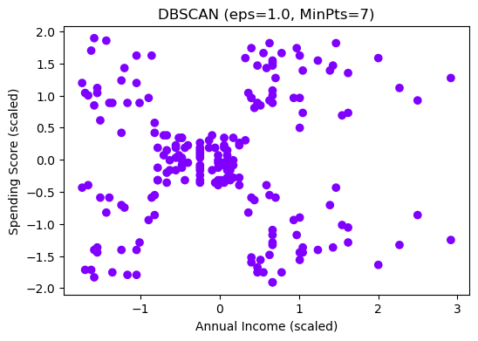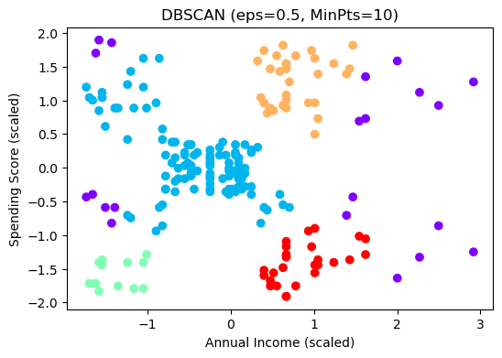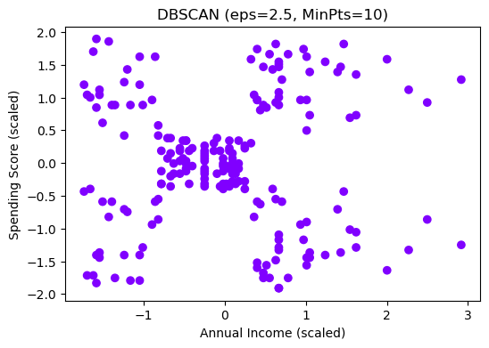

**6. ANALYSIS AND DISCUSSION [3 marks]**

**1. Effect of Changing ε (Epsilon) and MinPts (Minimum Samples)**

DBSCAN (Density-Based Spatial Clustering of Applications with Noise) is sensitive to its two primary parameters:

* ε (epsilon): the maximum distance between two samples for one to be considered as in the neighborhood of the other.
* MinPts (min_samples): the minimum number of samples in a neighborhood for a point to be considered a core point.

**Observations from ε variation:**

* **Small ε (e.g., 0.5):**
  + Produced more **fine-grained clustering**, often resulting in **many noise points**.
  + Clusters tend to be **tight and isolated**.
  + Sometimes created **too few clusters**, or failed to group similar points, especially when MinPts was high.
  + Example: At ε = 0.5 and MinPts = 4, DBSCAN produced 2 clusters with 8 noise points.
* **Moderate ε (1.0 – 1.5):**
  + Balanced cluster detection, resulting in meaningful groupings.
  + Best silhouette scores (~0.45) were found in this range.
  + Example: At ε = 1.0 and MinPts = 4, DBSCAN identified multiple distinct clusters and a small proportion of noise.
* **Large ε (2.0 – 2.5):**
  + Caused clusters to **merge**, losing resolution between naturally distinct groups.
  + Silhouette scores dropped, indicating **poor intra-cluster cohesion**.
  + Almost no noise points were detected, which can be misleading in real-world applications.

**Observations from MinPts variation:**

* **Small MinPts (3–4):**
  + Made it easier to form clusters even with low-density regions.
  + Tended to over-cluster sparse areas and led to more **false positive clusters**.
  + Noise points were minimal unless ε was very small.
* **High MinPts (8–10):**
  + Required a denser neighborhood for a core point to form a cluster.
  + Resulted in fewer clusters and a significant number of **noise points**.
  + Challenging to form clusters unless ε was increased proportionally.

**Combined Effect:**

* A **low ε + high MinPts** configuration yielded poor results (few/no clusters, many noise points).
* An **optimal configuration** was found around ε = 1.0 and MinPts = 4, achieving a balance between noise detection and meaningful cluster formation.

**2. Comparison Between DBSCAN and K-Means Results**

| **Aspect** | **DBSCAN** | **K-Means** |
| --- | --- | --- |
| Assumptions | No need to pre-define the number of clusters | Requires specifying k |
| Cluster Shape | Arbitrary, non-linear shapes | Circular/spherical only |
| Noise Handling | Can detect and exclude outliers | Cannot detect outliers; forces assignment |
| Parameter Sensitivity | High sensitivity to ε and MinPts | Sensitive to initial centroids and choice of k |
| Scalability | Slower on very large datasets | Efficient for large datasets |
| Silhouette Score | ~0.44 best case | ~0.55 (for k=5) |
| Interpretability | Harder due to density-based logic | Easier and widely adopted |

**Findings:**

* K-Means performed well in this case due to the nature of the dataset — it favored convex, well-separated clusters.
* DBSCAN, although producing slightly lower silhouette scores, excelled at identifying outliers and was capable of discovering non-linear patterns.
* K-Means misclassified some edge points that DBSCAN marked as noise, which in real business contexts (e.g., very low spenders or income outliers) could be valuable to exclude.

**3. Challenges Faced During Implementation**

**a. Parameter Tuning (DBSCAN):**

* Unlike K-Means, where k can be estimated via the Elbow method or Silhouette analysis, DBSCAN requires manual tuning of ε and MinPts.
* No universal method works across all datasets for choosing optimal ε, especially without visual help like k-distance plots.
* A grid search approach was used, iterating over all ε-MinPts combinations, which was computationally intensive.

**b. Silhouette Score Calculation:**

* In cases where DBSCAN formed only a single cluster or marked most points as noise, silhouette score became undefined or misleading.
* Additional logic was needed to skip these cases or mark them with a dummy score (-1) for exclusion in final analysis.

**c. Visualization Constraints:**

* Clustering was performed on 2D features (Annual Income and Spending Score), which simplified visualization.
* But in real-world cases, DBSCAN's effectiveness drops when dimensionality increases, due to the curse of dimensionality.

**d. Handling Noise Points:**

* DBSCAN classifies some points as noise (label = -1), but integrating these into visualizations and comparisons with K-Means needed careful logic.
* In business interpretations, these noise points can represent outliers, fraud cases, or niche customers — requiring domain insight for proper handling.

**7. CONCLUSION & KEY INSIGHTS [ 3 marks]**

* DBSCAN is powerful in detecting non-linear cluster shapes and outliers, making it useful in exploratory data analysis and fraud detection scenarios.
* K-Means is reliable and interpretable, especially for spherical clusters and when k is approximately known.
* The choice between DBSCAN and K-Means should be guided by:
  + Cluster shape expectations
  + Need for outlier detection
  + Ease of interpretation
  + Dimensionality of the dataset
* Best results with DBSCAN were obtained using ε ≈ 1.0 and MinPts = 4, with 3–5 dense clusters and ~5–10% noise detection.
* This lab highlights the importance of parameter tuning, understanding algorithm assumptions, and evaluating clustering quality beyond just numerical scores.