Isolation game heuristic analysis

Heuristics
For the Isolation game agent project by Artificial Intelligence Engineer Nanodegree I have experimented with following heuristics (score calculations):
- [AB_Custom] Number of moves for player and his opponent from the current position. The more moves one player has, the better his chances to win. Let’s call it a basic heuristic.
- [AB_Custom_2] Basic heuristic plus a number of next moves that points to the same position on the board for a player and his opponent. The idea – a player can move onto position that his opponent could reach too. Consequently a player reduces the number of moves of his opponent. I added this improvement with a weight, which I found in an empirical way.
- [AB_Custom_3] Basis heuristic plus positional advantage. Positional advantage in my case is a Manhattan distance from the current position to the center of the board. I added this improvement with a weight, which I found in an empirical way.

Experiments
I ran a tournament to check, which of the heuristics performs better, and to see, whether one of those could beat AB_Improved agent. To get a better statistic I ran a tournament 3 times.

Results

First run
Match # | Opponent | AB_Improved |  | AB_Custom |  | AB_Custom_2 |  | AB_Custom_3
 |  | W | L | W | L | W | L | W | L
1 | Random | 9 | 1 | 10 | 0 | 8 | 2 | 9 | 1
2 | MM_Open | 5 | 5 | 8 | 2 | 8 | 2 | 8 | 2
3 | MM_Center | 8 | 2 | 8 | 2 | 8 | 2 | 10 | 0
4 | MM_Improved | 4 | 6 | 4 | 6 | 4 | 6 | 5 | 5
5 | AB_Open | 6 | 4 | 5 | 5 | 7 | 3 | 5 | 5
6 | AB_Center | 8 | 2 | 7 | 3 | 6 | 4 | 5 | 5
7 | AB_Improved | 4 | 6 | 5 | 5 | 4 | 6 | 4 | 6
Win Rate |  | 62.9% |  | 67.1% |  | 64.3% |  | 65.7%

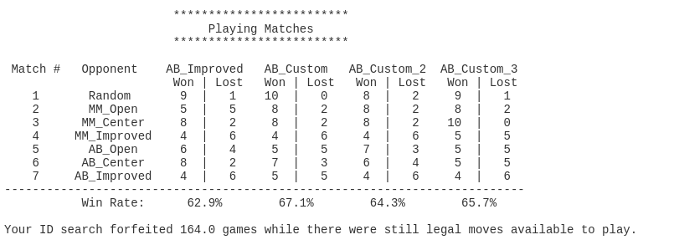

Second run
Match # | Opponent | AB_Improved |  | AB_Custom |  | AB_Custom_2 |  | AB_Custom_3
 |  | W | L | W | L | W | L | W | L
1 | Random | 8 | 2 | 6 | 4 | 7 | 3 | 9 | 1
2 | MM_Open | 7 | 3 | 4 | 6 | 6 | 4 | 8 | 2
3 | MM_Center | 7 | 3 | 8 | 2 | 10 | 0 | 9 | 1
4 | MM_Improved | 7 | 3 | 6 | 4 | 5 | 5 | 6 | 4
5 | AB_Open | 7 | 3 | 3 | 7 | 6 | 4 | 3 | 7
6 | AB_Center | 4 | 6 | 5 | 5 | 8 | 2 | 5 | 5
7 | AB_Improved | 5 | 5 | 3 | 7 | 7 | 3 | 7 | 3
Win Rate |  | 64.3% |  | 50.0% |  | 70.0% |  | 67.1%

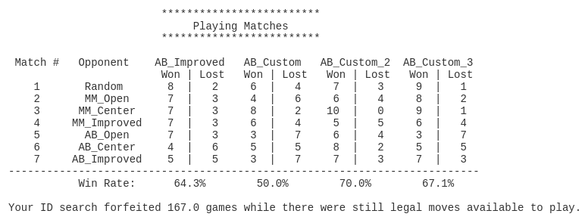

Third run
Match # | Opponent | AB_Improved |  | AB_Custom |  | AB_Custom_2 |  | AB_Custom_3
 |  | W | L | W | L | W | L | W | L
1 | Random | 10 | 0 | 7 | 3 | 8 | 2 | 7 | 3
2 | MM_Open | 9 | 1 | 7 | 3 | 8 | 2 | 7 | 3
3 | MM_Center | 7 | 3 | 8 | 2 | 10 | 0 | 7 | 3
4 | MM_Improved | 7 | 3 | 5 | 5 | 7 | 3 | 6 | 4
5 | AB_Open | 4 | 6 | 5 | 5 | 6 | 4 | 5 | 5
6 | AB_Center | 5 | 5 | 7 | 3 | 6 | 4 | 8 | 2
7 | AB_Improved | 5 | 5 | 5 | 5 | 3 | 7 | 5 | 5
Win Rate |  | 67.1% |  | 62.9% |  | 68.6% |  | 64.3%

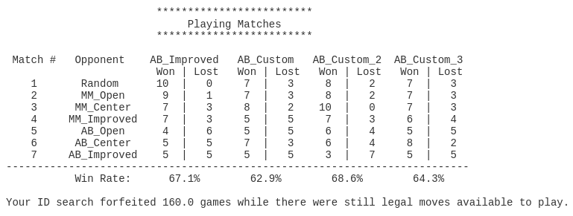

Resume
I would recommend to use AB_Custom_2 heuristic because of the following factors:
- It translates the reduction of possible opponent moves into advantage of the game agent.
- Because of that we reduce the search space for future moves too, which allows us to go deeper in a search tree in the same amount of time.
- Among 3 runs, its average winning rate was always greater than ones, achieved by AB_Improved heuristic.
AB_Custom_2 adds sophistication and required more computations. Though this works in a our case with 7x7 board and L-shape moves better than other introduced heuristics, I suppose, this brings significant disadvantage in more complex games.

