CHAPTER 1
INTRODUCTION

Introduction
  - Overview
Earthquakes cause mass destruction and loss of life and one of the most devastating natural disasters, Natural disasters like floods, tornados, and hurricanes have existed since the beginning of time, yet we are able to predict when these natural disasters will occur, where they will occur, and the projected damage they will inflict. Often times the most reliable, method for predicting earthquakes is using a seismograph which can allow us to detect imminent earthquakes. The mere seconds before an earthquake, is often not enough time to take action and prevent massive structural damage.
A traditional method to predict earthquakes is to look to past recurrence intervals. Because the recurrences are not constant, predictions can only be made within broad time windows. One such model predicted that a strong earthquake would occur between 1985 and 1993 in the Parkfield California area but no significant event actually occurred until 2004.
Another way to predict earthquakes are based on changes in land elevation, ground water levels, animal behavior or foreshocks. There are couple examples when this method of prediction worked. One well-known successful earthquake prediction was for the Haicheng, China earthquake of 1975, when an evacuation warning was issued the day before a magnitude 7.3 earthquake. In the preceding months changes in land elevation and in ground water levels, widespread reports of peculiar animal behavior, and many foreshocks had led to a lower-level warning. An increase in foreshock activity triggered the evacuation warning. Unfortunately, most earthquakes do not have such obvious precursors. In spite of their success in 1975, there was no warning of the 1976 Tangshan earthquake, magnitude 7.6, which caused an estimated 250,000 fatalities.
Advances in instrumentation quality and density have fostered hope that progress can be made in forecasting. These advances have led to discoveries of previously unidentified slip processes such as slow slips. Slow Slip Earthquakes (SSE) are fault behaviors that occur slowly enough to make them undetectable without instrumentation. They do not cause immediate widespread destruction like regular earthquakes do. They occur near the boundaries of large earthquake rupture zones. There is evidence to suggest that there is a relationship between slow slip earthquakes and more noticeable regular earthquakes.
Researchers imitate natural slow slip earthquakes in the laboratory by placing rocky material between steel blocks and applying shear stress to induce slipping. Recent improvements in the instruments used to measure signals have enabled the collection of larger volume and more data of natural earthquake. However, processing the data and detecting patterns in it has become more difficult.
Methods to detect patterns of aperiodic seismic signals that precede earthquakes are presented in this paper. We use acoustic data provided by the Los Alamos National Laboratory (LANL) as part of a 2019 Kaggle competition, which represents laboratory slow-slip earthquakes. The data is very aperiodic and more akin to natural earthquakes than the data LANL studied earlier in 2017. We demonstrate that deep learning can be used to detect patterns in the data that and predict laboratory earthquakes with mean absolute error of ~0.21 seconds. Given seismic signal data with considerably more aperiodic slow-slip laboratory earthquake failures, we predict time remaining before failure at any time in the slip cycle based solely on acoustical signal’s statistical features derived from the small, local, moving time windows and do not make use of its history. The results of this experiment are potentially applicable to the field of real world earthquakes. Essential improvements in providing new understanding of fault physics may be brought by applying this technique to acoustic seismic data. Other potential applications include avalanche prediction, landslides and failure of machine parts.
  - Earthquake
An earthquake is the shaking of the Earth’s surface caused by sudden releases of energy in the lithosphere that creates seismic waves. It happens when two blocks of the earth suddenly slip past one another. The surface where they slip is called the fault or fault plane. The location below the earth’s surface where the earthquake starts is called the hypocenter, and the location directly above it on the surface of the earth is called the epicenter.
Smaller earthquakes that happen in the same location as a larger earthquake that follows are called foreshocks. Scientists can’t determine whether an earthquake is a foreshock until the larger earthquake happens. The largest, main earthquake is called the mainshock. Mainshocks always have aftershocks that follow, smaller earthquakes that occur afterwards in the same place as the mainshock. Depending on the size of the mainshock, aftershocks can continue for weeks, months, and even years after the mainshock.
The earth has four major layers: the inner core, outer core, mantle and crust. The crust and the top of the mantle make up a thin skin on the surface of our planet, this skin is not all in one piece, it is made up of many pieces like a puzzle covering the surface of the earth. These puzzle pieces are called tectonic plates, and the edges of the plates are called the plate boundaries. Tectonic plates move slowly and continuously; sliding past and bumping into each other. The plate boundaries are made up of many faults, and most of the earthquakes around the world occur on these faults. Because the edges of the plates are not smooth they can get stuck while the rest of the plate keeps moving. Finally, when the plate has moved far enough, the edges unstick on one of the faults and there is an earthquake.
While the edges of faults are stuck together, and the rest of the block is moving, the energy that would normally cause the blocks to slide past one another is being stored up. When the force of the moving blocks finally overcomes the friction of the jagged edges of the fault and it unsticks and all of the stored energy is released. The energy radiates outward from the fault in all directions in the form of seismic waves, those waves shake the earth as they move through it, and when the waves reach the earth’s surface, they shake the ground and anything on it.
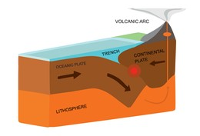
Figure.1 Diagram of earthquake

The size of an earthquake depends on the size of the fault and the amount of slip on the fault, but that’s not something scientists can simply measure with a measuring tape since faults are many kilometers deep beneath the earth’s surface. The strength of the shaking from an earthquake diminishes with increasing distance from the earthquake’s source, so the strength of the shaking at the surface from an earthquake that occurs 500km below the surface can considerably less than if the same earthquake had occurred 20 km below the surface . The size of the earthquake is called its magnitude. The Richter Scale (ML) is what most people have heard about (scale range from 0 to 9), but in practice it is not commonly used anymore, except for small earthquakes recorded locally, for which ML and short-period surface wave magnitude (Mblg) are the only magnitudes that can be measured.
For all other earthquakes, the moment (Tanyuk et al) Machine Learning Predicts Laboratory Earthquakes Published by SMU Scholar, 2019 magnitude (Mw) scale is a more accurate measure of the earthquake size. Moment Magnitude (MW) is based on physical properties of the earthquake derived from an analysis of all the wave forms recorded from the shaking. First the seismic moment is computed, and then it is converted to a magnitude designed to be roughly equal to the Richter Scale in the magnitude range where they overlay. Another way to measure the size of an earthquake is to compute how much energy it released. The amount of energy radiated by an earthquake is a measure of the potential for damage to man-made structures . The energy can be converted into yet another magnitude type called the Energy Magnitude (Me).
Slow Slip Earthquakes (SSE) are fault behaviors that occur slowly enough to make them undetectable without instrumentation. They do not cause immediate widespread destruction like regular earthquakes do. They occur near the boundaries of large earthquake rupture zones. Most SSE’s have been observed near the downdip limit of the seismogenic zone at depths of 25–45 km, but in well instrumented areas they have also been detected at shallow depths (less than 10 km), updip of large earthquake ruptures. SSE’s at tectonic boundaries probably occur at the plate interface, and therefore should be controlled by the frictional properties and conditions that characterize fault zones. For deep slow slip events, laboratory testing of natural material under in situ conditions is not feasible at presents.

  - STATEMENT OF THE PROBLEM
As per statistics received from BBC, data varies for every earthquake occurred till date. Approximately, up to thousands are dead, about 50,000 are injured, around 1-3 million are dislocated, while significant amount go missing and homeless. Almost 100% structural damage is experienced. It also affects the economic loss, varying from 10 to 16 million dollars. The consequences of earthquake are devastating and are not limited to loss and damage of living as well as non-living, but it also causes significant amount of change from surrounding and lifestyle to economic.
In this situation deep learning model can help in accurately predict the earthquake, has we train a deep learning model that can acquire their knowledge by extracting features from raw data to recognize natural objects and make expert-level decisions in various disciplines. Besides the advancement in computational power, it has become straightforward to train large models. These advantages make deep learning suitable for applications in earthquake prediction.
  - MOTIVATION
To many, earthquakes might not seem like that big of a threat, but history has proven their potential to devastate entire population. On a average, about 10,000 people die from earthquake and at least one magnitude 8 earthquake occurs every year, In addition to an array of fatal effect such as floods, earthquake can topple building ,open up sinkholes, trigger landslides and devastating tsunamis.
Since deep neural networks has ability to learn complex, nonlinear hypotheses through data without explicitly modeling features .Which makes it possible to design and train the robust earthquake prediction model that prediction without using the past information.
1.5 APPLICATION
The main goal of this project is to accurately predict the earthquake using deep learning model and identify which model gives us better result, such that this study can help in building a earthquake alarm which can save million of life.
Since we study seismic signals to predict earthquake, were this can also help in predicting the volcanic eruption, landside and tsunamis also all this are related to each other, this paper can help in building some kind of tsunamis warning system.
Develop early warning system monitor precursory slow earthquakes globally, detect mega earthquakes as soon as they start, tens of minutes before damaging waves arrive, apply technology to induced earthquakes, we can recognize mega earthquakes as soon as they are taking place, 5 to 15 minutes before the damage start
1.6 PERFORMANCE EVALUATION
To measure the performance of all the model, we have used Mean Absolute Error (MAE) and R squared.
Mean absolute error (MAE) is a loss function used for regression. The loss is the mean overseen data of the absolute differences between true and predicted values
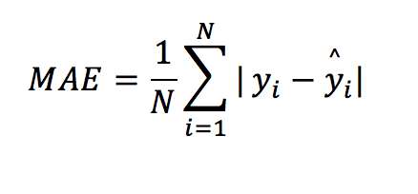
Figure.1.6.a Mean absolute error formula
Where y_{i} is a actual value, y^_{i} is a predicted value n is the total number of observations
MAE is not sensitive towards outliers and given several examples with the same input feature values, and the optimal prediction will be their median target value. This should be compared with Mean Squared Error, where the optimal prediction is the mean.

R-Squared error (R²) is a statistical measure that represents the proportion of the variance for a dependent variable that's explained by an independent variable or variables in a regression model. Whereas correlation explains the strength of the relationship between an independent and dependent variable,

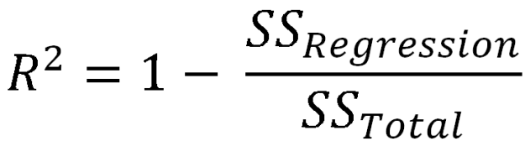

Figure.1.6.b R² error value

SS_{Regression} is sum of regression

SS_{Total} is total sum of squared

R-squared explains to what extent the variance of one variable explains the variance of the second variable. So, if the R² of a model is 0.50, then approximately half of the observed variation can be explained by the model's inputs.

  - ORGANIZATION OF REPORT
This project report is structured into 5 chapters.
Chapter 1: Gives a brief overview about the project in terms of its, Earthquake, Statement of the problem, Challenges, application and the approach that is used to achieve the goal. It also provides definitions and terms that are widely used throughout this project.
Chapter 2: Literature Survey in this section which shows the various analysis and research made in the fields of one’s interest and the result analysis and research made in the fields of one’s interest and the result already published, taking into account the various parameters of the project and extent of the project.
Chapter 3: Methodology it includes overview and the architecture of the project, Overview gives detail about how architecture is build and model used.
Chapter 4: Experiments and results. The experiments and results include the screenshots of some important result.
Chapter 5: Provides the conclusion drawn from result. It also states the work that can be done in future in order to further enhance the proposed system.

CHAPTER 2
LITERATURE SURVEY

Literature Review
Major earthquake event prediction using various machine learning algorithms by Roxane Mallouhy, Chady Abou Jaoude, Christophe Guyeux, Abdallah Makhoul
They worked on two basic categories of earthquake prediction exist: short-term predictions and forecast ones. Short term earthquake predictions are made hours or days in advance, while forecasts are predicted months to years in advance. The majority of studies are done on forecast, taking into consideration the history of earthquakes in specific countries and areas. In this context, the core idea of this work is to predict whereas an event is classified as negative or positive major earthquake by applying different machine learning algorithms. Eight different algorithms have been applied on a real earthquake dataset, namely: Random Forest, Naive Bayes, Logistic Regression, MultiLayer Perceptron, AdaBoost, K-nearest neighbors, Support Vector Machine, and Classification and Regression Trees. For each selected model, various hyperparameters have been selected, The study has been applied to a dataset collected from a center in California, which was recording inputs for 36 years and obtained prediction results have been fairly compared using various metrics, KNN, Random Forest and MLP are the best by producing the least false output (FP) while SVM, KNN, MLP and Random Forest classify the higher number of output correctly

Earthquake magnitude prediction in Hindukush region using machine learning techniques
by K. M. Asim , F. Martinez-A lvarez, A. Basit, T. Iqbal
This paper is done by taking the historic seismic activities in Hindukush region and predict the earthquake magnitude. Prediction has been made on the basis of mathematically calculated eight seismic indicators using the earthquake catalog of the region. In this research, four machine learning techniques including pattern recognition neural network, recurrent neural network, random forest and linear programming boost ensemble classifier are separately applied to model relationships between calculated seismic parameters and future earthquake occurrences. The problem is formulated as a binary classification task and predictions are made for earthquakes of magnitude greater than or equal to 5.5 (M 5.5), for the duration of 1 month. Furthermore, Eight mathematically calculated seismicity parameters have been considered to be used as classifiers inputs. Every applied classifier shows slightly different results from each other. Linear Programming Boost ensemble classifier shows better results in terms of sensitivity, while Pattern Recognition Neural Network tends to produce the least false alarms as compared to the other classifiers. The study shows, although earthquake occurrence is supposed to be decidedly nonlinear and appears to be a random phenomenon, yet it can be modeled on the basis of geophysical facts of the seismic region along with highly sophisticated modeling and learning approaches of machine learning.
Earthquake warning system : Detecting earthquake precursor signals using deep neural network by Mustsfs Al Ibrahim , Jihoon Park and Noah Athens
In this paper, they have address the earthquake recognition (P1) and earthquake prediction problems (P2), the dataset is continuous seismic waveform through public funded seismic station network that monitor and catalog seismic events. Therefore, dataset contains seismic stations across different region with earthquake magnitude and single or multi-channel waveforms. They test the performance of 1D CNN, 2D CNN and RNN neural networks on both problem .In problem P1, the goal is to predict whether an earthquake has occurred given a seismic waveform, generally the state-of-the- art is high, largely depending on the magnitude of the earthquake and problem P2 ,the goal is to predict whether an earthquake will occur given a seismic waveform. All of the presented neural network models achieved high performance on the earthquake recognition problem 1D CNN 94.4%, 2D CNN and RNN 100% but predicting earthquake before they occur is still a challenging problem, 1D CNN 54%, 2D CNN 52 % and RNN 56.4%.
Early Forecasting of Quakes via Machine Learning by Chester Holtz, Vignesh Gokul
In this study, they explore the application of a broad set of approaches and techniques from machine learning, statistics, and optimization including deep neural networks (LSTM, CNN, WaveNet), sparse quantile regression, and other online regression algorithms. In addition to applying these techniques to do prediction on the raw signal, we also experimented with various pre-processing and feature learning algorithms (Robust PCA, MFCC features, and spectral embeddings).Our intent is to design algorithms that are effective for forecasting quakes, but also to make sure that they are efficient (fast, low footprint) enough to potentially run on embedded monitoring devices in the field. Thus, we propose to evaluate the efficiency of inference of our algorithms by calculuating a normalized sparsity metric. We leveraged a gold-standard synthetic & real dataset released by Los Alamos National Laboratory. They explore and evaluate audio based approaches to processing and machine learning and deep learning to analyze seismic patterns in order to predict the time remaining till the next earthquake also believe that this would help save a lot of life and property if it can be incorporated in a real life scenario. We also hope that more research in this direction is pursued, as it looks really promising, based on our results.
Quake ML: Earthquake Forecasting by Stanley Dillon Hicks,Meher Akhil Birlangi,Jun Hao (Simon) Hu
In this paper, earthquake forecasting can be broken down into three key subproblems: when an earthquake will occur, where an earthquake will occur, and what is the magnitude of the earthquake. In this paper, they focus on the problem of predicting when an earthquake will occur using statistical, They present numerical results using earthquake acoustic data collected in a laboratory simulated experiment and then tested with Random Forest and XGBoost models, recieving poor validation performance with Random Forest a MAE of 3.6736, but a considerably higher performance using XGBoost due to better regularization and higher ease of training. With XGBoost, we get a final MAE of 2.0745 using the denoised data.
Analysis and Prediction of Earthquake Impact-a Machine Learning approach by Anmol Gaba, Arnab Jana, Rahul Subramaniam, Yash Agrawal, Merin Meleet
In this study, Earthquakes are measured using seismometers, that detect the vibrations due to seismic waves travelling through the earth’s crust. In this paper, the damage that is caused by an earthquake was classified into damage grades, ranging in values from one to five. A previously acquired data set was used, wherein a series of parameters were taken into consideration to predict the damage grade of a given building, which is associated with a Unique Identification String. The prediction was done using a survey of existing machine learning classifier algorithms, work show that the Random Forest Classifier algorithm has the highest accuracy in predicting the damage due to earthquakes, based on the F1 score calculated for each of the four algorithms previously mentioned in this work. K-Nearest Neighbors has been observed to be the second most preferred algorithm for earthquake damage prediction.
Earthquake Prediction using Machine Learning Algorithm by Pratiksha Bangar, Deeksha Gupta, Sonali Gaikwad, Bhagyashree Marekar, Jyoti Patil
In this paper, they are predicting earthquake and location, the data is extracted from United States Geological Survey India Meteorological Department, then they perform data engineering and feature engineering and used SVM and Random Forest Regression also used bagging, boosting and stacking techniques. The randomforest-support vector machine model in combination work well for large dataset. The accuracy obtained for stacking model is the highest- 83% as compared to the accuracy of bagging and boosting. Response time is same for all the methodologies, finally conclude that integration of seismic activity with machine learning technology yields efficient and significant result and can be used to predict earthquakes widely, given the past history of the same is well maintained. The collaboration of the two can further be advanced to guard earthquakes more acutely. Large datasets prove to be very significant. Prediction models can be deployed in an area centric manner, thus increasing the chances of accurate prediction exponentially but at the cost of studying algorithms used to build Stacking model, as it will perform well only if the algorithms chosen to build metaregressor are accurate themselves. The use of the methodology can be expanded in predicting various natural disasters as well.
Spatiotemporally explicit earthquake prediction using deep neural network by Mohsen Yousefzadeh, Seyyed AhmadHosseini, MahdiFarnaghi
In this study, Due to the complexity of predicting future earthquakes, machine learning algorithms have been used by several researchers to increase the Accuracy of the forecast. However, the concentration of previous studies has chiefly been on the temporal rather than spatial parameters. Additionally, the less correlated variables were typically eliminated in the feature analysis and did not enter the model. This study introduces and investigates the effect of spatial parameters on four ML algorithms' performance for predicting the magnitude of future earthquakes in Iran as one of the most earthquake-prone countries in the world. We compared the performances of conventional methods of Support Vector Machine (SVM), Decision Tree (DT), and a Shallow Neural Network (SNN) with the contemporary Deep Neural Network (DNN) method for predicting the magnitude of the biggest upcoming earthquake in the next week. conventional machine learning algorithms of SNN, SVM, and DT, as well as the contemporary DNN method, were exploited to predict earthquakes in Iran. In addition to the commonly used seismic parameters described in the previous research, a new parameter named FD was also introduced, which ameliorated the Accuracy of the deep learning earthquake prediction model. The results showed satisfactory performances of DNN and SVM in predicting the classes of high magnitudes. However, the performance of DT was more promising in coping with events of both high and low magnitudes.

CHAPTER 3
METHODOLOGY
Methodology
3.1 Overview
In this Chapter, we define the model used in this project and explain model one by one, In 3.2 we see architecture of the project and flow of the data with different model, In 3.3 we have how the dataset is collected and information of the data and 3.4 we explain all model in detail how it works.

3.2 ARCHITECTURE OF PROPOSED SYSTEM

Feature Selection
Feature Extraction
Data Exploration
Dataset

Spilt data into Train and test

RNN
CNN
RNN-LSTM
CNN-RNN
CNN-LSTM
LSTM

Model Predication
Evaluation the Model

Figure.3.2.1 ARCHITECTURE OF PROPOSED MODEL
3.3 DATASET
Data Generation Experimental Setup
The laboratory system is a two-fault configuration that contains fault gouge material submitted to double direct shear (Figure 5)

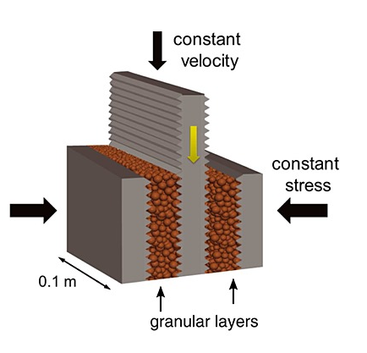
Figure.3.3.1 Data collection setup
Two fault gouge layers are sheared simultaneously while being subjected to a constant normal load and a prescribed shear velocity. The laboratory faults fail in repetitive cycles of stick and slip that is meant to mimic the cycle of loading and failure on tectonic faults. While the experiment is considerably simpler than a fault in the Earth it shares many physical characteristics.
A driving piston displaces at a very constant velocity during the inter-event time and accelerates briefly when a slip occurs. An accelerometer records the acoustic emission emanating from the shearing layers. The steel blocks are extremely stiff therefore the deformation takes place largely in the gouge.
Under a broad range of load and shear velocity conditions, the apparatus stick-slips quasi-periodically for hundreds of stress cycles during a single experiment and in general follows predictions from rate and state friction . The rate of impulsive precursors accelerates as failure approaches suggesting that upcoming laboratory earthquake timing could be predicted.
The experimental data has 16 earthquakes. The shortest time to failure is 1.5 seconds for the first earthquake, 7 seconds for the 7th and the longest is around 16 seconds.
3.4 MODELS
3.4.1 Convolutional Neural Network
Convolutional Neural Networks, or CNNs, are a type of neural network developed for two-dimensional image data, although they can be used for one-dimensional data such as sequences of text and time series. When operating on one-dimensional data, the CNN reads across a sequence of lag observations and learns to extract features that are relevant for making a prediction.
As we now, CNN convolutions are popularly known to work on spatial or 2D data. What’s less popular is that there are also convolutions for 1D data. This allows CNN to be used in more general data type including texts and other time series data. Instead of extracting spatial information, you use 1D convolutions to extract information along the time dimension.
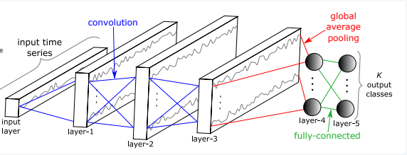
Input layer
Output
Max Pooling
Figure.3.4.a General CNN model
A convolution can be thought of a ‘weighted sum of memories’, assume that f(t) is sound and h(\tau) is the proportion one heard from \tau seconds ago, and that one can only hear sound at discrete time steps. Then what you hear at time t is
The convolution layer may have multiple filters. The vectors (one for each filter) resulting from taking all of these inner products of the weights and every k elements of the original vector is the convolutional layer.
Pooling involves chunking a vector into non-overlapping equal sized groups or ‘pools’, and then taking a summary statistic for each group. This further smooths out noise in local dynamics. Three common types of pool are max pooling (very common with images), average or mean pooling, and min pooling. The relu layer takes the smoothed vector from applying a convolutional and pooling layer, and then applies non-linearity to it to prepare it for the final out put layer.
The final output layer takes a representation of our original data that has undergone two layers of smoothing and one layer of non-linear transformation, and applies an activation function to a weighted sum of that representation to output data that is of the relevant form based on our choice of activation function. This could be class probabilities, a continuous-valued response, count data, or ordinal data.
We have define a CNN with three convolutional layers for extracting features from the input sequences. Each will have a configurable number of filters, pooling and kernel size and will use the rectified linear activation function. The number of filters determines the number of parallel fields on which the weighted inputs are read and projected. The kernel size defines the number of time steps read within each snapshot as the network reads along the input sequence.A max pooling layer is used after convolutional layers to distill the weighted input features into those that are most salient followed by a dense fully connected layer that interprets the features extracted by the convolutional part of the model and to reduce the feature maps to a single one-dimensional vector.
3.4.2 Recurrent Neural Network
Recurrent neural networks, or RNNs, are those types of neural networks that use an output of the network from a prior step as an input in attempt to automatically learn across sequence data. RNNs are specially designed to work with sequential data. RNNs have been able to produce state-of-the-art results in fields such as natural language processing, computer vision, and time series analysis. In RNNs, each hidden layer of the neural network feeds the next layer with it’s output ( Feed Forward ) and also feeds itself the output at time step ‘t’ while training on the data at next time step ‘t+1’. That is RNN tries to learn a sequence of data rather than independent data that a normal neural network learns. Because of this sequence learning capability, RNNs have the capability to learn language videos, time series etc.
The formula for the current state can be written is
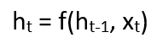
h_{t} current state
h_{t-1} previous state
x_{t} input state
We now have a state of the previous input instead of the input itself, because the input neuron would have applied the transformations on our previous input.
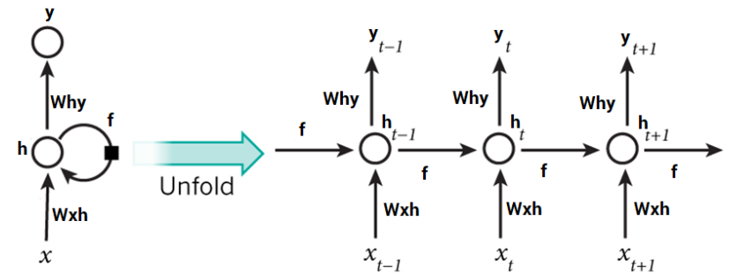
Figure.3.4.b General RNN model
So each successive input is called as a time step. In this case we have four inputs to be given to the network, during a recurrence formula, the same function and the same weights are applied to the network at each time step. Taking the simplest form of a recurrent neural network, let’s say that the activation function is tanh, the weight at the recurrent neuron is Whh and the weight at the input neuron is Wxh, we can write the equation for the state at time t as –
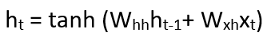

w_{hh} -> weight at recurrent neuron
w_{xh} -> weight at input neuron The Recurrent neuron in this case is just taking the immediate previous state into consideration. For longer sequences the equation can involve multiple such states. Once the final state is calculated we can go on to produce the output Now, once the current state is calculated we can calculate the output state as
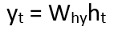
Y_{t} output
W_{hy} weight at output layer
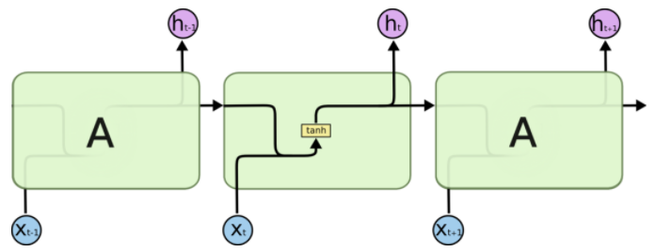
Figure.3.4.c RNN State

A single time step of the input is provided to the network. Then calculate its current state using set of current input and the previous state. The current ht becomes ht-1 for the next time step. One can go as many time steps according to the problem and join the information from all the previous states. Once all the time steps are completed the final current state is used to calculate the output. The output is then compared to the actual output i.e the target output and the error is generated. The error is then back-propagated to the network to update the weights and hence the network (RNN) is trained. In case of a forward propagation, the inputs enter and move forward at each time step. In case of a backward propagation in this case, we are figuratively going back in time to change the weights, hence we call it the Back propagation through time (BPTT).

3.4.3 Long Short-Term Memory Network
The Long Short-Term Memory network, or LSTM network, is a recurrent neural network that is trained using Backpropagation. Through Time and overcomes the vanishing gradient problem. As such, it can be used to create large recurrent networks that in turn can be used to address difficult sequence problems in deep learning and achieve state-of-the-art results.
Turns out that an RNN doesn’t do so. In order to add a new information, it transforms the existing information completely by applying a function. Because of this, the entire information is modified,
LSTMs on the other hand, make small modifications to the information by multiplications and additions. With LSTMs, the information flows through a mechanism known as cell states. This way, LSTMs can selectively remember or forget things. The information at a particular cell state has three different dependencies. These dependencies can be generalized to any problem as: ▹ The current long-term memory of the network — known as the cell state ▹ The output at the previous point in time — known as the previous hidden state ▹ The input data at the current time step
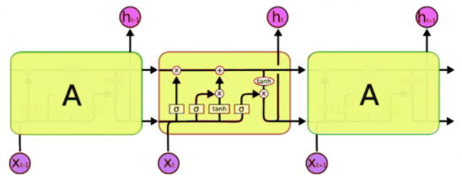
Figure 3.4.d LSTM State
LSTMs use a series of ‘gates’ which control how the information in a sequence of data comes into, is stored in and leaves the network. There are three gates in a typical LSTM; forget gate, input gate and output gate. These gates can be thought of as filters and are each their own neural network. We will explore them all in detail during the course of this article.
In the following explanation, we consider an LSTM cell as visualised in the following diagram. When looking at the diagrams in this article, imagine moving from left to right.
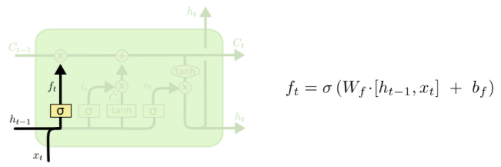
Figure 3.4.e LSTM forget gate
The first step in our LSTM is to decide what information we’re going to throw away from the cell state. This decision is made by a sigmoid layer called the “forget gate layer.” It looks at h_{t−1} and x_{t}, and outputs a number between 0 and 1 for each number in the cell state C_{t−1}. A 1 represents “completely keep this” while a 0 represents "completely get rid of this".
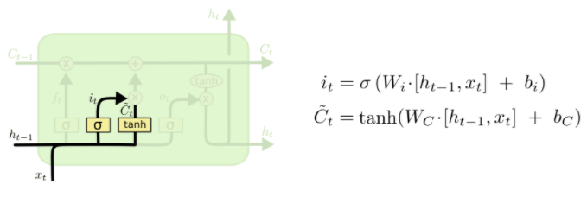
Figure3.4.f LSTM input gate
The next step is to decide what new information we’re going to store in the cell state. This has two parts. First, a sigmoid layer called the “input gate layer” decides which values we’ll update. Next, a tanh layer creates a vector of new candidate values, C_{t}, that could be added to the state. In the next step, we’ll combine these two to create an update to the state.
It’s now time to update the old cell state, C_{t−1}, into the new cell state C_{t}. The previous steps already decided what to do, we just need to actually do it.

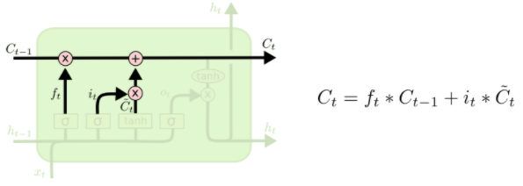
Figure.3.4.g LSTM update state

We multiply the old state by ft, forgetting the things we decided to forget earlier. Then we add i_{t}∗C~_{t}. This is the new candidate values, scaled by how much we decided to update each state value.
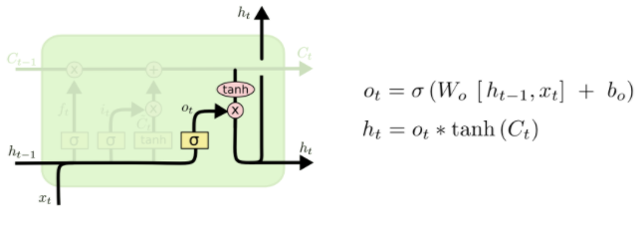
Figure.3.4.h LSTM output state
Finally, we need to decide what we’re going to output. This output will be based on our cell state, but will be a filtered version. First, we run a sigmoid layer which decides what parts of the cell state we’re going to output. Then, we put the cell state through tanh (to push the values to be between −1 and 1) and multiply it by the output of the sigmoid gate, so that we only output the parts we decided to.

3.4.4 Convolutional Neural Network And Recurrent Neural Network
Since our CNN and RNN were giving descent result, we combined the model, As CNNs are good with hierarchical and extracting unlabeled features. Those could be images or time series. CNNs take fixed size inputs and generate fixed size outputs.
RNNs are good at temporal or otherwise sequential data. Could be letters or words in a body of text, time series data or speech recognition. RNNs can input and output arbitrary lengths of data.
For our problem we defined A one-dimensional CNN model that has a convolutional hidden layer that operates over a 1D sequence and pooling layers, then CuDNNGRU layer is followed by a dropout and dense fully connected layer.

3.4.5 Convolutional Neural Network And Long Short-Term Memory Network
We have seen that the CNN model is capable of automatically learning and extracting features from the data without scaling or differencing. We can combine this capability with the LSTM where a CNN model is applied to sub-sequences of input data, the results of which together form a time series of extracted features that can be interpreted by an LSTM model.
This combination of a CNN model used to read multiple subsequences over time by an LSTM is called a CNN-LSTM model.
The model requires that each input sequence, The output of one application of the CNN submodel will be a vector. The output of the submodel to each input subsequence will be a time series of interpretations that can be interpreted by an LSTM model. This can be followed by a fully connected layer to interpret the outcomes of the LSTM and finally an output layer for making one-step predictions.
For our problem we defined one Conv1D layer that has a convolutional hidden layer that operates over a 1D sequence and pooling layers, then stacked by two LSTM layer followed by fully dense layer
3.4.6 Recurrent Neural Network And Long Short-Term Memory Network
As we know RNN is recurrent in nature as it performs the same function for every input of data while the output of the current input depends on the past one computation. After producing the output, it is copied and sent back into the recurrent network. For making a decision, it considers the current input and the output that it has learned from the previous input.
Long Short-Term Memory (LSTM) networks are a modified version of recurrent neural networks, which makes it easier to remember past data in memory. The vanishing gradient problem of RNN is resolved here. LSTM is well-suited to classify, process and predict time series given time lags of unknown duration. It trains the model by using back-propagation

CHAPTER 4
EXPERIMENTAL RESULTS

4. EXPERIMENTAL RESULTS
4.1 Overview
In this Chapter, we see the experiment conducted on 6 different deep learning model and what are their result. Initially we import pandas, numpy, matplotlib and from sklearn.metrics import train test split, mean absolute error, r2_scorer then from tensorflow import keras, Sequential, Dense, Dropout and optimizer as our basic dependence.
Then depending upon the model, we import the model layer ,then the dataset is divided into train test split next we created the model compile and fit the model with epoch and batch size, lastly evaluate the model with mean absolute error and r squared
In Dataset we define how data was collect and what was setup while collecting In Data Exploration we understand the dataset clearly and also added some screenshot of data exploration and also performed data pre-processing since we had noise in dataset,
Then we have Feature Extraction were we define different feature in detail and In Feature Selection we define method used while selecting feature and lastly we have Models were we define all the model used in project with their structure.
In 4.6 we have step to implement the model reference on model build in 4.6.a and also screenshot of train loss and prediction. Similarly from 4.7 to 4.11 the step are define and associate model reference and screenshot.
Lastly we have evaluation the mean absolute error and r squared value of all model used and associated screenshot are present.

4.2 Data Exploration
Data exploration is a methodology where we explore a large data set in an unstructured way to uncover initial patterns, characteristics, and points of interest. Essentially, Data exploration is pruning of data to remove unusable parts and identify potential relationships between different types of data. The data used in this work is a 157.275 second recording of seismic signals (ordered sequentially). It was recorded at 4MHz hence 629,145,480 data points accompanied by the time remaining in seconds until the following lab earthquake. The seismic signals are recorded using a piezoceramic sensor which outputs a voltage upon deformation by incoming seismic waves (henceforth we will use the term acoustic signal). The seismic data, which serves as the input to our analysis, is this recorded voltage, in integers.
The Acoustic Signal is the voltage upon deformation by incoming seismic waves.
These signals are integers in the range [-5515 to 5444] with a mean of 4.52. The distribution of the acoustic signals has a very high peak and we see outliers in both directions.
The Time to Failure is the remaining time in seconds until an actual stick-slip failure occurred. The minimum value is very close to zero (9.55039650e-05 seconds) and the maximum is 16 seconds. The distribution of the time to failure is right skewed (Figure 7).
The first five rows of the data are shown in Table 1.
TABLE 1 First Five rows
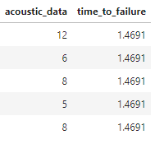
Figure.4.2 First Five rows of dataset
The acoustic signal shows huge fluctuations regularly just before each failure (Figure 5). It is also worth noting that failures can be predicted visually as cases when huge fluctuations in the signal are followed by smaller signals.
On a zoomed-in time plot (Figure 6) we see that the large acoustic signal oscillation at the 1.572 second mark is not at the exact time of the failure but just before it. There are trains of intense signal oscillations preceding the large one and some smaller ones after it.

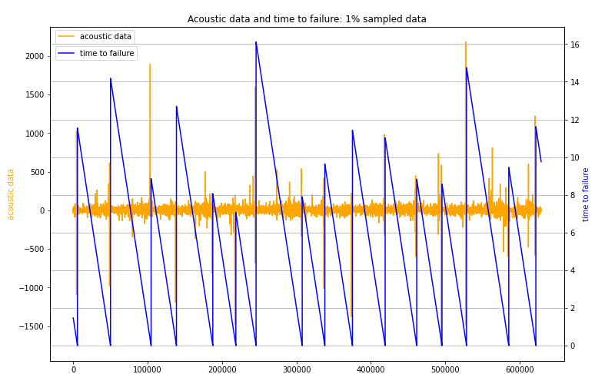
Figure.4.2.a 157.275 seconds of the data

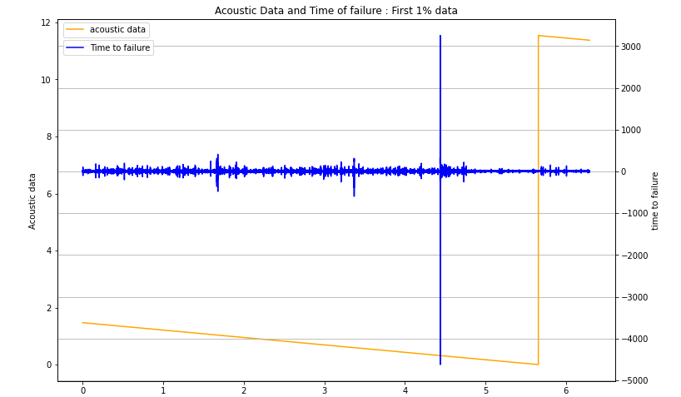
Figure 4.2.b First 1% of data

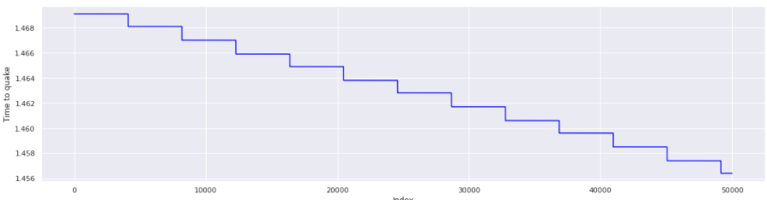
Figure 4.2.c First 50k Time of failure data
In this Figure 20 the time of failure seems to stay almost constant up to index 4000. Then a step decrease occurs. Afterwards this kind of pattern is repeated.
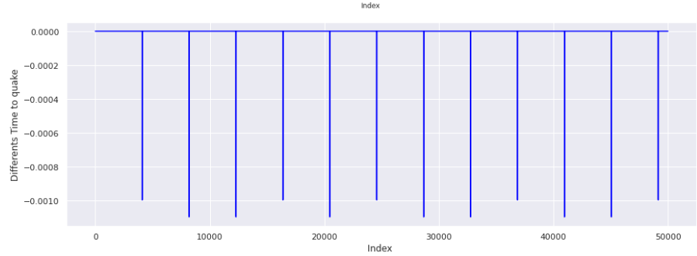
Figure.4.2.d Explore step of time of failure data
In Figure 21 reveals that the second jump of the time of failure is larger than the first.
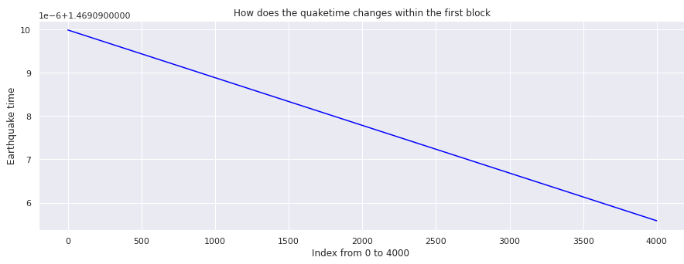
Figure.4.2.e Seeing one step of time of failure data
In Figure 22 the time of failure within such a “constant” block is not really constant but linear decreasing even though with very small numbers.
4.3 DATA PRE-PROCESSING
Pre-processing refers to the transformations applied to our data before feeding it to the algorithm. Data Preprocessing is a technique that is used to convert the raw data into a clean data set. In other words, whenever the data is gathered from different sources it is collected in raw format which is not feasible for the analysis.
Since the data was physical experiment and through our data exploration we find that the data consist of noise. So to overcome the noise we use Butterworth filter and Short Time Average over Long Time Average (STA/LTA) to remove the noise and also since our problem is regression, Linear regression equation helps to smoothen noise by fitting all data points in a regression function.
Butterworth filter
The Butterworth filter is a type of signal processing filter designed to have a frequency response as flat as possible in the pass band. It is also referred to as a maximally flat magnitude filter. For our experiment we used high pass filter, low pass filter and band pass filter.
A filter is a system that allow certain frequency to pass to its output and reject all other signals. The low pass filter is a filter that allows the signal with the frequency is lower than the cutoff frequency and helps in cancel the aliasing effect. The high pass filter is a filter that allows the signal with the frequency is higher than the cutoff frequency and cancel the low-frequency noise from the input signal. The band pass filter is a filter that follows the frequencies within specific range and rejects frequencies outside range.

Short Time Average over Long Time Average (STA/LTA)
Today, (STA/LTA) is the most broadly used algorithm in weak-motion seismology. It continuously calculates the average values of the absolute amplitude of a seismic signal in two consecutive moving-time windows. The short time window (STA) is sensitive to seismic events while the long time window (LTA) provides information about the temporal amplitude of seismic noise at the site. When the ratio of both exceeds a pre-set value, an event is ‘declared’ and data starts being recorded in a file

4.4 FEATURE EXTRACTION
Feature extraction is a process of dimensionality reduction by which an initial set of raw data is reduced to more manageable groups for processing. A characteristic of these large data sets is a large number of variables that require a lot of computing resources to process. Feature extraction is the name for methods that select and /or combine variables into features, effectively reducing the amount of data that must be processed, while still accurately and completely describing the original data set.
.
Extraction of feature was done in three parts
- Statistical Feature
Statistical features are selected by deriving various statistical metrics that represent different local and global aspects of the underlying signal. We compute sliding-window features for a variety of different window sizes to capture local and global descriptors of the earthquake signal.
- Absolute features: max, mean and std.
- Aggregations for first and last 10000 and 50000 values Rolling Feature
- 1% ,10%,90,99% Quantile of rolling standard deviation for 100, 1000, 10000 observations
- Other statistical feature kurtosis,skew and 9 different range of filter.
- Filter Feature
The Butterworth filter is a type of signal processing filter designed to have a frequency response as flat as possible in the passband. It is also referred to as a maximally flat magnitude filter.
The short time window (STA) is sensitive to seismic events while the long time window (LTA) provides information about the temporal amplitude of seismic noise at the site. When the ratio of both exceeds a pre-set value, an event is ‘declared’ and data starts being recorded in a file
- Applied different range of Butterworth filter on rolling window.
- Applied different STA/LTA on rolling window and extracted the feature

- Fourier Feature
The aim of applying Fourier transform is to decompose the original signal into a sum of its simpler signals, no matter how complex the original one looks. We refer to simpler signals, as the trigonometric functions sine and cosine.
- Fourier magnitude with 1%,10%,90%,99% quantile.
- Fourier phrases with mean and std.
- Fourier real part with min, max, std.
4.5 Feature Selection
Feature selection is the process of isolating the most consistent, non-redundant, and relevant features to use in model construction. Methodically reducing the size of datasets is important as the size and variety of datasets continue to grow. The main goal of feature selection is to improve the performance of a predictive model and reduce the computational cost of modeling.
Feature Selection using Select from Model starts with determining the threshold value to give a boundary between the features to be selected and the features that will be eliminated, then all features will be sorted by Gini importance score from the smallest to the largest. Furthermore, features with Gini importance score that are below the threshold value will be eliminated. Selected features will be used in the Random Forest algorithm Feature Selection using Select from Model starts with determining the threshold value to give a boundary between the features to be selected
For our feature selection done, using Select from Model starts with determining the threshold value to give a boundary between the feature to be selected and the feature thar will be eliminated, then all feature will be stored by Gini importance score from the smallest to the largest .Furthermore, feature with Gini importance score that are below the threshold value will be eliminated . Selected feature will be used in Random Forest algorithm.

Algorithm for feature selection:
- All Feature Extraction data is taken and splited
- Then from sklearn ensemble import RandomForestRegressor
- Give the n_estimator and fit the model
- Then from sklearn feature selection import SelectFromModel
- Give the threshold
- We will get important feature

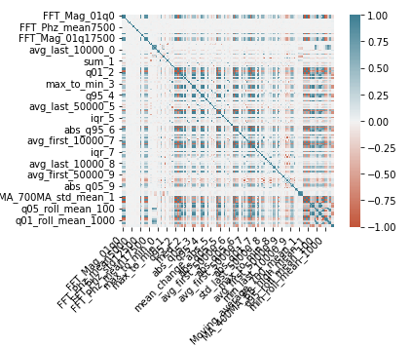
Figure.4.5 Important Feature Selected

4.6 CNN
Step 1 : Import all basic dependence and Conv1D layer and split the data.
Step 2 : Build the CNN as in figure 4.6.a
Step 3 : Fit the model with epoch and batch size as in figure 4.6.b
Step 4 : Evaluate the model with mean absolute error and r squared
Step 5 : The result show that CNN model as rightly predicted with mean absolute error of 0.31
and r squared of 0.97
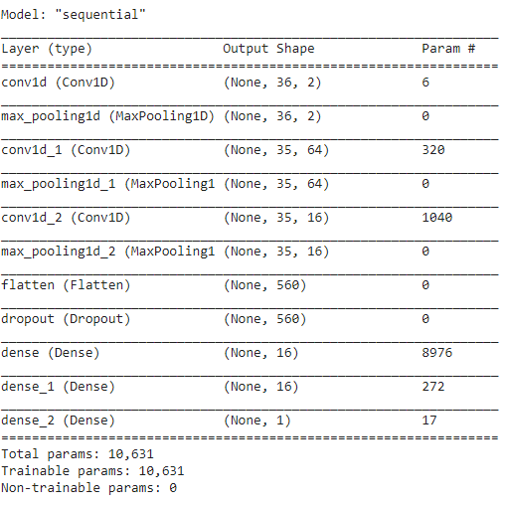
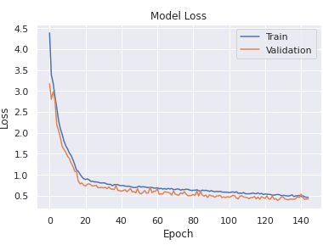
Figure.4.6.a CNN built model Figure.4.6.b Train loss of CNN model
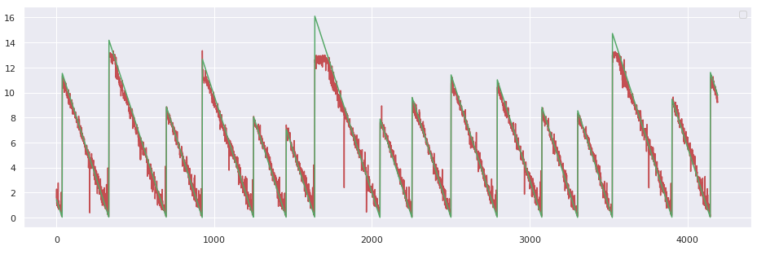
Figure.4.6.c CNN Prediction MAE is 0.31 and r ² is 0.97
4.7 RNN
Step 1 : Import all basic dependence and CuDNNGRU layer and split the data.
Step 2 : Build the RNN as in figure 4.7.a
Step 3 : Fit the model with epoch and batch size as in figure 4.7.b
Step 4 : Evaluate the model with mean absolute error and r squared
Step 5 : The result show that RNN model as rightly predicted with mean absolute error of 0.29
and r squared of 0.98
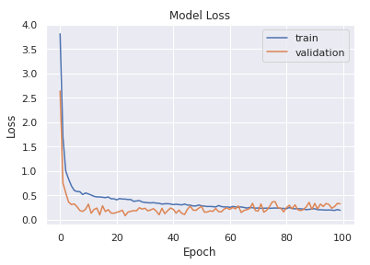
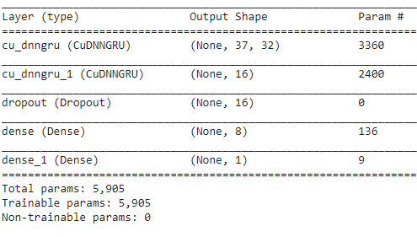
Figure.4.7.a RNN built model Figure.4.7.b Train loss of RNN model
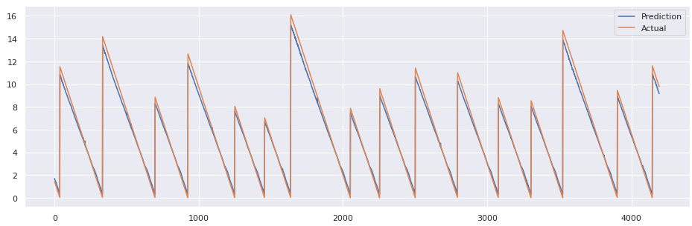
Figure.4.7.c RNN Prediction MAE is 0.29 and r ² is 0.98
4.8 LSTM
Step 1 : Import all basic dependence and LSTM layer and split the data.
Step 2 : Build the RNN as in figure 4.8.a
Step 3 : Fit the model with epoch and batch size as in figure 4.8.b
Step 4 : Evaluate the model with mean absolute error and r squared
Step 5 : The result show that RNN model as rightly predicted with mean absolute error of 0.21
and r squared of 0.99
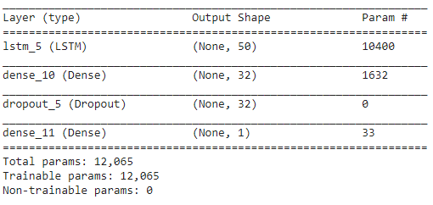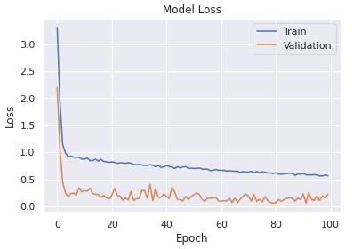
Figure.4.8.a LSTM built model Figure.4.8.b Train loss of LSTM model
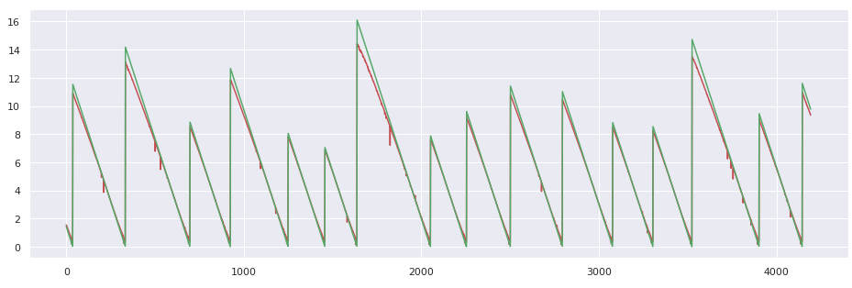
Figure.4.8.c LSTM Prediction MAE is 0.21 and r ² is 0.99
4.9 CNN –RNN
Step 1 : Import all basic dependence and Conv1D ,CuDNNGRU layer and split the data.
Step 2 : Build the CNN-RNN as in figure 4.9.a
Step 3 : Fit the model with epoch and batch size as in figure 4.9.b
Step 4 : Evaluate the model with mean absolute error and r squared
Step 5 : The result show that RNN model as rightly predicted with mean absolute error of 0.29
and r squared of 0.98
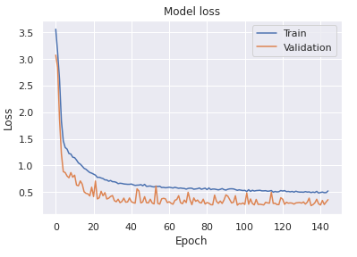
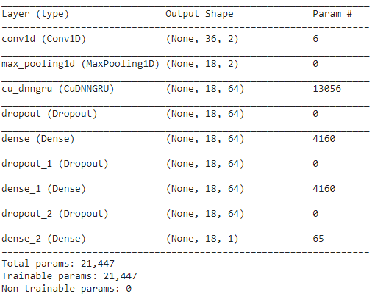
Figure.4.9.a CNN-RNN built model Figure.4.9.b Train loss of CNN-RNN Model
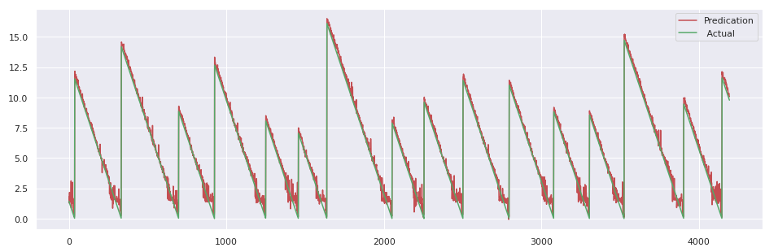
Figure.4.9.c CNN-RNN Prediction MAE is 0.29 and r ² is 0.98
4.10 CNN – LSTM
Step 1 : Import all basic dependence and Conv1D,LSTM layer and split the data.
Step 2 : Build the CNN-LSTM as in figure 4.10.a
Step 3 : Fit the model with epoch and batch size as in figure 4.10.b
Step 4 : Evaluate the model with mean absolute error and r squared
Step 5 : The result show that RNN model as rightly predicted with mean absolute error of 0.22
and r squared of 0.98
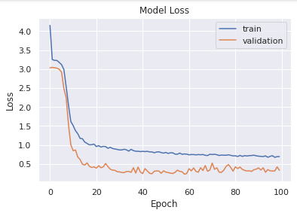
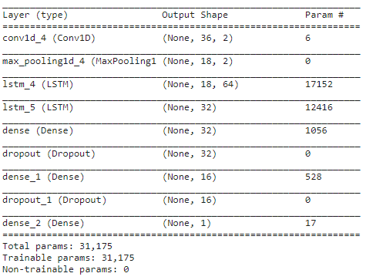
Figure.4.10.a CNN-LSTM built model Figure.4.10.b Train loss of CNN-LSTM Model
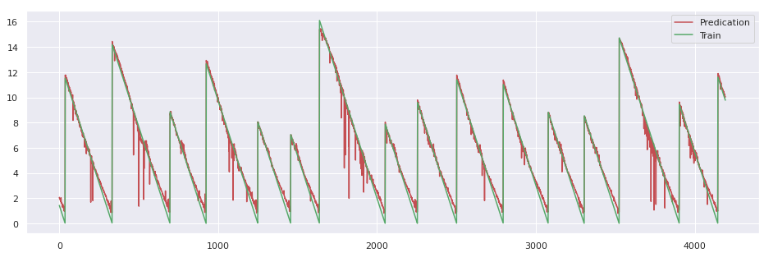
Figure.4.10.c CNN-LSTM Prediction MAE is 0.22 and r ² is 0.98
4.11 RNN –LSTM
Step 1 : Import all basic dependence and CuDNNGRU,LSTM layer and split the data.
Step 2 : Build the RNN-LSTM as in figure 4.11.a
Step 3 : Fit the model with epoch and batch size as in figure 4.11.b
Step 4 : Evaluate the model with mean absolute error and r squared
Step 5 : The result show that RNN model as rightly predicted with mean absolute error of 0.23
and r squared of 0.98
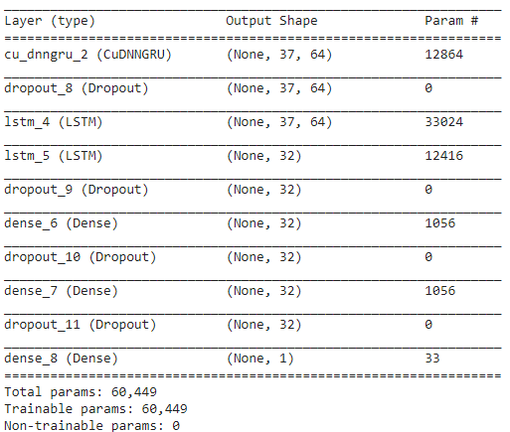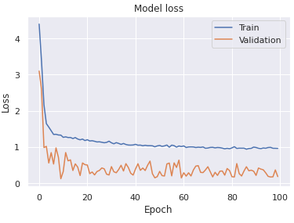
Figure.4.11.a RNN-LSTM built model Figure.4.11.b Train loss of RNN-LSTM Model
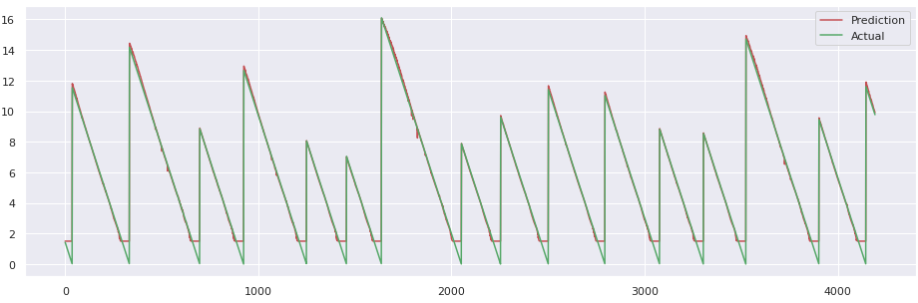
Figure.4.11.c RNN-LSTM Prediction MAE is 0.29 and r ² is 0.98
4.12 EVALUTION OF MODEL
Here we see the comparison of the all model, below in the figure 29 saw the graphical representation of the model and CNN-LSTM and LSTM model gave the accuracy of MAE ~0.21 and rest have MAE around ~0.25
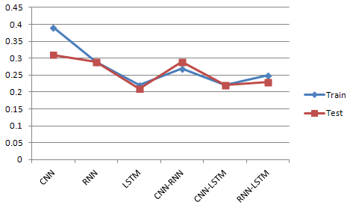
Figure.4.12.a Train Test of All Model
Below is the representation of R squared value and LSTM got the best result of R² is 0.99 and rest got 0.98
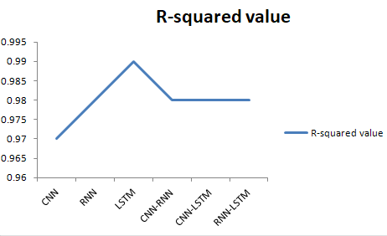
Figure.4.12.b Comparison of all R² value

CHAPTER 5
CONCLUSION AND FUTURE WORK

CONCLUSION AND FUTURE WORK
In this project, from acoustic data sourced from laboratory earthquakes, we were able to detect the time to failure for each earthquake using deep learning methods. We utilized denoising techniques like Butterworth filter and short time window/ long time window on this acoustic data to remove sensor noise and then extracted feature from data and finally used 37 features to build model.
We tested on CNN, RNN, LSTM and also stacked RNN-CNN, CNN-LSTM, RNN-LSTM models, receiving poor validation performance with CNN of 0.39 of mean absolute error, but a considerably little higher performance using LSTM, CNN-LSTM with MAE of 0.21. Our results show that further feature generation and denoising of acoustic data can result in accurate predictions for time to failure for laboratory earthquakes. Finally, we conclude that LSTM and CNN-LSTM model is better for predicating earthquake on laboratory dataset.

For future work we can use hyper parameter to make our model more robust and use cloud based platform to stream live data to the model, as our work is potentially applicable to the field of real world earthquakes. Essential improvements in providing new understanding of fault physics may be brought by applying this technique to acoustic seismic data. Other potential applications include avalanche prediction, landslides and failure of machine parts and also help in developing early warning system, monitor precursory slow earthquakes globally, detect mega earthquakes as soon as they start, tens of minutes before damaging waves arrive, apply technology to induced earthquakes, we can recognize mega earthquakes as soon as they are taking place, 5 to 15 minutes before the damage starts

REFERENCE
- Major earthquake event prediction using various machine learning algorithms by Roxane Mallouhy, Chady Abou Jaoude, Christophe Guyeux, Abdallah Makhoul.
DOI : 10.1109/ICT-DM47966.2019.9032983
- Earthquake magnitude prediction in Hindukush region using machine learning techniques by K. M. Asim , F. Martı´nez-A´ lvarez, A. Basit, T. Iqbal
DOI : 10.1007/s11069-016-2579-3
- Earthquake warning system : Detecting earthquake precursor signals using deep neural network by Mustsfs Al Ibrahim , Jihoon Park and Noah Athens
Link : https://cs230.stanford.edu/projects_spring_2018/reports/8291012.pdf
- Early Forecasting of Quakes via Machine Learning by Chester Holtz, Vignesh Gokul
Link :https://kastner.ucsd.edu/Earthquake-FinalReport.pdf
- Dataset link LANL-Earthquake-Prediction/data
- Quake ML: Earthquake Forecasting by Stanley Dillon Hicks,Meher Akhil Birlangi,Jun Hao (Simon) Hu
Link : http://noiselab.ucsd.edu/ECE228-2020/projects/Report/9Report.pdf
- Analysis and Prediction of Earthquake Impact-a Machine Learning approach by Anmol Gaba, Arnab Jana, Rahul Subramaniam, Yash Agrawal, Merin Meleet
DOI : 10.1109/CSITSS47250.2019.9031026
- Earthquake Prediction using Machine Learning Algorithm by Pratiksha Bangar, Deeksha Gupta, Sonali Gaikwad, Bhagyashree Marekar, Jyoti Patil
Link : https://www.ijrte.org/wp-content/uploads/papers/v8i6/F9110038620.pdf
- Spatiotemporally explicit earthquake prediction using deep neural network by Mohsen Yousefzadeh, Seyyed AhmadHosseini, MahdiFarnaghi
Link : https://ris.utwente.nl/ws/portalfile1_s2.0_S0267726121000853_main.pdf
- Machine Learning Predicts LaboratoryEarthquake
Link : https://doi.org/10.1002/2017GL074677
- Estimating Fault Friction From Seismic Signals in the Laboratory
Link : https://doi.org/10.1002/2017GL076708
- Similarity of fast and slow earthquakes illuminated by machine learning
Link : https://www.nature.com/articles
- Continuous chatter of the Cascadia subduction zone revealed by machine learning
Link :

List of Figures
Figure.1 Earthquake
Figure.1.6.a Mean absolute error formula
Figure.1.6.b R² error value

Figure.3.2.1 Architecture of proposed model

Figure.3.3.1 Data collection setup
Figure.3.4.a General CNN model
Figure.3.4.b General RNN model
Figure.3.4.c RNN State
Figure 3.4.d LSTM State
Figure 3.4.e LSTM forget gate
Figure3.4.f LSTM input gate
Figure.3.4.g LSTM update state
Figure.3.4.h LSTM output state
Figure.4.2 First Five rows of dataset
Figure.4.2.a 157.275 seconds of the data
Figure 4.2.b First 1% of data
Figure 4.2.c First 50k Time of failure data
Figure.4.2.d Explore step of time of failure data
Figure.4.2.e Seeing one step of time of failure data
Figure.4.5 Important Feature Selected
Figure.4.6.a CNN built model
Figure.4.6.b Train loss of CNN model
Figure.4.6.c CNN Prediction MAE is 0.31 and r ² is 0.97
Figure.4.7.a RNN built model
Figure.4.7.b Train loss of RNN model
Figure.4.7.c RNN Prediction MAE is 0.29 and r ² is 0.98
Figure.4.8.a LSTM built model
Figure.4.8.b Train loss of LSTM model
Figure.4.8.c LSTM Prediction MAE is 0.21 and r ² is 0.99
Figure.4.9.a CNN-RNN built model
Figure.4.9.b Train loss of CNN-RNN Model
Figure.4.9.c CNN-RNN Prediction MAE is 0.29 and r ² is 0.98
Figure.4.10.a CNN-LSTM built model
Figure.4.10.b Train loss of CNN-LSTM Model
Figure.4.10.c CNN-LSTM Prediction MAE is 0.22 and r ² is 0.98
Figure.4.11.a RNN-LSTM built model
Figure.4.11.b Train loss of RNN-LSTM Model
Figure.4.11.c RNN-LSTM Prediction MAE is 0.29 and r ² is 0.98
Figure.4.12.a Train Test of All Model
Figure.4.12.b Comparison of all R² value

